- in phpmyadmin or the command line: Create a database named websyslab8.
  - CREATE DATABASE websyslab8;
- Create a table named courses. It should contain
crn (int 11, primary key)
prefix (varchar 4, not null)
number (smallint 4, not null)
title (varchar 255, not null)
collate should be utf8_unicode_ci
  - CREATE TABLE courses (
crn INT(11) NOT NULL PRIMARY KEY,
prefix VARCHAR(4) NOT NULL,
number SMALLINT(4) NOT NULL,
title VARCHAR(255) NOT NULL
)
CHARACTER SET utf8
COLLATE utf8_unicode_ci;
- Create a table named students. It should contain
rin (int 9, primary key)
rcsID (char 7)
first name (varchar 100, not null)
last name (varchar 100, not null)
alias (varchar 100, not null)
phone (int 10)
collate should be utf8_unicode_ci
CREATE TABLE students (
rin INT(9) NOT NULL PRIMARY KEY,
rcsID CHAR(7),
first_name VARCHAR(100) NOT NULL,
last_name VARCHAR(100) NOT NULL,
alias VARCHAR(100) NOT NULL,
phone BIGINT(10)
)
CHARACTER SET utf8
COLLATE utf8_unicode_ci;
- Add address fields (street, city, state, zip) to the students table
  - ALTER TABLE students
ADD street VARCHAR(255) NOT NULL,
ADD city VARCHAR(100) NOT NULL,
ADD state CHAR(2) NOT NULL,
ADD zip CHAR(10) NOT NULL;
- Add section and year fields to the courses table
  - ALTER TABLE courses
ADD section TINYINT UNSIGNED NOT NULL,
ADD year SMALLINT UNSIGNED NOT NULL;
- CREATE a grades table containing
id (int primary key, auto increment)
crn (foreign key)
rin (foreign key)
grade (int 3 not null)
  - CREATE TABLE grades (
id INT NOT NULL AUTO_INCREMENT PRIMARY KEY,
crn INT(11),
rin INT(9),
grade INT(3) NOT NULL,
FOREIGN KEY (crn) REFERENCES courses(crn),
FOREIGN KEY (rin) REFERENCES students(rin)
)
CHARACTER SET utf8
COLLATE utf8_unicode_ci;
- INSERT at least 4 courses into the courses table
  - INSERT INTO courses (crn, prefix, number, title, section, year)
VALUES
(73131, 'CSCI', 2200, 'Foundations of Computer Science', 1, 2025),
(75418, 'CSCI', 2800, 'Computer Architecture and Operating Systems', 2, 2025),
(73048, 'ITWS', 2110, 'Web Systems Development', 1, 2025),
(75254, 'STSO', 1100, 'Science, Tech, & Society', 2, 2025);
- INSERT at least 4 students into the students table
INSERT INTO students (rin, rcsID, first_name, last_name, alias, phone, street, city, state, zip)
VALUES
(662089080, 'collej2', 'Jake', 'Collen', 'Jake', 5188059384, '211 Foster Rd', 'Cropseyville', 'NY', 12052),
(100000001, 'johnsb5', 'Bob', 'Johnson', 'Bobby', 5167430967, '110 8th Street', 'Troy', 'NY', 12180),

(100000002, 'willic7', 'Charlie', 'Williams', 'Chuck', 3489592734, '110 8th Street', 'Troy', 'NY', 12180),
(100000003, 'brownd9', 'Diana', 'Brown', 'Di', 5830129342, '110 8th Street', 'Troy', 'NY', 12180);
- ADD 10 grades into the grades table
  - INSERT INTO grades (crn, rin, grade)
VALUES
(73048, 662089080, 99),
(73131, 662089080, 79),
(75418, 662089080, 89),
(73048, 100000001, 88),
(73131, 100000001, 87),
(75418, 100000001, 91),
(73048, 100000002, 92),
(75254, 100000002, 93),
(73048, 100000003, 85),
(75254, 100000003, 89);
- list all students in the following sequences; in alphabetical order by rin, last name, RCSid, and firstname
  - SELECT * FROM students
ORDER BY rin ASC;
    - 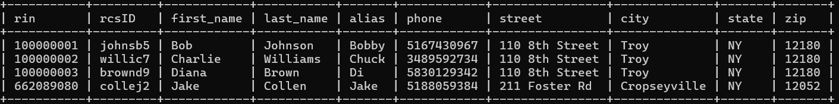

  - SELECT * FROM students ORDER BY last_name ASC;
    - 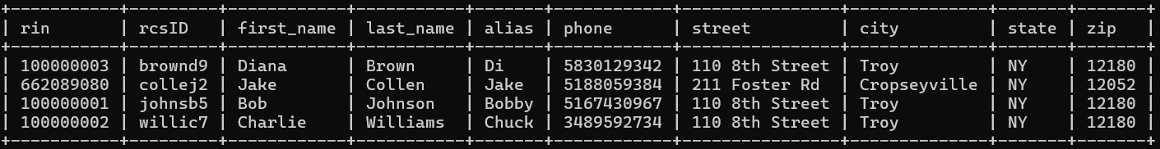

  - SELECT * FROM students ORDER BY rcsID ASC;
    - 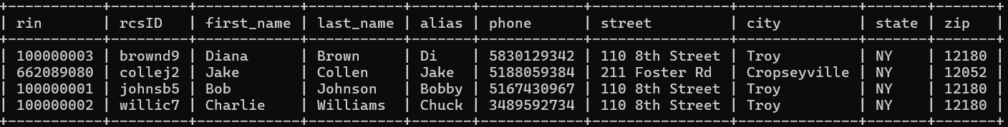

  - SELECT * FROM students ORDER BY first_name ASC;
    - 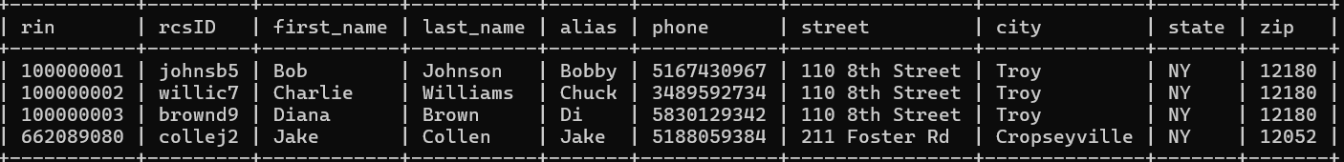

- list all students rin, name and address if their grade in any course was higher than a 90
  - SELECT s.rin, s.first_name, s.last_name, s.street, s.city, s.state, s.zip
FROM students s
JOIN grades g ON s.rin = g.rin
WHERE g.grade > 90;
- 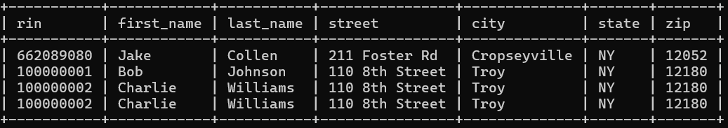

- list out the average grade in each course
  - SELECT crn, AVG(grade) AS average_grade
FROM grades
GROUP BY crn;
- 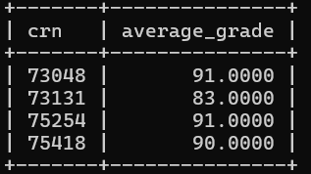

- list out the number of students in each course
  - SELECT crn, COUNT(rin) AS num_students
FROM grades
GROUP BY crn;
    - 