Final Project: Survey program

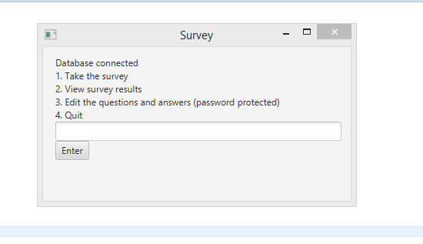

Figure : Main UI provides options for user.

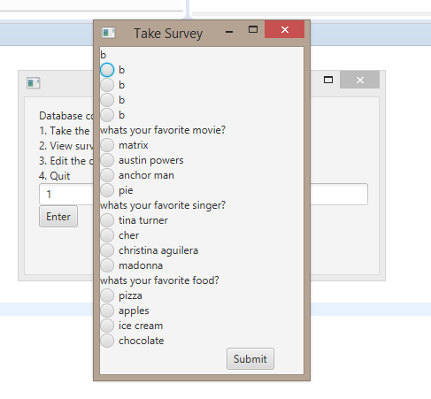

Figure : This displays the survey as selected in main UI. The method that displays this window is connected to the database. Upon submission, the votes in the data base are updated and the window then closes.

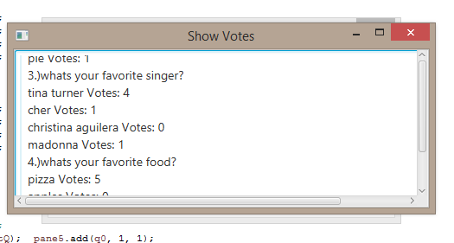

Figure : The show votes window induces a method belonging to db package that runs a query which is then printed in text area that is nested in scroll window.

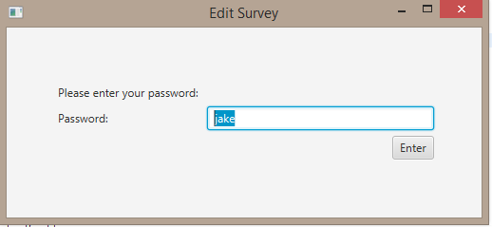

Figure : After select option three in the main UI, the user is prompted enter password.

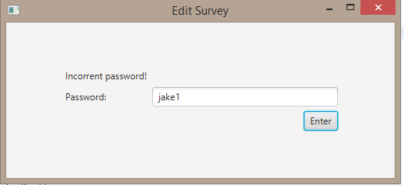

Figure : If the password is wrong then the user is prompted in label.

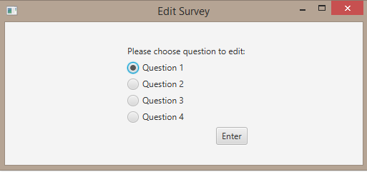

Figure : After password is correct, the user is then given the option to choose what question to edit. After submission, the value of the toggle is then sent the method that actually edits the question selected.

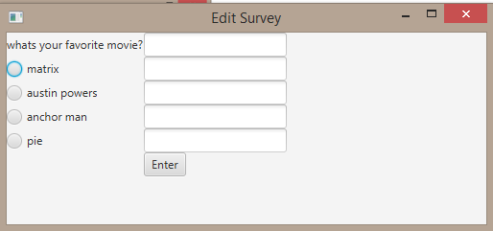

Figure : Here the user enters the new questions and answers in there corresponding text fields. Upon submission, a method belonging to db package is induced which runs an update script.

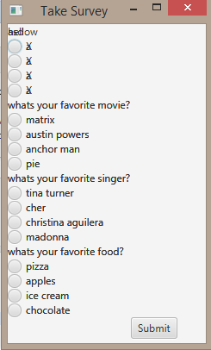

Figure : The issue I had was that after a second update to the same question, the initial change still remain. As result, the newly updated question and answers overlap. I try to address this issue by creating a method in db package that sets questions and answers to a string of nothing. However, even attempted that did not correct this overlapping issue.