Compete in the Cloud: A Small Business’s Framework for Cloud Migration

Jake Derkowski

Department of Computer Science

Cyber Forensics Intelligence Center

Sam Houston State University

Huntsville, TX, USA

jad084@shsu.edu

Abstract—Cloud Computing is a process of delivering services available on a host computer over the Internet to other machines. However simple this may seem, there still are a lot of people who get scared of new or foreign technology which discourages learning the truth. This trust is that the benefits that it offers to all kinds of organizations is nothing that has ever been possible with traditional hosting: including, but not limited to, cost-efficacy, built-in security, compliance, and more. Due to lack of resources and education, many small to medium-sized businesses (SMBs) have been hesitant to migrate to the cloud due to the fear of experiencing outages or data breaches. This paper is intended to reach these organizations that fear migration as well as those who do not think it is necessary. The objective of this paper is to show that cloud computing is here to stay and to encourage the utilization of it by providing a framework on how to do so.

Index Terms—cloud computing, migration, disaster recovery, business continuity

1. INTRODUCTION

This research is focused on supplying small to medium-sized businesses (SMBs) a guideline to a successful cloud migration or implementation. In today’s rapidly changing technological landscape, we believe that these businesses deserve some help with their attempt to combat their corporate competitor. We hope that this paper will illustrate the wide range of solutions and advantages cloud computing provides to businesses such as flexibility, scalability, agility, plus at a reduced cost [1].

We have designed our framework to fit the profile of the SMBs because SMBs are not equipped with the right knowledge or perspective of this new technology. This flawed conception of the cloud has resulted in a fear which will be shown to be common within similar sized organizations—but it is nothing to be afraid of. Larger businesses and corporations have people that they pay to keep then current with technology as well as takes care of all of it for them; this is rare for SMBs. When a technology is not fully understood is can most certainly be frightening, and with many horror stories that have spread (mainly amongst the SMBs) they have little trust in this technology and those who would be supplying it to them.

The cloud service providers (CSPs), such as Microsoft’s Azure, Amazon Web Services (AWS), and Google Cloud

Cihan Varol

Department of Computer Science

Cyber Forensics Intelligence Center

Sam Houston State University

Huntsville, TX, USA

cvarol@shsu.edu

Platform (GCP) are some, if not, the largest corporations in the world and some could even say they are the “en-emy”—however true this may be, the cloud service in which they offer essentially makes them a friend [2]. Does not change a thing though, the fact is that SMBs are reluctant to change for several reasons, but they all boil down to the same thing: they fear something that they know nothing about.

According to a survey [3], this fear to adopt cloud cervices comes from these following information technology (IT) be-liefs:

1. Expensive to invest and maintain new technology
2. Lack of IT literacy–especially in management
3. level of difficulty required to use IT

Organizations that choose to ignore new technologies will eventually fall short of their competitors [4] which do not. Soon, we will come to see that this perspective, especially one that pertains to the cloud, is inaccurate. It is likely there are experience these issues currently but that does not mean its permanent–technology is supposed to be a tool what enables us to do more by making tasks easier to be done.

This paper is written for these SMBs that want to improve their organizations by implementing modern technology. We will illustrate the cloud computing concept by identifying the architectural components which are relevant to you. The aim of this paper is to prepare and provide SMBs with the knowledge and tools to design their own successful cloud migration plans.

Following the introduction, section II presents a literature review related to the current study, section III presents the responsible migration guidelines, section IV discusses a use case for this proposed model, section V discusses the findings of the research which is then followed by the conclusion and future works.

1. RELATED WORK

The standard definition of cloud computing, according to the US National Institute of Standard and Technology (NIST), is: ”a model for enabling ubiquitous, convenient, on-demand network access to a shared pool of configurable computing resources (e.g., networks, servers, storage, applications, and services) that can be rapidly provisioned and released with

minimal management effort or service provider interaction.” [5]

Cloud computing encompasses a wide range of services, capabilities and implementation methods which can do all that the traditional server can do plus offers some new features. Basic knowledge the cloud infrastructure will help when designing an effect deployment plan. This section will discuss cloud-related works and will equip the reader with enough information for the reader to be more successful in their own cloud designs.

The Cloud can easily be misunderstood by one who has not done a little bit of research. The term cloud is derived from the idea of businesses and users being able to access applications from anywhere in the world on demand [2]. In order words, it is just another service provided on the Internet– this is essentially what the cloud is.

The difference between the cloud and the Internet is that the cloud is available for renting. Cloud service providers (CSPs) own large data centers packed with modern, cutting edge hardware that has reinforced security as well as various backup power lines, intending on delivering access to customers non-stop [3]. Cloud services are made available for anyone and organization that signs up for their services. All the literature found in this research included three main types of services that CSPs offer, but others do exist. Knowledge of these service types, or models, will aid in a successful migration [6].

A. Cloud Service Models

Software as a Service (SaaS), Platform as a Service (PaaS), and Infrastructure as a Service (IaaS) (1) are the three most common types of cloud services. Knowledge of what these types are and how they differ can make the difference in a successful cloud migration.

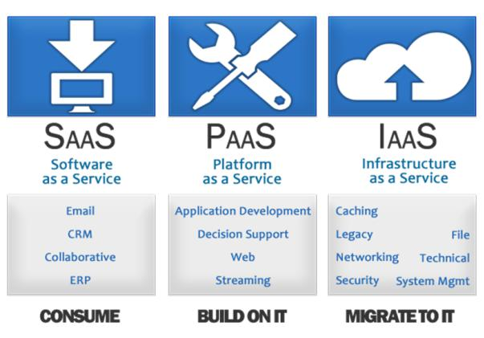

Fig. 1. Overview of the 3 main types of service models [7]

Software as a Service (SaaS): Software and applications that are rented and are accessible via web browsers [8].

Platform as a Service (PaaS): software that provides access to development tools, APIs, and deployment instruments. [9]

Infrastructure as a Service (IaaS): provides businesses with ready-to-use IT infrastructure [1].

The main differences in each service model are the main-tenance and configuration efforts that each require to be deployed. Figure ?? illustrates where responsibility falls for each service model.

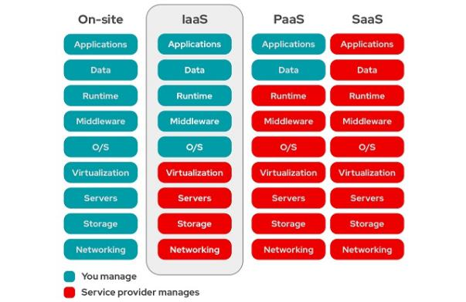

Fig. 2. Cloud service model usage

B. Cloud Deployment Models

Related literature describes four cloud deployment models (see figure 3), [2]

There are four main variations, or types, of cloud environ-ments that can be deployed: 1) Public 2) Private 3) Commu-nity, and 4) Hybrid cloud as shown in [10]:

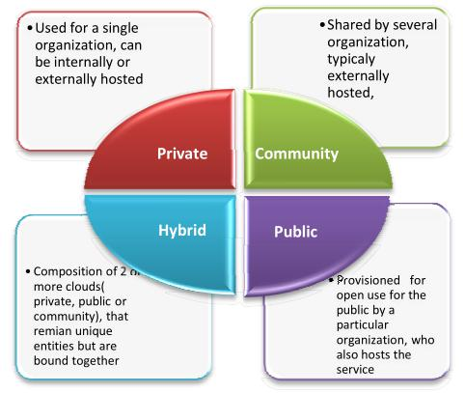

Fig. 3. Types of cloud deployment

Like the models of service, the level of responsibility given to the role varies so it is also important to select the most appropriate model of deployment [6]. In most cases, selecting the most appropriate model for deployment is obvious.

Public cloud: Most common in model, third-party services typically live (Google Apps, Dropbox, etc.) [11]. Maintained by CSP; little security possible.

Private cloud: A network which is created and managed by the large enterprises who own it. This is much more hands-on, and typically requires an in-house team to manage it [1].

Community cloud: Essentially a mix between a private and public cloud–privately owned but shared between the number of corporations.

Hybrid cloud: Most resembles traditional network model: a private cloud for sensitive data, customer access available on public cloud.

The deployment model that is chosen will typically be based on the level of responsibility in which the organization wants to have the environment. The ”with great power, comes great responsibility” saying is especially true here, figure 4 shows how organizations have chosen their model [12].

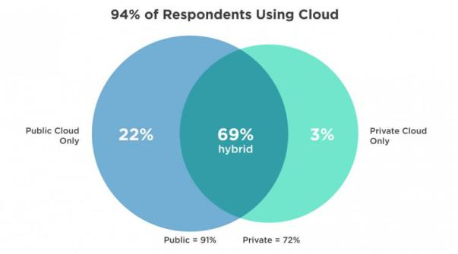

Fig. 4. Roles in the types of service

C. Cloud Benefits

By looking at the architecture of cloud computing many of the benefits of the technology can be easily seen. [3], [9], and

1. all had similar contributions as to the appeal of cloud environments.

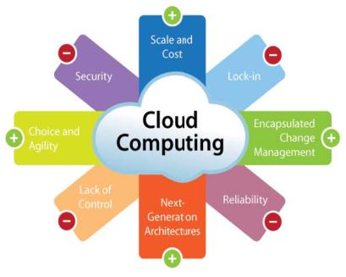

Fig. 5. AWS Amazon: The benefits of cloud computing

* 1. Flexibility: Gives organizations the option where to work from [3].
  2. Cost Reduction: The subscription model of payment charges are based on usage. Services are easily configurable to reflect desired costs (technical not required) [8]. This is nearly a direct response to SMBs’ concerns about cloud technology [3].
  3. Maintenance and Upkeep: CSPs are responsible for most system maintenance and updates [6].
  4. Agility: Cloud computing increases agility by offering three types of low-level administrations from cloud providers:

1. System infrastructure
2. Backup policies
3. Single application [9].
   1. Scalability: The ability to change the amount of computer power, the amount of storage, as well add and remove services all within a few clicks [9].

The convenience that the cloud offers can make a SMB more time efficient and flexible by allowing employees to work from anywhere, at any time [10]. Cloud’s ease of use stretches to other, surprising areas like accounting. Businesses are now outsourcing services via cloud which has reduced administrative overhead and produced time to focus on their strategic work and development.

Adding new services or integrating new applications can be done easily and at low costs. Allowing enterprise applications to be offered at affordable rates. The subscription or renting of software eliminates much of the fear associated with buying enterprise licenses. A survey from [8] said the SMBs have seen a 70% cost reduction once adopting an Amazon Web Services (AWS) environment. The rate should continue to increase as we see AWS rates continue to drop [8].

As shown, there are significant benefits and opportunities that are inherent to cloud computing but there are also some new security concerns which follow. Much focus of the work in [13] [10] is about how these concerns are justifiable how-ever, 59% of the small businesses were satisfied by the level of cloud security [11]. The security restraints that naturally come from sharing environments with other people will be addressed as the technology is developed [3]. However, these concerns should not be the ultimate deterrent for SMBs because it is more likely that the security provided by the CSPs protects SMB data more than it currently has in the currently configured private networks.

D. Future of Computing

All the services that came with traditional computing are still available via the cloud [1]. Creating mini virtual machines, or ”cloud containers” that are designed for specific purposes can be purchased and are ready out of the box. Some of these

include a container that only hosts a MySQL database or as a home for a NodeJS application can be obtained in only a few mouse clicks–no configuration necessary.

Another service that ought to be highly desired by SMBs is called Remote Desktop Session Host (RDSH). This service sits within a cloud Windows Server and allows for the creation of up to five separate desktop instances at the cost of only one license [1]. If this level of strain were to be on the same server but using the familiar Remote Desktop Protocol (RDP) the cost would be significantly higher and the quality that much lower.

Economic trends show that adoption of cloud computing is rapidly increasing, [8] some researchers believe that is will soon become the standard practice [10]. History tells many stories about organizations that do not keep up advancements of technology: the last story they are part of. Cloud computing is not a ”fad”, it is the modern and foreseeable future of technology. Take advantage of this technology.

1. MIGRATION METHODOLOGY

After being exposed to some of the cloud terminology and architecture it is likely that you are now more confused, perhaps even overwhelmed. The following framework will guide through this confusion–we have designed a four-step procedure that is direct but effective. This framework provides benefits regardless of the decision that it leads them to. The framework implements [6] principles and utilizes a total cost management (TCM) [14] approach in making the most efficient decision.

Migration Framework Overview:

1. Identify resource, dependencies, and risks
2. Determine service and deploy model
3. Calculate deploy costs
4. Compare and Decide

Preparation

This process is most effective when there is a knowledge-able representative of each department actively participating (at least in the first step). Varying perspectives of the way operations connect, relate, and affect another can vary greatly. This discussion can have power teaching potential which will improve internal communication.

For SMBs, it is imperative for there to be communication. The decisions that result from this process can greatly affect employees and should at minimum be aware of this. Initially, the organization should generally, but explicitly, state what it hopes to gain. Common goals would be: 1) eliminate the need for infrastructure on-site 2) provide a given resource entirely using cloud services 3) establish a directory access service.

If a network diagram of the current infrastructure does not already exist, then creating one will prove to be useful in the following steps. There are free, open-source tools out there that will generate a network topology report automatically. We suggest using a tool such as ZeNmap (a front-end of Nmap to generate a topology report the labeling the IP addresses according to its purpose and the services found on it.

Step 1: Identify Target Resource(s)

Identify the resource in which we are going to migrate and gather necessary information to move it to cloud successfully.

When we discuss resources we are specifically talking about data, assets, applications, and services that a network provides or requires. These will be specific to each organization–we are looking for the resources that are critical to the business function. We recommend starting by drawing a logical diagram showing the ways in which they interact (example: figure 6).

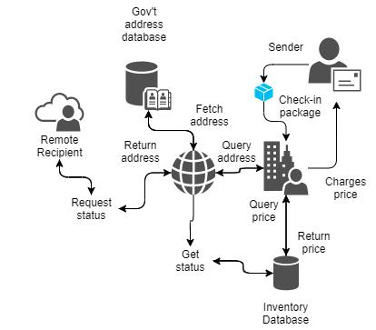

Fig. 6. Private post office: resource flow chart

Figure 6 is for a generic, private post office and a simple interaction between various critical business functions (CBFs). A CBF is any function considered vital to an organization–we suggest beginning here. The mapping of these BCFs plus the technologies in which they rely, will provide several potential migration targets, and will aid in the next task.

1.1 Identify Dependencies

Dependencies must be identified and handled accordingly so that components can still function properly–we must identity:

1. Are there any resources that rely on the specified migra-tion resource? 2) What, if any, does the migration target rely on? Some other questions to consider:

How does this resource receive data? What does it do with data?

Where is it stored? Is it sensitive?

1.2 Identify Associated Risks

Identify the associate risks with moving the selected re-source into the cloud. Some these may include:

Cost vs. Revenue

Employee skill level Data confidentiality

Transparency & Accountability Loss of governance

Disaster recovery and business continuity

Step: 2 Determine Appropriate Models

2.1 Service Model

Refer to Step 1 where the function of the target resource has been identified. In most cases, SMBs will not be designing their own infrastructure, therefore SaaS and PaaS are the most common models. How to determine which to pick:

SaaS (Software as a Service) ! Ready-to-use software PaaS (Platform as a Service) ! Developed for SMB

2.2 Deployment Model

As shown in figure 4, the final cloud environment will most likely be a hybrid cloud therefore there is only two options here: 1) stored in private segment 2) stored in public segment. If the data is sensitive, especially if it requires adherence to specific policies (Payment Card Industry Data Security Standard (PCI DSS)) or laws like Health Insurance Portability and Accountability Act (HIPAA) then there are cloud services that guarantee compliance. Otherwise, the answer will most almost always be public cloud.

This would be ideal for SMBs because it will reduce administrative overhead as well as save them from potential lawsuits.

Step 3: Calculate Deployment Costs

Cloud Service Providers

The ”cloud giants” like AWS, Microsoft Azure, and Google cloud are always safe choices. AWS has been around longer, has more services available, and typically have lower rates. We have seen Active Directory being more cost efficient in Azure but is not always necessary to have–other Lightweight Directory Access Protocols (LDAP) services exist, it is just a matter of preference. If organizations are unfamiliar with the previous terms, then this should not be a concern.

Using Cost Calculators

The CSPs mentioned above all have their own cost cal-culators where the desired system characteristics including computing power and storage space can be defined. The workload can be adjusted per size of organization plus the size of customer base. Cloud services which require more computing power will obviously cost more. This is SMBs time to conduct their own research.

Step 4: Compare and Decide

Compare the Projected Costs and Benefits

Using the data gathered from the previous step and consider-ing the difficulty the deployment and usage is to be compared with the current system. If possible, it would be useful to note the estimated cost associated with services being unavailable.

Make a Decision

The information that this process gathers should make this decision relatively easy and serve as a good foundation for next steps. If migration has been agreed upon, then contacting the CSP from the previous step would logically follow–begin enjoying the benefits of the cloud!

If it does not appear that it is the right time for mi-gration, then we suggest using what has been gathered to devise policies such as a business continuity and disaster recovery plans. These plans will provide some remediation for organizations in times of crisis by supporting CBFs. This remediation and availability of CBFs is handled by CSPs in a cloud environment so this is not a necessary step for those that did migrate.

IV. USE CASE

In this section we will use the proposed model described in last section to identify what data, asset, application, or services should be given priority and if migration is the fiscally responsible. A company, which remain anonymous for privacy reasons, called BIZWW approved the testing of the framework for their private, internal network. BizWW is a SMB that has approximately 25 employees and are spread out across these departments: 1) Administration 2) Office 3) workshop. BizWW’s core function is the buying and reselling of parts for large trucks but also brokers parts needed on oil rigs. There-fore, the technologies support their customer communication, invoicing, storing customer records and part numbers is of utmost importance. The administration and sales team often remote into the server to work from home.

Before we begin step one, I want to get as much information about the current network architecture and assets as possible. Once I was given access to the private network I began scanning it using NMAP and viewed its topology from the graphical user interface (GUI). Figure 7 shows the output it generated. shows the network topology of the internal network.

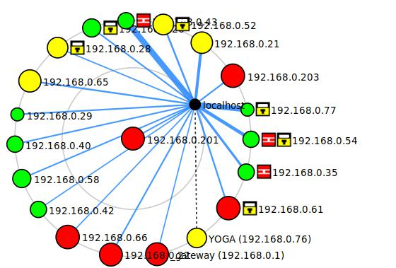

Fig. 7. Topology of internal network

Each one of these circles represents a host on the network. The size and color of each circle is generated by the number ports that are open. If there are over six open ports it will be

red which will then increase in size. This is relevant to migra-tions for several reasons, security within cloud environments can potentially be risky. Connecting and migrating services from a vulnerable network can introduce unnecessary risks. Further investigation on the hosts where there is a firewall and lock symbol (filtered ports) may discover more weaknesses.

After a discussion with BizWW’s management and ”Office Administrator” we were able to determine what the goal of this migration will be: ”security” and ”sharing”.

Step 1: Identify resource, dependencies, and risks

Since the critical business functions have already be identified–now we identify the technologies that they rely on. Management informed that the main tools they use Quick-Books Desktop and Microsoft Office Suite (M365); both require licenses.

M365 is already a cloud-based suite of applications that is accessible through a web browser or can be installed onto a host machine. User accessibility to user’s files is always available, therefore will not be the targeted resource.

QuickBooks supports all the CBFs; bookkeeping, invoicing, taxes, and payroll are the most common usage. Currently Quickbooks Desktop is accessed via the local-host server on-site. Through more research, we have identified that this server’s primary function is hosting QuickBooks and allowing for remote connections.

We believe that if we were to migrate from QuickBooks Desktop to the cloud-based version; Quickbooks Online that we can accomplish our goal and provide a good foundation for the rest of the migrations.

Dependencies: To deploy a QuickBooks Online, into the cloud such cloud environment must exist–we will have to create one. However, on the other end, Quickbooks Desktop only depends on the data that it has already stored onto the physical machine. This cloud instance and the installation and configuration of QuickBooks and be completed before we have to the current system.

Associated Risks:

Giving attackers another attack surface

Error during migration, leaking information, is always a possibility

Step 2: Determine Appropriate Models

Service Model: As already mentioned, to have a cloud-based QuickBooks application that will need a host to be installed on: This fits the PaaS (Platform as a Service) model.

Deployment Model: Contrary to the earlier claim regarding SMBs and public clouds, the given example will be a private cloud deployment. In hindsight, this makes sense if we are taking a business continuity-type approach because CBFs are likely to contain sensitive data.

Step 3: Calculate Deployment Costs

Cloud Service Providers: We have decided with going with Azure ass our cloud service provider for several reasons. First if we are just to deploy a virtual machine, despite the

operating system, costs stay relative the same across the board. Therefore, it would be in our best interest to stick with Azure because of the easily transferable Active Directory. This will have to a slow and easy process so that we can ease into costs and ease out of the current ones.

Using Cost Calculators: Using the Azure calculator service, we were able determine what the cost would be for a variety of different deployments. All of which has shown to be a bit more than we expected, but still turns out to be less than the current costs of the physical server and should not have nearly the number of outages but will have more security.

Step 4: Compare and Decide

We have decided to begin with the migration process because there is relatively little business critical that is stored on the on-site machines including software. We have identified that the present security risks security far outweighs the risks of a cloud environment.

Through the research that we have conducted there will significantly price cuts as well as increased availability. In the deployment method that we have designed, BizWW will begin experiencing the advantages of cloud computing.

1. CONCLUSION

This paper has shown the importance of growing and evolv-ing with technology–specifically regarding cloud migration, and the opportunities that it creates for SMBs. The proposed migration framework is a four-step process, which has been designed to promote confidence and simplicity by focusing on the aspects most relevant to SMBs and their successful migration.

If there are still those organizations that are not yet confident the cloud computing technology or in their abilities to plan and deploy the proposed framework can still be a beneficial business exercise. The knowledge that framework produces can be extremely useful in identifying weaknesses in systems as well as used in the creation of disaster recovery and business continuity polices.

We hope this paper was able to help SMBs in their under-standing of cloud computing as well as initiate the migration planning and deployment processes. Full migrations may not always be desirable or even necessary, we would just like to see more SMBs receive the freedom that is offered.

VI. FUTURE WORK

To further this research, we believe working with orga-nizations throughout their migration planning and decision-making process will provide insight on the ways in which the proposed decision-making model can be improved. Finding organizations that are willing to participate or observe them in this process will most certainly be difficult to find. Therefore, organizations of all size and all industries are encouraged. We believe that after a couple more organization interactions we will be able to identify some of the common software, applications, and approaches used to support critical business functions.

We hope to find software and services are consistently high on the migration priority list so that we can develop tools that can assist with the actual deployment into a given cloud service provided environment. An example of this maybe a PowerShell script that can analyze Microsoft Active Direc-tory’s perform some security and configuration checks before it automates the deployment into the desired Azure container. If we can improve the decision-making process and provide reliable automation tools businesses will look forward to future migrations.

REFERENCES

1. A. Sether, “Cloud computing benefits,” Available at SSRN 2781593, 2016.
2. C. Low, Y. Chen, and M. Wu, “Understanding the determinants of cloud computing adoption,” Industrial management & data systems, 2011.
3. Hendrik, I. Vitra Paputungan, T. Budi Susilo, and H. Setiaji, “Designing a cloud-based system for small and medium enterprises with multiple branches,” in 2018 3rd International Conference on Computer and Communication Systems (ICCCS), pp. 121–124, 2018.
4. R. M. Utami and D. C. Lantu, “Development competitiveness model for small-medium enterprises among the creative industry in bandung,” Procedia-Social and Behavioral Sciences, vol. 115, no. 21, pp. 305–323, 2014.
5. F. Liu, J. Tong, J. Mao, R. Bohn, J. Messina, L. Badger, and D. Leaf, “Nist cloud computing reference architecture,” NIST special publication, vol. 500, no. 2011, pp. 1–28, 2011.
6. S. Islam, E. R. Weippl, and K. Krombholz, “A decision framework model for migration into cloud: Business, application, security and privacy perspectives,” (New York, NY, USA), p. 185–189, Association for Computing Machinery, 2014.
7. A. K. Fielder, “Very simple introduction to cloud computing,” Jun 2012.
8. C. L. Devasena, “Impact study of cloud computing on business develop-ment,” Operations Research and Applications: An International Journal (ORAJ), vol. 1, no. 1, pp. 1–7, 2014.
9. C. T. S. Xue and F. T. W. Xin, “Benefits and challenges of the adoption of cloud computing in business,” International Journal on Cloud Computing: Services and Architecture, vol. 6, no. 6, pp. 01–15, 2016.
10. E. Chovancova,´ L. Vokorokos, and M. Chovanec, “Cloud computing system for small and medium corporations,” in 2015 IEEE 13th Inter-national Symposium on Applied Machine Intelligence and Informatics (SAMI), pp. 171–174, 2015.
11. G. S. Alijani, H. K. Fulk, A. Omar, and R. Tulsi, “Cloud computing effects on small business,” The Entrepreneurial Executive, vol. 19, p. 35, 2014.
12. K. Yuso, “Cloud service models explained: Saas, iaas, paas, faas,” Sep 2020.
13. O. Lavriv, M. Klymash, G. Grynkevych, O. Tkachenko, and V. Va-sylenko, “Method of cloud system disaster recovery based on ”infras-tructure as a code” concept,” in 2018 14th International Conference on Advanced Trends in Radioelecrtronics, Telecommunications and Computer Engineering (TCSET), pp. 1139–1142, 2018.
14. B. Nicoletti, “Cloud computing and procurement,” in Proceedings of the International Conference on Internet of Things and Cloud Computing, ICC ’16, (New York, NY, USA), Association for Computing Machinery, 2016.