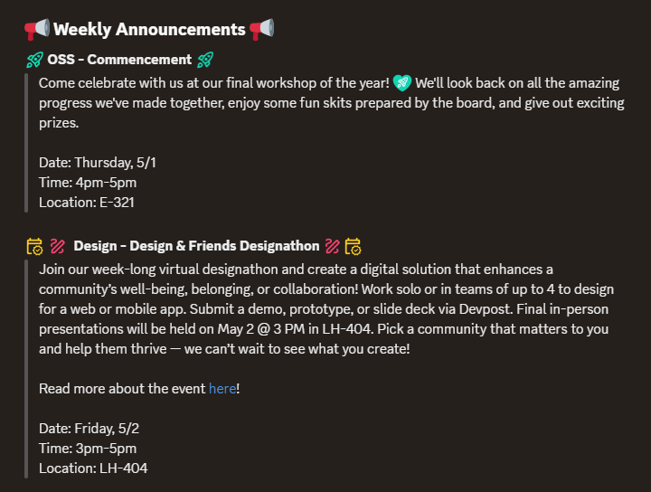
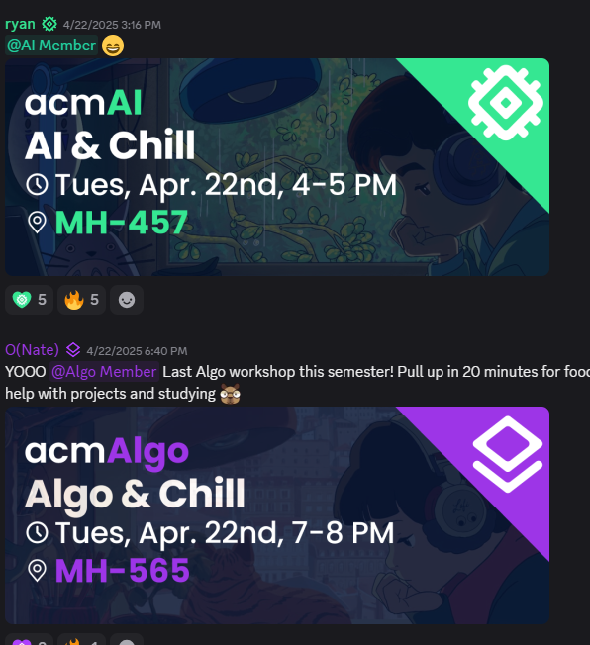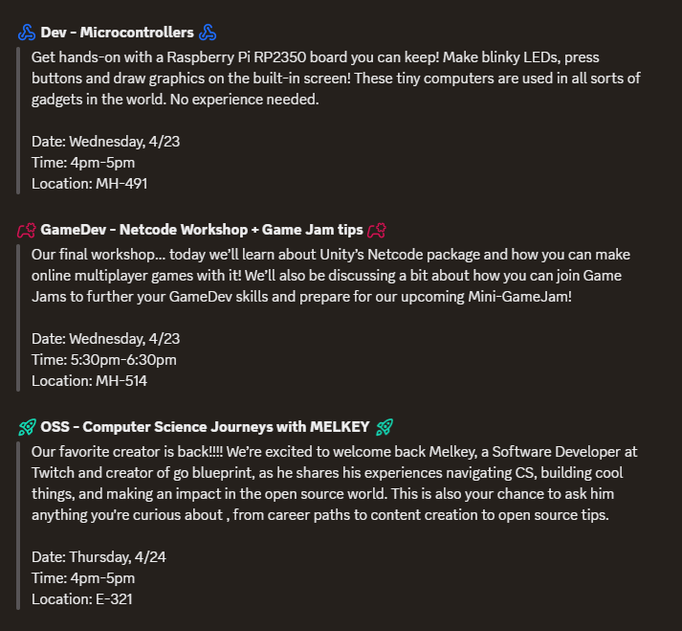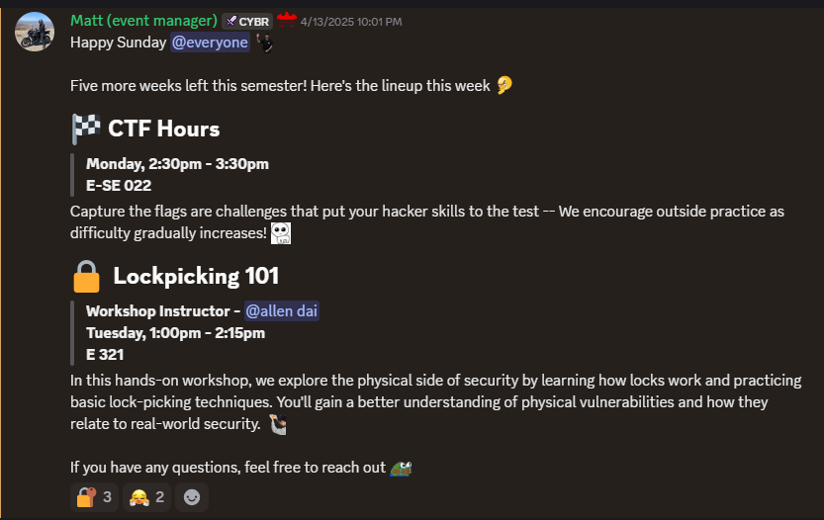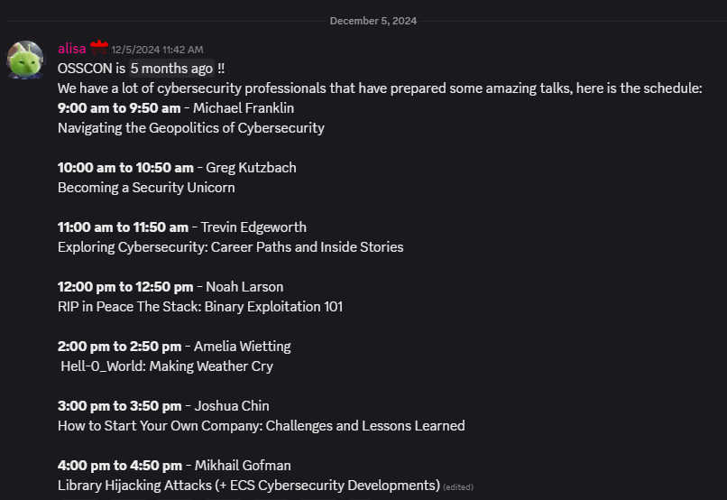
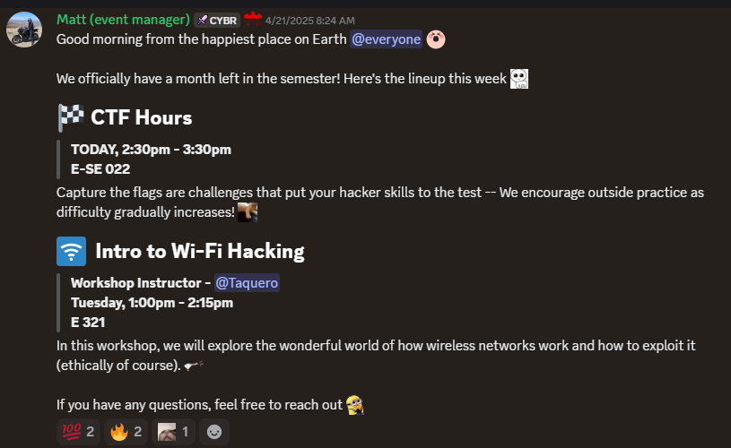

Also please randomly add in some of these classes
Just the onese that sound interesting like

CPSC 352 – Cryptography class – CS 104 - 7pm 945 pm – priority HIGH

• CPSC 315
Professional Ethics in Computing
10 Class Options Available

• CPSC 323
Compilers and Languages
9 Class Options Available

• CPSC 332
File Structures and Database Systems
8 Class Options Available

• CPSC 335
Algorithm Engineering
11 Class Options Available

• CPSC 349
Web Front-End Engineering
5 Class Options Available

• CPSC 351
Operating Systems Concepts
9 Class Options Available

• CPSC 352
Cryptography
1 Class Option Available

• CPSC 362
Foundations of Software Engineering
12 Class Options Available

• CPSC 375
Introduction to Data Science and Big Data
3 Class Options Available

• CPSC 386
Introduction to Game Design and Production
2 Class Options Available

• CPSC 411
Mobile Device Application Programming
2 Class Options Available

• CPSC 411A
Mobile Device Application Programming for Android
2 Class Options Available

• CPSC 431
Database and Applications
2 Class Options Available

• CPSC 439
Theory of Computation
1 Class Option Available

• CPSC 440
Computer System Architecture
2 Class Options Available

• CPSC 449
Web Back-End Engineering
4 Class Options Available

• CPSC 454
Cloud Computing and Security
3 Class Options Available

• CPSC 455
Web Security
2 Class Options Available

• CPSC 456
Network Security Fundamentals
3 Class Options Available

• CPSC 459
Blockchain Technologies
1 Class Option Available

• CPSC 462
Software Design
3 Class Options Available

• CPSC 463
Software Testing
1 Class Option Available

• CPSC 464
Software Architecture
2 Class Options Available

• CPSC 465
Modern Software Deployment and Operations
1 Class Option Available

• CPSC 466
Software Process
1 Class Option Available

• CPSC 471
Computer Communications
8 Class Options Available

• CPSC 476
Edge AI: Principles and Practices
1 Class Option Available

• CPSC 481
Artificial Intelligence
9 Class Options Available

• CPSC 483
Introduction to Machine Learning
5 Class Options Available

• CPSC 484
Principles of Computer Graphics
2 Class Options Available

• CPSC 485
Computational Bioinformatics
1 Class Option Available

• CPSC 490
Undergraduate Seminar in Computer Science
6 Class Options Available

• CPSC 491
Senior Capstone Project in Computer Science
9 Class Options Available

• CPSC 499
Independent Study
4 Class Options Available

• CPSC 531
Advanced Database Management
2 Class Options Available

• CPSC 535
Advanced Algorithms
2 Class Options Available

• CPSC 541
Systems and Software Standards and Requirements
2 Class Options Available

• CPSC 543
Software Maintenance
3 Class Options Available

• CPSC 544
Advanced Software Process
2 Class Options Available

• CPSC 545
Software Design and Architecture
5 Class Options Available

