Matthew Sirota

* + 1. n=20, P(N<=8.25)=0.5955987
    2. n=30, P(N<=8.25)=0.09401122
    3. n=50, P(N<=8.25)=0.0002305229
    4. n=100, P(N<=8.25)=5.431127e-13
    5. n=20, P(N<=8.25)= 0.5207689
    6. n=30, P(N<=8.25)= 0.3012414
    7. n=50, P(N<=8.25)= 0.1637488
    8. n=100, P(N<=8.25)= 0.09293155
  1. 1. error for n=20 is 0.0748298
     2. error for n=30 is 0.2072302
     3. error for n=50 is 0.1635183
     4. error for n=100 is 0.09293155

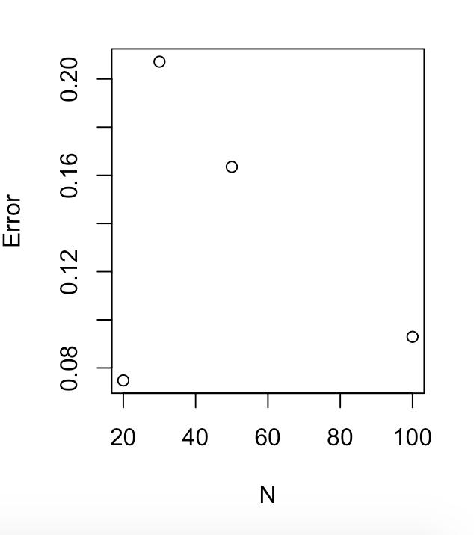

* 1. Based on the plot, np and npq were not greater than 10 so it does not follow the pattern. For the rest of the N’s, the error gradually decreased as N increased.

1. 1. Sample= 5.96324588, 0.07708956, 0.13273840, 8.06381509, 3.97570800 6.36697273, 2.24782830, 2.80405559, 0.14981418, 0.59898607, 2.23958270 0.91428957, 5.02498042, 0.03049148, 4.53227739, 3.79462791, -2.53090784 2.89821391, 1.37342090, 4.87586247

Xbar=2.676655, s^2=7.02473

(xbar-2)/(sqrt(9/n))= 1.0087

(n-1)s^2 / 9 = 14.82999

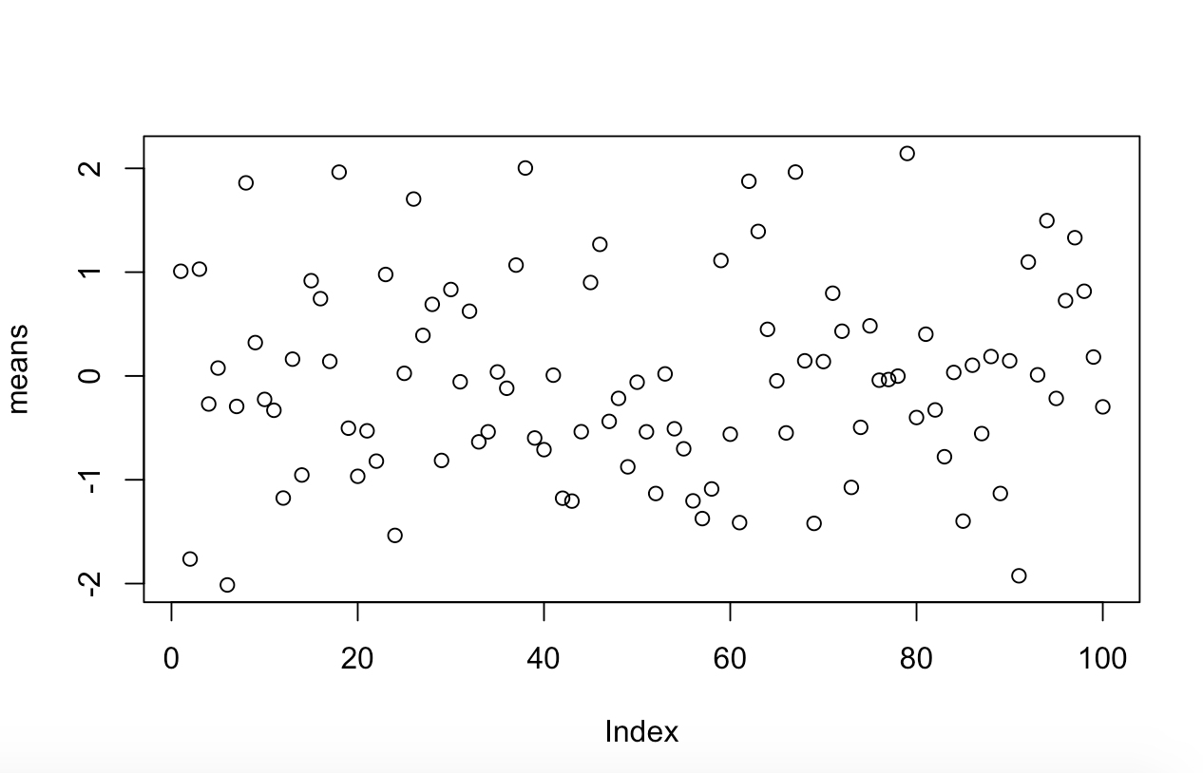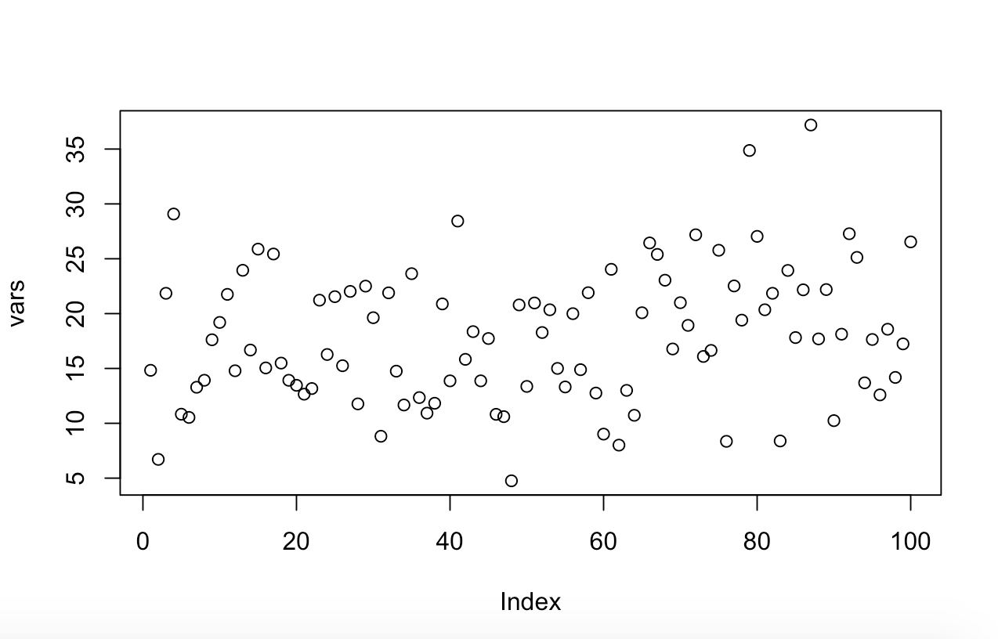

(xbar-2)/(sqrt(9/n)) (n-1)s^2 / 9

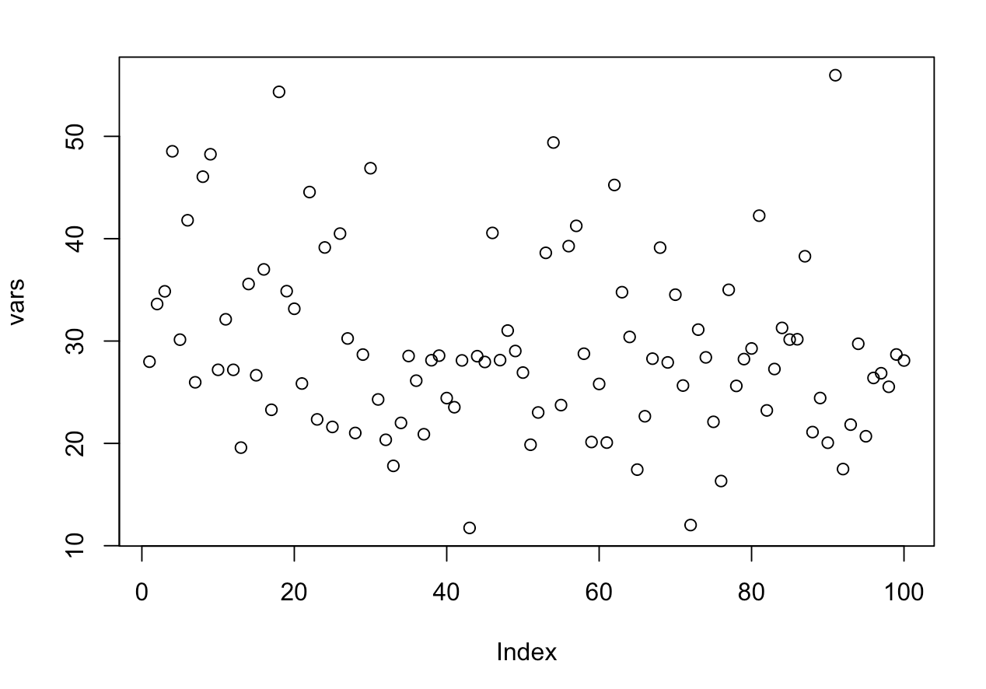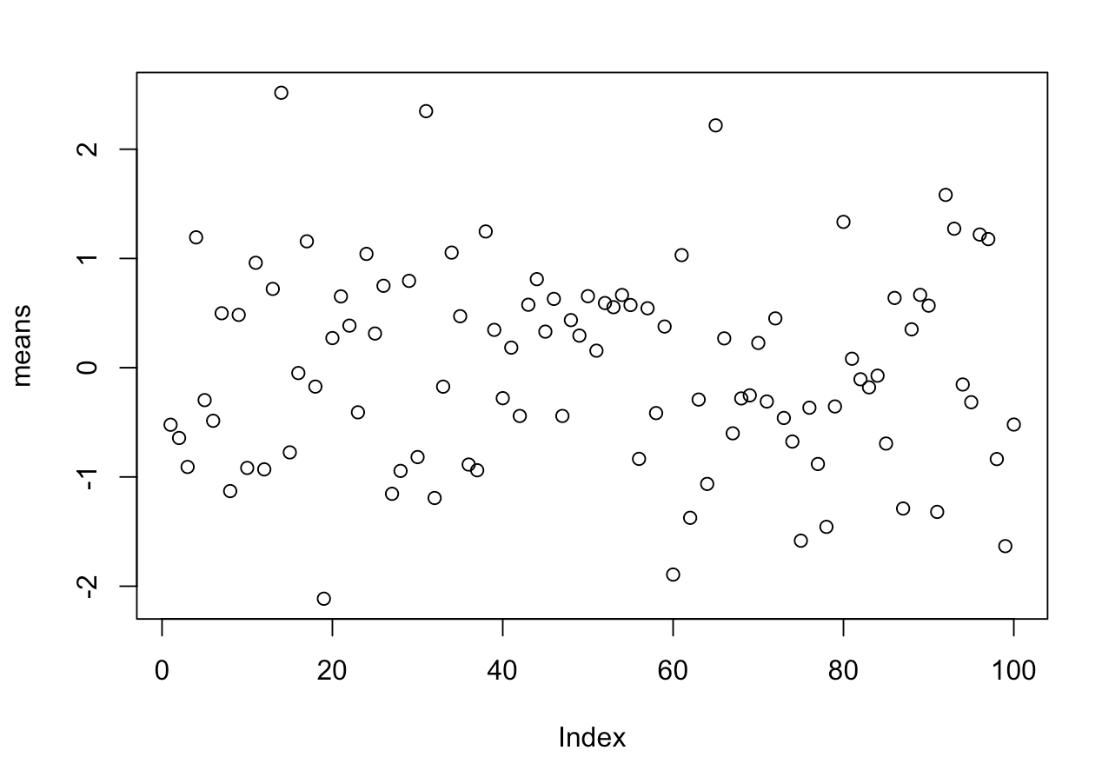



(xbar-2)/(sqrt(9/n)) (n-1)s^2 / 9

* 1. 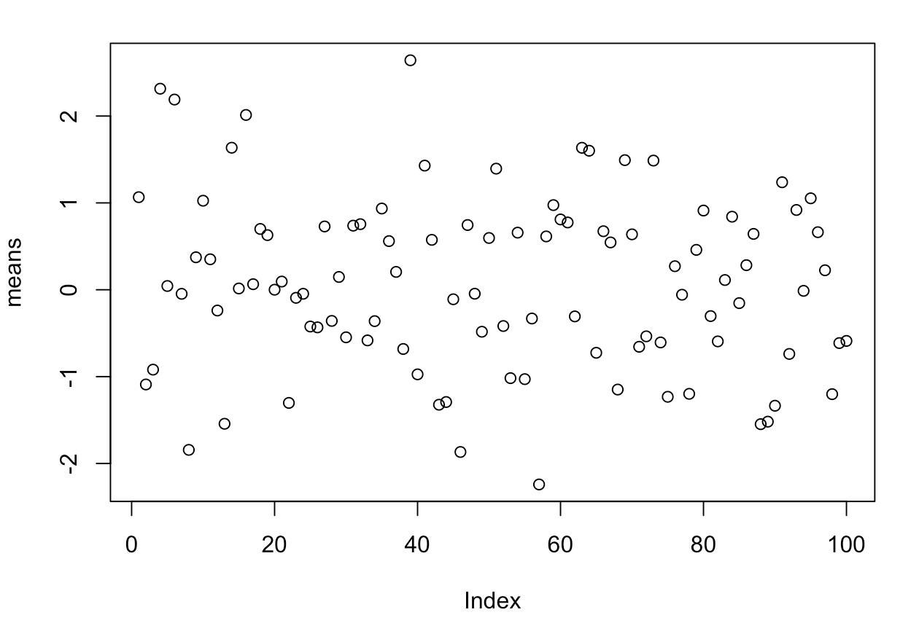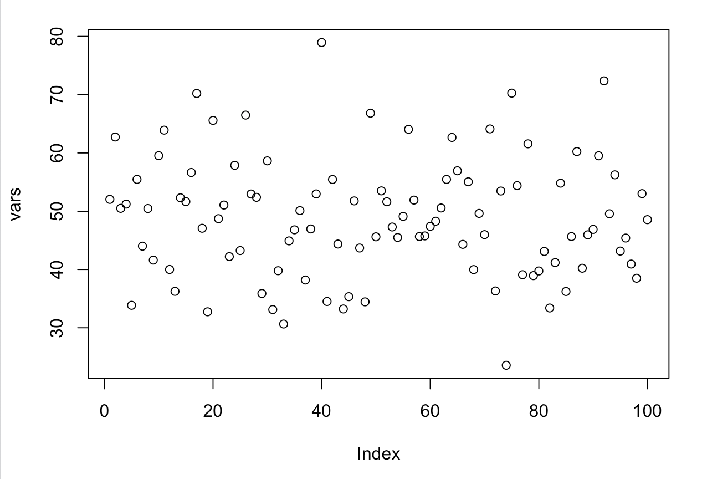

(xbar-2)/(sqrt(9/n)) (n-1)s^2 / 9

* 1. (xbar-2)/(sqrt(9/n)) stayed in about the same range as the n was increased. (n-1)s^2 / 9 had an increased range as the n was increased. T