Pythons and Crocodiles: Predicting Crocodilian Population Conservation Status Using a Python XGBoost Classifier
Jake Gendreau
CS 4771 / Python for Machine Learning
December 17, 2025

Introduction & Problem Statement
This project aimed to examine the widespread problem of habitat loss which is facing many species of crocodilians. Many crocodilians are considered to be “indicator species”, meaning that the health of their species is directly linked to the health of their environment. By tracking the health of crocodilians, we can provide insights and evidence into the continued damage to their environments. Particularly, this project aims to connect the energy demands of countries, where said countries get their energy from, and how much energy is being used per capita in that country to the health of crocodilians which are present in that country. The health of the crocodilians is measured by their species endangered status, which contains the classes of “Vulnerable”, “Endangered”, “Critically Endangered”, and “Least Concern”. Ultimately, the question which this project is trying to answer is “Given the CO2 output and energy sources of a country, can we predict what endangered species status affected crocodiles will have?”

Methodology & Approach
This project consists of three main parts. The first part is the data preprocessing, the second part is the model training, and the final part is the model testing. The part of the project which I was taking charge of was the data preprocessing. Our data comes from three distinct datasets, which are as follows:
1. Global Crocodile Species Dataset: This dataset contains entries about crocodilian species all around the world. The features which were used from this dataset are the scientific name, the date of observation, the country of observation, and the conservation status.
2. Carbon (CO2) Emissions By Country: This dataset contains data about yearly carbon dioxide emissions per country all over the world. The features used from this dataset are the country, date, and kilotons (of CO2) generated.
3. World Energy Consumption: This dataset includes information about the usage of different energy sources by countries from around the world, as well as data about how that relates to population. The features used from this dataset are country, year, amount of renewables used, amount of fossil fuels used, metric tons of CO2 per capita, population, and GDP.
In order to combine these three datasets into a single dataset which may be used by a machine learning model, we had to find where we could intersect the data. It turns out that every dataset had columns for date and for country. To use those two columns to merge the datasets, we had to normalize the date and the country. Normalizing the date was easy, as it would just be reduced to a year, but the countries were more tricky, since things like the U.S. could have a variety of names (U.S, United States, USA, United States of America, etc...). I wrote a program which would pick out all of the unique countries in each dataset, then list them. I then wrote a mapping which would take these unique country names and translate them into standardized names. After doing that, I was able to use the merge() function to combine the datasets based on the year and the country. The preprocessing program then drops any rows with incomplete data, and removes duplicate rows. The last thing that the data preprocessing program does is perform one-hot encoding on the scientific names of the species, and the country of observation. The result is about 300 rows of complete data, which can be used by the machine learning model.
The second and third part of the project is to train and test the model. In order to train the model, we first broke the training data into an 80/20 training and testing split. The data was then scaled using a standard scaler, and the XGBoost classifier was then trained using the RandomizedSearchCV() function. The Randomized Search utilized an f1 score for its grading and finds the most optimal hyperparameters for the model. For testing, the model then runs on the testing data which was isolated earlier, and produces a classification report of it which utilizes the f1 score as its metric.
Our approach changed slightly from the original proposal because we misunderstood the datasets which we had. The first change which was made was that we had to swap out the dataset which contains carbon emissions data for a different one with similar data. We had to do this because the first dataset only tracked a handful of countries, and this caused the number of lines in the combined dataset to only be about 30, which is not enough to train a machine learning model on. Another thing which we had to change was what the model was predicting. The proposal said that our model would predict the date in which a species would go extinct, however, the data which was used was not viable for that prediction, as actual crocodilian populations were not included, instead, it was just the endangered species status for each crocodilian. We opted to make the model predict the endangered status of the crocodilians to accommodate for how the dataset was structured.
The software which was used are VSCode and Python. The python libraries used are numpy, pandas, matplotlib, xgboost, seaborn, and sklearn. I can’t speak for my teammates, but I ran everything locally on my machine, so I did not use any cloud compute services such as Kaggle or Google Colab. All of our data came from Kaggle.

Results & Analysis
The machine learning model ended up working extremely well on our data. There was no confusion in the model, as evidenced by the confusion matrix (Figure 1).
The confusion matrix (right) shows that the XGBoost model correctly predicted every endangered species category for every row in the testing data.
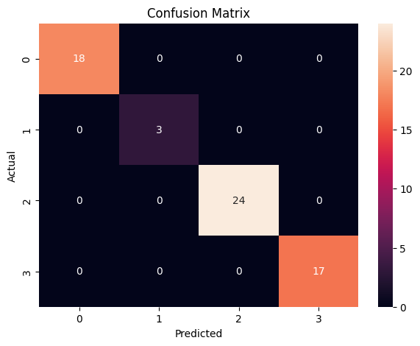Figure 1: The Confusion Matrix produced by the model

Since the model ended up being so high-performing, the F1 scores, as represented per-class, produce this chart (Figure 2)
Since the model was able to predict every row of training data accurately and correctly, each of the per-class F1 scores is 1.
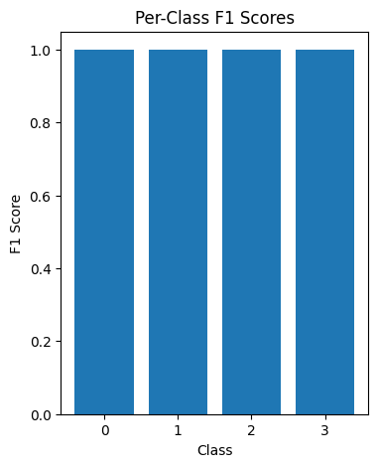Figure 2: Chart showing F1 scores per class

By using the XGBoost plot_importance() function, the importance of the various classes in the dataset can be visualized (Figure 3).
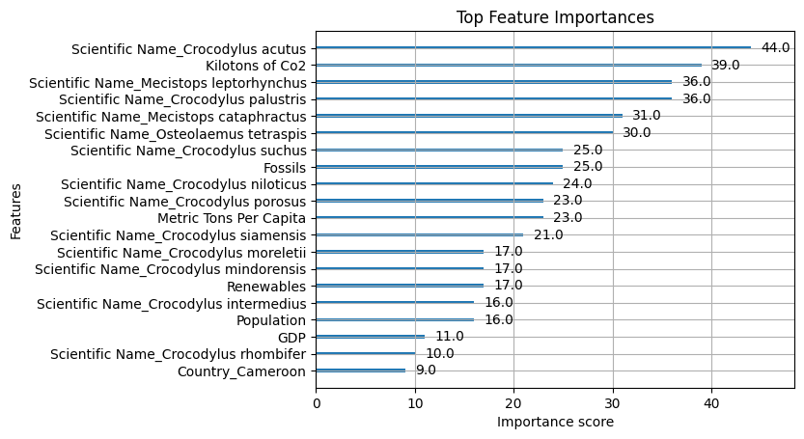Figure 3: The importance of the 20 most important categories in the data
Upon inspection, it is clear that the species of crocodilian is the most important factor for predicting their endangered species status. That being said, many other factors are also high ranking, such as kilotons of CO2, and where the energy that a country uses comes from.
The findings presented by the machine learning model which we developed has a strong implication that the more CO2 is emitted by a country, the more endangered a given species of crocodilian will be. Our model was able to predict what the endangered status would be with 100% accuracy on the given test data. Interestingly, while Kilotons of CO2 was, on paper, the second most important metric, a deeper look at the feature importances chart reveals that of the top 20 most important features, 13 of them were listing what species of crocodilians is being analyzed due to the one-hot encoding. Of the top 10, 8 of them were species. This means that while kilotons of CO2 emitted, amount of fossil fuels used, amount of renewable resources used, population, and GDP of a country all have an impact on the endangered status of a given species of crocodilian, the biggest factor is what the species already is.
If I had to guess why the species of crocodilian is the most important feature, I would say it is because the endangered species status for many of these crocodilians has not changed much in the time period which is being studied, thus, the model was able to develop extremely strong correlations between a species of crocodile and what its endangered status will be. To test this theory, I put the crocodile dataset into another program which would take all of the conservation statuses for each species of crocodilian, then put them into a heatmap (Figure 4).
The heatmap in figure 4 is a representation of the conservation statuses of the different crocodilian species. The columns represent the different conservation status classes. From left to right, these are L for “Least Concern”, V for “Vulnerable”, EN for “Endangered”, and CR for “Critically Endangered”. The rows represent the different crocodilian species. In the graphic, a cell is yellow if it has one or more instances of the conservation class for the given crocodilian species, and a cell is purple if it has zero instances of the conservation class. For each row, only a single cell is yellow, which implies that each crocodilian species has only a single conservation class for the entire duration of the study, thus allowing the machine learning model to build a strong association between conservation classes and crocodilian species.

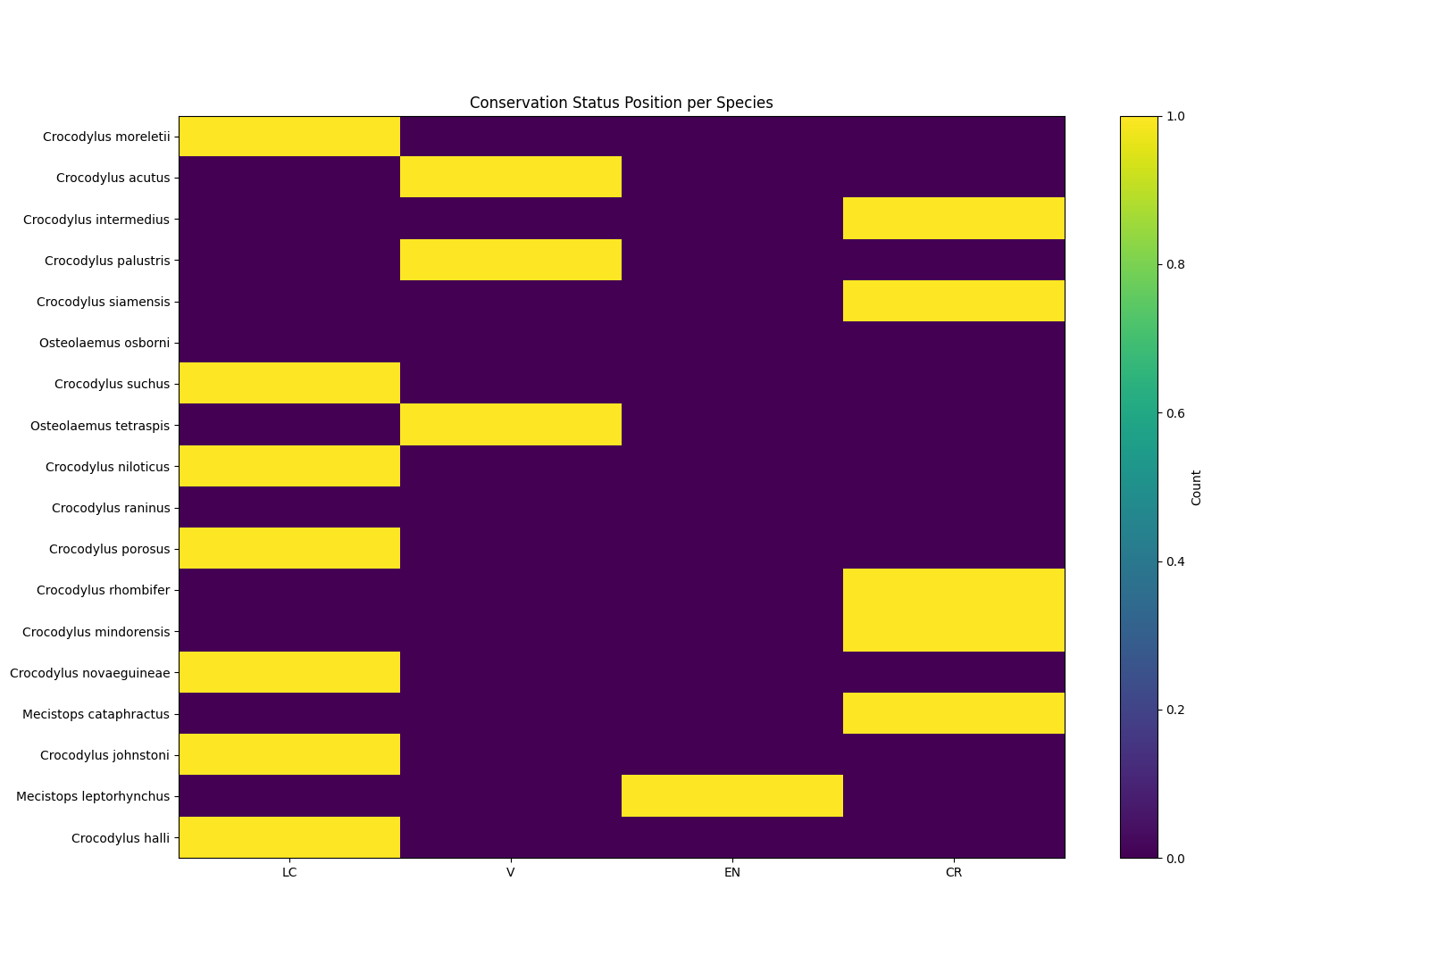Figure 4: Graphic demonstrating how each crocodilian species has only one category of conservation status

Conclusion
Overall, this project was successful in regards to answering the question of “Given the CO2 output and energy sources of a country, can we predict what endangered species status affected crocodiles will have?”. The answer is a strong yes. We were able to develop a machine learning model which, given information about a country’s CO2 output and energy sources, we were able to accurately predict what the conservation status of a certain affected crocodilian would be.

References
“World Energy Consumption.” Www.kaggle.com, www.kaggle.com/datasets/pralabhpoudel/world-energy-consumption.
Rana, Ravender Singh. “Carbon (CO2) Emissions.” Kaggle.com, 2024, www.kaggle.com/datasets/ravindrasinghrana/carbon-co2-emissions.
Bhrami Zadafiya. “Global Crocodile Species Dataset.” Kaggle.com, 2025, www.kaggle.com/datasets/zadafiyabhrami/global-crocodile-species-dataset

