AFL - Scoresystem

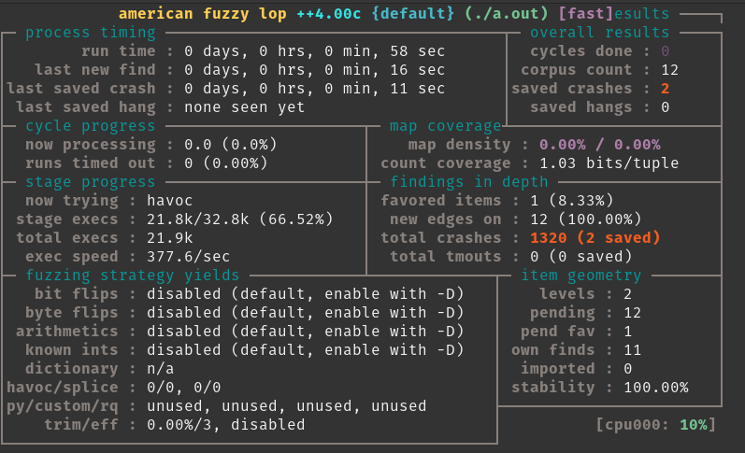Invalid input:

test,60

-1#yes

It is using cin to write the input to an int, but the non-numeric values are causing it to crash.

AFL - AFLTest

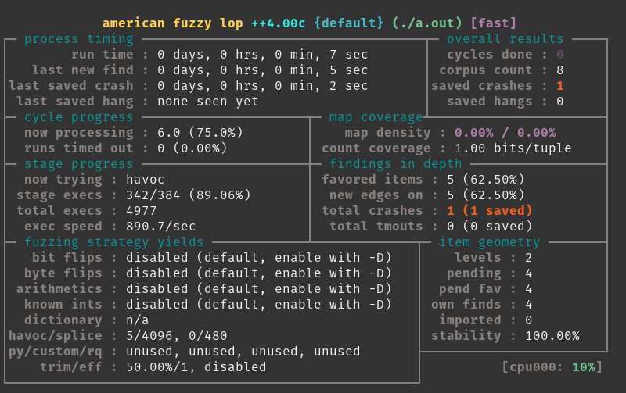Invalid Input:

CYB220

\FF\FF\FF\FF1

Why it crashed:

If the user input matches 'CYB220', the abort function will be called and the program will crash.

AFL - AdvCalc

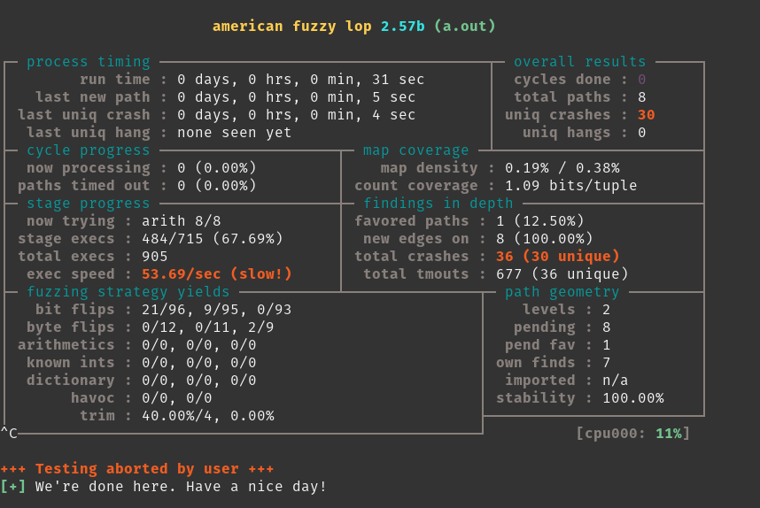Invalid Input:

²000+4000

ab

〲0㐫〰ਰ扡  
  
Analysis:

Interestingly, I went through all 30 unique crashes and tested them all in my calculator, and none of them caused crashes when I ran them. I'm not sure why running it through afl causes it to crash, but I am yet to find an input that can crash my calculator.

AFL - Lab2

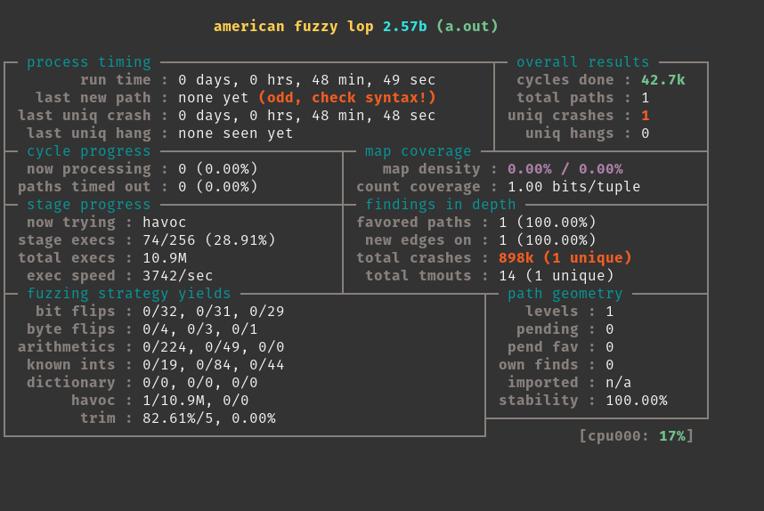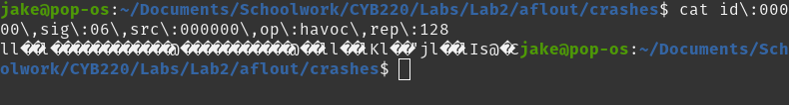  
Given that Lab2 was the one where format string attacks were used with an unsafe printf() function, I would guess that the input tried to access invalid memory and caused a segmentation fault. Obviously, the contents of the output aren't exceptionally clear, but a segfault is the most likely scenario where this would happen.

AFL Summary

AFL is a tool which will automatically test various inputs with a program, known as fuzzing. Fuzzing is the process of tweaking inputs slightly and seeing what the resulting output is. It's pretty fun to watch it run, and I enjoy seeing the crash reports and trying to work it in reverse to figure out what caused the crash.