I wrote these programs in pure C.

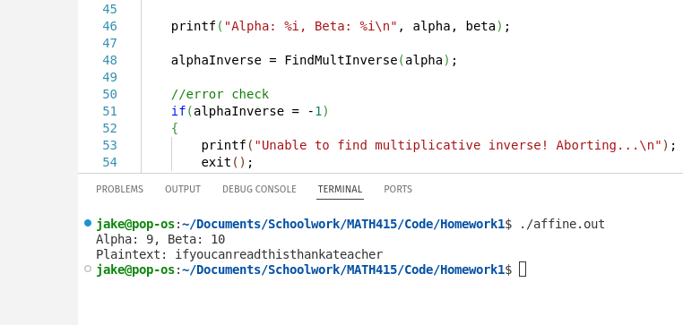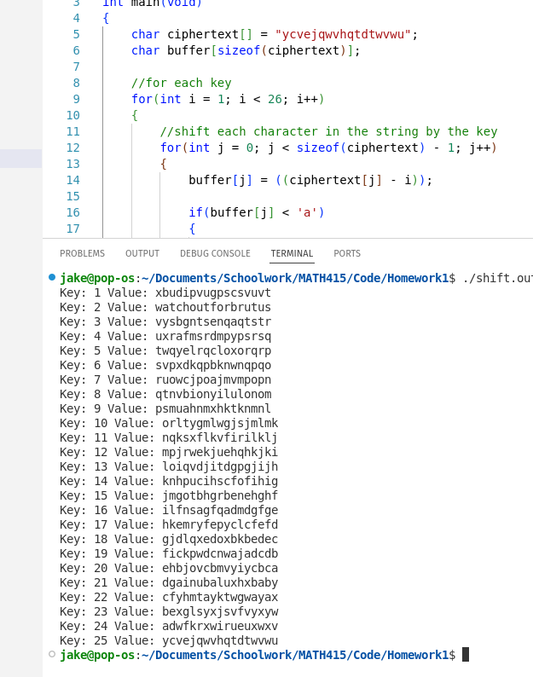In Problem 1, the plaintext was "watchoutforbrutus" with a key of 2. I solved this via brute force

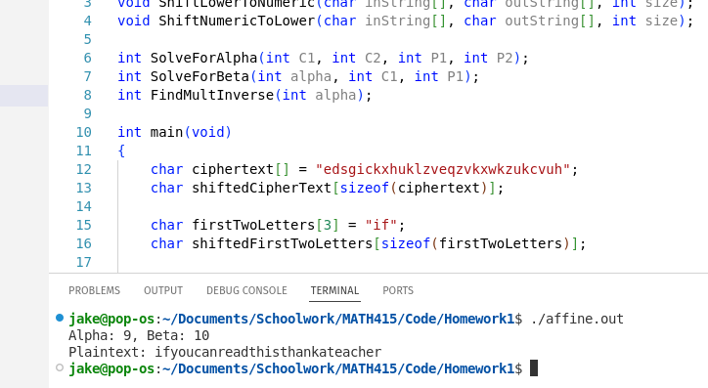In problem 3, the plaintext was "ifyoucanreadthisthankateacher" with a key of (9, 10). I got this via the same method that we used with pen and paper