10.

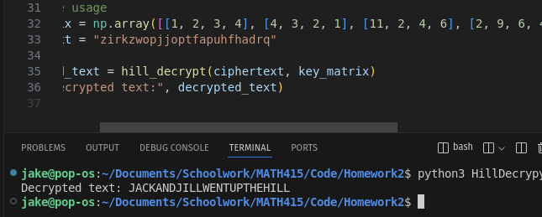The decrypted text is "Jack and Jill went up the hill"

12.

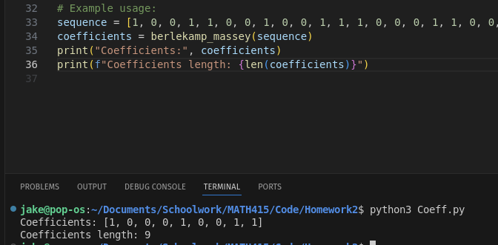I don't know if this is correct or not, but my program got [1, 0, 0, 0, 1, 0, 0, 1, 1] for the coefficients sequence