**CS215 Ch 3.18 Measures of Central Tendency (__________________________) Date:_____________**

Context: 6 Hospitals were asked how many patients contracted a staph infection yesterday.

110 76 29 38 105 31 105

Mean:

Mode:

Median:

* The code to find these things:

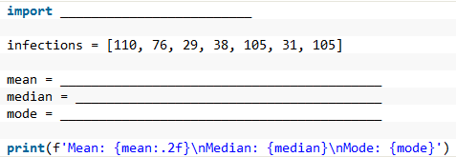

* Q: What would happen in the code above if infections = [110, 76, 29, 38, 105, 31]?

Other helpful code functions to know about:

* To sum up a list:
* To find how many elements in a list:
* To order a list (but this does not _____________________________________)
* What is printed out below?

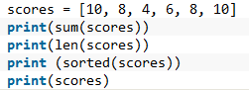

* Use sum(….) and len(…) to find the average of a list called numSiblings
* Why are mean, median, mode called *measures of central tendency*?
* Below are 3 different distributions. Where are the measures of central tendency on each? Where are the outliers?

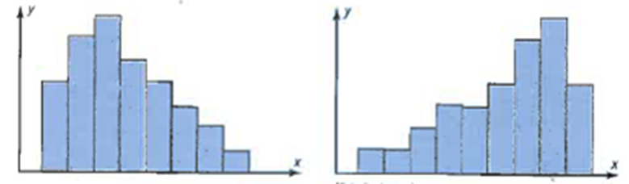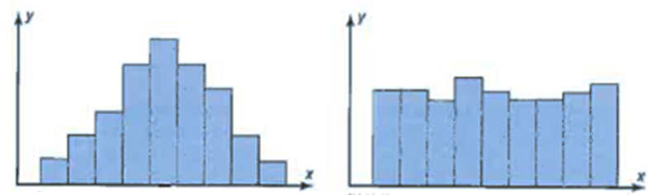

**Note: In a testing scenario, you are expected to understand the facts about mean/median/mode that you learn from your next lab.