Reflection
The Parking Lot Management System is a portfolio project displaying the usage of object oriented programming principles. In the initial few weeks, I created standard classes of a Customer, Car, and ParkingLot that were utilized to present a minimal-viable product of the project. The customers would have a car, and enter/exit a parking lot. Later in the quarter, I added classes such as Money, or CarType to depict how a customer should be charged for parking in the lot. The object oriented principles helped steer the project in decoupling of the classes. Finally, we have added manager classes that integrate into the project and manage the parking transactions, and permits.

The class diagram shows the complete architecture of the Parking Lot Management System with three distinct layers; the three layers are the core domain classes (including supporting classes) being the foundation, the manager classes, and the facade layer.
The foundation consists of basic building blocks. Address stores location information with street addresses, city, state, and zip code. CarType is an enumeration with two values: COMPACT and SUV, providing type-safe constants. Car represents vehicles with a license plate, type, and owner ID. Customer maintains personal information and owns a collection of Car objects. Money handles all financial amounts using cents internally to avoid floating-point precision errors. ParkingLot represents physical parking facilities with an ID, address, and capacity. There are supporting classes being ParkingPermit, ParkingTransaction, and ParkingCharge. ParkingPermit connects a Car to registration and expiration dates with a unique UUID identifier. It's immutable once created. ParkingTransaction records individual parking events, linking a permit to a lot on a specific date with the fee charged. It calculates fees based on car type during construction. I did keep ParkingCharge for now but it is duplicated due to the introduction of ParkingTransaction this week.
The two manager classes doing the coordination of the core classes are the PermitManager centralizing all permit operations, and TransactionManager managing parking events. PermitManager maintains a Map (HashMap) that indexes ParkingPermit objects by their unique ID strings. When you call register(Car), it creates a new ParkingPermit with a UUID, sets expiration to one year from registration, and stores it in the map. The method getPermitsByCustomer(Customer) filters permits by customer ownership. TransactionManager manages parking events. It maintains two data structures: a List of all ParkingTransaction objects in chronological order, and a Map that groups transactions by permit ID for fast queries. When park() is called, it creates a ParkingTransaction capturing the date, permit, lot, and calculated fee (applying the 20% compact car discount). Methods like getParkingCharges() aggregate fees across transactions.
The facade layer does all the coordination between the layers and classes, and serves as the system's main entry point and coordinator. ParkingOffice is the main class of the facade layer that would allow scaling (if wanted) of multiple offices and would allow hiding of the complexity by doing the initializing of the lots, office, locations, and transaction manager.
The most significant learning curve when doing this project is that during the early weeks when the classes were very coupled, changing one class would affect all the tests, and the implementation of the other classes. I found that viewing an object as standalone was very helpful to overcome this; the decoupling week, as well as adding the list methods were great to learn actual implementation of object oriented programming that overcomes this burden.

Whilst I did know about object oriented programming, and have used it some in the past and present, I had not rigorously adhered to its principles before this class. I hadn’t read much into the separations of concerns that Srinam talks about in the Geeks for Geeks article until the class as well, but it makes complete sense and will be something I focus on now. This was eye opening and has led to better programming practices for me. The main tool I hadn’t used before this class was JUnit. I don’t think I have ever written tests for Java classes so that was new to me. I have used PyTest plenty before, so the decorators and practices carried over well. I hadn’t used Intellij much as an IDE, normally VSCode or PyCharm, so the usage of the IDE including the ability to pull the imports as src files was new to me as well. I found using the IDE to be very difficult but rewarding. I can see why Java developers pay for Intellij, or request their work to, as it does improve productivity.

Given additional development time, several enhancements could transform
this from a portfolio project into a production-ready deployable application. A
reservation system could allow customers to book parking spots in
advance, requiring new classes like Reservation and ReservationManager
plus business logic preventing overbooking and handling cancellations. The main development here would be persistent data for the classes across rolling out new versions, and syncing of time to ensure reservations are correct for each user's time zone. Real-time checking would be required to give each ParkingLot a current count preventing entry when capacity is reached and providing availability
information to customers.

Class Diagram
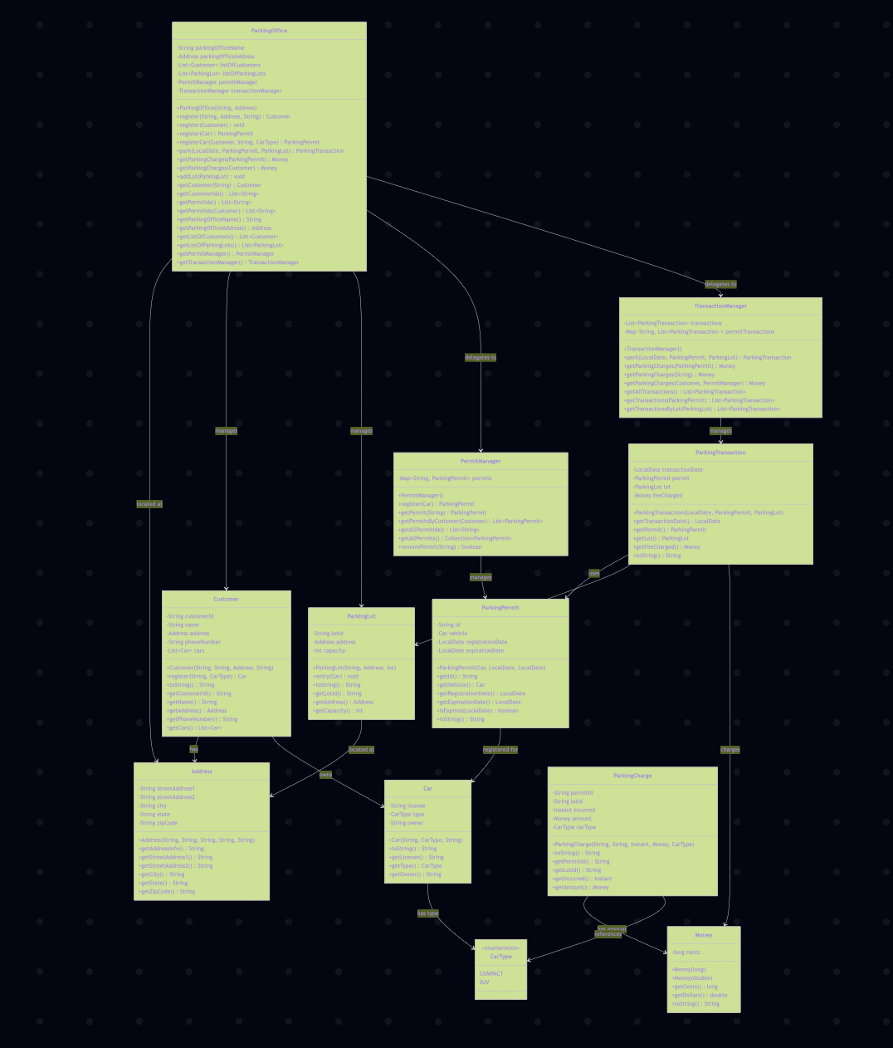

References
Srinam (2024) Separation of concerns (SOC), GeeksforGeeks. Available at: https://www.geeksforgeeks.org/software-engineering/separation-of-concerns-soc/ (Accessed: 09 November 2025).

