**Tasks**

1. Breakdown resources and tasks
   1. Download PMOD documentation from Digilent, schematic of PMOD, and SSD1331 OLED controller reference manual
   2. Determine I/O of PMOD
   3. Determine how to startup, turn off, and reset controller
   4. Determine different available commands
2. FPGA MOSI SPI interface
   1. Drive FPGA as master to control chip select, MOSI, and slave clock
   2. Should send 1 byte of data, or 2 hex values at a time
   3. Should drive D/C (data/command control) bit at start of every byte sent
3. MOSI Byte Buffer
   1. Take in X bytes to transmit concurrently, with individual D/C bits for each
4. Shape Wrapper
   1. Startup
   2. Draw a line
   3. Draw a rectangle
   4. Clear window
   5. Reset
5. Wrapper for SPI interface to change color of drawn shapes
6. Write text, update over certain amount of time
   1. Create table for ASCII values

**Nbit_MOSI_SPI**

Function

* Load 1 byte of data and serial transmit from MSB to LSB over o_MOSI
* Drive o_CS and o_DC on neg edge so will be stable for slave to read

Parameter

* WIDTH: default 8, N bits to transmit in one set

Input

* I_RST: asynchronous reset
* I_SCK: clock for slave interface, has to transmit on it
* I_DATA: byte to transmit to OLED interface slave (can either be command or data)
* I_START: begin transmitting byte in i_DATA
* I_DC: D/C control to be updated on negedge at same time as data on MOSI line

Output

* O_MOSI: Output 1 bit at a time of i_DATA, starting with MSB
* O_CS: chip select, active low
* O_DC: D/C to control data vs. command for the OLED controller
* O_MOSI_FINAL_TX: asserted when last bit transmitted

States

* Idle: waiting for i_START to be asserted once to transmit byte
* Transmit: transmit byte, stay in state if i_START asserted by end, otherwise back to idle

**Nbit_MOSI_SPI_tb**

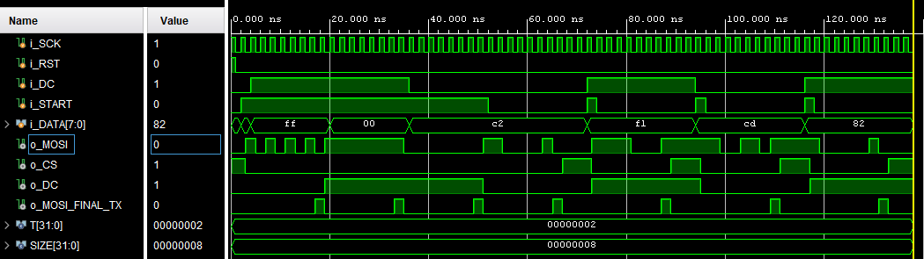

**Nbyte_MOSI_SPI_buffer**

Take in X inputs parallel, serially load them and drive start of master SPI MOSI

Paramters

* WIDTH: number of bits to transmit in one set
* N: max # of sets that can be parallel loaded

Inputs

* I_SCK: SPI clock
* I_RST: asynch reset
* [WIDTH*N-1:0] i_DATA: 2D bit array holding N sets to transmit over MOSI
* [N-1:0] i_DC: D/C command for each byte
* I_START: start from driver control, initiate parallel load of bytes
* [4:0] i_N_transmit: # of N bytes to transmit on load, will be counted

Outputs

* [WIDTH-1:0] o_DATA: byte to feed to master SPI shift module
* O_START: start bit to transmit another byte over MOSI, keep on to keep going
* O_DC: D/C read from input DC for each respective byte
* O_MOSI_FINAL_BYTE: final byte to transmit

**Nbyte_MOSI_SPI_buffer_tb**

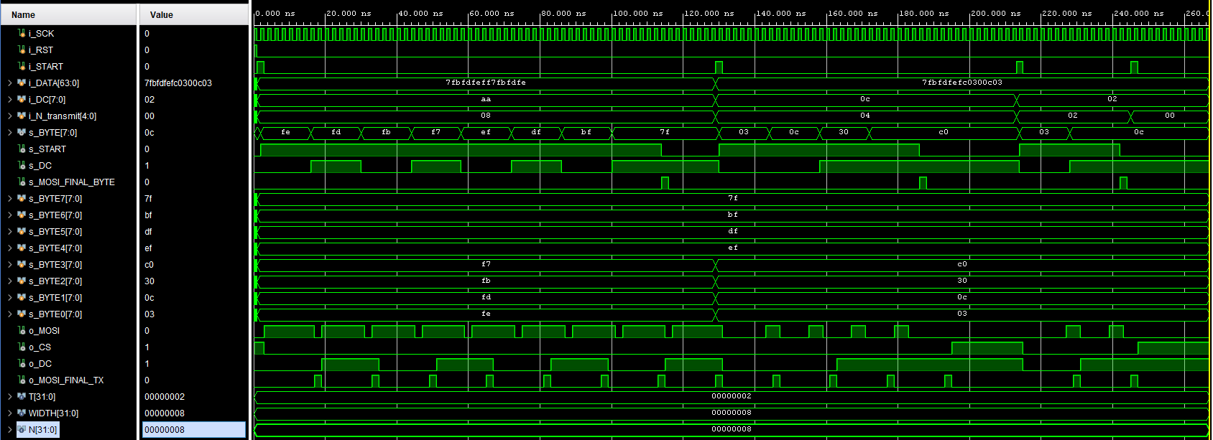

**Clock Divider**

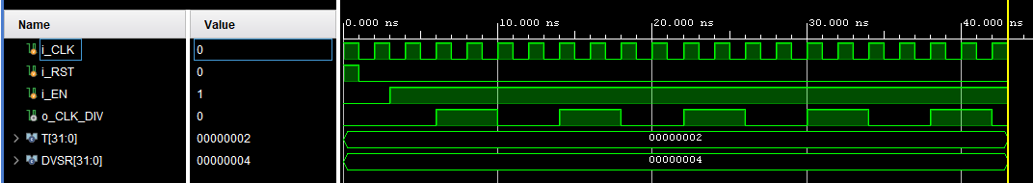

**OLED Interface wrapper**

Paramters

* WIDTH: number of bits to transmit in one set
* N: max # of sets that can be parallel loaded

Input

* I_CLK: FPGA clock
* I_RST: asynch reset
* [1:0] I_MODE: display mode select, will determine state machine load
* I_START: load bytes and transmit
* I_ROW1: ROW1 byte data
* I_ROW2: ROW2 byte data
* I_ROW3: ROW3 byte data
* I_COL1: COL1 byte data
* I_COL2: COL2 byte data
* I_COL3: COL3 byte data

Output

* O_CS: Active low chip select
* O_MOSI: Master out slave in serial bit
* O_SCK: Slave clock
* O_D/C: Data/Command control
* O_RES: power reset
* O_VCCEN: VCC Enable
* O_PMODEN: Vdd Logic Voltage control

Uses the Nbit_MOSI_SPI to send serial bits to OLED display over MOSI. Also drives CS and D/C. This will include a clock divider to count/utilize the FPGA clock and drive O_SCK for the byte buffer and slave OLED display.

Turn on Steps:

1. Apply power to VDD, VDDIO (3V3 supply on FPGA)
2. Set RES pin to low for atleast 3 us
3. Set RES pin to high, set VCCEN to high, set PMODEN to high, wait 3 us
4. After VCC is stable, send command 0xAF for display ON, wait 100 ms
5. Set Display Settings
   1. Send command byte 0xA0
   2. Send data byte to update to 256 color format (bit 6 to 1)
   3. Set display row/col order: A[5:3] = 3b111
   4. Other bits kept as default settings like in reset

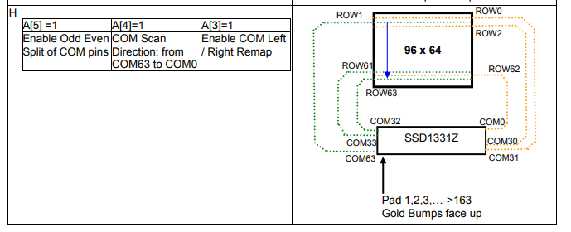

Draw steps:

1. Set start row to 0, end row to 63
   1. Set Row command, 0x75
   2. Starting row address (range from 00d to 63d) , data command
   3. Ending row address (range from 00d to 63d), data command
2. Set start column to 0, end column to 95
   1. Set Row command, 0x15
   2. Starting row address (range from 00d to 93d), data command
   3. Ending row address (range from 00d to 93d), data command
3. Transmit Data