Hal

|  |  |  |  |
| --- | --- | --- | --- |
| Project (P15) | Current 6 | TBD | Bryan Kalkhoff |

HARdware Documentation

Kalkhoff, Bryan S [E CPE]

2021

|  |  |  |  |
| --- | --- | --- | --- |
| Revision History | | | |
| Rev # | **Description** | **Hardware Manager** | **Approved By**  **Need 2/3 for approval: eteam director or assistant director, eteam manager, or alumni** |
| Initial Rev | P14 buttonboard | Bryce Staver |  |
| Rev 2 | Reworked Hal from P14. This was started as a new member project Fall 2020. Most of the changes were done here. | Bryce Staver | Bryan Kalkhoff, Ashley Robertson |
| Rev 3 | We changed the 12V connector to a Megafit and added a reverse polarity protection and fuse blown circuit. | Bryce Staver | Bryan Kalkhoff, Ashley Robertson |
| Rev 4 | Added power filtering for 12V_Main coming into the board | Bryan Kalkhoff | Douglas Zuercher,  Ashley Robertson |
| Rev 5 | Respeced the mosfet for the Horn to fit the the current draw of the horn. | Bryan Kalkhoff | Ashley Robertson Will Galles |
| Rev 6 |  | Bryan Kalkhoff |  |

Contents

**Theory of Operation 3**

**Description 3**

**Board Placement 3**

**Purpose 3**

**Application 4**

**System Level 4**

**Block Diagram 4**

**Pin Diagram 5**

**Board Level 6**

**Schematic 6**

**PCB Picture 7**

**Project Specifics 7**

**Proof of Operation 8**

**Test Procedure 8**

**Test Results 8**

**Troubleshooting 8**

**Additional Resources……………………………………………………………………………………...9**

**Prisum Contacts..………………………………………………………………………………………9**

**Other Contacts………………………………………………………………………………………10**

**Appendix 4**

**Reference 4**

**Figures 4**

**BOM List 4**

# **Theory of Operation**

## **Description**

Hal is used to take in inputs from CAN and send them to our compute module. It has one 2 pin connector to take in all these inputs, which are the core of the board. HAL is powered off 12V_Main.

## **Board Placement**

Rear HAL is located on the passenger-side behind the rear-isolation panel next to Telem and underneath Fuseboards. Front HAL is mounted in the passenger footwell. Refer to Figure 1 and figure 2 for a diagram in how the board and inputs will fit into the car. Hal’s dimensions are **5545 mils long** and **3120 mils wide**. The mounting holes are offset **300 mils in the y direction** and offset **300mils in the x direction**. The diameter of the mounting holes is **350 mil**. The block diagram below gives a general idea of how the board will fit into the front of the car.

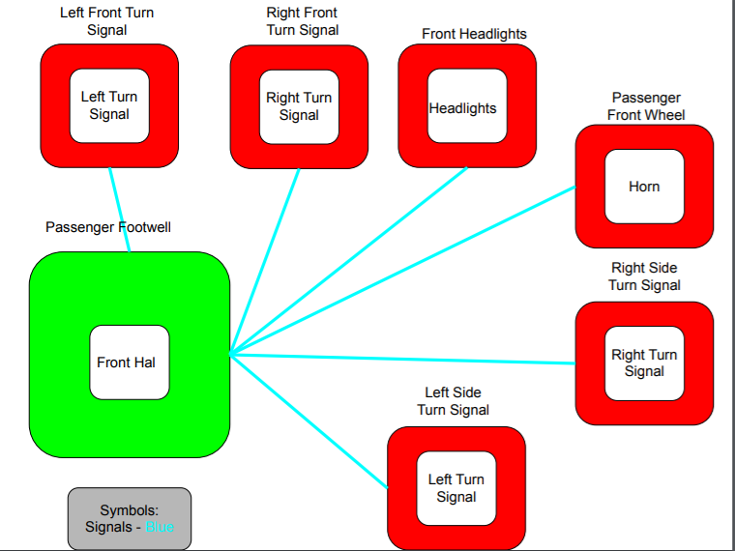

Figure 1.

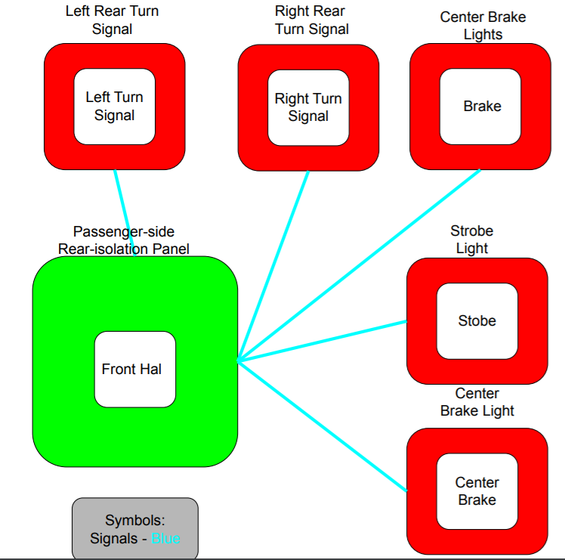

Figure 2.

## **Purpose**

The purpose of Hal is to interface between CAN and all the lights and Horn. There are two Hal boards in the Car, one for the front lights and horn and one for the rear lights.

# **Application**

## **System Level**

### **Block Diagram**

Hal will get 12V_Main voltage from powerboard. The inputs in Hal will be processed through CAN and sent to respective components to turn on different signals in the car like turn lights, horn, or hazard lights. Below is a block diagram showing how Hal gets power from powerboard and sends its CAN signals to the horn and lights.

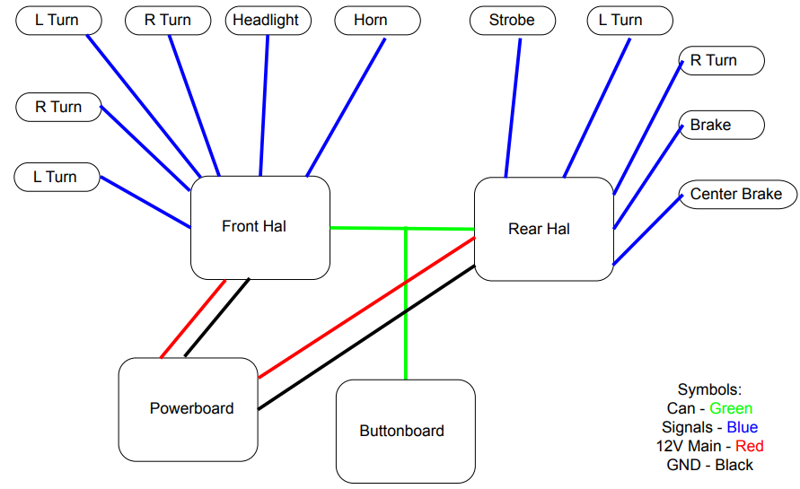

Figure 3.

### **Pin Diagram**

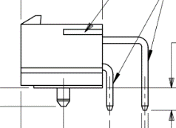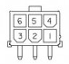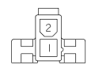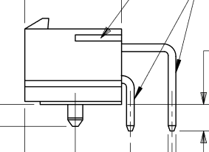

Figure 4. 2 pin connector diagram Figure 5. 6 pin diagram

A pin connection table is provided below for wiring purposes. In general, the wire with a greater voltage on it is connected to the lower pins, and the wire with a lower voltage on it is connected to the upper pins of a connector. The intention of wiring in this fashion is to decrease the chances of someone accidentally brushing the connector and touching the high-voltage signal.

Table 1: Pin diagram

|  |  |  |  |
| --- | --- | --- | --- |
| **Connector designator** | **Connector Type** | **Pin #** | **Description of Signal** |
| J1 – 12V_Main | Megafit | 1 – MGND  2- 12V_Main | 12V_Main from powerboard |
| J6 – 5V_INPUT | Minifit | 1 – 5V  2 – MGND | 5V input possibly needed for buttons. NOT CURRENTLY USED |
| J2 – CAN1 | Minifit | 1 – CAN_H  2 – CAN_L | CAN1 Connector |
| J3 – CAN2 | Minifit | 1 – CAN_H  2 – CAN_L | CAN2 Connector |
| J4 – Front Outputs | Megafit | 1 – Left Turn  2 – Head Light  3 – Right Turn  4 – Left Turn  5 – Horn  6 – Right Turn | Takes Can inputs and adjusts the light and horn output accordingly |
| J5 – Rear Outputs | Megafit | 1 – Right Turn  2 – Spare  3 – Left Turn  4 – Brake  5 – Brake  6 – Strobe | Takes Can inputs and adjusts the light output accordingly |

## **Board Level**

### **Schematic**

Hal’s schematic can be seen in Figure 1 under the appendix at the bottom of this document. For connectors, it should be noted that J1, the **12V_Main** connector, is a megafit connector instead of a minifit, unlike the other connectors. In addition, J4 and J5 for front and rear connection are mega fit as well. This is something that was changed across all the boards to help us from accidentally frying compute modules.

**Power**

The circuitry between the **12V_Main** megafit connector and the 5V switching reg, **PS**, is standard between a few different boards. Specifically, buttonboard and motorboard were designed around the same time as buttonboard and share a similar circuit and parts. The first PMOS, **Q10**, is used for reverse polarity protection. This is here so that just in case we accidentally swap our 12V and MGND inputs, we can’t accidentally burn anything up. Since we are using a PMOS, if our ground is connected in the right pin of the connector, pin 1, then the gate will enable the mosfet to send the 12V source from the drain (3 of **Q10**) to source (2 of **Q10**). **F1** is our fuse holder. If our fuse is blown or not connected, a second PMOS (Q9) will turn on the Fault LED indicator. **C1** is a decoupling capacitor that helps smooth out our input voltage into the 5V switching regulator. **D17** is a TVS diode that helps to prevent fast voltage spikes to protect our circuit.

U1 is our switching regulator that turns our 12V voltage into 5V. Because of the TVS diode (**D17**), we had a 0.7V drop in our input, which LED us to use **R2** and **R3**. These two resistors are used to adjust the output voltage to help us get as close to 5V as we can. Before we added these, we were getting around a 4.2 V output. After the switching regulator we have a 5V LED Indicator to show that the switching regulator is working as we need and to show that our 5V plane on top of the board has voltage on it.

**POWER FILTERING**

The power filtering circuit, shown in Figure 6, helps us smooth high frequency noise from our 12V line coming into buttonboard. FB1 is a ferrite bead, which can be used to filter out the unwanted noise. The capacitors after it are designed to be placed in decreasing order of capacitance and size. If you look at the PCB design, you will notice that C2 and C3 have a package size of 1206, C4 has 0805, and C5 has 0603. They also decrease in order of capacitance, which is easier to see on the schematic.

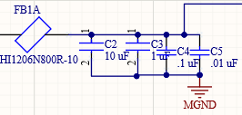

Figure 6. Power filtering circuit

**Connectors**

We have two connectors for can, which *can* be seen with the **J2** and **J3** connectors. These go into the CANH and CANL pins of the S+ (**U1**). For the input section, we have two 6 pin megafit connector, **J4** and **J5**, used to get the ground to the light or horns and turn them on.

**Board Logic**

The logic for the board consists of a set of mosfets that when given input from the compute it gives ground to the given component turning the light on or setting the horn off. The board has a switch that provides information to the compute for if the board is designated as front Hal or Rear Hal. On previous revs of the board it was set up so the second of the two switches could be used to turn off the on board debugging leds for the sake of reducing power consumption. See figure 10 for reference.

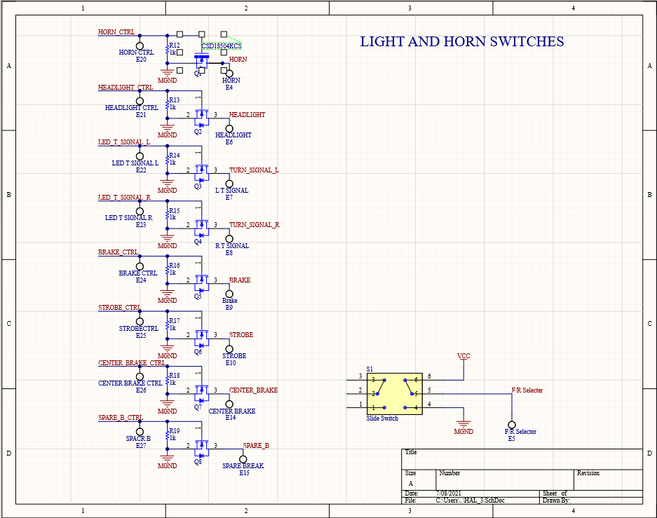

Figure 10. Hal_3.SchDoc

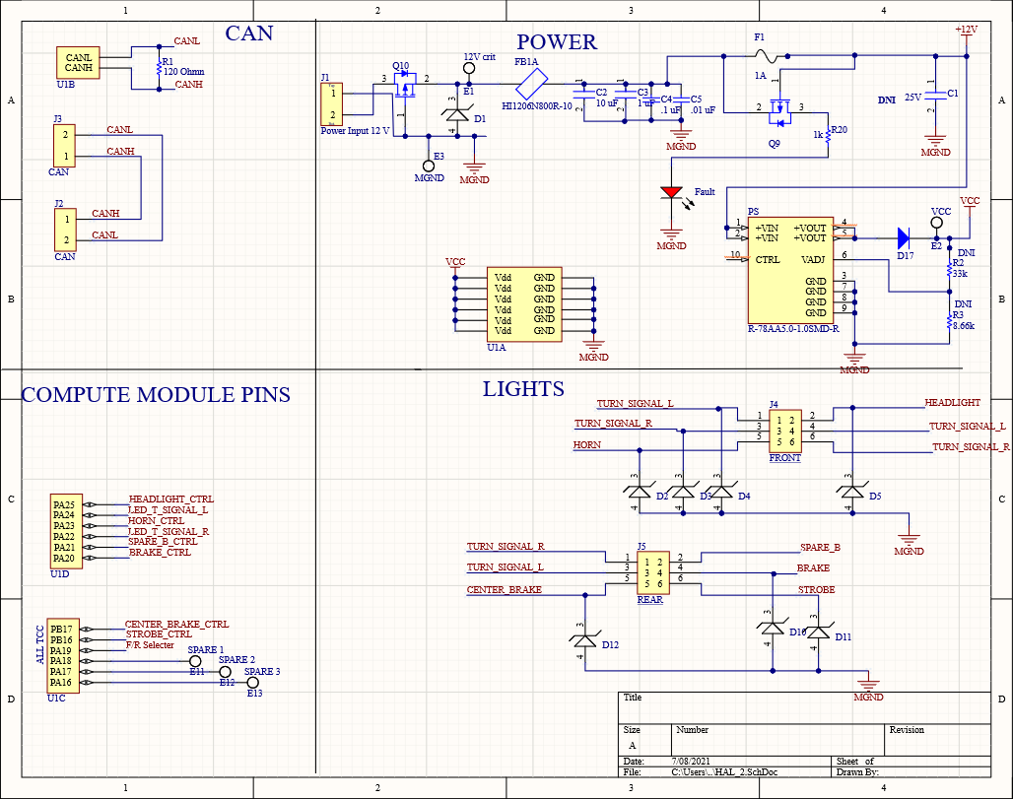

Figure 7. Hal_2.SchDoc

### **PCB Picture**

A picture of Hal’s PCB can be seen in Figure 2 below in the appendix. The layout of the board is simple overall. On the top middle of the board, we have our **12V_Main** connector and all our power protection and switching regulator. All the components to the right of Can, above the compute and to the left of the 5V switching reg relate to the Power section of the schematic. To note with this, Figure 3 shows the 0.5 A silkscreen that is used to denote what type of fuse we need in the fuse holder. The CAN connectors are on the top left of the board, and the outputs can be seen below J4 and J5. We also added test points for a couple different things. We added test points for **MGND** and 5V on the left side of the board and 12 Volt Crit in the power section, so it is easy to see if our fuse and switching regulator are working as planned. We also added test points and labels for all our different around the board. We made it a point to include these on the sides of the board so they would be easy to probe and access.

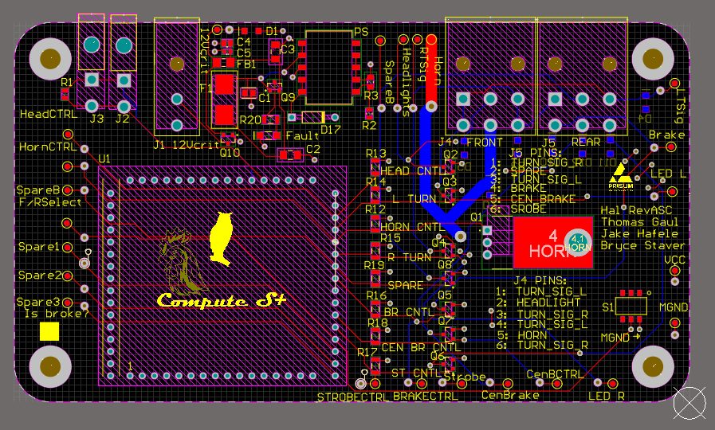

Figure 8. Hal_2.PcbDoc

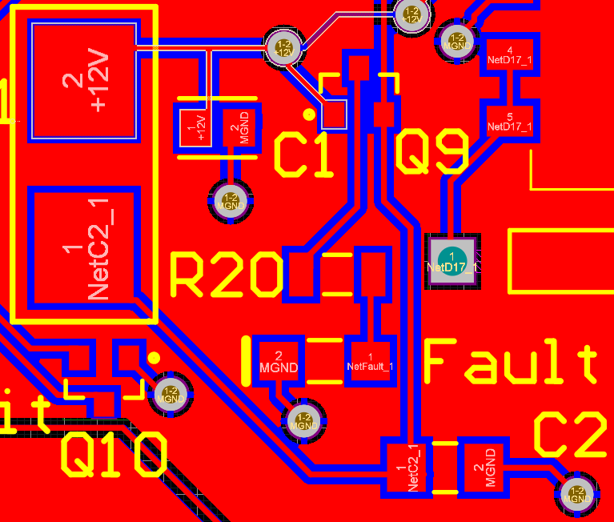

Figure 9. PCB Fuse and circuit protection block

### **Project Specifics**

Using Figure 4 we can find the correct trim up resistor to adjust the output voltage to match 5V. According to figure 5, if we include a diode before VOut we need to add that voltage drop onto **Vo**, which will be roughly 0.7V. After plugging in values of **R1**, **R2**, **R3**, **Vo**, and **VRef** for the values spec’d out at the 5V switching regulator, we get a trim up resistor of 47 kOhms. Based on the protection diagram in Figure 5, we do not need to include a trim down resistor, and only a trim up resistor. This is a mistake I made while testing during Rev 2.1.

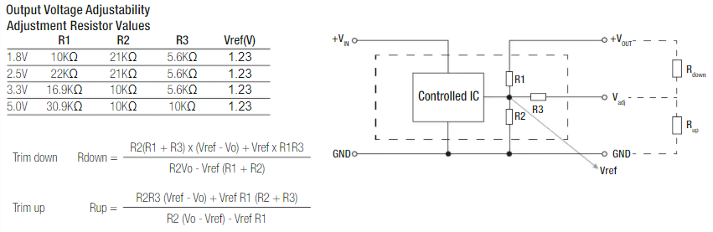

Figure 11. 5V Switching Regulator resistor equations

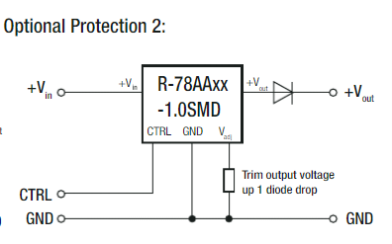

Figure 12. 5V Switching regulator diode protection

# **Proof of Operation**

## **Test Procedure**

Testing hardware for Hal Rev 4 was very straightforward After soldering all our parts on, we tested for continuity by probing different parts of the board. More specifically, we tested for continuity around our fuse and switching regulator, to make sure we would get our 5V out. After this, we applied 5 volts to the mosfet lines and checked continuity through from output to ground.

For testing Hal in the future, follow this checklist:

1. Does the power LED indicator turn on after providing a 12V source in J1?
2. Does the 5V switching regulator output 5V? This can be checked by probing the 5V and MGND test points. If not, try checking you placed the trim up resistor on **R3** and not **R2**!
3. Make sure ground is on the top pin of the connector (1) and the 12 V line is on the bottom (2). Refer to the 2 pin Minifit connector in the pin diagram above.
4. Test reverse polarity by swapping the 12V and ground line on **J1** and make sure the board DOES NOT turn on (Thanks to **Q10**)
5. Test the fuse blown circuit by making sure the **FAULT LED** turns on when you take out a fuse cartridge (Thanks to **Q9**)

## **Test Results**

The only thing that was wrong with hardware during testing of Rev 4 was that our output voltage from the 5V switching regulator was around 4.2 V. After looking at the schematic, we determined that this was because of the TVS diode before the voltage output, which was dropping the voltage. To fix this, we set the output voltage to 5.7V to account for the diode drop and calculate the trim up resistor based on Figure 4 and Figure 5.

With Rev 4 we found that J3 power input had lines flipped which caused wiring issues. In addition the horn drew too much current on startup burning up the mosfet. We respect a mosfet to handle the current draw on horn startup.

## **Troubleshooting**

If any step of the test procedure failed, follow the troubleshooting for that step below:

1. Check if the fuse blown LED is on from a blown fuse, and check if the power LED is soldered on the right way with a diode check
2. Check to make sure mosfets are working by checking conteutiy between the output and ground plan when 5 volts if provided to mosfet.
3. To confirm this, check which pin is connected to the bottom layer/plane of the board which is ground. The pin closer to the inside of the board should be grounded.
4. Verify an N-MOS is on **Q10**
5. Make sure the fuse is out and the fault LED is facing the right direction

## **Race Considerations**

If either the 0.5 A fuse on **F1** is blown or there is not a fuse in the fuse holder, the **FAULT** LED indicator will light up. This should never be on. Instead, the 5V LED indicator should be on if 12 volts goes through the switching regulator. Both are on the left side of the board and can be seen in the PCB in Figure 2. Only one should be on at once and should indicate the current condition of power through the board.

## **Future Considerations**

Standardizing parts between 2020’s new member projects were a big plus for buttonboard. When I was working on the schematic, it was helpful to share parts or circuit protection with other boards like Buttonboard or motorboard. To note, many of the boards shared the same switching regulator and circuit protection, since these boards all had the same 12V input coming into them. This is something that makes life easier for people ordering parts and the people designing them. For future revisions of the board there might also be some worthwhile information in documentation from both Buttonboard and motorboard.

# **Additional Resources**

## **PrISUm Contacts**

|  |  |  |  |
| --- | --- | --- | --- |
| **Name** | **ISU Email** | **Personal Email** | **Phone** |
| Thomas Gaul | [tvgaul@iastate.edu](mailto:tvgaul@iastate.edu) | [81kingchicken@gmail.com](mailto:81kingchicken@gmail.com) | (641)-780-5534 |
| Jake Hafele | jmhafele@iastate.edu | jakehafele@gmail.com | (309)-696-0228 |

# **Appendix**

## **Reference**

5V Switching Regulator Datasheet (**U1**) - <https://www.digikey.com/htmldatasheets/production/705190/0/0/1/r-78aa-1-0-series-datasheet.html>

## **Figures**

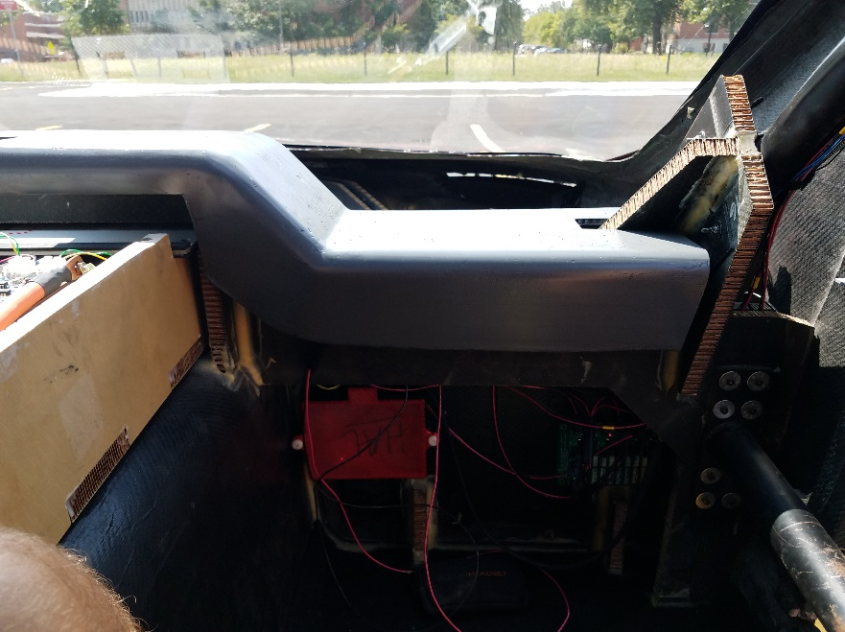

Figure 13 Front Hal location: Passenger side footwell

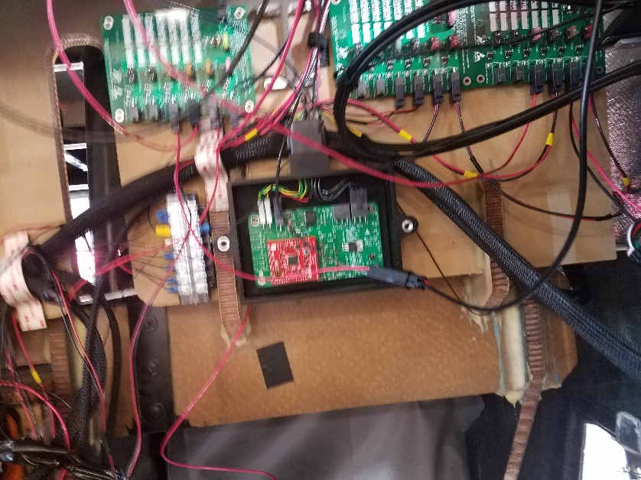

Figure 14 Rear Hal location: Passenger side rear isolation panel

## **BOM List**

|  |  |  |  |  |  |  |  |  |
| --- | --- | --- | --- | --- | --- | --- | --- | --- |
| Description | Designator | Digikey Part Number | Manufacturer Number | Order Amount | Package | Value | Precision | Power |
| 20.1V 19.01A Diode | D1, D2, D3, D4, D5, D10, D11, D12 | 112-VTVS12ASMF-M3-08CT-ND | VTVS12ASMF-M3-08 | 8 |  |  |  |  |
| 50V 1A Diode | D17 | 1N4001DICT-ND | 1N4001-T | 1 |  |  |  |  |
| Fuse | F1 | F2574CT-ND | 0451.500MRL | 1 |  |  |  |  |
| Fuse Holder | F1 | F1889-ND | 01550900M | 1 |  |  |  |  |
| 2- pin Megafit | J1 | WM11969-ND | 768250002 | 1 |  |  |  |  |
| 6- pin Megafit | J4, J5 | WM11971-ND | 768250006 | 2 |  |  |  |  |
| Transistor | Q2, Q3, Q4, Q5, Q6, Q7, Q8 | 1727-2707-1-ND | PMV65UNER | 7 |  |  |  |  |
| 120 Ohms Resistor | R1 | RR12P120DCT-ND | RR1220P-121-D | 1 | 805 | 120 OHM | 0.50% | 1/10W |
| 33.3K Resistor | R2 | 311-33KARCT-ND | RC0805JR-0733KL | 1 | 805 | 33.3Ohm | 5.00% | 1/8W |
| 1 kOhms Resistor | R12, R13, R14, R15, R16, R17, R18, R19, R20, R4, R5, R6, R7, R8, R9, R10, R11 | A106056CT-ND | CRG0805F1K0 | 17 | 1206 | 1 kOhms | 5% | 1/4W |
| Slide Switch | S1 | CASD20GCT-ND | CAS-D20TB | 1 |  |  |  |  |
| Compute Pins | U1 | S7049-ND | PPPC161LFBN-RC | 4 |  |  |  |  |
| P-Channel MOSFET | Q9, Q10 | IRLML6402PBFCT-ND | IRLML6402TRPBF | 2 |  |  |  |  |
| Fuse Blown LED | Fault | 516-1439-1-ND | HSMH-C150 | 1 | 1206 |  |  |  |
| 22 uF Capacitor | C1 | 490-14661-6-ND | GRM21BR61E226ME44K | 1 | 805 | 25V | ±20% | 22uF |
| 8.66k resistor | R3 | 311-8.66KCRCT-ND | RC0805FR-078K66L | 1 | 805 | 8.66k | 1% | 1/8W |
| 10 uF capacitor | C2 | 1276-2877-1-ND | CL31A106MOHNNNE | 1 | 1206 |  |  |  |
| 1 uF capacitor | C3 | 478-1580-1-ND | 12065G105ZAT2A | 1 | 1206 |  |  |  |
| .1 uF Capacitor | C4 | 478-3352-1-ND | 08055C104JAT2A | 1 | 805 |  |  |  |
| .01 uF Capacitor | C5 | 445-1311-1-ND | C1608X7R1H103K080AA | 1 | 603 |  |  |  |
| Ferrite Bead | FB1 | 240-2409-1-ND | HI1206N800R-10 | 1 |  |  |  |  |
| Transistor | Q1 | 296-35578-5-ND | CSD18504KCS | 1 |  |  |  |  |