HAL – Horn and Lights

|  |  |  |  |
| --- | --- | --- | --- |
| Project (P15) | Rev 6 | TBD | Jake Hafele |

HARdware Documentation

Hafele, Jake M [E CPE]

2022

|  |  |  |  |
| --- | --- | --- | --- |
| Revision History | | | |
| Rev # | **Description** | **Hardware Manager** | **Approved By**  **Need 2/3 for approval: eteam director or assistant director, eteam manager, or alumni** |
| Initial Rev | P14 buttonboard | Bryce Staver |  |
| Rev 2 | Reworked Hal from P14. This was started as a new member project Fall 2020. Most of the changes were done here. | Bryce Staver | Bryan Kalkhoff, Ashley Robertson |
| Rev 3 | We changed the 12V connector to a Megafit and added a reverse polarity protection and fuse blown circuit. | Bryce Staver | Bryan Kalkhoff, Ashley Robertson |
| Rev 4 | Added power filtering for 12V_Main coming into the board | Bryan Kalkhoff | Douglas Zuercher,  Ashley Robertson |
| Rev 5 | Respeced the mosfet for the Horn to fit the the current draw of the horn. | Bryan Kalkhoff | Ashley Robertson, Will Galles |
| Rev 6 | Redid circuit for lights so that HAL supplies both the 12V signal for lights and the ground in a closed connection. Each mosfet is specced like the previously replaced Horn mosfet. | Jake Hafele | Bryan Kalkhoff,  Thomas Gaul |

Contents

**Theory of Operation** 3

**Description** 3

**Board Placement** 3

**Purpose** 3

**Application** 4

**System Level** 4

**Block Diagram** 5

**Pin Diagram** 6

**Board Level** 7

**Schematic** 7

**PCB Picture** 11

**Project Specifics** 12

**Proof of Operation** 13

**Test Procedure** 13

**Test Results** 14

**Troubleshooting** 14

**Race Considerations** 15

**Future Considerations** 15

**Additional Resources** 15

**PrISUm Contacts** 15

**Appendix** 15

**Reference** 15

**Figures** 16

**BOM** 21

# **Theory of Operation**

## **Description**

Hal is used to take in inputs from CAN and send them to our compute module. It has one 2 pin connector to take in all these inputs, which are how the board knows what lights to turn on through our software. HAL is powered off 12V_Main. Currently in the car, there are three versions of HAL running.

## **Board Placement**

Strobe HAL is located on the passenger-side behind the rear-isolation panel. Front HAL is mounted in the passenger footwell. Finally, rear HAL is located on the driver-side behind the rear isolation panel similar to Strobe HAL. Hal’s dimensions are **5545 mils long** and **3120 mils wide**. The mounting holes are offset **300 mils in the y direction** and offset **300mils in the x direction**. The diameter of the mounting holes is **350 mil**. The block diagram below gives a general idea of how the board will fit into the front of the car.

## **Purpose**

The purpose of Hal is to interface between CAN and all the lights and Horn. Front HAL powers the headlights, horn, and front turn signals. Rear HAL powers the rear turn signals, brake, and center brake lights. Strobe HAL powers the BPS Strobe signal that will flash when there is a BPS fault in the car.

# **Application**

## **System Level**

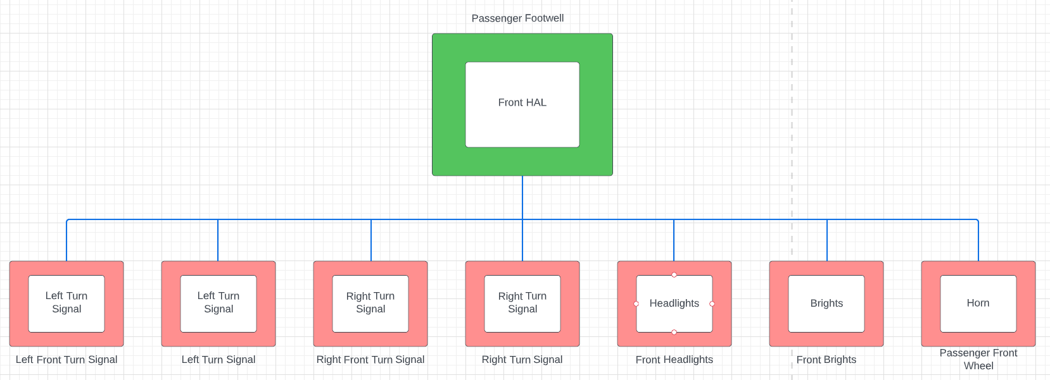

**Figure 1.** Front HAL System Diagram

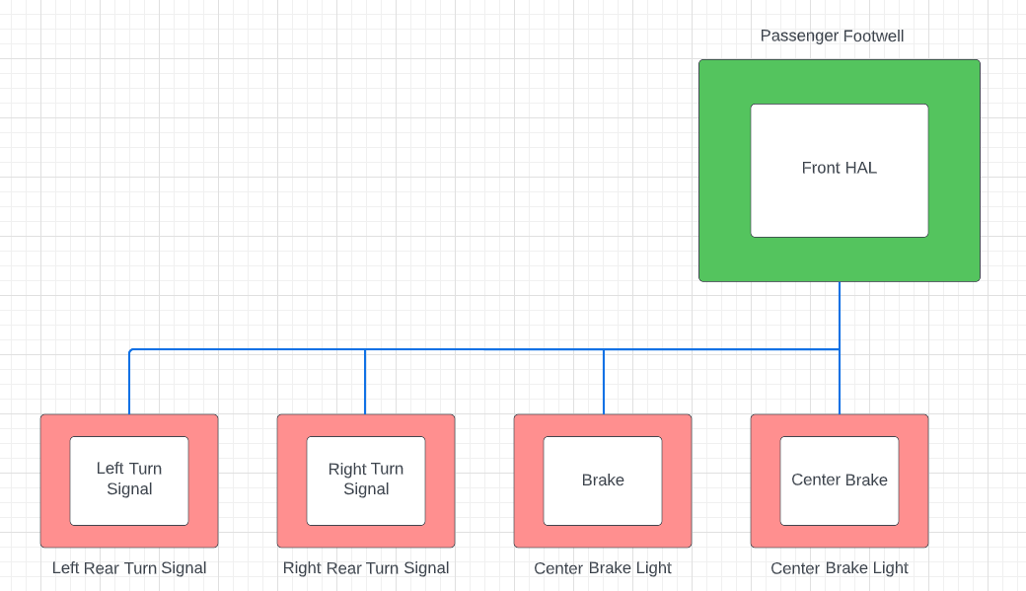

**Figure 2.** Rear HAL System Diagram

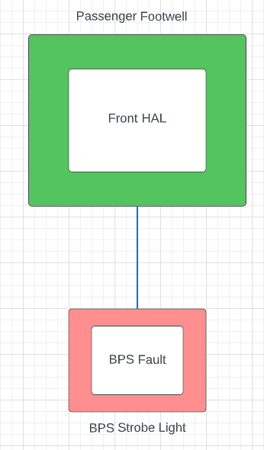

**Figure 3.** Strobe HAL System Diagram

### **Block Diagram**

HAL will get 12V_Main voltage from powerboard. The inputs in HAL will be processed through CAN and sent to respective components to turn on different signals in the car like turn lights, horn, or hazard lights. Below is a block diagram showing how HAL gets power from powerboard and sends its CAN signals to the horn and lights.

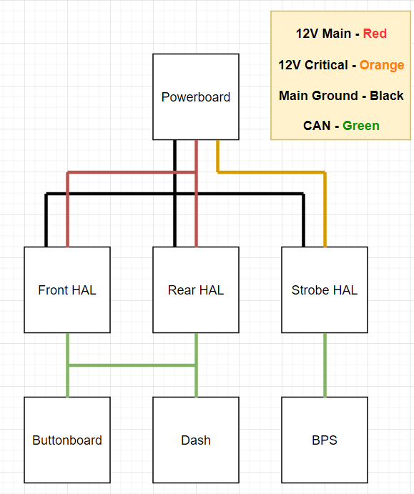

**Figure 4.** HAL Block Diagram

### **Pin Diagram**

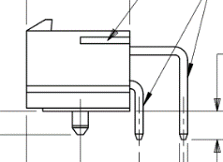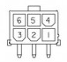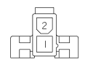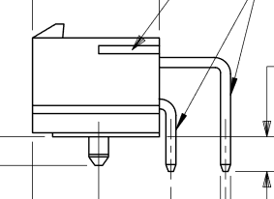

**Figure 5.** 2 pin connector diagram **Figure 6.** 6 pin diagram

A pin connection table is provided below for wiring purposes. In general, the wire with a greater voltage on it is connected to the lower pins, and the wire with a lower voltage on it is connected to the upper pins of a connector. The intention of wiring in this fashion is to decrease the chances of someone accidentally brushing the connector and touching the high-voltage signal.

Table 1: Pin diagram

|  |  |  |  |
| --- | --- | --- | --- |
| **Connector designator** | **Connector Type** | **Pin #** | **Description of Signal** |
| J1 – 12V_Main | 2 pin Megafit | 1 – MGND  2- 12V_Main | 12V_Main from powerboard |
| J2 – HEADLIGHT, HORN, L_TURN | 6 pin Megafit | 1 – Headlight  2 – Horn  3 – Left Turn  4 to 6 - MGND | Sent to Horn and light strips |
| J3 – L_TURN, R_TURN | 6 pin Megafit | 1 – Left Turn  2 – Right Turn  3 – Right Turn  4 to 6 - MGND | Sent to Right and Left turn light strips |
| J4 – SPARE_B, STROBE, BRAKE | 6 pin Megafit | 1 – Left Turn  2 – Right Turn  3 – Right Turn  4 to 6 - MGND | Sent to Right and Left turn light strips |
| J5 – R_TURN, CTR_BRK, L_TURN | 6 pin Megafit | 1 – Left Turn  2 – Right Turn  3 – Right Turn  4 to 6 - MGND | Sent to Right and Left turn light strips |
| CAN 1 | 2 pin minifit | 1 – CAN High  2 – CAN Low | One end of CAN bus |
| CAN 2 | 2 pin minifit | 1 – CAN High  2 – CAN Low | Other end of CAN bus |

## **Board Level**

### **Schematic**

HAL’s schematic can be seen in Figure 1 under the appendix at the bottom of this document. For connectors, it should be noted that J1, the **12V_Main** connector, is a megafit connector instead of a Minifit. This also applies to **J2**, **J3**, **J4**, and **J5**. This is something that was changed across all the boards to help us from accidentally frying compute modules.

**Power**

The circuitry between the **12V_Main** megafit connector and the 5V switching reg, **U1**, is standard between a few different boards. Specifically, buttonboard and motorboard were designed around the same time as buttonboard and share a similar circuit and parts. The first PMOS, **Q1**, is used for reverse polarity protection. This is here so that just in case we accidentally swap our 12V and MGND inputs, we can’t accidentally burn anything up. Since we are using a PMOS, if our ground is connected in the right pin of the connector, pin 1, then the gate will enable the mosfet to send the 12V source from the drain (3 of **Q1**) to source (2 of **Q1**). **F1** is our fuse holder. If our fuse is blown or not connected, a second PMOS (**Q2**) will turn on the Fault LED indicator. **D2** is a 12V TVS diode that helps to prevent fast voltage spikes to protect our circuit.

**U1** is our switching regulator that turns our 12V voltage into 5V. Because of the diode (**D1**), we had around a 0.7V drop in our input, which LED us to use **R2** and **R3**. These two resistors are used to adjust the output voltage to help us get as close to 5V as we can. Before we added these, we were getting around a 4.2 V output. After the switching regulator we have a 5V LED Indicator to show that the switching regulator is working as we need and to show that our 5V plane on top of the board has voltage on it.

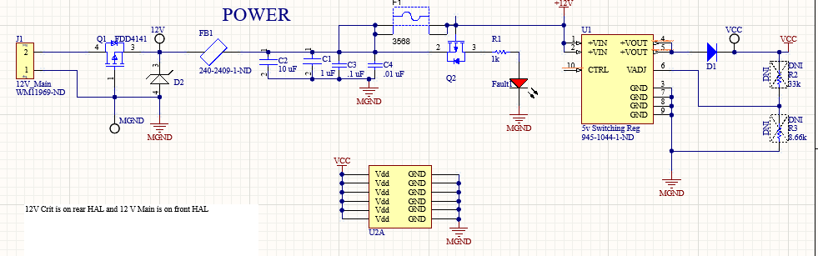

**Figure 7.** Power circuit

**POWER FILTERING**

The power filtering circuit, shown in **Figure 8**, helps us smooth high frequency noise from our 12V line coming into buttonboard. FB1 is a ferrite bead, which can be used to filter out the unwanted noise. The capacitors after it are designed to be placed in decreasing order of capacitance and size. If you look at the PCB design, you will notice that C2 and C3 have a package size of 1206, C4 has 0805, and C5 has 0603. They also decrease in order of capacitance, which is easier to see on the schematic.

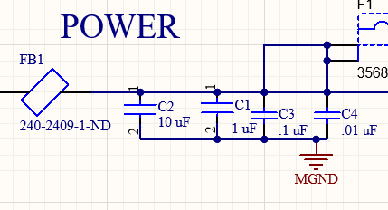

**Figure 8.** Power filtering circuit

**Connectors**

We have two connectors for can, which *can* be seen with the **CAN1** and **CAN2** connectors. These go into the CANH and CANL pins of the S+ (**U2**). For the output section, we have four 6 pin megafit connector, **J2, J3, J4,** and **J5**, used to get the ground to the lights or horns and turn them on.

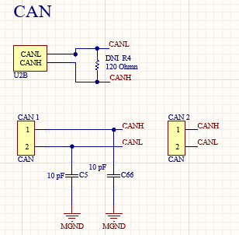

**Figure 9.** CAN Connections

We also included a fuse and TVS diode to each output connecting to a light or horn. An example of one of these connectors can be seen with **J2** below in **Figure 10**. This same setup applies to **J3**, **J4**, and **J5** as well.

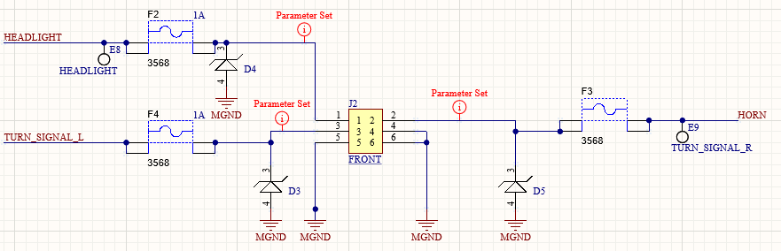

**Figure 10.** Light Connections

**Board Logic**

The microcontroller and software detects if the HAL is placed in the front or rear of the car through the slide switch selector S1. This can be seen below in **Figure 11**. If the switch is placed in the up configuration, the 5V signal will indicate that the HAL is placed in the front of the car and will turn on headlights, front turn signals, and the horn. If the switch is in the down position and grounded, the HAL will power the brake lights, rear turn signals, or BPS Strobe.

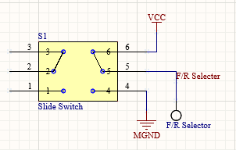

**Figure 11.** F/R Selector

Below is an example of the logic that works between the control signals from the MCU to drive the output signals 12V. If a control signal from the MCU is 5V, then the output lights or horn will receive 12V. If the control signal is 0V, or MGND, then the outputted device will receive no power as it will be an open circuit. To achieve this, we use two mosfets as a buffer. When 5V is applied to HEADLIGHT_CTRL, Then Vgs will be large enough to conduct current between pins 1 and 2 of **Q6** and drive current between pins 2 and 3 or Q6. So, by applying 5V to the control line, The NMOS Q6 will turn on. When Q6 is on, MGND will conduct onto the gate, pin 1, of **Q3**.Since Q3 is a PMOS, The difference between pins 1 and 3 will be large enough so that 12V and current will be conducted between pins 3 and 4 of **Q3**. So, by turning the control line to 5V, both Q6 and Q3 will conduct current and in turn give 12V of main power to the headlight signal, which will then output through a 6 pin megafit connector.

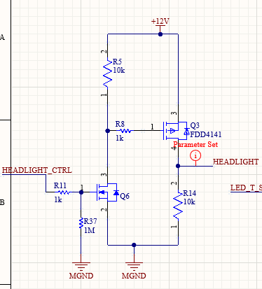

**Figure 12.** Mosfet Buffer Logic

### **PCB Picture**

A picture of Hal’s PCB can be seen in **Figure 13** below. The board gets its power from the top left connector J1 through 12V Main from powerboard. The connectors **CAN1** and **CAN2** to **J1’s** right will supply the microcontroller with a CAN signal that will loop through the board. Connectors **J2**, **J3**, **J4**, and **J5** will output 12V Main lines to power the lights and horn in the car on the right side of the PCB. The left side of the board contains the power circuit depicted above in **Figure 7**. It should be noted that all of these parts are on the top of the board and to the left of the microcontroller. This is also where the fuse blown indicator and fuse are. The Front/Rear switch selector is placed below the microcontroller.

The busiest part of the board lies to the right of the compute board. It should be noted that HAL is now a 4 layer board, in the following order:

1. 12V Main - Red
2. MGND – Brown
3. 5V – Light Blue
4. MGND – Blue

All signal traces are placed either on the top of the board in red or on the bottom of the board in blue. Most of the logic parts are placed on the bottom board since we did not have room for them all on the top of the board. It should also be noted that one software control signal changes three turn signal outputs through one set of logic, as seen between **F4**, **F5**, and **F13**.

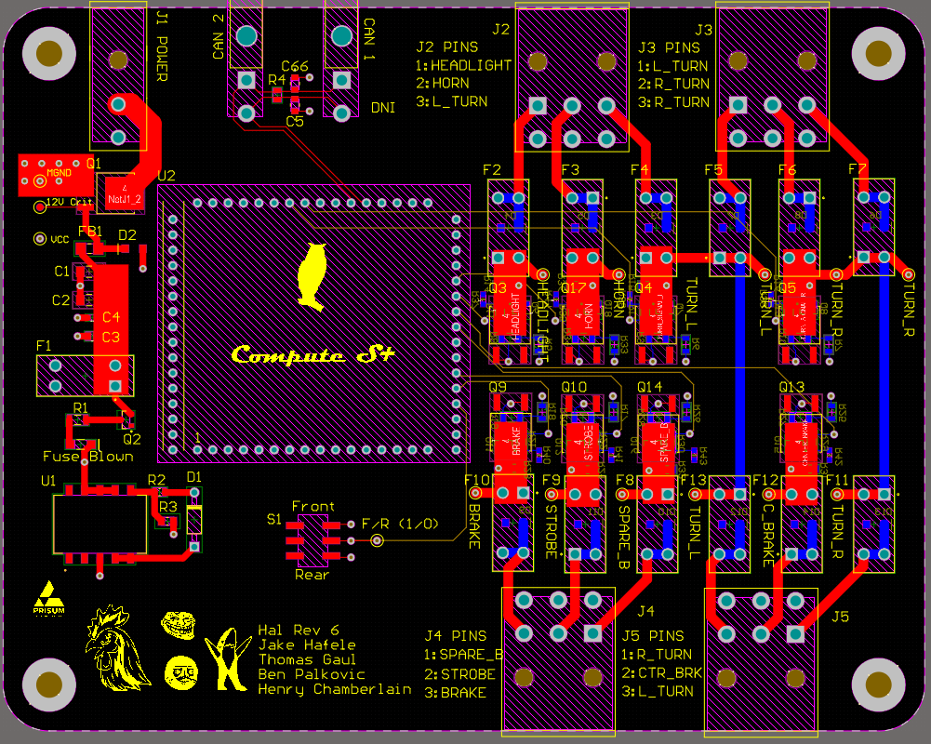

**Figure 13. Hal_2.PcbDoc**

### **Project Specifics**

Using Figure 4 we can find the correct trim up resistor to adjust the output voltage to match 5V. According to figure 5, if we include a diode before VOut we need to add that voltage drop onto **Vo**, which will be roughly 0.7V. After plugging in values of **R1**, **R2**, **R3**, **Vo**, and **VRef** for the values spec’d out at the 5V switching regulator, we get a trim up resistor of 47 kOhms. Based on the protection diagram in Figure 5, we do not need to include a trim down resistor, and only a trim up resistor. This is a mistake I made while testing during Rev 2.1.

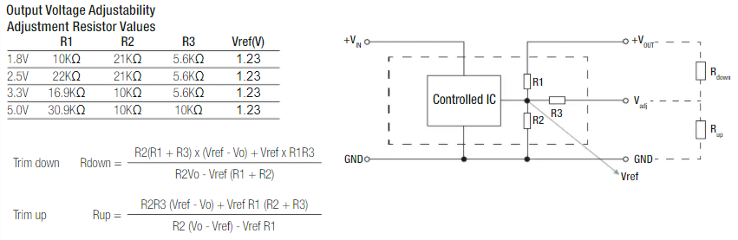

**Figure 14.** 5V Switching Regulator resistor equations

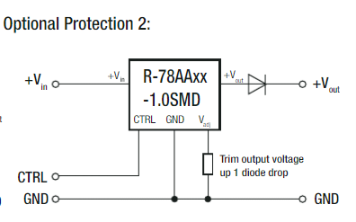

**Figure 15.** 5V Switching regulator diode protection

# **Proof of Operation**

## **Test Procedure**

Testing hardware for Hal Rev 6 was very straightforward After soldering all our parts on, we tested for continuity by probing different parts of the board. More specifically, we tested for continuity around our fuse and switching regulator, to make sure we would get our 5V out. After this, we applied 5 volts to the mosfet lines and checked continuity through from output to ground.

For testing Hal in the future, follow this checklist:

1. Does the power LED indicator turn on after providing a 12V source in J1?
2. Does the 5V switching regulator output 5V? This can be checked by probing the 5V and MGND test points. If not, try checking you placed the trim up resistor on **R3** and not **R2**!
3. Make sure ground is on the top pin of the connector (1) and the 12 V line is on the bottom (2). Refer to the 2 pin Minifit connector in the pin diagram above.
4. Test reverse polarity by swapping the 12V and ground line on **J1** and make sure the board DOES NOT turn on (Thanks to **Q10**)
5. Test the fuse blown circuit by making sure the **FAULT LED** turns on when you take out a fuse cartridge (Thanks to **Q9**)

## **Test Results**

The only thing that was wrong with hardware during testing of Rev 4 was that our output voltage from the 5V switching regulator was around 4.2 V. After looking at the schematic, we determined that this was because of the TVS diode before the voltage output, which was dropping the voltage. To fix this, we set the output voltage to 5.7V to account for the diode drop and calculate the trim up resistor based on Figure 4 and Figure 5.

With Rev 4 we found that J3 power input had lines flipped which caused wiring issues. In addition the horn drew too much current on startup burning up the mosfet. We respect a mosfet to handle the current draw on horn startup.

## **Troubleshooting**

If any step of the test procedure failed, follow the troubleshooting for that step below:

1. Check if the fuse blown LED is on from a blown fuse, and check if the power LED is soldered on the right way with a diode check
2. Check to make sure mosfets are working by checking conteutiy between the output and ground plan when 5 volts if provided to mosfet.
3. To confirm this, check which pin is connected to the bottom layer/plane of the board which is ground. The pin closer to the inside of the board should be grounded.
4. Verify an N-MOS is on **Q10**
5. Make sure the fuse is out and the fault LED is facing the right direction

## **Race Considerations**

If either the 0.5 A fuse on **F1** is blown or there is not a fuse in the fuse holder, the **FAULT** LED indicator will light up. This should never be on. Instead, the 5V LED indicator should be on if 12 volts goes through the switching regulator. Both are on the left side of the board and can be seen in the PCB in Figure 2. Only one should be on at once and should indicate the current condition of power through the board.

## **Future Considerations**

Standardizing parts between 2020’s new member projects were a big plus for buttonboard. When I was working on the schematic, it was helpful to share parts or circuit protection with other boards like Buttonboard or motorboard. To note, many of the boards shared the same switching regulator and circuit protection, since these boards all had the same 12V input coming into them. This is something that makes life easier for people ordering parts and the people designing them. For future revisions of the board there might also be some worthwhile information in documentation from both Buttonboard and motorboard.

# **Additional Resources**

## **PrISUm Contacts**

|  |  |  |  |
| --- | --- | --- | --- |
| **Name** | **ISU Email** | **Personal Email** | **Phone** |
| Thomas Gaul | [tvgaul@iastate.edu](mailto:tvgaul@iastate.edu) | [81kingchicken@gmail.com](mailto:81kingchicken@gmail.com) | (641)-780-5534 |
| Jake Hafele | jmhafele@iastate.edu | jakehafele@gmail.com | (309)-696-0228 |

# **Appendix**

## **Reference**

5V Switching Regulator Datasheet (**U1**) - <https://www.digikey.com/htmldatasheets/production/705190/0/0/1/r-78aa-1-0-series-datasheet.html>

## **Figures**

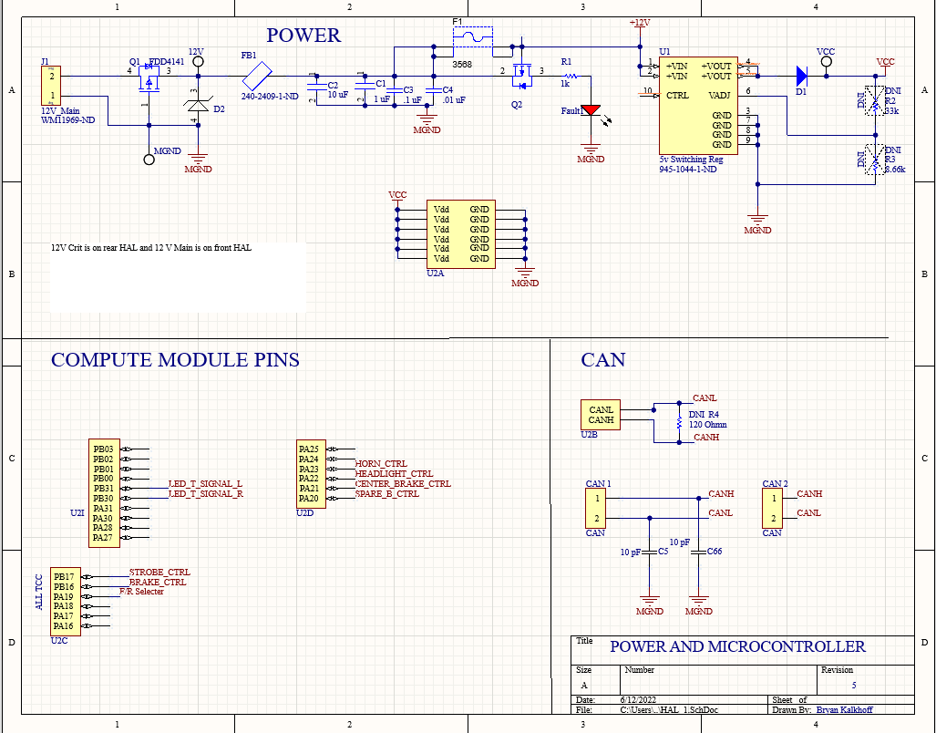

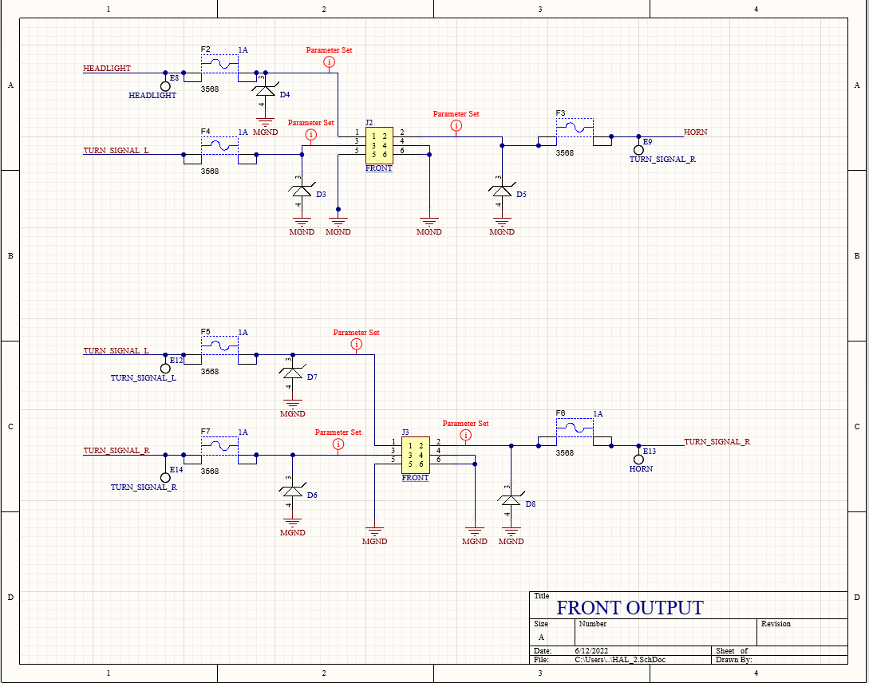

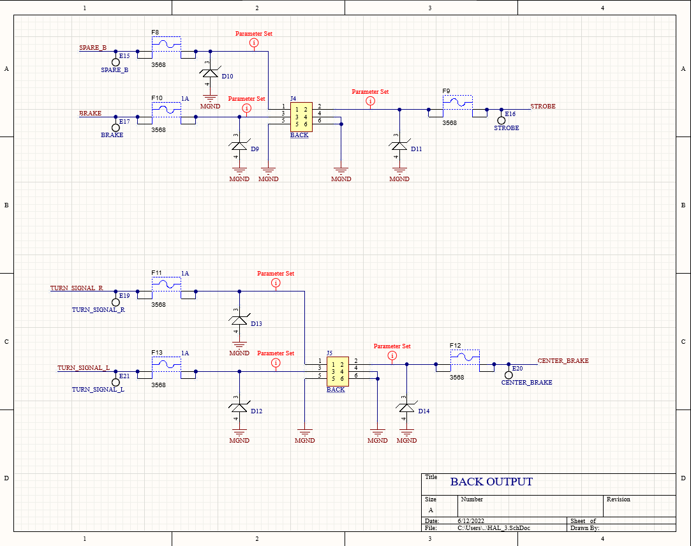

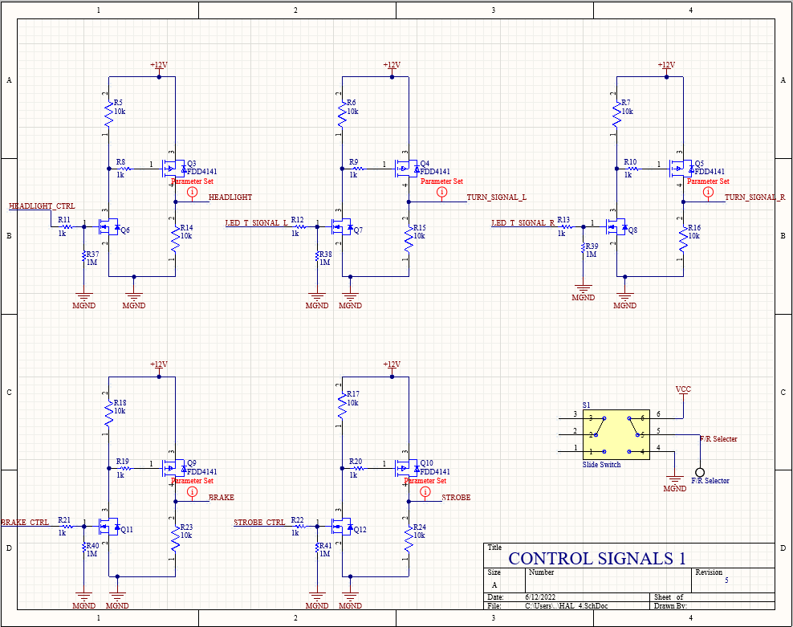

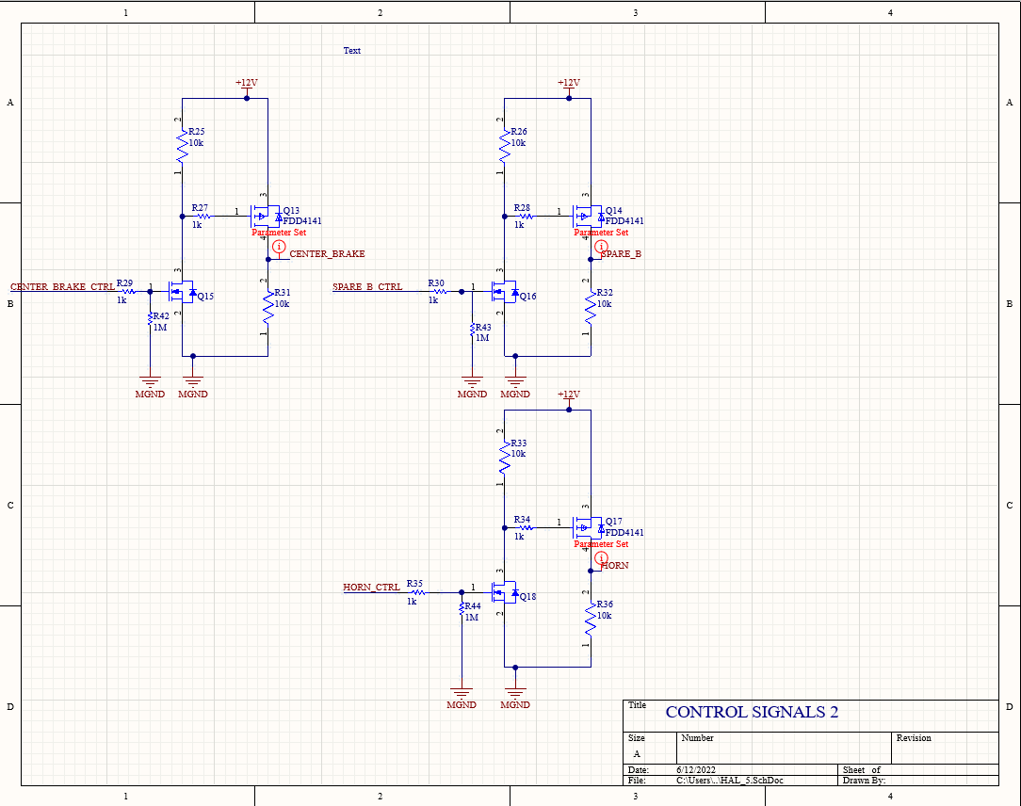

## 

## **BOM**

|  |  |  |  |  |  |  |
| --- | --- | --- | --- | --- | --- | --- |
| **General Part** | **PCB Label** | **Custom Reference** | **Manufacturer Number** | **Retailer Number** | **Package Size** | **Value** |
| 2 pin megafit | J1 | HAL J1 | 768250002 | WM11969-ND | 2 pin mega |  |
| Pfet 40V 10.8 A | Q1, Q3, Q4, Q5, Q9, Q10 | HAL Q1, Q3, Q4, Q5, Q9, Q10 | FDD4141 | FDD4141CT-ND | TO-252-3 |  |
| TVS Diode 20.1 V | D2, D3, D4, D5, D6, D7, D8, D9, D10, D11, D12, D13, D14 | HAL D2, D3, D4, D5, D6, D7, D8, D9, D10, D11, D12, D13, D14 | VTVS12ASMF-M3-08 | 112-VTVS12ASMF-M3-08CT-ND | DO-219AB |  |
| Ferrite Bead | FB1 | HAL FB1 | HI1206N800R-10 | 240-2409-1-ND | 1206 |  |
| 10uF 16V Capacitor | C2 | HAL C2 | CL31A106KOHNNNE | 1276-1137-1-ND | 1206 | 10uF 16V |
| 1uF 16V Capacitor | C1 | HAL C1 | CL31F105ZOCNNNC | 1276-2857-1-ND | 1206 | 1uF 16V |
| 0.1 uF 100V Capacitor | C3 | HAL C3 | 08051C104M4Z2A | 478-7432-1-ND | 805 | 0.1 uF 100V |
| 4700 pF 50V Capacitor | C4 | HAL C4 | 06035C472K4T4A | 478-12727-1-ND | 603 | 4700 pF 50V |
| Mini Blade Fuse Holder | F1, F2, F3, F4, F5, F6, F7, F8, F9, F10, F11, F12, F13 | HAL F1, F2, F3, F4, F5, F6, F7, F8, F9, F10, F11, F12, F13 | 3568 | 36-3568-ND | Mini |  |
| Pfet 20V 3.7A | Q2 | HAL Q2 | IRLML6402TRPBF | IRLML6402PBFCT-ND | SOT-23-3 |  |
| 1kOhm 0.25W Resistor | R1, R8, R9, R10, R11, R12, R13,R19, R20, R21, R22, R29, R30, R35, R27, R28, R34 | HAL R1, R8, R9, R10, R11, R12, R13,R19, R20, R21, R22, R29, R30, R35, R27, R28, R34 | RK73B2BTTD102J | 2019-RK73B2BTTD102JCT-ND | 1206 | 1kOhm 0.25W |
| LED Red Diffused Chip | Fault1 | HAL Fault1 | HSMH-C150 | 516-1439-1-ND | 1206 |  |
| 5V Switching Reg | U1 | HAL U1 | R-78AA5.0-1.0SMD-R | 945-1044-1-ND | 10-SMD |  |
| Diode 50V | D1 | HAL D1 | 1N4001-T | 2516-1N4001-TTR-ND | DO-41 |  |
| 2 pin minifit | CAN 1, CAN 2 | HAL CAN 1, CAN 2 | 39300020 | WM21351-ND | 2 pin mini |  |
| 10 pF 50V Capacitor | C5, C66 | HAL C5, C66 | CL21C100CBANNNC | 1276-2561-2-ND | 805 | 10pF 50V |
| 6 pin megafit | J2, J3, J4, J5 | HAL J2, J3, J4, J5 | 768250006 | WM11971-ND | 6 pin mega |  |
| Nfet 20V 3.2A | Q6, Q7, Q8, Q11, Q12 | HAL Q6, Q7, Q8, Q11, Q12 | NTR4501NT1G | NTR4501NT1GOSCT-ND | SOT-23-3 |  |
| 10kOhm 1/8W Resistor | R5, R6, R7, R8, R14, R15, R16, R17, R18, R23, R24, R25, R26, R31, R32, R33, R36 | HAL R5, R6, R7, R8, R14, R15, R16, R17, R18, R23, R24, R25, R26, R31, R32, R33, R36 | RC0805FR-0710KL | 311-10.0KCRCT-ND | 805 | 10k |
| 1MOhm 0.1W Resistor | R37, R38, R39, R40, R41, R42, R43, R44 | HAL R37, R38, R39, R40, R41, R42, R43, R44 | CRCW06031M00FKEA | 541-1.00MHCT-ND | 603 | 1MOhm 0.1W |
| Slide Switch | S1 | HAL S1 | CAS-D20TB | CASD20GCT-ND | SPDT x 2 |  |