Pymaceutials Data Report

Jake Hatcher

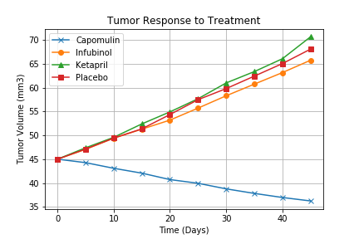

Of the drugs we were interested in testing, only Capomulin showed a reduction in tumor volume over the course of treatment while the other two, Infubinol and Ketapril showed negligible deviation to the placebo group.

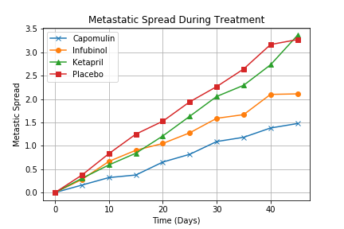

In terms of limiting the Metastatic spread of the tumors, Capomulin is once again ahead of the rest by a significant margin, however unlike when preventing cancerous growth, Infubinol shows the possibility of being useful in preventing Metastatic spread. Ketapril still is struggling to differentiate itself from the placebo group

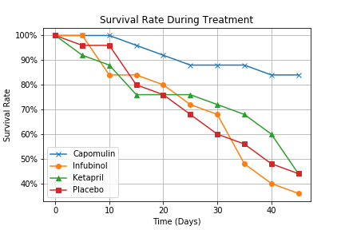

Capomulin once again showing a significantly better result compared to the others. As far as these results go, Infubinol has a higher mortality rating when compared to the placebo group with Ketapril once again showing little deviation to the placebo group.

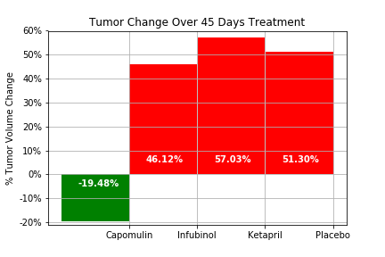

As the previous charts have shown, Capomulin is the only one of this bunch to show positive results and while Ketapril shows promise in preventing the Metastatic spread, it also has the worse overall results even when compared to the placebo group.