iCATch project

- Description of the system, user interfaces Done
- Potential application Done
3. Lesson learned /Technique Done
4. Citation Done
5. Demo Done

- Description of the system, user interfaces

System consists of three parts:
- Hardware modules (we use Arduino UNO and use I2C protocol to allow slave modules to be added)
- Communication mechanism between sensors and cell phone ( we are using Bluetooth)
- The mobile application (at this stage, it is a fraction game that utilizes 3 light sensor inputs)

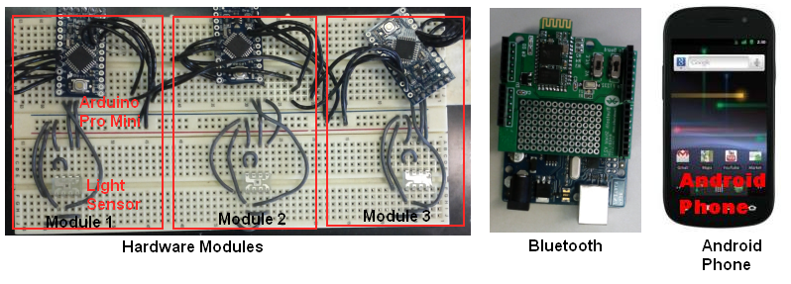
Mobile application:
The mobile application also consists of three parts
- The game frameworks to supply basic support to create simple games. We used the android game framework coded in the book -- Beginning Android games by Mario Zecher.
- sensor library (bunch of java classes to provide a consistent and uniform way of accessing sensor readings)
- Android application (at this case, the fraction game)

Bluetooth:
Communication mechanism we used is Bluetooth, since it is available on every cell phone. The idea is to create a Bluetooth connection between the application and hardware module when the application is first launched and set it to global. So we don’t need to do any further configuration even when we are adding more games in the future. All those games will use this global Bluetooth connection to access the sensor data..

Hardware modules:
We use Arduino UNO with Bluetooth Shield to provide Bluetooth connection with the cell phone. The mechanism used to add more modules is to use the I2C protocol. We create the I2C slave device by using Arduino pro mini and programming it using the WIRE library provided by the Arduino.
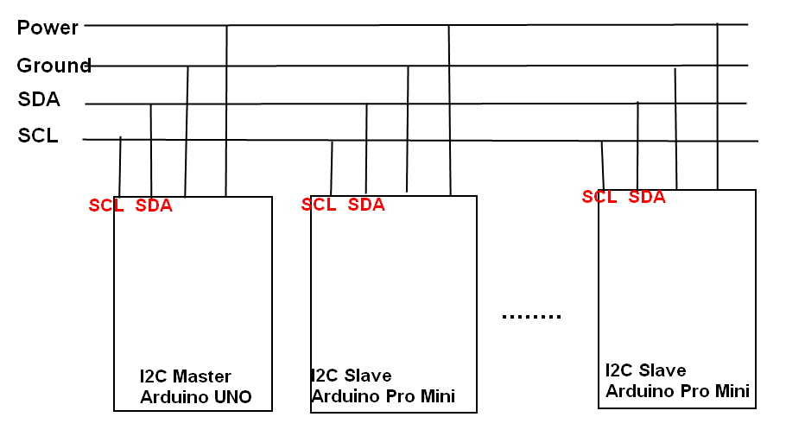

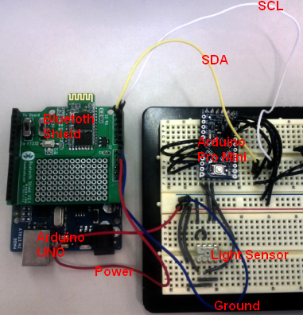

2. Potential Application:
- Hardware input device for mobile gaming
Right now, the most common input mechanism for mobile gaming (or mobile application in general) is to use multi-touching which requires you to constantly tap the screen to give feedback.
By using our system, you can plug in appropriate modules to provide richer input than simply tapping the screen.
For a game like flying a jet, if you only use multi-touching, you need to place different buttons on the screen to specify your commands like directions, diving, drop the bomb etc. The much more fun and natural way to control the jet will be to use hand to model the jet by excluding your thumb, index and little finger, and folding the middle and ring fingers into your palm. So the index finger signifies the heading direction of the jet. The thumb signifies the left wing. The little finger signifies the right wing. The middle and ring fingers signifies the bombs it‘s carrying. You can also specify the speed by how further apart you extending your thumb and little finger. By using this mechanism, users don’t need to decompose the motion of the jets into the commands presented on the screen and tap the corresponding commands accordingly. They can imagine their hands are jets and simply “fly” it by positioning their hands differently. The different gesture of his/her hand will activate different command. We are further expanding the constraints placed on the possible motion of the jets. If we use multi-touching, the possible motion is constrained by the available buttons placed on the screen. By using gesture, the motion is constrained by how you possibly position your hands. One single gesture conveys more information than one button on the screen. So using gesture simplifies the input process for user. For example, to fly the jet up side down you need to tap the rotating command until it is upside down. If we use hand gesture, we simply flip our hands up side down and let the module to worry about capturing the gesture, process the gesture into callable subcommands and actually call those commands to make jet up side down. This approach also frees up the space taken by the buttons on the screen.
I don’t’ know the exact way of doing gesture recognition right now.

2. Smart home

Every day, we spend time on many tedious tasks like clean the house, turn on the PC, switch on/off the light, flush the toilet etc. Many of these can’t be turned into automatic tasks by using simple sensors like ultrasound sensor or light sensor etc.
We can design a hardware module that is capable of turning existing light switch into auto switch. This hardware module needs to have following components:
- WIFI to connect to Internet
- light sensor
- motor to switch light on or off

The idea is to build this module as a single unit so the users can simply place on the top of the existing switch. Then it is good to go.
The reason to have WIFI is to simplify the configuration needed to be done by the users. Once the device is placed, the users download a mobile application and connect the module to the cell phone using cable or Bluetooth. The configuration is simply setting the home WIFE network name and key, so the module can connect the server and be configured from there.

The next step for the users will be going to the website, upload the floor plan, click the appropriate position on the map and add the corresponding modules. Users can further configure the module by right clicking and choosing suitable options. Once that’s done, the revised program will be downloaded to the module to get it working.

The benefits of having all the hardware modules connected to the server are
- It allows users to make changes at one place with the assistant of the GUI.
- It allows users to keep track of the important information about the house. For example, by placing a people-detect (ultrasound sensor + WIFI) by the door, each time someone goes near the door, it will detect it and log it on the server with the timestamp. Another example will be keep track of the water usage (for cooking, washing hands or showing etc).

We can further create a mobile application to allow users check the status of their houses and make any changes necessary from the cell phone.

3. Lesson learned

3.1 How to create I2C slave module
Since I have no idea how to create circuit board, I end up using Arduino Pro Mini as I2C slave device. The Arduino Pro Mini has the same functionally as the Arduino UNO but smaller in size. The programming needed to make it an I2C slave device is simple. First we use Wire.begin(9) to specify this Arduino Pro Mini as slave device with the address 9. Next we add callback to event handler --- Wire.onReceive() and Wire.onRequest(). Wire.onReceive() specifies the action to take whenever it receives message (command) from the master device. Wire.onRequest() is called whenever it receives a request from the master device. The most common steps taken by master device to receive data from the slaves are
Step 1: Start the Wire library
Wire.begin()

Step 2: send command to the slave deive
Wire.beginTransmission(device_number); // transmit to device
Wire.send(command); // sends command
Wire.endTransmission(); // stop transmitting

Step 3: request data from the slave device
Wire.requestFrom(device_number, number_of_bytes_data);
// request number_of_bytes_data from device specified by the device number

Step 4: receive the data
if (Wire.available()){
result = Wire.receive(); //retrieve one byte from the stream.
}
The way how master receives the data from the slave means the slave device will first receive command which specifies what kind of data master device wants, and then it will receive a request that specifies the number of bytes of data it wants the slave to return. The callback to the event Wire.onReceive() usually updates the global command variable. The loop () method will do different action based on this command variable. Finally, the callback to the event Wire.onRequest() will return the result calculated in the loop ().

#include <Wire.h>
int command = 0; //specify which command received
int lightReading = 0; // light sensor reading
byte reading[2]; // holding two bytes; first byte for high order byte of int,
//second byte for low order byte

void setup() {
Wire.begin(9); // make this device have address 9

Wire.onReceive(receiveEventHandler); // specify handler to handle incoming bytes
Wire.onRequest(myRequestHandler);
}

void loop() {
lightReading = readTSL230(TSL230_samples, TSL230_Pin); // read light sensor
}

void receiveEventHandler(int numBytesReceived) {
command = Wire.receive(); // receive byte as an integer as the command
}
void myRequestHandler() {
if (command == 1) {
reading[0] = byte(lightReading & 0xFF); //move low order byte
reading[1] = byte(lightReading >> 8 & 0xFF); //move high order byte
Wire.send(reading, 2); // return 2 bytes since master device requests two bytes
}
}

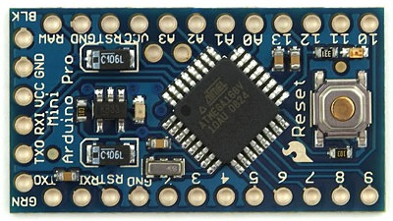
Arduino Pro Mini

3.2 How to create I2C master
It is also easy to create an I2C master device by using Arduino. First we use #include <Wire.h> to include the Wire library. Then we use Wire.begin() to specify this device as master device. We use
Wire.beginTransmission(device); // transmit to device
Wire.send(com); // sends x
Wire.endTransmission(); // stop transmitting
to send command to the slave. Later we use Wire.requestFrom(device, number_of_bytes) to request number of bytes of data from the device. The final step is to use Wire.availbale() to test if there is data available to process and call Wire.receive() to receive one byte of the data if there is data available.

#include <Wire.h>
int result = 0;
int DEVICE7 = 7;
int COM_LIGHT_READ = 1;

void setup(){
Serial.begin(9600);
Wire.begin();

}

void loop()
Serial.print(sendCommand(DEVICE7, COM_LIGHT_READ));
Serial.print(" ")
}

int sendCommand(int device,int com) {
Wire.beginTransmission(device); // transmit to device #9
Wire.send(com); // sends x
Wire.endTransmission(); // stop transmitting

Wire.requestFrom(device, 2);
if (Wire.available()){
result = Wire.receive();
if(Wire.available()){
result = int(word(Wire.receive(), result));
}else{
result = 0;
}
}else{
result = 0;
}
}

3.3 How to create game in Android
- I use the game framework from the book -- Beginning Android games by Mario Zecher,
since it will take very long time to come up our game framework. The problem now becomes to understand the sample game showed in the book, and make changes to create our fraction game.

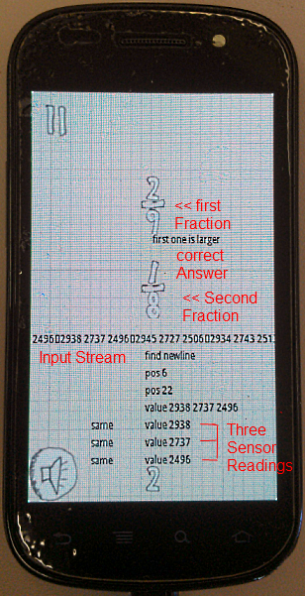
As you can see, the fraction game will generate two fractions every five seconds. The users will have five seconds to figure out which fraction is larger by sensing the correct light sensor (we can achieve the same thing by using three switches). If the user correctly picked the larger fraction, text “Right” will be displayed otherwise text “Wrong” will be displayed.

3.4. Bluetooth
For the Bluetooth, I used the program posted by Radu Motisan on the PocketMaigc.com.
It has only the ability to send commands to the connected device. I added the ability to receive data. The ability to receive data is the main function we needed for our project.

3.5 How to merge Bluetooth and fraction faction
The most difficult problem of this project so far is to make the Bluetooth accessible to the fraction game. To solve this problem, we use the fact that we can provide our own implementation of the Application class by specifying its name in your AndroidManifest.xml's <application> tag, which will cause that class to be instantiated for us when the process for our application/package is created. We can make the Bluetooth socket the member data of the application class. By doing so, every activity contained in the Application can access this global variable.

  - How to capsulate the game framework
Since we want to use the game framework as a black box, we need to make it a library so that we can simply import it and use the methods provided by its interface. We can achieve this by right-clicking the activity contained the game framework in Eclipse SDK, choose “property”, then click the “Android” and check “is Library” checkbox to make a library.

- Citation

I used Bluetooth program posted on the http://www.pocketmagic.net/?p=1398 by Radu Motisan. It has the capability of discovering the Bluetooth devices, connecting to the device with the specified MAC address and sending the command to it. I later added the functionality of receiving data.

I used the game framework coded in the book –Beginning Android games by Mario Zecher., to create the faction game.

5. Demo
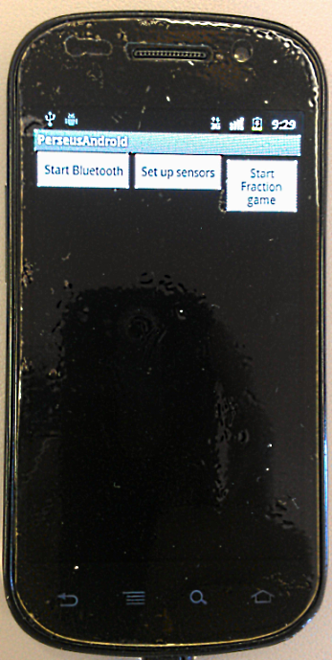
We first start searching the Bluetooth devices by clicking the “Start Bluetooth”.

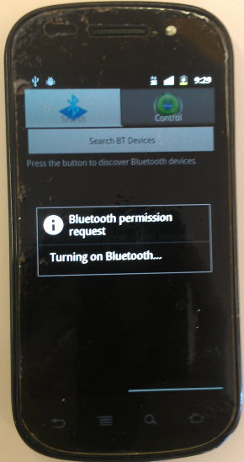
Turning on the Bluetooth

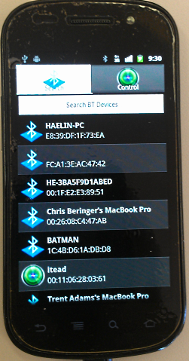
Found our “itead”, we then click it to connect. After it is connected (The light on the Bluetooth shield stops blinking), click backward to go to the main menu. Now we can start our game by clicking the “Start Fraction game” button.

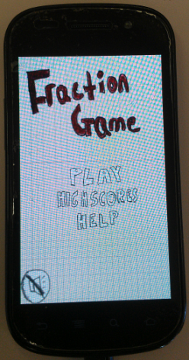
Click the “play” to start the game

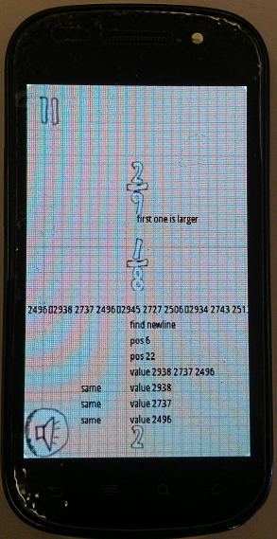
Now user can pick the larger fraction by sensing the correct light sensor.

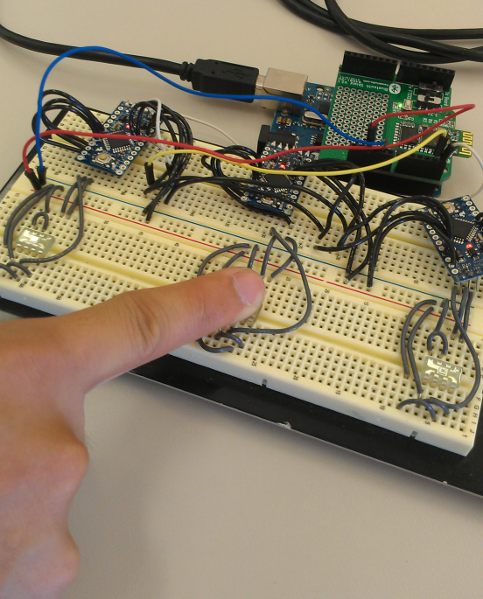
Sensing the left sensor if the top fraction is larger, the middle sensor if they are equal and the right sensor is the bottom fraction is larger.

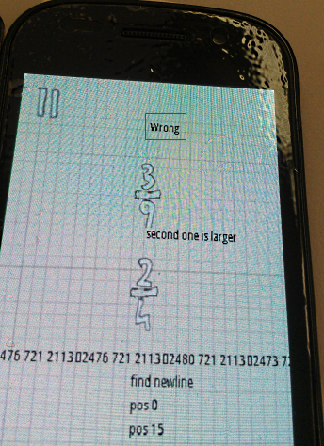
User didn’t pick the right fraction so “Wrong” is displayed.

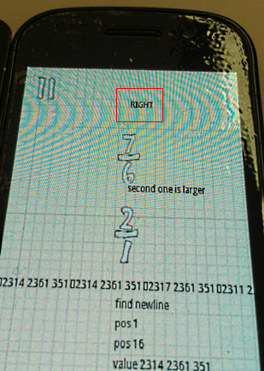
Text “RIGHT” will be outputted if user correctly picks the larger fraction.

