Southampton Solent University

SCHOOL OF MEDIA ARTS AND TECHNOLOGY

**BSc (Hons) Computing**

**Third Year**

**Jake Lambert**

***Societies & Sport Teams Prototype***

Website : <http://54.246.253.236/>

Words : 10,536

Supervisor : Craig Gallen

Date of presentation : 04-05-2018

# Acknowledgments

**Craig Gallen –** Supervisor, with his knowledge and skills he guided me through every phase of this project.

**Darren Cunningham –** Helped with the technicalities of choosing to use static HTML or a dynamic CMS.

**Martin Reid** – The lectures he conducted was a massive help with planning out each phase of the project to meet the deadlines.

**Jamal Wiseman –** Participating in the agile process development in this project.

**Pheobe Pearson –** Participating in the agile process development in this project.

**Josh Dewitt –** Participating in the agile process development in this project.

# Acronyms

API – Application programming Interface

AWS – Amazon Web Service

CMS – Content Management System

CRUD – Create, Read, Update, & Delete

DOM – Document Object Model

FTP – File Transfer Protocol

HCI – Human-computer Interaction

HTML – Hypertext Mark-up Language

PHP – Hypertext Pre-processor

Qual – Qualitative data

Quan – Quantitative data

RIBS – Remuneration, Influence, Belonging, & Significance

RSS – Rich Site Summary

SEO – Search Engine Optimisation

SSM – Soft-systems Methodology

SU – Student Union

UK – United Kingdom

URL – Uniform Resource Locator

WP - WordPress

# Abstract

The purpose of this project is to identify whether a web presence will help raise the profile for societies and sports teams within Southampton Solent University. Furthermore, try to increase the number of students signing up to these student groups. We will be building a prototype with multiple system features like: Online signups, league tables and statistics for sports, recent news and forums. We will be focusing on the best way to get students connected with each other and create a good social platform to build an online community. We will be developing the project using selected methodologies to create the best potential prototype.

# Contents

Acknowledgments II

Acronyms II

Abstract II

Contents III

List of tables & figures 1

1. Introduction 1

1.1 Background 1

1.2 Aims 3

2. Literature review 5

2.1 Creating online communities that last 5

2.2 Technical review 6

2.3 Design methodology for information system 8

3. Design 10

3.1 Functional requirements: 10

3.2 Non-functional requirements: 10

3.2.1 Professional 10

3.2.2 Legal 11

3.2.3 Ethical 11

3.3 Specifications of the features & functionalities 11

3.4 Methods 12

4. Design methodology 13

4.1 Initial surveys 13

4.2 Agile methodology 13

4.3 Soft-systems methodology 15

5. System Architecture 17

5.1 How to choose a web builder 17

5.2 Static HTML vs Dynamic CMS 20

5.3 WordPress vs Wix 22

5.3.1 Flexibility 23

5.3.2 Design and layout 24

5.3.3 Pricing policy 25

5.3.4 Evaluation of chosen CMS 27

5.3.5 Choice of plugins 29

6. System Features 33

6.1 Society/Sports team information and signup 33

6.2 Sports statistics and information 34

6.3 Student groups blog and news 34

6.4 Forum social 35

7. System Management 36

7.1 Societies/Sports 36

7.2 Performance 36

7.3 News Blogs 37

7.4 Social 38

7.5 System administration team 38

7.5.1 Common Maintenance Protocol 38

7.5.2 Marketing Strategies 39

7.5.3 Continued Improvement & Optimization 40

41

8. Conclusions 42

8.1 Evaluation of Design 42

8.2 Future Work Recommendations 44

8.2.1 Updating sports results through mobile application using REST API 44

8.2.2 OpenID login system 45

8.2.3 Student group events & chat page 45

8.3 Learnings from Project 45

8.4 Prototype limitations 46

9. Reference List 47

10. Appendix 51

10.1 Primary Research Interview 51

10.2 The Agile process model 52

10.3 Organizational analysis - The systems perspective 53

10.4 Seven-stage model of SSM 54

10.5 Survey Results 55

10.6 Primary Research 59

10.7 Risk register 60

10.8 Gantt chart 63

10.9 Agile Process Methodology 64

10.11 Participants Feedback 73

10.12 Diagram of overall system 75

10.13 Plugins list 76

# List of tables & figures

**Figure 1 -** WordPress uses on 25 percent of all websites(McGee 2015)

**Figure 2 –** Diagram to the Agile process (O'Niell 2017)

**Figure 3 -** Organisational analysis – the systems perspective(Vidgen 2002)

**Figure 4 –** Seven-stage model of SSM (adapted from Checkland & Scholes, 1990)(Vidgen 2002)

**Figure 5 -** The web coverage landscape for 2016.(O'Niel 2016)

**Figure 6 -** Comparing on-demand compute pricing: AWS vs Azure vs Google Cloud(Weins 2016)

**Figure 7 –** HTML back-end vs CMS back-end(Lehman 2013) [1]

**Figure 8** – How extensive the WordPress community is(Wong 2018)

**Figure 9 –** The Wix AppMarket(Nunan )

**Figure 10 –** Design comparison chart(Steele 2017)

**Figure 11 –** Summary table Wix vs WordPress(Wong 2018)

**Figure 12 –** Most popular CMS’s[2]

**Figure 13 –** New WordPress 3.8 dashboard(Bitnami 2013)

**Figure 14** – The back-end overview for the SportsPress plugin

*This is a from the back-end to our WordPress website*

**Figure 15 –** Creating a new event in the SportsPress plugin

*This is a from the back-end to our WordPress website*

**Figure 16 –** OpenID Diagram (Oracle Learning Library 2017)

# 1. Introduction

The purpose of this report is to investigate whether a web presence would help raise the profile of and potentially increase the number of students participating in student societies and sports teams at Solent University. For this project we will create and design a prototype built around these student groups with the aim of connecting students to get them involved with student groups.

## 1.1 Background

The background to this project starts with a personal experience of mine that occurred in my first year of university, I really wanted to join a society with the idea of meeting new people and competing in sports. This never came true. At the time, I was looking for a central online hub where all society information could be found and wanted to connect with others whom were currently in a society, due to there being no such thing, my desire to join a society faded and I never did join one.

Currently there is only 1/10 (961 students) of all students that have signed up with a society this academic year 2017/2018 **See Appendix 1**. The only current way to sign up is through filling out paper forms and to find out information on societies, there is just the Solent SU website which has vague information (Solent Student Union 2017) [3] or the Solent sports page which is slightly more detailed but still vague (Southampton Solent University 2017) [4].This suggests the reason for a lack of students signing up to societies is due to brief information and not having a quicker way to sign up.

There might be other factors to consider, like Solent University only being granted university status in 2005 (Solent University 2016) [5] for this reason they have not had a lot of time to establish the student groups. This could mean there is not a lot of culture for societies, thus students are not so interested in getting involved.

Another factor could be the lack of Solent University providing news and upcoming schedules for student groups, if we compare this to University of Southampton’s Student Union page (University of Southampton's Student Union 2017) [6] they display a weekly timetable of upcoming events regarding the student groups. This gathers more interest in students, for our project we can investigate potentially hiring a student as a publisher for upcoming events and news in Societies whom would likely be employed by Solent University.

Solent’s Societies have a fresher’s fayre (Solent University 2018) [7] where all societies have their separate stalls setup in the Guild Hall (Southampton’s town hall), this takes place during fresher’s week. This is where they offer leaflets and talk to students about joining. This could be a great platform to make student aware and entice them to get involved with the website.

Solent University currently have 961 students involved in Societies, and the number of undergraduate students in the academic year 17/18 is 9807, so roughly 1/10 are currently in societies (See Appendix 1). If we look at University of Southampton, who have an estimated number of students in societies to be in the range 6000 – 9000. They have around 23,500 students so an estimate percentage of students within societies would be between 25% - 40% (See Appendix 6).

From these figures we can understand University of Southampton has more than double the number of students involved in societies to Solent university.

We can focus on using techniques used from the neighbouring University of Southampton, we can try to work on making Solent Societies have more of an influence on student lives. We will be creating a prototype for future work to implement this site, along with a list of recommendations.

More than 1,200 students compete in Sports in Solent University each year (Nailor 2017) [8]. This is more than a 1/10, again here we can see there is room for improvement.

## 1.2 Aims

The aim of this project is to investigate whether we can improve student participation in student societies through a better designed website and online community. The aim of this project is to investigate how many students are currently signed up to student groups and look at how Solent University offers knowledge on these groups to students. This project will address the following specific objectives.

1. To design a prototype that will be a platform for students view information, sports team performances and socialise with other students building an online community.
2. Conduct research using interviews of members of staff from the student union and sports centre to gain knowledge on the student groups.
3. Build an online community with strong foundations.
4. To use a content management-system to build the website, that can implement all features and functionalities effectively.
5. Design a sight with the objective to Improve recruitment and retention for participants of all societies and sports teams.
6. Investigate a variety of features to implement and maintain, select the ones that give the most benefit for the least cost and the least technical skill.
7. Provide future Recommendations for a full production solution which will be implemented beyond the scope of this project

In chapter 2 there will be a literature review about our current knowledge including substantive findings, as well as methodological and theoretical contributors to the topic of online communities, technical review and design methodologies.

In chapter 3 we will be discussing our functional and non-functional requirements including legal and ethical concerns for the project.

In chapter 4 we will discuss the findings from our initial surveys. Also, the design methodologies we chose and how we come to choosing our participants involved.

Chapter 5 is the overall system architecture of how we managed the development of the prototype, comparing different systems to find which one best suits our needs.

Chapter 6 includes all the features and functionalities of the project, and how they will be used by our end users.

Chapter 7 is the system management and how the back-end of the project works with the plugins and themes.

Chapter 8 are the conclusions from the project, the evaluation of what went well and bad, further recommendation for work and website restrictions.

# 2. Literature review

In this paper we will be exploring how Universities in the UK can build strong and lasting online communities through creating a social web application involving societies and sports teams. In addition, we include a technical review for a CMS and a discussion on methodologies for designing information systems.

## 2.1 Creating online communities that last

Common sense seems to dictate that creating a social web application for student groups will help boost communities but, in order to recognize and incorporate this change (Bell 2009, p. xvii) states that the website needs to offer something genuinely useful and become a home away from home for a community, the people who arrive at the site need to feel comfortable communicating with others there and want to come back for more. Based on expectation-confirmation theory (Stewart 2010, p. 555-556), we can determine what factors affect the willingness of online community members to remain members and to contribute knowledge to the community. I’ve always believed that it is important to give users the feeling of wanting to come back for more as this is the main idea of our website offering a social aspect as well as weekly updated information to keep the users engaged.

(Bell 2009, p. 16) make a great point, to obtain long-term engagement with your readers, a challenging decision arises, do you let people write what they want, or do you pick and choose what appears on your site? For our site we want students to write stories regarding student groups, and then the head publisher will decide on what story to publish. This is a better method as we can manage the relevant stories we want our website to display to the students.

(Howard 2009, p. 7) emphasises a theory called RIBS, four elements necessary for long-term success of online communities. These four elements go by the name of RIBS which stand for: Remuneration, Influence, Belonging and Significance.

I believe that RIBS have a perfect set of elements to follow when forming an online community. If we can make a member believe they will get a positive return on investing their time and energy to participate in the community (remuneration), feel like they have a voice and it being heard within in the community (influence), to feel like they belong and have that strong emotional attachment to the community (belonging), and to be respected from other communities as a success (significance) then this will create a strong community with tremendous values.

Despite a vast amount of research covering the topic of online communities, this topic has been up for debate, the question being whether communities can be sustained online or not? has been talked about by a couple of scholars (Andreas 2001, p. 63; Miller 2012, p. 137). Research has shown, a lack of contributions and user activity has been recently found out to be the reason for online communities failing (Beenen 2006). This bleeds well into the creation of our website, as we need to be wary of user inactivity and find a mechanism to keep the users active and contribute to the content of the site.

Previous research have identified two factors that demonstrate participation, viewing and posting of community content, therefore this dictates two types of characters in the community; passive and active members, the ones who browse and take advantage of content without contributing at all, and members that post content on the site respectively (Preece, Nonnecke and Andrews 2004, p. 202). We will keep in mind that we will have passive users and active users and take this into consideration when designing our website so both members can participate to their needs.

(Ozok and Zaphiris 2007, p. 13-22) has identified that navigation across online platforms, has become increasingly challenging for many individuals. This is the case for users who require special navigation assistance due to visual, physical, or cognitive impairments. We need to create a navigation system that is universal which provides navigational assistance to those users with special needs, anywhere and anytime (Ghafourian 2009, p. 13-14).

## 2.2 Technical review

74.6 million sites depend on WordPress, around 50% of this figure is hosted on the free WordPress.com. If we take all the self-hosted sites in the world, WordPress would account for 18.9% of these websites. That’s even more mind-blowing if you consider over a staggering 70% of all sites around the world do not use CMS (Ewer 2014) [9] . Due to the fact WordPress is the leading CMS globally, we will be using it to create our website as we believe this will be the best way to construct our website with multiple functionalities.

Two of the most flexible areas with the WordPress software is themes and plugins. There are more than 12,000 plugins within the WordPress plugin directory for implementing additional features to your site. It’s essential to find the best fit combination of plugins that best suit your content goals and administrative needs (Jones and Farrington 2010, p. 16). A sites theme controls the structure of content that is displayed on your site, giving you the tools to change the look and feel to make your site feel unique.

When it comes to creating content, it’s important to have structured forms and fields to focus publishing efforts on the content rather than being distracted from the ambiguity that arises with poorly navigable user interfaces (Jones and Farrington 2011, p. 23). We understand a WordPress site must be secure, the database backed up, and the site must be optimised for speedy response times.

You want to find a hosting service for your website that provides services for: hard drive space, bandwidth (transfer), domain e-mail with web mail access, FTP access, comprehensive website statistics, MySQL databases and PHP (Sabin-Wilson 2013, p. 21-23).

One universal definition of Content Management System is: “A system that lets you apply management principles to content”. There is different CMS’s out there that perform differently providing good user support, security, and plugins (Savan 2011, p. 1).

Web development CMSs are becoming increasingly popular, the consensus is the main CMS’s are Joomla, Drupal and WordPress in open source. Business data is very critical that floats on the cloud and this causes for a growing concern for Web Application Security (Savan 2014, p. 334). In a recent study by top analyst companies and leading security software vendors said that two-thirds of Web Applications world-wide are vulnerable to attacks and 80% of these will experience attacks soon (Savan 2014).

(Anon.) [10] acknowledges that as an owner of a site you usually will have passwords to give specific users access as a sort of security system. Hackers try to get through these security systems to obtain write access to your server. Once they obtain this they can then add, edit or delete files, from this point they can conflict as much damage as they want. Regarding our sports teams for our website, we will have to carefully manage specific login details attached to each team, thus making sure none of the data gets crossed over or wrongly changed to cheat the system.

## 2.3 Design methodology for information system

In today’s world information systems are characterised by an extraordinary mixture of features and functionalities that makes them fundamentally different to previous web information systems (Escalona 2004, p. 193). The development of Web applications has several characteristics compared to the development of other kinds of applications. On one side of the coin, the main features of these systems are the user interface, navigational structure, and the personalization capabilities. On the other side of the coin, the development process consists of several participating stakeholders: analysts, customers, graphical designers, marketing, multimedia and security.

When it comes to performing tasks in traditional methods this is often referred to as ‘backwards’ (Graham 2008, p. 771), compared to using modern methods to move forward and progress. To keep our design structure modern, we will try to use the web information systems and systems analysis and design methodologies. The nature of web application development environment has it that schedules for development are usually short, around one to two months (Pressman 2000, p. 18), this suits the time frame we have planned for our project.

Furthermore, there are methods used for prototyping application development. One method we can explore is known as the “Throw Away” prototype, a small part of the system is developed and given to the end user where they try it out and form an evaluation (Bidgoli 2004). With the user’s feedback, it can quickly be incorporated into the main system [11]. Then the prototype gets thrown away. One technique used for the throw away method is to create a visual display of what the web pages will look like using a graphical tool like Mockingbot or Macromedia (French 2011, p. 4). The “Throw Away” method will work nicely with our project as we are designing a prototype for Solent University with further recommendations for work.

Modifiability, scalability, and robustness are important factors that are a necessity in any information system (Adam 2008, p. 246). Due to the dynamic nature of internet applications and their need to be viewed 24/7, these factors have become even more predominant (French 2011). Scalability is a key component when designing an information system. These days there is a need to rapidly change requirements, content and the architecture of internet applications. Scalability is essential when designing our prototype for Solent University, as we are going to have a high demand from users to keep on viewing the site daily therefore we will need further recommended strategies to keep data relevant and the website feeling fresh.

(Escalona 2002, p. 25) insist that a few internet application development methodologies fail to address the requirements phase. It’s best to spend more time on the front end for information gathering and analysis, which will allow for quicker implementation of web applications in the future. Most web information systems have the tendency to grow quickly with frequent re-designs and updates, it is these factors that decrease the level of maintainability and can cause problems throughout the application lifecycle (Gellerson 1999, p. 60).

In chapter 3 we look at the functional, non-functional and legal requirements for the project.

# 3. Design

## 3.1 Functional requirements:

1. Up to date league tables for Sports teams.
2. An online signup form for the student groups.
3. A chat system and chat forum.
4. Login system for students of Southampton Solent University.
5. A tab system to select and view each student group.
6. Implement responsive web design with media queries so the website can be viewed on a mobile.

## 3.2 Non-functional requirements:

1. To have data integrity, to maintain the accuracy and consistency of data over its entire life-cycle.
2. Restrictions on the personal data of students, ask the University for permissions.
3. Accessibility restrictions on who can input data onto the site.
4. The website must be compatible with mobile and tablet devices.
5. The website must be easily maintainable for those with minimal technical knowledge
6. Changes and updates to the site must be backed up and be recovered if need be.
7. Scalability, the scope of the target audience is predicted to grow.

### 3.2.1 Professional

We should consider the scale and magnitude of the website provided to accommodate the vast diversities in the UK.

We will need to acknowledge the language, content, layout, abbreviations and customs according to the social environment used (UK Essays 2015) [12].

With these factors in mind, our goals are to create a professional website that takes into consideration all diversities.

### 3.2.2 Legal

Legal issues to be regarded are the Data Protection Act 1998 (The National Archives 1998) [13] and the Disability Discrimination Act 1995 (The National Archives 1995) [14], the later act is there to defeat victimization of people with disabilities.

The Data Protection Act will be considered as our website will be storing data on students, which will most likely be there personal data, so we need to abide by the current rules.

The Disability Discrimination Act will be used because there are a variety of different students in Solent, especially disabled students therefore we need to provide a website which gives accessibility to all.

### 3.2.3 Ethical

We need to keep to the moral standards for our website development, taking diversity into consideration. Diversity ranges from language barriers, cultural differences, mental disability, visual impairment etc (UK Essays 2015) [15].

It’s important to investigate features that may cause offense to others. When developing a website, it is essential to apply a moral and ethical balance to all proceedings.

Again, with such a diverse student population in Solent all these factors need to be considered, so the web page is fair, equal and ultimately usable as all.

## 3.3 Specifications of the features & functionalities

|  |  |
| --- | --- |
| **Feature or functionality** | **Explanation** |
| Signup feature | The students that want to sign up to a student group, they can input their email where they will get a signup form response |
| Coding to implement | The coding languages we will be using is HTML, PHP, JavaScript, CSS & Java |
| Chat forum | This will be used to open discussion for students about society related things. |
| Login system | For the students that want to comment or post on the forum they will need to login |
| League tables | This will display the standings for each sports team or show their tournament progress. |
| Informative page for each student group | Each student group will have a page which will display a variety of information like current number of students, how they are doing competitively and details on the groups. |
| Blog posts | Writers can write blogs regarding student groups, they will be send an email weekly to remind them |
| Facebook page | Implement a section to display the Solent SU Facebook page |
| RSS feed | Implement a section for RSS feed, displaying recent news on the University. |
| Fixtures & results | Users can keep track of the team they want to follow, check recent results and get a heads up for the upcoming matches |

## 3.4 Methods

Methods I will be using to help me evaluate my project are:

1. Taking surveys testing the hypothesis of “Is there much value to an online presence for student groups” to a student? Also, the students can provide some usable and interesting suggestions. We can have qualitative and quantitative responses.
2. Interview the main people that run societies and the students who are involved in them, then get their feedback on this design project. Snowball.
3. User testing, the plan is to have three stages of this. Each time we will receive feedback which can be used to improve the website.
4. Validate and test the code to make sure it is all working according to plan.
5. After the prototype has been completed, we can interview our user testing participants to see what their evaluations are.

In chapter 4 we will discuss our initial survey findings and our agile and soft-systems methodologies.

# 4. Design methodology

## 4.1 Initial surveys

We have conducted some interviews as primary research, these were with the Societies Activity Coordinator for the Students Union, Kirstie Guildford, and the Sport Programme Officer-clubs for Solent Sport, Basia Dudek. The results gathered from Kirstie told us there is a definite niche in the market in terms of creating a website for societies. She said, “currently there is only 1/10 (961 students) of all students whom have signed up with a society this academic year 2017/2018” (See Appendix 1), this is an indication there is room for improvement to get more students involved. **See Appendix 5** for survey results.

## 4.2 Agile methodology

For selecting our process model for our methodology, we are creating a prototype and will be constantly developing and updating along the way. The methodology we are going to use is Agile process model **See Figure 2**.

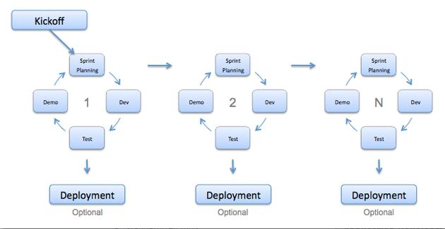

**Figure 2 – Diagram to the Agile process.**

To see our initial agile process plan before our development, **See Appendix 2**.

With the Agile process our software will be developed in incremental, rapid cycles. This cycle results in small incremental changes with each release being built on the previous functionality. Each release will be tested with the same consistency and thoroughness to maintain software quality. At the end of a sprint retrospective we should have identified and committed to a practical number of process improvement actions that will be undertaken in the next sprint. (Rubin 2012, p. 20-28). To see intermediate agile process designs, **See Appendix 9**.

Agile participants

Our agile methodology requires us to involve three participants into our software development cycle. There is a selection process to get the suitable participants, this is the criteria:

* Currently be involved with a society or sports team
* Cannot be a well-known friend
* They all must be from different years of study

This set of criteria will enable us to reach our full potential for the development process. The students whom are currently involved with a student group will have important knowledge and experience, they can use this to identify how is best to interest students into the student groups and how we can maintain the website keeping the students wanting to come back for more and feel a sense of remuneration, influence, belonging and significance (Howard 2009). There is a risk of bias and not truly identifying the key areas to improve the development if a participant is a close friend. It’s important to have a variety of participants from different year groups as they will provide a unique perspective for the development. In addition, students can give us a good perspective on how to heighten the level of interest in our student group website.

Our participants are three students of Southampton Solent University, Phoebe Pearson, Jamal Wiseman & Josh Dewitt. A first year involved in the Pole Fitness society, a second year involved in Team Solent football and third year involved in the Hockey team respectively.

The participants get involved with all three sprints where they test each requirement for the sprint and provide feedback after each one. There feedback gets used to re-develop the project eventually leading to the final prototype. To see the participants feedback on the website, **See Appendix 11.**

## 4.3 Soft-systems methodology

We used the ‘soft’ systems methodology (SSM) **See Figure 3**.

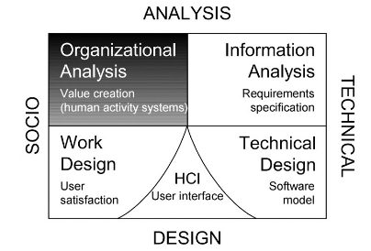

**Figure 3 - Organisational analysis – the systems perspective**

To see the Organizational analysis - The systems Perspective **See Appendix 3**.

In soft systems we organize our thinking about the world systematically, while recognizing that the perceived world is problematic. In some organizational setting the word “problem” can often have negative connotations, where people talk along the lines of having “opportunities” rather than problems. The phrase “problem situation” doesn’t mean to be a good or bad thing but instead encompasses an “opportunity” situation. In the context of SSM we will continue to use the term “problem situation” (Vidgen 2002, pg. 82-94)

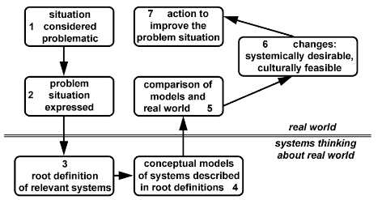

**Figure 4 – Seven-stage model of SSM.**

To see the Project plan, use the Seven-stage model of SSM **See Appendix 4**.

We created our own “rich picture” which includes all the people involved with using, creating and maintaining the website **See Appendix 10**.

In chapter 5 we investigate what website builder best suits our project and what all the plugins do for our website features.

# 5. System Architecture

## 5.1 How to choose a web builder

Back in the day, you either had to know how to code HTML, PHP, CSS etc or hire someone who had these skills. On the other hand, these days there are multiple web builders; they offer a service to develop a website using simple tools. They sort out the coding for you and offer thousands of templates that you can use to customize with text, images, sections, sidebars, navigation bars etc [16].

The factors we took into consideration when determining our web builder were: budget, capabilities and maintenance.

What is our budget?

Usually web builders are very cost-friendly, offering a basic plan as a free package or simply a free trial. Although these give you a lot to work with, you generally would have to upgrade at some point, whether that be paying a subscription fee or an up-front package deal which scales up with the size of the website. This upgrade would usually grant you with premium features, themes & plugins, advanced SEO tools, support, add-on services such as web hosting and more [17].

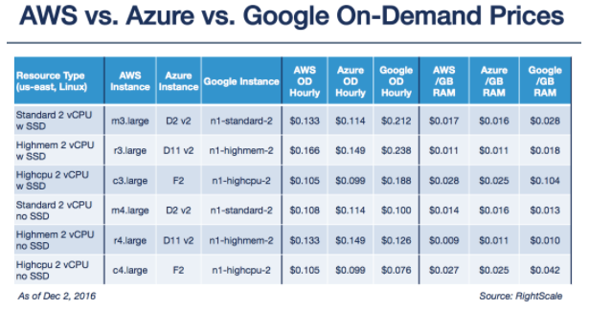To determine our budget, we take into consideration that we are building a prototype. To use all the free plugins to create our functionalities, we can download a CMS for free with Bitnami for example. But to host our website on a server we will need to connect to a web service, and these usually cost a monthly-fee (Weins 2016). The three big hosting services are AWS, Azure & Google Instance Types. **See** **Figure 6** for a side-by-side comparison for the prices on offer. Overall, Azure has the lowest price for 6 scenarios meaning its regarded slightly the cheapest service.

**Figure 6 – Comparing on-demand compute pricing: AWS vs Azure vs Google Cloud**

What will the site look like?

CMS’s offer users a variety of custom templates and themes which give you great opportunity to easily and quickly design a web site. The down-side is you will reach a glass ceiling, in other words you will be restricted in terms of being creative with your design. If you are looking for a template or theme that is exclusively unique and never been used before or that’s completely customisable from the ground up, then you might want to consider creating a custom site with static HTML manually structuring and developing code.

Due to time-constraints we opt to use custom templates and themes, with the vast amount on offer we can assure we find some that suit the features and functionalities of our website.

What will the site be used for?

The design themes and templates the web builders offer, cover all types of website types and industries including e-commerce, blogs, events and more. Once you identify the purpose of your site, then you can decide on what web builder is best suited for you.

Our website is a social platform to build a community around following student groups and providing blogs on the latest news. WordPress offers tremendous plugins that can assist with achieving these features, they are easy to use and maintain.

Who should be designing & maintaining the site?

Web builders are a great tool for people with little to no experience in coding, especially if they want to create and make their own changes and not wanting to hire a professional web developer. Furthermore, they are ideal for people that want to get the website initially setup by a professional then can have anyone update the site further on down the line.

Even though we have experience with HTML, PHP etc we still want to challenge ourselves with using a CMS plus this will give us a new skill to learn. Also, the main reason to use the web developer is for maintenance as we need an easy to use web editor for those who need to update parts of the website [18].

## 5.2 Static HTML vs Dynamic CMS

Initially, there are two ‘paths’ that come to mind; hand coding the website or using a content management system. The most important decision to make is to decide how you want to design and manage the content on your site. If your aim is to simply convey a web presence, then a simple site will be tailored to your need, thus, a HTML-based website may be a perfect solution. On the other hand, if your aim is to build a website that is planned to have frequent updates and changes then you are better off going down the CMS-driven route (Hafling 2013).

**Figure 7 – HTML back-end vs CMS back-end**

HTML was developed as a standard page formatting language of the internet. To further enhance the webpages additional languages/features such as PHP, JavaScript, CSS and more were included to work in conjunction with HTML pages. The addition of these languages meant it raised the bar for the overall complexity a user can create a website boosting the users experiences, this skill does require a professional specialist coder/programmer to create and maintain the site.

These days the average business person simply doesn’t have enough time on their hands to require expertise in learning these languages, therefore they call upon a highly skilled web developer. If you are looking to build a website from a clean slate, then it’s going to end up becoming an expensive outlay and take even more time to update/maintain. Not to mention, individual pages rely on each other so if you are to make change then it’s very likely you’ll have change multiple pages (Provost 2010).

A content management system is an application that allows you to create a web application managed using an admin panel. As we have mentioned recently, CMS can significantly reduce the website implementation and costs whilst enabling the ability to change and update features. You can use a CMS with having little to no knowledge, so you can see why it’s so appealing especially when you consider how the system programs are intuitive and east to use tools (Amberd 2017).

**Pros of static HTML**

1. Full creative flexibility to customise code
2. Pick and choose what coding languages to implement
3. The ability to use your imagination and create some original content
4. Use code and design-view content editors
5. See all code on one page
6. Complete control, greater understanding making it easier to identify where a problem lies in the code

**Cons of static HTML**

1. Time consuming to change content/page elements
2. Big risk of breaking an entire page
3. Need considerable technical coding knowledge
4. Time consuming to build from scratch
5. The cost will be great if you hire a professional even for the smallest tasks

(Ross 2013)

**Pros of dynamic CMS**

1. You can change content frequently without having to learn to code.
2. Installation is very quick and easy, and the learning curve is minimal
3. Can change content/page elements quickly
4. Easy for database integration
5. Thousands of templates/themes
6. Easy to manage content
7. Provides a database for the website, i.e. connects to mySQL.

**Cons of dynamic CMS**

1. To use advanced features, you will most likely have to pay for a package
2. Restrictions for design when using themes
3. Open-source and web-based
4. You will need take time to learn the CMS technology

You will need an understanding of the concept of plugins and how they are best used to fit your needs

The plan of our project is to have further updates, changes, and new features after we complete our prototype, for this reason a CMS will be perfect as we can use multiple plugins to ‘do the work for us’ so to speak, furthermore these plugins provide the content creator/editor a clear backend interface to change/improve features & functionalities.

We want to have the freedom and control of the website and not have to rely and spend money on web developers to make changes to the website. WordPress will be the best choice for this, thus we can make changes any time.

You will be able to be part of a global community of WordPress to manage an online presence, with access to free themes, plugins, resources that are constantly evolving to maximise user functionality.

Coding a static HTML page will come with its errors which will cost you valuable amounts of time which could be just a simple one-line code fix. In contrast, a CMS will tell you where the error is thus you can easily change the variables and settings within plugins, and not to mention you barely run into any errors with CMS.

A massive benefit to using a CMS is they all provide a database with the website, so you haven’t got to manually set this up yourself. It will just have it set up, so the content creator can have data saved.

## 5.3 WordPress vs Wix

There are dozens of content management systems, but to simplify we have narrowed it down for the interest of time to just two Wix and WordPress.

We will be breaking these two CMSs into three categories:

1. Flexibility
2. Design and layout
3. Pricing policy

### 5.3.1 Flexibility

WordPress is an open source platform, this means their codes are open for everyone to use and modify. Any coders can create their own plugins and themes, but this can be a potential problem. This means the quality of these tools could be either rubbish or fantastic.

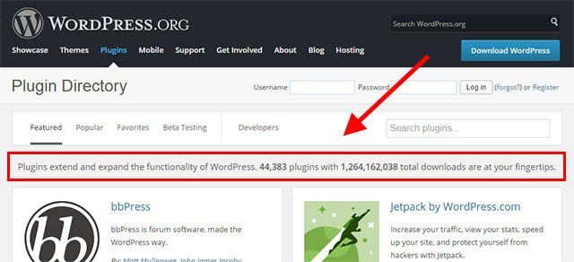

**Figure 8 - How extensive the WordPress community is**

A leading WordPress company, called Securi conducted a recent study of over 11,000 hacked websites (Mcleod 2017). In their report, they suggested a finding that studied 11,000 hacked websites, with 75% of them being created with WordPress.

On the opposite side of the spectrum, Wix isn’t an open source platform so their codes are not available to be modified. This means only their own private development team produce these building tools.

The vital concern with WordPress is not all its web tools are created by skilled developers therefore these poorly built tools could potentially crash, slow down, or cause conflicts.

If something like this did happen then there may not be anywhere to look for support and the plugin developer might not help.

With Wix, due to all their tools being tried and tested by their developers you are guaranteed to not run into any problems and they provide good centralized support functions.

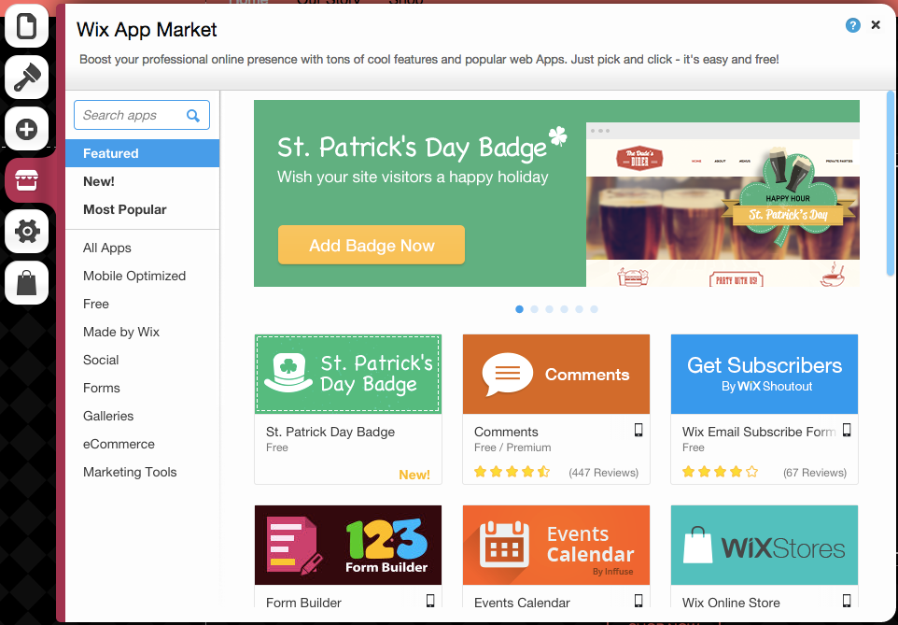**Figure 9 - The Wix AppMarket**

### 5.3.2 Design and layout

Wix comes with more than 500+ pre-made templates to choose from. All the designs are fully responsive. They offer built-in tools for you to use to customize layout and design. One down side is once you select a template then you will not be able to change it, once its selected that’s it, but you can modify and change it from using the built-in tools.

WordPress offers thousands of free and paid themes. The free ones usually will offer minimal support, but never the less they do go through a strict review process. Alternatively, the paid ones offer premium support options and advanced features.

WordPress has a deeper scope of themes and design layouts compared to Wix. Moreover, WordPress users can switch between themes/templates whenever they chose too without being restricted (Editorial Staff 2016).

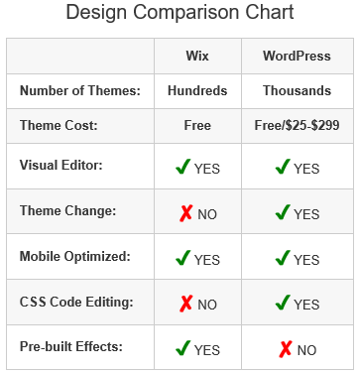  
**Figure 10 – Design comparison chart**

### 5.3.3 Pricing policy

WordPress, the CMS itself is free. If you want to couple this with publishing the website, then you will have to purchase a hosting plan package. To give some actual numbers, it is estimated to cost £5 - £8 to setup hosting per month.

Wix however is known as a ‘freemium’ web builder. You are given the capabilities to create and publish an ad-supported website using a free account. If you decide to upgrade then there are various payment package options, ranging from £3.5 - £18 which come discounted if you decide to pay up front annually (Steele 2017).

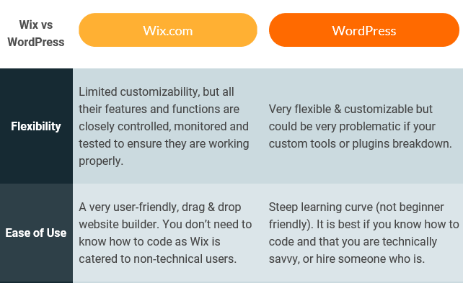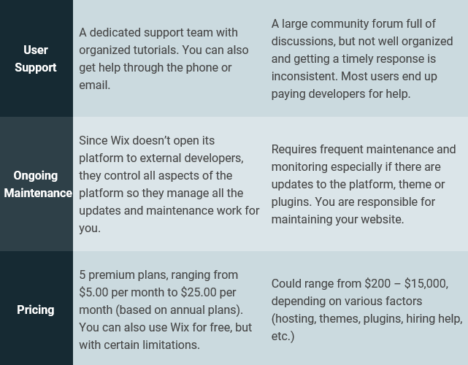

**Figure 11 – Summary table Wix vs WordPress**

### 5.3.4 Evaluation of chosen CMS

Ultimately, our decision was far weighed heavy on one side that being WordPress, when it comes to the WordPress vs Wix. Here are reasons why:

* It allows users to customize all aspects of the website from editing the code in a plugin to customizing themes
* There are hundreds of tutorials, articles and guides on how to use all themes & plugins, these can help speed up the learning curve.
* Even though the user must take security issues into their own hands, they are provided with the tools to do so
* We can use more advanced features making our site very complex in functionality.

You can argue it is easier to use Wix as you can throw together some tools and have the site up and running in no time, although you save more time this way we have a long development time frame therefore we can afford to take the time to learn WordPress.

Although there are a lot of ‘useless’ plugins, we can just ignore them and chose the more high-end plugins. We will know this by looking at the plugin ratings and reviews, if they are usually over 4/5 stars then you know they will be beneficial for you to use. With the abundance of tutorials/videos on the internet you can be sure to pick using theses plugins with ease.

WordPress currently accounts for over a quarter of all websites globally. As a result, many users are already familiar with this CMS, therefore not a lot of staff training will have to be conducted when building a new website.

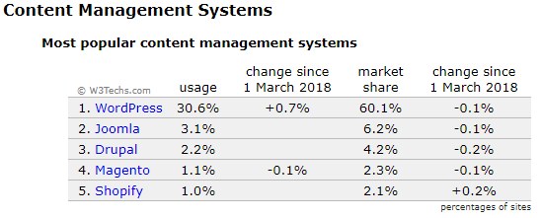

**Figure 12 – Most popular CMS’s**

Open source, with over 50,000 WordPress plugins to choose from your customization capabilities are endless, whether you want to customize the code of an existing plugin to benefit your needs or you completely code a plugin from scratch making it your own.

Low setup and maintenance cost, according to DeviousMedia WordPress incurs less maintenance and customization costs compared to other open-source CMSs. Additionally, you don’t get restricted like a static HTML site or proprietary CMS that costs to make changes after the initial development [19].

MySQL is a database management system that is used by WordPress, is uses the CRUD functions for website information. It runs as a server and allows to create and manage multiple databases. MySQL stores and retrieve all data including post content, custom post types and user profiles. WordPress uses the PHP programming language, it runs SQL queries to dynamically generate data [20].

Picking the right price planning can be tricky, WordPress comes with three payment packages. The three packages are personal, premium and business, £3, £7 and £20 respectively, each month. The cheaper deal £3/month is an ideal package for us to build our prototype, but the downside is that it must be a one payment yearly fee up front. This would add up to £36, but we want to keep our costs to the bare minimum when creating the prototype.

Bitnami

The alternative to using one of these payment packages, is to use Bitnami WordPress Stack which provides a one-click install solution for WordPress. It downloads a virtual machine and installers, so you can be up and running in no time.

Developers and users will have to install and configure WordPress locally, the multiplatform, open-source server/database/programming languages combination sets you up for development.

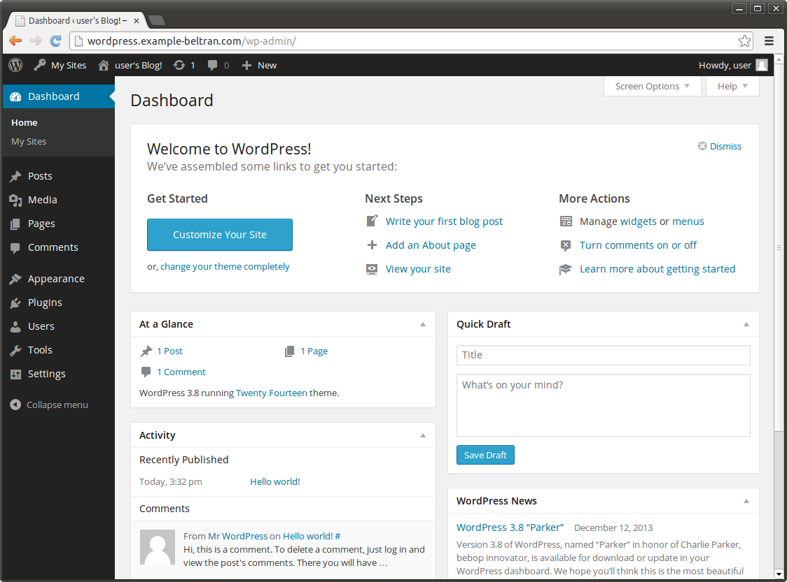As the WordPress application will be run locally on your machine, you will have to open it from a Bitnami admin panel window where you will be presented with the WordPress dashboard. This application presents its users with all the tools you would have if you were to go with the payment packages.

**Figure 14 – New WordPress 3.8 dashboard**

To see a diagram of the overall system **See Appendix 12.**

### 5.3.5 Choice of plugins

WordPress plugins are software tools that can be uploaded to extend and expand the functionality of your WordPress site. There is an abundance of free plugins available in the plugin directory, and for more advanced plugins you can go for the premium or paid ones if necessary.

You may ask yourself why I would pay for a plugin when there are so many good free ones to choose from, well paid plugins usually offer a full support service managed by a development team. They maintain compatibility and security of plugins with the latest version of WordPress, as well as the compatibility between plugins and themes.

When you start to use multiple plugins together then sometimes they conflict with each other and cause crashes and errors, so it’s good to know you have a support team that can always solve your issues with the breadth of their knowledge.

SportsPress

This plugin pretty much covers all aspects for the sports side-of-things in the website. You can create a fully configurable club, league section. Provides sports tools including automated standings, fixtures & results, player rankings, and individual profiles for clubs, players and staff.

This is a great to use for a professional team who like to maintain their statistics and information online. You can setup a whole league with each team and give them identity with a badge, stadium and list of all their players and staff. You can then setup events (matches), so you can have a schedule displayed in a calendar, so people can look at upcoming fixtures.

It comes with a custom theme which displays all the features in a very user-friendly manner, and really gives the look of a sporty website.

Elementor

Elementor is a great live page builder, the sky is the limit in terms of design. This page builder offers a plethora of creative page designs and advanced capabilities.

It has achieved being an instant reaction tool, using a drag-and-drop system, with instant live edit and page load.

We use Elementor to build all our pages on the site, our home page is heavily used by this building tool. We also use it for our blogs page, and then the rest of the site is put together with short code and widgets.

BackWPup

This plugin is a very important one, this backs up your whole installation including wp-content and pushes them to an external backup service like DropBox. A simple backup .zip file is used to make restoring your installation easy. You can setup a specific backup to trigger every so often i.e. every week.

This is very vital for a project, just in case your site crashes you can restore one of your recent backups. Let’s say you have a few people that change and update the site, and somebody makes is huge mistake then you can just restore one of your backups.

All-in-one WP Migration

This plugin helps host your website, it exports your whole WordPress websites including media files, database, themes and plugins. We have used this plugin, it retrieved all our files from our WordPress on our local machine, and then inserted them into our hosted WordPress site on AWS.

BbPress

This plugin is an open-source forum software, it makes easy to add a forum keeping it extensible and simplistic for WordPress. It provides short code, so you can have the forum anywhere in your site, it provides us with a login system where users can login. The login system exists so you can comment or write a post, also there is a forgotten password and register functions that work with our email.

Google Analytics for WordPress by MonsterInsights

This plugin means there’s no need to hire a developer to add Google analytics to your site. Google analytics allows you to see how users find and use your website, so you can improve it, so they keep coming back.

From our Google analytics dashboard we can get real time stats with demographic and interest reports to get a better understanding of our audience.

Recent Post Widget with Thumbnails

This plugin provides custom and flexible recent posts, which can be displayed via short code. You can display recent posts with a thumbnail from the featured image of the post, also additional information like date and author. We use this plugin on the right sidebar on our blogs page, it displays our recent posts with thumbnails.

Easy signup

This plugin provides a simple sign up form, the user enters their details which gets sent to a chosen email. We use this on our student groups signup page, the user scrolls to the bottom of the page to sign up.

MailPoet

This plugin acts as a friendly reminder for blog writers, it has been setup to send out a weekly email to the writers of the website reminding them to write a blog/article. This is setup to remind writers every week to write for our site.

To see a list of all plugins used on our website, **See Appendix 13.**

In chapter 6 System Features we are looking at how to use the features of our website and explain the benefits of each one.

# 6. System Features

When planning out our project we had some initial ideas for features, throughout the development stage we kept a few of these ideas as well as scrapping some. During this process some of our features evolved as we learnt more about plugins, ending up with a set of features we are very happy with. Our system features will be used by the students, we explain them below.

The following sections describes implementation for our website which you can see at <http://54.246.253.236/>

## 6.1 Society/Sports team information and signup

One of our main focuses to our project was to implement an online signup system for student groups in Solent University. On our Home page the users can select their desired student group, where they will be presented with a page with all relevant information, then at the bottom of the page there will be a signup form. They input their email which gets sent to the head of societies email, where they can verify the user is a student of Solent University, then subsequently will be sent a signup email response.



We use the Simple Signup Form plugin for this, this is ideal due to the fact there are multiple student groups heads, so with this plugin we can manage what emails get sent to. This feature speeds up the current signup process, so students don’t have to physically go into the University to fill out forms.

## 6.2 Sports statistics and information

This is the feature with the richest content, we wanted to provide a platform for students to view their team’s performances, not only but also their own individual performances.

This whole section was implemented through the plugin SportsPress. As we are building a prototype we focused on just Team Solent, this can be expanded to more teams if further work was undertaken.

Users can view their teams progress with a weekly updated league table over the course a season. They can view the teams set of results and upcoming fixtures, these are clickable then subsequently display to the user the date, time of event and google map view of where the game is being played at. Not to mention those matches that have been played display detailed analysis for what half the goal was scored in as well as who scored and got disciplined.

Furthermore, there is a countdown clock for the teams next match, as well as a calendar to display all matches in that month and a widget that displays all results from the current match day.

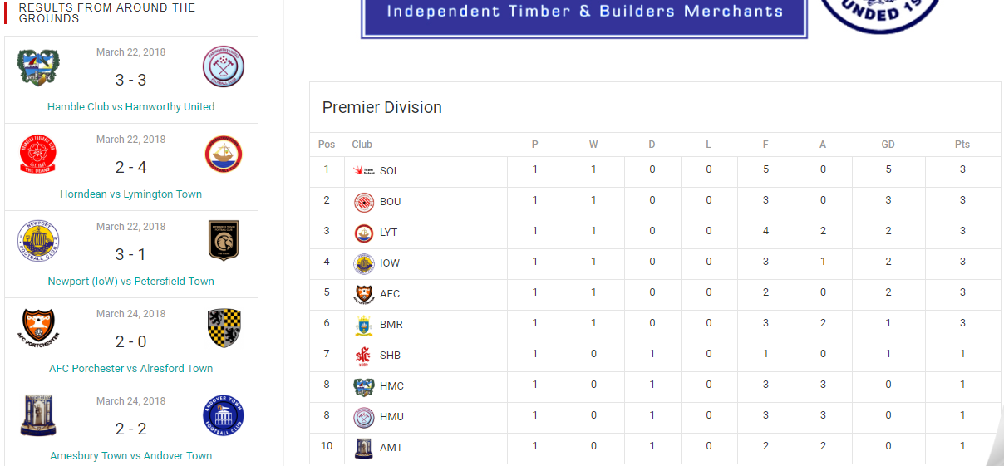

## 6.3 Student groups blog and news

We wanted to have a page that just focuses all relevant information and news regarding student groups, this is to give the user interest with what is going on. We provide blogs on sports team progress, society events, and current facilities. We have the SolentSU Facebook page linked up to keep up to date with their latest posts, likewise an RSS feed that displays recent news regarding the university.

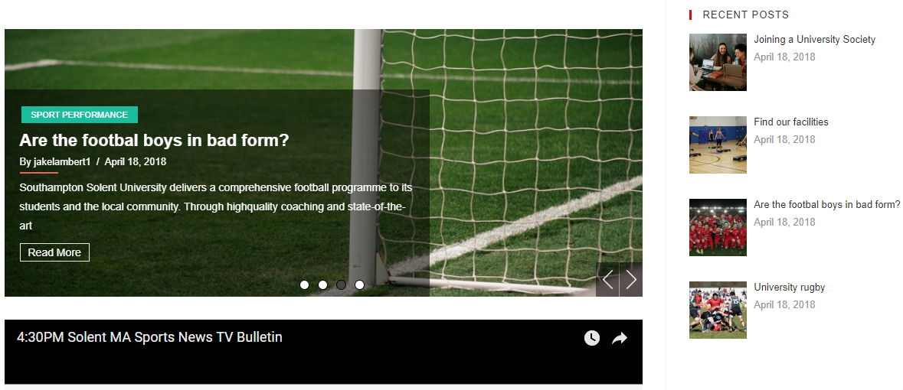

## 6.4 Forum social

Granted we have provided features for viewing the goings on in the student group stratosphere, one of our other goals was to get students involves socially and give them a sense of community, belonging and significance (Howard 2009). These values will be a major cog in our wheel to building an online community, thus we setup a forum where anyone can sign up and create a topic of discussion or comment on an already existing topic.

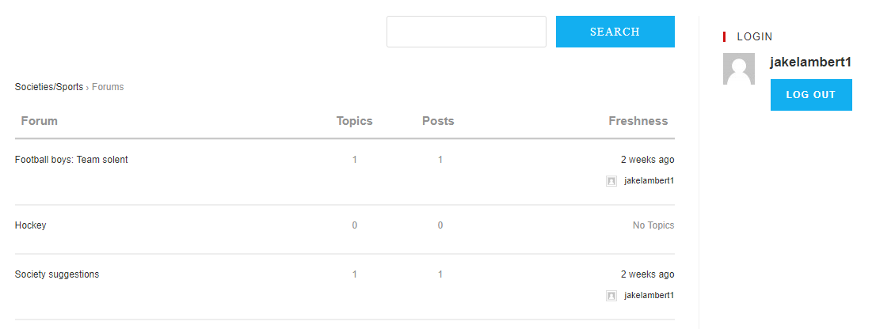

The plugin we used was bbPress, the user will have to have an account to contribute in the forum section. There has a register page already setup, as well as a forgotten password page. Students can contribute to changing the way student groups are run for the better, again giving them the feeling of having a significance in the community.

In chapter 7 we will discuss how the back-end of the website works in terms of updating data, adding and managing content etc. Furthermore, we will highlight the roles within the website maintenance and identify what people can be assigned these roles.

# 7. System Management

The launch is the crucial first step in any website journey. But to make the website succeed and grow we need to consistently update, improve and contribute to the site [21]. It’s important to have a website management plan for the long-term growth stages of the site (Cunliffe 2000). We have broken down our website management plan into the four main sections of our website.

## 7.1 Societies/Sports

On the Home page the user is presented with the student groups of Southampton Solent. We have used a 2-tab system widget to separate Societies to Sports groups, this widget was part of the Elementor plugin. Each image is linked to that student groups information/signup page. Furthermore, to maintain this page you can simply add & delete student groups and keep information up to date.

## 7.2 Performance

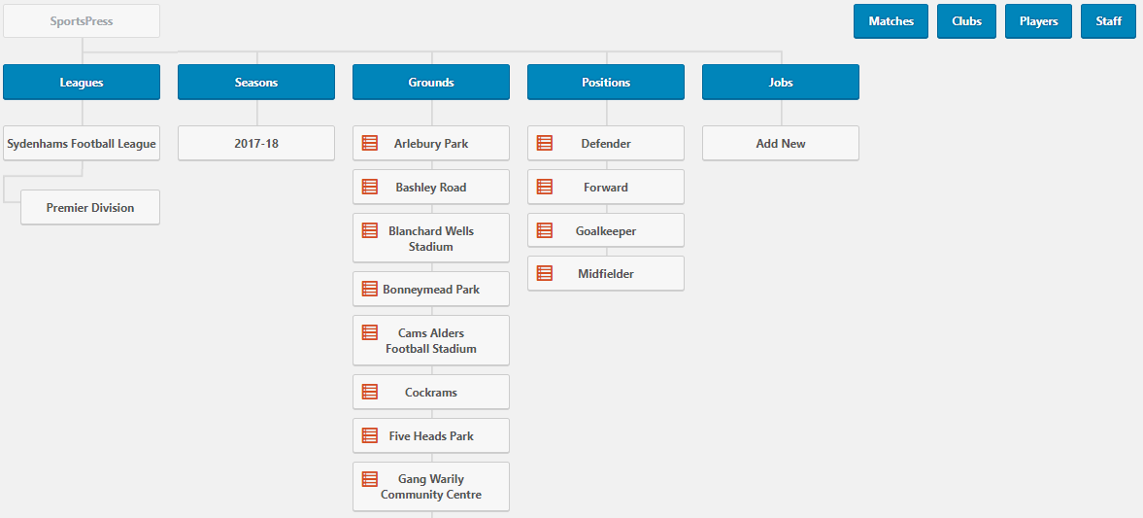This section includes leagues, match events, clubs, players and staff **See Figure 14** for overview of setup. We have created the league according to the official Sydenhams Football League (Wessex) [22], this is the league where Team Solent compete. We have included all 22 teams, each have been assigned their official badge, ground and abbreviation.

**Figure 14 – The back-end overview for the SportsPress plugin**

To setup a match you create an event, on the event page you can add a range of details and statistics about the match **See Figure 15.**

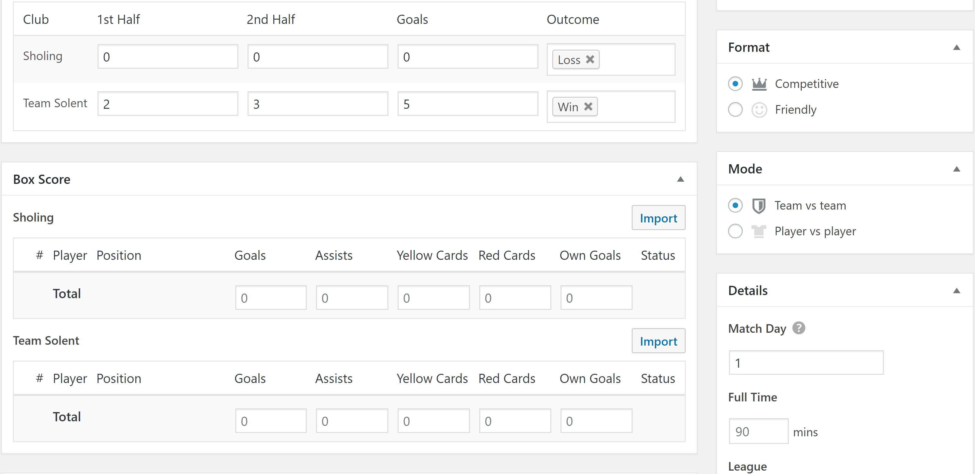

**Figure 15 – Creating a new event in the SportsPress plugin**

To create and maintain leagues the SportsPress plugin has everything you need, it gives you the option to choose a sport then will populate the back-end setup according to the chosen sport.

Each sports team will have their own private login details, where they will be able to fill in their match event details and statistics.

## 7.3 News Blogs

This whole page is very easily maintained, we use plugins and widget to format the page, so you will only have to edit the content from the widgets. We use Recent Post Slider plugin at the top of the page, you can choose what blogs/posts you want to display in the slider. Further down the page we have a YouTube video, which is just a simple URL link, but we have a YouTube plugin where you can embed a YouTube channel by generating the API key for that channel.

On the right-side bar, we are using three widgets, one to display recent posts, one that is linked to the SolentSU Facebook page and lastly an RSS feed displaying recent Solent university news.

## 7.4 Social

This section is managed by the bbPress plugin, you can simply add and remove forum posts from the back-end menu and manage the comments. This section sort of manages itself as the users are the that are writing the forum posts and adding comments.

## 7.5 System administration team

As the website will be updated and maintained we need to devise a team and assign roles. We can break this down into site maintenance and site contributors. Having a good-looking and well-run professional website is a great way to say something about the quality of your organization (Dobrien 2013).

### 7.5.1 Common Maintenance Protocol

Maintenance and protection is a key factor as you may become susceptible to being hacked [23]. A person with a high level of technical knowledge can fulfil these roles:

|  |  |
| --- | --- |
| **Roles** | **Explained** |
| Regular website backups | These don’t have to be frequent, just make sure the website is backed up in a safe location after any updates. |
| Plugins and themes up to date | You can become vulnerable if you don’t keep these up to date, WordPress will usually notify you when an update is needed and will only take a few minutes to update. |
| Run database sweep | Over time your database can become crowded and unorganised, you can find plugins that solve this problem. |
| Use complex passwords | The more complex the harder they are guess. |
| Use firewalls to protect admin directories | Firewalls are a barrier to stop your site being hacked, you can find plugins that limit the amount of login attempts allowed |

### 7.5.2 Marketing Strategies

Due to the nature of our website, it is important to keep content up-to-date. Over-time it is essential you keep on rolling out fresh content and keep users involved with social media frequently, so users don’t get bored (Niel 2011).

|  |  |
| --- | --- |
| **Roles** | **Explained** |
| Social media presence | These tools are used to build a community and can be a significant source of influence. SolentSU already have social media setup so we can work with them and keep the community in the loop. |
| Content marketing | This is essential to bringing value to the readers with content in the form of blog posts. We will need to manage what blogs to post, the blogs will be organized into categories. |
| Content creation | We will need to gather a few blog writers that will frequently write on a weekly basis. To ensure the weekly basis we use a plugin MailPoet which sends out an email reminder for them to write a blog. |
| Data content | The sports section needs to update regularly, so we will give each team their personal login, so they can update their match events. |

The main issue with maintaining a societies website in Solent is its too difficult to maintain and there was no previous structure in place for assigned roles to a management team.

We have come up a with an organized management plan, distributing roles to a team of staff members in Solent university.

The administrative role can be assigned to one of the head officers from Solent Student Union, they will suit this role as they will already have the knowledge of managing a big system.

The content creation role can be managed by a head publisher, someone from the Solent SU who has previous experience with managing the current SU website content. We can have student heads to write blogs and send them into the head publisher whom will decide upon publishing the blog.

The data content role can be staff members who manage the current sports teams in Solent, they can keep statistics up to date.

### 7.5.3 Continued Improvement & Optimization

You will need to build up a bit of traffic before you can start optimizing the website. Proper optimization is crucial to knowing what parts of your site your audience finds valuable.

There are some great plugins that allow for great optimization for instance Google Analytics. It can allow you to run content experiments, so you can optimize the site by modifying small elements. This role can be undertaken by one person whom has general website design knowledge.

The workflow for running this site is illustrated in **Figure 17.**

In chapter 8 we will be concluding this report with an evaluation of our objectives regarding the overall project. We will illustrate some recommendations, for somebody to take on further work for this prototype. In addition, we will express the learnings from this project and prototype limitations.

## 

# 8. Conclusions

## 8.1 Evaluation of Design

Meeting objectives

At the start of this project we set ourselves some objectives to achieve the aims of this project. Throughout the development of this project we managed to achieve our objectives some successfully and some unsuccessfully.

We conducted some solid research and interviews with society/sports heads, this was part of our primary research to gain knowledge on these student groups. We wanted to be able to gage how successful Solent University is in terms of student group participation, compared to another university that being University of Southampton. From our research we found out Solent have 20% less participation in student groups compared to UoS.

We wanted to create the foundation for our online community using the RIBS theory (Howard 2009). We tried to build our community on these values, we wanted the user to feel positive after every visit to the website so that’s why the plan is to have regular content updated weekly. Our forums page means the community can have a voice to translate their criticisms or compliments on student groups. In our evaluation we don’t believe there is a strong amount of belonging for the users. Our initial plan was for each student group to have their own page which displays upcoming training sessions and social events, this would have given users a better sense of an online community presence. By not setting up this page, it also meant we couldn’t give each student group significance amongst each other.

We used a quality CMS WordPress, this gave us all the tools to implement our features and functionalities. It saved us time and gave us skills when creating these features, also gave us the skills to combine features with certain plugins.

As we built a prototype there is no way to gage how to improve recruitment and retention to student groups, so this will have to be a done if this project was taken on as a full website. If Solent university built this as a full website that cooperated with the current Solent Online Learning website login system, then you can determine student participation through the online signup forms.

Plugins are ideal tools for putting together your ideas for website features. The plugin directory offers so many plugins that cater for pretty much anything. You can find some easy-to-use plugins that do not require any technical website knowledge therefore you can hire almost anyone to keep the site maintained. The cost will be nothing as they are mostly all free, although they offer a pro service, the free service usually is enough to provide good functionality.

We have provided some great recommendations for further work below. These were formed from the features we didn’t manage to implement due to time and skill constraints.

Problems encountered

Along our development journey we come across a few obstacles that got in our way, this gave us some real challenges, but we had the initiative to carry on and taught us some invaluable skills.

Firstly, a major challenge we faced was not having any experience with using WordPress, this seemed a daunting task to learn how to use it but as you start getting familiar with the CMS you learn along the way. It was hard to grasp the concept of plugins when we started building and how to benefit from them. We should have looked at a few tutorials first instead of developing with no knowledge.

One problem we encountered was a memory issue with WordPress, this occurred when we tried to load up our WordPress back-end setup, it wouldn’t allow us to load anything up for editing. We had to open our files in file explorer, we located a ‘wp-config.php’ so we can manually increase the size of the PHP memory limit. We increased the limit to 500m.

It would have been better if we used our project management plan we designed at the start of the project more effectively, if we would have worked to our set milestones then we may have designed our features with more creativity.

Would have been nice to adjust our specifications to build a central web page for each student group that would have had a chat function for only the students in that student group and display all relevant information. We didn’t manage to achieve this due to time constraints and having to make sure the other sections of the website were solid and full functional.

Agile process

This methodology was very beneficial for the development of this prototype. Each stage of the process was vital to us reaching our end goal. Our three participants helped construct our features in the project backlog, we used their ideas to have a wide spectrum of features.

From the list of features in the project backlog, we selected the best ones that would meet our aims & objectives. There were some nice ideas we didn’t pass onto the release backlog, this is because we had to make sure the features made sense and flowed well together with the navigation of the website, if we used every feature then there would have been too much going on, taking away from the main features of the site. In the release backlog we arranged the features by their priority and gave them each an estimated time to complete.

## 8.2 Future Work Recommendations

Due to limitations and areas of improvement within our project we have indicated the following areas of recommendations for work.

### 8.2.1 Updating sports results through mobile application using REST API

Instead of updating results on the website, we suggest creating a mobile application to update results. We can achieve this using the REST API. The recent update to the SportsPress plugin means it’s now compatible with REST API. You will need to install the WP REST API plugin, which gives you instant access to retrieve your data [24]. REST API enables you to create, update and delete existing data, this requires a bit more configuration, see guide[25].

### 8.2.2 OpenID login system

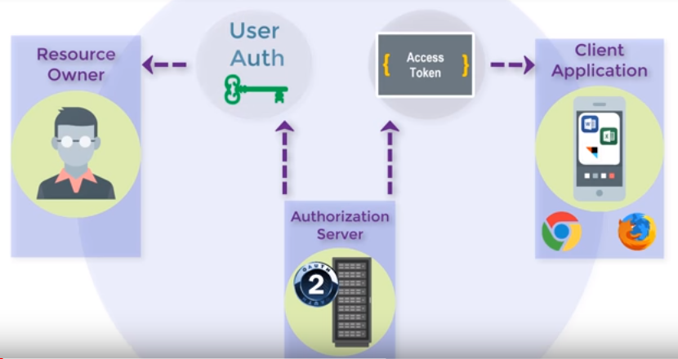Solent University could implement OpenID Connect to allow users logged into the university site to also access this website. OpenID provides an identity layer on top of the OAuth 2.0 protocol, it enables clients to verify the identity of the end user based on the authentication performed by an authorization server [26]. OpenID Connect also obtains basic profile information about the end user using REST APIs, OpenID Connect is needed because even though OAuth provides authorization it doesn’t provide authentication. **See Figure 16** for diagram.

**Figure 16 – OpenID Diagram**

### 8.2.3 Student group events & chat page

The idea behind this web page was to let student’s login with their Solent university login details, then will be presented with this page which will be based around the student group that student is involved in.

This page would display the student groups upcoming social, competitive, and training events so the student can easily keep to date with schedules. Another feature of this page could be a chat function, where students can communicate in a group chat about organizing social and training events or just simply used for socializing.

## 8.3 Learnings from Project

This project has illustrated to us how to use a recognised methodology to design a web community using widely known CMS WordPress. We have gained the knowledge in the build vs buy debate, its cheaper to build your own website plus you learn the technical side of using a website builder.

We saved time using plugins instead of raw code, the plugins gave us the capabilities to transfer our ideas into website features.

## 8.4 Prototype limitations

We know a prototype is a “sketch with interactions” to create a rough model of usability. Due to the decision to create a prototype, we ended making some restrictions when demonstrating features.

We only display nine societies/sports teams each on the Home page, this is just because we are only demonstrating simplified features for the prototype.

To demonstrate the student groups signup pages, we have only given access to two pages one for societies and one for sports teams, Drama & Performance and Athletics respectively. These are accessed from the SOCIETIES/SPORTS page.

On the navigation bar, the sub-menu from the PERFORMANCE tab also has only nine sports teams displayed. For prototype purposes we have demonstrated one page from this sub-menu, that being the Football page.

The Performance page has nothing displayed on it as we are only displaying the Football page as we are only demonstrating a prototype.

# 9. Reference List

ADAM, R., 2008. Defining changeability: Reconciling flexibility, adaptability, scalability, modifiable, and robustness for maintaining system lifecycle value. 11(3), 246-247

AMBERD, 2017. *Static HTML websites vs. Dynamic CMS*[viewed Apr 12, 2018]. Available from: <https://www.amberddesign.com/static-html-vs-cms/>

ANDREAS, W., 2001. Toward a Network Sociality. *Toward a Network Sociality,*18

BEENEN, G., 2006. Using Social Psychology to Motivate Contributions  
to Online Communities.

BELL, G., 2009. *Building Social Web Applications.*First Edition ed. O'Reilly Media

BIDGOLI, H., 2004. *The Internet Encyclopedia, Volume 3.*

BITNAMI, B., 2013. *WordPress 3.8 now available on Bitnami*[viewed Apr 25, 2018]. Available from: <http://blog.bitnami.com/2013/12/wordpress-38-now-available-on-bitnami.html>

COWIE, F., 2006. *How to Create a Successful Commercial Website.*First Edition ed. Straighforward

CUNLIFFE, D., 2000. Developing usable Web sites – a review and model. 10(4), 295-308

DOBRIEN, J., 2013. Putting Your Best Face Forward: Website Maintenance. 78(5), 54-58

EDITORIAL STAFF, 2016. *Wix vs WordPress – Which One is Better? (Pros and Cons)*[viewed Apr 01, 2018]. Available from: <http://www.wpbeginner.com/opinion/wix-vs-wordpress-which-one-is-better-pros-and-cons/>

ESCALONA, J., 2002. Methodologies to develop Web Information Systems  
and Comparative Analysis. *Information Retrieval and the Web,*3(3), 25-26

ESCALONA, J., 2004. Requirements Engineering for Web Applications – A Comparative Study. *Web Engineering,*2(3), 193-212

EWER, T., 2014. 14 Surprising Statistics about WordPress Usage. In: *managewp.*Feb 4, Available from: <https://managewp.com/blog/14-surprising-statistics-about-wordpress-usage>

FRENCH, A., 2011. Web Development Life Cycle: A New Methodology for Developing Web Applications. *Internet Banking and Commerce,*16(2), 4-5

FRIEDLEIN, A., 2001. *Web project management: Delivering successful commercial Web sites.*Morgan Kaufmann

GELLERSON, H., 1999. Object-Oriented We Application Development. *IEEE Internet Computing,*3(1), 60-68

GHAFOURIAN, M., 2009. Universal Navigation through Social Networking. *online Communities,*, 13-14

GRAHAM, M., 2008. Warped Geographies of Development:The Internet and Theories of Economic  
Development. *Geography Compass,*2(3), 771-789

HAFLING, J., 2013. *CMS vs. HTML*[viewed Apr 28, 2018]. Available from: <https://www.jayhafling.com/articles-for-seo/cms-vs-html/>

HOWARD, T., 2009. *Design to thrive : creating social networks and online communities that last.*Morgan Kaufmann

JACOBS, I., 2014. OPENSOCIAL FOUNDATION MOVES STANDARDS WORK TO W3C SOCIAL WEB ACTIVITY. In: *w3.org.*Dec 16, Available from: <https://www.w3.org/blog/2014/12/opensocial-foundation-moves-standards-work-to-w3c-social-web-activity/>

JONES, K. and P. FARRINGTON, 2010. Full-on Customisation with Themes and Plugins. 47(3), 16-17

JONES, K. and P. FARRINGTON, 2011. WordPress Cookbooks: Tips, Tricks, and Plugins. 46(3), 23

KIM, A.J., 2000. *Community Building on the Web: Secret Strategies for Successful Online Communities.*Peachpit Press

LEHMAN, A., 2013. Brackets Sprint 23 Build. In: Apr 12, Available from: <http://blog.brackets.io/2013/04/12/brackets-sprint-23-build/>

MCGEE, M., 2015. *WordPress Used On 25 Percent Of All Websites.*[viewed Feb 3, 2018]. Available from: <https://martechtoday.com/wordpress-used-on-25-percent-of-all-websites-report-151115>

MCLEOD, R., 2017. *Website Hacked Trend Report.*[viewed Apr 20, 2018]. Available from: <https://sucuri.net/website-security/Reports/Sucuri-Website-Hacked-Report-2016Q1.pdf>

MILLER, V., 2012. Understanding Digital Culture. 6, 4-5

NAILOR, M., 2017. Solent Sport Brochure&nbsp; *Reach New Heights,*

NIEL, B., 2011. Website essentials. 36(2),

NUNAN, G., *WixStores: the eCommerce Website Builder*[viewed Feb 5, 2018]. Available from: <https://www.blogtrepreneur.com/wixstores-ecommerce-website-builder/>

NYE, A., 2015. *Web Dev: CMS VS Hand Coding*[viewed Apr 12, 2018]. Available from: <http://ashleynye.co.uk/web-dev-cms-vs-hand-coding/>

O'NIEL, S., 2016. *Tips for Responsive Web Design Testing*[viewed Jan 1, 2018]. Available from: <http://blog.perfectomobile.com/responsive-web-design/responsive-web-design-testing-tips/>

O'NIELL, S., 2017. *What is Agile model – advantages, disadvantages and when to use it?*[viewed Jan 22, 2018]. Available from: <http://istqbexamcertification.com/what-is-agile-model-advantages-disadvantages-and-when-to-use-it/>

ORACLE LEARNING LIBRARY, 2017. *An Introduction To OpenID Connect*[viewed Apr 23, 2018].

OZOK, A. and P. ZAPHIRIS, 2007. *Online communities and social computing.*Illustrated ed. Springer-Verlag

PETERSON, C., 2014. *Learning Responsive Web Design: A Beginner's Guide.*" O'Reilly Media, Inc."

PREECE, J., B. NONNECKE and D. ANDREWS, 2004. The top five reasons for lurking: improving  
community experiences for everyone. *Computers in Human Behaviour,*20(2), 203

PRESSMAN, R., 2000. What a Tangled Web We Weave. *IEEE Software,*17(1), 18-21

PROVOST, P., 2010. *HTML versus Content Management System (CMS) Websites*[viewed Apr 23, 2018]. Available from: <http://www.6pmarketing.com/articles/branding-science/74-web-strategy/180-html-versus-content-management-system-cms-websites>

ROSS, 2013. *HTML Web Design vs CMS*[viewed Apr 10, 2018]. Available from: <http://icon-web-design.co.uk/html-web-design-vs-cms/>

RUBIN, K.S., 2012. *Essential Scrum: A practical guide to the most popular Agile process.*Addison-Wesley

SABIN-WILSON, L., 2013. *WordPress Web Design for Dummies.*2nd ed. John Wiley & Sons, Inc

SAVAN, P., 2011. Joomla, Drupal and WordPress - a statistical comparison of open source CMS. , 1

SAVAN, P., 2014. Comparative analysis of web security in open source content management system.

SOLENT STUDENT UNION, 2017. *Student Opportunities*[viewed Feb 1, 2018]. Available from: <https://www.solentsu.co.uk/get-involved/societies/find-a-society/>

SOLENT UNIVERSITY, 2016. *Our History*[viewed Feb 5, 2018]. Available from: <https://www.solent.ac.uk/about/our-history>

SOLENT UNIVERSITY, 2018. *Welcome Week &amp; Enrolment*[viewed Feb 6, 2018]. Available from: <https://www.solent.ac.uk/hello-uni/welcome-week-and-enrolment>

SOUTHAMPTON SOLENT UNIVERSITY, 2017. *Solent Sport*[viewed Jan 25, 2018]. Available from: <https://www.solent.ac.uk/solent-sport>

STEELE, H., 2017. *Wix vs WordPress*[viewed Apr 20, 2018]. Available from: <https://superbwebsitebuilders.com/wix-vs-wordpress/>

STEWART, T., 2010. Online Communities. *Behaviour & Information Technology,*29, 555-556

THE NATIONAL ARCHIVES, 1995. *Disability Discrimination Act 1995*Available from: <http://www.legislation.gov.uk/ukpga/1995/50>

THE NATIONAL ARCHIVES, 1998. *Data Protection Act 1998*Available from: <http://www.legislation.gov.uk/ukpga/1998/29/contents>

UK ESSAYS, 2015. *Legal Social Ethical and Professional Issues*[viewed Feb 5, 2018]. Available from: <https://www.ukessays.com/essays/information-technology/legal-social-ethical-and-professional-issues-information-technology-essay.php>

UNIVERSITY OF SOUTHAMPTON'S STUDENT UNION, 2017. *Student Union Calendar*[viewed Jan 28, 2018]. Available from: <https://www.susu.org/calendar/>

VIDGEN, R., 2002. *Developing Web Information Systems: From Strategy to Implementation.*Elsevier

*W3Techs - World Wide Web Technology Surveys*2018. [viewed Feb 26, 2018]. Available from: <https://w3techs.com/>

WEINS, K., 2016. *AWS vs Azure vs Google Cloud Pricing: Compute Instances*[viewed Apr 11, 2018]. Available from: <https://www.rightscale.com/blog/cloud-cost-analysis/aws-vs-azure-vs-google-cloud-pricing-compute-instances>

*What is a Website hack? Basic information to help webmaster block hackers*a. [viewed Apr 10, 2018]. Available from: <https://www.expiry.com/members/knowledgebase/142/What-is-a-Website-hack-Basic-information-to-help-webmaster-block-hackers.html>

*What is MySQL*b. [viewed Apr 01, 2018]. Available from: <http://www.wpbeginner.com/glossary/mysql/>

WONG, J., 2018. *5 Top Differences You Should Be Aware Of | Wix vs WordPress 2018*[viewed Apr 12, 2018]. Available from: <https://www.websitebuilderexpert.com/wix-vs-wordpress/>

# 10. Appendix

## 10.1 Primary Research Interview

Kirstie Guildford – Admin at Solent’s Student Union

Interview

1. How do students currently signup to a society?
   1. They must come into the Student Union and fill in some signup forms. There is no online signup.
2. I am creating a prototype that offers a platform for students to seek information on societies, socialize and view league tables, what do you think?
   1. Yes, I think that sounds like a good idea, currently the only way of finding information on Societies is by visiting the Solent Student Union website, also some societies have no information on their individual page.
3. How would you rate the current state of societies now?
   1. At this present time, we have 961 students currently involved in societies (the total number of members across all 47 societies – 3 new ones were just ratified). The society with the highest number of members is Sonar Film with 72 members. The number of undergraduate students this academic year 17/18 is 9807, so that means roughly 1/10 are currently involved in societies.
4. What is your experience working with societies?
   1. I was working at University of Southampton’s societies club, so I understand the magnitude of their student groups. I understand they have great groups setup with a big enthesis on student involvement. Now I have a job at Solent Societies, it is a mission of mine to increase the popularity of them here.
5. Do you have any suggestions for this website I am proposing?
   1. Yes, I like the idea of the focus being on connecting students, I would like to see this idea progress into a central hub where all students can login to and instantly start talking with current members of societies and yes it would be a great platform to setup extra training classes and social events.

## 10.2 The Agile process model

This is my interpretation of the Agile process methodology model.

|  |  |
| --- | --- |
| **The agile process model** | |
| Create initial website | * Design website to be functional * Produce a project backlog formed from my ideas and some ideas from my participants. * Produce release backlog formed from the project backlog. |
| Sprint 1 | * Full list of student groups * Setup a forum page * Setup a register page for forum * Matches as events * Login system to create topic in forum * Chat functionality |
| Sprint retrospective 1   * Call in participants * Integrate & test * Feedback review * Record & incorporate features * Change design & code accordingly * Adjust & track. Re-priorities features * Next iteration into development | |
| Sprint 2 | * Recent news about student groups * Display results & fixtures for sports teams * League tables update according to match results * Give sports teams access to only update their information * Create event page, for social events and training session * Make website fully functional on other devices |
| Sprint retrospective 2 | |
| Sprint 3 | * Detailed information for each student group * Google maps location for venues * Implement sports team members * Setup news page for published stories * Use an API to retrieve data from third-party websites |
| Sprint retrospective 3 & overall evaluation   * Review iterations * Assess the development of the features over each sprint * Compare the development website to initial planned requirements * Evaluate whether the website adheres to the project needs * Measure success of the project in the agile model | |

## 10.3 Organizational analysis - The systems perspective

The table is my interpretation of (Vidgen 2002) methodology on the Organizational analysis.

|  |  |
| --- | --- |
| **Organizational analysis – The systems perspective** | |
| **Organizational Analysis – SWOT analysis**  Strengths   1. One advantage is we already have a platform to build from, the Student Union website 2. Our unique selling point can be creating a platform to connect students together for social and competitive reasons 3. Our idea is unique, there’s no other website that does what we want to achieve.   Weakness   1. Lack of knowledge in creating a commercial website 2. We need to avoid implementing stats into our website, as this can become problematic 3. Having no experience with using a content-management system like WordPress   Opportunities   1. An opportunity to enhance the societies community 2. We are aware of the social events societies have each Wednesday 3. The Football sports team is one of the best in the country, producing young talent out of the Southampton academy.   Threats   1. Getting permission from the University to use their information on the site 2. Uni of Southampton have had far more years to establish their student groups | **Information Analysis**  Our website will be displaying a vast amount of information which will be broken down into:  Society/sports information   1. Signup fees 2. Overall description 3. Layout of events over academic year   Society/sports organizers   1. List of students whom help run the student group 2. The heads of the student groups 3. Coaches   Schedule of events   1. Weekly training sessions 2. Weekly classes 3. Social events   Sports league tables   1. Standings for sports teams 2. Top scorers 3. Tournament progress |
| **Work Design**   |  |  | | --- | --- | | Job demands | Job resources | | Work to the milestones set | Advice from current society students | | Fully functional prototype | Stimulate personal growth | | Recommendations for future work | Library with plenty of books for methodologies | | **Technical Design**  I will be the software architect and software developer.   1. The screen layout – This will be as user-friendly as possible, with clear navigation from screen to screen. 2. Software – Adopt Wordpress to be the content-management system of choice. 3. Coding language – We will be using HTML, PHP, JavaScript & CSS. 4. Database – We will use SQL to implement a database into our website. |
| **HCI**   1. Strive for consistency throughout the website so the user feels a sense of familiarity 2. Give users shortcuts, so the more they use the website the more they can reach their end goals quicker 3. Offer informative feedback and never have the user confused on where to go next 4. Strive for consistency, identical terminology should be used in prompts, menus, and help screens. | |

## 10.4 Seven-stage model of SSM

This is my interpretation of the (Vidgen 2002) Seven-stage model of SSM.

## 10.5 Survey Results

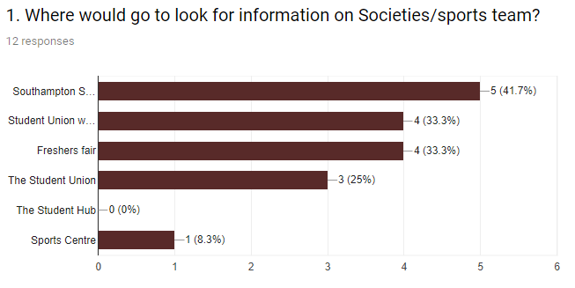

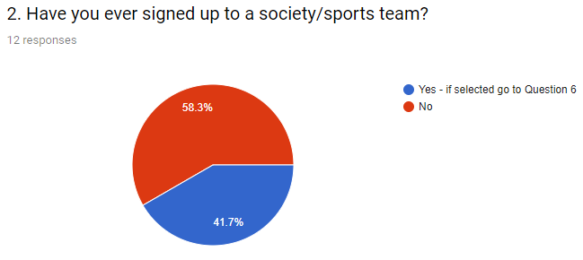

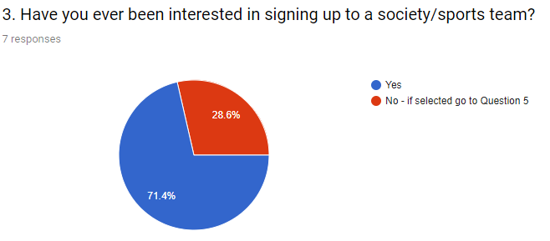

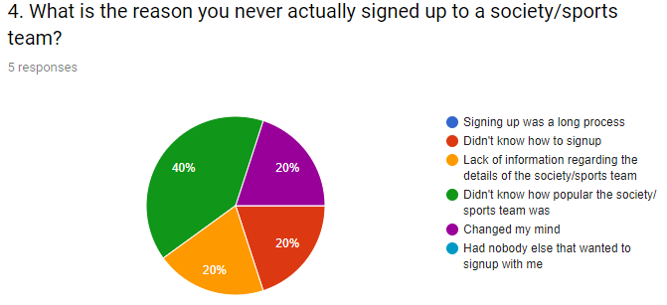

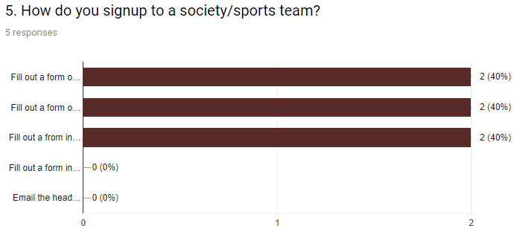

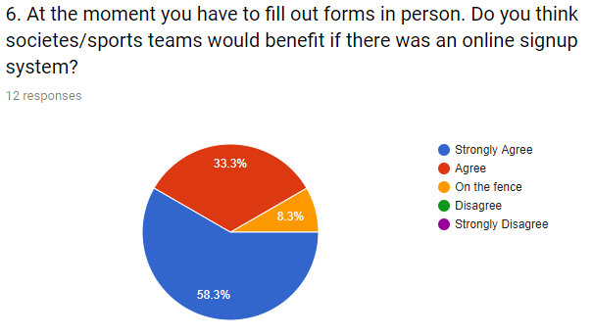

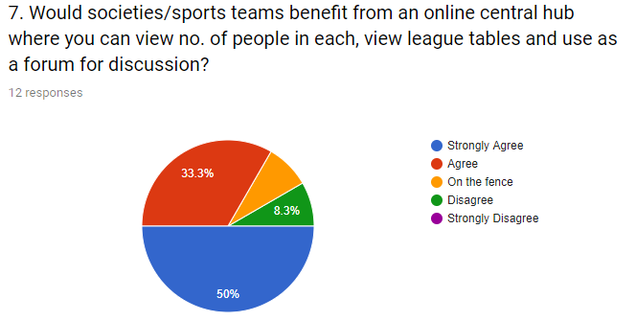

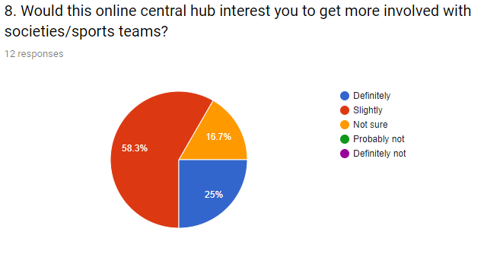

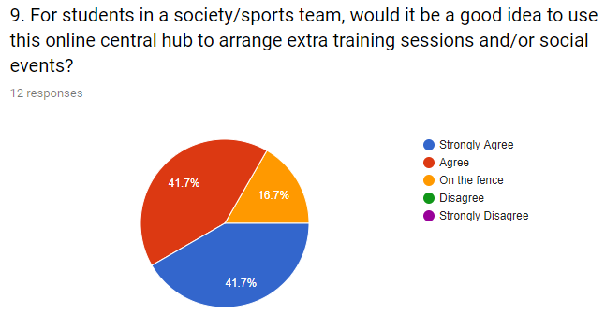

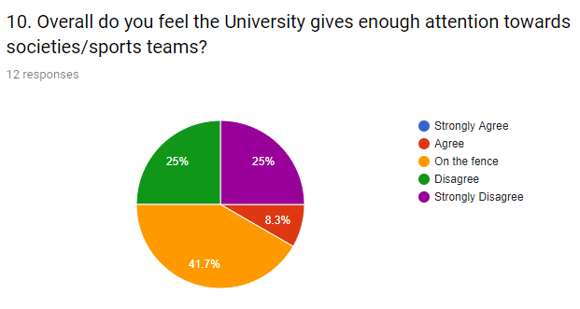

## 10.6 Primary Research

University of Southampton Students’ Union email from Daniel Thrower, Executive Office Coordinator

Hi Jake,

Hope you are doing well.

I was trying to put some numbers and percentages together for the number of students who are part of societies at the University of Southampton.

Societies are supposed to list their members on their online Groups Hub page, but unfortunately most societies just don’t list their ordinary members at all, only their committees. So, we have no accurate way of knowing how many students involved in our student groups are.

We have 340 groups in total and I would estimate that the number of students who are part of societies would be in the 6000-9000 range. We have around 23,500 students so I’d estimate a percentage of students who are part of student groups to be between 25%-40%. Please note that these are just rough estimates and should not be taken as official figures from our Students’ Union.

## 10.7 Risk register

|  |  |  |  |  |  |  |
| --- | --- | --- | --- | --- | --- | --- |
| **Category** | **Risk** | **Risk ID** | **Probability** | **Impact** | **Mitigation** | **Contingency** |
| Platform | Not understanding how to use Wordpress effectively | 1.1 | Low | High | Although I will start with no experience in Wordpress, I can spend 2 hours per day learning how to use it | Manually write out the HTML, PHP, and CSS code in the program Brackets, using my knowledge I’ve learnt in the last 3 years of my computing course |
| Platform | Not using the correct plugins to work with features & functionalities | 1.2 | Low | Medium | Do a lot of research for the popular plugins. When looking at one type of plugin also consider the other types and compare. | Adapt my features & functionalities to match up with the plugins that I can understand to use. |
| Project completion | Not enough time to complete project | 2.1 | Low | Medium | Spend 20 + hours per week on the project | Make sure the project is at least done to a good standard even if it is not complete |
| Project completion | Website not working | 2.2 | Low | Medium | Keep running tests frequently and save backups each time | Go back to a working backup |
| Research | Not enough content to fill out the 10,000 words | 3.1 | Low | High | Spend 10 + hours per week on research and document in the project library | Try my best to reach the word count without watering down my research |
| Research | Not relevant enough or trying to cover too many areas in the subject field | 3.2 | Medium | Medium | Make sure I have a clear idea in my head where I am heading with my project and try not to stray elsewhere | Try not to have all my sub-heading within the project disconnected from one another. |
| Survey | Results might not answer my hypothesis | 4.1 | Medium | Low | When picking my questions, make sure they all relate to the hypothesis | Re-write the survey and try to get responses again |
| Usability testing | Not being able to get participants to test website | 5.1 | Low | High | Ask participants a week or two in advance | Ask course mates or go into the library and people in person if they will test my website |
| My skills | My skills not being adequate enough to make a high-quality website | 6.1 | Low | High | Invest multiple hours per week on developing my skills, and learn new skills as well | Make sure at least there is enough research there to talk about proving I have invested multiple hours into this |
| My skills | Poor problem-solving abilities | 6.2 | Medium | Medium | Make sure to meet my supervisor Craig Gallen every week and email him when I come across a problem I can’t solve | Look at external sources for information and try developing my personal skill-set to resolve problems |
| Interview and discussions | Not being able to arrange any meetings with anybody | 7.1 | Low | Medium | Try arranging meetings early into the project | Keep on emailing various people |
| Project scope | Project creep | 8.1 | Medium | Low | Clearly define the project scope before starting and select a design production process | Try keep to the design production process |
| Project features & functionalities | Not having the skills or knowledge to complete all features planned on website | 9.1 | Medium | Medium | Ensure I have the skills required to create the features | I’ll have to leave out these features in the website |

## 10.8 Gantt chart

## 10.9 Agile Process Methodology

**Project backlog**

**Release backlog**

These are the user stories we wanted to put into the release.

We have prioritized the user stories, RED = High priority and GREEN = Low priority.

Each user story has been given an estimated time for completion.

**Planned 3 sprints**

**First sprint**

|  |  |
| --- | --- |
| What was good?   1. The forum on the Social page.   The login feature is ideal, as students will need to login using their University login to comment or write a topic.  Also, the register account and restore password features are very user-friendly.   1. With the OceanWP theme, this allowed us to add a submenu to the Performance tab through customizing menus. 2. The Football page which is linked through the Performance tab, is very well put together.   SportsPress is a perfect plugin, gives us the ability to add teams into a league along with their home ground and a badge, this gives the teams a sense of identity and legitimacy.  SportsPress offers great functionality for adding matches/events, furthermore the results of these automatically update the league table accordingly.   1. The Sport teams pages have a different theme, this give more of a feel towards a sporty vibe. 2. Navigation bar connects all the pages correctly and is very readable & understandable. 3. The layout of the Societies and Sports teams logos is nice, the 2-tab idea is an efficient way to display them. | What was bad?   1. The submenu in the Performance tab, presents the Sports team in a poor manner, forcing the user to scroll down to view all teams. 2. The Performance page is blank for the time being, we didn’t have enough time. Need to rethink the contents of this page. 3. On the Home page there are too many Societies and Sports teams displayed, especially if it is only a prototype. 4. Image carrousel on the Home page takes up too much of the page. 5. There is a blank space on the right side of the Football page. 6. Poor footer on the Social page. 7. No footer on the Football page. 8. Not enough options to go from the navigation bar. 9. The logo is basic. 10. At the moment, anybody can update results for a match. 11. There is no text on the images from the image carousel. |
| Ideas?   1. Lessen the number of Sports teams in the submenu to be displayed all on one page. 2. Add the Sports teams to the Performance page but display them in a grid layout to give the page an interesting look. 3. Match the number of Sports teams on the Home page to the amount in the submenu. 4. Also lessen the amount of Societies on the Home page to about the same number of Sports teams. 5. Decrease the height of the image carousel. 6. Add consistent footers to every page. 7. Add the ability to add news stories to the image carousel, which will display a heading for the news story. 8. Add a chat function so students within their groups can communicate with each other. | Actions?   1. For the overall prototype we will only demonstrate 9/10 Societies and sports teams. 2. Fill out the Performance page with pictures and logos in grid format for a nice design. 3. For the image carousel, use a publishing plugin to give writers the ability to write some stories to publish. We can use a plugin called blog in blog which can create a blog within a blog using a category.   Also, we can use a plugin called MailPoet Newsletter which can send an email to the writers reminding them to write a story.   1. Add another tab to the navigation bar, one which will be a chat function for students within their student groups. With this they can arrange training sessions and social events. |

**Sprint retrospective 1**

**Second sprint**

**Sprint retrospective 2**

|  |  |
| --- | --- |
| What was good?   1. The decreased amount of student groups on display is more presentable, especially that we are only creating prototype 2. The sub-menu that displays in the navigation bar is more navigation-friendly, displays a correct number of sports teams. 3. The image scroll on the home page look slick, also you can now see the student groups logos without having to scroll down to see them 4. The countdown to the next match on the Football page is great 5. On the Football page, the section that displays all results from the current match day and the calendar displaying the fixtures is a great addition to the left side bar. Also, this page looks more user-friendly now it is using the same theme as the rest of the site 6. Good idea to have a news blog page 7. Logo links back to home page | What was bad?   1. The bright colourful logo doesn’t suit the navigation bar plus it doesn’t fit it perfectly 2. On the home page, none of the sports teams are linked to any pages 3. There is no way to sign up to the student groups 4. Could be clearly on the football page to let the user know it’s the Team Solent page 5. Add more blogs to the news blogs page 6. Still nothing on the performance page 7. Images are not displaying on the drama & performance page |
| Ideas?   1. Change the logo to match the consistent colour across the website 2. Make it so all the sports teams link to their own pages 3. There must be signup page 4. Give the Team Solent page more identity by changing the colours to match their badge 5. Add more sections to the blog page, maybe implement a side bar and display some of the Solent University’s social medias 6. Add the parallax scrolling to the student groups pages to make them more interesting to view for the user 7. Add chat functionality to the social page | Actions?   1. Create a better design for the logo, make it consistent with the website colours 2. Have it so one sports team and one society link to their own page where users will find out more information on them 3. We can add a signup form to the student groups individual pages, this can send out an email with the information they’ll need to signup 4. On the blog page, create more blogs, implement Solent social medias, and add an RSS feed 5. Find out how to implement parallax scrolling to make the page more creative for user experience. 6. Implement more content to the social page 7. Show more information about Team Solent so the user will have a better interest viewing the page |

**Third sprint**

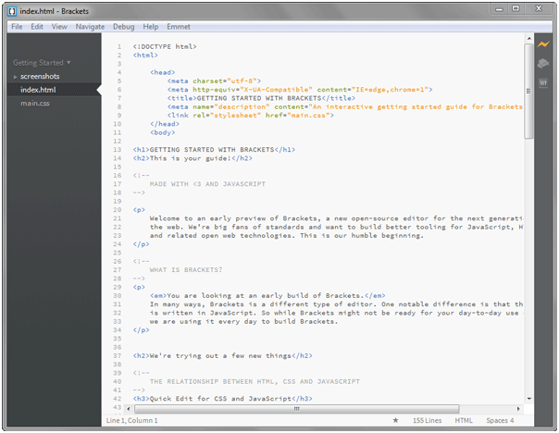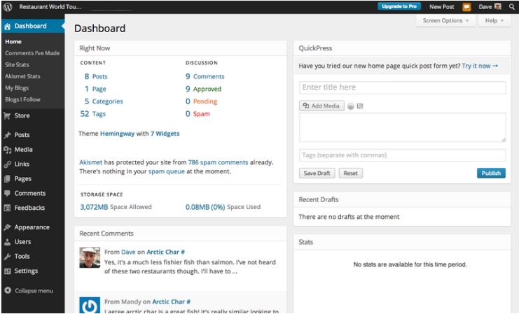

HTML

CMS

**Student groups website**

Central Hub



**Curious Student**

I want to look at what student groups there are

I want to see how many people are currently in a group

I want to sign up to a group



**Involved Student**

I want to see how my team are performing

I want to see when our next match is

I want to see top goal scorers in league

I want to post a discussion on a forum

I want to see latest news regarding my sport



**Website Creator**

What plugins will I need to implement features

How does the site need to be laid out?

What theme should I use?

What is my time frame?

Will the site be easy to maintain after launch?



**Maintenance**

Do I have enough technical knowledge

Are plugins & themes up to date?

Has the site been backed up?

Is everything running smooth?

Are the layouts still the same?



**Social media**

Are we releasing frequent content?

Is the content relevant?

Do we have a strong social media presence?



**Security**

Is our password complex enough?

Have we got firewalls to prevent being hacked?

Have we swept our database?

Is our data protected?

Regular website backups



**Writers**

What do we write?

Are we writing a blog?

What’s the recent news stories?

Is our article interesting to the target audience?

Is our article relevant to student groups?



**Head** **publisher**

Have we sent our weekly reminder to our writers?

Is the content sent in to a good standard?

Is it relevant?

Will students find an interest in the blog?

What blogs should we post to the site?



**1**

**2**

**3**



**Real World**

**Systems thinking about real world**



Full list of all societies and sports teams

Detailed info on the student groups i.e. Amount of students & weekly meets

Recent news involving the student groups

Calendar to display events happening each month

Display results & fixtures for sports teams.

Use an API to retrieve data from third-party websites, implement into website

Have league tables update upon updating match results

Only allow users from each team to only update their own data

At least have all the Solent sports team’s members on the website

Google map location for each venue a match is played at

Have a profile for each player from every team

Form tables and graphs

Matches as events displaying all the relevant information

Setup the news page to have publishers write the stories

Setup forum to discuss relevant topics within the student groups

Login system to comment or create a topic

Chat functionality for each sports team/society

Setup Facebook group to display photos, status’s, events.

Register page to comment on forum

Create event page, for training session or social event

Sell Solent merchandise

Have the website fully functional and navigationally-friendly on other devices

Add pictures and videos onto the match events page



1 Full list of all societies and sports teams

8 HRS

Detailed info on the student groups i.e. Amount of students & weekly meets

8 HRS

Recent news involving the student groups

4 HRS

Display results & fixtures for sports teams.

4 HRS

Use an API to retrieve data from third-party websites, implement into website

10 DAYS

Have league tables update upon updating match results

2 DAYS

Only allow users from each team to only update their own data

2 HRS

At least have all the Solent sports team’s members on the website

2 DAYS

Google map location for each venue a match is played at

4 HRS

Matches as events displaying all the relevant information

2 DAYS

Setup the news page to have publishers write the stories

5 DAYS

Setup forum to discuss relevant topics within the student groups

8 HRS

Login system to comment or create a topic

4 HRS

Chat functionality for each sports team/society

2 DAYS

Register page to comment on forum

4 HRS

Create event page, for training session or social event

2 DAYS

Have the website fully functional and navigationally-friendly on other devices

5 DAYS



SPRINT 1

Full list of all societies and sports teams

8 HRS

Setup forum to discuss relevant topics within the student groups

8 HRS

Recent news involving the student groups

4 HRS

SPRINT 2

SPRINT 3

Detailed info on the student groups i.e. Amount of students & weekly meets

8 HRS

Display results & fixtures for sports teams.

4 HRS

Have league tables update upon updating match results

2 DAYS

Only allow users from each team to only update their own data

2 HRS

Google map location for each venue a match is played at

4 HRS

At least have all the Solent sports team’s members on the website

2 DAYS

Register page to comment on forum

4 HRS

Create event page, for training session or social event

2 DAYS

Setup the news page to have publishers write the stories

5 DAYS

Matches as events displaying all the relevant information

2 DAYS

Login system to comment or create a topic

4 HRS

Use an API to retrieve data from third-party websites, implement into website

10 DAYS

Chat functionality for each sports team/society

2 DAYS

Have the website fully functional and navigationally-friendly on other devices

5 DAYS

**Estimated time: 5 DAYS**

**Estimated time: 9 DAYS, 10 HRS**

**Estimated time: 17 DAYS, 12 HRS**



SPRINT 1

Requirements

Full list of all societies and sports teams.

Setup forum to discuss relevant topics within the student groups.

Register page to comment on forum

Login system to comment or create a topic.

Fully working navigation bar connecting all relevant pages.

Setup the Performance page, implement league tables and results & fixtures.

Google map location for each venue a match is played at

Day 1

Day 2

Day 3

Day 4

Day 5

Day 6

Day 7

Requirement 7 was slightly late.



SPRINT 2

Requirements

Decrease the number of societies and sports teams

Also decrease the number of sports teams in the navigation bar

Change the size of the image scroll on the main page

Add more content to the sports page

Get rid of using a different theme for the sports page

Add a new blog page

Add a logo to link back to home page

Day 1

Day 2

Day 3

Day 4

Day 5

Day 6

Day 7



SPRINT 3

Requirements

Create a logo that follows the websites consistent colours, and fit the navigation bar

Add content to the Football information page

Add signup forms to student group pages

Create more blogs to display in the news blogs page

Implement Solent social media and RSS feed

Add sports teams to the Performance page

Add a countdown and calendar to Team Solents page

Add recent posts widget to blog page

Add a video to the blog page

Day 1

Day 2

Day 3

Day 4

Day 5

Day 6

Day 7





**Sprint retrospective 3**

|  |  |
| --- | --- |
| What was good?   1. You can leave a comment on every news blog 2. Inside a blog you also have suggested blogs to click on 3. Share feature on each blog to social media 4. Implement Solent SU Facebook page 5. Good use of recent post widget 6. Good use of video and the RSS feed on the blogs page 7. The Team Solent page looks sportier with more content for the user to view 8. Good use of displaying all results from match day on the sidebar 9. The calendar is very intuitive and organized 10. The signup page allows users to write in their details, then this will send automated signup application to the Solent email 11. Parallax scrolling adds to the user experience and makes it more appealing on the eye | What was bad?   1. The footers on every page are not consistent 2. Layout of content on the Team Solent page could be a bit more organized 3. The blog pages cold be better organized and designed more creatively 4. When you sign up on the website you can’t add a password 5. Each individual team has to manually add in data to their page |
| Recommendation for future work?   1. Use an API to retrieve data from third-party sites and implement into the league tables for example 2. Create an application where each team can login and updates their stats, this will update on the website 3. Add players and player profiles to the sports page with profile pictures 4. Have more content on the blogs page like events 5. Have a login system so students from their student groups can login exclusively into their student group page where they will have their own social events, training sessions, and chat functionalities | |

## 10.11 Participants Feedback

Josh Dewitt – Hockey Team – Third year of study

1. **Would students be interested in this website and why?**

Yes, I believe the current student involved in student groups probably won’t use it that much as they haven’t known there to be a website, but the new freshers would show a lot of interest.

1. **Could you see student using this website frequently?**

Yes and no, I think freshers would use it frequently if they were told about the website when they first arrive, so then they will thin it is the norm to use the website.

1. **Would student’s signup on our website rather than at the student union?**

Yes, I don’t see why not. As long as it is a simple 1 step process for them to sign up.

1. **Would students be bothered to discuss topics on the forum of this website?**

Yes, if they get used to using the website a lot then i can see them wanting to express their opinions, and what a great to do so.

1. **What benefits would students have checking results on this website compared to**

**the Syndenhams official website?**

The Syndenhams website doesn’t seem very user-friendly and looks like a very basic website. I think due to your sports page having a very nice layout and gives off that sporty vibe, then students will prefer to use it.

1. **Does this website have potential to build a strong online community?**

Yes, but I have a feeling it might take a long time to get every year group using it, maybe 2/3 years.

Pheobe Pearson – Pole Fitness – Second year of study

1. **Would students be interested in this website and why?**

In my opinion, being a girl in pole fitness we wouldn’t really have that much use for the website as know when our training classes are each week. But I like the idea of having a group chat function, we already have a whatsapp one now, so I think that would be a good idea.

1. **Could you see student using this website frequently?**

I can see the sports teams using it a lot as it seems very sports orientated. Us society students would use it to perhaps look at the latest news.

1. **Would student’s signup on our website rather than at the student union?**

Yes, I think this is much easier, I have personally had a few friends that didn’t signup because the process was too long.

1. **Would students be bothered to discuss topics on the forum of this website?**

Yes, definitely if someone has a good idea that would benefit everybody in that society.

1. **What benefits would students have checking results on this website compared to**

**the Syndenhams official website?**

Yes, because they can easily sign in with their Solent logins.

1. **Does this website have potential to build a strong online community?**

Yes, I think the sports guys would love to use this website, they will enjoy the social aspect of it as well as viewing competitive stats.

Jamal Wiseman– Team Solent – First year of study

1. **Would students be interested in this website and why?**

It provides some good information on the student groups which you can’t find anywhere else. The news aspect will interest students a lot as they always want to be in the know.

1. **Could you see student using this website frequently?**

Yes, if this was given to me at the start of the university year then I could see myself using it a lot.

1. **Would student’s signup on our website rather than at the student union?**

I don’t see why not, its good to have a couple different ways to sign up for students.

1. **Would students be bothered to discuss topics on the forum of this website?**

I’m not sure, I can see that being used for the guys in societies as they are more in specific, so they will have more talking points.

1. **What benefits would students have checking results on this website compared to**

**the Syndenhams official website?**

To be honest not a lot of boys even check out the Syndenhams website, its usually one guy in the team who checks it for the whole team. But on your website, I would like to view my stats to see how I am performing.

1. **Does this website have potential to build a strong online community?**

Yes it 100% has potential to be used by all students, it seems to cater for everyone so people would like to come together on this site for socializing and competitive purposes.

## 10.12 Diagram of overall system

Amazon AWS

MySQL

Bitnami

HTTPD

WordPress

Plugins

## 10.13 Plugins list

|  |  |  |
| --- | --- | --- |
| Plugin | Description | System use |
| Advanced Image Styles | Adjust an image’s margins and border with ease in the visual editor | On the home page we used this tool to align the images in a organised fashion. |
| All-in-One WP Migration | Migrate tool to export or import content with a single click | We used this to migrate our whole site from being local on our machine to being hosted on AWS |
| BackWPup | WordPress backup plugin | We used this to backup our website once every week |
| bbPress | Forum software with a twist from the creators of WordPress | We have a forum setup on our Social page |
| Easy Facebook Likebox | Allows you to easily display a Facebook like box | This is used on our blogs page, we have displayed the Solent SU facebook page |
| Easy Sign Up | E-mail sign up and redirection to a url | This is used on the student groups individual pages to signup |
| Elementor | Advanced front end drag & drop page builder | This web builder is used to layout all our pages |
| Google Analytics for WordPress by MonsterInsights | See how visitors find and use your website, so you can keep them coming back | We have setup an account to use google analytics for our website, |
| Granular Controls Elementor | Take control of page builder elements for better UI/UX | This gave use extra tools to edit the CSS of our pages |
| MailePoet 3 | Create and send newsletters, and post notifications | We use this to send out a weekly email to notify our writers to write a blog |
| Ocean Extra | Add extra features like widgets, and metaboxes. | This allowed us to edit our sidebars, we used this on the blogs page |
| Recent Posts Widget with Thumbnails | To display in the sidebar a list of linked titles and thumbnails | We use this widget on on our blogs page to display our recent blogs |
| SportsPress | Manage your club and its players, staff, events, league tables, and player list | This was used for our whole sports section to layout clubs, events and league tables |
| WP Responsive Recent Post Slider | Easy to add and display recent post slider | This was used on our blogs page, we have it at the top of the page displaying a recent post slider |
| YouTube | YouTube embed and YouTube gallery WordPress plugin | This was used on our blogs page, it embeds a YouTube channel |

1. <https://en.wikipedia.org/wiki/File:WordPress_MP6_dashboard.png>
2. https://w3techs.com/
3. https://www.solentsu.co.uk/get-involved/societies/find-a-society/
4. https://www.solent.ac.uk/solent-sport
5. https://www.solent.ac.uk/about/our-history
6. <https://www.susu.org/calendar/>
7. <https://www.solent.ac.uk/hello-uni/welcome-week-and-enrolment>
8. https://www.solent.ac.uk/solent-sport/documents/solent-sport-brochure.pdf
9. https://managewp.com/blog/14-surprising-statistics-about-wordpress-usage
10. https://www.expiry.com/members/knowledgebase/142/What-is-a-Website-hack-Basic-information-to-help-webmaster-block-hackers.html
11. http://www.teach-ict.com/as_a2_ict_new/ocr/A2_G063/331_systems_cycle/prototyping_RAD/miniweb/pg4.htm
12. <https://www.ukessays.com/essays/information-technology/legal-social-ethical-and-professional-issues-information-technology-essay.php>
13. http://www.legislation.gov.uk/ukpga/1998/29/contents
14. <http://www.legislation.gov.uk/ukpga/1995/50>
15. <https://www.ukessays.com/essays/information-technology/legal-social-ethical-and-professional-issues-information-technology-essay.php>
16. [https://domains.google/learn/how-to-choose-a-web-builder.html#/](https://domains.google/learn/how-to-choose-a-web-builder.html" \l "/)
17. [https://domains.google/learn/how-to-choose-a-web-builder.html#/](https://domains.google/learn/how-to-choose-a-web-builder.html" \l "/)
18. [https://domains.google/learn/how-to-choose-a-web-builder.html#/](https://domains.google/learn/how-to-choose-a-web-builder.html" \l "/)
19. <https://www.freshconsulting.com/5-reasons-why-we-use-wordpress/>
20. <http://www.wpbeginner.com/glossary/mysql/>
21. <https://modeeffect.com/4-keys-managing-website-after-launch/>
22. <http://wessexleague.co.uk/?page_id=890>
23. <https://modeeffect.com/4-keys-managing-website-after-launch/>
24. <https://support.themeboy.com/article/283-rest-api>
25. https://developer.wordpress.org/rest-api/using-the-rest-api/authentication/
26. <http://openid.net/connect/>