

SOUTHAMPTON SOLENT UNIVERSITY   
**School of Media Arts and Technology**

BSc (Hons) COMPUTING

**Academic Year 2017-2018**

**Jake Lambert**

**Social Societies Website**

**Review Report -** Assignment 1

**Project CDA600/CHE600**

**Tutor: Craig Gallen 23/02/2018**

# 1. Acronyms

SU – Student Union

Qual – Qualitative data

Quan – Quantitative data

UK – United Kingdom

HTML – Hypertext Markup Language

PHP – Hypertext Preprocessor

SSM – Soft-systems Methodology

HCI – Human-computer Interaction

DOM – Document Object Model

Contents

1. Acronyms 2

2. List of Figures 5

3. Background - Introduction & context of the project. 6

3.1 Introduction 6

3.2 Background & context 6

4. Project Aim 7

4.1 Aim 7

4.2 Objectives 7

5. Requirements/Specification 7

5.1 Functional requirements: 7

5.2 No-functional requirements: 8

5.3 Specifications of the features & functionalities 8

6. Methods 9

7. Discussion of professional, legal and ethical issues 9

7.1 Professional 9

7.2 Legal 9

7.3 Ethical 9

8. Project Progress 10

8.1 Initial surveys 10

8.2 Guidelines 10

8.3 Evaluation 10

8.4 Experimentation 11

9. Project Management 12

9.1 Assessment & discussion of Risks 12

9.2 Selection and timing 14

10. Design and Implementation plan for the final phase of the project 15

10.1 Design and Implementation strategy/process 15

10.2 Selection of a process model diagrams - Appropriate to your project. Methodology for the overall implementation 15

10.3 Testing and validation plan 17

10.4 Preparation for poster day. Awareness of what an academic poster is, and how I’m going to create it. 18

11. Reference List Use page numbers in references as per Harvard Ref & website should have date accessed. 18

Bibliography List 20

12. Appendices 21

12.1 Annotated bibliography 21

12.2 Appendix 24

12.2.1 Interview 24

12.2.2 The Agile process model 25

12.2.3 Organizational analysis - The systems perspective 26

12.2.4 Seven-stage model of SSM 27

12.2.5 Survey Results 28

# 2. List of Figures

**Figure 1: WordPress uses on 25 percent of all websites.**

MCGEE, M., 2018. *WordPress Used On 25% of All Websites [Report]*Available from: <https://martechtoday.com/wordpress-used-on-25-percent-of-all-websites-report-151115>

**Figure 2 – Diagram to the Agile process.**

*What is Agile model – advantages, disadvantages and when to use it?*2017. Available from: <http://istqbexamcertification.com/what-is-agile-model-advantages-disadvantages-and-when-to-use-it/>

**Figure 3: Organisational analysis – the systems perspective**

VIDGEN, R., 2002. *Developing Web information systems: From strategy to implementation.*Elsevier

**Figure 4 – Seven-stage model of SSM (adapted from Checkland & Scholes, 1990)**

VIDGEN, R., 2002. *Developing Web information systems: From strategy to implementation.*Elsevier, pp. 82.

**Figure 5 - The web coverage landscape for 2016. (Source: Perfecto)**

O'NIEL, S., Tips for Responsive Web Design Testing. In: Available from: <http://blog.perfectomobile.com/responsive-web-design/responsive-web-design-testing-tips/>

# 3. Background - Introduction & context of the project.

## 3.1 Introduction

The purpose of this report is to investigate whether a better web presence can be designed which would help raise the profile of and potentially increase the number of students participating in student societies at Solent University. For this project we will create and design a prototype built around Southampton Solents Societies with the aim of connecting students and overall getting them more engaged with societies.

## 3.2 Background & context

The background to this project starts with a personal experience of mine that occurred in my first year of university, I really wanted to join a society with the idea of meeting new people and competing in sports. This never came true. At the time, I was looking for a central hub online where all society information could be found along with potentially connecting with others whom were currently within a society, due to there being no such thing, my desire to join a society faded and I never did join one.

Currently there is only 1/10 (961 students) of all students whom have signed up with a society this academic year 2017/2018 (See Appendix 1). The only current way to sign up is through filling out paper forms and to find out information on societies there is just the Solent SU website which has vague information (Solent Student Union, 2017) [1] or the Solent sports page which is slightly more detailed but still vague (Solent University, 2017) [2].This leads me to believe the reason for a lack of students signing up to societies is due to brief information and not having a quicker way to sign up.

There might be other factors to consider, with the Solent University only being granted university status in 2005 [(Solent University, 2016)](https://en.wikipedia.org/wiki/Southampton_Solent_University) [3] therefore not having a lot of time to establish the society and sport groups. This can contribute to the current culture in Solent University of Societies not being a major focus for students.

Another factor could be the lack of Solent University providing news and upcoming schedules for Societies, if we compare this to University of Southampton’s Student Union page (University of Southampton’s Student Union, 2018) [4] they display a daily timetable of upcoming events regarding the student groups. This gathers more interest in students, for our project we can investigate potentially hiring a student as a publisher for upcoming events and news in Societies whom would likely be employed by Solent University.

Solents Societies have a fresher’s fayre (Solent University, 2018) where all societies have their separate stalls setup in the Guild Hall (Southampton’s town hall), this takes place during fresher’s week. This is where they offer leaflets and talk to students about joining them. This could potentially be a good platform to use to try and entice students to engage with the website.

Solent University currently have 961 students involved in Societies, and the number of undergraduate students in the academic year 17/18 is 9807, so roughly 1/10 are currently in societies (See Appendix 1). If we look at University of Southampton, who have an estimate number of students in societies to be in the range 6000 – 9000. They have around 23,500 students so an estimate percentage of students within societies would be between 25% - 40% (See Appendix 6).

From these figures we can understand University of Southampton has at least slightly more than double the number of students involved in societies.

We can focus on using techniques and structures used from the neighboring University of Southampton, we can try to work on making Solent Societies have more of an influence on student lives. We will be creating a prototype for future work to implement this site, along with a list of recommendations.

More than 1,200 students compete in Sports in Solent University each year [5]. This is around a bit more than a 1/10, again here we can see there is room for improvement.

# 4. Project Aim

## 4.1 Aim

The aim of this project is to investigate how many students are currently signed up to student groups and look at what Solent University offer to give students knowledge on these groups.

Also, to design a prototype that can be a platform to students where they can view important information, performance and socialize on the different student groups.

## 4.2 Objectives

1. Conduct research and interviews to members of staff from the student union & sports centre about the student groups. All discussions will be saved into a discussions document.
2. Conduct research about community building on a social web application.
3. To use a quality management-system to build the website, that can implement all the features and functionalities effectively.
4. Improve recruitment and retention of participants to all societies and sports teams.
5. Investigate a variety of features to implement and maintain, select the ones that give the most benefit for the least cost to Solent University.
6. Recommendations for a full production solution which will be implemented beyond the scope of this project.

# 5. Requirements/Specification

## 5.1 Functional requirements:

1. Up to date league tables for Sports teams.
2. An online signup form for the student groups.
3. A chat system and chat forum.
4. Login system for students of Southampton Solent University.
5. A tab system to select and view each student group.
6. Implement responsive web design with media queries so the website can be viewed on a mobile.

## No-functional requirements:

1. To ensure it is accessible to current Solent University students and students who are not.
2. To have data integrity, to maintain the accuracy and consistency of data over its entire life-cycle.
3. Maintainability to improve the reliability of the website based on maintenance experience.
4. Usability, user-friendliness which the website can be used by target audience to achieve quantified objectives with effectiveness.

## 5.3 Specifications of the features & functionalities

|  |  |
| --- | --- |
| **Feature or functionality** | **Explanation** |
| WordPress | We will be creating our website using this management-system |
| Coding to implement | The coding languages we will be using is HTML, PHP, JavaScript, CSS & Java |
| Login system | For the students to signup to a student group, they will need to login using their student ID’s. |
| Chat forum | This will be used to open discussion for students about society related things. |
| League tables | This will display the standings for each sports team or show their tournament progress. |
| Informative page for each student group | Each student group will have a page which will display a variety of information like current number of students, how they are doing competitively and details on the groups as a whole. |

# 6. Methods

Methods I will be using to help me evaluate my project are:

1. Taking surveys testing the hypothesis of Is there much value to a social societies website to a student? Also, students can come up with some valuable suggestions. Quan vs Qual.
2. Interview the main people whom run societies and students who are involved then get their feedback on this design project. Snowball.
3. User testing, the plan is to have three stages of this. Each time I will receive feedback which can be used to improve my website.
4. Validate and test the code to make sure it is all working according to plan.
5. Heat maps & gaze plots for data visualizations that can communicate important aspects of visual behaviour.

# 7. Discussion of professional, legal and ethical issues

## 7.1 Professional

Consider the scale or magnitude of the website provided to accommodate the vast diversities in the UK.

We will need to acknowledge the language, content, layout, abbreviations and customs according to the social environment used (UK Essays, 2013) [6].

The service should be represented in a professional manner.

## 7.2 Legal

Legal issues to be regarded are the Data Protection Act 1998 (The National Archives, 1998) [7] and the Disability Discrimination Act 1995 (The National Archives, 1995) [8], the later act is there to defeat victimization of people with disabilities.

The Data Protection Act will be used because our society’s website will be storing data on students, which will most likely be there personal data, so we need to abide by the current rules.

The Disability Discrimination Act will be used because there are a variety of different students in Solent, especially disabled students therefore we need to provide a website which gives accessibility to all.

## 7.3 Ethical

We need to keep to the moral standards which the web page can be developed, takin diversity into consideration. Diversity ranges from language barriers, cultural differences, mental disability, visual impairment etc (UK Essays, 2005) [9].

It’s important to investigate features that may cause offense to others. When developing a web page, it is essential to apply a moral and ethical balance to all proceedings.

Again, which such a diverse student population in Solent all these factors need to be considered, so the web page is fair, equal and ultimately usable as possible.

# 8. Project Progress

## 8.1 Initial surveys

At this point the project progress has been researched from all different angles to establish the best methods and techniques to reach the potential of this project.

We have conducted some interviews as primary research, these were with the Societies Activity Coordinator for the Students Union, Kirstie Guildford, and the Sport Programme Officer-clubs for Solent Sport, Basia Dudek. The results gathered from Kirstie told us there is a definite niche in the market in terms of creating a website for societies. She said, “currently there is only 1/10 (961 students) of all students whom have signed up with a society this academic year 2017/2018” (See Appendix 1), this is an indication there is room for improvement to get more students involved.

## 8.2 Guidelines

Some guidelines to adhere by for this project will be to test this website with only the most popular societies and sports teams as this will give us the most accurate and informative results.

Also, the overall goal is to create a prototype and not an actual ready to use website, therefore the focus hasn’t got to be on look and feel of the site but more the functionalities and logic of it.

## 8.3 Evaluation

For the design of the project we have done initial investigations and have decided to adopt WordPress which will be the best suited towards the project. The justification for using this platform will be using plugins to allow us to extend the functionalities of the WordPress site without spending loads of time coding manually in HTML, PHP etc. A recent study (Anon, 2015) estimates that approximately 25% of sites on the internet are run by WordPress in 2015 according to **see Figure 1.**

**Figure 1 – WordPress uses on 25 percent of all websites.**

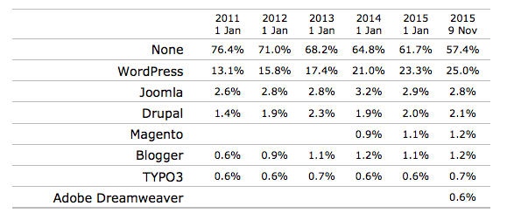

## 8.4 Experimentation

For experimentation we will apply tools, design methods and techniques to practice. As part of the design methodology we will have some prototype users who will give feedback which informs each stage of the AGILE process.

As we are prototyping, we could use Mocking Bot or WebFlow online tools to build interactive web sites that can later be tested on by users. With these tools we can create many wireframes and get them tested to find the perfect design.

# 9. Project Management

## 9.1 Assessment & discussion of Risks

### 9.1.1 Scope

The scope of this project will focus on the boundaries of the project/research. We will be researching around the subject area of community building and creating a commercial website. Community building will be important as we are looking to bring students together and join student groups. A commercial website will be what we are looking to create, we will identify critical website requirements and options according to the scope of the project.

### 9.1.2 Constraints

Our constraints will consist of having a lack of knowledge for using a management-system like WordPress, so we will need to manage time to learn the skills we need to implement our project.

We need to be careful with not spending too much time on sections of our project, so we need to stick to our project milestones. Also, we don’t want to get caught up in trying to implement lots off features, but instead keep to only a few features keeping it simpler.

### 9.1.3 Resources

Resources we are going to use will be plugins are they will save us a lot of time and effort, there are many plugins out there that can help create our features & functionalities.

## 9.2 Assessment & discussion of Risks Stick in the appendix. What would go here to replace it.

|  |  |  |  |  |  |  |
| --- | --- | --- | --- | --- | --- | --- |
| **Category** | **Risk** | **Risk ID** | **Probability** | **Impact** | **Mitigation** | **Contingency** |
| Platform | Not understanding how to use Wordpress effectively | 1.1 | Low | High | Although I will start with no experience in Wordpress, I can spend 2 hours per day learning how to use it | Manually write out the HTML, PHP, and CSS code in the program Brackets, using my knowledge I’ve learnt in the last 3 years of my computing course |
| Platform | Not using the correct plugins to work with features & functionalities | 1.2 | Low | Medium | Do a lot of research for the popular plugins. When looking at one type of plugin also consider the other types and compare. | Adapt my features & functionalities to match up with the plugins that I can understand to use. |
| Project completion | Not enough time to complete project | 2.1 | Low | Medium | Spend 20 + hours per week on the project | Make sure the project is atleast done to a good standard even if it is not complete |
| Project completion | Website not working | 2.2 | Low | Medium | Keep running tests frequently and save backups each time | Go back to a working backup |
| Research | Not enough content to fill out the 10,000 words | 3.1 | Low | High | Spend 10 + hours per week on research and document in the project library | Try my best to reach the word count without watering down my research |
| Research | Not relevant enough or trying to cover too many areas in the subject field | 3.2 | Medium | Medium | Make sure I have a clear idea in my head where I am heading with my project and try not to stray elsewhere | Try not to have all my sub-heading within the project disconnected from one another. |
| Survey | Results might not answer my hypothesis | 4.1 | Medium | Low | When picking my questions, make sure they all relate to the hypothesis | Re-write the survey and try to get responses again |
| Usability testing | Not being able to get participants to test website | 5.1 | Low | High | Ask participants a week or two In advance | Ask course mates or go into the library and people in person if they will test my website |
| My skills | My skills not being adequate enough to make a high quality website | 6.1 | Low | High | Invest multiple hours per week on developing my skills, and learn new skills as well | Make sure at least there is enough research there to talk about proving I have invested multiple hours into this |
| My skills | Poor problem-solving abilities | 6.2 | Medium | Medium | Make sure to meet my supervisor Craig Gallen every week and email him when I come across an problem I can’t solve | Look at external sources for information and try develop my personal skill-set to resolve problems |
| Interview and discussions | Not being able to arrange any meetings with anybody | 7.1 | Low | Medium | Try arrange meetings early into the project | Keep on emailing various different people |
| Project scope | Project creep | 8.1 | Medium | Low | Clearly define the project scope before starting and select a design production process | Try keep to the design production process |
| Project features & functionalities | Not having the skills or knowledge to complete all features planned on website | 9.1 | Medium | Medium | Ensure I have the skills required to create the features | I’ll have to leave out these features in the website |

## 9.3 Selection and timing

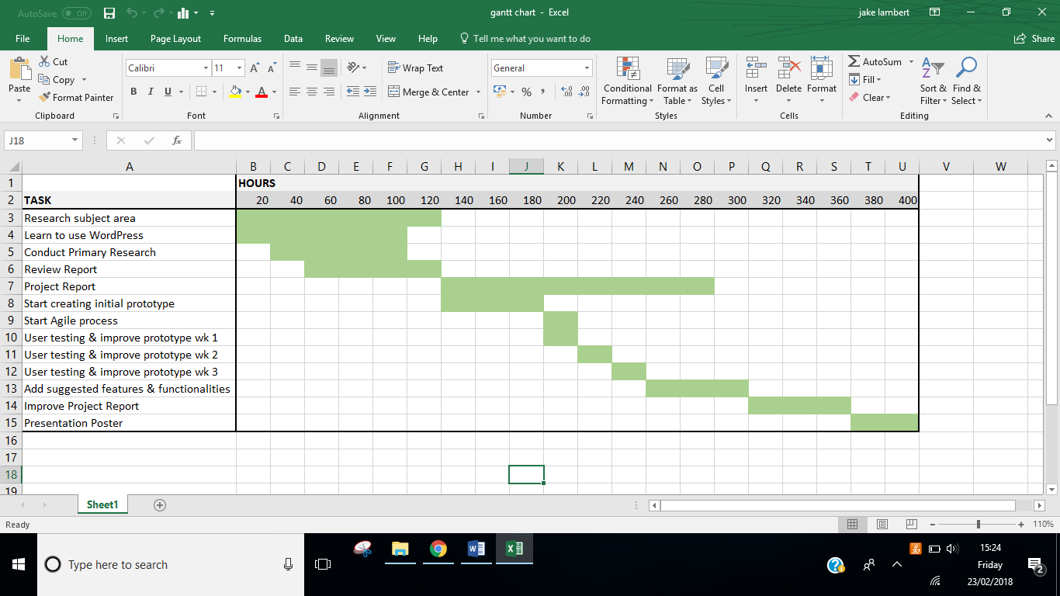

# 10. Design and Implementation plan for the final phase of the project

## 10.1 Design and Implementation strategy/process

We are looking to achieve a prototype through strategically planning out our design stages through a series of steps to meet our targets and end goals. We need to priorities our focus on our planned features & functionalities and recognize whether our skills and knowledge make these design choices realistic.

## 10.2 Selection of a [process model](https://www.google.co.uk/search?q=process+model+in+software+engineering&source=lnms&tbm=isch&sa=X&ved=0ahUKEwjH6v_Y0tHVAhXiCcAKHf0zDp4Q_AUICigB&biw=1605&bih=1272) diagrams - Appropriate to your project. Methodology for the overall implementation

For selecting our process model to be our foundation for our methodology, as we are creating a prototype and will be constantly developing and updating it along the

way, we seemed fit to use the Agile process model **See Figure 2**.

With the Agile process our software will be developed in incremental, rapid cycles. This cycle results in small incremental releases with each release being built on the previous functionality. Each release will be tested with the same consistency and thoroughness to maintain software quality. At the end of a sprint retrospective we should have identified and committed to a practical number of process improvement actions that will be undertaken in the next sprint. (Rubin, K.S, 2012).

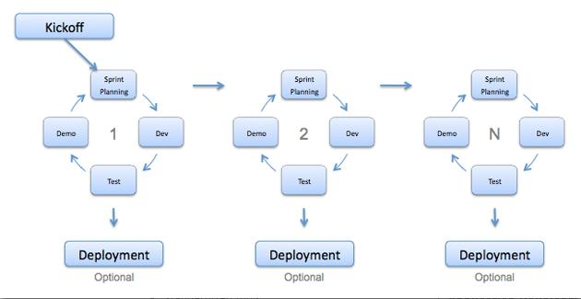

**Figure 2 – Diagram to the Agile process.**

To see the Project plan for creating the prototype using the Agile methodology (See Appendix 2). Link to an agile process book

We will kick off with creating a prototype which will be the first phase of its lifecycle, and then at each sprint we will have a select number of users ranging with different skills sets (from different University courses) to test our prototype. After this stage they will be presented with a feedback form where they can provide us with valuable comments to assist us in developing the prototype further.

We will repeat this process three times, eventually getting to our end goal of fulfilling our aims and objectives for this project.

Other methodologies we are taking into consideration are, using the ‘soft’ systems methodology (SSM)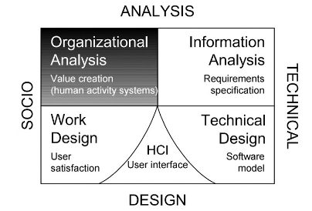 (VIDGEN, R., 2002).

**Figure 3 - Organisational analysis – the systems perspective**

To see the Project plan, use the soft-systems methodology (See Appendix 3).

In soft systems thinking we organize our thinking about the world systematically, while recognizing that the perceived world is problematic. In some organizational setting the word “problem” can often have negative connotations, where people talk along the lines of having “opportunities” rather than problems. The phrase “problem situation” doesn’t mean to be a good or bad thing but instead encompasses an “opportunity” situation. In the context of SSM we will continue to use the term “problem situation” (VIDGEN, R., 2002).

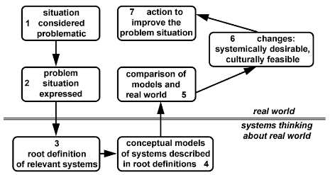

**Figure 4 – Seven-stage model of SSM.**

To see the Project plan, use the Seven-stage model of SSM (See Appendix 4).

## 10.3 Testing and validation plan

For testing our website, we will run some functional tests to confirm that website features work according to the code. But these tests do not validate whether links and buttons align correctly on all browsers or devices.

For testing on desktop, we can look into our web traffic analytics to understand the most used desktop browsers that we should be testing against. Below is a list of browser releases in 2016, as you can see there is a lot of beta versions due to browser updates often happening automatically without users knowing.

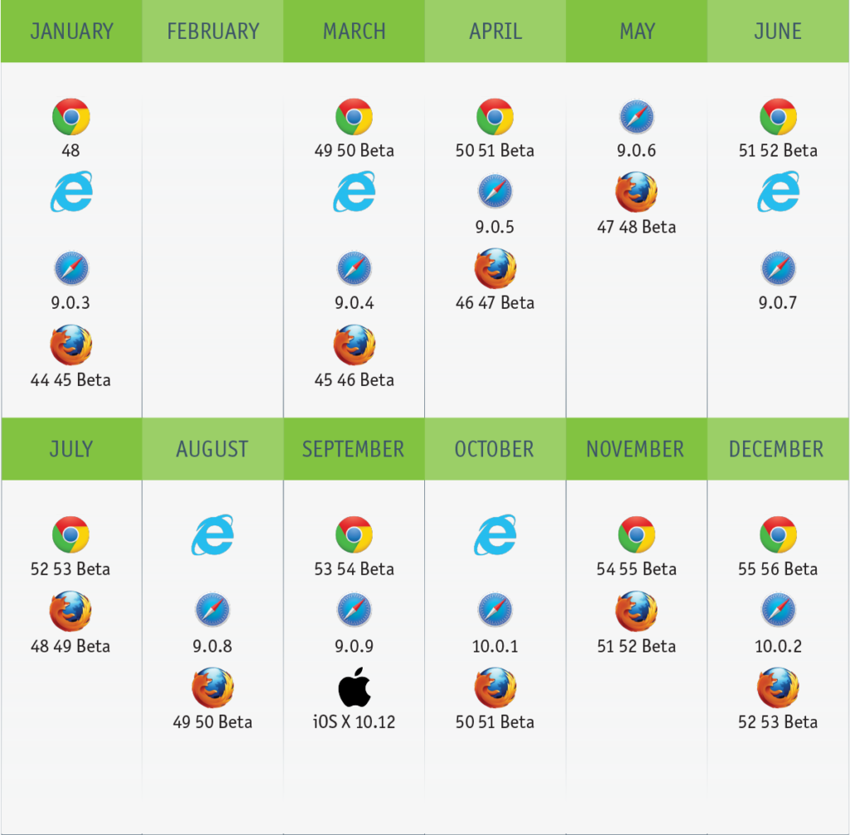

**Figure 5 - The web coverage landscape for 2016. (Source: Perfecto)**

## 10.4 Preparation for poster day. Awareness of what an academic poster is, and how I’m going to create it.

We are aware of The Computing Degree Show Poster Presentation on the 22nd May 2018. We will prepare & display presentation materials that allows someone who has no prior knowledge of the project, to quickly grasp the basic understanding of what has been achieved in the project.

Our poster will be attractive, eye-catching, informative and other presentation materials to arouse the intended audience. Demonstrate evidence of the project artefacts to high-level of technical expertise.

We will provide evidence of our fully structured and planned approach to the conduct of our project. Also, confidently discuss the technically sophisticated aspects of our project process.

# 11. Reference List Use page numbers in references as per Harvard Ref & website should have date accessed. Add foot notes for URLs and referencing sentences.

Reference the books in the main text.

ANON., 2015. WordPress powers 25% of all websites. In: Nov 5, Available from: <https://w3techs.com/blog/entry/wordpress-powers-25-percent-of-all-websites> [2018, 3rd February].

BELL, G., 2009. *Building Social Web Applications&nbsp;*First Edition ed. United States of America: O'Reilly Media

COWIE, F., 2006. *how to create a successful commercial website&nbsp;*First Edition ed. Straighforward

FRIEDLEIN, A., 2001. *Web project management: Delivering successful commercial Web sites.*Morgan Kaufmann

KIM, A.J., 2000. *Community building on the web: Secret strategies for successful online communities.*Addison-Wesley Longman Publishing Co., Inc.

O'NIEL, S., Tips for Responsive Web Design Testing. In: Available from: <http://blog.perfectomobile.com/responsive-web-design/responsive-web-design-testing-tips/> [2018, 21st January].

PETERSON, C., 2014. *Learning responsive web design: a beginner's guide.*" O'Reilly Media, Inc."

RUBIN, K.S., 2012. *Essential Scrum: A practical guide to the most popular Agile process.*Addison-Wesley, pp. 28.

SOLENT, 2017. *Solent Sport*Available from: <https://www.solent.ac.uk/solent-sport> [2018, 25th January].

SOLENT STUDENT UNION, 2017. *Student Opportunities*Available from: <https://www.solentsu.co.uk/get-involved/societies/find-a-society/> [2018, 1st February].

SOLENT UNIVERSITY, 2016. *Our History*Available from: <https://www.solent.ac.uk/about/our-history> [2018, 5th February].

SOLENT UNIVERSITY, 2018. *Welcome Week &amp; Enrolment*Available from: <https://www.solent.ac.uk/hello-uni/welcome-week-and-enrolment> [2018, 6th February].

THE NATIONAL ARCHIVES, 1995. *Disability Discrimination Act 1995*Available from: [http://www.legislation.gov.uk/ukpga/1998/29/contents](http://www.legislation.gov.uk/ukpga/1995/50) [2018, 28th January].

THE NATIONAL ARCHIVES, 1998. *Data Protection Act 1995*Available from: <http://www.legislation.gov.uk/ukpga/1995/50.> [2018, 7th February].

UK ESSAYS, 2005. *Legal social ethical and professional issues*Available from: <https://www.ukessays.com/essays/information-technology/legal-social-ethical-and-professional-issues-information-technology-essay.php> [2018, 5th February].

UK ESSAYS, 2013. *Legal, Social, Ethical, and Professional Issues*Available from: <https://www.ukessays.com/essays/information-technology/legal-social-ethical-and-professional-issues-information-technology-essay.php> [2018, 1st February].

UNIVERSITY OF SOUTHAMPTON'S STUDENT UNION, 2017. *Student Union Calendar*Available from: <https://www.susu.org/calendar/> [2018, 5th February].

VIDGEN, R., 2002. *Developing Web information systems: From strategy to implementation.*Elsevier, pp 82.

# Bibliography List

BELL, G., 2009a. *Building social Web applications: Establishing community at the heart of your site.*" O'Reilly Media, Inc."

BELL, G., 2009b. *Building social Web applications: Establishing community at the heart of your site.*" O'Reilly Media, Inc."

CUNLIFFE, D., 2000a. Developing usable Web sites–a review and model. *Internet Research,*10(4), 295-308

CUNLIFFE, D., 2000b. Developing usable Web sites–a review and model. *Internet Research,*10(4), 295-308

*Ethical and Legal  
Issues in Web  
Development.*a. Available from: <https://www.okaloosaschools.com/fwb/sites/okaloosaschools.com.fwb/files/users/anthonybryant/wds_v1.1_ssg_l11.pdf>

*Flash Scores&nbsp;*b. Available from: <https://www.flashscores.co.uk/>

GEHRKE, D. and E. TURBAN, 1999. Determinants of successful website design: relative importance and recommendations for effectiveness. *Systems Sciences, 1999. HICSS-32. Proceedings of the 32nd Annual Hawaii International Conference on.*IEEE, pp.8 pp.

LAURANCE, N., *How to create a successful website that keeps customers returning*Available from: <https://www.theguardian.com/small-business-network/2014/aug/04/how-to-create-successful-a-website>

*LEGAL AND ETHICAL ISSUES IN WEB DESIGN*2012. Available from: <https://paulstevensdesign.wordpress.com/2012/01/02/legal-and-ethical-issues-in-web-design/>

# 12. Appendices

## 12.1 Annotated bibliography Ask Craig do I really need to have text here. Also do I need to talk about the books in this report, coz im going to discuss them in the write up.

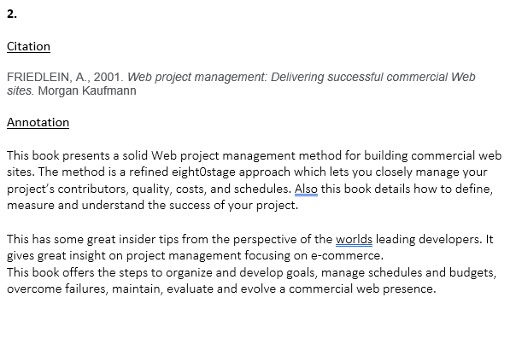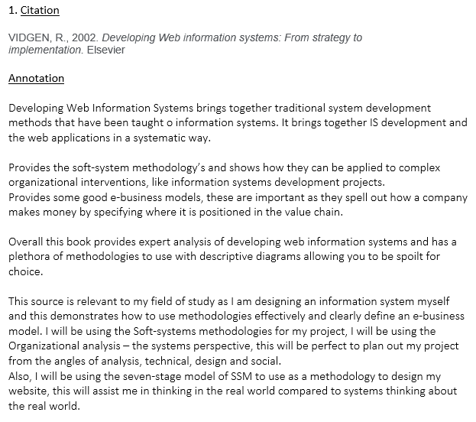

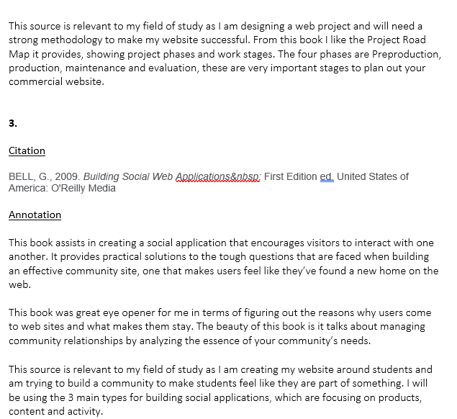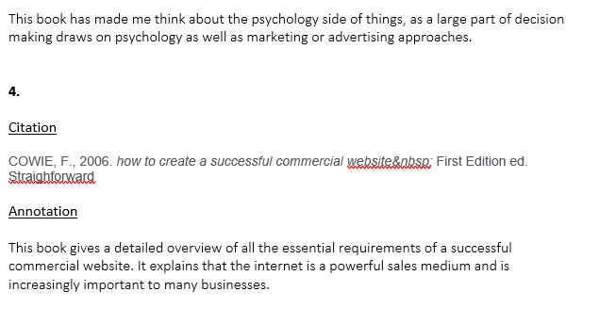

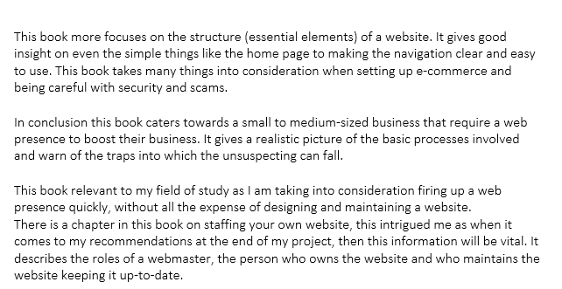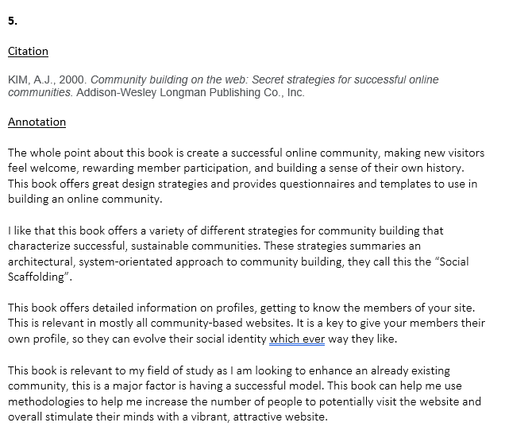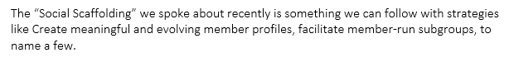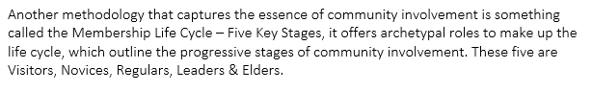

## 12.2 Appendix

### 12.2.1 Primary Research - Interview Ask Craig how as actual text.

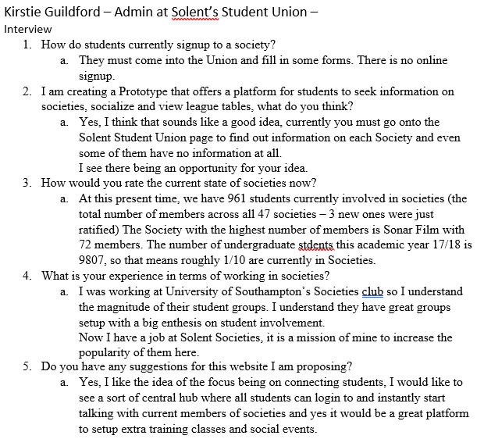

### 12.2.2 The Agile process model find a book on agile process

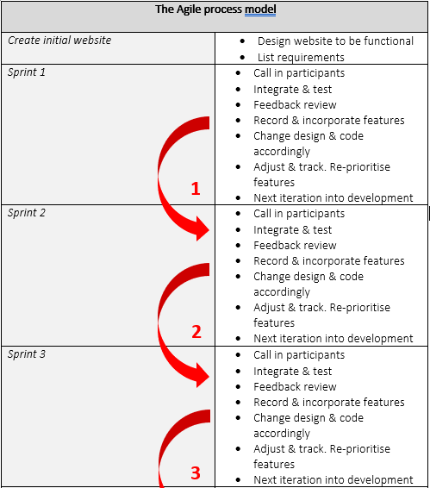

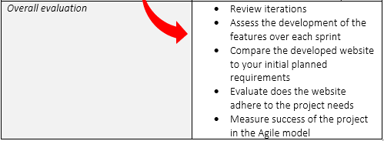

### 12.2.3 Organizational analysis - The systems perspective

The table is my interpretation of aversons methodology on page…

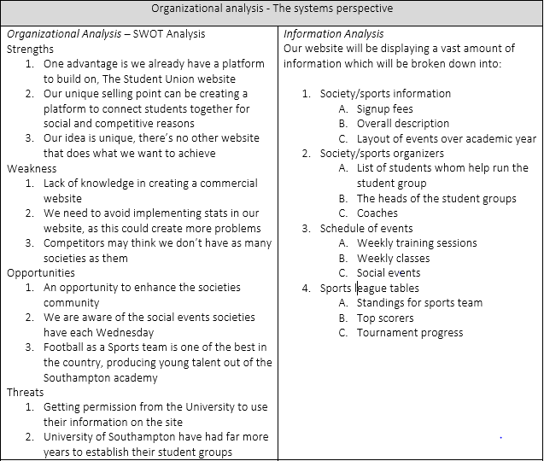

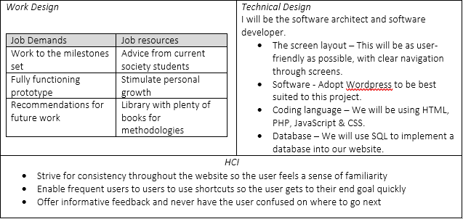

### 12.2.4 Seven-stage model of SSM

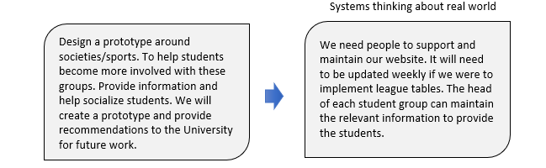

### 12.2.5 Survey Results

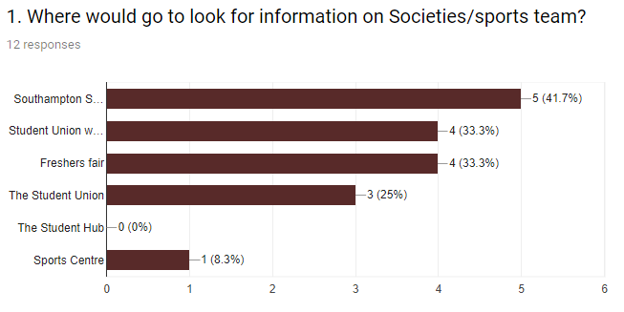

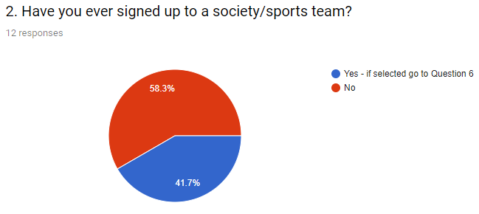

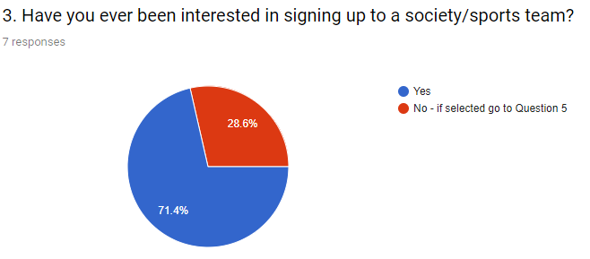

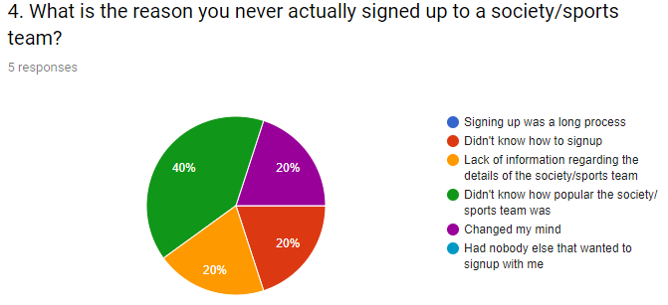

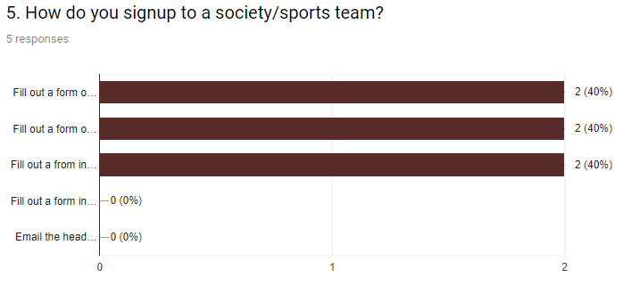

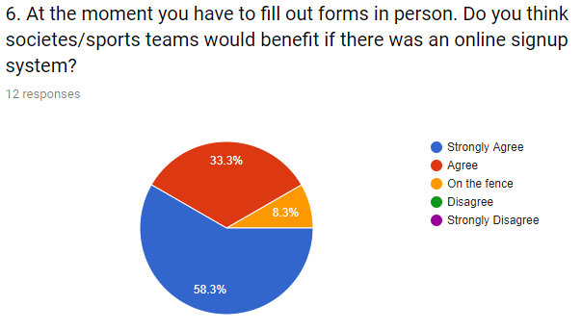

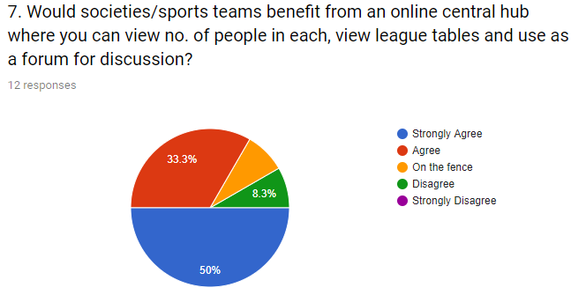

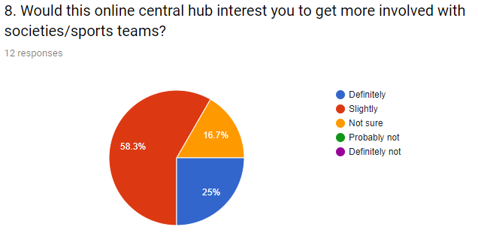

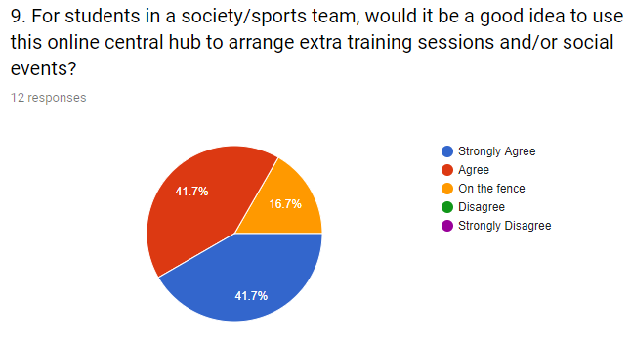

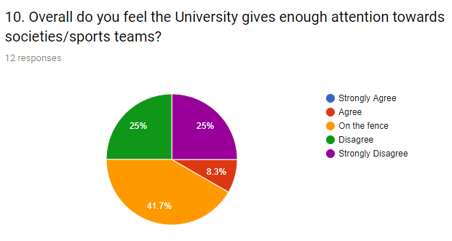

### 12.2.6 Primary Research - University of Southampton Students’ Union email from Daniel Thrower, Executive Office Coordinator

Hi Jake,

Hope you are doing well.

I was trying to put some numbers and percentages together for the number of students who are part of societies at the University of Southampton.

Societies are supposed to list their members on their online Groups Hub page, but unfortunately most societies just don’t list their ordinary members at all, only their committees. So, we have no accurate way of knowing how many students are part of our student groups.

We have 340 groups in total and I would estimate that the number of students who are part of societies would be in the 6000-9000 range. We have around 23,500 students so I’d estimate a percentage of students who are part of student groups to be between 25%-40%. Please note that these are just rough estimates and should not be taken as official figures from our Students’ Union.

1. https://www.solentsu.co.uk/get-involved/societies/find-a-society/
2. https://www.solent.ac.uk/solent-sport
3. https://www.solent.ac.uk/about/our-history
4. https://www.susu.org/
5. https://www.solent.ac.uk/solent-sport/documents/solent-sport-brochure.pdf
6. <https://www.ukessays.com/essays/information-technology/legal-social-ethical-and-professional-issues-information-technology-essay.php>
7. [http://www.legislation.gov.uk/ukpga/1998/29/contents](http://www.legislation.gov.uk/ukpga/1995/50)
8. <http://www.legislation.gov.uk/ukpga/1995/50>
9. <https://www.ukessays.com/essays/information-technology/legal-social-ethical-and-professional-issues-information-technology-essay.php>