Parallel Design for our Home page

Participant 1

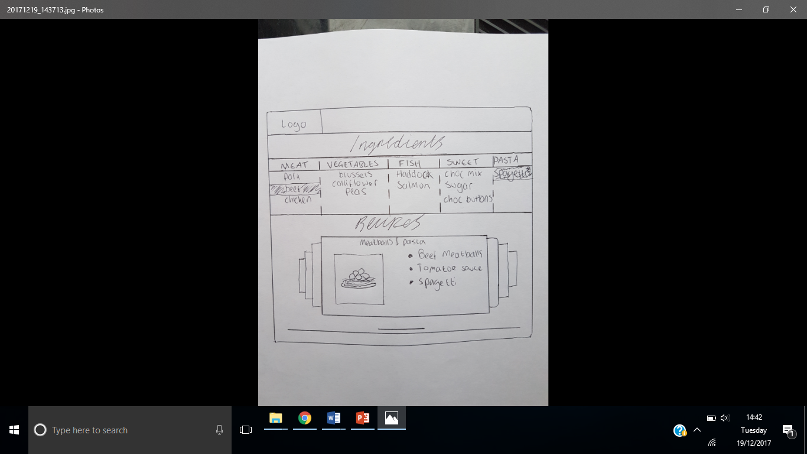

List of user ingredients.

Swipe sytem for looking at multiple recipes.

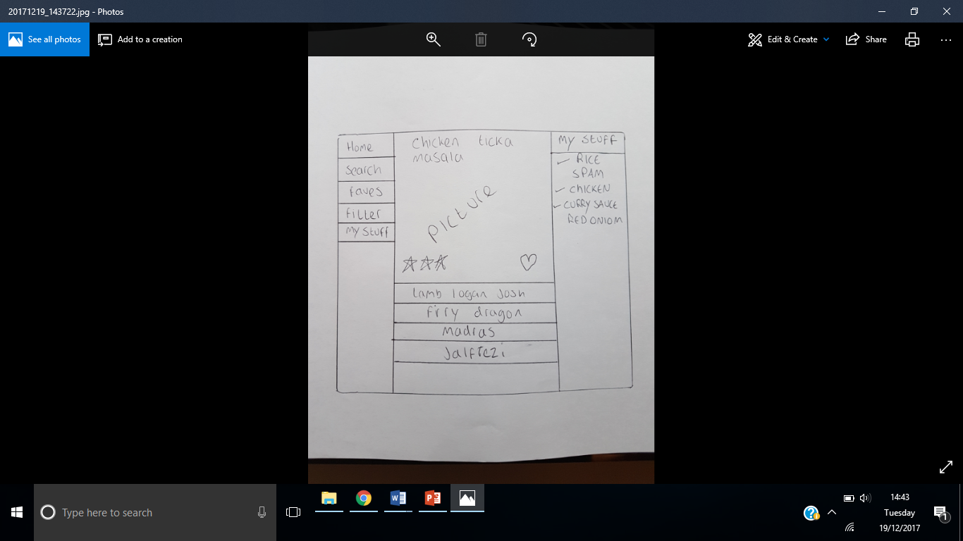

This is a list of all the users ingredients where they can use to search for recipes

This is a list of other searched recipes

This is one recipe the user is viewing.

Navigation menu.

Participant 2