Section 8: A Real App: The Burger Builder
Planning an App in React
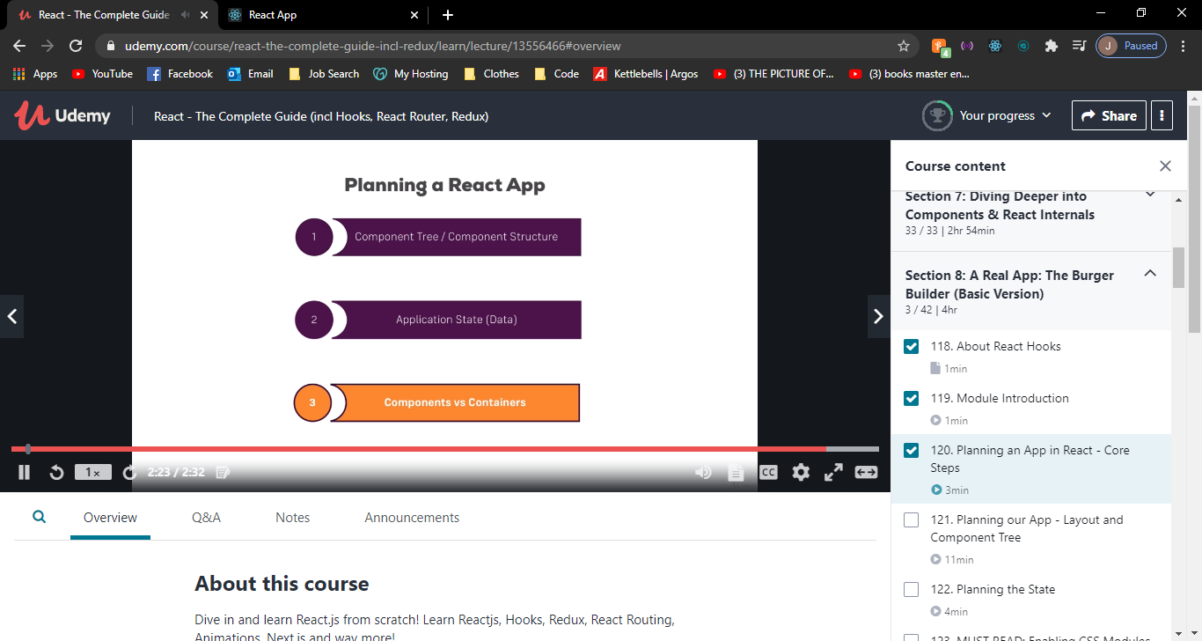

Layout & component tree & planning the state
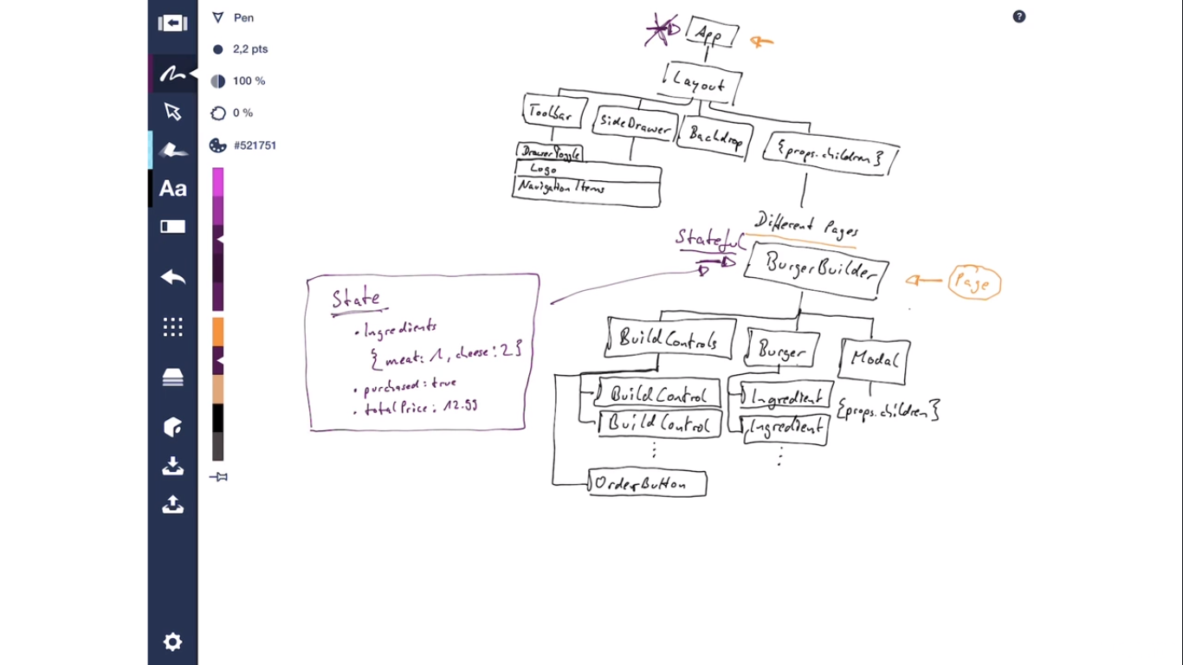

Setting up the project
Git add .
Git commit -m ‘save before eject’
Npm run eject
If you aren’t satisfied with the build tool and configuration choices, you can eject at any time. This command will remove the single build dependency from your project.
Instead, it will copy all the configuration files and the transitive dependencies (webpack, Babel, ESLint, etc.) into your project as dependencies in package.json and as a config folder. Technically, the distinction between dependencies and development dependencies is pretty arbitrary for front-end apps that produce static bundles.

Install Prop Types

npm install -–save prop-types

Prop-types are used to send data from one component to another.
If a component receives the wrong types of props, it can lead to bugs and unexpected errors in your app.
It will check props parsed to your components against those definitions, and return an error if they don’t match.

