Section 2: Natours Project

Building the header part 1
- vh – Viewport Height
- linear-gradient
- If we use position: absolute then its parent element must have position: relative to have a reference to.
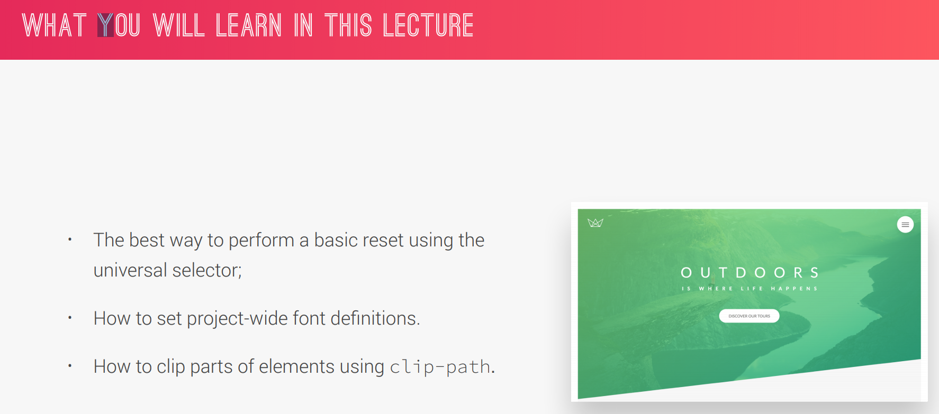

Building the header part 2
- <span> is used to style part of a text
- display: block – occupies the whole width and uses a line break after the element
- top, bottom etc are in relation to the parent element. Whereas transform: translate() is in relation to itself

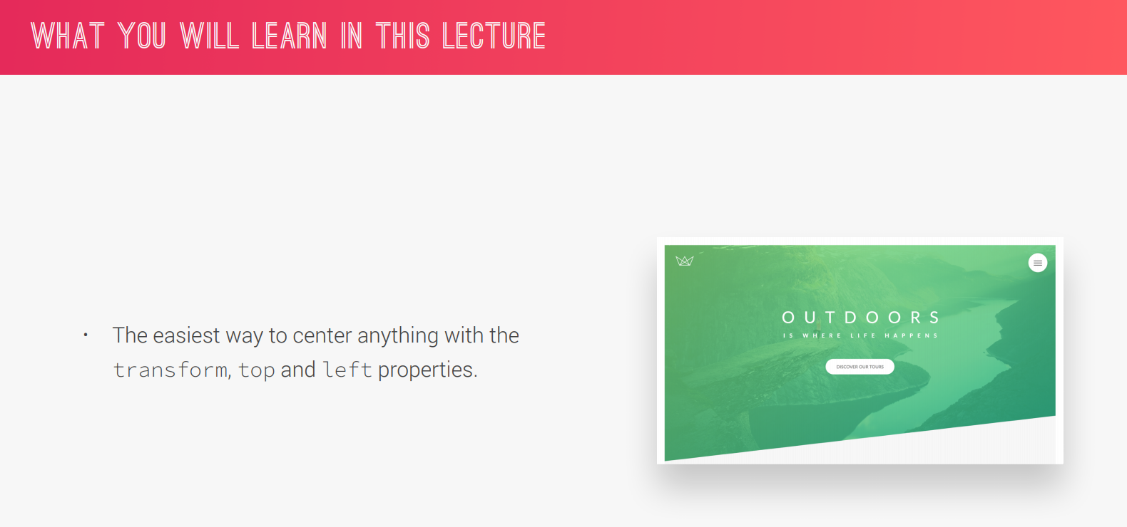

Creating Cool CSS Animations
- animation-timing-function - Specifies the speed curve of an animation.
https://www.w3schools.com/cssref/css3_pr_animation-timing-function.asp
FYI in the parent element: backface-visability: hidden

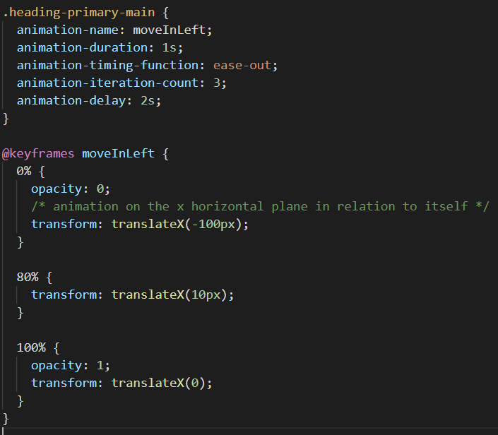

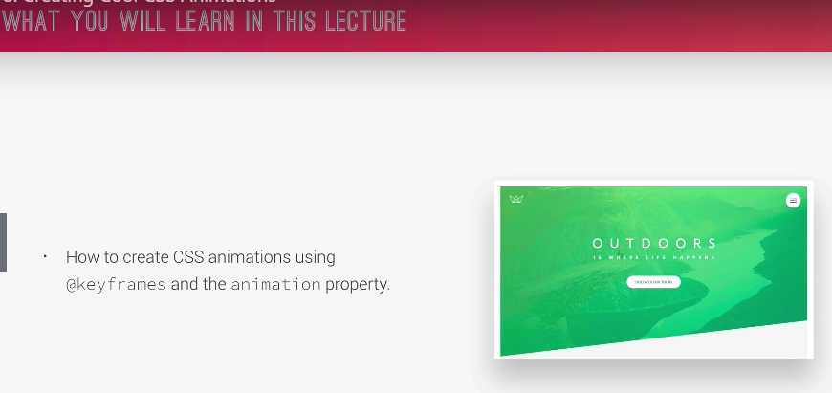
Building a Complex Animated Button – Part 1

