Section 11: Multi Page Feeling in a Single Page App – Routing
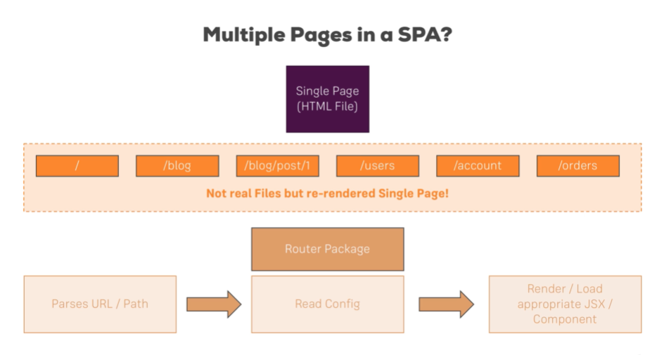

f

Setting up the Router Package
install react router and react router dom
npm I –save react-router-dom react-router

Setting Up and Rendering Routes
Import Browser Router into app.js
import { BrowserRouter} from 'react-router-dom';

Wrap entire JSX in Browser Router
<BrowserRouter>
<div className='App'>
<Blog />
</div>
</BrowserRouter>

Import Route and use the Render prop
import { Route } from 'react-router-dom';
<Route path='/' exact render={() => <h1>tovdfbvf</h1>} />

Exact prop:
So what if you want to display only profile and not dashboard when you visit ‘/dashboard/profile’. Just add exact keyword on dashboard route and you could only see App and Profile components rendered and Dashboard component is ignored in this path.

Rendering Components for Render

Use the Component prop
import Posts from './Posts/Posts';
<Route path='/' exact component={Posts} />

Using Link to Switch Pages
With the above examples, these cause the page to reload meaning all JS state data is reset, we do NOT want this to happen.

Link is used instead of a HTML anchor tag <a><a/>
Link will prevent the default meaning, it will NOT reload the page
import { Route, Link } from 'react-router-dom';
<Link to='/'>Home</Link>

<Link
to={{
pathname: '/new-post',
hash: '#submit',
search: '?quick-submit=true'
}}>
Home
</Link>

Absolute vs Relative paths

Absolute Paths
By default, if you just enter to="/some-path" or to="some-path" , that's an absolute path.
Absolute path means that it's always appended right after your domain. Therefore, both syntaxes (with and without leading slash) lead to example.com/some-path .

Relative Paths
Sometimes, you might want to create a relative path instead. This is especially useful, if your component is already loaded given a specific path (e.g. posts ) and you then want to append something to that existing path (so that you, for example, get /posts/new ).
If you're on a component loaded via /posts , to="new" would lead to example.com/new , NOT example.com/posts/new .
To change this behavior, you have to find out which path you're on and add the new fragment to that existing path. You can do that with the url property of props.match :
<Link to={props.match.url + '/new'}> will lead to example.com/posts/new when placing this link in a component loaded on /posts . If you'd use the same <Link> in a component loaded via /all-posts , the link would point to /all-posts/new .
There's no better or worse way of creating Link paths - choose the one you need. Sometimes, you want to ensure that you always load the same path, no matter on which path you already are => Use absolute paths in this scenario.
Use relative paths if you want to navigate relative to your existing path.

Styling the Active Routes
NavLink: A special version of the <Link> that will add styling attributes to the rendered element when it matches the current URL.
The className will be assigned to the element when it is active. The default given class is active. This will be joined with the className prop.
import { NavLink } from 'react-router-dom';
<NavLink to='/'>Home</NavLink>

In the CSS file:
.Blog a.active { color: #fa923f;

Additionally:
exact – We need to specify this as a prop, to give the active class specifically to that exact route.
activeClassName - We can overwrite the active class with our own class name.
activeStyle - We can edit singular CSS styles.
<NavLink
to='/'
exact
activeClassName='my-active'
activeStyle={{
color: '#fa923f',
textDecoration: 'underline'
}}
>
Passing Route Parameters
This is essentially setting up a query string.
Setup a <Route> with a path format ‘/:id’
<Route path='/:id' exact component={FullPost} />
Setup the <Link> in another file, wrapping the JSX. This must be the same format as stated in the <Route>
<Link to={'/' + post.id} key={post.id}>
<Post
title={post.title}
author={post.author}
clicked={() => this.postSelectedHandler(post.id)}
/>
</Link>

Extracting Route Parameters
In the FullPost Component we can extract the id with:
this.props.match.params.id

Passing Multiple Route Parameters
<Route path='/courses/:id/:title' exact component={Course} />
<Link
key={course.id}
to={this.props.match.url + '/' + course.id + '/' + course.title}
/>

<h1>{this.props.match.params.title}</h1>
p>{this.props.match.params.id}</p>

Using Switch to Load a Single Route
Switch tells React Router to only Load 1 Route
Or alternatively you can just use the prop exact
<Switch>
<Route path='/' exact component={Posts} />
<Route path='/new-post' exact component={NewPost} />
<Route path='/:id' exact component={FullPost} />
</Switch>

Navigating Programmatically
You navigate to pages through your own custom pages instead of Links and NavLinks. There are two ways of using push()
postSelectedHandler = id => {
console.log(this.props.history);
this.props.history.push({ pathname: '/' + id });
// OR this.props.history.push('/ + id')
};
Understanding Nested Routes
By using a dynamic path we can truly nest our routes
<Route path={this.props.match.url + '/:id'} exact component={FullPost} />
Redirecting Requests
Rendering a <Redirect> will navigate to a new location. Basically when the URL has / then it will redirect to /posts
import { Redirect } from 'react-router-dom';
<Switch>
<Route path='/posts' component={Posts} />
<Redirect from='/' to='/posts' />
</Switch>

Working with Guards
Using a Guard Clause can deny/accept authorisation for the user
state = {
auth: false
};

{this.state.auth ? <Route path='/new-post' exact component={NewPost} /> : null}
Handling 404 case
Display error message if there’s an unknown route
<Route render={() => <h1>Not found</h1>} />

