Section 8: A Real App: The Burger Builder
Planning an App in React
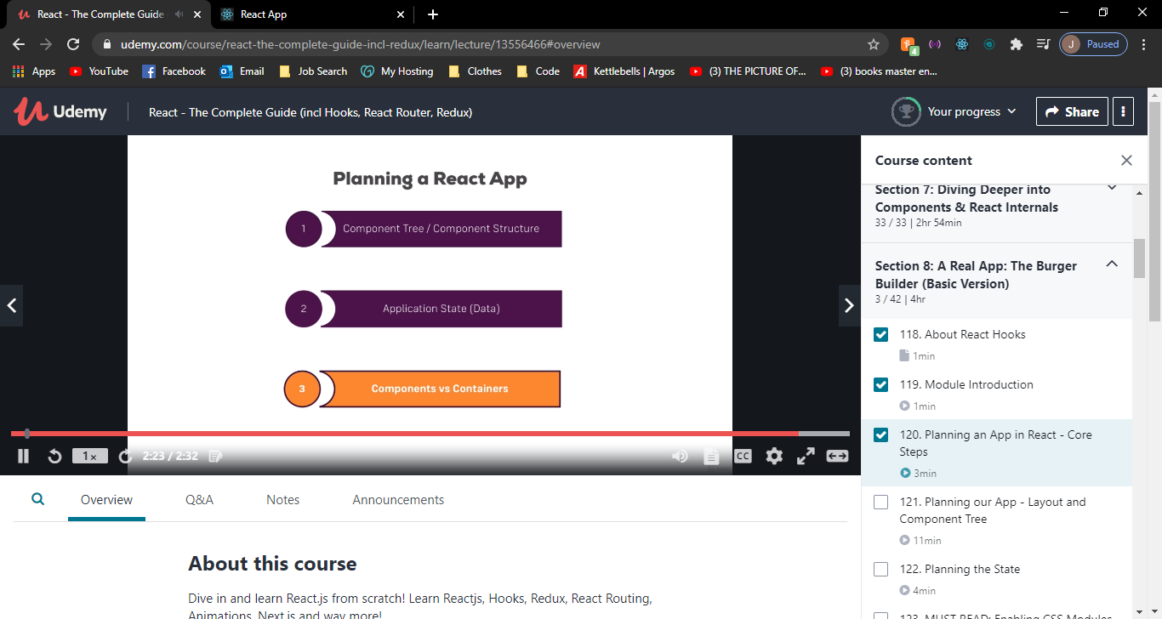

Layout & component tree & planning the state
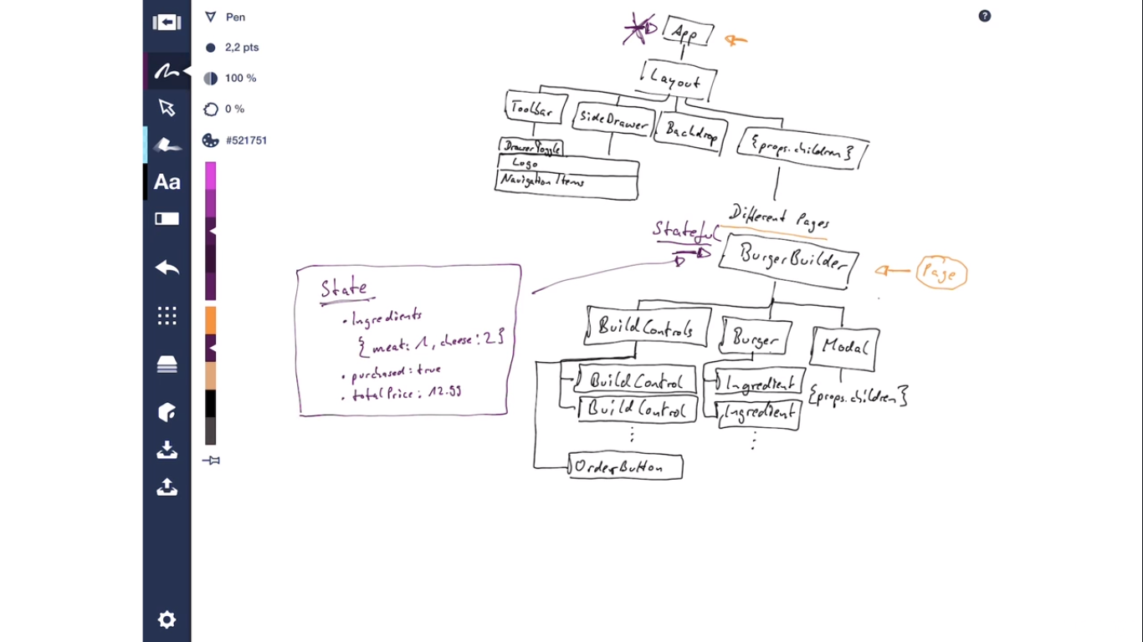

Setting up the project
Git add .
Git commit -m ‘save before eject’
Npm run eject
If you aren’t satisfied with the build tool and configuration choices, you can eject at any time. This command will remove the single build dependency from your project.
Instead, it will copy all the configuration files and the transitive dependencies (webpack, Babel, ESLint, etc.) into your project as dependencies in package.json and as a config folder. Technically, the distinction between dependencies and development dependencies is pretty arbitrary for front-end apps that produce static bundles.

Install Prop Types

npm install -–save prop-types

Prop-types are used to send data from one component to another.
If a component receives the wrong types of props, it can lead to bugs and unexpected errors in your app.
It will check props parsed to your components against those definitions, and return an error if they don’t match.

Section 10: Burger Builder Project: Accessing a Server
Creating a Firebase Account
Create Project > Setup Realtime Database > Rules:
{
"rules": {
".read": true,
".write": true
}
}
This is so all users can have access only for the time being, during production. We will convert them back to false once we are all setup

Creating the Axios Instance
Install Axios
npm I –save axios

Setup baseURL in a file https://create-my-burger-e2081-default-rtdb.firebaseio.com/

Sending a POST request
This will add an Orders Node to our Firebase Database
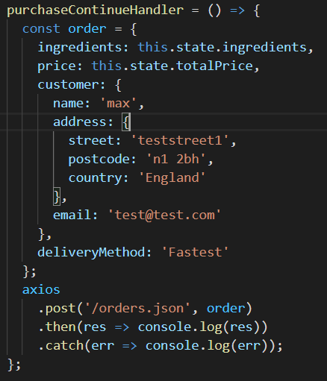
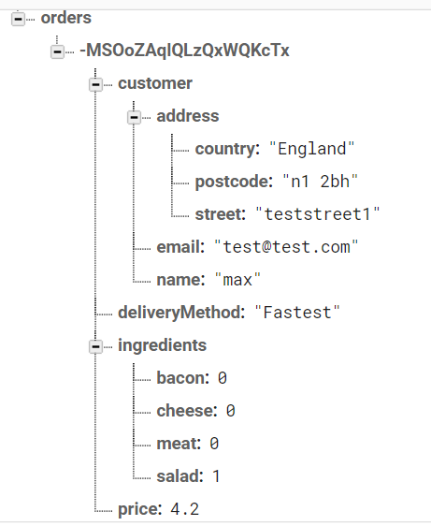

Displaying a Spinner while Sending a Request

Find a variety of spinners
https://projects.lukehaas.me/css-loaders/

Copy the CSS code and paste into the Spinner.css file
Copy the HTML div and paste into the Spinner.js file

Add into React project as:
<Spinner />

Handling Errors
DID NOT FULLY UNDERSTAND

Retrieving Data from the Back end
Add data structure into Firebase Database
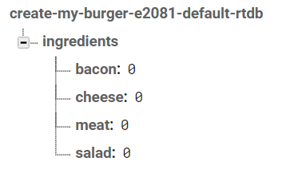

GET request to handle response data
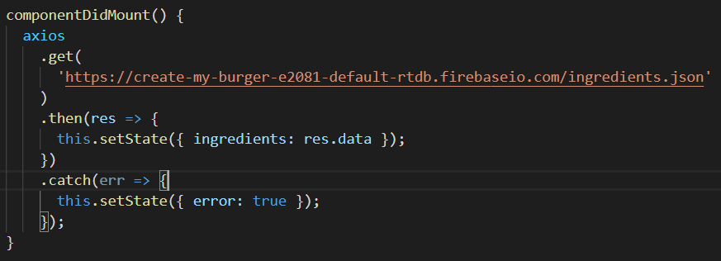

Section 12: Adding Routing to our Burger Project
Install React Router Dom
npm I –-save react-router-dom

Replace current URL
this.props.history.replace('/checkout/contact-data');

Go back to previous page
this.props.history.goBack();

In the Checkout.js we change the component property to the render property. This is so we can parse dynamic data to the Component.
component={ContactData}

render={() => <ContactData ingredients={this.state.ingredients} />}

Section 13: Forms and Form Validation
Alternate approaches to the manual setup in this section:
- react-validation package: https://www.npmjs.com/package/react-validation
- formsy-react package: https://github.com/christianalfoni/formsy-react

Section 15: Adding Redux to our Project
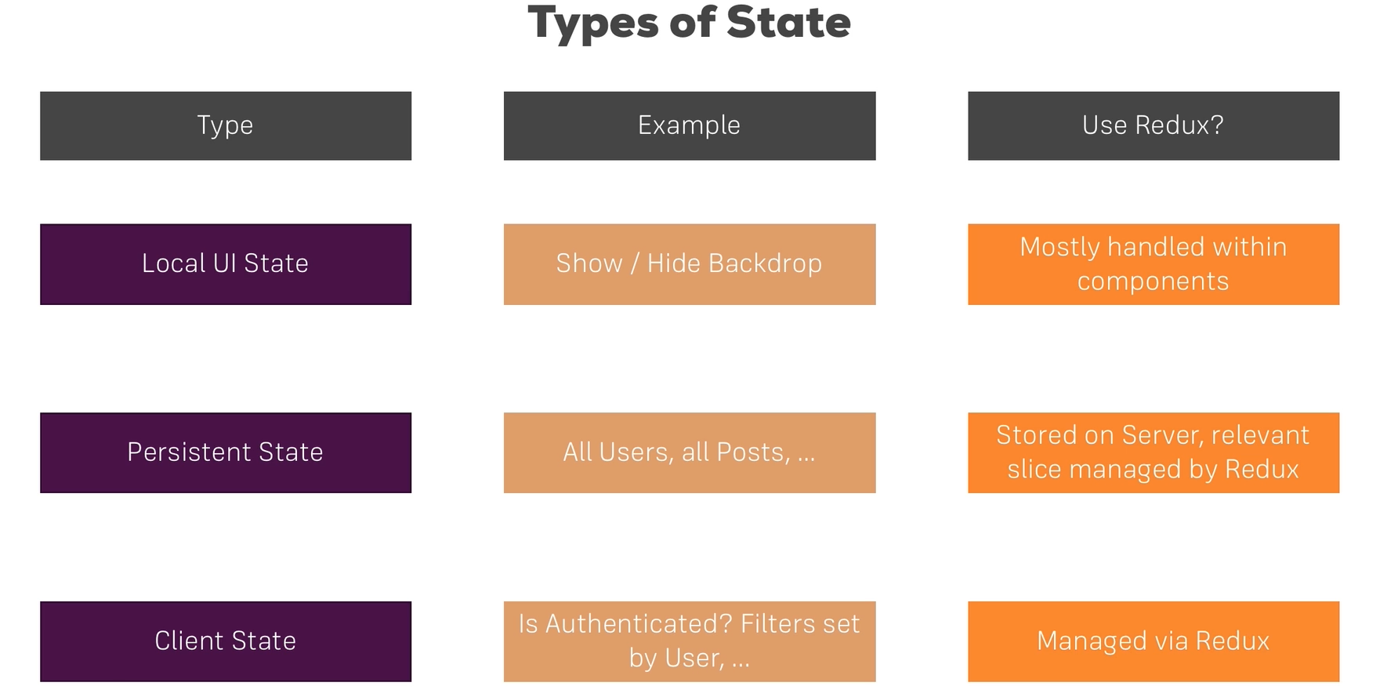
Redux should not use all types of State. Local UI state would only be used in its Component.
f

