Supplenam
Question for Aydin
- SanityCMS will give the client access to upload and edit content
- HOME
- Does the client want a CMS so they can make changes themselves in the future? I will provide further touch ups if needed in the future.
- I like the idea of opening a page for each job. Will be good to show film, write up, & photos.
- How do we want the awards displayed, a list of awards then on hover it displays the related job/film? Or the same as the old website https://supplenam.com/ award section?
- Embed the ShowReel into the site. Saves the user that extra step opening Youtube
- SERVICES
- EXTRA
- Do you want logo design which will be included in the price.
- Does the client have reviews where we can display as testimonials & a carousel of all clients worked with?
- I will include nice animations to give it the extra professional edge

Project Structure
- Home
  - Show reel
  - Awards
    - Clicking opens a YouTube video
    - Open page for each award
  - Latest work
    - Clicking opens a YouTube video
    - Open page for each job
  - Get in touch (link to contact form)
- Work
  - Commercial
    - List
  - Music video
    - List
  - Television
    - List
  - Live show
    - List
- About
- Contact

Videographer Portfolio Examples
https://www.kylejenkinscamera.com/kylejenkinscamera
https://www.samkolder.com/filmmaking
https://www.format.com/online-portfolio-website/video/best

Embed ShowReel
https://www.wix.com/website-template/view/html/1269?siteId=0ba696c3-9a66-48fc-8d7d-afaf007e1abf&metaSiteId=f5870249-de8d-4061-a5d7-95617e749c4b&originUrl=https%3A%2F%2Fwww.wix.com%2Fwebsite%2Ftemplates%2Fhtml%2Fvideo
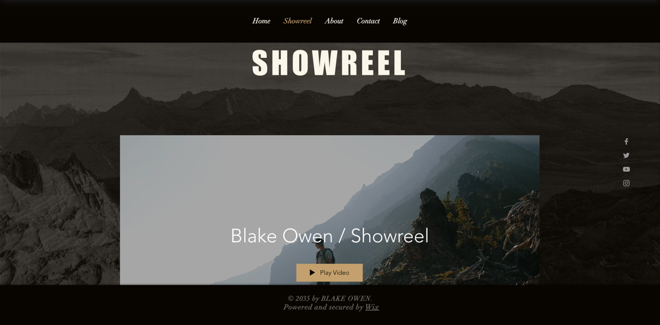
Reviews & clients
https://www.wix.com/website-template/view/html/1198?siteId=131c103c-a61d-7f42-50b4-32144060420e&metaSiteId=131c103c-a270-b7eb-4c47-4c73fc2f8d8b&originUrl=https%3A%2F%2Fwww.wix.com%2Fwebsite%2Ftemplates%2Fhtml%2Fvideo
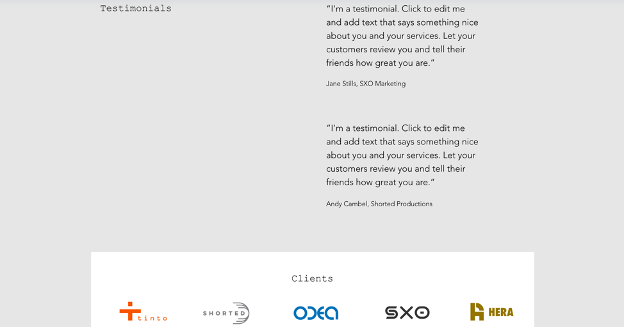

Cool way to display work
https://www.wix.com/website-template/view/html/2111?siteId=3767bdcb-02f6-45b1-ac3e-878e1cae3983&metaSiteId=0d101644-bccb-4824-a496-6cbfdc83af1d&originUrl=https%3A%2F%2Fwww.wix.com%2Fwebsite%2Ftemplates%2Fhtml%2Fvideo
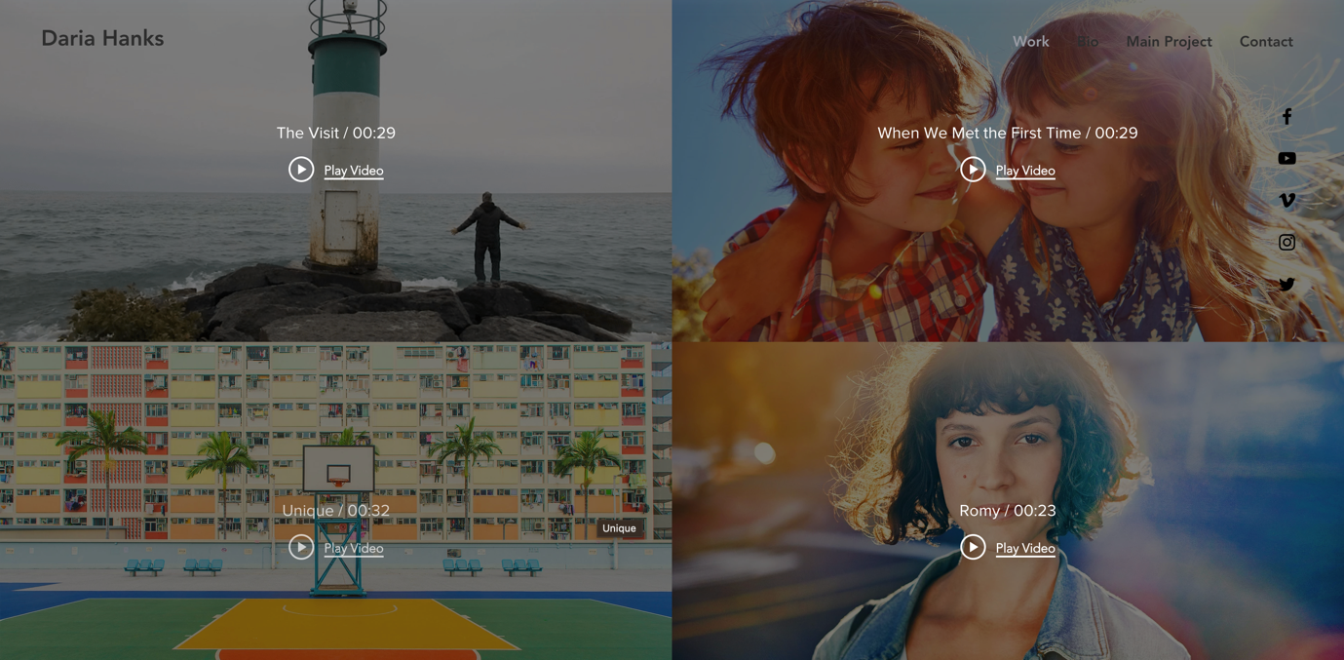
As the user hovers on image it expands inside of its box
https://www.kylejenkinscamera.com/clientwork
Photo of behind the scenes. Give a professional edge.
https://www.pixpa.com/examples/photography/videography
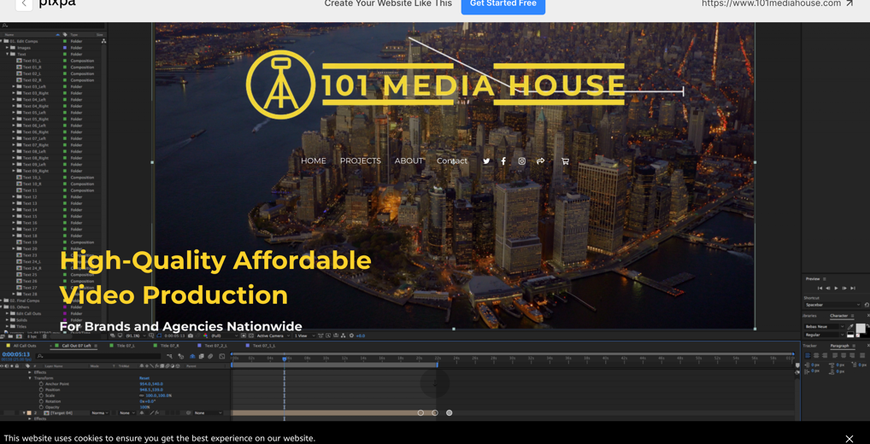

Good idea for Services sub sections
https://www.pixpa.com/examples/photography/videography
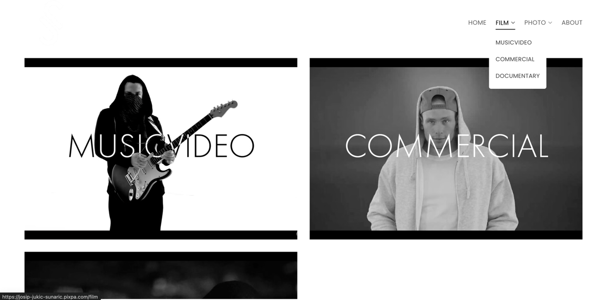
Landing page carousel of pictures with Videographers name and job role
https://www.pixpa.com/examples/photography/videography

Video starts on page load
https://www.format.com/online-portfolio-website/video/best


Clean Grid system to display work
https://ethanhillmedia.com/
Nice way to display work categories
https://bloomweddings.co.uk/portfolio-photography-and-video-packages/
Slick display for work and nice about section
https://www.nainoalanger.com/film
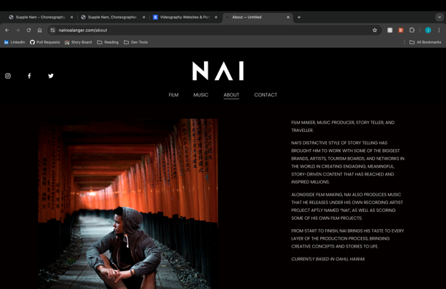

Cool Awards section
https://www.redcreativefilms.com/awards

