I was having an issue when using the application where leaving a session idle for a period of time would result in an exception being thrown.

The problem occurred because IIS was recycling the app pool on sessions which remained idle for a predetermined amount of time. This setting is located on the Application Pool in IIS under the Advanced Settings

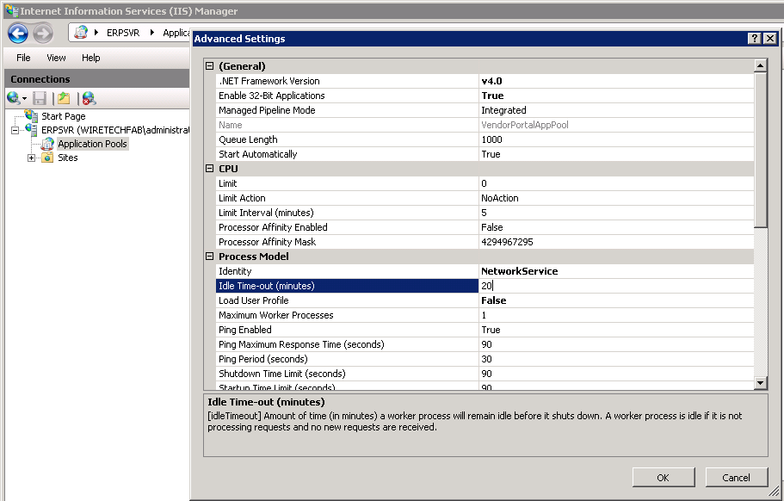

However the authentication timeout settings located in Web.config (not the Web.config under ‘Views) under system.web had been set to 2880 minutes.

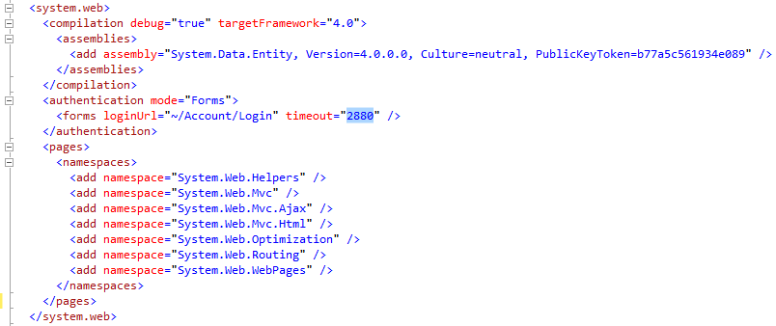

What this was doing was causing the Application Pool to recycle before the user was required to re-authenticate. So the user would go to the app after a period of inactivity (thereby recycling the app pool) and try to access the application and receive an exception. The solution was to synchronize these values so that re-authentication would occur at the same time the app pool recycled.

