Taken from : <http://www.codeproject.com/Articles/15487/Magnetic-Tape-Data-Storage-Part-1-Tape-Drive-IO-Co>

Step 1 - Configuration

Congratulations, you've bought a tape device and connected it to your PC. Now you can implement simple backup utility in C#. Actually there are three ways to work with your tape:

1. You can operate it via driver
2. You can work with it via some management software (if it's provided by the device manufacturer)
3. And the last, simplest way to do it is to operate it via OS handle. This is our case; I'll show to you how you can operate it via OS handle

It is well known that each external device is interpreted by OS as a file, it's true for tape devices as well. The only thing that you have to find out before we start is the appropriate device file name. Open the device manager Window of your PC and you'll see your tape device under the *Tape drives* node (see picture 1 below).

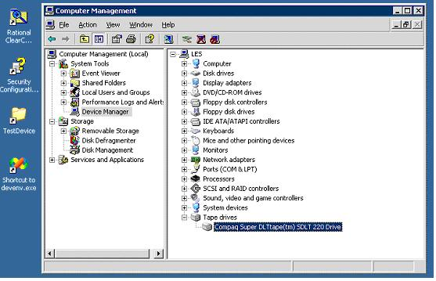

***Picture 1***

Perform mouse right click on your tape device node and choose Tape Symbolic Name tab. In this tab you can see tape symbolic name, Tape0 in our example (see Picture 2). This name can be used to create a handle for your device.

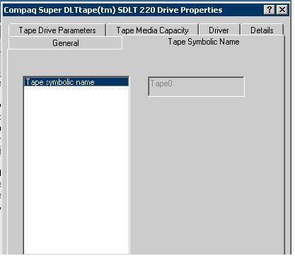

***Picture 2***

So the appropriate file name for your device is *@file://./Tape0*.