4. Results
This section presents the empirical results of the proposed capital allocation framework, with the objective of evaluating how banks optimally balance profitability and liquidity under varying economic conditions and modeling assumptions. The analysis is structured along two key dimensions: (i) different macro-financial environments, captured through four representative states, and (ii) different modeling approaches, namely deterministic and stochastic optimization.
The first dimension reflects the fact that bank balance sheets and liquidity conditions are inherently state-dependent. To capture this, the analysis considers four distinct scenarios: a representative benchmark state, a current state reflecting recent post-regulatory conditions, a stress scenario corresponding to the global financial crisis of 2007–2009, and a more recent stress period during the COVID-19 pandemic (2019–2021). These states are designed to span a broad spectrum of economic environments, ranging from stable conditions to periods of severe market disruption. By structuring the analysis in this way, the study is able to isolate how changes in funding conditions, liquidity pressures, and market dynamics affect both the feasibility and optimality of capital allocation decisions.
This state-based approach is particularly important in the context of liquidity regulation. Under the Basel III framework, metrics such as the Liquidity Coverage Ratio (LCR) are highly sensitive to both the composition of liabilities and the behavior of cash flows under stress. As a result, a portfolio that appears optimal in a stable environment may become infeasible or suboptimal under adverse conditions. By explicitly modeling multiple states, the analysis avoids relying on a single “average” scenario and instead captures the structural shifts that occur during periods of financial stress. This is crucial for understanding not only the level of risk, but also the robustness of allocation strategies across different economic regimes.
The second dimension of the analysis concerns the modeling framework itself. The study distinguishes between deterministic and stochastic optimization approaches. In the deterministic setting, key inputs such as interest rates and liquidity outflows are treated as fixed and known in advance. This provides a useful benchmark, allowing for a clear characterization of the trade-off between return and liquidity under simplified conditions. However, such an approach inherently ignores uncertainty, particularly the variability and tail risk associated with funding conditions and market dynamics.
To address this limitation, the stochastic model extends the framework by introducing uncertainty in both interest rates and liquidity demand. Instead of producing single-point estimates, the stochastic approach generates distributions of outcomes, thereby capturing not only expected performance but also variability and downside risk. This distinction is critical in a banking context, where extreme but plausible scenarios—such as sudden liquidity shocks or adverse interest rate movements—can have disproportionate impacts on solvency and regulatory compliance. By incorporating stochastic elements, the model is able to evaluate more realistic and robust allocation strategies that remain feasible under a wider range of conditions.
Importantly, the combination of these two dimensions—multiple economic states and stochastic modeling—allows for a comprehensive assessment of bank behavior. The deterministic model provides a baseline understanding of optimal allocation under idealized conditions, while the stochastic model reveals how these strategies adjust when uncertainty is taken into account. At the same time, the comparison across states highlights how macro-financial environments influence both the level of risk and the effectiveness of regulatory constraints.
The remainder of this section is organized as follows. Section 4.1 presents the baseline financial and liquidity position of the bank across the four states, establishing the structural differences that motivate the optimization analysis. Section 4.2 reports the results of the deterministic optimization model, focusing on the trade-off between profitability and liquidity. Section 4.3 introduces the stochastic framework and examines how uncertainty affects optimal allocation and risk profiles. Section 4.4 compares results across states, highlighting the role of economic conditions, while Sections 4.5 and 4.6 provide scenario analysis, sensitivity analysis, and key economic insights.
  - Baseline financial and liquidity position
Table 4.1: Baseline financial and liquidity metrics across states
State | HQLA | Outflows | Inflows | LCR (%) | ROA (%)
Representative | 380,821 | 864,083 | 323,082 | 70.4 | 5.23
Current (Dec 2025) | 1,151,098 | 1,821,490 | 692,073 | 101.9 | 4.70
Crisis (2007–09) | 164,552 | 452,875 | 163,005 | 56.8 | 6.86
COVID (2019–21) | 541,142 | 1,123,836 | 402,317 | 75.0 | 2.68

This section establishes the baseline financial structure and liquidity position of the bank across the four considered states: a representative benchmark, the current period, the global financial crisis (2007–2009), and the COVID-19 period (2019–2021). Table 4.1 summarizes the key liquidity and performance metrics, while Table 4.2 reports the corresponding portfolio allocations. Together, these provide a comprehensive view of how balance sheet composition translates into liquidity risk and profitability under different economic conditions.
A first key insight emerging from Table 4.1 is the strong variation in liquidity adequacy across states. Only the current state satisfies the Basel III requirement, with an LCR slightly above 100%, whereas all other states fall significantly below the regulatory threshold. The crisis period exhibits the weakest liquidity position, with an LCR of 56.8%, while the representative and COVID-19 states remain moderately below compliance at 70.4% and 75.0%, respectively. This pattern indicates that, in the absence of favorable conditions or regulatory discipline, the bank’s baseline balance sheet structure tends to generate insufficient liquidity buffers. In particular, the crisis state combines relatively low HQLA with substantial net cash outflows, resulting in a pronounced liquidity shortfall. Even in the COVID-19 period, where HQLA levels are considerably higher, liquidity remains inadequate due to persistently elevated outflows, suggesting that increases in liquid asset holdings alone are insufficient when funding pressures intensify.
Table 4.2: Portfolio Allocation Weights Across States
State | Cash & Reserves | Interbank lending | Government bonds | Corporate bonds | Government loans | Domestic loans
Representative | 4.28% | 28.24% | 14.76% | 1.53% | 3.56% | 47.63%
Current (Dec 2025) | 8.57% | 32.68% | 19.35% | 1.02% | 2.95% | 35.43%
Crisis (2007–09) | 3.98% | 27.20% | 12.48% | 0.47% | 2.37% | 53.51%
COVID (2019–21) | 3.28% | 25.70% | 17.20% | 2.14% | 3.48% | 48.20%

The underlying drivers of these liquidity outcomes become clearer when considering the portfolio composition reported in Table 4.2. Across all states, a substantial proportion of the portfolio is concentrated in the sixth asset category, with weights ranging from 35.4% in the current state to over 53.5% during the financial crisis. This concentration becomes more pronounced under stress, particularly in the crisis scenario, where the reallocation toward a single dominant asset coincides with reduced diversification across other components. A similar, though less extreme, pattern is observed in the COVID-19 state. In contrast, the current state exhibits a more balanced allocation, with relatively higher exposure to the second and third asset classes, indicating a more diversified and potentially more resilient structure. This suggests that improved diversification, rather than simply higher liquidity buffers, plays an important role in achieving regulatory compliance.
A further important observation concerns the interaction between cash flow dynamics and liquidity risk. As shown in Table 4.1, the current state benefits from relatively strong inflows, which help offset gross outflows and support compliance with the LCR requirement. In contrast, the crisis state is characterized by a combination of elevated outflows and comparatively weak inflows, leading to the largest net liquidity gap among all scenarios. The representative and COVID-19 states lie between these extremes, but still exhibit structural imbalances where inflows are insufficient to materially reduce net outflows. This is consistent with the Basel III framework, where inflows are effectively constrained and cannot fully compensate for stressed outflow conditions, reinforcing the importance of maintaining sufficiently large stocks of high-quality liquid assets.
The profitability profile reported in Table 4.1 reveals a clear and economically meaningful trade-off with liquidity. The crisis state delivers the highest return, followed by the representative state, while the current and COVID-19 states exhibit progressively lower returns. This inverse relationship indicates that higher returns are achieved through balance sheet configurations that are less liquid and more exposed to funding risk. In particular, the crisis state combines the highest return with the weakest liquidity position, highlighting a configuration that is profitable but not sustainable under regulatory constraints. Conversely, the current state, which is the only one meeting the LCR requirement, exhibits a more moderate return, reflecting the cost associated with maintaining adequate liquidity buffers and a more diversified asset allocation.
Taken together, these results highlight three central insights. First, liquidity risk is strongly state-dependent and deteriorates significantly under stressed conditions. Second, regulatory compliance is not naturally achieved by the bank’s baseline allocation, but instead requires structural adjustments in both asset composition and funding dynamics. Third, there exists a clear trade-off between profitability and liquidity, whereby higher returns are associated with weaker liquidity positions. These findings provide a strong motivation for the optimization framework developed in the subsequent sections, where the objective is to identify allocation strategies that balance these competing objectives while satisfying regulatory constraints, particularly under uncertainty.
Building on the baseline analysis, it is evident that the bank’s current balance sheet configurations fail to simultaneously achieve both regulatory liquidity requirements and attractive profitability levels in most states. This highlights the need for a systematic framework that explicitly balances these competing objectives. To address this, the following section introduces the deterministic optimization model, which provides a benchmark for optimal capital allocation under simplified, certainty-based assumptions.
  - Deterministic optimization results
    - Pareto Frontier Analysis
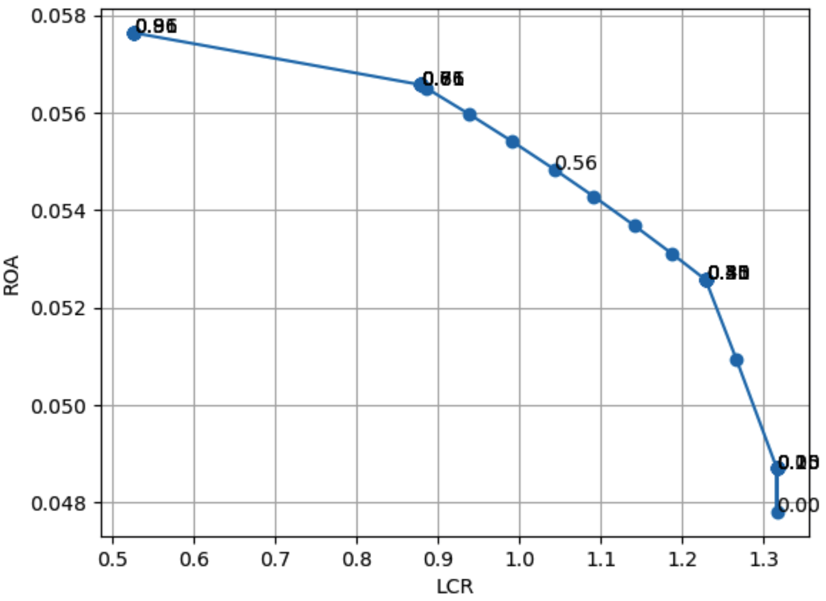
Figure 4.1: Pareto frontier of representative state in determininistic model
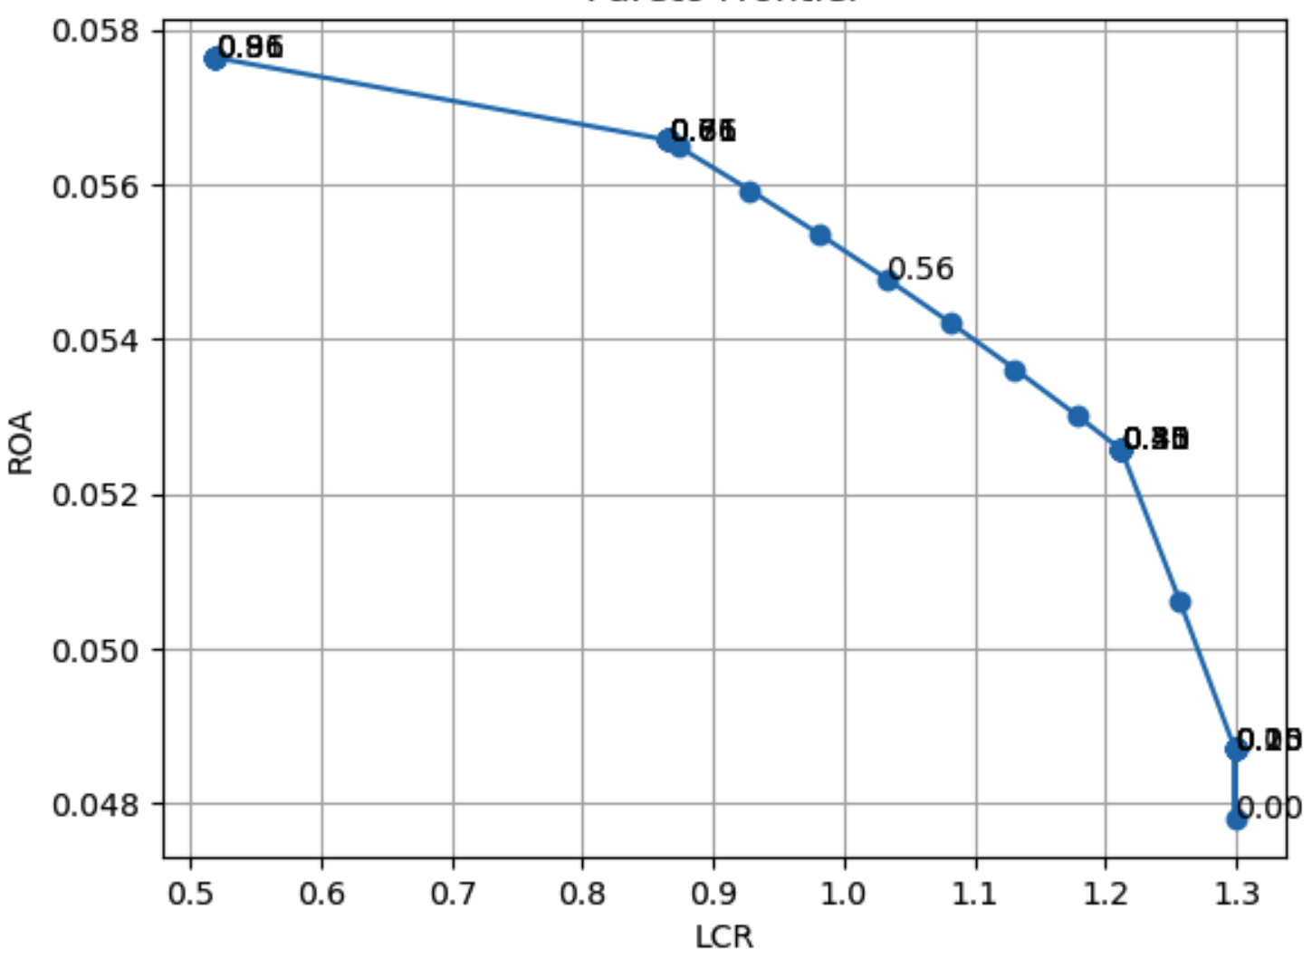
Figure 4.2: Pareto frontier of current state (Dec 2025) in determininistic model

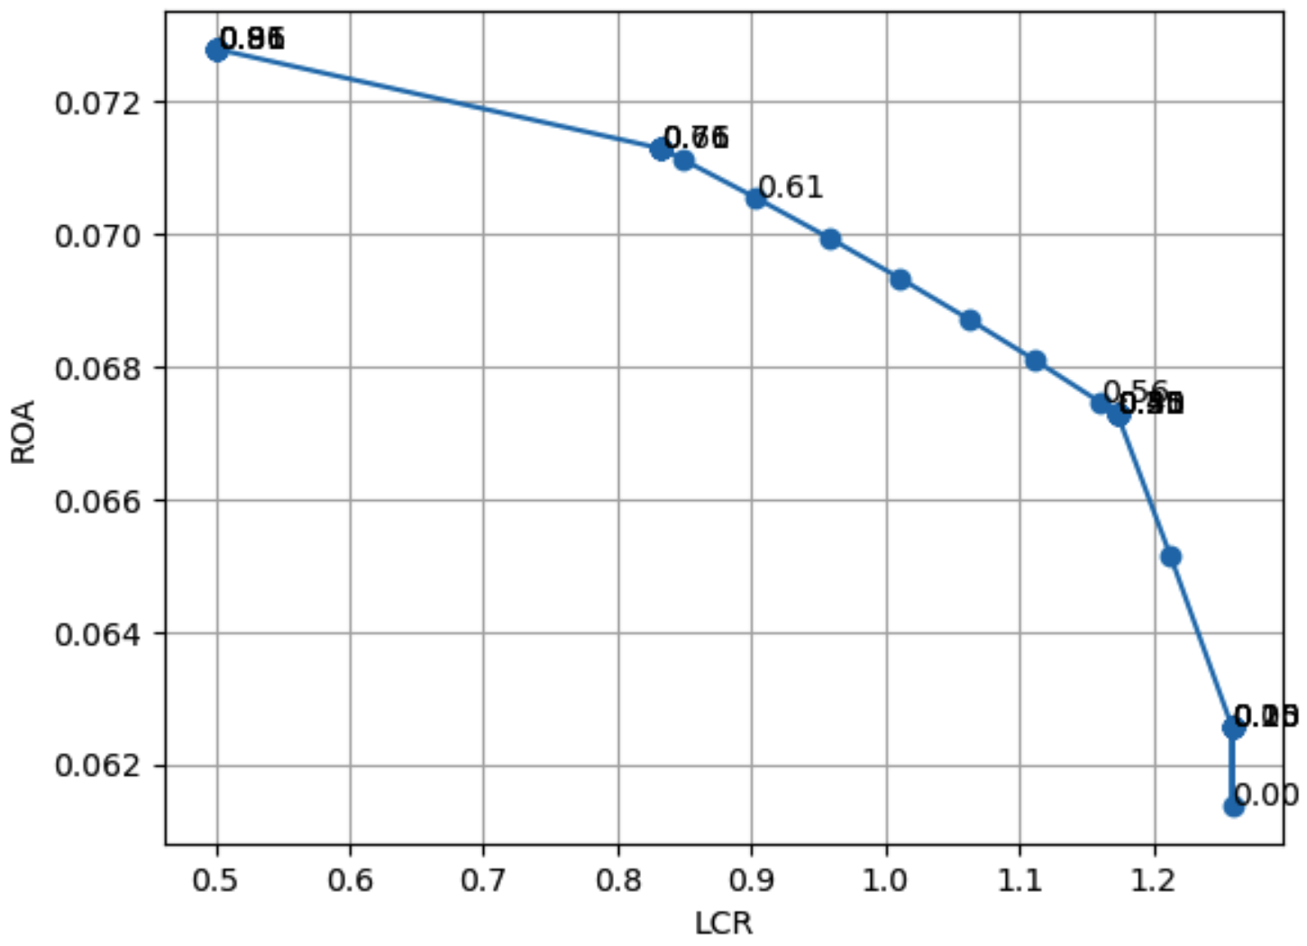
Figure 4.3: Pareto frontier of financial crisis state (2007 - 2009) in determininistic model
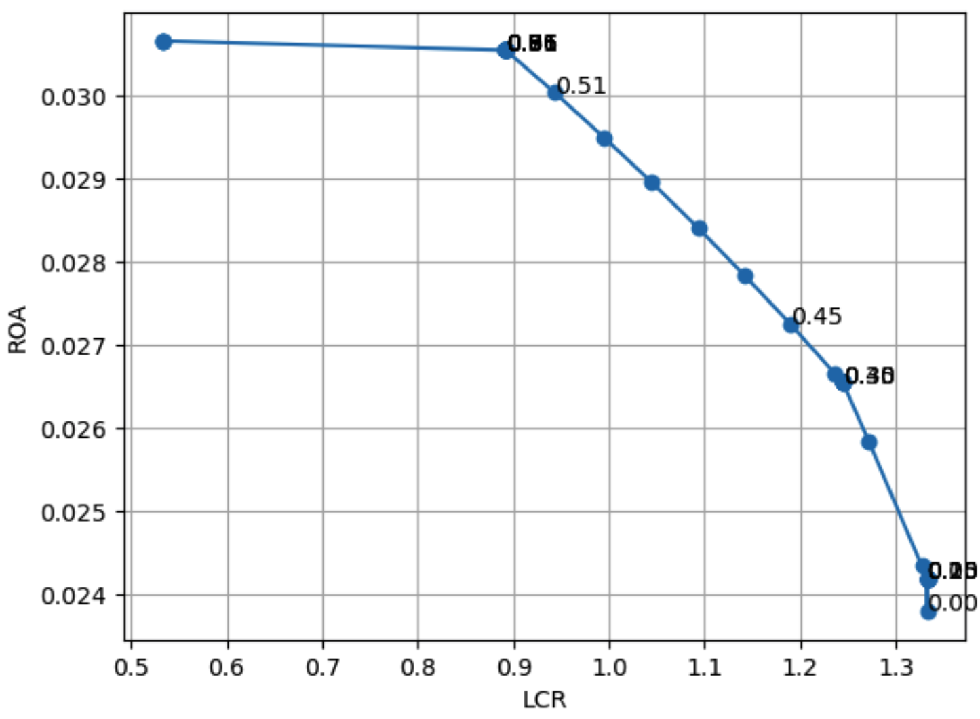
Figure 4.3: Pareto frontier of COVID pandemic state (2019 – 2021) in determininistic model
The deterministic optimization model provides a benchmark for understanding the trade-off between profitability and liquidity under certainty across different economic states. Figures 4.1–4.4 present the Pareto frontiers for the representative, current, crisis (2007–2009), and COVID-19 states, respectively. Each point on the frontier corresponds to an optimal portfolio for a given preference parameter, reflecting different trade-offs between return maximization and liquidity preservation.
Across all states, the Pareto frontiers exhibit a consistent downward-sloping and convex shape, indicating a well-defined and economically intuitive trade-off. As the Liquidity Coverage Ratio (LCR) increases, the return on assets (ROA) declines monotonically, reflecting the cost of maintaining higher levels of high-quality liquid assets. The convexity of the frontier further suggests that this trade-off is nonlinear: small reductions in liquidity above regulatory levels result in limited gains in return, whereas more aggressive reductions in LCR generate disproportionately larger improvements in profitability. This implies that the marginal cost of liquidity increases as banks move toward more conservative positions.
While the qualitative structure of the trade-off is stable, important quantitative differences emerge across states. The crisis period (2007–2009) achieves the highest levels of return across the frontier, reflecting elevated spreads and risk premia during stressed conditions. In contrast, the COVID-19 state exhibits significantly lower returns for comparable levels of LCR, indicating a more constrained profitability environment. The representative and current states occupy an intermediate position, with similar frontier shapes and ranges. These differences suggest that while the trade-off itself is structural, the attainable performance levels are strongly influenced by the macro-financial environment.
A further important observation is that the Basel III regulatory threshold (LCR = 1) lies within the interior of the Pareto frontier in all states. This implies that regulatory compliance does not correspond to an extreme allocation, but rather to a feasible region where both liquidity and profitability can be jointly balanced. However, moving toward higher returns beyond this region requires accepting a rapid deterioration in liquidity, highlighting the tension between regulatory requirements and profit-seeking behavior.
    - Optimal Portfolio Allocation at α = 0.5
To provide a concrete illustration of portfolio structure along the Pareto frontier, this section focuses on the allocation corresponding to a balanced preference parameter (α = 0.5), which places equal weight on profitability and liquidity objectives. This point lies in the interior of the Pareto frontier and represents a compromise solution between return maximization and regulatory compliance.

Table 4.3: Optimal Allocation and Performance at α = 0.5

State | Cash & Reserves | Interbank lending | Government bonds | Corporate bonds | Government loans | Domestic loans | LCR | ROA (%)
Representative | 2.0% | 20.0% | 30.0% | 16.0% | 2.0% | 30.0% | 1.229 | 5.26
Current | 2.0% | 20.0% | 30.0% | 16.0% | 2.0% | 30.0% | 1.212 | 5.26
Crisis (2007–09) | 2.0% | 20.0% | 30.0% | 16.0% | 2.0% | 30.0% | 1.173 | 6.73
COVID (2019–21) | 2.0% | 20.0% | 13.9% | 32.1% | 2.0% | 30.0% | 0.969 | 2.98

The resulting optimal allocations and performance metrics are reported in Table 4.3. A striking result is the convergence to an identical allocation vector across the representative, current, and financial crisis states, given by (2%, 20%, 30%, 16%, 2%, 30%). Despite substantial differences in baseline liquidity conditions and return levels, the deterministic model consistently identifies the same portfolio structure as optimal under balanced preferences. This allocation achieves LCR values above the regulatory threshold in all three states, while delivering competitive returns, particularly in the crisis scenario.
This convergence suggests that, within the deterministic framework, the optimization problem exhibits a form of structural invariance. The relative attractiveness of asset classes remains unchanged across states, leading to a single dominant allocation strategy when equal importance is assigned to liquidity and profitability. From an economic perspective, the allocation reflects a balance between yield-generating and liquidity-supporting assets. The third and sixth asset classes receive the largest weights, indicating their central role in driving returns, while the second and fourth components provide diversification and contribute to maintaining liquidity. The relatively small weights assigned to the first and fifth components suggest that these assets are less efficient in improving either objective.
The COVID-19 state represents a notable deviation from this pattern. In this case, the model reallocates weight from the third to the fourth asset class, resulting in a more conservative structure. This shift suggests that under lower return conditions, the model prioritizes assets with more favorable liquidity characteristics or more stable performance. However, despite this adjustment, the resulting LCR remains below the regulatory threshold, indicating that even the optimal deterministic allocation may fail to ensure compliance in certain environments.
    - Cross-state comparison and structural implications
A comparison across states reveals an important limitation of the deterministic framework. While the model successfully captures differences in achievable return levels, ranging from high profitability in crisis periods to subdued returns during COVID-19, it fails to generate meaningful variation in optimal portfolio composition. The persistence of identical allocations across multiple states suggests that the model is primarily driven by relative asset characteristics rather than by state-dependent risk factors.
In practice, banks adjust their balance sheets significantly in response to changing economic conditions, particularly during periods of stress. The lack of sensitivity observed here indicates that the deterministic model does not fully capture the dynamics of liquidity risk, funding instability, or uncertainty in market conditions. Instead, it implicitly assumes that all relevant parameters are known with certainty and remain stable across states.
This limitation is particularly evident in the COVID-19 scenario, where the model is unable to achieve regulatory compliance even after adjusting the portfolio composition. This suggests that deterministic optimization may underestimate the severity of liquidity constraints under certain conditions and fail to identify sufficiently robust strategies.
    - Key insights from the deterministic model
The deterministic results highlight three central insights. First, the trade-off between profitability and liquidity is stable, well-defined, and characterized by a convex Pareto frontier. Second, regulatory compliance is generally achievable within a reasonable region of the frontier, but requires accepting a reduction in returns. Third, and most importantly, the optimal allocation is largely invariant across states when preferences are balanced, indicating that the deterministic framework lacks sensitivity to changes in economic conditions.
This invariance represents a critical limitation. By ignoring uncertainty and treating key inputs as fixed, the model abstracts away from the very risks that drive bank behavior in practice. As a result, it may overstate the robustness of a single optimal allocation and underestimate the need for adaptive strategies.
These findings provide a strong motivation for extending the analysis to a stochastic framework. While the deterministic model provides a clear benchmark for the trade-off between profitability and liquidity, the results reveal an important limitation: the optimal allocation remains largely invariant across different economic states. This lack of sensitivity suggests that the model fails to capture the uncertainty and state-dependent risks that are central to bank decision-making in practice. To address this limitation, the following section extends the framework by incorporating stochastic interest rates and liquidity demand, allowing for a more realistic and robust assessment of optimal capital allocation.
  - Stochastic optimization results
    - Pareto analysis
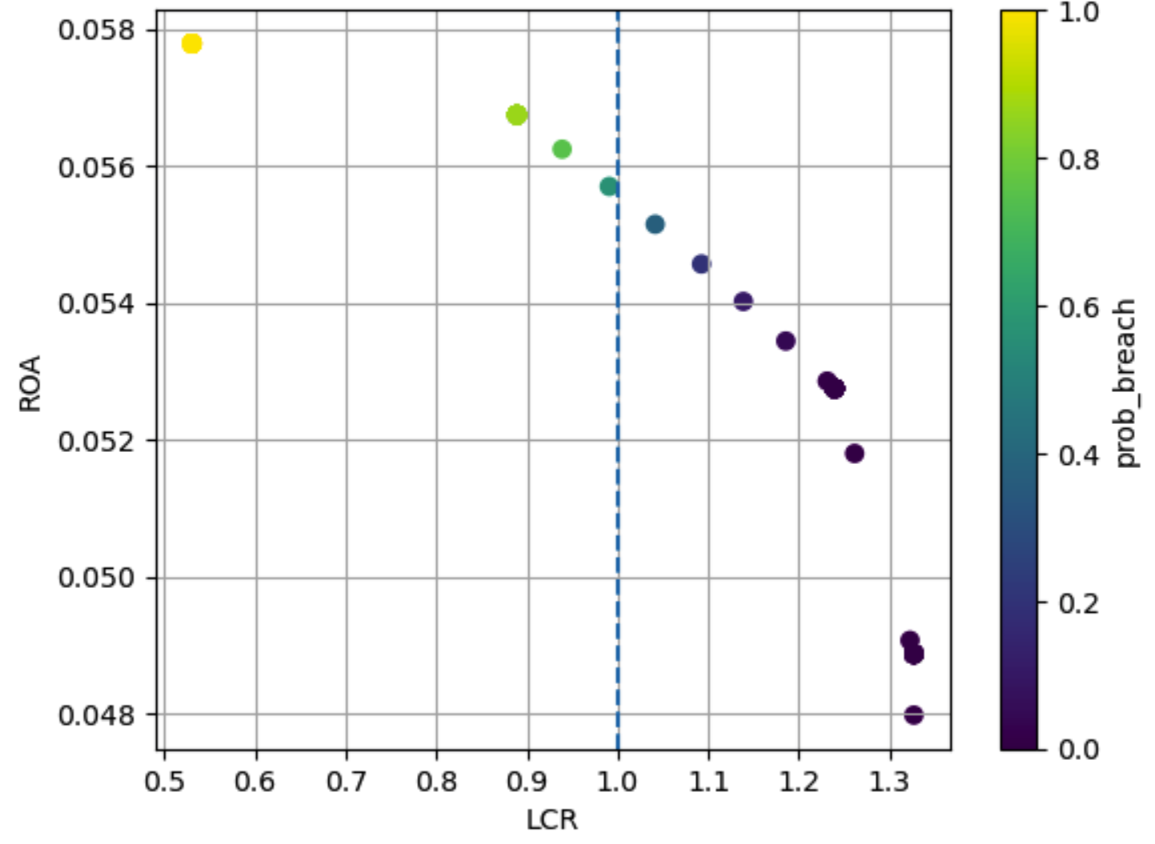
Figure 4.5: Pareto frontier of representative state in stochastic model

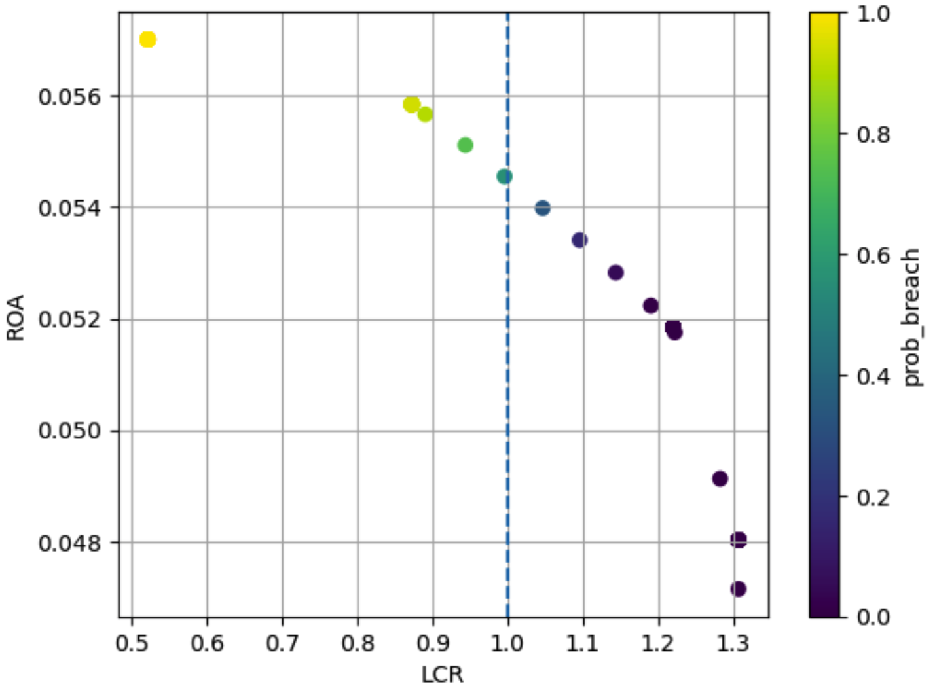
Figure 4.6: Pareto frontier of current state (Dec 2025) in stochastic model

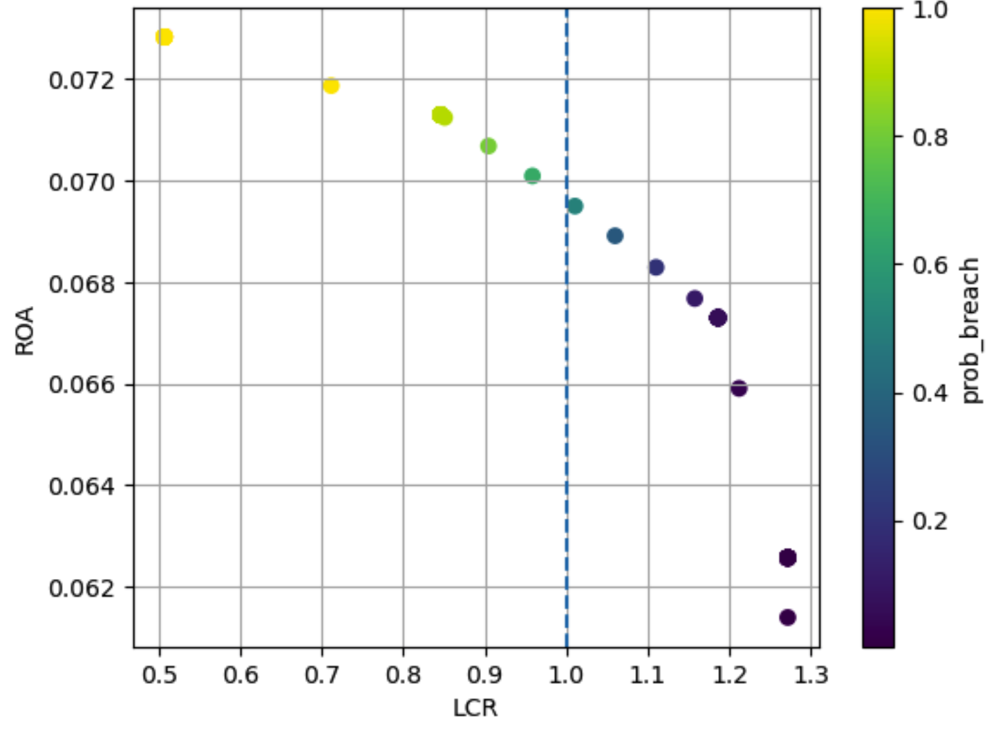
Figure 4.7: Pareto frontier of financial crisis state (2007-2009) in stochastic model

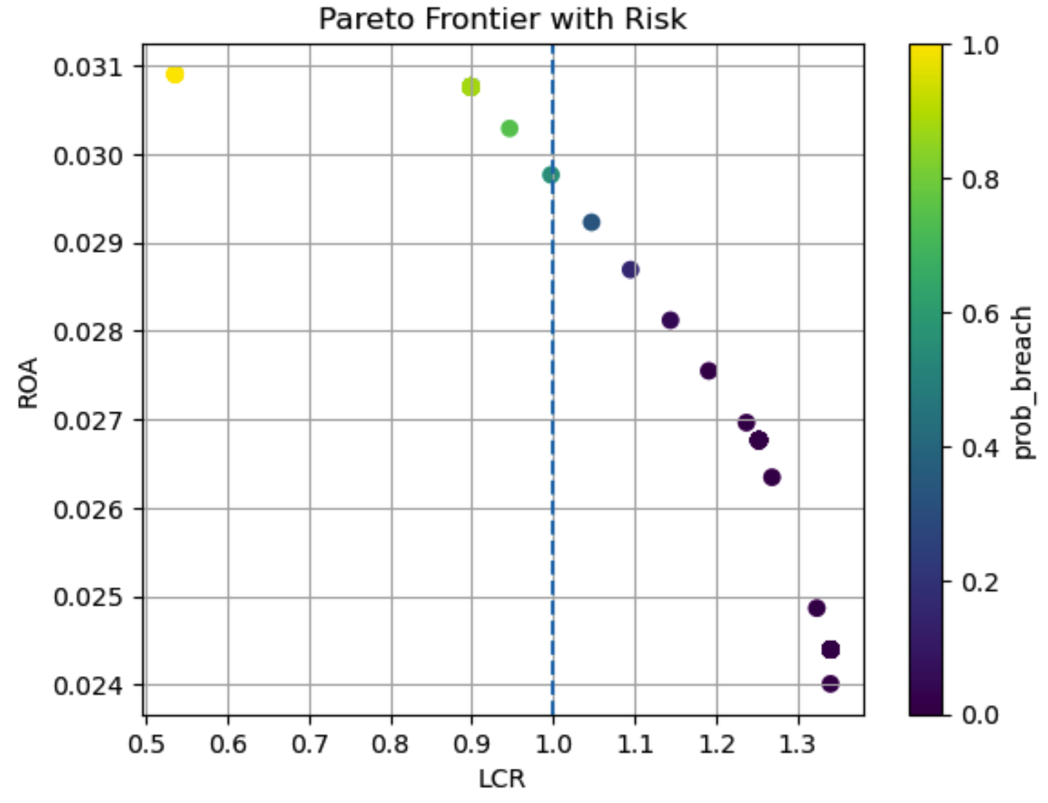
Figure 4.8: Pareto frontier of COVID pandemic state (2019-2021) in stochastic model

The stochastic Pareto frontiers provide further insight into how uncertainty affects the trade-off between profitability and liquidity. Figures 4.5–4.8 illustrate the risk-adjusted Pareto frontiers for each state, where each point is additionally characterized by the probability of breaching the LCR requirement.
Compared to the deterministic case, the overall shape of the Pareto frontier remains downward-sloping and convex, indicating that the fundamental trade-off between return and liquidity persists even under uncertainty. However, a key difference emerges in the interpretation of the frontier. Rather than representing a set of equally feasible optimal solutions, the stochastic frontier reveals a gradient of risk across portfolios, as reflected by the probability of LCR violation.
In particular, portfolios located to the left of the regulatory threshold (LCR < 1) are associated with high probabilities of breach, often approaching certainty in extreme cases. As portfolios move toward higher levels of LCR, the probability of violation declines sharply, indicating that liquidity buffers play a critical role in mitigating downside risk. This transition is especially steep around the regulatory boundary, suggesting that small increases in LCR near the threshold can lead to significant reductions in risk.
The differences across states are particularly pronounced. In the representative and current states, most portfolios with LCR above 1 exhibit very low probabilities of violation, indicating a relatively stable and resilient environment. In contrast, the crisis state shows a wider dispersion of risk, with even some portfolios near the regulatory threshold exhibiting non-negligible probabilities of breach. This reflects the heightened uncertainty and volatility associated with stressed financial conditions.
The COVID-19 state displays the most extreme behavior. A large portion of the frontier lies in regions with high violation probability, including portfolios with LCR values close to or even above 1. This suggests that, under severe and persistent stress, maintaining an LCR near the regulatory threshold may not be sufficient to ensure robustness. Instead, substantially higher liquidity buffers may be required to achieve acceptable risk levels.
Overall, the stochastic Pareto frontiers demonstrate that optimal portfolio selection cannot be based solely on expected return and liquidity levels. Instead, the risk associated with constraint violations must be explicitly considered. This highlights the importance of extending the optimization framework beyond deterministic metrics and incorporating probabilistic measures of regulatory compliance.
    - Distribution of outcomes and risk characterization
To address the limitations of the deterministic framework, the optimization model is extended to incorporate stochastic interest rates and liquidity demand. Unlike the deterministic case, where outcomes are represented by single-point estimates, the stochastic model generates distributions of key variables, allowing for a more comprehensive assessment of both expected performance and downside risk.
Table 4.4 summarizes the expected outcomes, worst-case realizations, and probabilities of regulatory breach across the four states as following:
Table 4.4: Stochastic outcomes at α = 0.5
State | Expected ROA (%) | Expected LCR | Worst LCR | P(LCR < 1)
Representative | 5.27 | 1.239 | 1.055 | 0.5%
Current | 5.18 | 1.220 | 1.069 | 0.3%
Crisis (2007–09) | 6.73 | 1.186 | 0.992 | 6.2%
COVID (2019–21) | 3.00 | 0.972 | 0.846 | 65.1%
The results reveal that incorporating uncertainty fundamentally changes the interpretation of liquidity risk. While expected LCR values remain above the regulatory threshold in most states, the distributional perspective highlights the presence of tail risk that is completely absent in the deterministic framework. In particular, the crisis state exhibits a non-negligible probability of breaching the LCR requirement (6.2%), despite having an expected LCR above 1. This indicates that compliance in expectation does not guarantee robustness under adverse conditions. The COVID-19 state represents an extreme case, where the expected LCR already falls below the regulatory threshold, and the probability of violation exceeds 65%. Moreover, the worst-case LCR drops significantly below 1, indicating severe vulnerability under stressed realizations. This highlights that in certain environments, liquidity risk is not only a tail event but a dominant characteristic of the system. In contrast, the representative and current states exhibit relatively low probabilities of violation (below 1%), with worst-case LCR values remaining above or close to the regulatory threshold. This suggests that under stable conditions, the bank’s allocation is robust to moderate fluctuations, although some residual risk remains.
A direct comparison with the deterministic model reveals a fundamental difference in how liquidity risk is captured. In the deterministic framework, the LCR constraint appears to be satisfied in several states, and the optimal allocation remains invariant across different environments. However, once uncertainty is introduced, this apparent robustness is significantly weakened.
The key distinction lies in the shift from point estimates to distributions. While deterministic results suggest that a given portfolio satisfies the LCR requirement, the stochastic model demonstrates that the same portfolio may violate the constraint with non-negligible probability. This is particularly evident in the crisis state, where the deterministic LCR exceeds 1, yet stochastic realizations reveal a meaningful likelihood of falling below the regulatory threshold.
This discrepancy highlights a critical limitation of deterministic optimization: it systematically underestimates risk by ignoring variability and tail events. As a result, it may lead to overly optimistic conclusions regarding regulatory compliance and portfolio robustness.
4.3.3 Optimal allocation under uncertainty
Table 4.5: Optimal allocation under stochastic model (α = 0.5)
State | Cash & Reserves | Interbank lending | Government bonds | Corporate bonds | Government loans | Domestic loans
Representative | 2.0% | 20.0% | 30.0% | 16.0% | 2.0% | 30.0%
Current | 2.0% | 20.0% | 30.0% | 16.0% | 2.0% | 30.0%
Crisis (2007–09) | 2.0% | 20.0% | 30.0% | 16.0% | 2.0% | 30.0%
COVID (2019–21) | 2.0% | 20.0% | 13.7% | 32.3% | 2.0% | 30.0%
Despite the introduction of stochastic elements, the optimal allocation at α = 0.5 remains largely unchanged for the representative, current, and crisis states, coinciding with the deterministic solution. This reinforces the observation that the optimization problem exhibits structural stability in terms of relative asset preferences. The optimal allocations under the stochastic framework are reported in Table 4.5. Consistent with the deterministic case, the states converge to an identical portfolio structure at α = 0.5, while the COVID-19 state exhibits a reallocation toward the fourth asset class. This result suggests that while stochastic modeling significantly alters the risk profile of the portfolio, it does not necessarily lead to substantial changes in the optimal allocation structure under balanced preferences.
The interpretation of this result changes significantly in the stochastic context. While the same allocation is identified as optimal, it is no longer guaranteed to satisfy regulatory constraints across all realizations. Instead, the portfolio must be evaluated in terms of its risk profile, including the likelihood and severity of constraint violations. The COVID-19 state again represents an important deviation. Similar to the deterministic case, the model shifts allocation toward the fourth asset class, indicating a preference for more stable or liquid assets under adverse conditions. Nevertheless, this adjustment is insufficient to ensure compliance, as the probability of LCR violation remains high. This suggests that under severe stress, even structurally different allocations may fail to fully mitigate liquidity risk.
    - Key insights from the stochastic model
A key advantage of the stochastic framework is the ability to explicitly quantify constraint risk. The probability of LCR breach provides a direct measure of how often regulatory requirements are violated under uncertainty.
The results show a clear gradient of risk across states. The representative and current states exhibit negligible violation probabilities, indicating that the LCR constraint is effectively non-binding in most realizations. In contrast, the crisis state shows moderate risk, where the constraint becomes binding in a subset of scenarios. Finally, the COVID-19 state is characterized by a high probability of violation, indicating that the constraint is effectively binding under most realizations. This progression illustrates that liquidity risk is highly state-dependent and becomes significantly more pronounced under stressed conditions. Importantly, it also demonstrates that the LCR constraint should not be interpreted as a binary condition (satisfied vs. violated), but rather as a probabilistic constraint that reflects the distribution of outcomes.
The stochastic results provide several important insights that extend and refine the conclusions from the deterministic analysis. First, while the trade-off between profitability and liquidity remains structurally similar, the introduction of uncertainty reveals that risk is concentrated in the tails of the distribution. Second, regulatory compliance cannot be assessed solely based on expected values, as portfolios that appear compliant in expectation may still exhibit significant probabilities of violation. Third, the invariance of optimal allocations across states persists, but no longer implies robustness, as identical portfolios can have very different risk profiles depending on the underlying economic environment.
Most importantly, the stochastic framework demonstrates that liquidity risk is not adequately captured by deterministic models. By explicitly accounting for variability and extreme outcomes, it provides a more realistic assessment of bank behavior and highlights the importance of designing allocation strategies that are robust not only in expectation but also under adverse scenarios. These findings confirm that incorporating stochastic elements is essential for evaluating capital allocation decisions in a regulatory context, and provide a strong justification for the use of multi-objective optimization under uncertainty.

