Name: JianHui (Jake) Li

Lesson 9: Insert and Update

1. **Create** a table with the following parameters:
   * CustomerID
   * CustomerName
   * Address
   * City
   * PostalCode
   * Country
   * Email

CREATE TABLE customers(

CustomerID SERIAL PRIMARY KEY,

CustomerName VARCHAR(100) NOT NULL,

Address VARCHAR(100),

City VARCHAR(50),

PostalCode CHAR(5),

Country VARCHAR(50),

Email VARCHAR(100) NOT NULL)

1. Insert 3 rows of data into these columns using **INSERT**. The data you insert should make sense for the column.

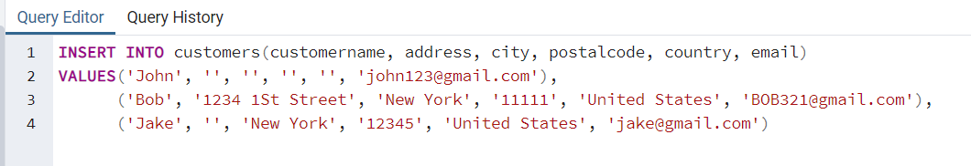

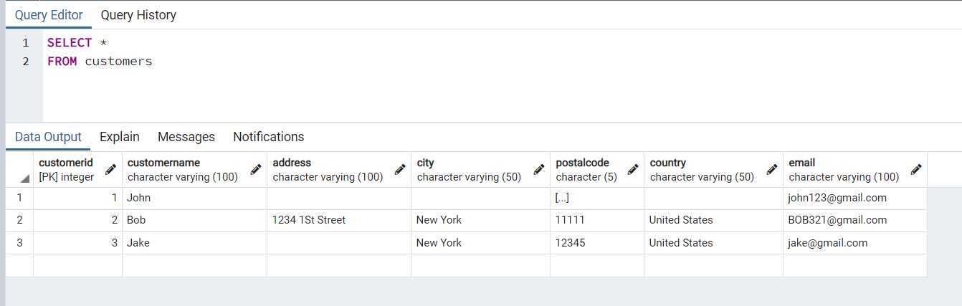

1. Use an **UPDATE** to modify any portion of the data

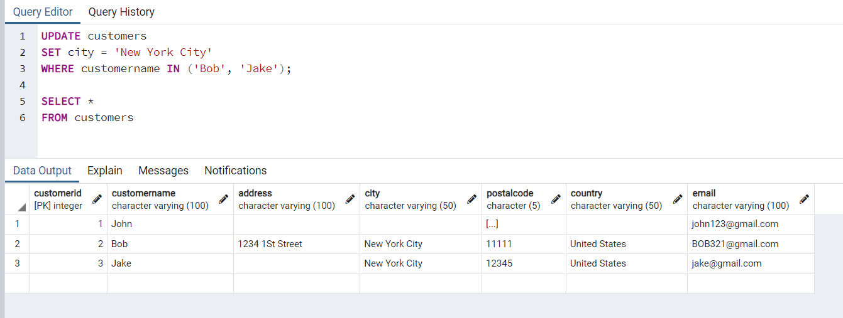

1. Finally, write a statement to **delete** one row of data.

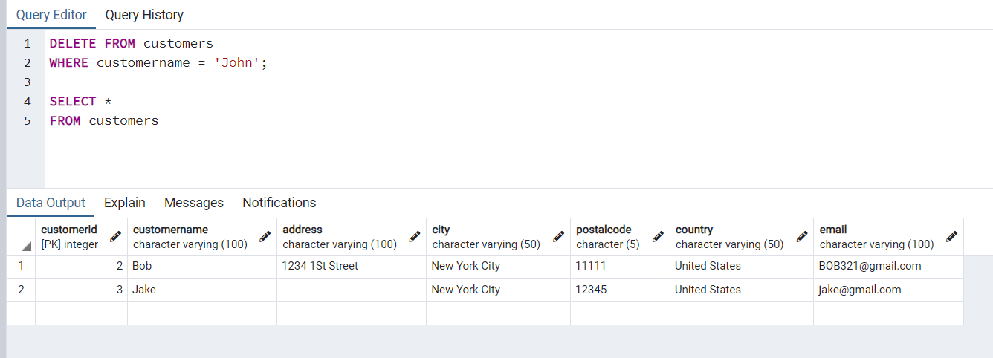

Using the following Link <https://github.com/niteen11/cuny_lagcc_micro_credential_data_analytics/tree/main/Track%20A/Unit%205%20-%20SQL_%20Relational%20Databases/guided%20exercise>

First, you have to create a table then upload the data, save the table into your Laptop and change the path accordingly. Use the following link for creating the table,

<https://github.com/niteen11/cuny_lagcc_micro_credential_data_analytics/blob/main/Track%20A/Unit%205%20-%20SQL_%20Relational%20Databases/guided%20exercise/student.sql>

And attached data set (Student_data and Student_marks), answer the following questions:

1. Students with the highest marks in Unit 4

There are 43 students who have the highest mark (100) in Unit 4.

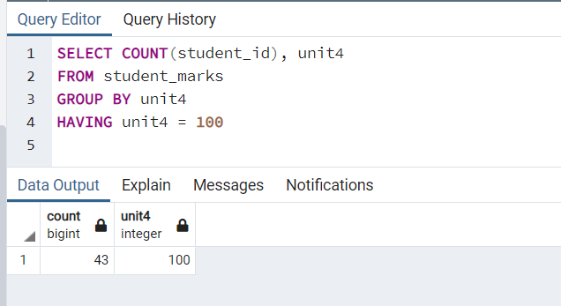

1. Find students scored between 89 and 100 unit4

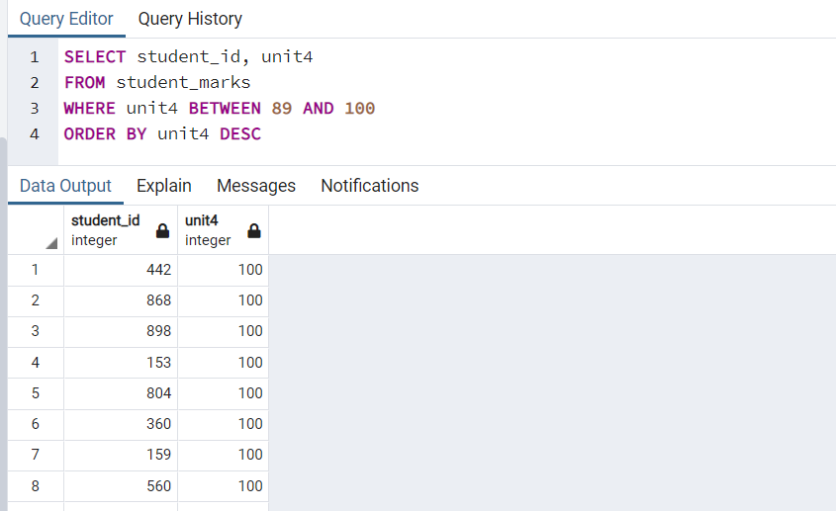

Open-ended questions:

1. Take a closer look at the tables that you created and come up with 10 different scenarios/ questions and form SQL
   1. How many students are male?

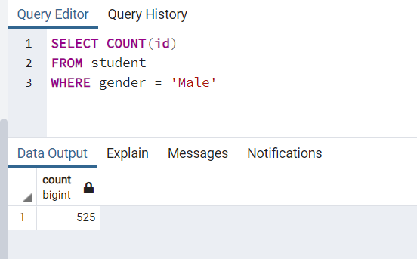

* 1. How many students are female?

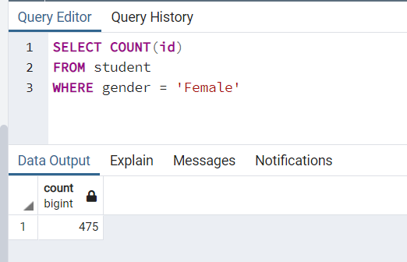

* 1. How many students prefer hard copy books?

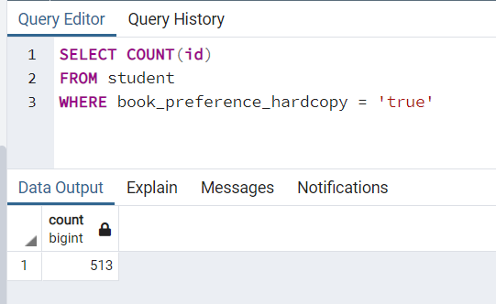

* 1. What is the average grade in unit 2?

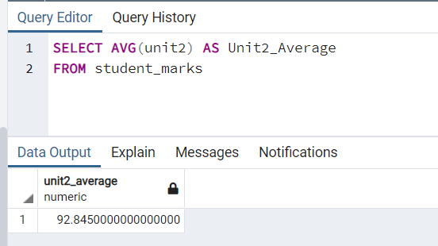

* 1. What is the average grade in unit 4?

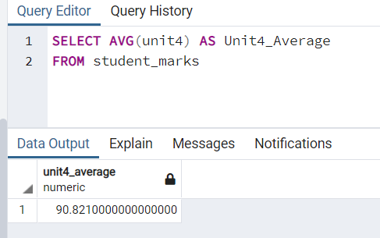

* 1. What is the lowest grade in unit 4?

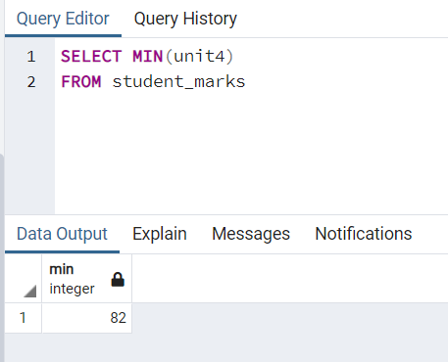

* 1. What is the highest grade in unit 4?

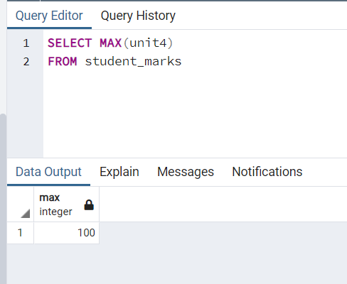

* 1. How many students are there in total?

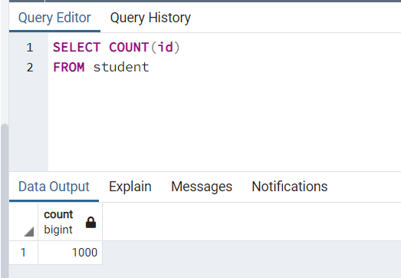

* 1. How many students' first name starts with ‘J’?

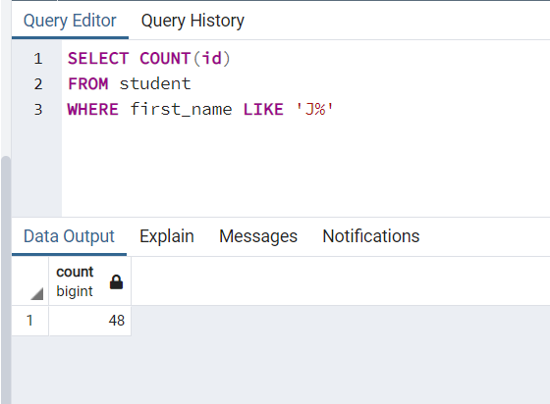

* 1. How many students’ phone number starts with ‘917’?

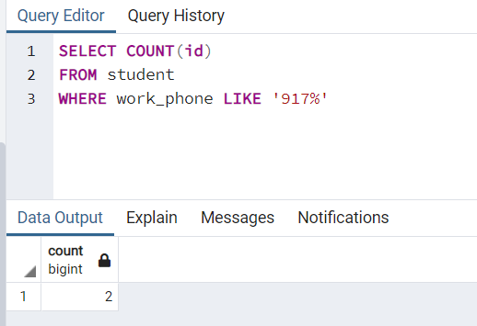

1. Ask your colleagues