ITWS 6250 Database Applications and Systems, Fall 2026
Lab 3: Knowledge Graph Implementation with Neo4j
Name: Jake Mandel
RCS email: mandej@rpi.edu
Level: 6000
Github: https://github.com/JakeMandel03/ITWS4250-6250_Lab3
Part 5: Graded questions
- Full Graph.
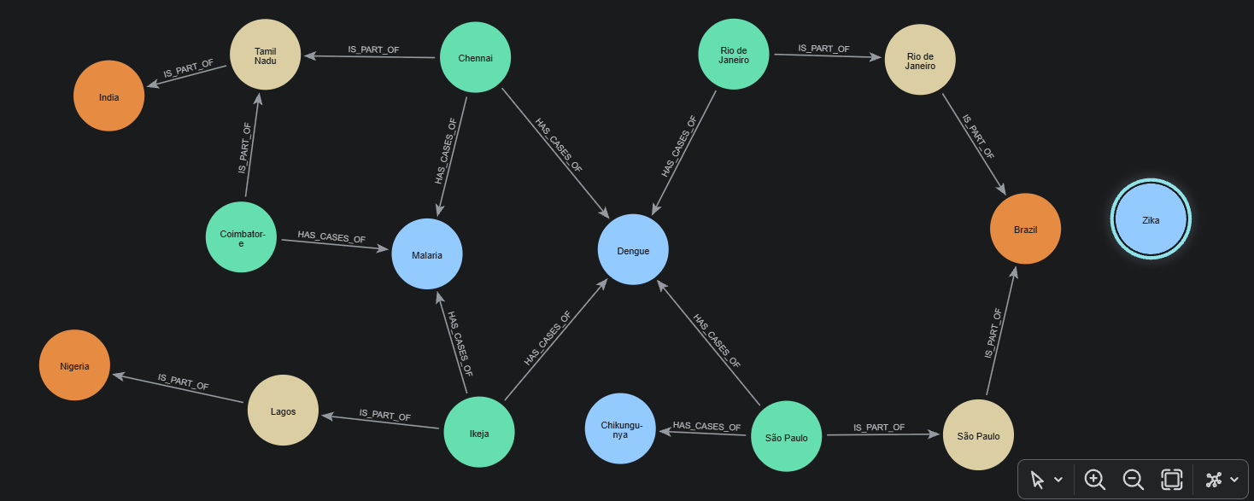
- Total cases per country. For each country, return its name and the sum of case_count over all reports from its cities. Order from the highest total to the lowest.
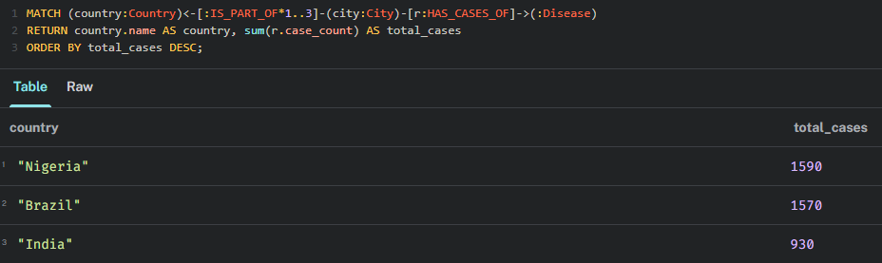
- Diseases across borders. For each disease that has at least one report, return the disease name, the number of different countries that reported it, the list of those countries, and its total cases. Order by total cases, highest first.
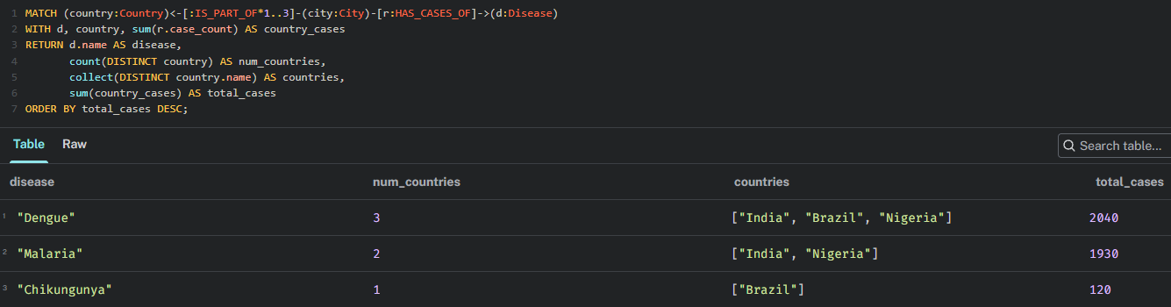
- The single worst outbreak. Find the report with the highest case_count in the whole graph. Return the city, its state, its country, the disease and the number of cases. Then, in one sentence, explain what your query would return if two reports tied for the highest count.
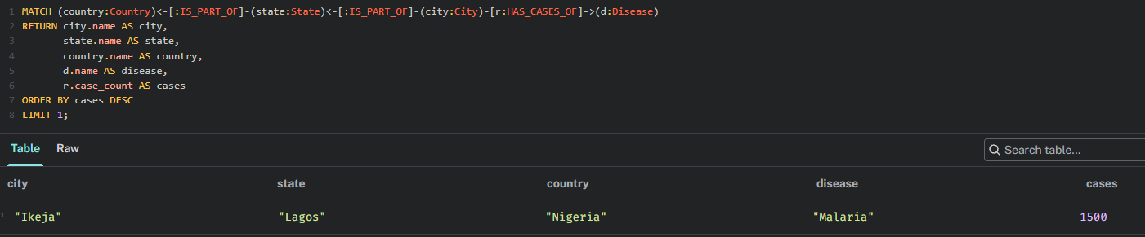
Because LIMIT 1 is applied without a secondary sorting key, if two reports tied for the highest count, Neo4j would return whichever record was processed first.
- Dengue share. For each country, return the Dengue cases, all cases, and Dengue cases as a percentage of all cases, rounded to one decimal place. Order by the percentage, highest first.
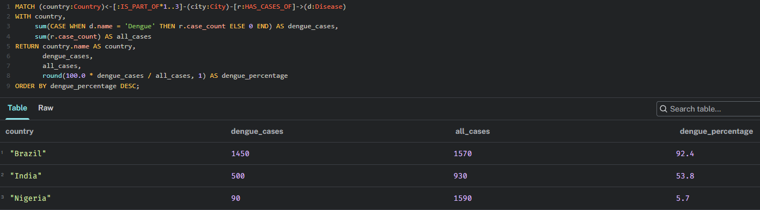
- Graph versus relational. Design a relational schema for the same data with a single Region(region_id, name, admin_level, parent_id) table plus Disease and CaseReport tables. Write the SQL query that answers Q1 (you will need WITH RECURSIVE; see Section 10.2 of the textbook). In 4 to 6 sentences, compare your SQL query with your Cypher query for Q1: which is easier to read, and what would change if a new administrative level (for example, districts between states and cities) were added?
Cypher is much easier to read than SQL because it uses a visual arrow pattern to traverse the hierarchy instead of a recursive CTE. In Neo4j, relationships act as direct pointers between nodes, and on the other hand, relational databases must repeatedly join foreign keys across rows. If an extra administrative level like districts were added, the Cypher query would need no change. However, the SQL query would completely break, and a recursive SQL query becomes harder to manage and slower to run as levels increase.

-- 1. Schema Definitions
CREATE TABLE Region (
region_id VARCHAR(20) PRIMARY KEY,
name VARCHAR(100) NOT NULL,
admin_level INT NOT NULL,
parent_id VARCHAR(20) REFERENCES Region(region_id)
);

CREATE TABLE Disease (
disease_id VARCHAR(20) PRIMARY KEY,
name VARCHAR(100) NOT NULL UNIQUE,
pathogen VARCHAR(100),
vector VARCHAR(100)
);

CREATE TABLE CaseReport (
report_id SERIAL PRIMARY KEY,
region_id VARCHAR(20) NOT NULL REFERENCES Region(region_id),
disease_id VARCHAR(20) NOT NULL REFERENCES Disease(disease_id),
case_count INT NOT NULL,
date_reported DATE NOT NULL
);

-- 2. Recursive Query: Total cases per country
WITH RECURSIVE RegionHierarchy AS (
SELECT
cr.case_count,
r.region_id AS current_region_id,
r.parent_id,
r.admin_level,
r.name AS current_name
FROM CaseReport cr
JOIN Region r ON cr.region_id = r.region_id

UNION ALL

SELECT
rh.case_count,
parent.region_id AS current_region_id,
parent.parent_id,
parent.admin_level,
parent.name AS current_name
FROM RegionHierarchy rh
JOIN Region parent ON rh.parent_id = parent.region_id
)
SELECT
current_name AS country,
SUM(case_count) AS total_cases
FROM RegionHierarchy
WHERE admin_level = 0
GROUP BY current_region_id, current_name
ORDER BY total_cases DESC;

