Assignment 03

1. Write a program to read SASHELP.CARS data set. Using the summary procedure, create a summary data set named ‘carsummry’ containing mean of variable msrp where cylinders values are 4, 6, and 8. Use the COMPLETETYPES and AUTONAME options. Limit the calculations performed to _TYPE_= 0 and combinations of two classification variables (cylinders and make, cylinders and type). by using TYPES statement. Display results using the print procedure.

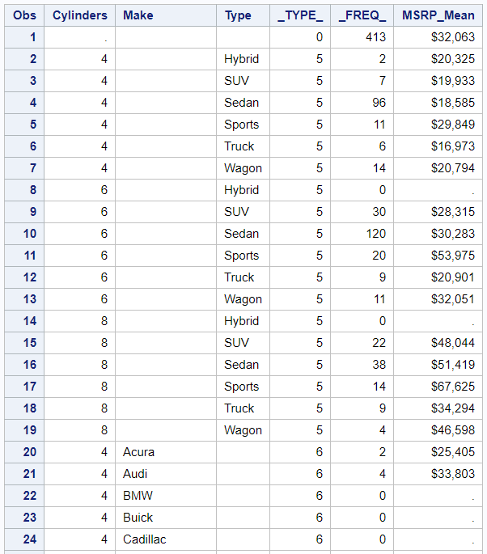

…portions of the table not shown…

1. Write a program to read SASHELP.CARS data set. Using the summary procedure, create a summary data set named ‘carsummry’ containing n, mean, min, and minid of variable msrp where origin value is ‘USA’. Identify the Model of car that has the min msrp for each make, type, and origin. Display results using the print procedure.

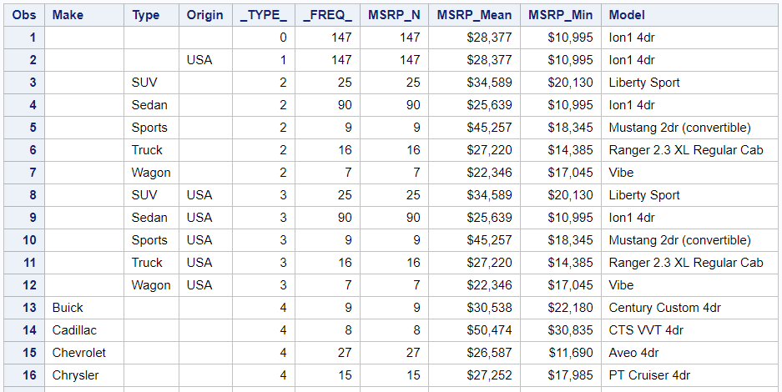

…portions of the table not shown…

1. Write a program to read SASHELP.CARS data set. Using the summary procedure, create a summary data set named ‘carsummry’ containing n, mean, and max of variable mpg_city where type values are ‘SUV’ or ‘Sedan’. Identify the **top two** Model of car that has the max mpg_city values for each make and type. Display results using the print procedure.

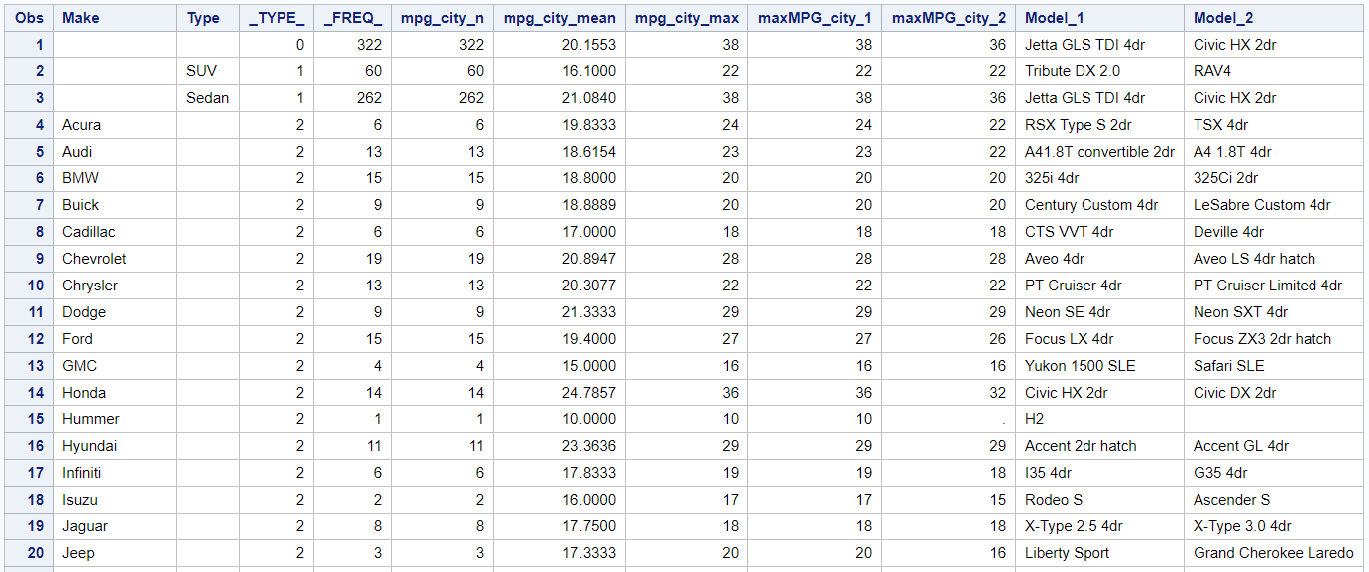

…portions of the table not shown…

1. Write a program to read SASHELP.CARS data set. Using the summary procedure, create a summary data set named ‘carsummry’ containing mean of variable msrp for each type and cylinders groups. Group cylinders low to 6 as ‘Group 1’ and 7 to high as ‘Group 2’. Use internal data values (i.e. Not grouped ones). Display results using the print procedure.

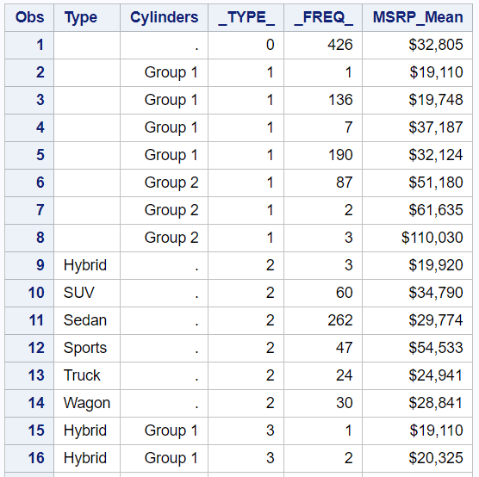

…portions of the table not shown…

1. Write a program to read SASHELP.CARS data set. Using the summary procedure, create a summary data set named ‘carsummry’ containing mean of variable msrp for each type and weight groups. Group weight low to 6000 as ‘Class 1’, 6000 to 10000 as ‘Class 2’, and 10000 to high as ‘Class 3 or higher’. PRELOAD formats and use completetypes option. Display results using the print procedure.

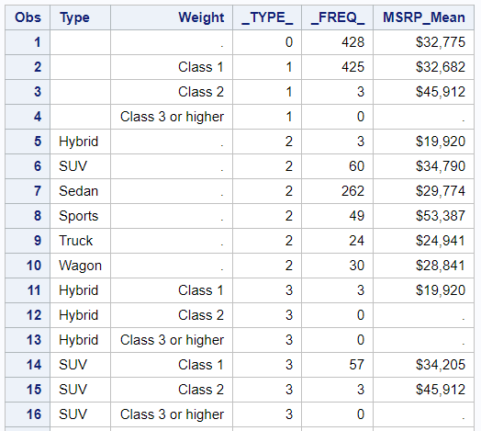

…portions of the table not shown…