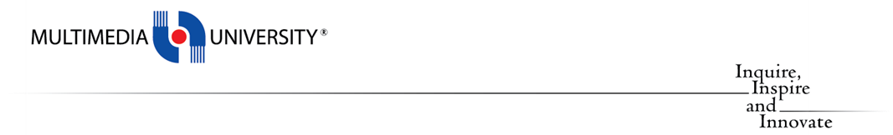

**TCP2201**

**Object-Oriented Analysis and Design**

**GROUP ASSIGNMENT REPORT**

***Trimester 2, Session 2022 / 2023***

|  |  |  |
| --- | --- | --- |
| **No.** | **Student ID** | **Student Name** |
| **1** | **1221303085** | **Mannoj Sakthivel** |

## UML Class Diagram

## UML Sequence Diagram

### 1 . Draw Triangle

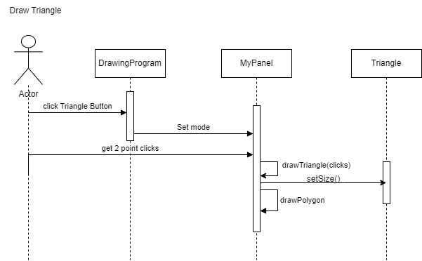2. Draw Pentagon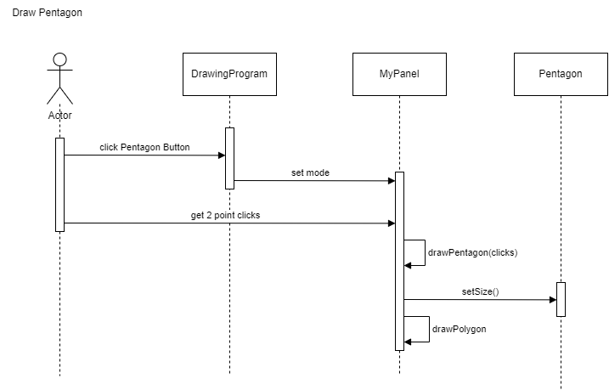

### 3. Draw Square

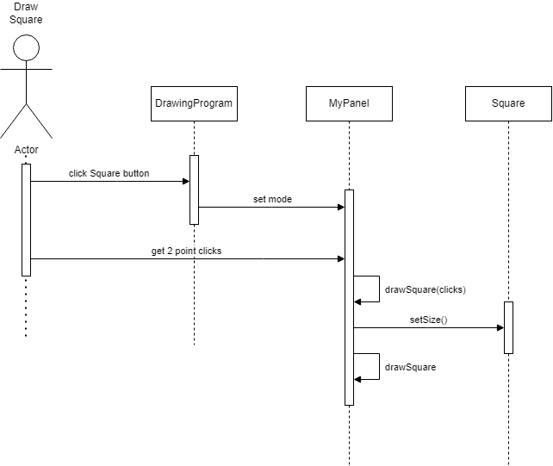

### 4. Draw Oval

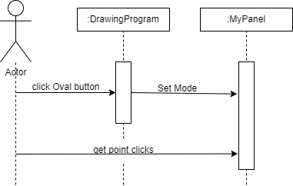

### 

### 5. Choose Pen Color

### 

### 6. Change Pen Size

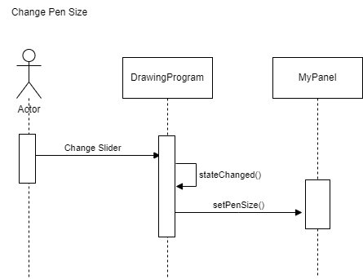

7. Draw Line

