**Silicon Valley Black Youth hack-a-thon**

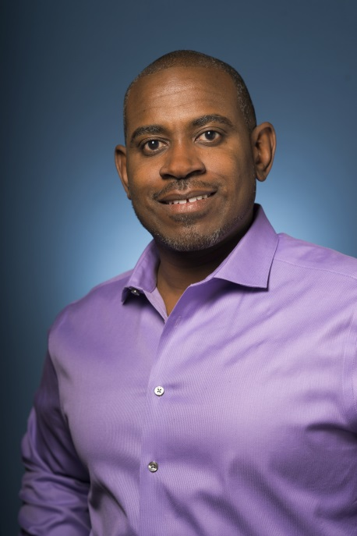**Speakers**

Michael Greene Intel Vice President and General Manager of the System Technologies & Optimization Intel’s Software and Services Group

Michael Greene is Intel Vice President and General Manager of the System Technologies & Optimization of Intel’s Software and Services Group. Greene leads a worldwide organization responsible for a broad range of development, enabling, architecture analysis and optimization efforts including system firmware, virtual platforms, modeling and simulation solutions, power analysis, client/server and big data software stack optimizations for a “Best in Class” user experience. Greene joined Intel in 1990, after graduating from the Massachusetts Institute of Technology and has managed several new product developments, research efforts, and engineering groups. He has served as Intel’s initiative owner for power efficiency, pre silicon software development, and has driven new technology benchmarking throughout his career.

Michael is also the Marketing Vice President on the National GEM Consortium’s (GEM) Executive Committee. GEM is a national non-profit providing programming and full fellowships to support the number of under-represented individuals who pursue a master’s or doctorate degree in science or engineering.

**Tony Prophet, Corporate Vice President Education Marketing**

As Corporate Vice President of Education Marketing, Tony is responsible for defining the Microsoft Education business model and channel strategy to drive sales, deployment and usage.  His team partners with sales and engineering to imagine and create the next-generation of Education experiences and is also responsible for creating and driving the execution of the company-wide Education marketing plans/programs across PR, events, digital and communities.

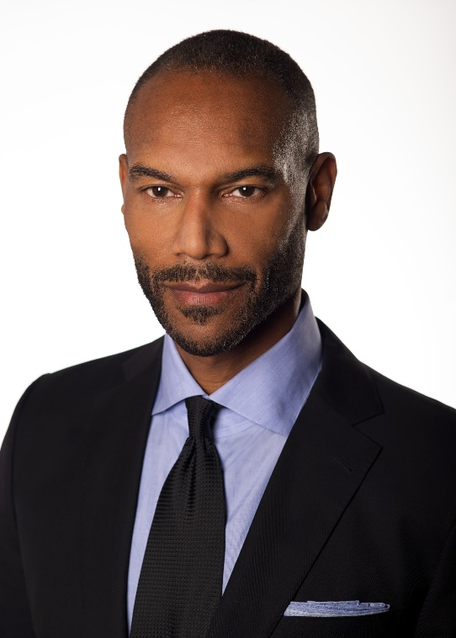

Prior to this role, Tony led Windows and Search Marketing and was responsible for pricing, product marketing, brand strategy, go-to-market strategy and the Windows App store. Relevant brands include Windows, Bing, Internet Explorer, Cortana, Microsoft Edge and MSN. His team led the business, marketing and launch planning for Windows 10.

Prophet also serves on the Board of Directors of Gannett Company, Inc. – an international media and marketing solutions company that informs and engages more than 100 million people every day, including the iconic USA Today brand.

Previously, he led Operations for Hewlett Packard's PC and Printing businesses and Central Direct Procurement. During his tenure, HP delivered more than 400 Million PCs to customers around the world.

Throughout his career, Prophet has been an industry champion for protecting the rights of young workers; educating female workers on women's health issues; and improving schools for children of migrant workers.

His work has been widely recognized – including by appointment to the National Academy of Sciences Board on Energy and the Environment; in China through the prestigious Three Gorges Award as well as the Magnolia Silver Award; and by the Booz Allen Professional Excellence Award.

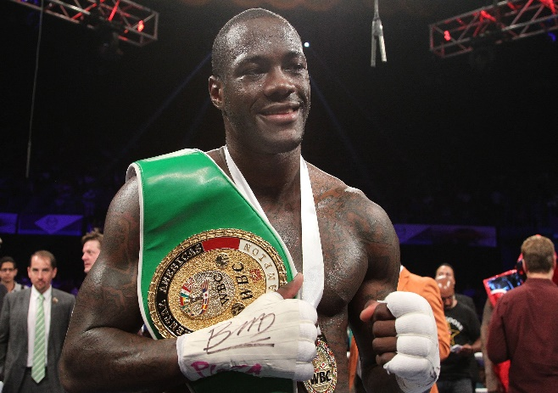

DEONTAY WILDER the WBC Heavyweight Boxing Champion of the World

Began boxing after discovering that his daughter would be born with Spina Bifida.

1. One of the few boxers to win an Olympic boxing medal (Bronze at Beijing Olympics in 2008) with 25 amateur boxing matches or less.
2. He was one of the athletes selected by Ralph Lauren to model the clothes for the 2008 U.S. Olympic team.
3. Before turning professional held jobs at Red Lobster, IHOP and drove a beer delivery truck to support his daughter.
4. Won the WBC heavyweight championship on Jan. 17, 2015, which is the birthday of Muhammad Ali and two days before the birthday of Martin Luther King, Jr.
5. One of the most active heavyweight champions in recent years. When he steps into the ring at the Barclays Center on Jan. 16 to defend the WBC title, Deontay will have fought four times in 364 days. The last boxer to do that was Lennox Lewis who fought four times in 358 days between 2000-2001.
6. In his fight against Johann Duhaupas, Deontay landed 56% of his punches (326 of 587) on the way to an 11th round KO. Duhaupas landed 98 of 332 punches only 30%. That connection percentage put him on par with Floyd Mayweather, Jr., who landed 57% against Andre Berto, in his last fight.
7. In the WBC championship fight against Bermane Stiverne he landed 10 of 35 jabs per round. The heavyweight average is 6 of 20 jabs landed a round. He landed 53% of his power shots, 9 of 17 per round. He threw an average of 52 punches a round.
8. He drives an alligator skin (faux) wrapped Lamborghini.
9. His goal is to become the undisputed heavyweight champion of the world. The last undisputed heavyweight champion was Lennox Lewis in 1999. Wilder was in junior high school at the time.