Lab 10 — Microsoft Azure Deployment
Cloud Data Centre | Student: C00287662
Section 1 — Azure Environment Setup
The resource group cdc-Section-rg was created in the canadacentral region. Tags were applied (Module, Owner, Environment) and RBAC was configured with Contributor role assigned via the Access Control (IAM) panel.
Section 2 — Provisioning Virtual Machines
A Linux VM (cdc-linux-vm) running Ubuntu 22.04 was provisioned. Nginx was installed and confirmed accessible via the public IP. A 16GB data disk was attached, formatted as ext4, and mounted at /data.
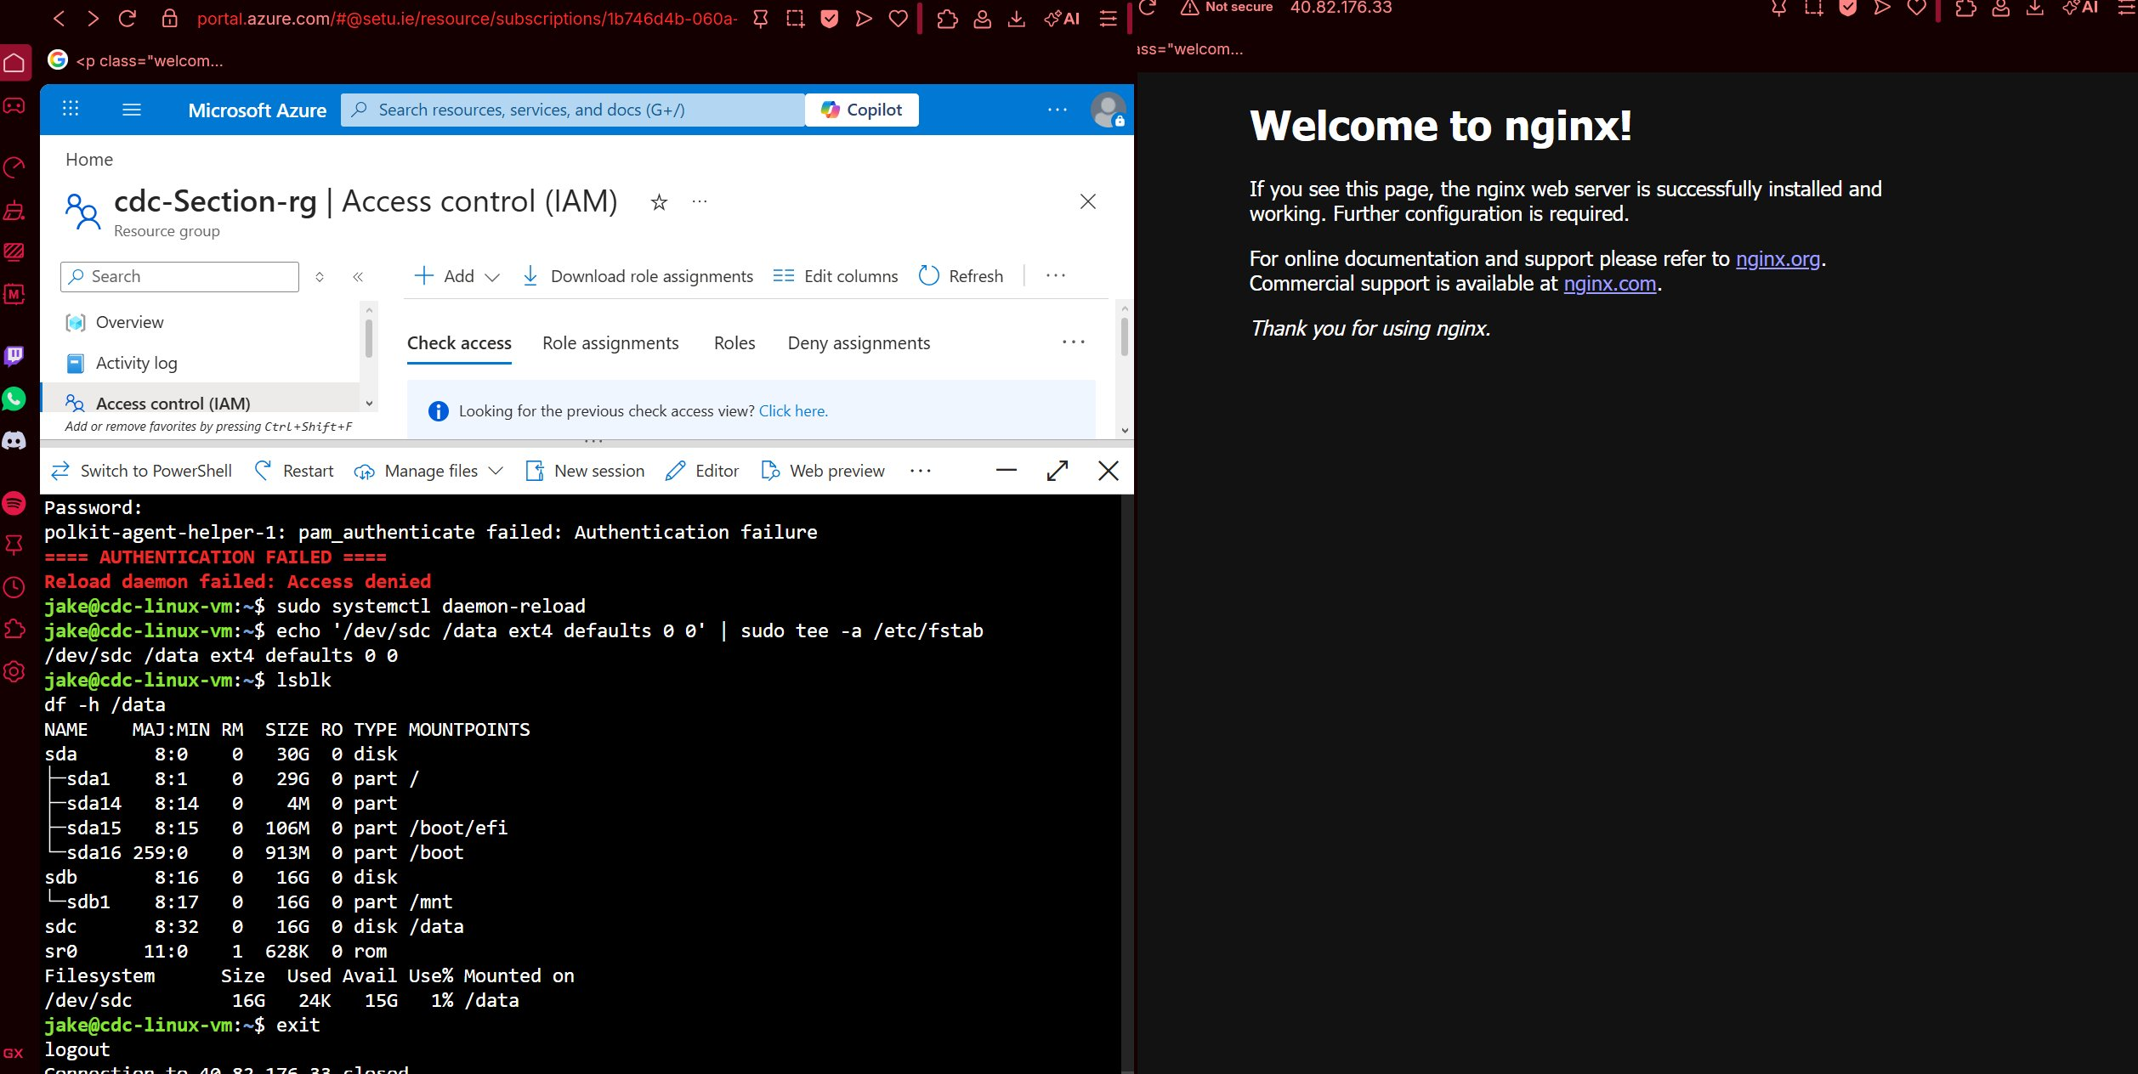

Section 3 — Azure Networking Fundamentals
A custom VNet (cdc-vnet) was created with address space 10.0.0.0/16, containing a public subnet (10.0.1.0/24) and private subnet (10.0.2.0/24). An NSG was configured allowing HTTP (80) and SSH (22) inbound. A DNS label was assigned to the public IP.
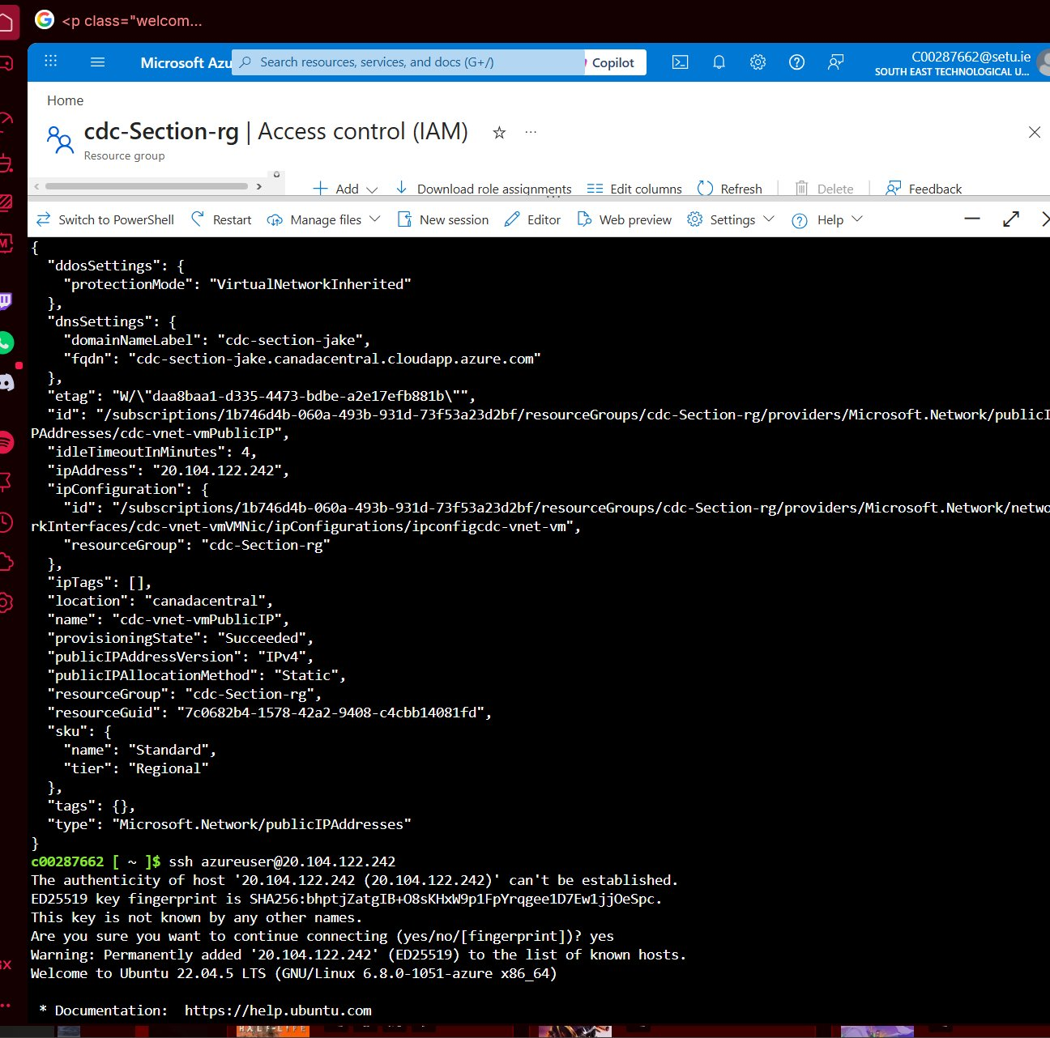

Section 4 — Azure Storage Services
A storage account (cdcstoragec00287662) was created with Hot tier. A blob container was created, a test file uploaded and downloaded successfully, and a time-limited SAS token was generated. An Azure File Share was created and mounted on the Linux VM via SMB.
Note: The lab guide contained a typo in the storage account name using mixed case. The name was corrected to all lowercase as required by Azure.
Section 5 — VM Scale Sets and Load Balancing
A VM Scale Set (cdc-vmss) was deployed with 2 initial instances running Nginx via a cloud-init script. An Azure Load Balancer (cdc-lb) was configured in front of the scale set with a health probe on port 80. Autoscale rules were configured to scale out when CPU exceeds 70% and scale in when below 30%.
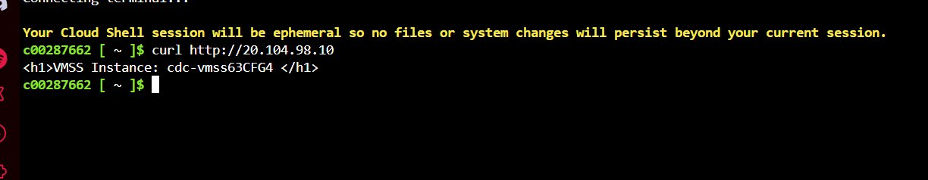
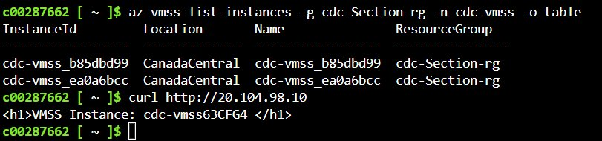
Note: Instance count was limited by available CPU cores in the student subscription, restricting the scale set to fewer instances than configured. This is expected behaviour under Azure for Students quotas.

Section 6 — Containerising Apps with Docker
6.2 — Build and Test Locally
A Python Flask application was containerised using Docker. The image was built locally as cdc-flask-app:v1 and tested by running the container on port 5000. The curl response confirmed the app returned HTTP 200 with the expected HTML output.
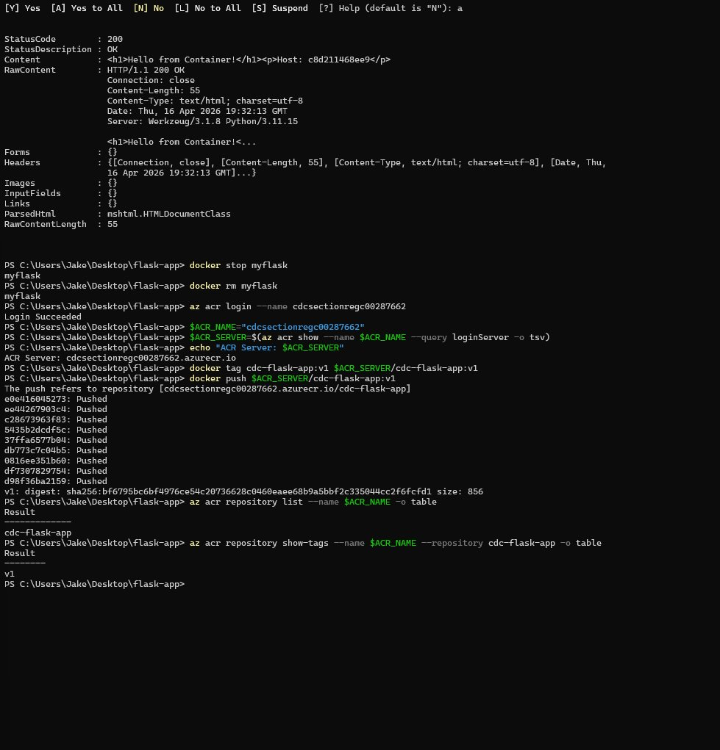

6.3 & 6.4 — Azure Container Registry and Image Push
An Azure Container Registry (cdcsectionregc00287662) was created with admin access enabled. The image was tagged for the ACR login server and pushed successfully. The repository list and tag output confirm the image is stored in ACR.
Note: The Microsoft.ContainerRegistry provider was not initially registered in the subscription, causing the first ACR creation attempt to fail. This was resolved by running az provider register --namespace Microsoft.ContainerRegistry before retrying.
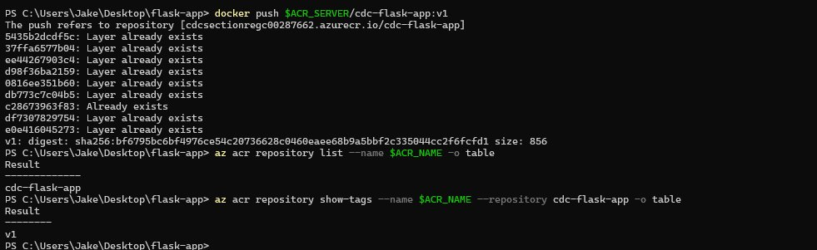
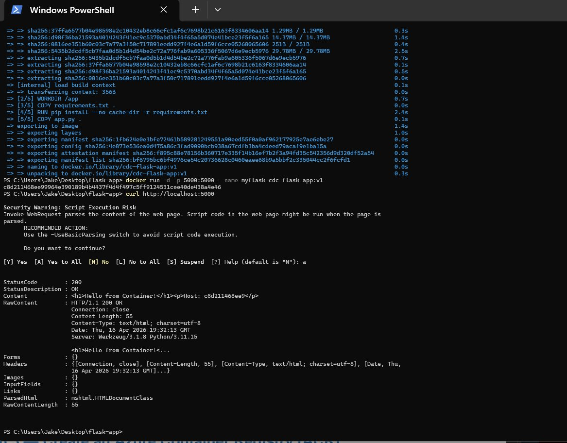

6.5 — Pull and Run from ACR on VM
Docker was installed on the Linux VM and the container image was pulled from ACR and run on port 8080 (port 80 was occupied by Nginx from Section 2). The app was confirmed accessible via the browser at the VM public IP.
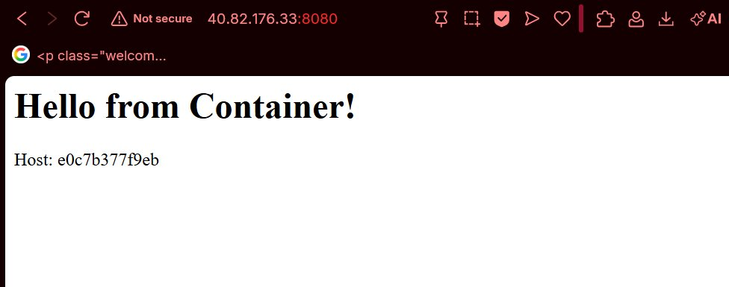
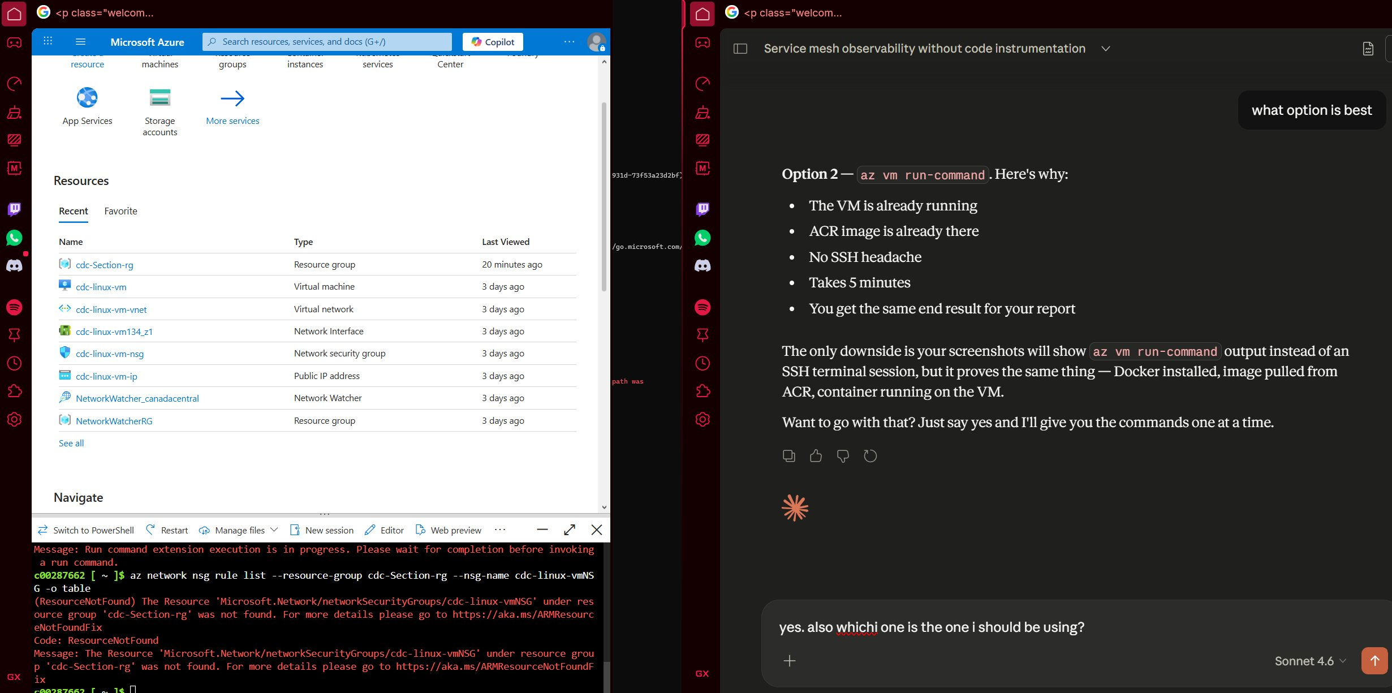

Section 7 — Docker Scaling and Load Balancing on Azure
7.1 — Azure Container Instances (ACI)
The Flask container was deployed to Azure Container Instances as cdc-aci-instance. The container was confirmed running with a public FQDN of cdc-flask-c00287662.canadacentral.azurecontainer.io on port 5000. The app was accessible via browser and logs confirmed successful HTTP requests.
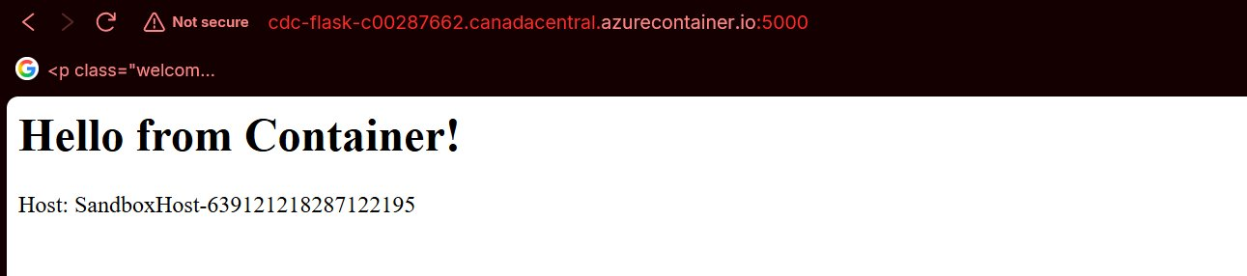
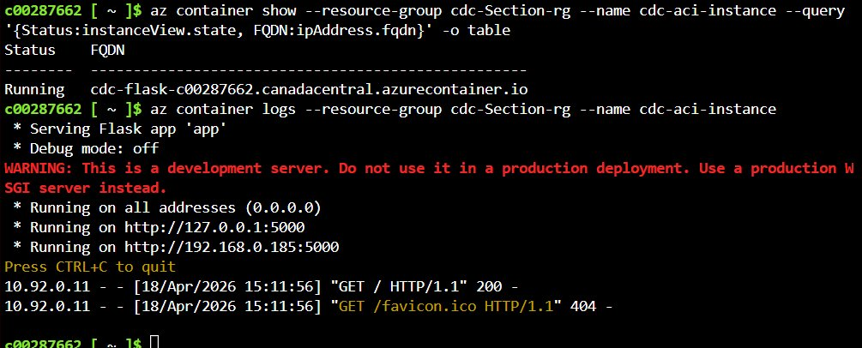

7.2 — Multi-Container Group (Sidecar Pattern)
A multi-container group (cdc-multi-container) was deployed using a YAML definition containing two containers: the Flask app and a busybox log-sidecar. Both containers started successfully. The sidecar logs confirmed it was running independently alongside the application container, printing "Sidecar running" every 30 seconds.
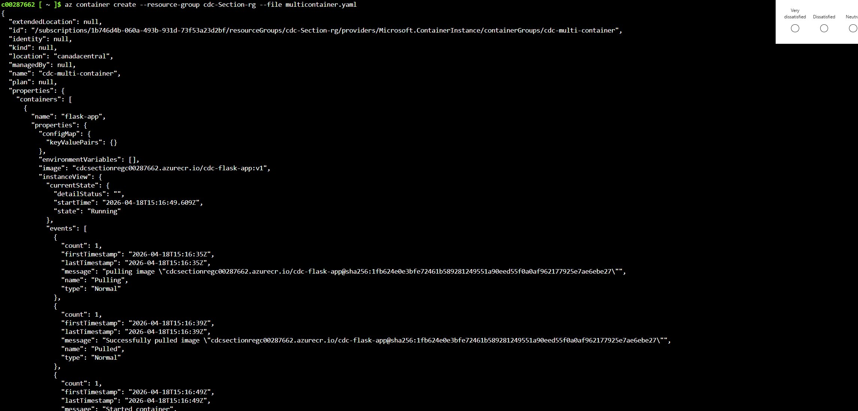
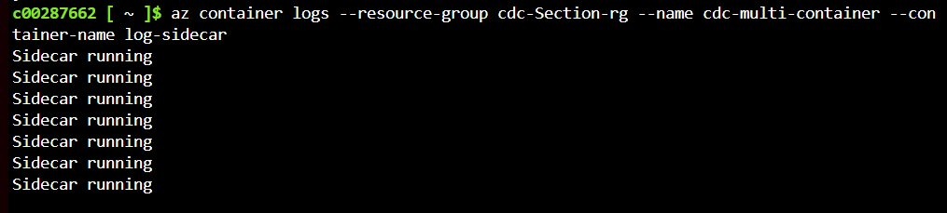

Section 8 — Teardown and Cost Management
All lab resources were listed prior to deletion. The entire resource group cdc-Section-rg was deleted using az group delete --no-wait. A monthly budget of $10 was configured in Azure Cost Management with email alerts at 80% and 100% thresholds.
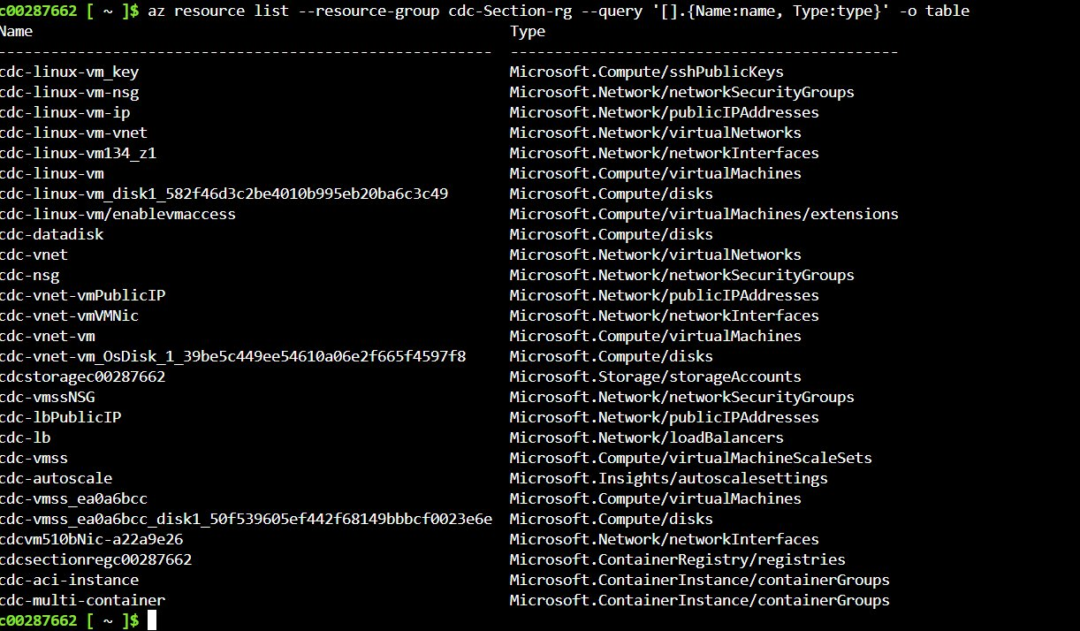
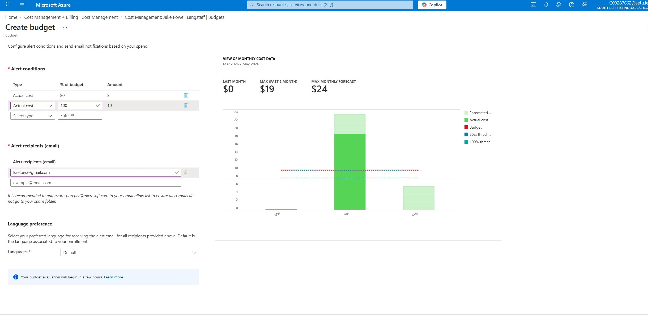
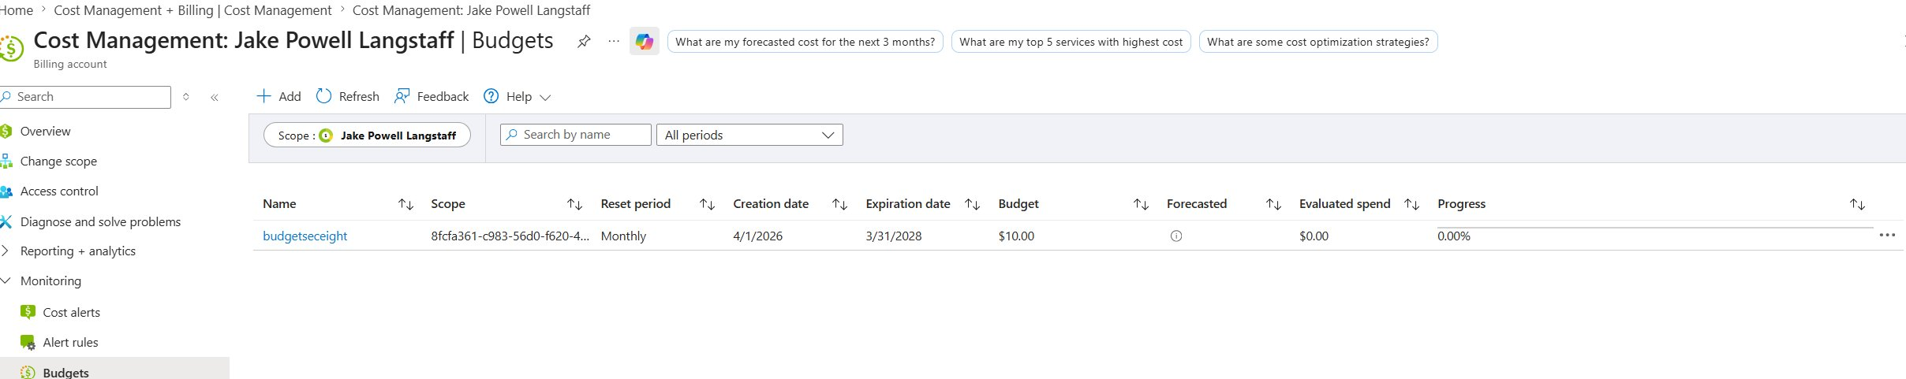
Lab Architecture Diagram
The following topology was exported from the Azure Resource Group visualiser prior to teardown. It shows all provisioned resources and their relationships across all sections of the lab.

Conclusion
This lab demonstrated the end-to-end provisioning of a cloud environment on Microsoft Azure. Starting from basic resource group setup and IAM configuration, the lab progressed through VM provisioning, custom networking with VNets and NSGs, blob and file storage, VM scale sets with load balancing and autoscale, and full containerisation of a Python Flask application.
The Docker workflow covered building a local image, pushing it to a private Azure Container Registry, and running it on both a Linux VM and as a serverless Azure Container Instance. The multi-container sidecar pattern demonstrated how ACI supports co-located containers sharing the same network namespace, a foundational concept for service mesh and observability patterns.
A key comparison observed in this lab is between ACI and AKS. ACI is suitable for simple, short-lived, or dev/test container workloads due to its fast startup and per-second billing model. AKS provides full Kubernetes orchestration including horizontal pod autoscaling, rolling deployments, and service mesh integration, making it appropriate for production microservices. The VM Scale Set with Azure Load Balancer demonstrated horizontal scaling at the infrastructure level, while ACI showed the same principle applied at the container level.
Several practical issues were encountered and resolved during the lab. The Microsoft.ContainerRegistry provider required manual registration before ACR could be created. Port conflicts on the VM required running the container on port 8080 instead of 80. These are realistic cloud deployment challenges and their resolution demonstrates practical troubleshooting skills.

