|  |  |
| --- | --- |
| A picture of a winding road and trees  Reliability of Solar Energy  in  SOUTHEAST Asia | Link:  <https://vocal-dodol-c89fa8.netlify.app/clientapp/>  Team Name:  Responder  Student Names & IDs:  **Siew Joe Kane** 103130764  **Foo Chi Ping** 103487570  Year and Semester:  2, Semester 4  Word Count:  2768 |
|  |  |

Table of Contents

1 Introduction 2

1.1 Background and Motivation 2

1.2 Visualisation Purpose 2

1.3 Project Schedule 3

2 Data 5

2.1 Data Source 5

2.2 Data Processing 5

3 Requirements 6

3.1 Must-Have Features 6

3.2 Optional Features 6

4 Visualisation Design 7

5 Validation 13

6 Conclusion 17

References 18

Appendix 19

# 1 Introduction

## 1.1 Background and Motivation

**Target Audience**

The users who will benefit from this visualization are energy enthusiasts, climate scientists, climate activists and businesspeople from the energy sector.

**Potential tasks**

The audience of this visualization will want to observe which Southeast Asia country has a better prospect of utilizing and generating a healthy amount of energy from solar compared to other alternatives in the space of renewable energy.

**Importance of the project**

The importance of this visualization project is to give insight to whether solar energy is a viable source of energy and should remain as an option for renewable energy.

## 1.2 Visualisation Purpose

**Questions users will be able to answer with your visualisation**

The visualization project aims to answer the question whether solar energy is a reliable renewable energy source in south-eastern region of Asia. The data could originate from government websites and publicly available data published by energy corporations.

List of possible benefits of the completed visualisation:

1. Figure out which south-east Asian country has the best prospects in harnessing the potential of solar energy.
2. Figure out if solar energy is a viable renewable energy source.

## 1.3 Project Schedule

Make sure that you plan your work so that you can avoid a big rush right before the final project deadline. Write this in terms of weekly deadlines.

|  |  |  |  |  |
| --- | --- | --- | --- | --- |
| **Task** | **Duration** | **Start Date** | **End Date** | **Task Dependency** |
| Project Start. | 24 days | 9/9/22, 8:00 AM | 10/12/22, 5:00 PM |  |
| Decide on topic. | 12 days | 9/9/22, 8:00 AM | 9/26/22, 5:00 PM |  |
| Search for data. Preferrably in CSV format. | 12 days | 9/27/22, 8:00 AM | 10/12/22, 5:00 PM | 1 |
| First Standup | 13.5 days | 10/13/22, 8:00 AM | 11/1/22, 1:00 PM |  |
| Find data. | 3 days | 10/13/22, 8:00 AM | 10/17/22, 5:00 PM |  |
| Design low fidelity designs. | 5 days | 10/18/22, 8:00 AM | 10/24/22, 5:00 PM | 4 |
| Draft first website design. | 5 days | 10/25/22, 8:00 AM | 10/31/22, 5:00 PM | 5 |
| First draft process book. | 0.5 days | 11/1/22, 8:00 AM | 11/1/22, 1:00 PM | 6 |
| Second Standup | 4.5 days | 11/1/22, 1:00 PM | 11/7/22, 5:00 PM | 3 |
| Research other countries. | 1 day | 11/1/22, 1:00 PM | 11/2/22, 1:00 PM |  |
| Implement new charts. | 3 days | 11/2/22, 1:00 PM | 11/7/22, 1:00 PM | 9 |
| Make progress on process book. | 0.5 days | 11/7/22, 1:00 PM | 11/7/22, 5:00 PM | 10 |
| Third Standup | 5 days | 11/8/22, 8:00 AM | 11/14/22, 5:00 PM | 8 |
| Finalize data visualization. | 5 days | 11/8/22, 8:00 AM | 11/14/22, 5:00 PM |  |
| Last Standup | 1 day | 11/22/22, 8:00 AM | 11/22/22, 5:00 PM | 12 |

Deliverables:

* **Project Start**
  + Decide on project title.
* **Standup Meeting 1**
  + Finalize project title.
  + Research on data relating to title.
  + Research on D3 template samples.
  + First draft of low fidelity design.
  + First draft process book/report.
* **Standup Meeting 2**
  + Complete at least 50% of process book/report.
  + Implement at least 1 chart.
  + Further research on data.
* **Standup Meeting 3**
  + Finalize website visualization.
  + Finalize process book/report.
  + Zip all data involved.
  + Ensure all relevant documents and codes are available on GitHub.
* **Final Standup Meeting**

# 2 Data

## 2.1 Data Source

**Data Sources**

Data collected for the visualization project are from publicly available government websites and published research data published by energy corporations.

The data used originate from the following sources:

1. data.gov.my
2. data.gov.sg
3. data.world
4. <https://www.aiddata.org/>
5. https://worldpopulationreview.com/

**Dataset Type**

The data used are in the form of CSV (Comma Separated Values) format. Although, the data available online are mainly in Excel formats with styled headers and body to describe the purpose of the research and data, therefore, some data cleaning and understanding were necessary.

**Attributes in data set and type of data are the values**

Chart 1: Year, Interval Data

Chart 2: Year, Interval Data

Chart 3: Countries, Categorical Data

Chart 4: Region, Qualitative/Nominal Data

**Data in the set that will not be included in your visualisation**

* + - 1. Dates that fall before 2016 will be discarded in all data set used.
      2. Data containing mixed renewable energy that is not focused on solar energy is omitted.

## 2.2 Data Processing

**Data Cleaning**

Data cleaning is expected due to the heavily formatted Excel sheet available online. Although, with data sets available in CSV format out of the box, then this step is unnecessary.

**Quantities to derive from data**

The whole entry available within a dataset will be used for processing. If not, a data cleaning process will be carried out to narrow down the dataset for easy data processing.

**Data Processing**

With invalid data, those entries will be filtered out in JavaScript when reading data. Null or missing values will also be filtered out rather than giving them average or ignored.

**Variables**

No variables will be derived through the process of developing the visualization.

**Clean-up process**

Clean up was done using Microsoft Excel to copy over important data from the source data since majority of the data is in Excel Workbook format into a separate CSV file. JavaScript was also used to process incoming data read into appropriate data structure that can be processed by the D3 templates.

**Calculations on Derived Variables**

There are no additional calculations required since all measurements are in metric measurements and not imperial measurements since the data gathered do not originate from the west.

# 3 Requirements

## 3.1 Must-Have Features

* A fully hosted and functioning website is a must-have features in this project.
* Each visualisation charts must contain at least one interactive element.

## 3.2 Optional Features

* Account Management Feature
  + login and sign-out function nice to have to but not required.
  + Account management.
* Live data fetching from 3rd Party API.
* Other language support
  + Support other languages like Malay and Chinese for Malaysian audiences.

**Delivery of extra features**

Due to time constraint and scope of the project, the above-mentioned features were not implemented. The account management feature is nice to have, but not necessary to achieve the key outcome of the visualization project. The implementation of real time 3rd party APIs is also nice to have which would make the charts update more dynamically but is not necessary. Other language support is nice to have but necessary, which can cater the visualization to a wider range of audiences.

# 4 Visualisation Design

**Displaying data**

A set of low fidelity design will be prepared before implement any coding development. The low fidelity design of website user interface and individual chart are sketched using draw.io; a web-based drawing tool and paint software from Microsoft. Each chart will be created from different dataset and included at least one interactive element such as mouse-over effect and interactive legend to filter and manipulate the data of the chart.

**Sketches**

**Sketches Screenshots (Website):**

First sketch is the interface design for the website. The content will be display only in one page. Project Title will be display on top area of the website as it showed a clear objective of the project to the users.

For content section, card view will be implemented to manage the content in more effective way. First card view consists of brief description regarding history of solar energy. Second card view will focus on displaying several charts in neat and clean position.

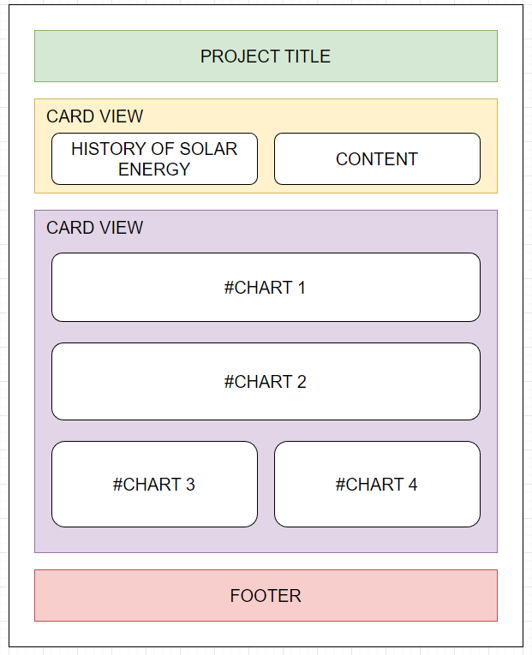

Figure 1 shows the initial draft low fidelity design.

**Sketches Screenshots (Charts):**

First chart will show user about the consumption of renewable energy in Southeast Asia. The dataset used are continuous data across multiple year, line chart will be suitable to handle the data.

Sketch below showing data displaying in line chart format. X axis is renewable energy consumption in year and Y axis is percentage of total consumption in each country. The chart will arrange a set of interactive legends (Southeast Asia countries) for user to click and filter the countries whether to display or not display in the line chart.

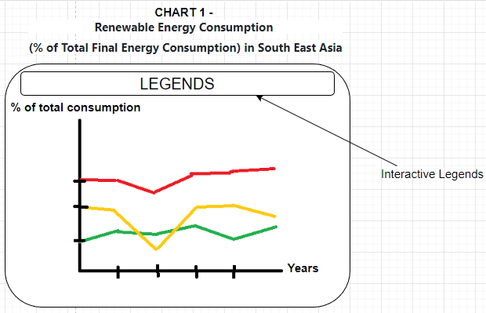

Figure 2 shows the renewable energy consumption in southeast Asia.

Second chart will show user about the percentage of total solar capacity in Southeast Asia. The dataset also provided continuous data across multiple year and line chart will be suitable to handle the data.

Sketch below showing data displaying in line chart. X axis is total solar capacity in year and Y axis is total capacity (MW) in each country. Unlike first chart, this line chart will equip with mouse-over effect to display detail information. On hover, the closest data point to the mouse cursor and its associated line series will be display the detail information.

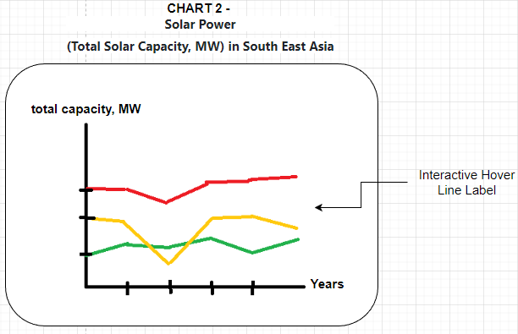

Figure 3 shows the solar power line charts.

Third chart will show user about the renewable energy production in Singapore. The dataset found is categorical dataset across multiple year. Stacked bar chart is suitable in displaying the data.

Sketch below showing data in stacked bar chart. X axis is production of each renewable energy category in year and Y axis is total energy generation of stacked categories in percentage. This stacked bar chart will equip with mouse-over effect to display detail information. On hover, different total percentage of energy production will display when mouse cursor pointed to the specific colour sector.

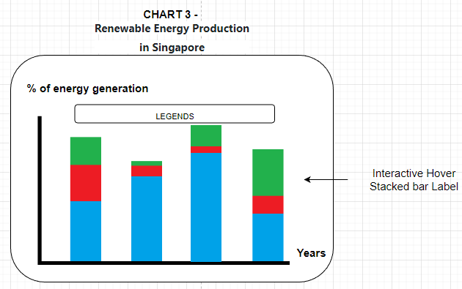

Figure 4 shows the renewable energy production.

Fourth chart will show user about the Singapore solar PV installation in region. The dataset used contain the information of PV installation in region of Singapore. So, geo map graph will be suitable to display the data.

The sketch below showing geo map group with hover effect. Detail information will show in bottom right corner when mouse cursor pointed to specific region.

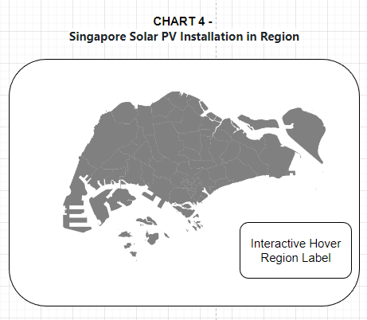

Figure 5 shows the Singapore solar pv geo map.

**Final Design**

After the website and visualization chart created, the outputs served well and the objective of reliability of solar energy in Southeast Asia is clearly showed to the user. Hence, the first sketches of the website and contents will be the final design for the project.

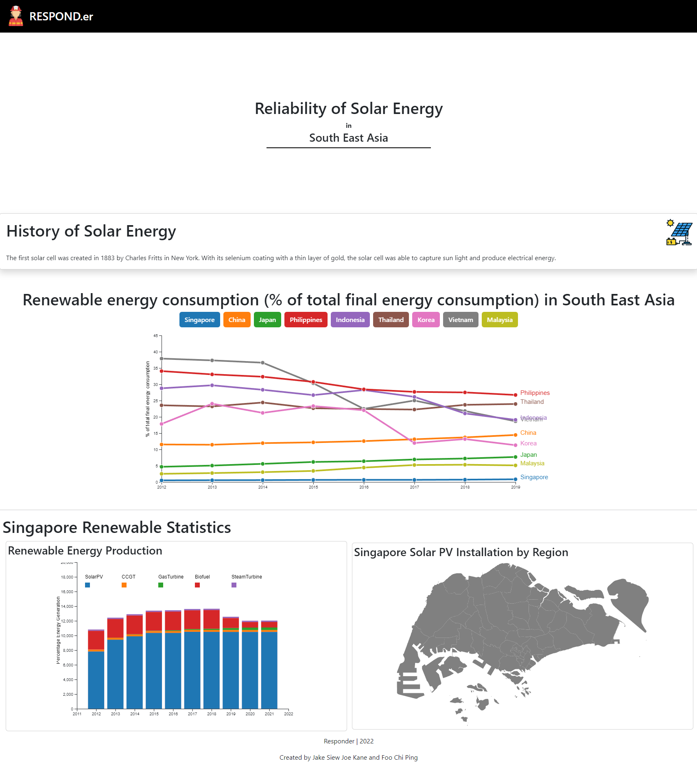

Figure 6 shows the overview of the final website.

**Renewable Energy Consumption:**

The following line graph can be filtered by clicking on each of the respective buttons. Click on each Country button will hide that country in the line graph to focus on other countries.

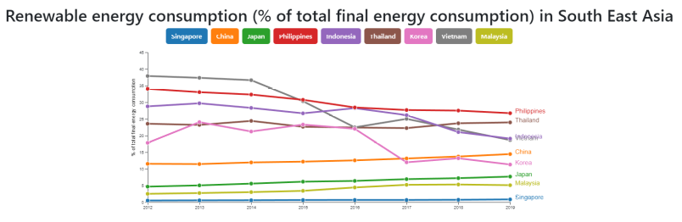

Figure 7 shows the total renewable energy consumption in southeast Asia with buttons to filter between countries.

**Renewable energy viability Stacked bar chart:**

The following is an interactive stacked bar chart where if the user hovers on one of the bar chart, the corresponding value associated with that bar chart will be displayed above.

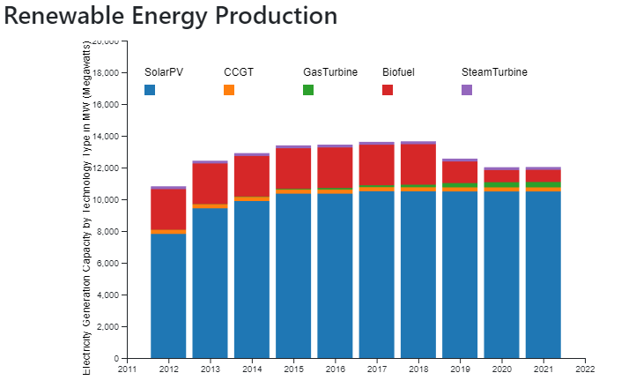

Figure 8 shows the stacked bar chart for Singapore’s renewable energy production in megawatts.

**Singapore Solar Panel Installations per Planning Regions (state):**

The following is an interactive map chart of Singapore to show solar panel installations per planning region or state. Upon hovering on each of the state will show the region/state name, total solar panel installations, and total energy generated using the solar panel.

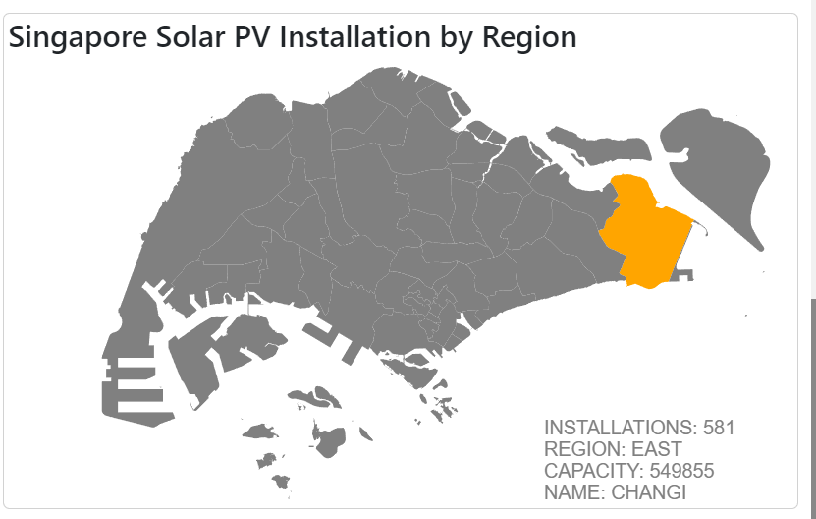

Figure 9 shows Singapore’s solar PV installation by planning region.

**Solar Power (total solar capacity, MW) in South East Asia:**

The following interactive Line chart displays the total solar power capacity generated per country in Southeast Asia. Upon hovering on one of the lines, it will focus on that particular country on that particular year highlighted with a distinct colour.

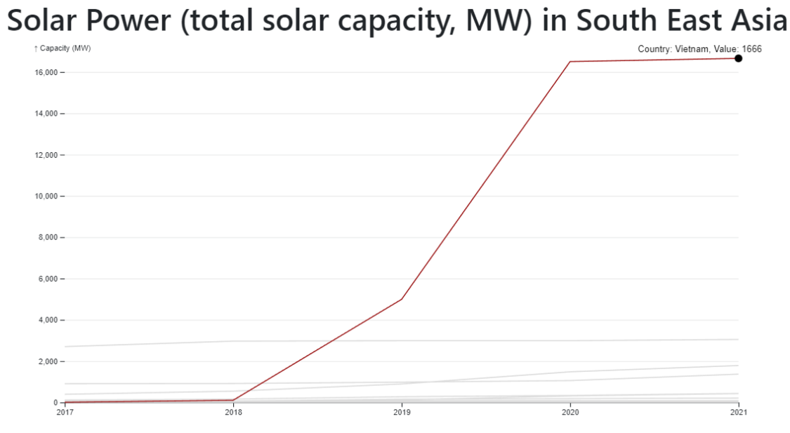

Figure 10 shows the line chart to visualize total solar capacity by ASEAN country.

# 5 Validation

Test your visualisation with users and report the results.

Usability testing was conducted using Google forms to ask a series of questions to 5 individuals who tested the visualization website. The following are the questions asked:

Are the charts easy to use and understand.

Rate each chart based on user experience.

Do u face any problems regarding "Renewable Energy Consumption in South East Asia" line chart? If yes, please state the problems

Do u face any problems regarding "Solar Power in South East Asia" line chart? If yes, please state the problems

Do u face any problems regarding "Renewable Energy Production in Singapore" stacked bar chart? If yes, please state the problems.

Do u face any problems regarding "Singapore Solar PV Installation by Region in Singapore" geo map chart? If yes, please state the problems

Based on all four chart you have experienced, do you think any chart above require any improvement? If yes, please provide your opinion.

Lastly, any recommendation of chart do you think is more suitable for the content and topic?

The following results shows the rating on the ease of use and understanding of the visualization charts. 40% of the respondents rated 8/10 and 10/10 respectively while the remaining 20% responded with 7/10.

The following results show that the Production in Singapore stacked bar chart received the highest rating at 3/5 responses voting above average. The Solar power in southeast Asia line chart, renewable energy production and solar PV installation each share the same rating at excellent.

The following results show the problems faced by the participants using the visualization website. Majority of the respondents feel that there are no issues with the website, with the exception of 1 respondent feel that the text is overlapping.

For the solar power in southeast Asia line chart, all the respondents responded with no issues using the line chart.

For the renewable energy production in Singapore stacked bar chart, majority of the respondents responded with no issues using the chart with the exception of 1 implying that they found it difficult to calculate the exact amount of comparison.

For the Singapore geo map, all the respondents responded with no issues using the Singapore map.

From the below results, 80% of the respondents responded that the charts fulfil their intended purpose.

The below are the suggestions provided by the respondents on how to further improve the visualization website.

# 6 Conclusion

In conclusion, solar energy may be a reliable energy source depending on the country in SouthEast Asia. An in-depth study was conducted on Singapore which showed other alternatives to solar energy yielded greater output in electricity generation capacity, therefore, solar energy may not be the best renewable energy source in Singapore. As compared to Vietnam, it can be observed that Vietnam was able to produce the highest energy capacity using solar compared to other countries making solar energy adoption the best in Vietnam out of the other Southeast Asian countries.

This project helps us builds the understanding of human perception, cognition and data visualisation design principles because we have to research real life dataset and analyse most suitable chart to display the data based on the project title and objective.

By creating an effective visualisation, we learnt conceptualise the visualisation design by sketching low fidelity to assist prototyping regarding how the chart going to be and what are the dataset being handle by the chart. After the prototyping completed, we start code development on website as the platform to display all the charts and contents to the audience. Lastly, we learned on creating an interactive data visualisation using real-world data set. We learned to create interactive data visualisation using D3 library which consist plenty of free interactive chart templates.

In summary, we learned to visualise data related to energy production from research, prototype and code development throughout this project. Other than that, communication and project planning between team member are very significant to ensure the project progress keep on track and end result produced meet the standard and objective.

# References

D3 Template References:

* Shuyao.X 2022, Line Chart, Multiple Series, Observable, viewed 8 November 2022, <https://observablehq.com/@miaomiaorepo/line-chart-multiple-series>.
* Holtz, Y. (n.d.). Connected scatter plot with interactive legend in d3.js. [online] d3-graph-gallery.com. Available at: https://d3-graph-gallery.com/graph/connectedscatter_legend.html [Accessed 8 Nov. 2022].

Data Sources:

* *Singapore Energy Information | Enerdata* n.d., www.enerdata.net, viewed 6 November 2022, <<https://www.enerdata.net/estore/energy-market/singapore/>>.
* *EMA | Generation Company Licensee: Sembcorp Solar Singapore Pte Ltd* n.d., www.ema.gov.sg, viewed 6 November 2022, <<https://www.ema.gov.sg/generation-company-sembcorp-solar-singapore-pte-ltd.aspx>>.
* *EMA | Singapore Energy Statistics (SES)* n.d., [www.ema.gov.sg](http://www.ema.gov.sg/).
* *Solar Power in Singapore: A Shining Energy Source*. (2022, June 16). Energy Tracker Asia. https://energytracker.asia/solar-power-singapore/
* National Climate Change Secretariat 2021, *Singapore’s Approach To Alternative Energy*, [www.nccs.gov.sg](http://www.nccs.gov.sg/).
* Singapore: solar energy capacity 2021 n.d., Statista, viewed 6 November 2022, <[https://www.statista.com/statistics/873116/solar-energy-capacity-singapore/#:~:text=In%202021%2C%20the%20solar%20energy](https://www.statista.com/statistics/873116/solar-energy-capacity-singapore/#:~:text=In 2021%2C the solar energy)>.‌
* solar energy singapore n.d., Data.gov.sg, viewed 6 November 2022, <<https://data.gov.sg/search?q=solar+energy+singapore>>.
* Renewable vs Nuclear Energy generation (1965-) n.d., www.kaggle.com, viewed 6 November 2022, <<https://www.kaggle.com/datasets/donjoeml/energy-consumption-and-generation-in-the-globe?select=share-energy-consum-by-source.csv>>.
* Renewable Energy n.d., www.kaggle.com, viewed 6 November 2022, <<https://www.kaggle.com/datasets/programmerrdai/renewable-energy?select=solar-share-energy.csv>>.
* Solar Resource Class & Country - dataset by doe n.d., data.world, viewed 6 November 2022, <<https://data.world/doe/solar-resource-class-country>>.
* Solar Power by Country 2020 2021, worldpopulationreview.com.

# Appendix

* + - 1. Hosted Website URL: <https://vocal-dodol-c89fa8.netlify.app/clientapp/>
      2. GitHub Repository: <https://github.com/JakeSiewJK64/COS30045-GRP10>
      3. Zipped Data File
      4. Zipped Source Code.