4 slides:

1. Intro and answer
2. 3 screen captures

Communication Channel:

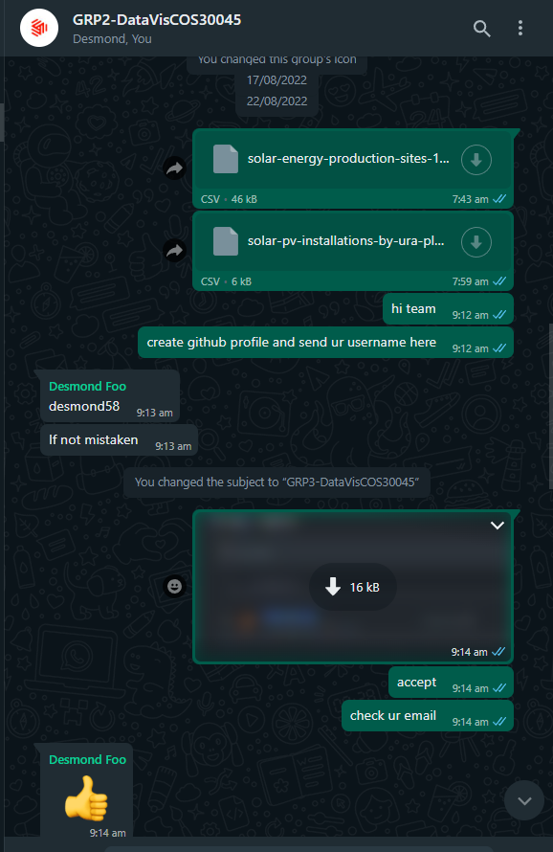

Github Repository:

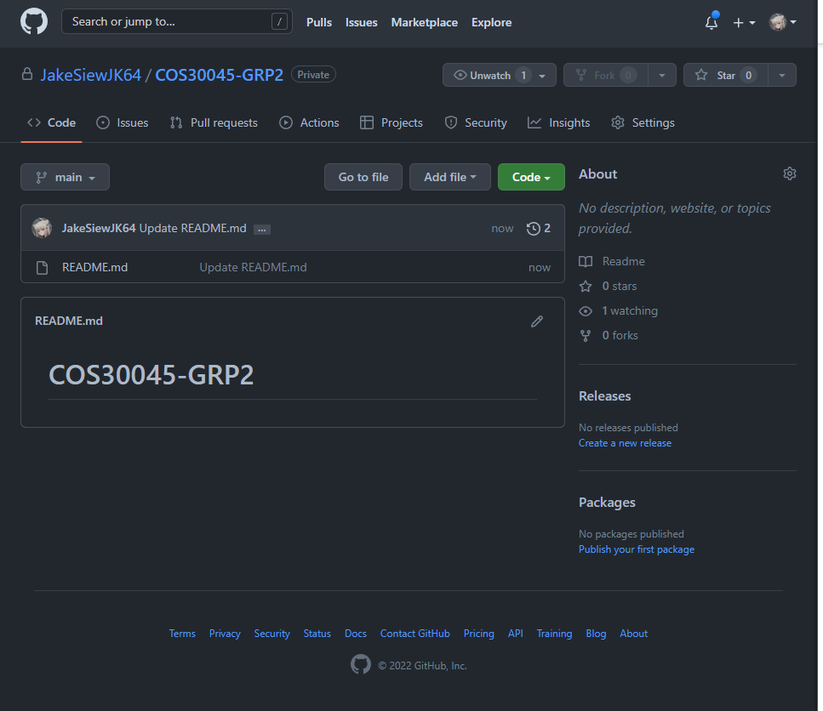

Collaborators:

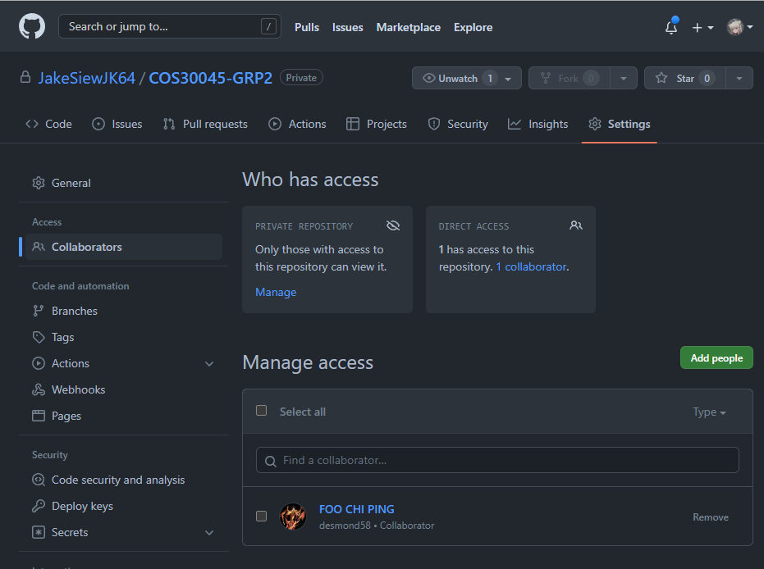

Resources:

1. [JakeSiewJK64/COS30045-GRP2 (github.com)](https://github.com/JakeSiewJK64/COS30045-GRP2)

Data Sources:

1. Data Sources:
2. data.gov.my (server may be down)
3. data.gov.sg
4. data.world
5. https://www.aiddata.org/