Take It Back!

Jacob Thurman

CIS226-HYB1

**Game Summary:**

This game will be a side-scrolling runner game. The game will have a goal each level of taking some object (which will change each level) to an endpoint while avoiding various obstacles, holes and baddies looking to get in the way. There will be a character traveling rightwards holding some object. The baddies will depend on the level but there should be about three different enemy types overall that will appear in different levels. Some harder levels may have more than one type of enemy. The first few will have none.

**Project Background:**

As I thought about it, I’ve always been the most interested in games I can play quick and be done with, such as the [chrome offline dinosaur game](http://www.omgchrome.com/chrome-easter-egg-trex-game-offline/), in addition to Super Mario, another side-scroller with a goal of reaching a flag at the end. This *Take It Back* game is semi-inspired by that and somewhat so by other similar side-scrollers. I feel this game will capture all of my interests in gaming well. I feel that as I develop it, it will evolve into something more interesting and unique. This game could be a fun way to forget about stress and worry for a just a few minutes in the life of someone even busier than I. The societal impact of this game will be a positive effect on the mood of the player, the game will be designed with the intention of being easy enough not to frustrate too much and hard enough to suck the player in. I get bored very quickly of games with no goals as well, and that is how I came up with the idea of taking an object back. A quick goal to waste time, but feel accomplished in it.

**IPOS Requirements:**

The program will receive input through keyboard interaction. The only final decision of the mapping thereof is that the spacebar will be used to jump. Whatever key combinations are used will be generic and potentially configurable in the game, depending on if I have enough time. The processing of the program will be the dynamic, random generation of the map and the calculation of the scroll speed and such. The output will be the rendered map: the obstacles, character, enemies and such. The game will have a data.json file (format may differ) to store things like the high score data and key combination settings.

Here is a basic mockup of how I mentally envision the game appearing.

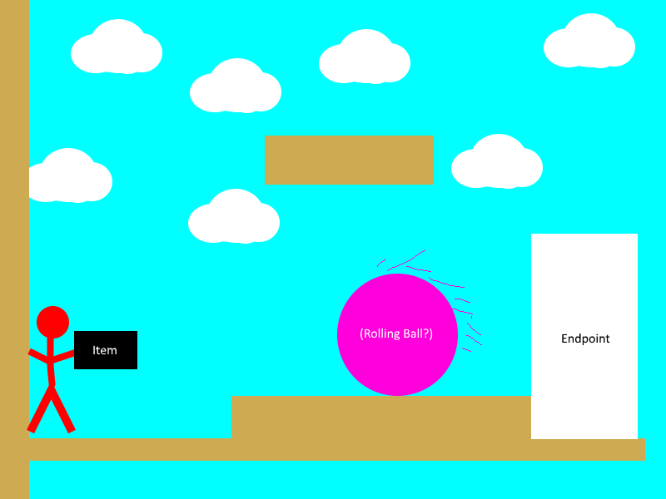

*Note: Visuals may appear different in final game*

**Conclusion:**

I believe that I should be approved to make this game because out of all of the options I brainstormed it was the only one that solidified in my mind as a “cool” idea. It was an idea that I felt excited to work on; something I will be proud of. I feel that this game will have a positive impact on players because it will be care free, goal oriented and pure, wholesome fun.

**References**

Carlisle, R. P. (2009). Encyclopedia of play in today's society (Vol. 1). Los Angeles: SAGE.

**Glossary**

Side-Scroller: A game that moves on to the right as the player moves

Endpoint**:** Where the level comes to a close. A point obviously marked to the user as the finish.