Take It Back!

Jacob Thurman

CIS226-HYB1

**Game Summary:**

This game will be a side-scrolling runner game. The game will have a goal each level of taking some object (which will change each level) to an endpoint while avoiding various obstacles, holes and baddies looking to get in the way. There will be a character traveling rightwards holding some object. The baddies will depend on the level but there should be about three different enemy types overall that will appear in different levels. Some harder levels may have more than one type of enemy. The first few will have none.

**Project Background:**

As I thought about it, I’ve always been the most interested in games I can play quick and be done with, such as the [chrome offline dinosaur game](http://www.omgchrome.com/chrome-easter-egg-trex-game-offline/), in addition to Super Mario, another side-scroller with a goal of reaching a flag at the end. This *Take It Back* game is semi-inspired by that and somewhat so by other similar side-scrollers. I feel this game will capture all of my interests in gaming well. I feel that as I develop it, it will evolve into something more interesting and unique. This game could be a fun way to forget about stress and worry for a just a few minutes in the life of someone even busier than I. The societal impact of this game will be a positive effect on the mood of the player, the game will be designed with the intention of being easy enough not to frustrate too much and hard enough to suck the player in. I get bored very quickly of games with no goals as well, and that is how I came up with the idea of taking an object back. A quick goal to waste time, but feel accomplished in it.

**IPOS Requirements:**

The program will receive input through keyboard interaction. The only final decision of the mapping thereof is that the spacebar will be used to jump. Whatever key combinations are used will be generic and potentially configurable in the game, depending on if I have enough time. The processing of the program will be the dynamic, random generation of the map and the calculation of the scroll speed and such. The output will be the rendered map: the obstacles, character, enemies and such. The game will have a data.json file (format may differ) to store things like the high score data and key combination settings.

**Assignment 2:**

Here is a basic mockup of how I mentally envision the game appearing.

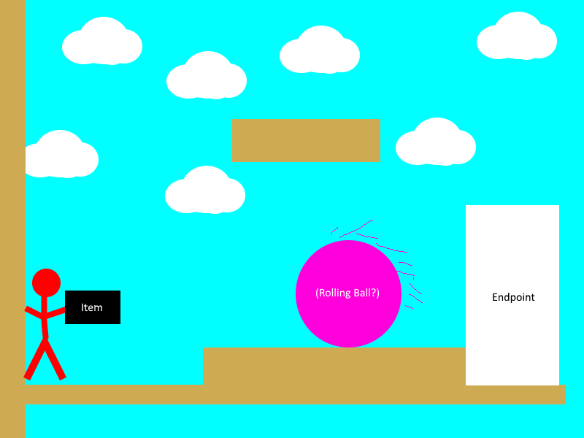

*Note: Visuals may appear different in final game*

**Assignment 3:**

Here is a screen shot of an actual level. You can see a few things here, the player is a stick figure, in about the center of the screen. You can see the almost wood-looking border of the map. These are normal walls. The grayscale version of this with arrows, as you can see on the left-hand side of the map are one-way-walls the player can travel through these only in the direction that the arrow faces. In the bottom right you will see a spiked-triangle (the graphic for this may change); this is a weapon block. They come in 10 different power ratings (0-9). Each level does more damage to the player, and shoots more often than lower levels. The red dash you can see between it and the player is a laser it has fired. If the player loses all of their health (I hope to add some sort of status bar to show this soon) the level will exit. To complete the level, the player must reach one of the “Win Blocks”; these are the white blocks with gold rings you can see a few of in the very top-left of the image.

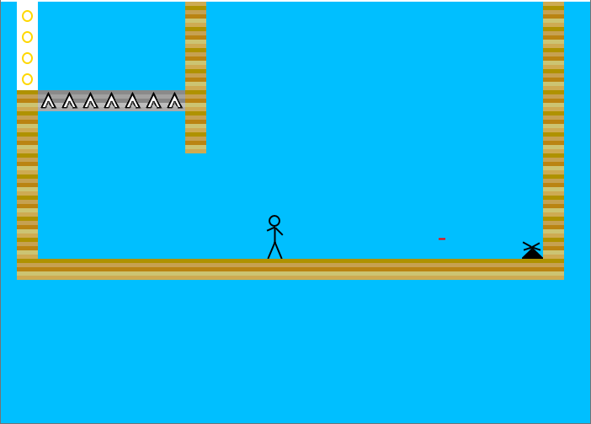

This is the level screen. This shows all of the available levels to play. You are taken here when you start the game, and also when you complete/lose/exit a level. Completed levels are shown in green with a check mark. (Note: checkmarks have not been added yet) I am also considering marking failed levels with Red. They also turn a lighter color on hover.

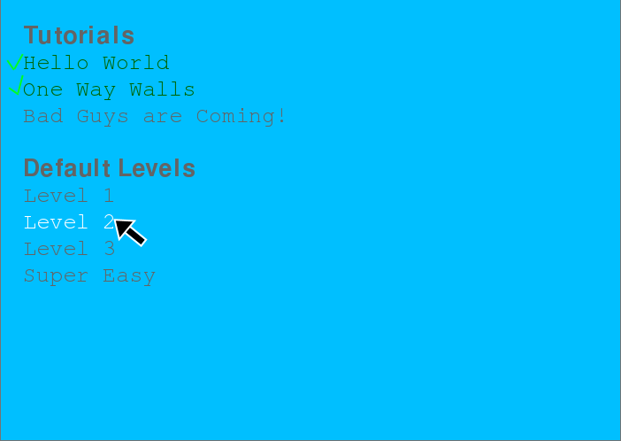

Finally, this is my arrow chart required. I did not include constructor calls for simplicity. (Also I didn’t know how to include that as the origin had no classes). In case this image is too small, the full .png file is located at /dev/arrow_map.png

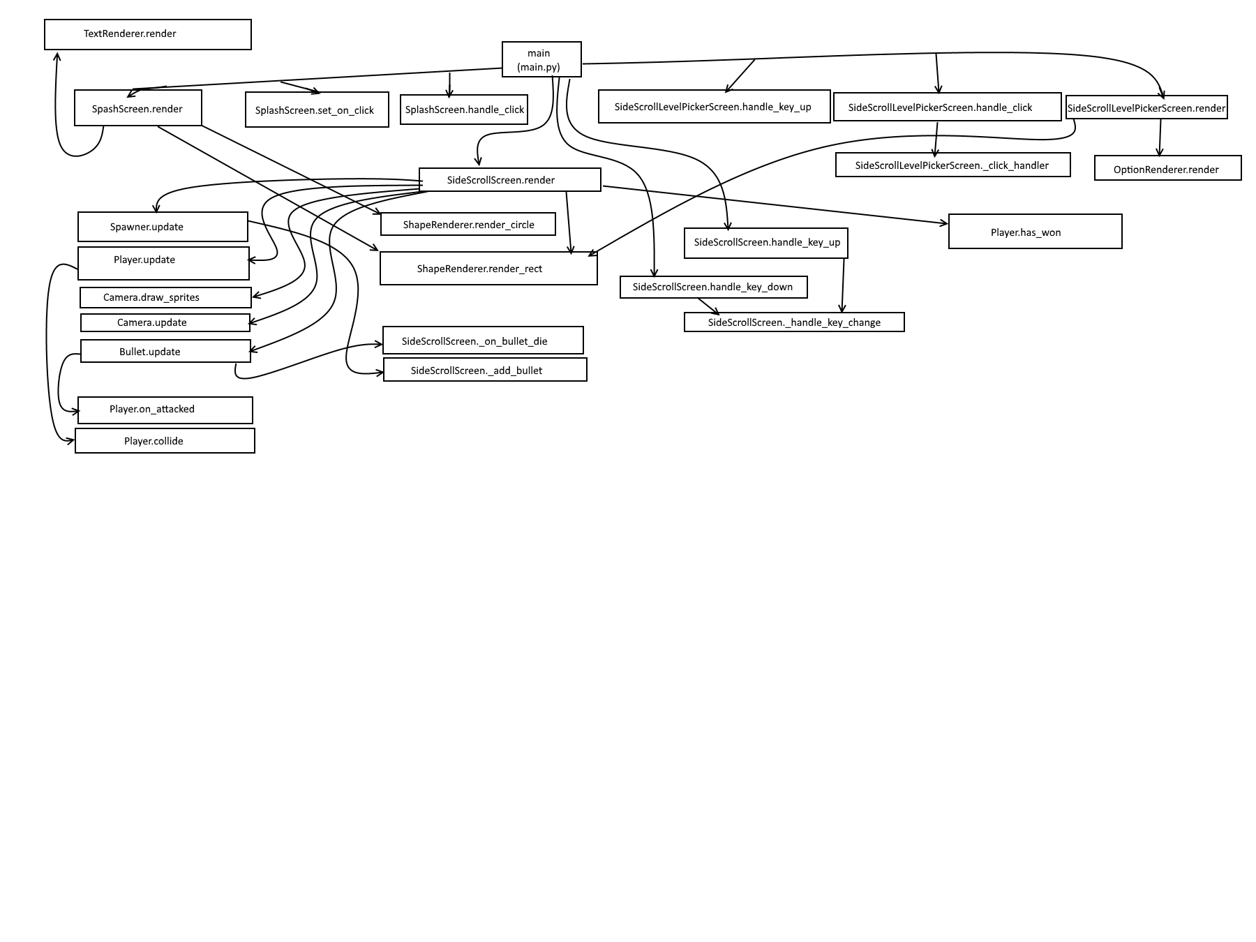

**Conclusion:**

I believe that I should be approved to make this game because out of all of the options I brainstormed it was the only one that solidified in my mind as a “cool” idea. It was an idea that I felt excited to work on; something I will be proud of. I feel that this game will have a positive impact on players because it will be care free, goal oriented and pure, wholesome fun.

**References**

Carlisle, R. P. (2009). Encyclopedia of play in today's society (Vol. 1). Los Angeles: SAGE.

**Glossary**

Side-Scroller: A game that moves on to the right as the player moves

Endpoint**:** Where the level comes to a close. A point obviously marked to the user as the finish.