**Irish Holiday App**

**Created By:** Jake Walsh and Jordan Williams

**Links**

APK File:<https://drive.google.com/open?id=1qS4Cfde4OsGpPK7LtT65AbnJsxB4NYby>

Swagger UI:<https://holiday-api.azurewebsites.net/swagger/index.html>

GitHub Repo: <https://github.com/JakeWalsh69/Holidays_API>

Raw Data: <https://holiday-api.azurewebsites.net/api/Holidays>

App Link: **TO BE ADDED**

Azure SQL DB Server Name: **holiday-api.database.windows.net**

**Overview**

This app uses a RESTful API to display Irish Holiday names and dates to the screen of an Android App. The backend API is coded in C# and is built using ASP.Net Core Entity Framework. The API utilizes a series of HTTP Requests to return data linked to endpoints such as: <https://holiday-api.azurewebsites.net/api/Holidays>. This link will output the raw JSON data pulled from the RESTful API using a GET Request. The database is deployed using Azure SQL Databases and can be accessed and queried by the admin as seen below:

**Azure SQL Database**

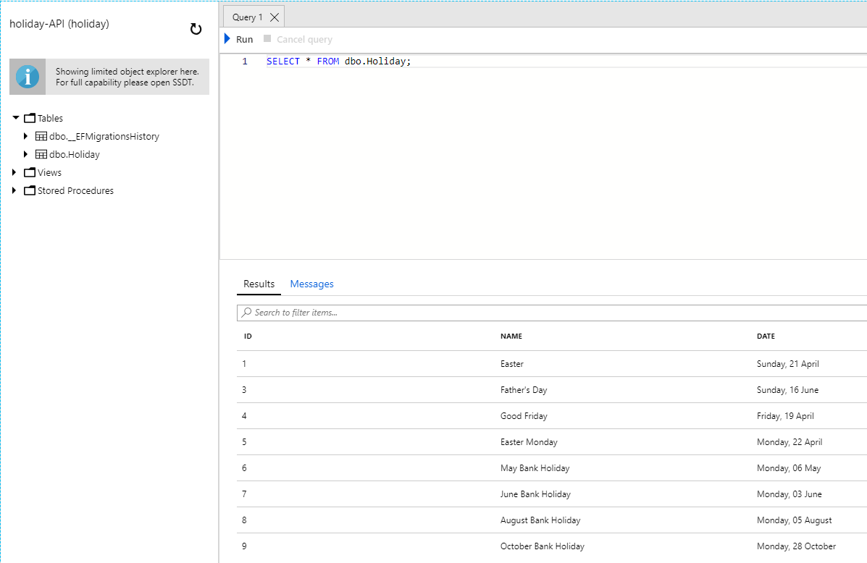

The RESTful service can also be tested by using the Swagger UI Webpage that we have generated in the ASP.Net Core project. On this page we can perform a number of HTTP Requests and perform some manual testing of the API to ensure that it is working correctly. Below we can see an example of some HTTP Requests on the Swagger UI Webpage:

**Swagger UI Webpage**

**GET Request –** Returns all Holiday Data.

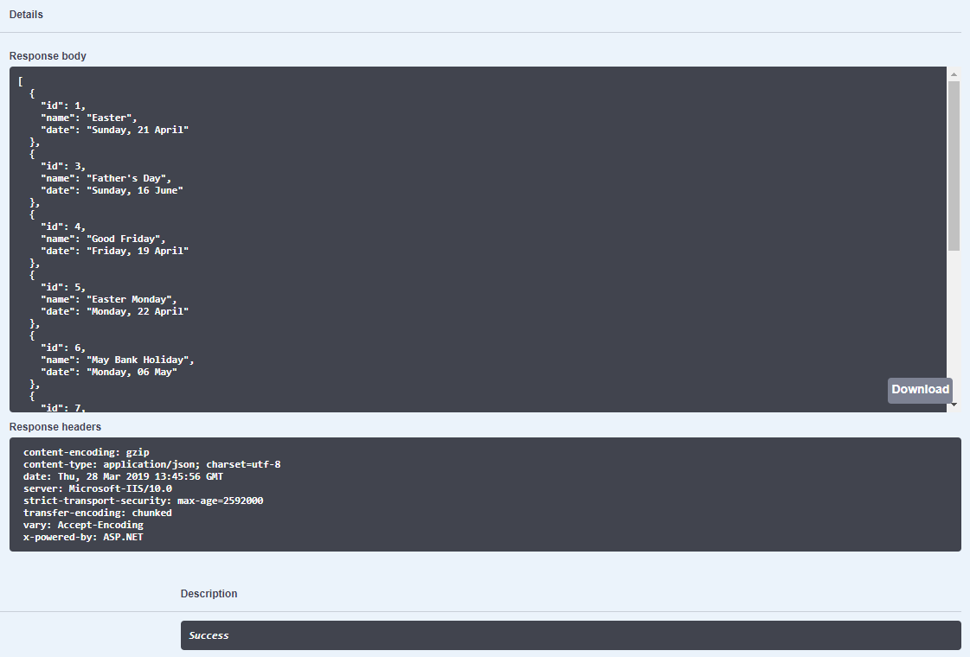

**GET Request –** Returns a Holiday Object based on a given ID (in this case 1).

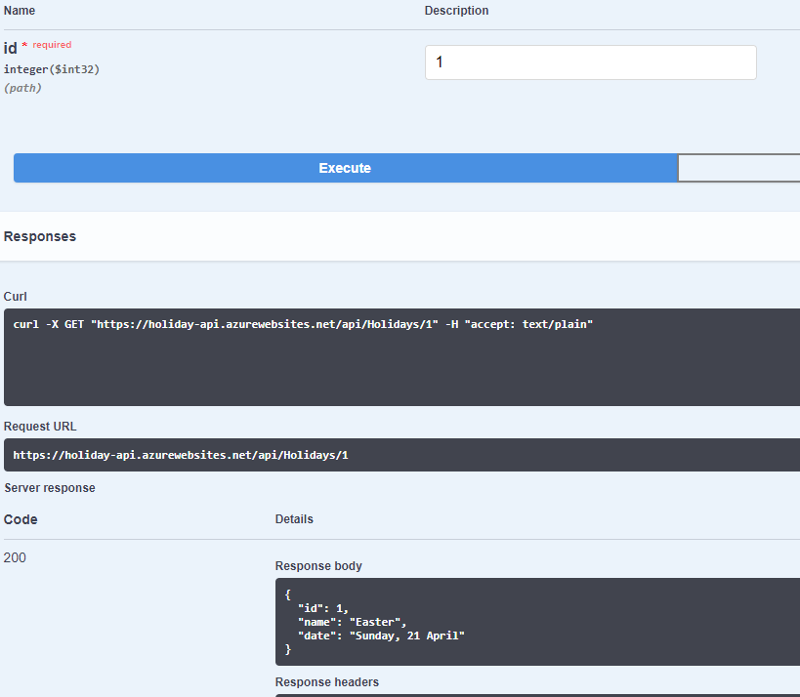

The information we have decided to display in our app is the name and dates of the next 10 holidays in Ireland for the year 2019. This data is loaded automatically when the app is started up and is ordered by the date that is closest to the present day. The user has the ability to scroll through the list of holidays and view them. The phone we chose during the creation of the app is the Nexus 5X API 28 which is used within the Android Emulator in Android Studio. We can see below what the app looks like when it is loaded up through the Android Emulator.

**Holiday App Home Screen**

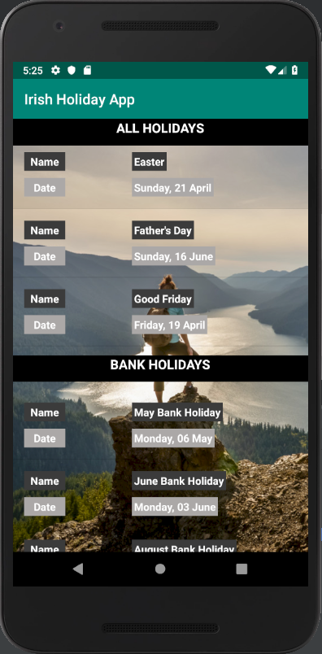

When the app is loaded, two separate lists are displayed. There is the All Holidays list which displays all of the remaining holidays left for the year 2019 as of the release date of the app (April 1st). The second list is a filtered set of results which shows all Bank Holidays remaining for the year to come. These lists are scrollable and show the days and dates that these holidays fall for this year. Belo we can see the scrollable functionality of the lists.

