**ICPro - USER GUIDE**

*ICPro does not require any interaction with the MATLAB command window. Everything, from specifying the processing parameters to viewing and exporting the results is managed via the user interface.*

1. About the processing

ICPro combines two types of data processing: **Trace Element (TE)** and **thorium/uranium (Th/U)**, each measured by inductively coupled plasma mass spectrometry (ICP-MS).

The **TE processing** consists of the following parts:

1. Correction of the raw isotope concentrations for (a) ICP-MS rinse, (b) ICP-MS quality control, (c) spiked samples, (d) oxide formation, (e) the procedural blank and (f) dilution during sediment digestion (in order of implementation). Each of these corrections are optional and can be selected as required.
2. Isotopic dilution (ID) calculations for 232Th and 238U.

The **Th/U processing** consists of the following parts:

1. Tailing and blank correction of raw Th and U counts per second (cps) retrieved from the ICP-MS. The corrections are performed on individual measurement runs.
2. Calculation of an average cps from a set of measurements conducted per isotope and sample (error estimated as standard deviation of the average).
3. Calculation of isotopic ratios to be used for ID calculations of 230Th and 234U.
4. Mass bias correction of the ratios.
5. ID calculations for 230Th and 234U.

In addition to the raw data processing, ICPro determines **accurate uncertainties** of the processing results by propagating errors after each processing step.

1. Starting ICPro

Start by opening ICPro.mlapp. The main user interface will appear.

* *Note: MATLAB will start as well. Don’t quit, it needs to run in the background.*

1. The processor interface

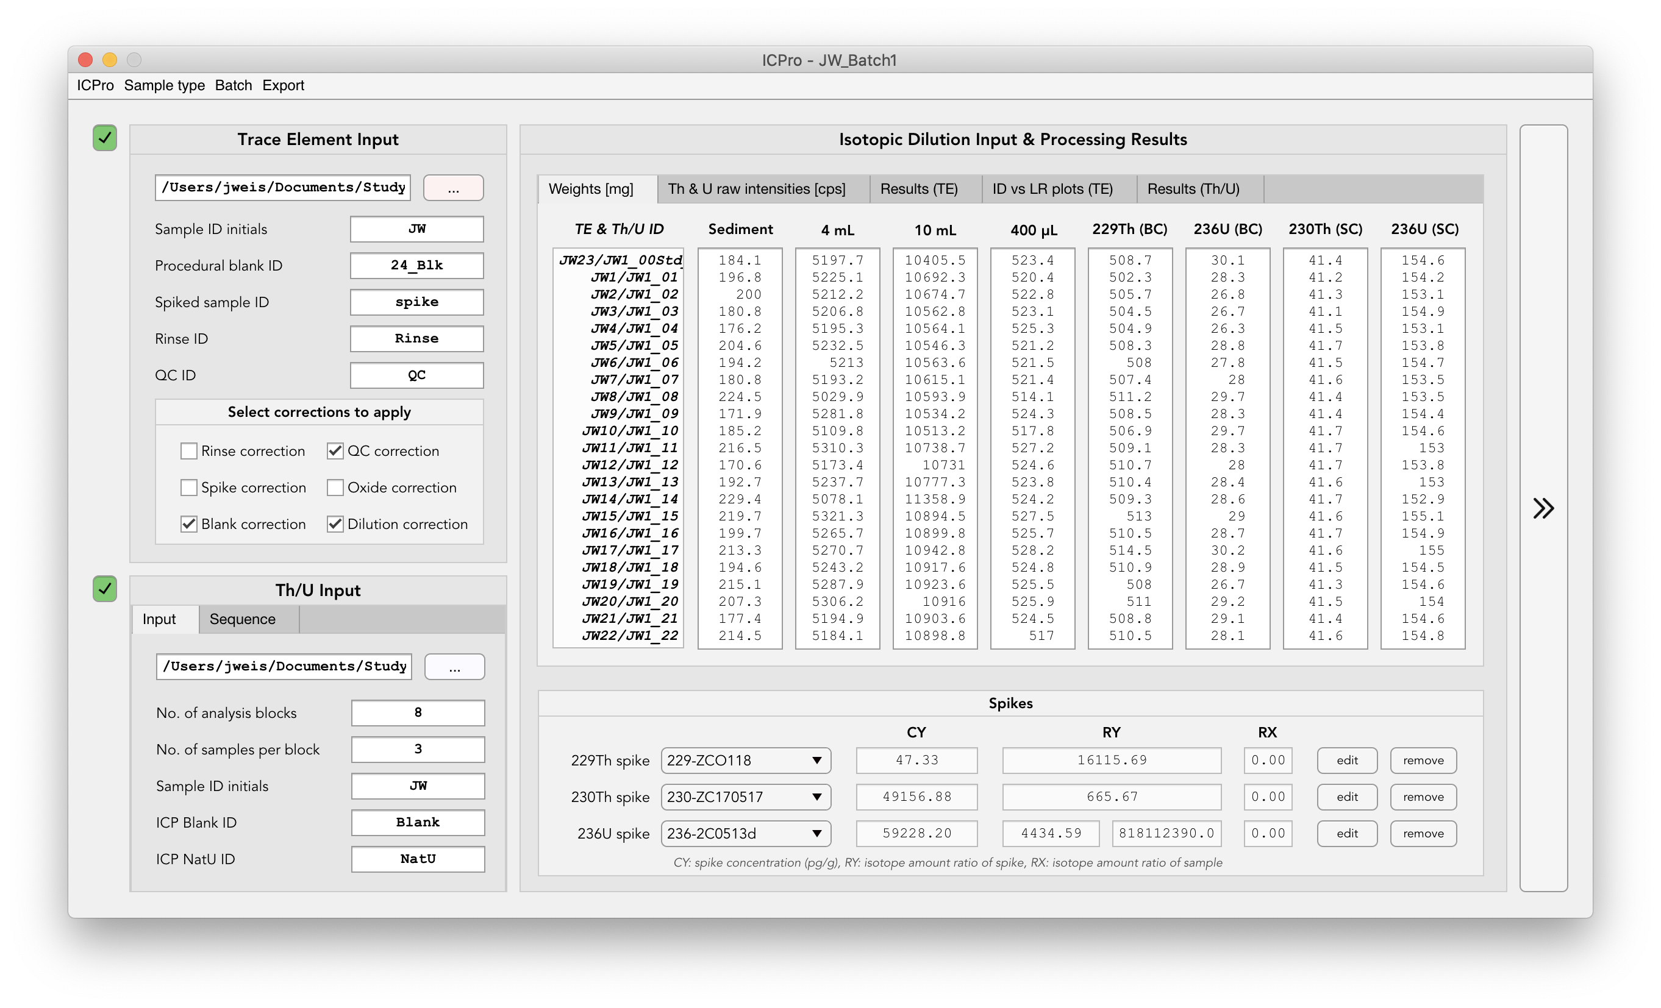

The user interface consists of the following **main elements**:

1. **TE input** (top left)
2. **Th/U input** (bottom left)
3. **Isotopic dilution input** (top right, tabs 1 and 2)
4. **Spike management** (bottom right)
5. **Processing results** (top right, tabs 3-5)

The type of processing can be selected as required via the toggle buttons at the top left corners of the TE and Th/U input windows. Depending on the analyses selected, redundant isotopic dilution and spike input fields will be disabled automatically. Once the analyses have been selected, all required inputs need to be provided:

1. **TE input panel**

1. File path to a raw data excel file (see ex. below)

2. Sample ID initials. Note: Initials are a character sequence which must appear in each sample ID and must not appear in either ICP rinse ID or ICP QC ID. *Ensure appropriate naming of samples in the ICP-MS software, else the raw file will need to be edited.*

3. Procedural blank ID (either the full ID or a character sequence unique to the blank ID)

4. Spiked sample ID (see 3)

5. ICP rinse ID (default: Rinse)

6. ICP QC ID (default: QC)

7. Corrections to apply to the raw concentrations.

Example TE raw data sheet:

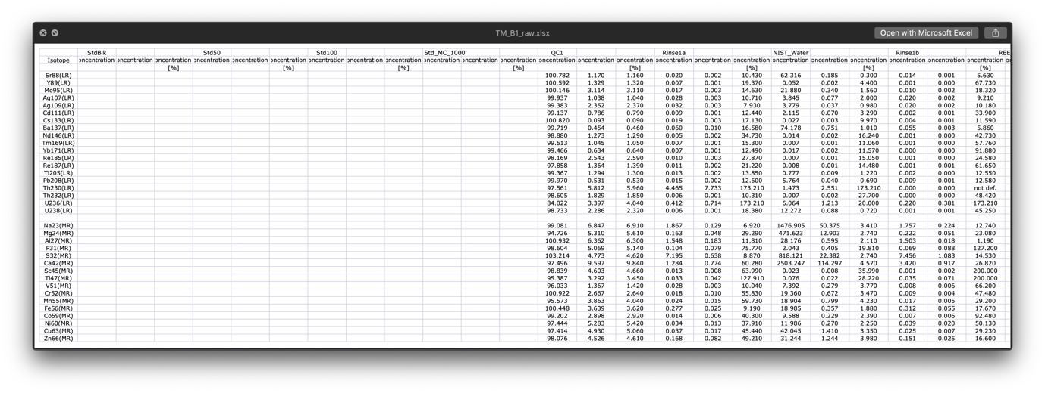

1. **Th/U input panel (and analysis sequence display)**

This part is technically what used to be the *UThProcessor* interface.

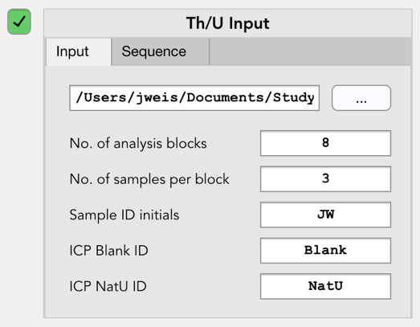1. Path to the folder containing the Th/U raw data files.

2. Number of analysis blocks in which analysis was conducted.

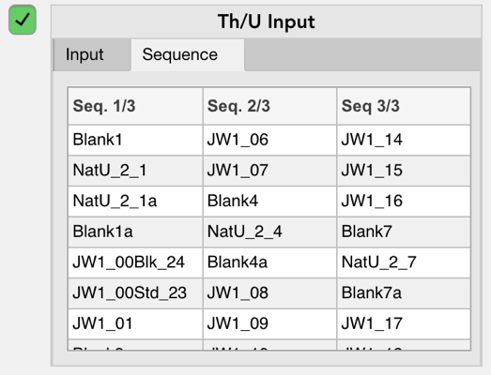3. Number of samples analysed in each block. If each block consists of the same number of samples only one value is required. In case of a variable number of samples per block, enter a value for block.

4. Sample ID initials (see TE input panel, 1)

5. ICP Blank ID (default: Blank)

6. ICP NatU ID (default: NatU)

Based on these parameters, an analysis sequence is generated (required for rinse correction). For this it is important that the raw data files are in correct order in the folder. To double-check that the sequence was generated correctly, switch to the ‘Sequence’ tab (displayed after processing).

1. **Isotopic dilution input**

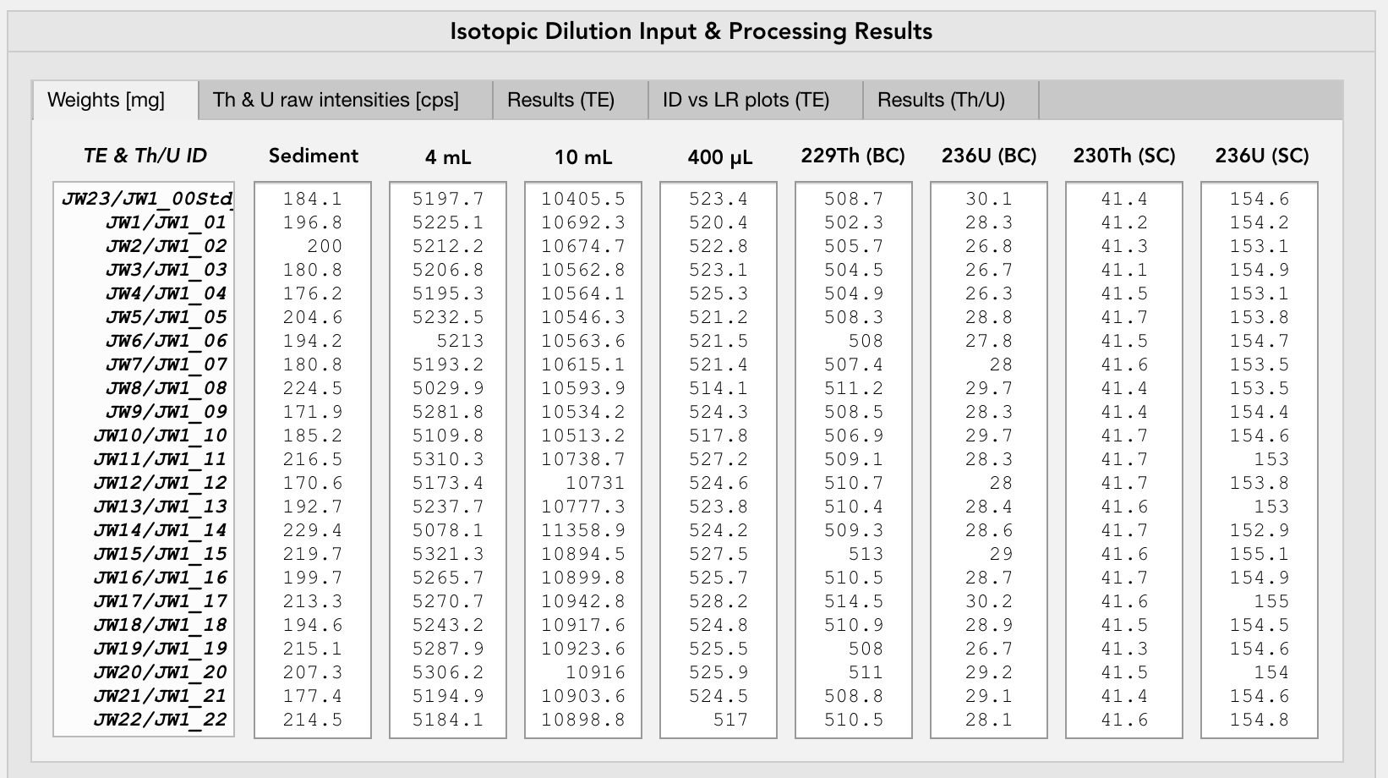

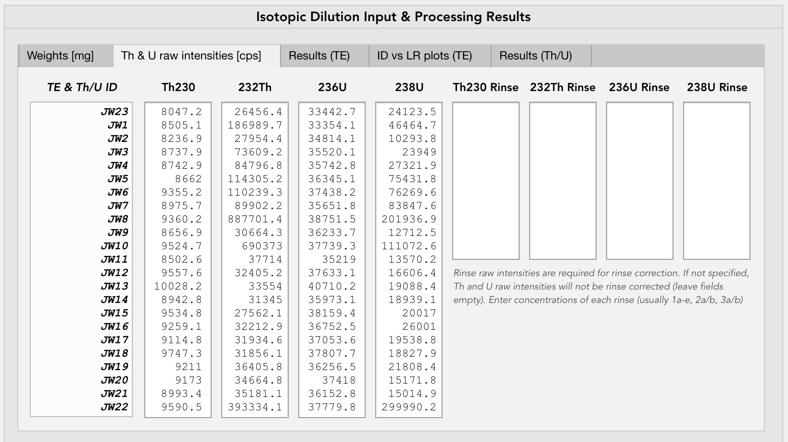

Once all TE and Th/U parameters have been provided, a list of sample IDs will be generated and displayed automatically (far left column). If TE and Th/U are run simultaneously, sample IDs of both analyses are shown. They should always correspond!

In order to perform the TE and Th/U isotopic dilution calculations a number of sample weights recorded during the sample preparation as well as certain isotope raw counts need to be provided via the respective input fields in the first two tabs of the ‘*Isotopic Dilution Input & Processing Results*’ panel (‘*Weights*’ and ‘*Th & U raw intensities*’).

*Note: Rinse raw counts are optional and only required if the sample raw counts need to be rinse corrected.*

1. **Spike management panel**

Spikes used during the sample preparation are managed and selected in the *spike management panel*. In here, spikes can be created, edited, removed and selected for processing. Recently used spikes have been pre-added (can be edited in case parameters are incorrect).

1. **Processing results**

*Processed TE isotope concentrations*

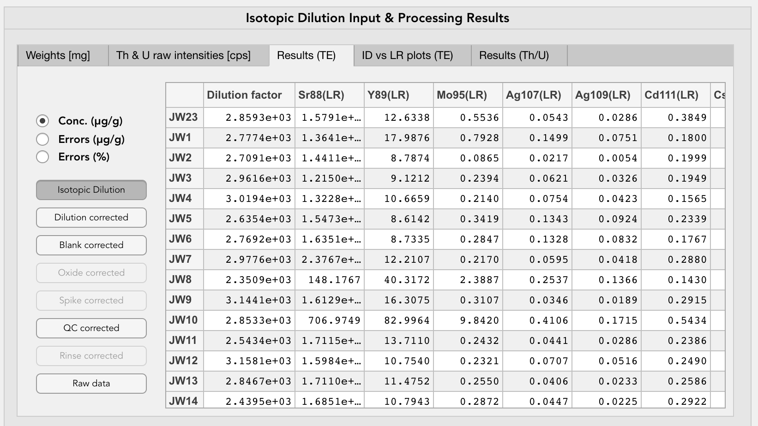

The ‘*Results (TE)*’ tab displays the TE processing results. In order to make the processing as transparent as possible, users can browse through the results of each processing step performed from the raw data to the end product. Results can further be displayed as concentrations in ppm, absolute errors in ppm and percentage errors.

*Note: Dilution-corrected and isotopic dilution results include the dilution factor.*

*Isotopic dilution vs linear regression plots*

In addition to the TE concentration results, regression plots of isotopic dilution (calculated by ICPro) vs. linear regression (calculated by ICP-MS) based 232Th and 238U concentrations are displayed in the ‘ID vs LR plots’ tab.

*Th/U processing results*

Th/U results are displayed in the ‘Results (Th/U)’ tab. Results to display include 230Th and 234U concentrations as well as certain isotope ratios: sample 229Th/230Th & 236U/234U (used for isotopic dilution calculations) and NatU standard 235U/234U (for control purposes). Similar to the TE concentrations results, absolute and percentage errors of all Th/U results can be displayed.