Jake Wenger

GEO482 – Location Analysis

Lab 2 – P-Median

2. After creating the two maps for population density and air pollution, looking at the population map we can see that the vast majority of people live in and around the urban core of Buffalo. And looking at the air pollution map, the majority of air pollution is located north of Buffalo, with the heaviest concentrations in Niagara County and Niagara Falls.

3. p=3: (55 287 178)

p=4: (18 17 284 178)

p=5: (18 49 288 245 159)

p=6: (14 17 296 246 159 137)

p=7: (14 49 225 275 88 159 124)

p=8: (14 49 224 297 167 195 183 197)

p=9: (14 49 207 275 83 181 148 89 195)

p=10: (14 49 13 276 210 156 195 125 104 197)

p=11: (14 49 13 76 210 173 195 184 281 104 140)

p=12: (14 49 31 188 292 274 156 149 125 119 195 147)

p=13: (14 49 13 188 76 210 156 181 184 281 119 195 140)

p=14: (14 49 13 188 76 210 156 181 125 281 119 195 147 241)

p=15: (14 2 49 13 188 76 210 156 181 125 281 119 195 147 241)

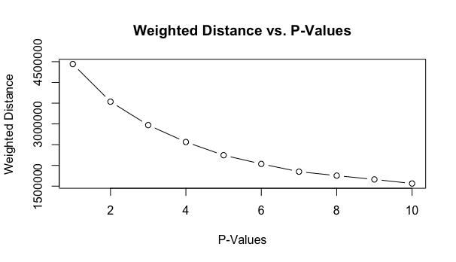

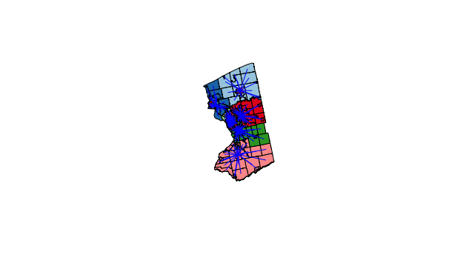

4. The solution set when fixing sites 1 and 100 is (1 17 100 284 178).

