ICE Exchange Conference Proposal

1. Presentation Title
Empowering SMEs via Item Modeling to Generate Quality Items, Sophisticated Item Types, Functional Distractors, and Rationales

2. Session Format
30 minutes: 25 minutes for presentation and 5 for Q and A

3. Target Audience
Psychometricians, Test Developers, Certification Program Managers, and Credentialing Executives interested in the intersection of Artificial Intelligence, cognitive psychology, and scalable assessment development.

4. Proposal Abstract (50-75 words)
This session introduces a novel framework for an AI-assisted item modeling SME toolkit that shifts the paradigm from simple LLM text-generation to principled cognitive engineering. By employing a 4-agent architecture—Encoder, Decoder, Diffusion, and Rationale actors—integrated with Retrieval-Augmented Generation (RAG) and semantic databases, we demonstrate how Subject Matter Experts (SMEs) can interactively construct high-order, psychometrically valid assessment items efficiently while minimizing construct-irrelevant variance.

5. Detailed Description (1-2 pages)

The Credentialing Challenge in AIG
Historically, Automated Item Generation has struggled to reliably produce high-order cognitive items suitable for high-stakes certification boundaries. Traditional templates or "blank-page" Large Language Model (LLM) prompts frequently result in items that are superficially paraphrased, cognitively shallow, or susceptible to item cloning vulnerabilities. To protect psychometric integrity within credentialing, an AIG system must explicitly model cognitive operations and content complexity before generating text.

The 4-Agent SME Toolkit Architecture
To solve this, we propose an AIG framework powered by four specialized AI agents operating in concert, guided interactively by a Subject Matter Expert (SME):
- **The Encoder Agent (Deconstruction)**
The Encoder's role is to decompose existing reference materials and seed items into a strict cognitive and structural blueprint. It operates across two primary areas: mapping domain/task knowledge and modeling cognitive depth. It identifies the target mental operations (e.g., analyze, prioritize, evaluate) and maps the underlying domain concepts, explicitly recognizing and decomposing the "radical" structural features from the superficial "incident" features (window dressing).
- **The Decoder Agent (Reconstruction)**
Operating on the blueprint created by the Encoder, the Decoder reconstructs the item model. It generates new clinical vignettes, scenarios, and prompts that remain entirely faithful to the intended cognitive construct. Crucially, the Decoder also creates the fundamental key feature space and misconception space used to guide formulation. This ensures the new items are cognitively isomorphic to the original standard while maintaining a highly diverse operational presentation.
- **The Diffusion Agent (Distractor Modeling via Cognitive Misconception Mapping)**
Formulating defensible distractors is the most challenging aspect of item writing. The Diffusion Agent leverages Cognitive Misconception Mapping (CMM) to validate and confirm the key feature space and misconception space. It uses this foundation to formulate functional distractors, utilizing semantic search against a Vector Database and referencing current item information within the bank (stored in a Relational Database). Each distractor purposefully targets a known, documented learner misconception.
- **The Rationale Agent (Validation & Documentation)**
The final agent acts as a quality assurance and documentation engine. The underlying RAG system is especially critical for this agent to validate the overall item model and distractors, ultimately confirming the accuracy of the information against source material. It produces comprehensive, multi-tiered rationales (Candidate-facing, SME-facing, and Audit-facing), creating a transparent evidence trace that justifies the correct key and explicitly explains why each distractor is incorrect.

Technical Foundation and the Human-in-the-Loop
This highly structured approach requires a sophisticated underlying technical stack:
- **Core AI Integration:** Advanced LLMs handle the nuanced natural language reasoning for each agent step.
- **Retrieval-Augmented Generation (RAG):** Ensures all generated content is deeply grounded in the most current, authorized reference materials, dramatically reducing the risk of hallucination.
- **Dual Database Architecture:** A **Vector Database** enables rapid semantic and mathematical search of key features and misconceptions, while a **Relational Database** manages meta-tags, workflow states, and the authoritative item bank.
Most importantly, this architecture fundamentally shifts the role of the Subject Matter Expert. The SME is no longer a blank-page item writer prone to fatigue; instead, the SME becomes an interactive partner and cognitive architect. The SME directs the agents, adjusts the foundational blueprint, reviews the dynamic cognitive misconception mapping of feature overlap, and approves the final output.

Learning Objectives
By the end of this session, attendees will be able to:
- Identify the limitations of basic prompt engineering and text-generation for high-stakes assessment items.
- Outline the workflow of a 4-agent AIG architecture (Encoder, Decoder, Diffusion, and Rationale).
- Understand how to use semantic search and Cognitive Misconception Mapping (CMM) to tie distractors to specific cognitive misconceptions.
- Describe how the SME role must evolve from "content creator" to "interactive cognitive architect" in the AI era.

Appendix: System Architecture Diagrams

4-Agent SME Toolkit Architecture
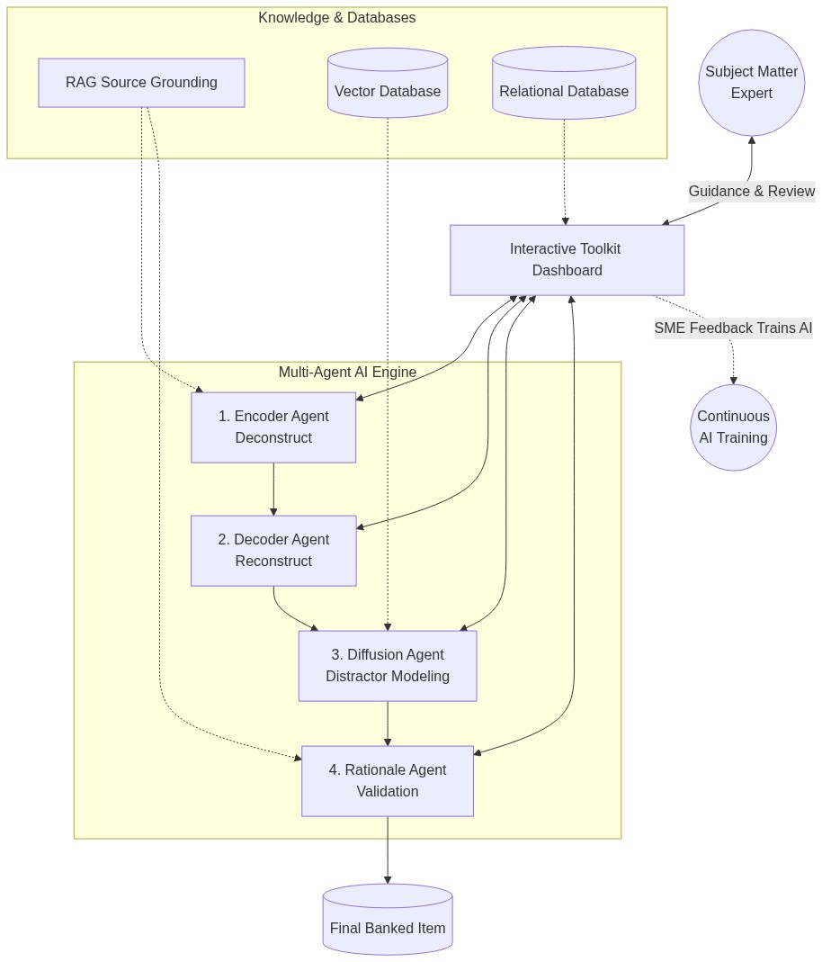

Key Feature Venn Diagram Method
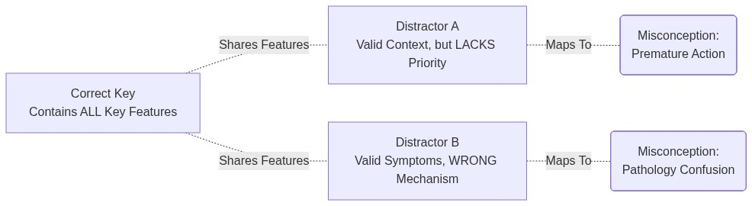

Complete Technical Foundation
