Increase in venous [K+] During Hyperbaric Exposure Independent of Changes in pH or O2 Concentration

Jacob Lamers,

Matthew Marcou,

Kent MacLaughlin,

Rudolf Braun,

Marlowe Eldridge

# Abstract

**Increase in venous [K+] During Hyperbaric Exposure Independent of Changes in pH or O2 Concentration**

**Increase in venous [K+] During Hyperbaric Exposure**

Plasma potassium regulation is important for function of numerous cells in the body. Changes in potassium levels during exposure to an increased O2 concentration is thought to be the result of the changes in pH and increasing reactive oxygen species (ROS). However, the effects of hyperbaria on plasma potassium concentration are not well understood.

Eight subjects were exposed to 1.3 atmospheres absolute (ATA) of hyperbaric air for 90 minutes, 10-times (M-F) over 12-days. Another eight subjects were exposed to 100% oxygen at 1 ATA over the same interval. Four venous blood draws were taken. On day 1 the first draw was taken immediately preceding treatment and the second was taken immediately following treatment. The third draw was taken prior to the 10th treatment and the 4th draw was taken 72 hours post final treatment. We analyzed samples on a blood gas analyzer and performed statistical analysis using a paired Wilcoxon signed-rank test.

The concentration group saw strong trend towards an increase in the potassium concentration from 4.09 ± 0.12 (mmol/L) to 4.28 ± 0.28 (mmol/L) (p = 0.065). In the hyperbaric group we see a significant increase in potassium concentration from 4.19 ± 0.26 (mmol/L) to 4.55 ± 0.27 (mmol/L) (p = 0.0068). In the concentration group we also see a significant increase in pH concentration from 7.37 ± 0.03 to 7.39 ± 0.01 (p= 0.021). A similar significant increase is not seen in the hyperbaric group.

These finding suggest that changes in potassium concentration in response to hyperbaria are not the result of oxygen concentration nor pH. Possible explanations include increased nitrogen levels due to hyperbaric air, increased CO2 concentration in hyperbaric chamber or changes in the activity of Na+,K+ ATPase pumps at the cellular level which may be a homeostatic response to combat pulmonary edema

Keywords: Potassium, Hyperbarics, Hyperoxia

# Introduction

      Plasma potassium levels are dependent on a multitude of factors and result from the interplay of intracellular and extracellular changes and intake and execration rates.1–3 While potassium is viewed as an intracellular cation significant levels are observed extracellularly.4 Extracellular plasma potassium levels are heavily regulated to fall within a narrow range of 3.5 to 5.0 mmol per liter and maintenance at these concentrations are of extreme importance to the role of organs throughout the body.3 This importance is underscored by the fact plasma potassium levels in both hypokalemia or hyperkalemia lead to an increased death rates in certain conditions.6,7 Based on these findings, the determination of pathways of regulation leading to changes in plasma potassium levels are of importance.

      Classic explanations for variations in plasma potassium levels emphasize the importance of acid-base distribution through their effects on ion transporters.1 Ion exchanges involving , , and are important for maintaining the intracellular and extracellular levels of potassium.1 Renal function is also of integral to the regulation of potassium.1 Previously mentioned ions and their transporters and the hormone aldosterone play a central role in modulating renal excretion and re-uptake rates of potassium.1 Although acid-base distribution, ion-exchange and renal excretion/re-absorption offer the main explanation of plasma potassium levels other factors influence their physiological concentrations.2,8 In this study concentration and increased pressure were the factors under investigation which may lead to changes in plasma potassium levels.

      Modulation of inspired concentration has been used as an effectives treatment for a multitude of conditions. The two main methods to administer this concentration increase are by directly varying concentration of inspired gases or by varying the ambient pressure. By combining these to aspects of concentration, three of the main modes of administration are obtained. These are hyperbaric , concentrated and hyperbaric treatment. According the UHMS hyperbaric oxygen therapy () is defined as exposure to near 100% while inside a pressurized chamber at greater than sea level pressure.9 In contrast hyperbaric treatment is exposure to an increase in pressure without an increase in administered gas concentration. Finally concentrated oxygen is the exposure to gas with a higher concentration of than normal air. Concentrated oxygen and hyperbaric treatment were the two treatments under investigation in this study.

      Effects of hyperoxia on plasma potassium levels remain ambiguous.2 A few studies have demonstrated an increase in plasma potassium as the result of hyperoxic exposure while others have found no similar increase.2,10 However research has shown that hyperoxia can effect voltage-gated K+ channels in humans11–13 One group found that long-term exposure to hyperoxia can result in a decrease in activity of voltage-gated K+ channels in lung tissue.11,12 Where as another study looking at voltage-gated K+ channels of the heart and saw a signifigant reduction of oxygen-sensitive Kv1.5 potassium channel protein expression.13 Internal potassium homeostasis and the distribution of intracellular and extracellular potassium in the body is primarily the result of ion-exchanges pumps and passive efflux.1,3 Hypoxia has also been shown to cause an increase in arterial potassium levels and cause changes in expression of Voltage gated K+ channel in pulmonary arterial myocytes through indicating a potential pathway through which potassium levels are modulated via changes in concentration.8,14–16 Therefore changes in activity or expression of these channels offers a potential linkage between effects hyperoxia on plasma potassium.

       Historically, studies in mice and rats have shown that exposure reduces lung injury and can help alleviate the effects of hypoxia and hypoxemia.17 While the mechanism for this is not entirely understood, it has been proposed that an upregulation in the activity of Na+/K+ ATPase and a subsequent increase in movement of Na+ and K+ ions inside the cells of lung tissue assists in relieving lung injury.18 In multiple cases, hyperbaric treatment has been shown to be effective in clearing edema in the lungs.17,18 Pulmonary edema is a common occurrence when using a SCUBA device for deep-sea diving, and hyperbaric oxygen has been an approved treatment for diving-related conditions for several years. Due to the risks that can be associated with breathing 100% for extended periods of time, it is worthwhile to discover if it is possible to alleviate these conditions with solely hyperbaric treatment, eliminating the harmful effects of 100% exposure. Literature detailing hyperbaric effects on plasma ion concentrations mostly focus on . As previously mentioned exposure to hyperoxia also causes changes in plasma ion concentrations. This means studies of and its effects on these concentrations can not seperate the effects of increased pressure and increased . The main goal of this study was to determine the similarities and differences in effects of concentrated and hyperbaria on the blood metabolites, specifically plasma potassium levels.

# Methods

      Healthy adult subjects were recruited via REDCap using a University of Wisconsin’s email list. A questionnaire was administered to determine characteristics of individuals such as pre-existing conditions and age. Individuals who responded to the survey were selected at random and contacted via phone. Participants in the study were separated into two groups. The first group received hyperbaric treatment in altitude sickness bags (n=13) while the second group received concentrated at room pressure (n=11).

      Although treatment varied between groups, treatment schedule remained consistent as shown in figure 1. Subjects arrived Monday and height and weight were determined. Blood was collected via venipuncture before treatment was used for a baseline metabolic panel and was analyzed on arterial blood gas (ABG) machine. Following blood draws subjects underwent 1.5 hours if in the hyperbaric arm or 1 hour if in the concentrated arm. After treatment blood was collected to determine acute response in blood metabolites. Following this, treatment was given Tuesday through Friday of the following week, taking a break for weekends where no treatment was administered. A blood draw and ABG analysis was preformed before the tenth and final treatment and after a weekend of no treatment following the final treatment another blood draw occurred and subsequent analysis was preformed.

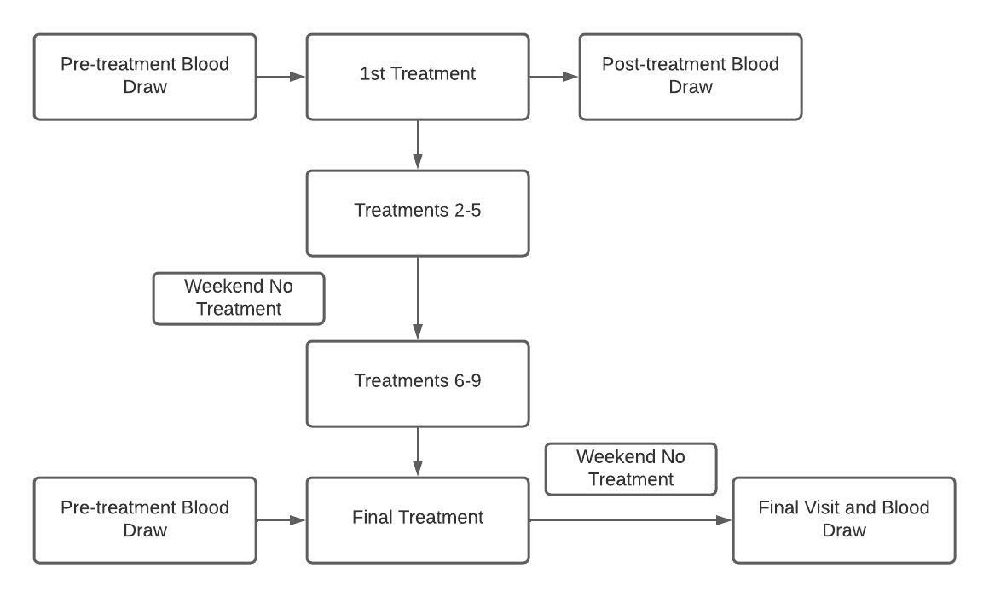

**Figure 1.** Outline detailing treatment schedule for both hyperbaric and hyperoxia treatment groups.

      A total of 36 metabolic indicators were reported by the ABG machine. Indicators were compared pairwise between the four draws. Statistical analysis and data visualization was performed using R (The R Foundation) where paired student t-tests were used for normally distributed lab results and while wilcox tests were used for the and because of their skewed distributions.19

# Results

      Tables one and two display values for classical ions of interest in potassium homeostasis for concentrated and hyperbaric air respectively. The concentrated group saw a significant increase in pH from baseline levels of to post-exposure levels of (p=0.023) while the hyperbaric group saw no similar significant increase. Plasma potassium levels were significantly increased in the hyperbaric oxygen group immediately post exposure when compared to thier baseline values as shown in figure one. The hyperbaric groups intial potassium levels were at and the post-exposure levels were .(p=0.0068). Although a few subjects show no change or slight decrease in plasma potassium a strong trend toward increase is observed in this group. However, in figure two there is so similar trend towards increase observed with only a few subjects experiencing a increase in plasma potassium levels.

Metabolite concentrations for concentrated oxygen group from pre, post, day 10 and final blood draws. Signifigance denoted by (* < 0.05), (** < 0.001)

| Metabolite | Pre (n=13) | Post (n=13) | Day 10 (n=10) | Final (n=9) |
| --- | --- | --- | --- | --- |
|  |  |  |  |  |
|  |  |  |  |  |
|  |  |  |  |  |
|  |  |  |  |  |
|  |  |  |  |  |
|  |  |  |  |  |
|  |  |  |  |  |

Metabolite concentrations for hyperbaric group from pre, post, day 10 and final blood draws. Signifigance denoted by (* < 0.05), (** < 0.001)

| Metabolite | Pre (n=11) | Post (n=11) | Day 10 (n=11) | Final (n=11) |
| --- | --- | --- | --- | --- |
|  |  |  | (n=8) |  |
|  |  |  | (n=8) |  |
|  | (n=8) | (n=7) | (n=10) |  |
|  |  |  |  |  |
|  |  |  |  |  |
|  |  |  |  |  |
|  |  |  |  |  |

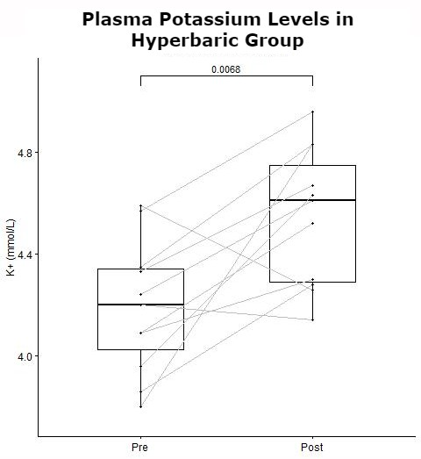

**Figure 2.** Signifigant acute increase in plasma potassium concentration before and after treatment in the hyperbaric group.

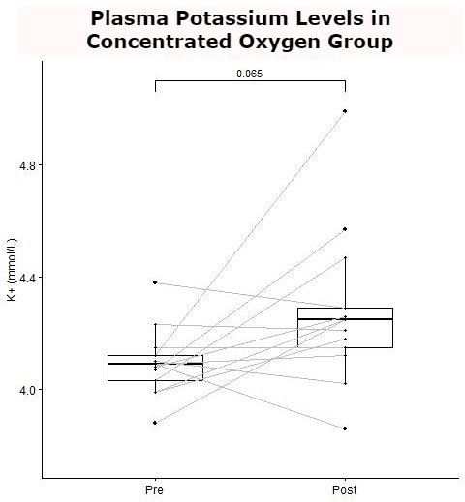

**Figure 3.** Comparison of plasma potassium concentration before and after treatment in the concentrated oxygen group.

# Discussion

     Our results show that hyperbaric exposure for 1.5 hours leads to an acute increase in plasma potassium levels. A similar increase was not observed in individuals exposed to 1 hour of hyperoxia. The increase in the hyperbaric group and lack there of in the hyperoxia group suggest changes in plasma potassium concentrations in the hyperbaric group are the result of a mechanism independent of exposure to increased pressure. Based on this finding and the fact that the classical metabolites implicated in plasma potassium levels experienced no significant fluctuations in this study hint a possible novel relationship between plasma potassium and hyperbaric treatment seems likely. Limitations of this study mean that exact mechanisms causing this relationship could not be determined based on findings in literature a few were preposed.

     Hypoxia-inducible factor 1 (HIF-1) is an important transcriptional factor that is integral to the bodies response to ROS.16 Hypoxia has been linked to changes in to expression and activity of certain potassium pumps.14–16 According to the hyperoxic-hypoxic paradox fluctuations in free concentration are integral to the response observed in cells rather than sign of those changes.20 This means that some physiological responses can be markedly similar between hypoxia and hyperoxia.20 Although the concentration is lower in the hyperbaric group, hyperbaria also increases the concentration of which in turn increases the amount of reactive nitrogen species (RNS). RNS have been shown to induce HIF-1 under non-hypoxic conditions.21 Based on the effects of RNS and ROS on HIF-1 and the fact that HIF-1 can cause fluctions in potassium pump activity and expression, RNS and ROS generated by hyperbaric exposure and thier effects on HIF-1 offer one possible explanation for the differences in changes in plasma potassium levels between the two groups.

      Another possible explanation for the observed rise in plasma potassium seen after hyperbaric exposure is an attempt of the cardiovascular system to combat pulmonary edema. We theorize that the external pressure experienced from the hyperbaric environment results in increased breathing effort and heart preload as a result of negative pressure breathing. This increased preload leads to both an increase in cardiac output, as well as the release of atrial natriuretic peptide (ANP) by cardiac muscle cells, a hormone that increases capillary permeability. Both effects are known to increase intravascular leakage and contribute to edema and have been well studied in SCUBA divers who experience pressures similar to those experienced by the hyperbaric study group.22 Therefore, it is plausible that similar effects could be seen here. Additionally, it has been found in similar studies that the activity of ion transporters in cells, specifically Na+/K+ ATPases of alveolar epithelial cells, is upregulated by hyperbaric (and hyperoxic) exposure.18,23 Due to this upregulation, and the increase in intracellular K+ observed when exposed to hyperoxia, we theorize the increase in Na+/K+ ATPase activity is a natural mechanism to combat pulmonary edema.23 By taking in more K+ ions into the cell, more Na+ ions are released from the cell via Na+/K+ ATPase and can be utilized by the body to absorb fluid accumulating in the lungs. The studies referenced were conducted using rat lung models, and further study is needed to determine if the same significant effect can be seen in a human model.

    Finally correlations between respratory acidosis and an increase in plasma potassium have been reported with few exceptions.2 During hyperbaric exprosure subjects exprienced an increase of level of at about 0.35 0.02% over room air. Subject expired gases and a lack of outflow of those respired gases in the altitude sickness bags is most likely responsible for the increase in observed in chamber. This increase in may result in a mild respratory acidosis which could be causing the corresponding increase in plasma potassium levels. However the lack of changes indicitive of respratory acidosis observed in other blood metabolites and the mild increase in concentration makes this explanation unlikely.

    This study provides a novel finding relating an increase in plasma potassium to hyperbaric exposure. However, limitations in study design and potential confounding variables mean that futher research is required to confirm the cause of this observation and its relationship with hyperbaric exposure.

# References

(1) Aronson, P. S.; Giebisch, G. [Effects of pH on Potassium: New Explanations for Old Observations](https://jasn.asnjournals.org/content/jnephrol/22/11/1981.full.pdf). *Journal of the American Society of Nephrology* **2011**, *22*, 1981–1989.

(2) Adrogué, H. J.; Madias, N. E. Changes in Plasma Potassium Concentration During Acute Acid-Base Disturbances. *The American Journal of Medicine* **1981**, *71* (3), 456–467. https://doi.org/[10.1016/0002-9343(81)90182-0](https://doi.org/10.1016/0002-9343(81)90182-0).

(3) Gumz, M. L.; Rabinowitz, L.; Wingo, C. S. An Integrated View of Potassium Homeostasis. *New England Journal of Medicine* **2015**, *373* (1), 60–72. https://doi.org/[10.1056/NEJMra1313341](https://doi.org/10.1056/NEJMra1313341).

(4) Gupta, S.; Fenves, A. Z. The Distribution of Plasma Electrolytes. *The American Journal of the Medical Sciences* **2017**, *354* (5), 443–444. https://doi.org/[10.1016/j.amjms.2017.08.025](https://doi.org/10.1016/j.amjms.2017.08.025).

(5) Youn, J. H.; McDonough, A. A. Recent Advances in Understanding Integrative Control of Potassium Homeostasis. *Annual Review of Physiology* **2009**, *71* (1), 381–401. https://doi.org/[10.1146/annurev.physiol.010908.163241](https://doi.org/10.1146/annurev.physiol.010908.163241).

(6) Torlén, K.; Kalantar-Zadeh, K.; Molnar, M. Z.; Vashistha, T.; Mehrotra, R. Serum Potassium and Cause-Specific Mortality in a Large Peritoneal Dialysis Cohort. *Clinical Journal of the American Society of Nephrology* **2012**, *7* (8), 1272–1284. https://doi.org/[10.2215/CJN.00960112](https://doi.org/10.2215/CJN.00960112).

(7) Goyal, A.; Spertus, J. A.; Gosch, K.; Venkitachalam, L.; Jones, P. G.; Van den Berghe, G.; Kosiborod, M. Serum Potassium Levels and Mortality in Acute Myocardial Infarction. *JAMA* **2012**, *307* (2), 157–164. https://doi.org/[10.1001/jama.2011.1967](https://doi.org/10.1001/jama.2011.1967).

(8) Barlow, C. W.; Qayyum, M. S.; Davey, P. P.; Paterson, D. J.; Robbins, P. A. Effect of Hypoxia on Arterial Potassium Concentration at Rest and During Exercise in Man. *Exp Physiol* **1994**, *79* (2), 257–260. https://doi.org/[10.1113/expphysiol.1994.sp003759](https://doi.org/10.1113/expphysiol.1994.sp003759).

(9) *Hyperbaric Oxygen Therapy Indications*; Moon, R. E., Ed.; Undersea; Hyperbaric Medical Society, 2019; Vol. 14th.

(10) Fraley, D. S.; Adler, S. Isohydric Regulation of Plasma Potassium by Bicarbonate in the Rat. *Kidney International* **1976**, *9* (4), 333–343. https://doi.org/[10.1038/ki.1976.39](https://doi.org/10.1038/ki.1976.39).

(11) Zyrianova, T.; Lopez, B.; Olcese, R.; Belperio, J.; Waters, C. M.; Wong, L.; Nguyen, V.; Talapaneni, S.; Schwingshackl, A. K2p2.1 (TREK-1) Potassium Channel Activation Protects Against Hyperoxia-Induced Lung Injury. *Scientific Reports* **2020**, *10* (1), 22011. https://doi.org/[10.1038/s41598-020-78886-y](https://doi.org/10.1038/s41598-020-78886-y).

(12) Schwingshackl, A.; Teng, B.; Ghosh, M.; West, A. N.; Makena, P.; Gorantla, V.; Sinclair, S. E.; Waters, C. M. Regulation and Function of the Two-Pore-Domain (K2p) Potassium Channel Trek-1 in Alveolar Epithelial Cells. *American Journal of Physiology-Lung Cellular and Molecular Physiology* **2012**, *302* (1), L93–L102. https://doi.org/[10.1152/ajplung.00078.2011](https://doi.org/10.1152/ajplung.00078.2011).

(13) Chapalamadugu, K. C.; Panguluri, S. K.; Bennett, E. S.; Kolliputi, N.; Tipparaju, S. M. High Level of Oxygen Treatment Causes Cardiotoxicity with Arrhythmias and Redox Modulation. *Toxicology and Applied Pharmacology* **2015**, *282* (1), 100–107. https://doi.org/[10.1016/j.taap.2014.10.019](https://doi.org/10.1016/j.taap.2014.10.019).

(14) Whitman, E. M.; Pisarcik, S.; Luke, T.; Fallon, M.; Wang, J.; Sylvester, J. T.; Semenza, G. L.; Shimoda, L. A. Endothelin-1 Mediates Hypoxia-Induced Inhibition of Voltage-Gated K+ Channel Expression in Pulmonary Arterial Myocytes. *American Journal of Physiology-Lung Cellular and Molecular Physiology* **2008**, *294* (2), L309–L318. https://doi.org/[10.1152/ajplung.00091.2007](https://doi.org/10.1152/ajplung.00091.2007).

(15) Dong, Q.; Zhao, N.; Xia, C. K.; Du, L. L.; Fu, X. X.; Du, Y. M. Hypoxia Induces Voltage-Gated K+ (Kv) Channel Expression in Pulmonary Arterial Smooth Muscle Cells Through Hypoxia-Inducible Factor-1 (HIF-1). *Bosn J Basic Med Sci* **2012**, *12* (3), 158–163. https://doi.org/[10.17305/bjbms.2012.2463](https://doi.org/10.17305/bjbms.2012.2463).

(16) Semenza, G. L. Regulation of Oxygen Homeostasis by Hypoxia-Inducible Factor 1. *Physiology* **2009**. https://doi.org/[10.1152/physiol.00045.2008](https://doi.org/10.1152/physiol.00045.2008).

(17) Perng, W.-C.; Wu, C.-P.; Chu, S.-J.; Kang, B.-H.; Huang, K.-L. [EFFECT OF HYPERBARIC OXYGEN ON ENDOTOXIN-INDUCED LUNG INJURY IN RATS](https://journals.lww.com/shockjournal/Fulltext/2004/04000/Inhibition_by_Terbutaline_of_Nitric_Oxide_and.00013.aspx). *Shock* **2004**, *21* (4), 370–375.

(18) Harris, Z. L.; Ridge, K. M.; Gonzalez-Flecha, B.; Gottlieb, L.; Zucker, A.; Sznajder, J. I. Hyperbaric Oxygenation Upregulates Rat Lung Na,K-ATPase. *European Respiratory Journal* **1996**, *9* (3), 472–477. https://doi.org/[10.1183/09031936.96.09030472](https://doi.org/10.1183/09031936.96.09030472).

(19) Feldman, M.; Dickson, B. Plasma Electrolyte Distributions in Humans—Normal or Skewed? *The American Journal of the Medical Sciences* **2017**, *354* (5), 453–457. https://doi.org/[10.1016/j.amjms.2017.07.012](https://doi.org/10.1016/j.amjms.2017.07.012).

(20) Hadanny, A.; Efrati, S. The Hyperoxic-Hypoxic Paradox. *Biomolecules* **2020**, *10* (6), 958. https://doi.org/[10.3390/biom10060958](https://doi.org/10.3390/biom10060958).

(21) Semenza, G. L. HIF-1 and Mechanisms of Hypoxia Sensing. *Current Opinion in Cell Biology* **2001**, *13* (2), 167–171. https://doi.org/[10.1016/S0955-0674(00)00194-0](https://doi.org/10.1016/S0955-0674(00)00194-0).

(22) Castagna, O.; Regnard, J.; Gempp, E.; Louge, P.; Brocq, F. X.; Schmid, B.; Desruelle, A.-V.; Crunel, V.; Maurin, A.; Chopard, R.; MacIver, D. H. The Key Roles of Negative Pressure Breathing and Exercise in the Development of Interstitial Pulmonary Edema in Professional Male SCUBA Divers. *Sports Medicine - Open* **2018**, *4* (1), 1. https://doi.org/[10.1186/s40798-017-0116-x](https://doi.org/10.1186/s40798-017-0116-x).

(23) Carter, E. P.; Wangensteen, O. D.; O’Grady, S. M.; Ingbar, D. H. Effects of Hyperoxia on Type II Cell Na-K-ATPase Function and Expression. *American Journal of Physiology-Lung Cellular and Molecular Physiology* **1997**, *272* (3), L542–L551. https://doi.org/[10.1152/ajplung.1997.272.3.L542](https://doi.org/10.1152/ajplung.1997.272.3.L542).