Campus Companion
Component 5 – Accessibility and User Testing

This PDF is to outline the accessibility evaluation and the user testing conducted on our Campus Companion web app,
Testing was conducted on our app which was deployed using Netlify and using WCAG 2.1 AA guidelines and real user testing for task analysis and correcting any issues on the website that may occur,

First, I checked our app using Netlify to see if the navigation works correctly and when navigating over buttons that they were correctly highlighted and opened to the correct page, I also confirmed that the use of the keyboard for navigation is also possible.
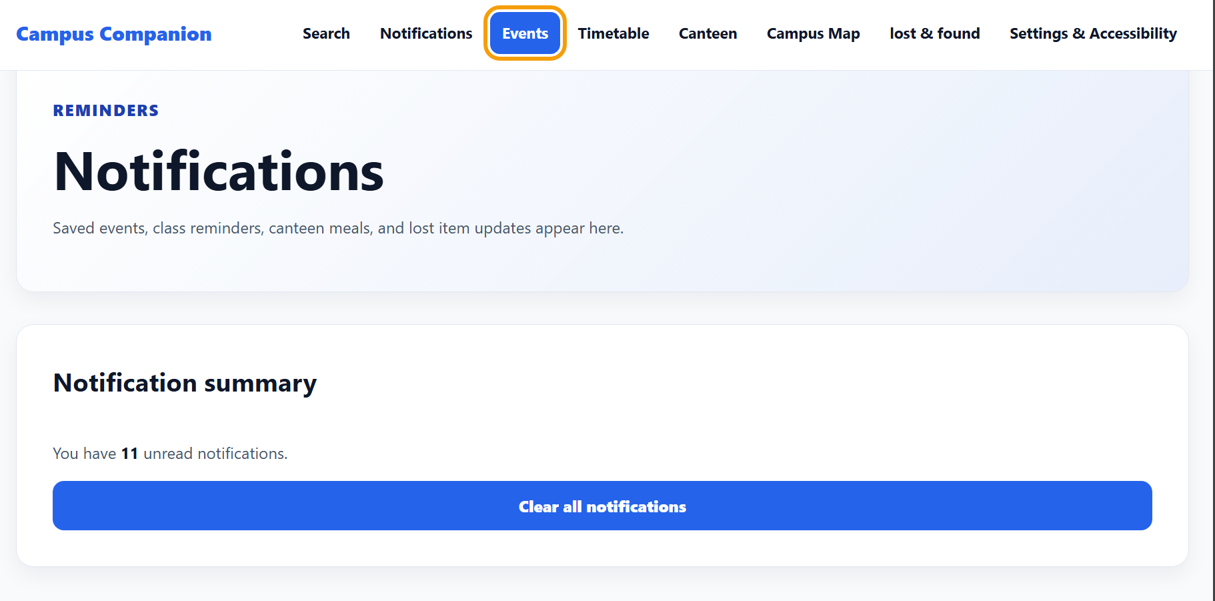
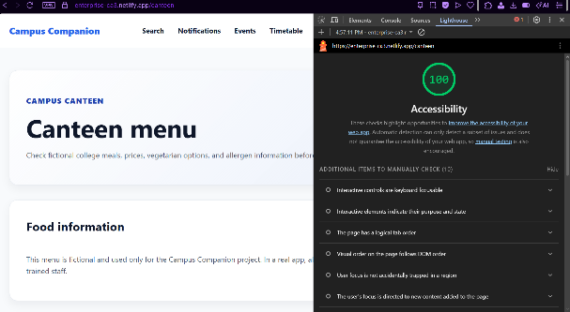
I also checked that all the accessibility features in the app worked as expected without any issues, Aswell as this, through inspecting the page I used the lighthouse feature to confirm that all accessibility features were working as intended,

Using Windows Magnifier’s built in Narrator aswell as a personal module I use ‘ZoomText’ to confirm that the text is legible for users using Screen Readers
During the review of the app there were a couple issues that had to be corrected;

- Missing button for Class Reminders
2.1.1 – keyboard accessible
4.1.2 – Name, Role, Value
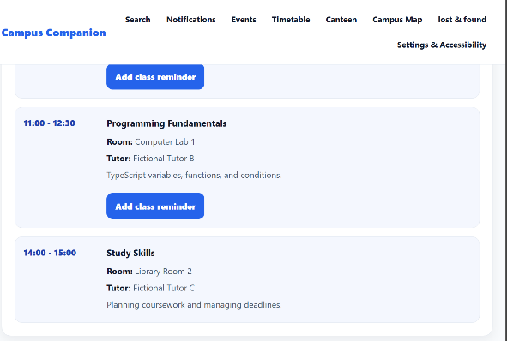
during the manual testing there was a missing button in the timetable tab under the social skills section that wouldn’t allow the user to add a class reminder, this would then result in the user skipping over the social skills section when navigating with the kyes

by using the past code from previous buttons I could correctly align and assign the button underneath the section, as well as importing the keyboard navigation option
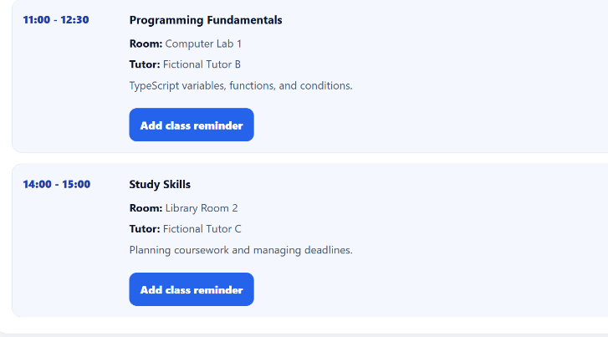

- Overlapping Menu Boxes at the end of the page
1.4.10 – Reflow
1.3.2 – Meaningful Sequence
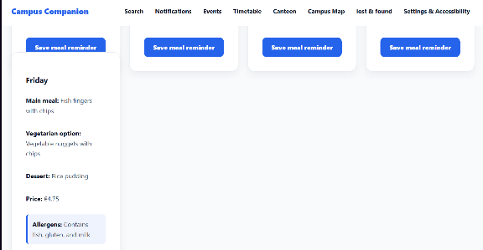
during manual testing while adjusting the app page size two of the menu boxes would overlap, this caused one of the Meal Reminder buttons to be partially covered which made it difficult to read and breaking the intended consistent layout, thi

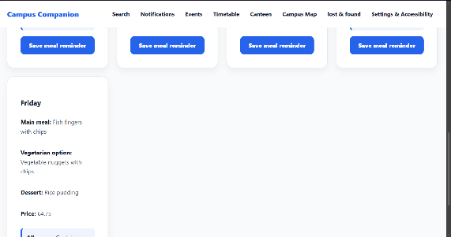
This was fixed by changing the css code and setting the width, margin-bottom, and the gap to correctly fit the position ensuring that each menu option stacks correctly and maintains the same distance on screen levels

- Accessibility issue of map overlapping on smaller screens
1.4.10 – Reflow
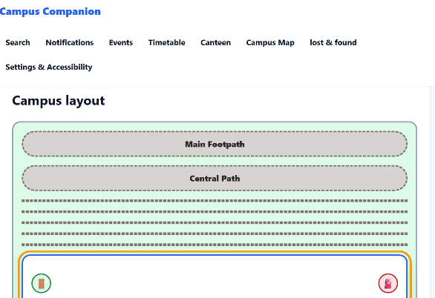
during responsive testing, the campus map became extremely illegible and impossible to navigate on smaller screens with the maps buildings and pathways overlapping and being incorrectly displayed, this impacted users that would use the app on a mobile device or have low vision and would increase the browser size,

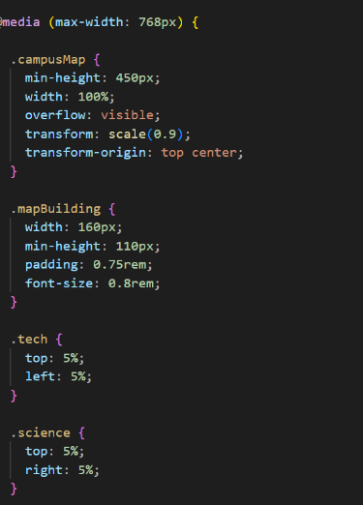
to fix this css code was added specifically for movile devices and devices with smaller screens, this was done using the @media and reducing the map heigh and allowed for scaling down of paths and buildings aswell as repositioning it all for mobile

User Testing
To truly test the usability and clarity of the website I sent the link to the netlify to three of my friends and asked them to complete a given set of tasks, I had them deploy it on their own devices to confirm usability across multiple different devices and any clarity issues,

We gave the following tasks to each of the members,
- Open the Timetable and set a reminder for one of the events and check it in their notifications
- Use the interactive campus map to locate the buildings with fire exits
- Open the accessibility settings, change the colour theme, and then find the daily meal in the canteen section

User 1
- Opened the timetable and set a reminder, initially unsure whether the reminder saved due to notification being subtle at the top of the web page
- Located the fire exits in the buildings that contain them
- Changed the colour theme in the accessibility and set a meal reminder without challenges

User 2
- Completed the reminder task without issue
- Located the buildings with fire exits without any issue
- Changed the accessibility colours and navigated to the daily meal section setting a reminder without issue

User 3
- Initially unsure of where the reminder notification was but completed the tesk without difficulty after locating
- Struggled with the map due to the scaling issues on mobile but could refer to which buildings contained such
- Changed the colour theme but commented that there could be more varied colours for user specific reasons

Observations
- Reminder Notification set could be made more visible after setting a reminder for a class using the timetable
- No major issues with usability on desktop whereas mobile seems to have consistent issues
- More accessibility options could be added

Across all three users the map and the reminder confirmation were the main areas where improvements needed to be made, mobile users also have a increasingly more difficult time with such more so than desktop users, the accessibility settings were also easy to use but one user commented on more varied options that could be implemented for specific users

The accessibility and User testing process highlights several areas where the app could be improved, particularly with mobile, accessibility and clarity, by identifying these issues with WCAG rules and resolving them the site became more usable for a wide range of users and devices,
Overall, the process redemonstrated the value of refinement and resulted in a more accessible user friendly app

