|  |  |  |  |  |
| --- | --- | --- | --- | --- |
| **Descriptive Statistics** | | | | |
|  | N | Mean | Std. Deviation | Variance |
| Age | 205 | 61.36 | 19.731 | 389.319 |
| Tumor_Size | 205 | 46.08 | 30.061 | 903.645 |
| Valid N (listwise) | 205 |  |  |  |

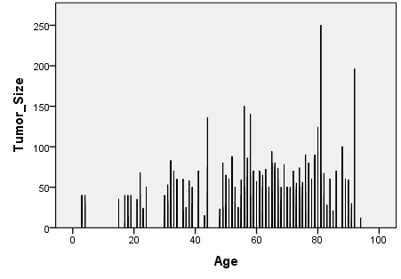

|  |  |  |  |  |
| --- | --- | --- | --- | --- |
| **Five Point Summaries** | | | | |
|  | | Age | Tumor_Size | Gender |
| N | Valid | 205 | 205 | 205 |
| Missing | 491 | 491 | 491 |
| Median | | 66.00 | 40.00 | .00 |
| Minimum | | 3 | 6 | 0 |
| Maximum | | 94 | 250 | 1 |
| Percentiles | .25 | 3.00 | 6.00 | .00 |
| .5 | 3.00 | 6.03 | .00 |
| .75 | 3.00 | 6.55 | .00 |