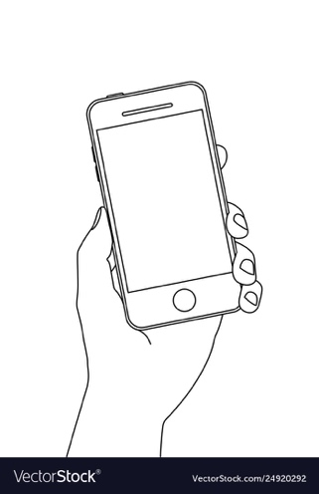

*#FakeB***H*

*Welcome*

** Berry_025**

**Tagged: 200**

**Commented: 15**

**Uncredited: 1**

After knowing who is the user stealing pictures then they can report them of stealing their work and the user is happy

The user later realized there is another user who is using your pictures and does not credited

Later the user uses our product, and when logging in they see who credited their work and which person didn’t credit your work

The user checks Instagram and checks how many likes they received on a post

Taught That

B***h



T

** Berry_025**

**Uncredited User:**

**S&42_09**

**Likes: 1,000,461**

That

Fake B***h

