Android Remote Control
Control an R/C toy from an Android device

Recording audio commands from the original remote control
Instructions for R/C transmitters based on TX-2, TX-2B, TX-2C, or TX-2G chips.

Archive note: This is an English cleanup of the original Russian instruction document. The diagrams and screenshots from the original document were preserved.

1. What you need
- An original R/C transmitter/remote for the toy.
- A 3.5 mm audio jack cable.
- A soldering iron and basic soldering tools.
- A PC sound input / microphone input.
- Nero WaveEditor, or another audio editor that can record mono WAV files.
To record the commands, solder a 3.5 mm jack to the transmitter board according to the diagrams below. Only two wires are required because the command signal is recorded as mono audio. In the original setup, only the right audio channel was used.

2. 3.5 mm jack wiring
Use the 3.5 mm jack pinout as a reference when soldering the audio cable.
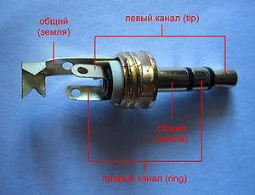
3.5 mm jack pinout

3. Soldering to the transmitter
Solder the audio jack wires to the transmitter board as shown below. Transmitter board layouts may vary slightly, but the soldering points are generally the same for TX-2, TX-2B, TX-2C, and TX-2G based transmitters.
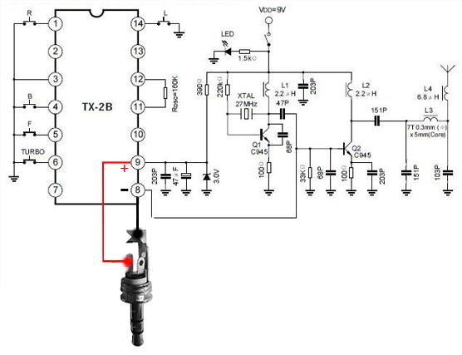
Soldering points on the transmitter board

4. Recording commands with Nero WaveEditor
Connect the 3.5 mm jack to the PC audio input and open Nero WaveEditor. Start the sound recording tool.
Sound recording tool icon
In the recording window, disable stereo recording. Record in mono.
Before recording, confirm that the program is receiving sound from the correct input. Hold a stick/button on the transmitter and watch the input level meters. If everything is connected correctly, the level meters should move.
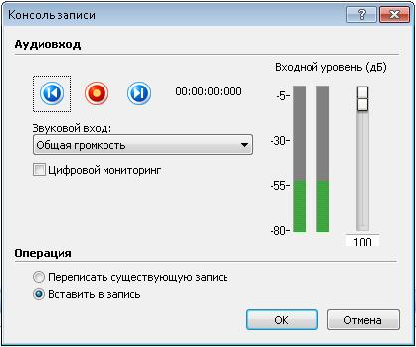
Checking that the input level changes when a command is pressed

5. Commands to record
Record each movement command separately from the original transmitter:
Command | How to record it
up | Move forward / up
down | Move backward / down
left | Turn left
right | Turn right
up-left | Press up and left at the same time
up-right | Press up and right at the same time
down-left | Press down and left at the same time
down-right | Press down and right at the same time

Important: Combination commands must be recorded directly from the transmitter by pressing both controls at the same time. Do not record “up” and “left” separately and then merge the files. The transmitter generates a separate signal for the combination command.

6. Making a clean command loop
Start recording and hold the required joystick direction or button. A 5-10 second recording is usually enough. After recording, the waveform will look similar to this:
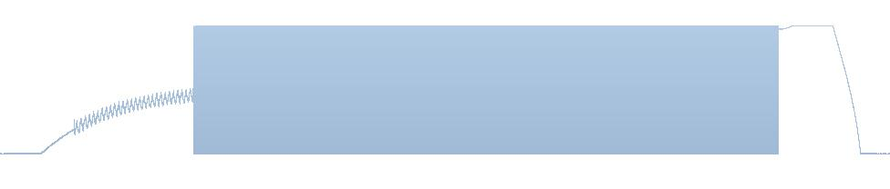
Example of a recorded command waveform
Do not use the whole recording. The beginning and the end may contain noise, clicks, or other distortions. Zoom into a clean section in the middle of the recording. You should see a repeating pattern. This repeating pattern is the cyclic command signal.
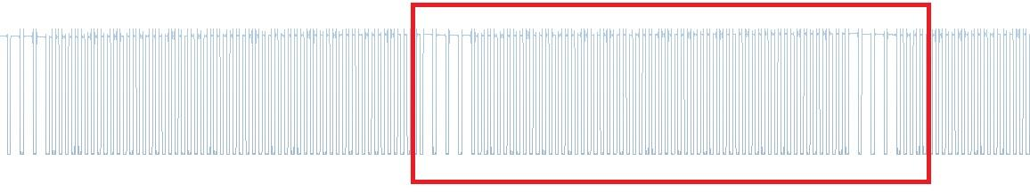
Clean repeating pattern in the middle of the command

7. Finding the start and end of one command cycle
This is the hardest part. You need to find the exact beginning and the exact end of one clean command cycle. Zoom in very closely at the beginning of the cycle.
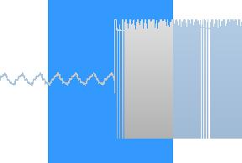
Zooming into the start of the command cycle
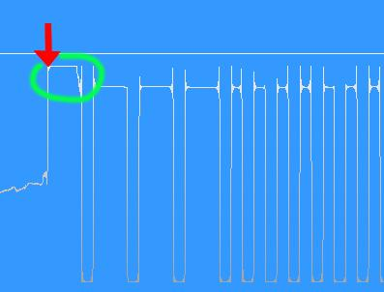
The start point of the command cycle
Then find the matching end point of the cycle.
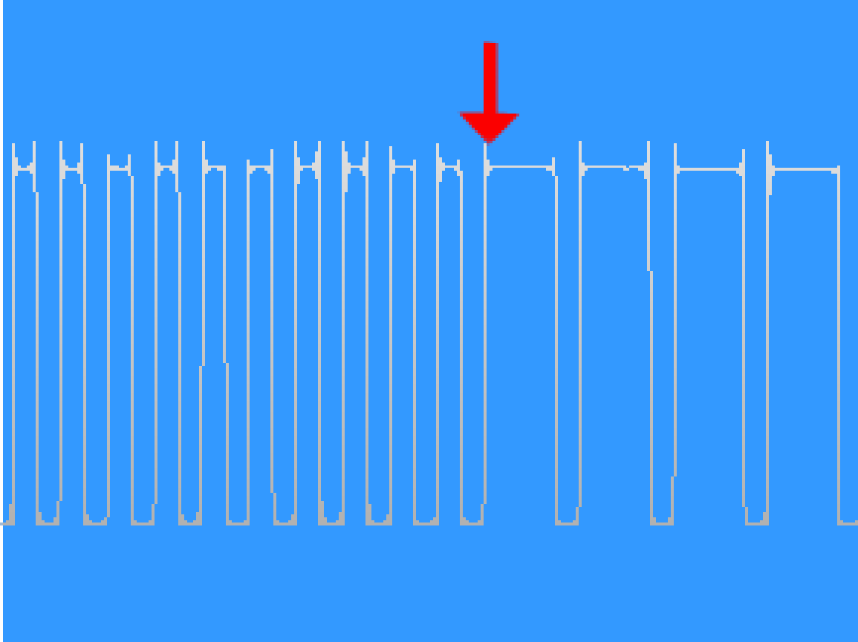
The end point of the command cycle
Select and copy a clean middle section of the command. Avoid distorted areas at the beginning or end of the recording. The selected section may be only a few milliseconds long.
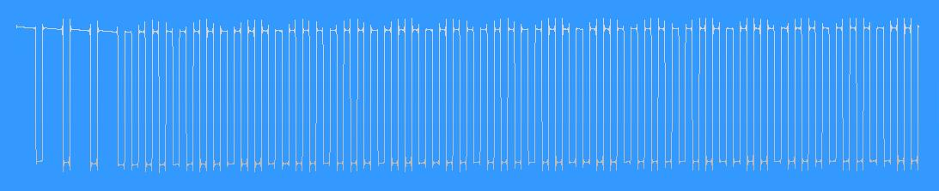
Clean command section selected for copying

8. Creating the final WAV command file
Create a new audio file. Paste the selected command cycle repeatedly until the track is about 10 seconds long. Save the final file in WAV format using these settings:
- Sample rate: 44100 Hz
- Bit depth: 16-bit
- Channels: Mono
- Format: WAV
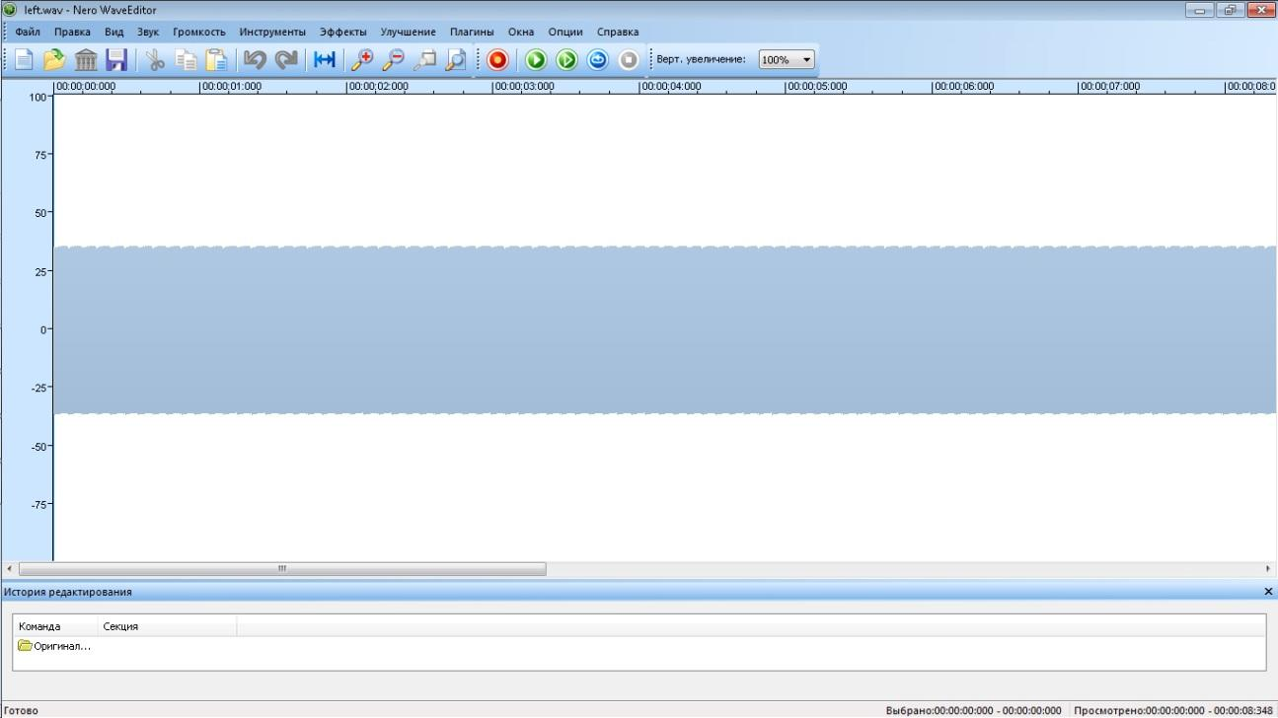
Final repeated command track
Repeat the same process for every command. For combination commands, press the required transmitter controls together while recording.

9. Recommended file names
For the old ARC audio-file based versions, save the command files with clear names such as:
- up.wav
- down.wav
- left.wav
- right.wav
- upleft.wav
- upright.wav
- leftdown.wav / downleft.wav
- rightdown.wav / downright.wav
These WAV command files are used by the older audio-file based ARC versions, such as ARCv09 Tank and ARCv09 Car.

