Configure your Microsoft 365 experience

Introduction
- 1 minute
The timely saying that you should "Plan your work and work your plan" is especially relevant when implementing Microsoft 365. Once you've finished planning your Microsoft 365 tenant experience, it's then time to configure that experience. For Microsoft 365, the configuration process includes:
- Setting up your organizational profile
- Managing your tenant subscriptions
- Managing your services and add-ins
- Completing your tenant configuration
This module examines each of these tasks, which you must complete to successfully configure your Microsoft 365 experience. After completing this module, you should be able to configure your company’s organization profile, which is essential for setting up for your company’s tenant. You also learn how to maintain minimum subscription requirements for your company. This process includes managing your services and add-ins by assigning more licenses, purchasing more storage, and so on.
The module also explores several organization-level settings that companies should consider implementing. The first are SharePoint Online and OneDrive settings that control how these services control external sharing. External sharing enables your users to share content with people outside the organization, such as partners, vendors, clients, or customers. You can configure these settings to provide the level of control that your organization requires. You can also configure tenant-level setting to control how your users can conduct meetings in Microsoft Teams. And lastly, you can enable Unified Audit Logging if your organization wants to monitor and investigate security incidents, compliance violations, and operational issues. You can also generate audit reports and alerts based on specific events or criteria.
Finally, to help you plan your work and work your plan, you learn how to create a checklist that enables you to confirm your Microsoft 365 tenant meets your business needs.
Explore your Microsoft 365 cloud environment
Completed 100 XP
- 10 minutes
Creating a path to an organization's digital transformation with Microsoft 365 cloud computing requires a firm foundation. The organization's workers can rely on that foundation for productivity, collaboration, performance, privacy, compliance, and security. Correct configuration of an organization's Microsoft 365 subscription and Microsoft Entra tenant provides that foundation.
Important
Azure Active Directory (Azure AD) is now Microsoft Entra ID. Learn more.
Microsoft 365 subscriptions and plans
When people discuss Microsoft 365 subscriptions, they often use the terms "plan" and "subscription" interchangeably. However, they actually refer to slightly different aspects of the offering.
In the context of Microsoft 365, a "plan" typically refers to a specific set of features and services included in a subscription. Microsoft offers various plans or editions of Microsoft 365, such as E3 or E5, each with different capabilities and pricing structures. These plans determine the specific features and applications available to users, and any other services or benefits included.
On the other hand, a "subscription" generally refers to the act of acquiring access to a particular Microsoft 365 plan. It involves paying a recurring fee to Microsoft in exchange for the right to use the selected plan's features and services for a specified period of time. The subscription is typically associated with a user or an organization and usually includes multiple licenses to cover multiple users.
So, while "plan" refers to the specific set of features and services offered by Microsoft, "subscription" refers to the ongoing access to those features and services, typically tied to a payment arrangement. In everyday conversations, however, people often use the terms "plan" and "subscription" interchangeably to refer to the overall Microsoft 365 offering.
Build your cloud-computing foundation on a Microsoft 365 subscription and a Microsoft Entra tenant
To build your cloud-computing foundation, you must first understand the relationship between a Microsoft 365 subscription and a Microsoft Entra tenant. A Microsoft 365 plan provides access to various Microsoft products like Word, Excel, PowerPoint, and Outlook, along with cloud services for storage, collaboration, and communication. For example, Exchange Online, SharePoint Online, OneDrive for Business, Microsoft Teams, and more. When an organization subscribes to a Microsoft 365 plan, it can create user accounts, assign licenses to those accounts, and manage the subscription settings.
When an organization purchases a subscription to a Microsoft 365 plan, such as Microsoft 365 E3 or E5, Microsoft creates a Microsoft Entra tenant that supports those Microsoft 365 services. This Microsoft Entra tenant is the underlying foundation that enables user authentication, authorization, and other identity-related functionalities for the Microsoft 365 services such as Office applications, Exchange Online, SharePoint, Teams, and more. This single tenant environment allows for seamless integration and management of Microsoft 365 and Azure services within an organization.
People sometimes refer to their tenant as a "Microsoft 365 tenant." Technically, it's a Microsoft Entra tenant. People commonly use the term "Microsoft 365 tenant" because Microsoft creates the Microsoft Entra tenant when an organization purchases a subscription to a Microsoft 365 plan, along with the fact that the tenant primarily manages user identities and access across the Microsoft 365 suite of services.
In summary, a Microsoft 365 subscription is the paid plan that gives an organization access to the Microsoft cloud services. A Microsoft Entra tenant is the container that holds all of the resources associated with that subscription. The tenant determines the URL for the organization's services. It's also the place where the organization's Microsoft 365 Administrator can manage the company's global settings, such as branding and security policies.
Microsoft 365 plans that don't create a Microsoft Entra tenant
Organizations can purchase multiple plans from Microsoft in a single subscription. For example, Microsoft 365 E5 and Enterprise Mobility + Security (EMS) E5. In these situations, Microsoft still only creates a single Microsoft Entra tenant for the subscription because some Microsoft 365 plans don't create a Microsoft Entra tenant. These plans provide limited Microsoft Entra functionality and don't include the full Microsoft Entra tenant creation.
Some of the more common Microsoft 365 plans that don't create a Microsoft Entra tenant include:
- Enterprise Mobility + Security (EMS) E5. The EMS E5 plan provides advanced security and management capabilities for mobile devices and cloud-based applications. While organizations can purchase EMS and Microsoft 365 plans separately, they often combine them to provide a comprehensive suite of productivity, collaboration, security, and management tools. By combining EMS E5 with a Microsoft 365 plan, you can access both advanced security features and the suite of Microsoft 365 services within a single Microsoft Entra tenant.
- Microsoft 365 Business Basic. This plan primarily focuses on cloud-based productivity and collaboration tools. It includes web versions of popular Microsoft Office applications such as Word, Excel, and PowerPoint. It also provides Exchange Online for email hosting (with a 50-GB mailbox per user), SharePoint Online for team sites and file storage, and Microsoft Teams for communication and collaboration.
- Microsoft 365 Business Standard. This plan includes all the features of Microsoft 365 Business Basic and adds the ability to install the full desktop versions of Office applications (Word, Excel, PowerPoint, Outlook, Publisher, and Access) on up to five devices per user. Given this functionality, users can work offline and take advantage of more advanced features available in the desktop versions.
- Microsoft 365 Apps. This plan provides the full desktop versions of the Microsoft Office applications for organizations. Microsoft tailored this plan for businesses that require the power and functionality of the Office suite installed on users' devices.
- Office 365 F3. Microsoft designed this plan for frontline workers who don't require the full suite of advanced Office applications but still need essential productivity tools and collaboration capabilities to perform their job duties effectively. It includes web and mobile versions of Office apps, email, and file storage.
- Microsoft 365 F1. Microsoft also designed this plan for frontline workers. It includes Office Online apps, email, and file storage. Microsoft 365 F1 provides a more comprehensive feature set than Office 365 F3, including enhanced security and compliance features, and more tools for automation and custom application development.
It's worth noting that while these plans don't create a Microsoft Entra tenant, they can still have limited Microsoft Entra functionality for user management and authentication purposes. However, for more advanced Microsoft Entra ID capabilities and features, such as advanced identity protection, Conditional Access, and device management, you would typically need to consider higher-tier plans like Microsoft 365 E3 or E5, which do create a Microsoft Entra tenant.
Licenses
When you subscribe to a Microsoft 365 plan, the number of licenses that you purchase for the plan are typically based on the number of users or seats you need for your organization. Here's the general process:
- Select the right Microsoft 365 plan for your organization. Microsoft offers various plans with different features and services. Each plan has its own set of capabilities and applications. You choose the plan that best suits your needs, based on the features you require.
- Purchase a Microsoft 365 plan with the appropriate number of licenses for your organization. When you subscribe to a Microsoft 365 plan, you purchase a specific number of users or seats for that plan. For example, if you have 50 employees, you would purchase a subscription for 50 user licenses for your selected plan.
- Allocate your licenses. Once you have purchased your subscription, you can allocate the licenses for your Microsoft 365 plan to individual users within your organization. You manage this process through the Microsoft 365 admin center. You can assign licenses to specific users, granting them access to the features and services included in the plan.
- Manage your licenses. As your organization's needs change, you can add or remove licenses as required. You can purchase more licenses for your plan to accommodate new users. You can also remove licenses for users who leave the organization or no longer require access. This flexibility enables you to scale your licensing based on your organization's size and requirements.
Important
The specific details of license allocation and management can vary depending on the Microsoft 365 plan you choose and any other services or add-ons you opt for. Microsoft provides tools and resources to help you manage licenses effectively, ensuring that you have the right number of licenses for your organization's users while maintaining compliance with the licensing terms.
Organizations with multiple Microsoft Entra tenants
When you purchase a Microsoft 365 subscription, Microsoft creates a Microsoft Entra tenant. The tenant supports and provides the identity and access management infrastructure for the Microsoft 365 plan you subscribed to. By having a single tenant for Microsoft 365 and Microsoft Entra ID, you can streamline administration, simplify user management, and establish consistent security and access controls across both platforms. It provides a cohesive environment for managing your organization's cloud services and resources.
An organization can have multiple Microsoft Entra tenants, where Microsoft sets up each tenant with a separate Microsoft Entra or Microsoft 365 subscription. Each Microsoft Entra or Microsoft 365 subscription is associated with its own dedicated Microsoft Entra tenant.
Large enterprise organizations often opt for multiple Microsoft 365 subscriptions to cater to the diverse needs of different user groups within the organization. They can tailor these subscriptions to specific roles or departments, providing the appropriate set of services and features required for each group. The following diagram shows an example of a Microsoft 365 subscription plan with a dedicated Microsoft Entra tenant.
There are several reasons why large enterprises choose to have multiple Microsoft 365 subscriptions:
- Different user requirements. Different departments or teams within an enterprise can have varying needs when it comes to productivity tools, collaboration features, and security controls. When an organization purchases multiple Microsoft 365 subscriptions, it can customize the offerings based on the specific requirements of each user group.
- Licensing flexibility. Large enterprises can have a mix of full-time employees, part-time employees, contractors, and external collaborators. By having multiple subscriptions, organizations can choose the appropriate licensing model (user-based or device-based) and license types (for example, Microsoft 365 E3, E5, or F1) to suit the needs and usage patterns of different user categories.
- Compliance and security considerations. Some industries or regulatory frameworks require specific security and compliance measures. Large enterprises sometimes opt for multiple subscriptions that provide advanced security and compliance features to meet these requirements while ensuring data protection and governance.
- Mergers and acquisitions. An organization involved in a merger or an acquisition can end up with multiple legacy systems or existing Microsoft 365 environments. Consolidation of these systems into a single subscription can take time, and during the transition period, they must maintain multiple subscriptions.
Caution
Managing multiple subscriptions can bring some complexity in terms of license management, user provisioning, and administration. However, large enterprise organizations often have dedicated IT teams or administrators who handle these tasks efficiently. Ultimately, the decision to purchase multiple Microsoft 365 subscriptions is based on the organization's unique requirements, the size and structure of the enterprise, and the need for customization and flexibility across different user groups.
Tenant information
During the sign-up process for a Microsoft 365 plan, Microsoft asks the organization to provide some basic information, such as its business name, country/region, and domain name. Microsoft then uses this information when it creates the new Microsoft Entra tenant for the organization. Microsoft bases the tenant URL that it creates on the domain name provided by the organization during sign-up. It typically looks something like this: https://contoso.onmicrosoft.com.
Once Microsoft creates an organization's tenant, the organization's Microsoft 365 Administrator can sign in to the Microsoft 365 admin center to manage the subscription and its associated resources. The admin center provides a web-based interface for managing users, licenses, domains, and more. The Microsoft 365 admin center provides an organization with complete control over its Microsoft 365 environment.
A Microsoft Entra tenant unified with a Microsoft 365 subscription provides a dedicated instance of Microsoft 365 services and an organization's data. Microsoft stores this information within a Microsoft datacenter in a specific default location, such as Europe or North America. Microsoft determines the location of the Microsoft datacenter assigned to the tenant when it creates the tenant for an organization. Each Microsoft Entra tenant is distinct, unique, and separate from all other Microsoft Entra tenants.
With a Microsoft 365 subscription, you can add up to 900 domains to a single tenant. An organization can use each domain to create email addresses for the users in those domains.
An organization can't have more than one tenant within a single Microsoft 365 subscription. However, as previously noted, it can have multiple tenants by purchasing multiple Microsoft 365 subscriptions. Each subscription comes with its own tenant, which can have its own set of users, domains, and other settings.
Attributes of a well-designed Microsoft Entra tenant
Beyond the correct name and location for an organization's tenant, there are other elements that an organization must plan, deploy, and manage. An organization that properly designs and manages these elements ensures that its user experiences with cloud productivity apps—such as Microsoft Teams and Exchange Online—are effective, secure, and performant.
An organization must properly configure and manage the following elements for their Microsoft Entra tenant:
- The correct set of products (subscriptions) and licenses.
  - The set of products match its business, IT, and security needs.
  - There's an adequate number of licenses for its workers and anticipated changes in staffing.
- For networking:
  - It configured the correct DNS domain names.
  - For enterprise networks, it optimized network traffic to the Microsoft network for onsite workers.
  - It optimized network traffic for remote workers who use a VPN client.
- If it has an on-premises Active Directory Domain Service (AD DS), it synchronized accounts, groups, and other objects:
  - It mapped its Microsoft Entra tenant accounts to Exchange Online mailboxes with the correct DNS domains for email addresses.
  - It assigned its user accounts the correct licenses from the correct purchased products (such as Microsoft 365 E3 or E5).
- It configured strong identity and access management.
  - It requires secure user sign-in with passwordless or multifactor authentication (MFA).
  - It created Conditional Access policies that enforce sign-in requirements and restrictions for higher levels of security.
- It either migrated on-premises Office servers and their data to cloud apps, or it deployed that data in a hybrid configuration.
- It performs device management with Intune or Basic Mobility and Security built into Microsoft 365.
  - It enrolls and manages organization-owned devices.
  - It manages apps for personal devices.
The following diagram displays an example of a Microsoft Entra tenant with all these elements in place to support a Microsoft 365 subscription.
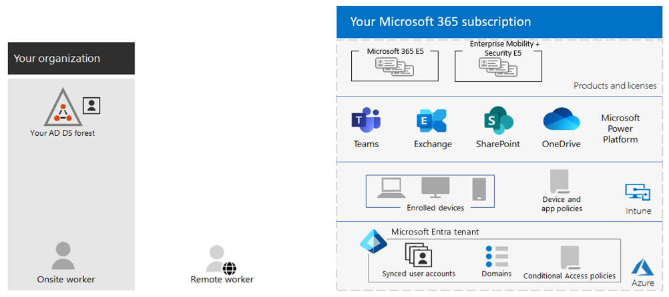
In this illustration, the Microsoft Entra tenant includes:
- Products and licenses for Microsoft 365 E5 and Enterprise Mobility. + Security E5.
- Microsoft 365 productivity apps.
- Intune with enrolled devices and device and application policies.
- A Microsoft Entra tenant with synchronized user accounts, domains, and Conditional Access policies. The diagram doesn't display groups and other directory objects.
Configure your Microsoft 365 organizational profile
200 XP
- 6 minutes
Completing your company’s organization profile is the starting point when setting up your company’s Microsoft Entra tenant. Some of the properties that a Microsoft 365 Administrator must maintain cause the provisioning process to halt if they’re incomplete. For example, one such attribute is the Address line. The provisioning process stops if an organization doesn't have a complete address.
Important
You must be assigned the Global Administrator role to update your company's organization profile.
Edit your organization profile
Complete the following steps to edit your organization’s profile information:
- Go to the Microsoft 365 admin center.
- In the left-hand navigation pane, select the Show All ellipsis … icon to display all the navigation menu options.
- In the left-hand navigation pane, select Settings and then select Org settings.
- On the Org settings page, select the Organization profile tab.
- On the Organization profile tab, the settings are segregated by group, such as Custom themes and Organization information. Select the appropriate group, make your edits, and then save the group. Repeat this process for each group of settings as needed.
The Organization information group contains the basic company information, such as organization name, address, phone number, and Preferred language.
Warning
There's one issue concerning the Preferred language field that you should be aware of. The preferred language determines the language for all communications that Microsoft sends to your organization. When you sign up, this setting also determines the language used by SharePoint Online, which your users see on your team site. If you change the Preferred language after you sign up, Microsoft sends all future communication in the most recent language selected. However, the language used by SharePoint Online remains in the original language selected because you can't change it.
The Organization information group also contains the country/region for your subscription.
Warning
You can't change the value of the country/region field.
The reason for this restriction is that the country/region where your organization is headquartered determines:
- Which services are available to you.
- The taxes and billing currency.
- The location of the Microsoft data center that supports the organization.
Important
Because you can't change the value in the country/region field, you must select the correct value when setting up your organization profile. If you enter an incorrect value, or if your organization's country/region actually does change, you must sign up for a new account. When doing so, you must choose the new country/region and purchase a new subscription.
Update your organization's theme
An organization's Microsoft 365 administrator can create multiple themes for their company's users. The organization theme is what appears in the top navigation bar as part of the Microsoft 365 suite header for people in the organization.
An organization can have a default theme and up to four custom themes. The default theme applies to everyone in the organization. Custom themes can be applied to specific users in the organization. You don't apply custom themes to individual users. Instead, you must apply the custom theme to one or more Microsoft 365 groups. If a custom theme is assigned to a group, the theme appears to the members of the group rather than the default theme.
Perform the following steps to add or update your organization's theme:
- In the Microsoft 365 admin center, go to the Settings > Org Settings page, and then choose the Organization profile tab.
- On the Organization profile tab, select Custom themes.
- To add a new theme, select Add theme and then add the required information for the tabs.
All organization themes can be customized using the following tabs.
Tab | What can you do?
General | Modify a theme name and assign to up to five groups (if applicable).
Logos | Add your organization logo, including alternate logo for dark theme.
Colors | Customize a color scheme by specifying navigation bar, accent, text, and icon colors.
Each of the tabs is examined in the following sections.
General tab: Modify a theme
Your experience on the General tab depends on whether you're adding or modifying the default theme or a group theme.
Update the default theme
The default theme is the first theme displayed.
- If you previously customized a theme for your organization, select Default Theme and use one of your saved customizations, or, select Add theme.
- On the General page, you can prevent users from overriding their theme and show the user’s display name.
- Select Save to save your changes.
Important
The default theme is unique. As such, it can't be renamed, and it applies to everyone in the organization. To delete the default theme, you must first delete all other themes.
Create a group theme
The default theme is shown to all employees. When an organization creates a new group theme, it must be mapped to one or more Microsoft 365 groups. You can't map themes to security groups or distribution groups.
The members of a Microsoft 365 group that has a theme assigned to it are displayed the group theme rather than the default theme. However, users who are assigned to multiple group themes are shown the default theme.
An organization can have a total of five themes - the default theme and up to four custom group themes.
- On the General page, enter a name for your new theme.
- Under Groups, you can select up to five Microsoft 365 Groups that can see your group theme rather than the default theme. You can also prevent users from overriding their theme and show the user's display name.
- Select Save.
Note
Only Global administrators can customize company themes. Global readers have read-only access.
Logos tab: Specify your theme logos
On the Logos page, you can add your logos and specify the URL where users navigate to when they select the logo.
- Default logo. Add a URL location that points to your logo. Make sure the URL uses HTTPS. Add an HTTPS image url that allows anonymous access and doesn't require authentication. For the default theme, you can also upload a logo image that is less than 10 kb in size. Your default logo can be in the JPG, PNG, GIF, or SVG format. SVG images are resized to fit 24 pixels vertically. JPG, PNG, GIF images are scaled to fit 200 x 48 pixels. Logo aspect ratio is always preserved.
- Alternate logo. Add a URL location that points to your logo. Your alternate logo should be optimized for use in Microsoft 365 dark themes. It also has the same requirements as the default logo.
- On-click link. Add a URL location that points to your logo. You can use your logo as a link to any company resource, such as your company's website. If you don’t select a URL location for your logo, it defaults to the Microsoft 365 home page.
You can remove your logos at any time. Just return to the Logos page and select Remove.
When you upload a logo URL, the logo must be a publicly addressable UR; otherwise, the upload fails and you receive an error.
When you specify a theme logo, the recommended contrast ratio between text, icon, or button color and background color is 4.5:1. If you receive a message indicating the logo doesn't meet the minimum contrast ratio of 4.5:1, you can override this recommendation and still save your theme. This contrast ratio isn't a requirement.
Note
The Microsoft 365 suite header is designed to accommodate various screen sizes, window sizes, and display settings. The responsive behavior of the suite header sometimes results in the logo not showing to give space to other capabilities shown on the suite header. A narrower image file is recommended to reduce the likelihood of this behavior.
Colors tab: Choose theme colors
On the Colors page, you can set the default colors and choose which logo should be used.
- Navigation bar color. Select a color to use for the background of the navigation bar. The navigation bar appears at the top on every page.
- Text and icon color. Select a color to use for the text and icons on the top navigation bar.
- Accent color. Pick one that shows up well on a white or light background. The accent color is used to color some links and buttons that show up on a white or light background. For example, the accent color is used to color elements in a user's Inbox and on their microsoft365.com portal page.
- Reset color. Select this link to reset colors to the default colors.
Exercise – Interactive demonstration
Select the following link to complete an interactive demonstration titled: Set up the organization profile.
This simulation guides you through the steps to set up an organization profile for the fictitious company known as Adatum Corporation.
Knowledge check
Choose the best response for the following question.
Check your knowledge

1.
Emily is the Microsoft 365 Administrator for Tailwind Traders, which up until last month was located in Paris, France. When Tailwind purchased its Microsoft 365 subscription two years ago, its Organization Profile listed the country/region in which the company is headquartered as France. However, Tailwind recently moved its corporate headquarters to New York. What should Emily do to change the company's headquarters for its Microsoft 365 subscription to the United States?

Emily should sign up for a new account, choose the United States as the desired country/region, and purchase a new subscription.
Correct. The country/region where an organization is headquartered determines which services are available to it, the taxes and billing currency, and the location of the Microsoft data center that supports the organization. As such, changing the location of the company headquarters requires that Emily sign up for a new account, choose the desired country/region, and purchase a new subscription.
Manage your tenant subscriptions in Microsoft 365
Completed 100 XP
- 3 minutes
Maintaining minimum subscription requirements is essential for an organization to remain functional. Purchasing an insufficient number of licenses can result in implementation delays, while purchasing an excessive number of licenses can result in overspending.
The following screenshot is an example from a tenant with group-based licensing. In this case, all available licenses are already assigned. This situation results in provisioning errors due to the depleted licenses.
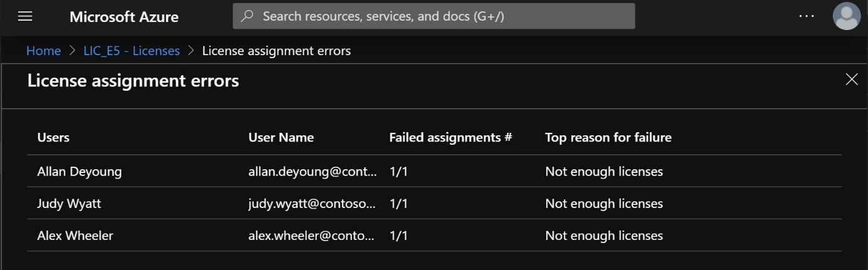
All active and deprovisioned licenses can be reviewed from the Microsoft 365 admin center. In the left-hand navigation pane, select the Billing group and then the Licenses page. On the Licenses page, select the Subscriptions tab.
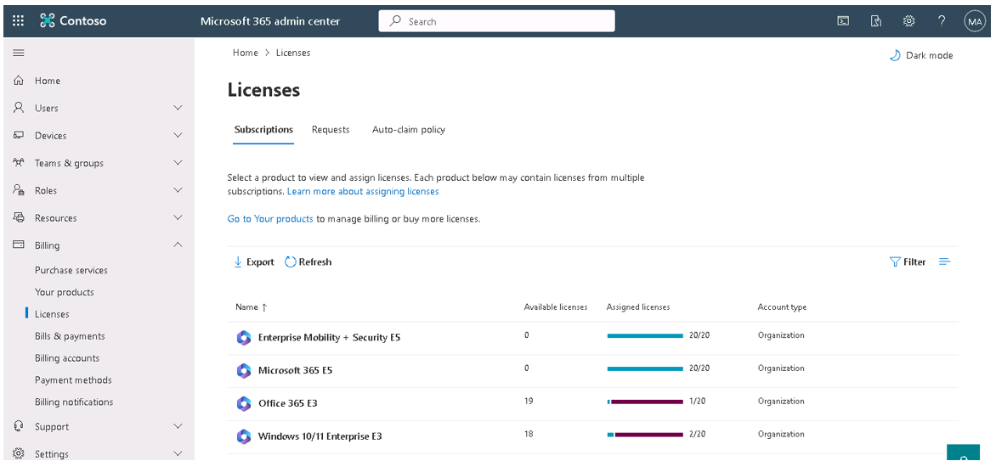
An administrator can use this page to assign and remove licenses to user accounts. Extra licenses can also be purchased from here.
Note
Purchasing extra licenses changes the monthly billing date for those specific licenses. For example, if the main subscription was purchased on May 14 and there was another purchase that was completed on May 15, then the next billing cycle would show subscriptions with due dates of June 15 and 16, respectively.
All the information about an organization's existing subscriptions, including billing and payment information, is available within the Billing group in the Microsoft 365 admin center. This group includes the following pages:
- Purchase services. This page enables an organization to do comparison shopping on up to three products at a time, and then start any purchases it wants to make.
- Your products. This page displays all the plans purchased by an organization. Those plans can also be maintained from here.
- Licenses. This page provides a summary of the licenses that were subscribed to for each plan purchased by an organization, including all the available licenses for each plan.
- Bills and payments. This page provides a history of all invoices charged to your organization, along with payment methods and billing profiles.
- Billing accounts. This page manages an organization's purchasing relationship with Microsoft. Each billing account contains defining information about the organization. For example, addresses, contact information, and any tax information that applies. Purchases made with an organization's billing account are covered by the agreement that it signed with Microsoft.
- Payment methods. This page enables an organization to define payment methods that it can use to pay for subscriptions.
- Billing notifications. This page identifies who receives billing notifications within an organization and how each billing statement is received.
Integrate Microsoft 365 with customer engagement apps
200 XP
- 6 minutes
One of the key responsibilities of a Microsoft 365 Administrator is management of the company tenant. For example, when configuring its company's tenant, an administrator must acquire and assign other licenses such as Project Online, Visio, Scheduler, and Microsoft Stream. Other times, the administrator must purchase extra capabilities, such as Microsoft Purview eDiscovery (Premium).
Integrating Microsoft 365 with customer engagement apps is a great way for an organization to enhance its customer relationship management with the power of cloud services:
- Easier maintenance
- Broader availability
- Better coordination across multiple devices
Microsoft 365 provides two mechanisms for organizations to integrate with customer apps - the Purchase services page in the Microsoft 365 admin center and Marketplace in the Microsoft Azure portal.
Note
Azure Marketplace is outside the general scope of this training. However, it's introduced in this unit to provide visibility into the options available to organizations for enhancing their abilities to integrate with customer engagement apps.
The following sections introduce you to each of these features.
Purchase services page in the Microsoft 365 admin center
The Purchase services page displays these add-on services. This page appears under the Billing group in the Microsoft 365 admin center's navigation pane. When you access the Purchase services page, Microsoft 365 displays both individual and full suite options. Some of the subscriptions provide a standard 30-day trial.
At the end of a service's 30-day trial subscription, the subscription expires, and you lose access to the features included in the service unless you purchase a subscription for the service. During the trial period, you can use all the features included in the service to evaluate their suitability for your organization's needs.
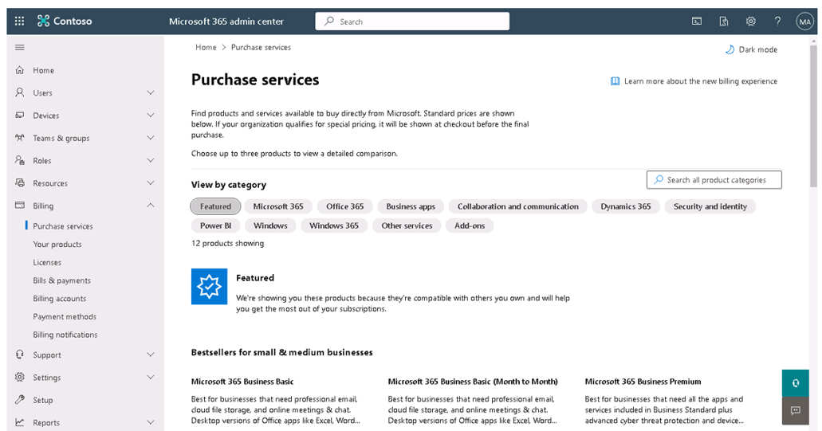
The Purchase services page in Microsoft 365 is a centralized location where organizations can purchase new products and add-on services for their Microsoft Entra tenant. Organizations can use this page for various reasons, including:
- Purchase new products. Organizations can use the Purchase services page to buy new Microsoft 365 products for their employees. They can choose from various plans, such as Microsoft 365 Business Premium, Microsoft 365 Business Standard, and Microsoft 365 Apps for Business.
- Add-on services. The Purchase services page also allows organizations to add more services to their existing plans, such as Microsoft Teams, Power BI, and Project Online.
- Manage licenses. Organizations can use the Purchase services page to manage their licenses. For example, they can add or remove licenses, change the number of licenses, and assign licenses to users.
- View purchase history. The Purchase services page provides organizations with a view of their purchase history. For example, the date of purchase, the service purchased, and the amount paid.
- Get recommendations. Microsoft also provides recommendations on the Purchase services page to help organizations select the best services for their needs.
The Purchase services page also enables an organization to compare product details for products that it's interested in. To do so, perform the following steps as shown in the screenshot:
- Select the Compare checkbox associated with each product you want to compare.
- Select the Compare button.
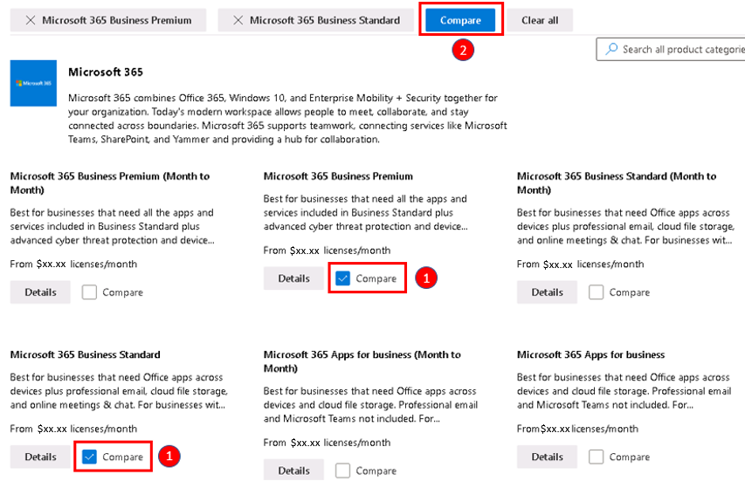
When you select products to compare on the Product services page, it displays the Product Comparison page. The Product comparison page shows a detailed comparison of the features and capabilities of the selected products. The Product comparison page displays the following information:
- Product overview. This section provides a brief introduction to the selected products, including their target audience, key features, and benefits.
- Features comparison. This section lists the features of each product side-by-side, making it easy to compare their capabilities. The screen groups features by category, such as productivity, security, and collaboration. Each feature displays a checkmark to indicate whether or not the product includes it.
- Pricing comparison. This section displays the pricing information for each product, including the subscription plans available and the cost per user per month.
- Technical specifications. This section provides technical details about the selected products, such as the supported platforms, system requirements, and integration capabilities.
- Customer reviews. The product comparison page can also include customer reviews and ratings for each product, providing insights into the user experience and satisfaction levels.
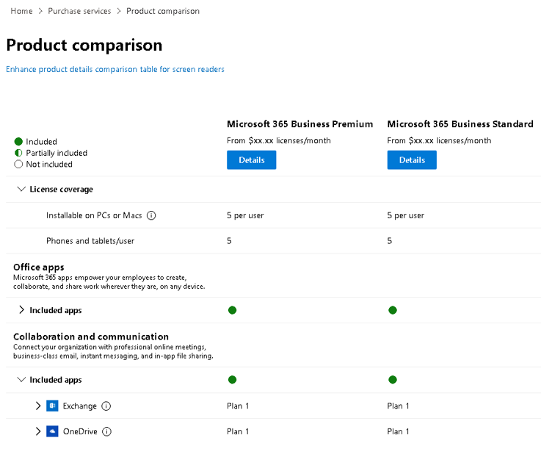
Overall, the Product comparison page is a valuable resource for organizations looking to compare and evaluate different Microsoft 365 products and services. It enables organizations to make informed decisions about which products are best suited to their needs.
Assign services
The Purchase services page provides organizations with a convenient and streamlined way to manage their Microsoft 365 subscriptions and services. To assign these services, you can either:
- Purchase the service add-on, then go to the User tab, locate the user, and then assign the license to the user’s account.
‎ or
- Select the Assign to option once you claim the license and then add it to the user’s account.
Additional reading. For more information, see the following article on Add-ons and services.
Marketplace in the Microsoft Azure portal
Azure Marketplace is a service that enables IT administrators to add a governance layer at the Azure tenant level. It does so by enabling administrators to control the third-party apps that users can deploy and purchase. Only apps approved by the private Azure Marketplace administrator can be deployed inside the Azure tenant. Users can search across the entire Azure Marketplace catalog, but they can only purchase and deploy approved solutions.
There are two forms of Azure Marketplace:
- Azure Marketplace. Azure Marketplace has thousands of industry-leading apps that are workload building blocks for Azure. You can find, try, and buy apps in a wide array of categories, such as Compute, DevOps, AI, and Machine Learning, just to name a few. Azure Marketplace enables users to find, try, and buy these apps and services.
- Private Azure Marketplace. This feature is a tenant-level feature built on top of the generic Azure Marketplace. It enables administrators to govern which products are available for deployment by users within their organization. Administrators can add apps from Azure Marketplace into the Private Azure Marketplace that comply with their organization's policies and standards. Users can then easily buy or deploy these pre-approved apps within the organization. Microsoft apps are automatically added to the Private Azure Marketplace.
A collection is a list of approved products in private Azure Marketplace, created by the marketplace administrator, that is available across different subscriptions throughout an organization. Collections are flexible and can include one or many approved plans associated with a solution. Collections provide marketplace administrators with a way to govern and control marketplace solutions at the subscription level when private Azure Marketplace is enabled.
After a private Azure Marketplace is created, a default collection is created for that private Marketplace The default collection is a system-generated collection set with the scope of all the subscriptions under the same tenant. The name and scope of the Default Collection can't be changed, and the collection can't be deleted.
In summary, the main difference is that the generic Azure Marketplace is open to all Azure users, while the Private Azure Marketplace is a controlled environment where administrators can manage and restrict the apps and services available to users within their organization based on compliance with organizational policies and standards. The following table summarizes the benefits provided by each of these features.
Benefit | Azure Marketplace | Private Azure Marketplace
Discover applications from Microsoft and Microsoft partners (ISVs) | Yes | Yes
Control deployment of cloud applications from Microsoft partners (ISVs) including endorsed Linux distributions | Limited | Yes
Control deployment of cloud applications from Microsoft partners (ISVs) at the plan (SKU) level, including current and future product plans | No | Yes
Create custom collections of applications available to specific subscriptions | No | Yes
Users can request the marketplace administrator to approve applications for deployment | No | Yes
Note
All applications published by Microsoft and endorsed Linux distributors are approved by default and can always be purchased and deployed. Only applications sold by Microsoft partners or Independent Software Vendors (ISVs) can be controlled using Private Azure Marketplace.
Organizations should follow these steps to create and enable a private Azure Marketplace:
- Assign the marketplace admin role to the person who manages the private Azure Marketplace.
- Create the private Azure Marketplace. Once you finish this process, you'll have a disabled private Azure Marketplace with one Default Collection.
- Customize and create collections. You can add items to the Default Collection. You can also add other collections to your private Azure Marketplace.
- Enable the private Azure Marketplace. A private Azure Marketplace is disabled by default when you create it. You must enable the private Azure Marketplace before users can deploy the approved products that are in its collections.
After you've created private Azure Marketplace, you start with a disabled and empty private marketplace. This marketplace consists of a default collection where you can add approved products and plans. All Microsoft solutions and Endorsed Linux distributions are automatically added to private Azure Marketplace by default.
Important
Private Azure Marketplace is at a tenant level. Once enabled, it sets the policy for all users under the tenant. You can manage the approved list on a subscription level using collections.
Additional reading. While Azure Marketplace is outside the general scope of this training, it does provide organizations with another level of integration with customer apps. For more information on implementing Private Azure Marketplace, see Govern and control using private Azure Marketplace.
Knowledge check
Choose the best response for the following question.
Check your knowledge

1.
You're the Microsoft 365 Administrator for Contoso, which has a Microsoft 365 Enterprise E3 subscription. The IT team wants to use Visio. While you're happy to accommodate the IT team, you want to do so while minimizing your costs. What should you do?

Purchase an add-on license for Visio Online
Correct. To provide this functionality while minimizing costs, you should purchase an add-on license for Visio Online.
Configure tenant-level sharing settings for SharePoint and OneDrive
Completed 100 XP
- 9 minutes
SharePoint and OneDrive are two cloud-based platforms that allow you to store, share, and collaborate on files and folders in Microsoft 365. The external sharing features of SharePoint and OneDrive let users in your organization share content with people outside the organization (such as partners, vendors, clients, or customers). You can also use external sharing to share between licensed users on multiple Microsoft 365 subscriptions if your organization has more than one subscription.
Tip
External sharing is turned on by default for your entire SharePoint and OneDrive environment. You might want to turn it off globally before people start using sites or until you know exactly how you want to use the feature.
This training unit focuses on how organizations can change their organization-level sharing settings. To change the sharing settings for a site after you set the organization-level sharing settings, see Change sharing settings for a site. To learn how to change the external sharing setting for a specific user's OneDrive, see Change the external sharing setting for a user's OneDrive.
Additional viewing. Watch the following short video titled Control user sharing options to see how the settings on the Sharing page in the SharePoint admin center affect the sharing options available to users.
Organization-level external sharing settings for SharePoint and OneDrive
SharePoint has external sharing settings at both the organization level and the site level (previously called the "site collection" level). To allow external sharing on any site, you must allow it at the organization level. You can then restrict external sharing for other sites. If a site's external sharing option and the organization-level sharing option don't match, the most restrictive value is always applied. OneDrive sharing settings can be the same as or more restrictive than the SharePoint settings. Only Global administrators and SharePoint administrators in Microsoft 365 can change their organization-level sharing settings for SharePoint and OneDrive.
To change the organization-level external sharing setting for SharePoint and OneDrive, you must navigate to the Sharing page in the SharePoint admin center:
- In the Microsoft 365 admin center, under the Admin centers section in the navigation pane, select SharePoint.
- In the SharePoint admin center, select Policies in the navigation pane, and then select Sharing.
On the Sharing page that appears, there are several sections of settings that you can configure:
- External sharing
- More external sharing settings
- File and folder links
- Advanced settings for Anyone links
- Other settings
The following sections examine each of these settings sections on the Sharing page.
External sharing
This section of the Sharing page allows you to configure the overall sharing setting for your organization. Each site has its own sharing setting that you can set independently, though it must be at the same or more restrictive setting as the organization. For more information, see Change the external sharing setting for a site.
Important
Microsoft Entra external collaboration settings determine who can invite guests in your organization for site sharing (always) and file and folder sharing (if Azure B2B collaboration is enabled). Be sure to review Microsoft Entra guest access settings as part of your SharePoint and OneDrive sharing setup.
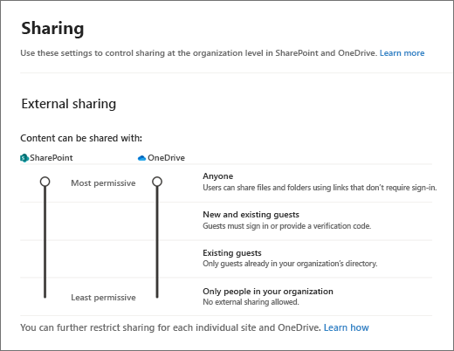
Note
The SharePoint setting applies to all site types, including those sites connected to Microsoft 365 groups and teams. Groups and Teams guest sharing settings also affect connected SharePoint sites. The OneDrive setting can be more restrictive than the SharePoint setting, but not more permissive.
SharePoint and OneDrive have four main types of sharing settings: Anyone, New and existing guests, Existing guests, and Only people in your organization. Each setting has different implications for the security and privacy of your content, and the ease of collaboration. The following table summarizes the main features and differences of each setting.
Select this option: | If you want to:
Anyone (default level for both SharePoint and OneDrive) | Allow users to share files and folders by using links that let anyone who has the link access the files or folders without authenticating. This setting also allows users to share sites with new and existing guests who authenticate. If you select this setting, you can restrict the Anyone links so that they must expire within a specific number of days, or so that they can give only View permission.  If you use file requests, then you must set OneDrive to Anyone, and you must enable the edit permissions for Anyone links. If OneDrive is set to anything other than Anyone, then file requests are disabled.  For more information, see Best practices for sharing files and folders with unauthenticated users.
New and existing guests | Require people who received invitations to sign in with their work or school account (if their organization uses Microsoft 365) or a Microsoft account, or to provide a code to verify their identity. Users can share with guests already in your organization's directory, and they can send invitations to people who will be added to the directory if they sign in. For more info about verification codes, see Secure external sharing in SharePoint
Existing guests | Allow sharing only with guests who are already in your directory. These guests might exist in your directory because they previously accepted sharing invitations or because they were manually added, such as through Azure B2B collaboration. (To see the guests in your organization, go to the Guests page in the Microsoft 365 admin center).
Only people in your organization | Turn off external sharing. If you restrict or turn off external sharing, guests typically lose access within one hour of the change. If you turn off external sharing for your organization and later turn it back on, guests who previously had access regain it. If you know that external sharing was previously turned on and in use for specific sites and you don't want guests to regain access, first turn off external sharing for those specific sites.
Whichever option you choose at the organization or site level, the more restrictive functionality is still available. For example, if you choose to allow unauthenticated sharing using "Anyone" links, users can still share with guests, who sign in, and with internal users.
Note
Even if your organization-level setting allows external sharing, not all new sites allow it by default. For more information, see Default site sharing settings.
If you have confidential information that should never be shared externally, Microsoft recommends storing the information in a site that has external sharing turned off. Create more sites as needed to use for external sharing. Doing so helps you to manage security risk by preventing external access to sensitive information.
Note
To limit internal sharing of contents on a site, you can prevent site members from sharing, and enable access requests. When users share a folder with multiple guests, the guests will be able to see each other's names in the Manage Access panel for the folder (and any items within it). However, they have different sharing settings that you can use to control who can access your content and what they can do with it. For more information, see Set up and manage access requests.
More external sharing settings
This section of the Sharing page allows you to configure more granular external sharing settings in your Microsoft 365 tenant.
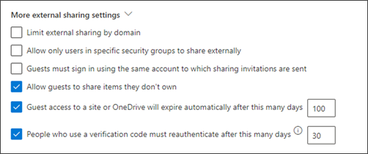
The settings that you can configure in this section include:
- Limit external sharing by domain. This setting is useful if you want to limit sharing with particular partners, or help prevent sharing with people at certain organizations. The organization-level setting on this page affects all SharePoint sites and each user's OneDrive. To use this setting, list the domains (maximum of 5000) in the box, using the format domain.com. To list multiple domains, press Enter after adding each domain.
You can also limit external sharing by domain by using the Set-SPOTenant Microsoft PowerShell cmdlet with -SharingDomainRestrictionMode and either -SharingAllowedDomainList or -SharingBlockedDomainList. For more information about limiting external sharing by domain at the site level, see Restricted domains sharing.
Allowed or blocked domains in Microsoft Entra ID also affect SharePoint and OneDrive site sharing (always) and file and folder sharing (if Azure B2B collaboration is enabled). Be sure to review Microsoft Entra collaboration restrictions as part of your SharePoint and OneDrive sharing setup.
- Allow only users in specific security groups to share externally. You can restrict external sharing of SharePoint and OneDrive content so that only users in specific security groups can share externally. People in these security groups must be allowed to invite guests in the Microsoft Entra guest invite settings. For more information, see Manage security groups.
- Guests must sign in using the same account to which sharing invitations are sent. By default, guests can receive an invitation at one account but sign in with a different account. After they redeem the invitation, it can't be used with any other account. This setting only applies to sharing that doesn't use Microsoft Entra B2B collaboration.
- Allow guests to share items they don't own. By default, guests must have full control permission to share items externally.
- Guest access to a site or OneDrive will expire automatically after this many days. If your administrator set an expiration time for guest access, each guest that you invite to the site or with whom you share individual files and folders is given access for a select number of days. For more information, see Manage guest expiration for a site
- People who use a verification code must reauthenticate after this many days. If people who use a verification code selected to "stay signed in" in the browser, they must prove they can still access the account they used to redeem the sharing invitation by entering a code sent to that account. If Azure B2B collaboration is enabled, the Microsoft Entra setting is used instead of this setting.
File and folder links
This section of the Sharing page allows you to choose the option to show by default when a user creates a sharing link. This setting specifies the default for your organization, but you can choose a different default link type for a site.
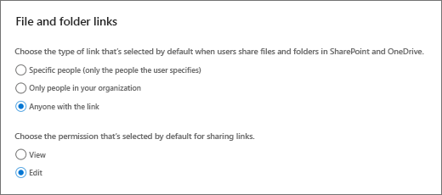
The settings that you can configure in this section include:
- Specific people. This option is most restrictive and impedes broad internal sharing. If you allow external sharing, this option lets users share with specific people outside the organization.
- Only people in your organization. If links are forwarded, they work for anyone in the organization. This option is best if your organization shares broadly internally and rarely shares externally.
- Anyone with the link. This option is available only if your external sharing setting is set to Anyone. Forwarded links work internally or externally, but you can't track who has access to shared items or who accessed shared items. This option is best for friction-free sharing if most files and folders in SharePoint and OneDrive aren't sensitive.
Important
If you select Anyone with the link, but the site or OneDrive is set to allow sharing only with guests who sign in or provide a verification code, the default link is Only people in your organization. Users need to change the link type to Specific people to share files and folders in the site or OneDrive externally.
Advanced settings for Anyone links
This section of the Sharing page enables you to select the expiration and permissions options for Anyone links.
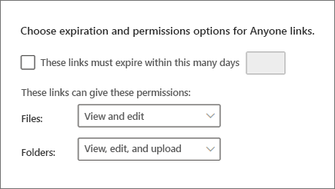
The settings that you can configure in this section include:
- Link expiration. You can require all Anyone links to expire, and specify the maximum number of days allowed. If you change the expiration time, existing links keep their current expiration time if the new setting is longer, or be updated to the new setting if the new setting is shorter.
- Link permissions. You can restrict Anyone links so that they can only provide view permission for files or folders.
If you're using file requests, the link permissions must be set to View and edit for files and View, edit, and upload for folders.
Other settings
This section of the Sharing page allows you to choose how SharePoint and OneDrive display user names for files or pages.
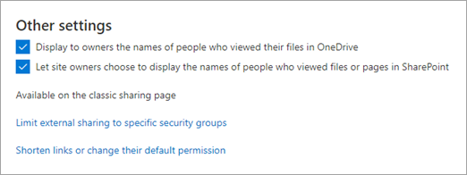
The settings that you can configure in this section include:
- Show owners the names of people who viewed their files in OneDrive. This setting lets you control whether the owner of a shared file can see on the file card the people who only view (and don't edit) the file in OneDrive. The file card appears when users hover over a file name or thumbnail in OneDrive. The info includes the number of views on the file, the number of people who viewed it, and the list of people who viewed it. To learn more about the file card, see See files you shared in OneDrive.
Note
This setting is selected by default. If you clear it, file viewer info is still recorded and available to you to audit as an admin. OneDrive owners can also still see people who viewed their shared Office files by opening the files from Office.com or from the Office desktop apps.
- Let site owners choose to display the names of people who viewed files or pages in SharePoint. This setting lets you specify whether site owners can allow users who have access to a file, page, or news post to see on the file card who viewed the item.
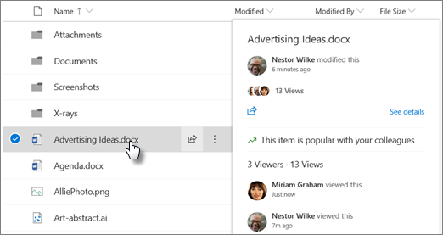
This setting is turned on by default at the organization level and off at the site level for existing sites. Viewer information is shown only when the setting is on at both the organization and site level. We recommend that site owners turn on this feature only on team sites that don't have sensitive information. Learn how site owners can turn on this feature.
Note
Historical data is included when this setting is enabled. Likewise, if the setting is turned off and back on at the organization level or site level, the views during the off period are included in the history.
- Use short links for sharing files and folders. When this option is selected, a shorter link format is used for sharing files and folders. This option might be useful if you have integrations that require a shorter URL.
Configure tenant-level settings for Microsoft Teams
200 XP
- 7 minutes
As a Microsoft 365 administrator, you can configure various organization-level tenant settings for Microsoft Teams. These settings affect how users and guests can access and use Teams features and capabilities. The following table outlines the different organization-level settings that you can configure in the Microsoft Teams admin center.
Setting | Description
Guest access | Allows you to enable or disable guest access to Teams. Guests are external users who can participate in Teams chats, calls, meetings, and channels, but have limited access to other resources. You can also control which domains can have guests in your organization, and which Teams features are available to guests.
Teams upgrade | Allows you to choose how users and organizations transition from Skype for Business to Teams. You can select from different coexistence and upgrade modes, such as Islands, Teams Only, Skype for Business Only, and others. Each mode determines which app is used for chat, calling, and meetings, and whether users can switch between apps.
Teams settings | Allows you to customize various aspects of Teams, such as the app setup policies, the meeting policies, the messaging policies, the live events policies, the voice settings, and the device settings. Each policy defines the user experience and permissions for a specific scenario, such as what apps are pinned to the app bar, what meeting features are enabled, what messaging options are available, what live event capabilities are supported, what voice services are configured, and what device management settings are applied.
Teams apps | Allows you to manage the apps that users can access and use in Teams. You can view, approve, upload, block, or uninstall apps. You can also create app permission and app setup policies. App permission policies control which app categories and specific apps are allowed or blocked for users. App setup policies control which apps are pinned to the app bar and which apps are installed by default for users.
Teams analytics and reports | Allows you to monitor and analyze the usage and performance of Teams in your organization. You can view various reports and dashboards, such as the Teams user activity report, the Teams device usage report, the Teams live event usage report, and the call quality dashboard. These reports and dashboards provide insights into the user adoption, device distribution, event statistics, and call quality of Teams.
Teams meeting settings
The following sections examine in greater detail the more popular Teams meeting settings - Meeting policy settings and Meeting configuration settings. These settings control how users can schedule, join, and conduct meetings in Teams. You can create and assign different meeting policies to different users or groups, depending on their needs and preferences.
Meeting policy settings
A meeting policy is a set of settings that defines the user experience and permissions for meetings in Teams. You can use the predefined meeting policies or create your own custom policies. You can assign a meeting policy to individual users, groups of users, or the entire organization. Some of the settings that you can configure in a meeting policy include:
- Allow scheduling private meetings. This setting determines whether users can schedule private meetings, which are meetings that aren't published to a channel and have a specific list of invitees. If this setting is enabled, users can schedule private meetings with specific participants. If it's disabled, users can only schedule channel meetings or meet now in channels.
- Allow meet now in channels. This setting determines whether users can start an instant meeting in a channel, which is a meeting that anyone in the channel can join. If this setting is enabled, users can start an instant meeting in any channel they're a member of. If it's disabled, users can only schedule meetings in advance.
- Allow channel meeting scheduling. This setting determines whether users can schedule channel meetings, which are meetings that are published to a channel and have the channel members as invitees. If this setting is enabled, users can schedule meetings in any channel they're a member of. If it's disabled, users can only schedule private meetings or meet now in channels.
- Allow IP video. This setting determines whether users can use video in meetings. If this setting is enabled, users can turn on their camera during a meeting to share video. If it's disabled, users can only share audio and content.
- Allow screen sharing. This setting determines whether users can share their screen or an app in meetings. If this setting is enabled, users can share their entire screen or a specific app or window during a meeting. If it's disabled, users can only share files and use the whiteboard.
- Allow transcription. This setting determines whether users can generate a transcript of the meeting audio. If this setting is enabled, users can turn on the transcription feature during a meeting to generate a real-time transcript of the audio. If it's disabled, no transcript is generated.
- Allow cloud recording. This setting determines whether users can record and store the meeting video and audio in the cloud. If this setting is enabled, users can start and stop a recording during a meeting. The recording is then processed and stored in the cloud, where it can be accessed and shared by the meeting organizer and participants. If it's disabled, no recording is available.
- Allow live captions. This setting determines whether users can see captions of the meeting audio. If this setting is enabled, users can turn on the live captions feature during a meeting to see real-time captions of the audio. If it's disabled, no captions are available.
- Media bit rate (Kbps). This setting determines the maximum bit rate for media traffic in meetings. The bit rate is the amount of data that is transmitted per second, measured in kilobits per second (Kbps). A higher bit rate can improve the quality of the audio and video, but it can also increase the network bandwidth usage. You can set the maximum bit rate to a value that balances quality and bandwidth usage for your organization.
- Allow live events. This setting determines whether users can create and host live events, which are large-scale online events that can have up to 10,000 attendees. If this setting is enabled, users can create and host live events, using the same tools and features as for regular meetings. If it's disabled, no live events are available.
Meeting configuration settings
A meeting configuration is a set of settings that applies to all meetings in your organization. You can configure these settings from the Meetings > Meeting settings page in the Microsoft Teams admin center. Some of the settings that you can configure include:
- Designated presenter role mode. This setting determines who can be a presenter in meetings. A presenter can share content, mute other participants, and admit people from the lobby. You can choose from four options: Everyone, Everyone in the same organization, Everyone in the same organization and federated users, or Organizer only. The option you choose determines who can be a presenter in all meetings in your organization.
- Who can bypass the lobby. This setting determines who can join the meeting directly without waiting in the lobby. You can choose from six options: Everyone, Everyone in my organization, Everyone in my organization and federated organizations, Everyone in my organization and trusted organizations, People I invite, or Only me. The option you choose determines who can bypass the lobby in all meetings in your organization.
- Announce when callers join or leave. This setting determines whether a sound is played when someone joins or leaves the meeting. If this setting is enabled, a sound is played when a participant joins or leaves the meeting, so that other participants are aware of their presence or absence. If it's disabled, no sound is played.
- Allow dial-in users to bypass the lobby. This setting determines whether users who join the meeting by phone can bypass the lobby. If this setting is enabled, users who join the meeting by dialing in with a phone can join the meeting directly without waiting in the lobby. If it's disabled, dial-in users must wait in the lobby until they're admitted by a presenter.
- Automatically admit people. This setting determines whether people are automatically admitted to the meeting or must wait in the lobby. You can choose from four options: Everyone, Everyone in your organization, Everyone in your organization and federated organizations, or Everyone in your organization and trusted organizations. The option you choose determines who is automatically admitted to all meetings in your organization.
- Allow anonymous users to join a meeting. This setting determines whether users who aren't signed in to Teams can join a meeting. If this setting is enabled, users who aren't signed in to Teams can join a meeting by clicking on the meeting link and entering their name. If it's disabled, only signed-in users can join a meeting.
- Allow users to chat privately. This setting determines whether users can send private chat messages to other participants during a meeting. If this setting is enabled, users can send private chat messages to other participants during a meeting, without other participants seeing the messages. If it's disabled, users can only send chat messages to the entire group.
- Allow users to send reactions. This setting determines whether users can send emoji reactions during a meeting. If this setting is enabled, users can send emoji reactions during a meeting, such as a thumbs up or a heart, to express their feelings or opinions. If it's disabled, no reactions are available.
- Allow users to view shared notes. This setting determines whether users can view the shared meeting notes during or after a meeting. If this setting is enabled, users can view and edit the shared meeting notes during the meeting. They can also access them after the meeting from the meeting chat or the meeting details. If it's disabled, no shared notes are available.
Knowledge check
Choose the best response for the following question.
Check your knowledge

1.
Which of the following tenant-level settings allows administrators to customize various aspects of Teams, such as the app setup policies, the meeting policies, the messaging policies, the live events policies, the voice settings, and the device settings?

Teams settings
Correct. This setting allows organizations to customize various aspects of Teams, such as the app setup policies, the meeting policies, the messaging policies, the live events policies, the voice settings, and the device settings. Each policy defines the user experience and permissions for a specific scenario, such as what apps are pinned to the app bar, what meeting features are enabled, what messaging options are available, what live event capabilities are supported, what voice services are configured, and what device management settings are applied.
Enable Unified Audit Logging in Microsoft 365
Completed 100 XP
- 3 minutes
Unified Audit Logging is a feature in Microsoft 365 that allows you to track and record user and admin activities across various services and applications, such as Exchange Online, SharePoint Online, OneDrive, Teams, Power BI, and Microsoft Entra ID.
With Unified Audit Logging, you can monitor and investigate security incidents, compliance violations, and operational issues. You can also generate audit reports and alerts based on specific events or criteria. The Unified Audit Log provides a centralized collection of audit events related to Microsoft 365. It encompasses activities such as file downloads from SharePoint or OneDrive, user sign-ins, and administrative actions.
You can access the audit log through the Microsoft Purview portal. Activities are grouped by service, making it easier to search for specific events. Unified Audit Logging can help you achieve the following benefits:
- Enhance security and compliance by detecting and responding to suspicious or unauthorized activities, such as data breaches, malware attacks, or policy violations.
- Improve operational efficiency and performance by identifying and resolving issues, such as configuration errors, service outages, or user feedback.
- Gain insights and visibility into user behavior and preferences by analyzing and reporting on user actions, such as file access, sharing, collaboration, or communication.
The audit log captures a wide range of activities, including:
- Application administration activities
  - These activities include adding or changing applications registered in Microsoft Entra ID.
  - Operations such as adding delegation entries, managing service principals, and modifying authentication permissions fall under this category.
- Microsoft Defender for Identity activities
  - These activities are logged in the unified audit log when they're enabled in the Microsoft Defender XDR portal.
  - To view these activities, ensure that the unified audit log is enabled.
- Custom Searches
  - You can create custom searches using the Audit search functionality to retrieve relevant information from the unified audit log.
Audit logging is turned on by default for Microsoft 365 organizations. However, when setting up a new Microsoft 365 organization, you should begin by verifying the auditing status for your organization (see the next section).
When auditing is turned on in the Microsoft Purview portal, user and administrator activity from your organization is recorded in the audit log and automatically retained for 180 days. The retention (lifetime) for audit data starts when it's added to the auditing log and is retained based on audit log retention policies and the license assigned to users. Changes to the user licensing or retention policies also change the expiration date of audit data.
Important
Audit (Standard) logs generated before October 17, 2023 are retained for 90 days. Audit (Standard) logs generated on or after October 17, 2023 follow the new default retention of 180 days.
An organization might have reasons for not wanting to record and retain audit log data. In these cases, a Global administrator can turn off auditing in Microsoft 365 for their organization.
Important
If you turn off auditing in Microsoft 365, you can't use the Office 365 Management Activity API or Microsoft Sentinel to access auditing data or logs for your organization. Turning off auditing means that no results are returned when you search the audit log using the Microsoft Purview portal, or when you run the Search-UnifiedAuditLog cmdlet in Exchange Online PowerShell.
Verify the auditing status for your organization
To verify that auditing is turned on for your organization, you can run the following command in Exchange Online PowerShell:
PowerShell
Get-AdminAuditLogConfig | Format-List UnifiedAuditLogIngestionEnabled
A value of True for the UnifiedAuditLogIngestionEnabled property indicates that auditing is turned on. A value of False indicates that auditing isn't turned on.
Important
Be sure to run the previous command in Exchange Online PowerShell. Although the Get-AdminAuditLogConfig cmdlet is also available in Security & Compliance PowerShell, the UnifiedAuditLogIngestionEnabled property is always False, even when auditing is turned on.
Turn on auditing
You must be assigned the Audit Logs role in Exchange Online to turn auditing on or off. By default, this role is assigned to the Compliance Management and Organization Management role groups on the Permissions page in the Exchange admin center.
If auditing isn't turned on for your organization, you can turn it on in the Microsoft Purview portal, or by using Exchange Online PowerShell. It can take up to an hour or so after you turn on auditing before you can return results when you search the audit log.
If you prefer to turn on auditing in the Microsoft Purview portal, then complete the following steps:
- Sign into the Microsoft Purview portal.
- Select the Audit solution card. If the Audit solution card isn't displayed, select View all solutions and then select Audit from the Core section.
- If auditing isn't turned on for your organization, a banner is displayed prompting you start recording user and admin activity.
- Select the Start recording user and admin activity banner.
If you prefer to turn on auditing using Exchange Online PowerShell, then complete the following steps:
- Connect to Exchange Online PowerShell.
- Run the following PowerShell command to turn on auditing.
PowerShell
Set-AdminAuditLogConfig -UnifiedAuditLogIngestionEnabled $true
Organizations that implement audit logging should also consider the following tasks to enhance their auditing experience:
- Configure the audit log retention policy. Navigate to Microsoft Purview portal > Audit > Policies and then select Create audit retention policy. When you configure a new policy, you can specify how long you want to retain the audit logs for each service and activity. The default retention period is 180 days (six months), but you can extend it up to 10 years.
- Search and export the audit logs. Navigate to Microsoft Purview portal > Audit > Search. Specify the date range, service, and activity that you want to search for. You can also use filters and keywords to refine your search. You can then export the results to a CSV file or to an Azure Storage account.
- Create audit alerts. Navigate to Microsoft Purview portal > Solutions > Compliance Manager > Policies and then select +Add. Define the conditions, actions, and recipients for the alert policy. You can also use the PowerShell cmdlet New-ProtectionAlert to create custom alerts.
- View audit reports. Navigate to Microsoft Purview portal > Solutions > Compliance Manager> Reports. You can view prebuilt reports, such as the History Report.

Complete your tenant configuration in Microsoft 365
Completed 100 XP
- 4 minutes
Finalizing your Microsoft 365 tenant configuration is a crucial step in ensuring a smooth transition for users and maintaining security and compliance. A well-structured checklist can help administrators verify that all necessary components are correctly configured and functioning.
Common tasks for tenant configuration
While specific configurations may vary depending on your organization's needs, the following are common steps to complete your Microsoft 365 tenant setup:
- User and Mailbox Migration: Ensure all users are migrated and have fully functional mailboxes, with appropriate data migration where applicable.
- System Resources and Permissions: Configure and assign necessary permissions to system resources.
- Domain Configuration: Transfer and verify custom domains (vanity domains).
- Device Management: Enroll Windows 10 and 11 devices into Microsoft Intune and configure co-management if using Microsoft Endpoint Configuration Manager.
- Mobile Device Governance: Implement governance policies for mobile devices.
- DNS Records and Mail Flow: Update and verify DNS records globally and configure policies to protect email communications.
- Identity Synchronization: Set up and validate Microsoft Entra Connect Sync, if in use.
- Multifactor Authentication (MFA): Enable MFA for added security.
- Security and Compliance Enhancements: Implement Conditional Access policies, disable legacy authentication, and configure audit logging.
- Data Protection: Configure Data Loss Prevention (DLP) policies and enable Azure Information Protection (AIP) to classify and protect sensitive information.
- Monitoring and Reporting: Use tools such as Microsoft Secure Score to track and improve security configurations.
- Regular Security Reviews: Review and update security settings and governance policies periodically.
Verifying tenant readiness
To confirm your Microsoft 365 environment is properly configured, use:
- Microsoft Remote Connectivity Analyzer: Checks DNS records and mail flow settings.
- Microsoft Support and Recovery Assistant (SARA): Diagnoses and resolves common connectivity issues.
Other consideration: tenant-to-tenant migration
Note
Tenant-to-tenant migration refers to the process of transferring data and configurations from one Microsoft 365 tenant to another, commonly required during mergers, acquisitions, or business restructurings. Given the complexity and specialized nature of such migrations, they are out of scope for this training. For more details, please refer to the Microsoft 365 tenant-to-tenant migrations article.
Administrators can ensure a smooth and secure Microsoft 365 tenant setup by following a structured checklist and verifying key configurations. Regular reviews and proactive monitoring help maintain performance, security, and compliance.

Check your knowledge

1.
Holly Dickson is the Microsoft 365 administrator for Adatum Corporation. Adatum has external sharing enabled, and its organizational sharing permission is set to Existing guests. Holly has created a new SharePoint site, and she set its external sharing setting to New and existing guests. When a user accesses Holly's new site, which external sharing setting will Microsoft 365 apply?
Existing guests
Correct
2.
You're the Microsoft 365 Administrator for Tailwind Traders, which up until last month was located in Paris, France. When Tailwind purchased its Microsoft 365 subscription two years ago, it set the Preferred Language setting in its Organization Profile to French. However, Tailwind recently moved its corporate headquarters to New York. Following the relocation, you changed the Preferred Language from French to English (US). After doing so, the language for all communications that are sent from Microsoft to Tailwind Traders are now in English (US). However, what aspect of your Microsoft 365 deployment is still in French?
The language used by SharePoint Online is still French.
Correct
3.
As the Microsoft 365 Administrator for Contoso, you want to confirm your company's readiness to deploy Microsoft 365. You're especially interested in checking the company's DNS records and mail flow to test whether its mailing policies are working properly. Which of the following tools should you run to check Contoso's DNS records and mailing policies?
Microsoft Remote Connectivity Analyzer
Correct

Summary
Completed 100 XP
- 1 minute
The start of this module mentioned the timely saying that you should "Plan your work and work your plan." With your Microsoft 365 deployment plan in place, this module examined the key tasks involved in configuring your Microsoft 365 tenant, specifically:
- Setting up your organizational profile
- Managing your tenant subscriptions
- Managing your services and add-ins
- Completing your tenant configuration
The module also explored several organization-level settings that companies should consider implementing. The first are SharePoint Online and OneDrive settings that control how these services control external sharing. External sharing enables your users to share content with people outside the organization, such as partners, vendors, clients, or customers. You learned how to configure these settings to provide the level of control that your organization requires. You also learned how to configure tenant-level setting to control how your users can conduct meetings in Microsoft Teams. And lastly, you learned how to enable Unified Audit Logging if your organization wants to monitor and investigate security incidents, compliance violations, and operational issues. Audit logging also enables organizations to generate audit reports and alerts based on specific events or criteria.
This module examined each of these tasks in detail. Microsoft 365 administrators must complete these tasks to successfully configure their organization's Microsoft 365 experience.

Manage users, licenses, guests, and contacts in Microsoft 365
Introduction
Completed 100 XP
- 1 minute
An organization’s Microsoft 365 administrator is typically responsible for creating and managing all the company's Microsoft 365 user accounts. This module provides instruction on how to manage user accounts and licenses in Microsoft 365. This process includes:
- Creating and managing user accounts.
- Assigning Microsoft 365 licenses to users.
- Recovering deleted user accounts.
Learning how to manage user accounts and licenses begins with identifying which user identity model is best suited for your organization. From there, you learn how to create user accounts from both the Microsoft 365 admin center and Windows PowerShell. This module also examines how to recover deleted user accounts in Microsoft 365.

Determine the user identity model for your organization
Completed 100 XP
- 5 minutes
To plan user identities, you must first understand the different types of Microsoft 365 user identities, namely: Cloud identities, Synchronized identities, and Federated identities. An organization can choose to maintain identities only in Microsoft 365, or it can integrate identities with its on-premises Active Directory.
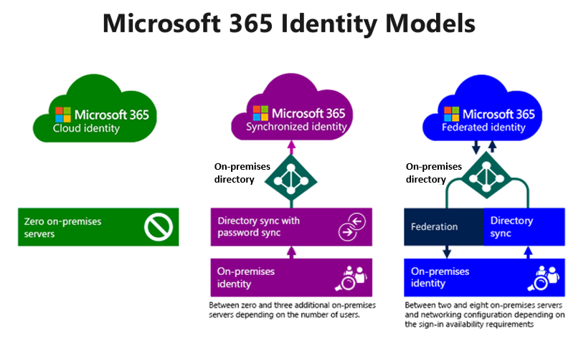
Cloud identities
A cloud identity is a user account that only exists in Microsoft Entra ID.
Important
Azure Active Directory (Azure AD) is now Microsoft Entra ID. Learn more.
While an organization can create a cloud identity with the same name as an on-premises Active Directory Domain Services (AD DS) user account, there isn't any link between the two accounts. They're two different, unique identities, each with their own password. Administrators use the Microsoft 365 admin center to create cloud identities. Most often, only small organizations use cloud identities because they don't need to maintain a local Active Directory implementation.
Synchronized identities
A synchronized identity is a user that exists in an on-premises AD DS and in Microsoft 365. The system synchronizes and links together the AD DS user and the Microsoft 365 user. The system then synchronizes any changes that you later make to the on-premises user account to the Microsoft 365 user account.
Organizations can synchronize their on-premises and cloud identities using either Microsoft Entra Connect Sync or Microsoft Entra Cloud Sync. The features of each tool are examined in greater detail in the training module titled Prepare for identity synchronization to Microsoft 365. These tools synchronize accounts and determine whether to synchronize passwords.
When an organization implements synchronized identities, its on-premises AD DS is the authoritative source for most information. As such, administrators must complete most of the administrative tasks on-premises. The system then synchronizes these changes to Microsoft Entra ID. In contrast, the system only synchronizes a small set of attributes from Microsoft 365 back to AD DS on-premises.
Authentication for synchronized identities occurs in Microsoft 365, unless the organization enabled Pass-Through Authentication (PTA). PTA is an authentication method provided by Microsoft 365 that allows users to authenticate directly against on-premises Active Directory instead of going through the Microsoft Entra ID cloud-based authentication. When an organization enables PTA, authentication for synchronized identities bypasses Microsoft 365 and occurs directly against the on-premises Active Directory.
If an organization doesn't enable PTA, authentication for synchronized identities occurs in Microsoft 365. In this scenario, Microsoft 365 evaluates the username and password without any reliance on the on-premises infrastructure.
Federated identities
A federated identity refers to an identity that an external identity provider (IdP) authenticated. When a user attempts to access a federated service such as Microsoft 365, Microsoft Entra ID redirects the authentication request to a designated, trusted IdP. The IdP is referred to as "trusted" because it has a mutual understanding and agreement with Microsoft 365 or Microsoft Entra ID regarding the authentication and authorization process for federated identities.
In a federated identity scenario, the trust relationship requires the organization to configure the settings and exchange the necessary information between Microsoft 365 or Microsoft Entra ID and the IdP. This configuration process typically includes:
- Configuring the relying party trust. Microsoft provides a set of administrative tools and interfaces that enable an organization's administrators to configure and manage the settings and policies within their Microsoft Entra tenant. The organization administrators have the authority and control to customize and define the policies that govern the authentication and authorization process for their users. So an organization that uses federated identities must configure Microsoft 365 or Microsoft Entra ID to recognize and trust a specific IdP as a valid authority for authenticating its users.
- Exchange of metadata. Microsoft 365 or Microsoft Entra ID exchanges metadata, such as security certificates and endpoint URLs, with the IdP. This metadata allows both parties to communicate securely and verify each other's identity.
- Trust policy configuration. Organizations can configure policies that govern the authentication and authorization process for their federated identities. These policies can define the rules and criteria for accepting the assertions made by the IdP, including:
  - Which claims and attributes the organization considers valid.
  - How the organization and IdP should handle the authentication process.
  - Any other security requirements.
The IdP could be Active Directory Federation Services (AD FS) or another federated identity provider. It authenticates the user using its own authentication mechanisms, such as Windows Authentication (Kerberos) or other supported methods. Once the IdP authenticates the user, it generates a security token that contains the user's identity claims. Microsoft Entra ID then accepts and validates this token to grant the user access to the requested resources.
Implementing federated identities used to be more complex than implementing synchronized identities because of the requirement to implement AD FS. However, Microsoft 365 removed that complexity with the adoption of Microsoft Entra Connect Sync and Microsoft Entra Cloud Sync, both of which deploy most of the AD FS infrastructure.
Because authentication to Microsoft 365 is dependent on the availability of AD FS, service interruptions to the on-premises infrastructure can affect Microsoft 365 authentication. For example, an on-premises Internet outage causes Microsoft 365 authentication to fail. However, organizations can mitigate this issue by placing a copy of AD DS and AD FS in Microsoft Azure.
The main benefit of using federated identities is single sign-on (SSO). Users authenticate at a domain-joined workstation by using their credentials. SSO uses these cached credentials to automatically authenticate to Microsoft 365 services. Synchronized identities typically need to enter their credentials manually when accessing Microsoft 365 services.
Federated identities also take advantage of password policies and account lockout policies in an on-premises AD DS. This design provides more flexibility when managing password policies for Microsoft 365.
Determining the best model for your organization
Each identify model has different advantages and disadvantages. To determine the best option for your company, you must first understand what scenario is best suited for each model, along with the greatest benefit for each model as outlined in the following table.
 | Cloud Identity | Synchronized Identity | Federated Identity
Definition | User account only exists in Microsoft 365. | User account exists in local Active Directory and an identical user in exists in Microsoft 365. | Synchronized user account authenticated by using AD FS.
Best for… | Small to medium-sized organizations or organizations that don't need a local Active Directory Domain Service (AD DS) anymore. | Organizations running on-premises Active Directory already and are planning to move to the cloud. | Organizations that want to centralize their authentication and authorization processes.  Organizations that run a federated authentication system, or require a special type of sign-in, such as with an ID card, also use this model.
Greatest benefit | Simple to use; no extra tools required. | Same Sign-In, and where organizations must manage identities in only one place. | Single sign-on, and where organizations must manage identities in only one place.
Create user accounts in Microsoft 365
200 XP
- 6 minutes
Depending on an organization's needs, it can use the following methods to provision user accounts:
- Microsoft 365 admin center. This portal provides a simple web interface for individually creating and managing users, their licenses, and permissions. It's also available as an app for mobile devices or tablets as Microsoft 365 admin app.
- Import multiple users. This option provides a method for the bulk importation of multiple users into the Microsoft 365 admin center through a comma-separated value (CSV) file.
- Windows PowerShell. You can use this cmdlet-based and script-based interface to create and manage single and multiple users. You should note that Microsoft scheduled the Azure AD, Azure AD Preview, and MSOnline PowerShell modules for deprecation. Microsoft Graph PowerShell is the PowerShell module to use for interacting with Microsoft Entra ID, Microsoft 365, and other Microsoft services.
- Directory synchronization. This option requires an organization to provision and manage users by synchronizing Microsoft 365 with an on-premises directory service such as Active Directory. Organizations can use either the Microsoft Entra Connect Sync or Microsoft Entra Cloud Sync tool to synchronize on-premises Active Directory objects with Microsoft Entra ID. Microsoft Entra Cloud Sync doesn't support Exchange hybrid deployments.
The most common and easiest way to create user accounts in nondirectory synchronized environments is to use the Microsoft 365 admin center or the Microsoft 365 admin app. Organizations normally use more advanced methods for mass-imports, such as importing multiple users, using Windows PowerShell, or running an automated script for user creation. In organizations that implement directory synchronization, they can't use the Microsoft 365 admin center or Windows PowerShell for user creation. They must instead use the local tools available in their on-premises Active Directory.
Creating users with the Microsoft 365 admin center
Using the Microsoft 365 admin center is the simplest method for creating one or more user accounts. To create a user, following these steps:
- Sign in to Microsoft 365 admin center.
- On the Microsoft 365 admin center, in the left-hand navigation pane, select the Users group and then select Active users.
- On the Active users page, select Add a user. This action starts a wizard that walks you through the steps necessary to add the user information.
- On the Set up the basics page, enter the required user and password information. Verify you select the correct domain for the Username.
- On the Assign product licenses page, select the product license(s) that you want to assign to the user.
- On the Optional settings page, select the role(s) you want to assign to this user.
- On the Review and finish page, review the information you entered. If necessary, correct any information that you entered incorrectly. When all information is correct, select the Finish adding button to add the user account.
Creating users with the Import multiple users option
Organizations can use the Add multiple users option in the Microsoft 365 admin center to add large numbers of users in one operation. Bulk importing of users in this manner requires the use of a comma-separated values (CSV) file. Microsoft 365 provides an empty template and a sample CSV file to make the process easier. Administrators can use a text-editing tool such as Notepad or Microsoft Excel to edit these files. To create users by using bulk import, you should complete the following steps:
- In the Microsoft 365 admin center, on the Active users page, select Add multiple users.
- Browse to the CSV file that contains your users.
- The verification result informs you if any errors are in your file. If there are errors, you can view the results in the linked log file.
- On the Set user options page, set the new users’ sign-in status, location, and licenses.
- On the View your results page, specify who should receive the email of the results. Microsoft recommends that you include your own email address so that you can provide the temporary passwords to your new users.
Creating users with Windows PowerShell
Some Microsoft 365 Administrators prefer to use Windows PowerShell rather than the Microsoft 365 admin center to complete user administrative functions. You must begin by installing Microsoft Graph PowerShell, importing the Microsoft.Graph.Identity.DirectoryManagement module, and connecting to MgGraph with the proper permissions. The following example provides the Read/Write permissions needed to add a new user.
PowerShell
Install-Module Microsoft.Graph -Scope CurrentUser
Import-Module Microsoft.Graph.Identity.DirectoryManagement
Connect-MgGraph -Scopes 'User.ReadWrite.All'
At this point, you're ready to use the New-MgUser cmdlet to create a user account in Microsoft 365. When creating a new user account with the Microsoft Graph PowerShell module, you must specify, at a minimum, the required properties for the user, which includes the user password. The password must satisfy minimum requirements as specified by the user’s PasswordPolicies property. By default, the system requires a strong password. You can optionally specify any other writable properties. For example, to create a new user account, you would run the following commands. The first command assigns the user's password to a variable. The New-MgUser command then references the variable.
$PasswordProfile = @{ Password = 'user password' }
New-MgUser -UserPrincipalName username@domainname –DisplayName 'Firstname Lastname' -GivenName 'Firstname' –Surname 'Lastname' -PasswordProfile $PasswordProfile -AccountEnabled -MailNickName 'email alias'
For example, the following commands create a user account for Allan Deyoung:
$PasswordProfile = @{ Password = 'User.pw1' }
New-MgUser –UserPrincipalName AllanD@Adatum.onmicrosoft.com –DisplayName 'Allan Deyoung' -GivenName 'Allan' –Surname 'Deyoung' -PasswordProfile $PasswordProfile -AccountEnabled -MailNickName 'AllanD'
Exercise – Interactive demonstration
Select the following link to complete an interactive demonstration titled: Create a user account for Adatum's Microsoft 365 Administrator.
This simulation guides you through the steps to create a Microsoft 365 user account and assign it the Global Administrator role. This demonstration centers around the fictitious Adatum Corporation. You create a user account for the equally fictitious Holly Dickson, who is Adatum's new Microsoft 365 Administrator. You then assign Holly the Microsoft 365 Global Administrator role.
Knowledge check
Choose the best response for the following question.
Check your knowledge

1.
As the Microsoft 365 Administrator for Contoso, you're configuring Contoso's Microsoft 365 tenant. Your plan is to provision and manage your user accounts by synchronizing Microsoft 365 with Contoso's on-premises Active Directory. What tool can you use to synchronize on-premises Active Directory objects with Microsoft Entra ID?

Microsoft Entra Connect Sync
Correct. This tool synchronizes on-premises Active Directory objects with Microsoft Entra ID.
Manage user account settings in Microsoft 365
Completed 100 XP
- 3 minutes
As soon as an organization purchases Microsoft 365, it can use the Microsoft 365 admin center and PowerShell to manage its user accounts. When an organization manages its cloud identities, every person in the company has a separate user account name and password. If you want to integrate with your on-premises infrastructure and have user accounts synchronized with Microsoft 365, you can use Microsoft Entra Connect Sync or Microsoft Entra Cloud Sync. These tools provide synchronization of identities and passwords for single sign-on (SSO) functionality.
Where and how you manage your user accounts depends on the identity model you want to use for your Microsoft 365 deployment. The two overall models are cloud-only and hybrid.
- Cloud-only. You create and manage users in the Microsoft 365 admin center. You can also use PowerShell or the Microsoft Entra admin center.
- Hybrid. Microsoft 365 synchronizes user accounts from AD DS. As such, you must use on-premises AD DS tools to manage user accounts.
The following table lists the different account management tools.
Tool | Notes
Microsoft 365 admin center | - Add users individually or in bulk  - Provides a simple web interface to add and change user accounts.  - You can't use the admin center to modify user accounts if the organization enables directory synchronization. However, you can use the admin center to set the location and license assignment.  - You can't use the admin center with SSO options.
Windows PowerShell | - Create user accounts with PowerShell.  - Allows you to add users in bulk users by using a Windows PowerShell script.  - You can use PowerShell to assign location and licenses to accounts, regardless of how you create the accounts.
Bulk import | - Add several users at the same time  - Allows you to import a CSV file to add a group of users to Microsoft 365.  - You can't use bulk import with SSO options.
Microsoft Entra ID | - You get a free edition of Microsoft Entra ID with your Microsoft 365 subscription. You can perform functions like self-service password reset for cloud users, and customization of the Sign-in and Access Panel pages by using the free edition. To get enhanced functionality, you can upgrade to the basic edition, Microsoft Entra Premium P1, or Microsoft Entra Premium P2. See Microsoft Entra ID editions for the list of supported features.
Directory synchronization | - Integrating your on-premises identities with Microsoft Entra ID  - For directory synchronization with or without password synchronization, see Microsoft Entra Connect Sync with express settings.  - For multiple forests and SSO options, see Custom Installation of Microsoft Entra Connect Sync.  - Provides the infrastructure that's necessary to enable SSO.  - Required for many hybrid scenarios such as staged migration and hybrid Exchange  - Synchronizes security and mail-enabled groups from your AD DS.  - You must install the directory synchronization software on servers within your on-premises environment. This software connects the identities between Microsoft 365 and your AD DS.  - Any directory synchronization option, including SSO options, requires that your AD DS attributes meet standards. A later Learning Path titled Implement identity synchronization explores the specifics of what attributes you must use in your directory and what maintenance (if any) you must perform.
Regardless of how you intend to add the user accounts to Microsoft 365, you must manage several account features, such as assigning licenses, specifying location, and so on. You can manage these features long-term from the Microsoft 365 admin center, or you can also use PowerShell (see the earlier link in the table).
Important
If you create accounts in Microsoft 365 without assigning a license (to SharePoint Online, for example), the account owner can view the Microsoft 365 admin center but can't access any of the services within your company's subscription. After you assign a location and license, the system replicates the account to the service or services that you assigned. The user can then sign-in to their account and use the services that you assigned to them.
Manage user accounts in the Microsoft 365 admin center
If you choose to add and manage all your users through the admin center, you can specify the location and assign licenses at the same time as creating the Microsoft 365 account. Managing user accounts involves managing several account settings, such as:
- Assigning administrator roles
- Setting users’ sign-in status
- Specifying user location settings
- Assigning licenses
To maintain this information, you don't have to use the same method that you used to originally provision the user accounts. You can manage these user settings through the Microsoft 365 admin center or by using Windows PowerShell. Given the simplicity of managing user accounts through the admin center, this approach is the area of focus in this training.
You can use the Microsoft 365 admin center to edit single or multiple users. Complete the following steps to edit a user account:
- On the Microsoft 365 admin center, in the left-hand navigation pane, select Users and then select Active Users.
- In the list of active user accounts, select the user that you want to edit to open the user's account pane. The user's account pane separates the user's account information into the following tabs:
  - Account. This tab enables you to modify the username and aliases, email addresses, group membership, roles, priority monitoring, and account contact information. You can also manage multifactor authentication for this user and force a sign out from all Microsoft 365 sessions. The tab also displays the user's sign-in history for the past 30 days, and the user's Microsoft 365 activations.
  - Devices. This tab displays the devices the user enrolled in Intune.
  - Licenses and Apps. This tab enables you to modify the licenses assigned to the user. You can also set the user location. Microsoft needs to know the location of each user who uses its Microsoft 365 services so that it only offers permitted services to that user. Finally, you can customize the list of apps available to the user.
  - Mail. This tab enables you to modify mailbox permissions, email forwarding, automatic replies, global address list visibility, litigation hold, Exchange properties, and email apps.
  - OneDrive. This tab enables you to obtain access to the user’s files, view the storage quota, and manage external sharing. It also provides links to the SharePoint admin center to manage your organization settings for data retention and default storage space.
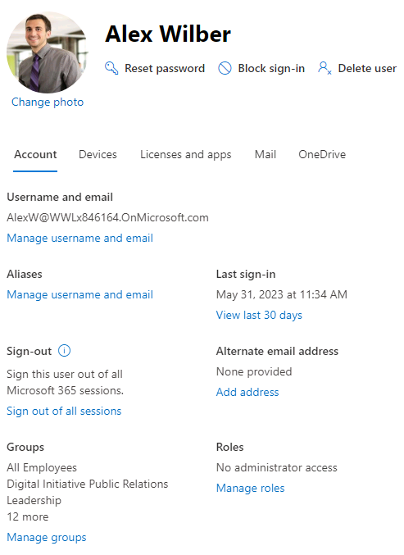
Manage user licenses in Microsoft 365
200 XP
- 5 minutes
Microsoft paid cloud services, such as Microsoft 365, Enterprise Mobility + Security, Dynamics 365, and other similar products, require licenses. These licenses are assigned to each user who needs access to these services. To manage licenses, administrators use one of the management portals (Microsoft 365 or Azure) and PowerShell cmdlets. Microsoft Entra ID is the underlying infrastructure that supports identity management for all Microsoft Cloud services. Microsoft Entra ID stores information about license assignment states for users.
One of the most basic tasks for Microsoft 365 Administrators is user management. To manage users, you must understand how to manage their licenses. Your organization’s users need licenses to use Microsoft 365 services, such as Microsoft Outlook and Microsoft SharePoint Online. When an administrator assigns a license to a user, the system automatically sets up the service for that user. For example, when you assign a SharePoint Online license to a user, the system assigns the user edit permissions on the default team site.
Only members of the Microsoft 365 Global admin and User Management admin roles can assign or remove licenses. They can assign or remove a license for single or multiple users.
Important
When an administrator removes a license from a user, the system deletes any service data that's associated with that user. You then have a 30-day grace period in which you can recover that data. After the grace period, the data isn't recoverable.
Viewing user license information
You can use the Microsoft 365 admin center to view important information about an organization's user license usage. For example, you can see how many licenses the organization used, how many are remaining, and which users are currently unlicensed.
To view the number of licenses remaining:
- In the Microsoft 365 admin center, on the left-hand navigation pane, select Billing and then select Licenses.
- In the Subscriptions tab, note how many licenses are available for each subscription and how many licenses the organization assigned.
To view any unlicensed users:
- In the Microsoft 365 admin center, on the left-hand navigation pane, select Users and then select Active users.
- In the menu bar, select Filter.
- In the drop-down menu that appears, note all the various options that you can select to view the users with these respective properties. To view unlicensed users, select Unlicensed users.
Assigning a license
Administrators can use both the Microsoft 365 admin center and Windows PowerShell to assign a license to a user. The prior unit provided instruction on how to edit the licenses for an individual user. However, administrators can maintain products licenses for multiple users at one time. To assign or remove licenses for multiple users in the Microsoft 365 admin center, complete the following steps:
- In the Microsoft 365 admin center, in the left-hand navigation pane, select Users and then select Active users.
- Select the check box for each user that you want to assign or remove licenses.
- On the menu bar, select Manage product licenses if it appears. If it doesn't appear due to the size of the screen, then select the ellipsis (More actions) icon. In the drop-down menu that appears, select Manage product licenses.
- On the Manage product licenses page, you must select one of the following options to apply to the selected users:
  - Replace. Unassign existing licenses and assign new ones.
  - Assign more. Keep the existing licenses and assign more.
  - Unassign all. Unassign all licenses for each selected user.
Using Microsoft Graph PowerShell to manage user licenses
Users can't use any Microsoft 365 services until an administrator assigns a license from a licensing plan to their account. If you prefer to use PowerShell rather than the Microsoft 365 admin center, you can assign a user license within Microsoft Graph PowerShell. You can use PowerShell to quickly assign licenses to unlicensed accounts.
Administrators must first assign a location to user accounts. The system requires a location when you create a new user account in the Microsoft 365 admin center. By default, accounts synchronized from an organization's on-premises Active Directory Domain Services (AD DS) don't have a location specified. You can configure a location for these accounts from:
- The Microsoft 365 admin center
- Microsoft Graph PowerShell
- The Microsoft Entra admin center
Finding unlicensed accounts using Microsoft Graph PowerShell
Assigning and removing licenses for a user requires the User.ReadWrite.All permission scope or one of the other permissions listed in the 'Assign license' Microsoft Graph API reference page.
PowerShell requires the Organization.Read.All permission scope to read the licenses available in the tenant.
PowerShell
Connect-MgGraph -Scopes User.ReadWrite.All, Organization.Read.All
Run the Get-MgSubscribedSku command to view the available licensing plans and the number of available licenses in each plan in your organization. The number of available licenses in each plan is ActiveUnits - WarningUnits - ConsumedUnits. For more information about licensing plans, licenses, and services, see View licenses and services with PowerShell.
To find the unlicensed accounts in your organization, run the following command.
PowerShell
Get-MgUser -Filter 'assignedLicenses/$count eq 0' -ConsistencyLevel eventual -CountVariable unlicensedUserCount -All
To find the unlicensed synchronized users in your organization, run the following command.
PowerShell
Get-MgUser -Filter 'assignedLicenses/$count eq 0 and OnPremisesSyncEnabled eq true' -ConsistencyLevel eventual -CountVariable unlicensedUserCount -All -Select UserPrincipalName
You can only assign licenses to user accounts that have the UsageLocation property set to a valid ISO 3166-1 alpha-2 country/region code. For example, US for the United States, and FR for France. Some Microsoft 365 services aren't available in certain countries/regions. For more information, see About license restrictions.
To find accounts that don't have a UsageLocation value, run the following command.
PowerShell
Get-MgUser -Select Id,DisplayName,Mail,UserPrincipalName,UsageLocation,UserType | where { $_.UsageLocation -eq $null -and $_.UserType -eq 'Member' }
To set the UsageLocation value on an account, run the following command.
PowerShell
$userUPN="<user sign-in name (UPN)>"
$userLoc="<ISO 3166-1 alpha-2 country code>"

Update-MgUser -UserId $userUPN -UsageLocation $userLoc
For example:
PowerShell
Update-MgUser -UserId "belindan@litwareinc.com" -UsageLocation US
Note
If you use the Get-MgUser cmdlet without using the -All parameter, PowerShell only displays the first 100 user accounts.
Assigning licenses to user accounts
To assign a license to a user, use the following command in Microsoft Graph PowerShell.
PowerShell
Set-MgUserLicense -UserId $userUPN -AddLicenses @{SkuId = "<SkuId>"} -RemoveLicenses @()
The following example assigns a license from the SPE_E5 (Microsoft 365 E5) licensing plan to the unlicensed user belindan@litwareinc.com:
PowerShell
$e5Sku = Get-MgSubscribedSku -All | Where SkuPartNumber -eq 'SPE_E5'
Set-MgUserLicense -UserId "belindan@litwareinc.com" -AddLicenses @{SkuId = $e5Sku.SkuId} -RemoveLicenses @()
The following example assigns SPE_E5 (Microsoft 365 E5) and EMSPREMIUM (Enterprise Mobility + Security E5) to the user belindan@litwareinc.com:
PowerShell
$e5Sku = Get-MgSubscribedSku -All | Where SkuPartNumber -eq 'SPE_E5'
$e5EmsSku = Get-MgSubscribedSku -All | Where SkuPartNumber -eq 'EMSPREMIUM'
$addLicenses = @(
@{SkuId = $e5Sku.SkuId},
@{SkuId = $e5EmsSku.SkuId}
)

Set-MgUserLicense -UserId "belinda@litwareinc.com" -AddLicenses $addLicenses -RemoveLicenses @()
The following example assigns SPE_E5 (Microsoft 365 E5) with the MICROSOFTBOOKINGS (Microsoft Bookings) and LOCKBOX_ENTERPRISE (Customer Lockbox) services turned off:
PowerShell
$e5Sku = Get-MgSubscribedSku -All | Where SkuPartNumber -eq 'SPE_E5'
$disabledPlans = $e5Sku.ServicePlans | `
Where ServicePlanName -in ("LOCKBOX_ENTERPRISE", "MICROSOFTBOOKINGS") | `
Select -ExpandProperty ServicePlanId

$addLicenses = @(
@{
SkuId = $e5Sku.SkuId
DisabledPlans = $disabledPlans
}
)

Set-MgUserLicense -UserId "belinda@litwareinc.com" -AddLicenses $addLicenses -RemoveLicenses @()
The following example updates a user with SPE_E5 (Microsoft 365 E5) and turns off the Sway and Forms service plans while leaving the user's existing disabled plans in their current state:
PowerShell
$userLicense = Get-MgUserLicenseDetail -UserId "belinda@litwareinc.com"
$userDisabledPlans = $userLicense.ServicePlans | `
Where ProvisioningStatus -eq "Disabled" | `
Select -ExpandProperty ServicePlanId

$e5Sku = Get-MgSubscribedSku -All | Where SkuPartNumber -eq 'SPE_E5'
$newDisabledPlans = $e5Sku.ServicePlans | `
Where ServicePlanName -in ("SWAY", "FORMS_PLAN_E5") | `
Select -ExpandProperty ServicePlanId

$disabledPlans = ($userDisabledPlans + $newDisabledPlans) | Select -Unique

$addLicenses = @(
@{
SkuId = $e5Sku.SkuId
DisabledPlans = $disabledPlans
}
)

Set-MgUserLicense -UserId "belinda@litwareinc.com" -AddLicenses $addLicenses -RemoveLicenses @()View license information
Knowledge check
Choose the best response for the following question.
Check your knowledge

1.
You're the Microsoft 365 Administrator for Tailspin Toys. When a member of the Sales team recently left the company, you removed the Microsoft 365 E3 license from the user's Microsoft 365 account. What happens to any service data associated with that user?

The system soft-deletes any service data associated with the user. However, you have a 30-day grace period in which you can recover the data before it gets permanently deleted.
Correct. When you remove the license from one of your users, the system soft-deletes any service data associated with that user. You then have a 30-day grace period in which you can recover that data. After the grace period, the data isn't recoverable.
Recover deleted user accounts in Microsoft 365
Completed 100 XP
- 3 minutes
When users leave an organization, its Microsoft 365 tenant no longer requires their user accounts. To ensure the security of its system, an organization must delete these accounts so these users can no longer access the organization's Microsoft 365 tenant. When an administrator deletes a user account, the assigned Microsoft 365 license for that user becomes available. The administrator can then assign this license to another user.
Deleting a user account
To delete one or more users using the Microsoft 365 admin center, complete the following steps:
- In the Microsoft 365 admin center, in the left-hand navigation pane, select Users and then select Active users.
- Select the users that you want to delete and then select the Delete user option that appears on the menu bar.
- In the Delete users pane that appears, select Delete users.
- Once the system successfully deletes the user, select Close.
You can also use Microsoft Graph PowerShell to delete user accounts by using the Remove-MgUser command with the –UserId string parameter. For example:
PowerShell
Remove-MgUser -UserId '5c442efb-5e66-484a-936a-91b6810bed14'
Restoring a deleted user account
When you delete a user account, it becomes inactive, and the user can't sign in to access Microsoft 365 services. However, sometimes an organization must restore a deleted user account. To support this scenario, Microsoft 365 keeps the account as a "soft deleted" inactive account for 30 days after deletion. This 30 day grace period enables an organization to restore deleted user accounts, if necessary.
The following diagram shows how deleted users are still a part of their managed tenant, and that a recovery operation simply reactivates a Microsoft 365 user account.
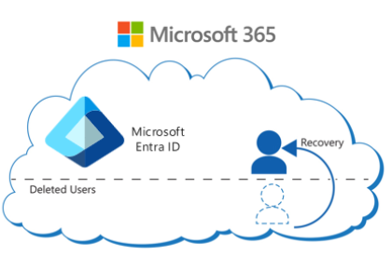
To restore a user using the Microsoft 365 admin center, complete the following steps:
- In the Microsoft 365 admin center, in the left-hand navigation pane, select Users and then select Deleted users.
- Select the deleted user that you want to restore and then select the Restore user option that appears on the menu bar.
- Select how you want to assign the user password and then select Restore.
You can also use Windows PowerShell to restore deleted user accounts. Microsoft Graph PowerShell uses the Restore-MgDirectoryDeletedItem cmdlet to restore a recently deleted application, group, servicePrincipal, administrative unit, or user object from the deleted items "container." Deleted items remain available to restore for up to 30 days. After 30 days, system permanently deletes the items. When recovering a deleted group, you can recover all group types except for Security groups. When you delete a Security group, the system permanently deletes it, and you can't recover it.
The previous PowerShell example showed how to delete a user account whose Object ID was "5c442efb-5e66-484a-936a-91b6810bed14." The following example shows how to restore this deleted user account using the Restore-MgDirectoryDeletedItem cmdlet:
PowerShell
Restore-MgDirectoryDeletedItem -DirectoryObjectId '5c442efb-5e66-484a-936a-91b6810bed14'
Perform bulk user maintenance in Microsoft Entra ID
Completed 100 XP
- 9 minutes
Microsoft Entra ID enables organizations to bulk create new users, bulk delete existing users, and bulk restore deleted users. Bulk user operations require that you fill out a comma-separated values (CSV) template to download the selected users from the Microsoft Entra admin center.
Note
To perform any of the bulk operations in the Microsoft Entra admin center, you must sign-in as a Global Administrator or User Administrator.
Create users in bulk
Bulk user operations require the use of a bulk user CSV template. The CSV template for bulk user creations is slightly different from the template used to bulk delete users, which is slightly different from the template used to bulk restore deleted users. Organizations should download and fill in the CSV template for the corresponding bulk operation.
The CSV template used to bulk create users should look like this example (older versions can vary):
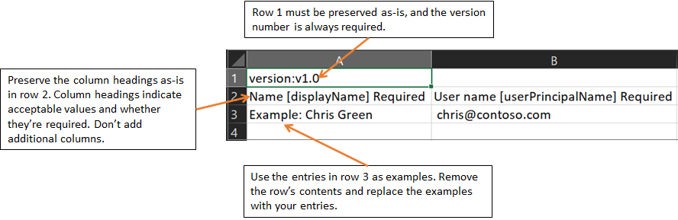
Warning
If you're adding only one entry using the CSV template, you must preserve row 3 and add your new entry to row 4. Ensure that you add the ".csv" file extension and remove any leading spaces before userPrincipalName, passwordProfile, and accountEnabled.
The rows in the downloaded CSV template to bulk create new users are as follows:
- Version number. The upload CSV file must contain the version number in the first row.
- Column headings. The format of the column headings is <Item name> [PropertyName] <Required or blank>. For example, Name [displayName] Required. Some older versions of the template can have slight variations.
- Examples row. The template includes a row of examples of acceptable values for each column. You must remove the examples row and replace it with your own entries.
Organizations should keep in mind the following issues related to the bulk create CSV template:
- You can't remove or modify the first two rows of the upload template, or the upload process fails.
- It lists the required columns first.
- Microsoft doesn't recommend that you add new columns to the template. The upload process ignores any other columns that you add.
- Microsoft recommends that you download the latest version of the CSV template as often as possible.
- Verify there's no unintended whitespace before or after any field. For User principal name, having such whitespace would cause import failure.
- Verify that values in the Initial password comply with the currently active password policy.
Organizations should complete the following steps to bulk create users in Microsoft Entra ID:
- In the Microsoft 365 admin center, under Admin centers in the navigation pane, select Identity.
- In the Microsoft Entra admin center, select Users, and then select All users.
- On the Users page, select Bulk operations on the menu bar. In the drop-down menu that appears, select Bulk create.
- In the Bulk create users pane that appears, select Download to receive a comma-separated values (CSV) file of user properties. Use this file as a template and add users you want to create.
- Open the CSV template file and add a line for each user you want to create. The only required values are Name, User principal name, Initial password, and Block sign in (Yes/No). Then save the file.
- On the Bulk create users pane, under Upload your CSV file, browse to the file. When you select the file and then select Submit, validation of the CSV file starts.
- After the system validates the file contents, a File uploaded successfully message appears. If there are errors, you must fix them before you can submit the job.
- When your file passes validation, select Submit to start the bulk operation that imports the new users.
- When the import operation completes, the system displays a notification indicating the bulk operation job status.
If there are errors, you can download and view the results file on the Bulk operation results page. The file contains the reason for each error. The file submission must match the provided template and include the exact column names.
Check status of your bulk operations
An organization can check the status of all its pending bulk requests in the Microsoft Entra admin center. On the Users page, under the Manage section in the middle navigation pane, select Bulk operation results.
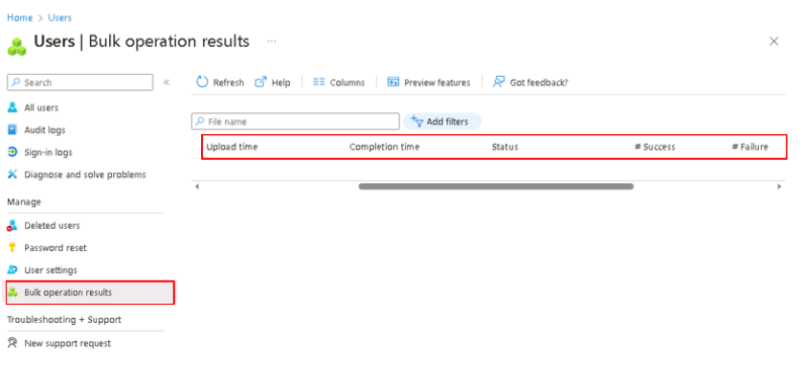
Warning
Each bulk activity to create users can run for up to one hour. This process enables bulk creation of at least 50,000 users.
Verify the users were created
An organization can then verify whether the users it created exist in the Microsoft Entra organization. It can do so either in the Microsoft Entra admin center or by using PowerShell.
Verify users in the Microsoft Entra admin center
Perform the following steps to verify the users that you created are visible in the Microsoft Entra admin center:
- In the Microsoft 365 admin center, under Admin centers in the navigation pane, select Identity.
- In the Microsoft Entra admin center, select Users, and then select All users.
- On the Users page, verify the users you submitted to be bulk created are displayed in the list.
Verify users with PowerShell
Some Microsoft 365 Administrators prefer to use Windows PowerShell rather than the Microsoft 365 admin center to complete user administrative functions. You must begin by installing Microsoft Graph PowerShell, importing the Microsoft.Graph.Identity.DirectoryManagement module, and connecting to MgGraph with the proper permissions. The following example provides the "Read only" permission needed to retrieve a user account.
PowerShell
Install-Module Microsoft.Graph -Scope CurrentUser
Import-Module Microsoft.Graph.Identity.DirectoryManagement
Connect-MgGraph -Scopes 'User.Read.All'
To verify the system bulk created the users that you submitted, run the following command using Microsoft Graph PowerShell:
PowerShell
Get-MgUser -Filter "UserType eq 'Member'"
Delete users in bulk
Just as you added users in bulk to Microsoft Entra ID, so too can you delete users in bulk. Both processes use a CSV file to identify the users you want to add and delete.
The template used for bulk deletion is slightly different from the template used for bulk creation. Instead of having two columns, the template only requires one column, as shown in the following image.
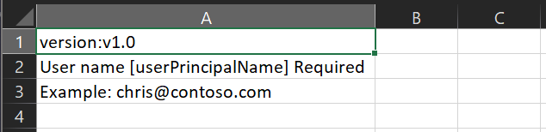
The rows in the downloaded CSV template to bulk deleted existing users are as follows:
- Version number. The upload CSV file must contain the version number in the first row.
- Column headings. User name [userPrincipalName] Required. Older versions of the template can vary.
- Examples row. The template includes an example of an acceptable value. Example: chris@contoso.com. You must remove the example row and replace it with your own entries.
Organizations should keep in mind the following issues related to the bulk delete CSV template:
- You can't modify or remove the first two rows of the template, or the delete process fails.
- The template lists the required columns first.
- Microsoft recommends that you don't add new columns to the template. The system ignores any other columns that you add.
- Microsoft recommends that you download the latest version of the CSV template as often as possible.
Organizations should complete the following steps to bulk delete users in Microsoft Entra ID:
- In the Microsoft 365 admin center, under Admin centers in the navigation pane, select Identity.
- In the Microsoft Entra admin center, select Users, and then select All users.
- On the Users page, select Bulk operations on the menu bar. In the drop-down menu that appears, select Bulk delete.
- On the Bulk delete users pane, select Download to receive a comma-separated values (CSV) file of user properties. Use this file as a template and add users you want to delete.
- Open the CSV file and add a line for each user you want to delete. The only required value is User principal name. Save the file.
- On the Bulk delete users pane, under Upload your csv file, browse to the file. When you select the file and select Submit, validation of the CSV file starts.
- After the system validates the file contents, a File uploaded successfully message appears. If there are errors, you must fix them before you can submit the job.
- When your file passes validation, select Submit to start the bulk operation that deletes the users.
- When the deletion operation completes, the system displays a notification indicating the bulk operation succeeded.
If there are errors, you can download and view the results file on the Bulk operation results page. The file contains the reason for each error.
You can see the status of all of your pending bulk requests in the Bulk operation results page.
Restore users in bulk
Just as you deleted users in bulk from Microsoft Entra ID, so too can you restore deleted users in bulk. Both processes use a CSV file to identify the users you want to delete and restore.
The template used for bulk restore is slightly different from the template used for bulk deletion. Rather than specifying each user's UPN, you instead specify the user's object ID.
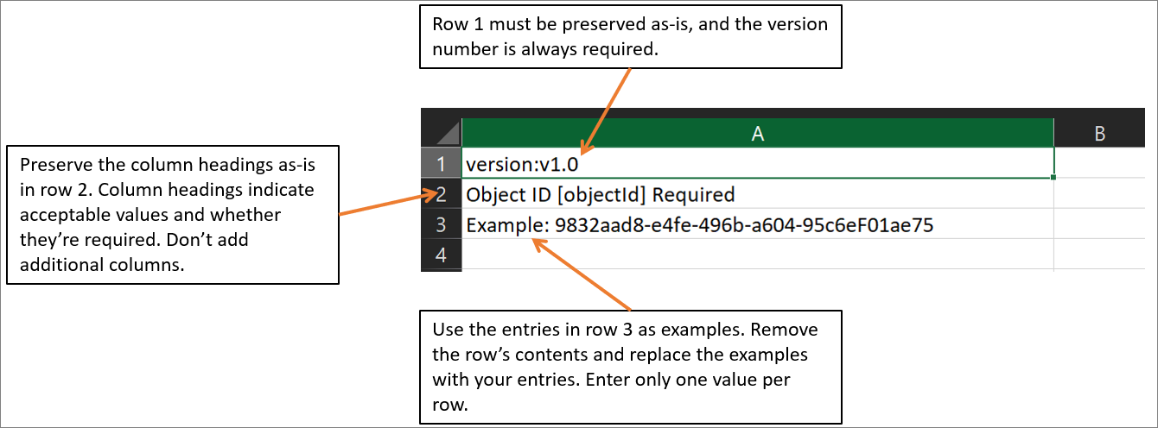
The rows in the downloaded CSV template to bulk restore deleted users are as follows:
- Version number. The upload CSV file must contain the version number in the first row.
- Column headings. The format of the column headings is <Item name> [PropertyName] <Required or blank>. For example, Object ID [objectId] Required. Some older versions of the template can have slight variations.
- Examples row. The template includes an example of an acceptable value. You must remove the example row and replace it with your own entries.
Organizations should keep in mind the following issues related to the bulk delete CSV template:
- You can't modify or remove the first two rows of the upload template, or the upload process fails.
- The template lists the required columns first.
- Microsoft doesn't recommend that you add new columns to the template. The system ignores any other columns that you add.
- Microsoft recommends that you download the latest version of the CSV template as often as possible.
Organizations should complete the following steps to bulk restore users in Microsoft Entra ID:
- In the Microsoft 365 admin center, under Admin centers in the navigation pane, select Identity.
- In the Microsoft Entra admin center, select Users, and then select Deleted users.
- On the Deleted user page, select the Bulk restore option on the menu bar to download the latest version of the CSV template.
- On the Bulk restore users pane, select Download to receive a comma-separated values (CSV) file of user properties. Use this file as a template and add the deleted users you want to restore.
- Open the CSV file and add a line for each user you want to restore. The only required value is ObjectID. Save the file.
- On the Bulk restore users pane, under Upload your csv file, browse to the file. When you select the file and select Submit, validation of the CSV file starts.
- After the system validates the file contents, a File uploaded successfully message appears. If there are errors, you must fix them before you can submit the job.
- When your file passes validation, select Submit to start the bulk operation that restores the deleted users.
- When the restore operation completes, the system displays a notification indicating the bulk operation succeeded.
If there are errors, you can download and view the results file on the Bulk operation results page. The file contains the reason for each error.
You can see the status of all of your pending bulk requests in the Bulk operation results page.
Create users in bulk using PowerShell
Some Microsoft 365 Administrators prefer to use Windows PowerShell rather than the Microsoft 365 admin center to complete user administrative functions. You must begin by installing Microsoft Graph PowerShell, importing the Microsoft.Graph.Identity.DirectoryManagement module, and connecting to MgGraph with the proper permissions. The following example provides the Read/Write permissions needed to add a new user.
PowerShell
Install-Module Microsoft.Graph -Scope CurrentUser
Import-Module Microsoft.Graph.Identity.DirectoryManagement
Connect-MgGraph -Scopes 'User.ReadWrite.All'
At this point, you're ready to use the New-MgUser cmdlet to create a user account in Microsoft 365. When creating a new user account with the Microsoft Graph PowerShell module, you must specify, at a minimum, the required properties for the user, which includes the user password. The password must satisfy minimum requirements as specified by the user’s PasswordPolicies property. By default, the system requires a strong password. You can optionally specify any other writable properties.
You must begin by creating a comma-separated value (CSV) file that contains the required user account information. For example:
PowerShell
UserPrincipalName,FirstName,LastName,DisplayName,UsageLocation,AccountSkuId,Password
ClaudeL@contoso.onmicrosoft.com,Claude,Loiselle,Claude Loiselle,US,contoso:ENTERPRISEPACK,User.pw1
LynneB@contoso.onmicrosoft.com,Lynne,Baxter,Lynne Baxter,US,contoso:ENTERPRISEPACK,User.pw2
ShawnM@contoso.onmicrosoft.com,Shawn,Melendez,Shawn Melendez,US,contoso:ENTERPRISEPACK,User.pw3
Note
The column names and their order in the first row of the CSV file are arbitrary. But make sure the order of the data in the rest of the file matches the order of the column names. The system uses the column names for the parameter values in the PowerShell command.
Run the Import-Csv command using the following syntax:
PowerShell
Import-Csv -Path <Input CSV File Path and Name> | foreach {New-MgUser -DisplayName $_.DisplayName -GivenName $_.FirstName -Surname $_.LastName -UserPrincipalName $_.UserPrincipalName -UsageLocation $_.UsageLocation -LicenseAssignmentStates $_.AccountSkuId -PasswordProfile $_.Password} | Export-Csv -Path <Output CSV File Path and Name>
The following example creates user accounts from the file C:\My Documents\NewAccounts.csv and logs the results in a file named C:\My Documents\NewAccountResults.csv.
PowerShell
Import-Csv -Path "C:\My Documents\NewAccounts.csv" | foreach {New-MgUser -DisplayName $_.DisplayName -GivenName $_.FirstName -Surname $_.LastName -UserPrincipalName $_.UserPrincipalName -UsageLocation $_.UsageLocation -LicenseAssignmentStates $_.AccountSkuId -PasswordProfile $_.Password} | Export-Csv -Path "C:\My Documents\NewAccountResults.csv"
Review the output file to see the results.
Create and manage guest users using B2B collaboration
Completed 100 XP
- 9 minutes
Microsoft 365 enables people from outside the Microsoft 365 organization to collaborate with users within the organization. It does so through B2B collaboration, which is a feature within Microsoft Entra External ID. With B2B collaboration, you can securely share your company's applications and services with external users, while maintaining control over your own corporate data. With B2B collaboration, you can work safely and securely with external partners, large or small, even if they don't have Microsoft Entra ID or an IT department.
With B2B collaboration, an external user is invited to sign in to your Microsoft Entra organization using their own credentials. This B2B collaboration user can then access the apps and resources you want to share with them. A user object is created for the B2B collaboration user in the same directory as your employees. B2B collaboration user objects have limited privileges in your directory by default, and they can be managed like employees, added to groups, and so on.
A simple invitation and redemption process lets partners use their own credentials to access your company's resources. You can also enable self-service sign-up user flows to let external users sign up for apps or resources themselves. Once the external user redeems their invitation or completes sign-up, they're represented in your directory as a user object. The user type for these B2B collaboration users is typically set to "guest" and their user principal name contains the #EXT# identifier.
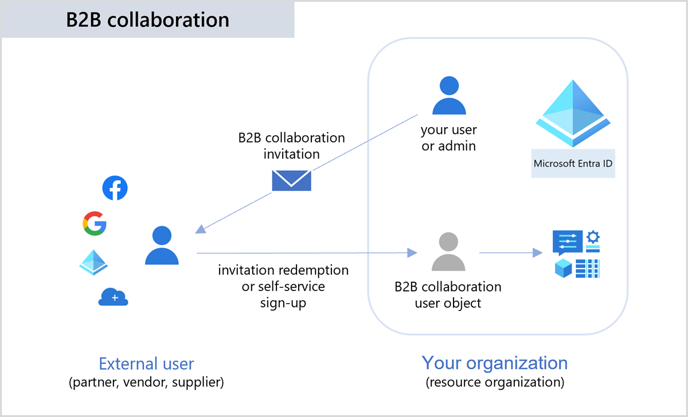
The following list describes B2B collaboration users based on how they authenticate (internally or externally) and their relationship to your organization (guest or member):
- External guest. Most users who are commonly considered external users or guests fall into this category. This B2B collaboration user has an account in an external Microsoft Entra organization or an external identity provider (such as a social identity), They also have guest-level permissions in the resource organization. The user object created in the resource Microsoft Entra directory has a UserType of Guest.
- External member. This B2B collaboration user has an account in an external Microsoft Entra organization or an external identity provider (such as a social identity) and member-level access to resources in your organization. This scenario is common in organizations consisting of multiple tenants, where users are considered part of the larger organization and need member-level access to resources in the organization's other tenants. The user object created in the resource Microsoft Entra directory has a UserType of Member.
- Internal guest. Before Microsoft Entra B2B collaboration was available, it was common to collaborate with distributors, suppliers, vendors, and others by setting up internal credentials for them and designating them as guests by setting the user object UserType to Guest. If you have internal guest users like these, you can invite them to use B2B collaboration instead so they can use their own credentials, allowing their external identity provider to manage authentication and their account lifecycle.
- Internal member. These users are generally considered employees of your organization. The user authenticates internally through Microsoft Entra ID, and the user object created in the resource Microsoft Entra directory has a UserType of Member.
Understanding guest accounts in Microsoft 365
Being able to easily share files and documents with the right people while preventing oversharing requires planning. The following resources provide more background to help you create a secure guest sharing environment in Microsoft 365.
- Plan external collaboration.
- Create a secure guest sharing environment.
- Set up secure file and document sharing and collaboration with Teams in Microsoft 365.
- Guest access in Microsoft Teams.
In addition to Microsoft Teams and SharePoint, Microsoft 365 also supports guest access in other applications. The following Microsoft 365 products support guest access.
- Power Apps. For more information, see Share a canvas app with guest users.
- Lists. For more information, see External or guest sharing in OneDrive, SharePoint, and Lists.
- OneDrive. For more information, see External or guest sharing in OneDrive, SharePoint, and Lists.
- Planner. Applies to Web and mobile platforms. For more information, see Guest access in Microsoft Planner.
- Microsoft 365 groups. For more information, see Manage guest access in Microsoft 365 groups.
- Yammer. For more information, see Work with external groups in Yammer networks not aligned to native mode.
Microsoft Office applications like Microsoft Word and Excel control guest access by the location of the output file, such as Microsoft SharePoint, Teams, or OneDrive.
External collaboration settings
As a Microsoft 365 administrator, you must ensure the configuration of your organization's external collaboration settings enable guest user access. If you want to add a guest user, an administrator must first assign you a role that allows you to create users in your tenant directory. Examples of such roles include a Global Administrator role or a limited administrator directory role, such as a Guest Inviter or User Administrator.
Note
Organizations can configure their external collaboration policies to prevent certain types of users or administrators from inviting guests. To find out how to view and set these policies, see Enable B2B external collaboration and manage who can invite guests.
Administrators can invite guest users to their organization's Microsoft Entra ID, to a group, or to an application. After they invite a person through any of these methods, the system adds the invited user's account to the organization's Microsoft Entra ID with a user type of Guest. The guest user must then redeem their invitation before they can begin collaborating with organizational users.
After an administrator adds a guest user to the organization's Microsoft Entra ID, the guest user can select either:
- A direct link to a shared application.
- The redemption URL in the invitation email they receive.
When an organization adds a guest user to its Microsoft Teams, SharePoint, or Microsoft Entra ID, the system automatically adds the user to the Guest users list in the Microsoft 365 admin center. Once a user shows up in the Guest users list, you can remove their access there as well. After you add a guest user in Microsoft Entra ID, you can assign them to a group, or give them access to an app in your organization.
By default, Microsoft 365 turns on guest access for an organization's Microsoft 365 groups. The Microsoft 365 Administrator controls whether to allow guest access to groups for the whole organization or for individual groups.
To view guest users in the Microsoft 365 admin center, expand Users in the left-hand navigation pane and then select Guest users.
The user profile for a Microsoft Entra B2B collaboration user includes the following key properties:
- User Principal Name (UPN). The UPN for a B2B collaboration user object contains a #EXT# identifier.
- User type. The UserType property indicates the relationship of the user to the host tenancy. This property can have two values:
  - Member. This value indicates an employee of the host organization and a user in the organization's payroll. For example, this user expects to have access to internal-only sites. This user isn't considered an external collaborator.
  - Guest. This value indicates a user who isn't considered internal to the company, such as an external collaborator, partner, or customer. Such a user isn't expected to receive a chief executive officer (CEO)'s internal memo or receive company benefits, for example.
Note
The UserType property has no relation to how the user signs in, the directory role of the user, and so on. This property simply indicates the user's relationship with the host organization and allows the organization to enforce policies that depend on this property.
- Identities. This property indicates the user's primary identity provider. A user can have several identity providers, which can be viewed by selecting the link next to Identities in the user's profile or by querying the Identities property through the Microsoft Graph API. Identities and UserType are independent properties.
Identities property value | Sign-in state
ExternalAzureAD | This user is homed in an external organization and authenticates by using a Microsoft Entra account that belongs to the other organization.
Microsoft account | This user is homed in a Microsoft account and authenticates by using a Microsoft account.
{host's domain} | This user authenticates by using a Microsoft Entra account that belongs to this organization.
google.com | This user has a Gmail account and signed up by using self-service to the other organization.
facebook.com | This user has a Facebook account and signed up by using self-service to the other organization.
mail | This user signed up by using Microsoft Entra External ID email one-time passcode (OTP).
{issuer URI} | This user is homed in an external organization that doesn't use Microsoft Entra ID as their identity provider, but instead uses a Security Assertion Markup Language (SAML)/WS-Fed-based identity provider. The issuer URI is shown when the Identities field is clicked.
- Note
- A value in Identities doesn't imply a particular value for UserType.
Restrict guest access permissions in Microsoft Entra ID
Microsoft Entra ID enables organizations to restrict what data guest users can see. Microsoft Entra ID sets guest users to a limited permission level by default, while the default for member users is the full set of user permissions. There's another guest user permission level in your organization's Microsoft Entra external collaboration settings for even more restricted access. The guest access levels include:
Permission level | Access level
Same as member users | Guests have the same access to Microsoft Entra resources as member users.
Limited access (default) | Guests can see membership of all nonhidden groups.
Restricted access | Guests can't see membership of any group.
When a guest user's permission level is set to Restricted access, they can view only their own user profile. They don't have permission to view other users, even if the guest searches by User Principal Name or objectId. Restricted access also restricts guest users from seeing the membership of groups they're in.
Note
There are no licensing requirements to restrict guest access.
External collaboration settings let an organization specify what roles it can invite guest users for B2B collaboration. These settings also include options for allowing or blocking specific domains, and options for restricting what guest users can see in your Microsoft Entra admin center. The following options are available:
- Determine guest user access. Microsoft Entra ID allows you to restrict what guest users can see in your Microsoft Entra directory. For example, you can limit guest users' view of group memberships, or allow guests to view only their own profile information.
- Specify who can invite guests. By default, all users in your organization, including B2B collaboration guest users, can invite guest users to B2B collaboration. If you want to limit the ability to send invitations, you can turn invitations on or off for everyone, or limit invitations to certain roles.
- Enable guest self-service sign-up via user flows. For applications you build, you can create user flows that allow a user to sign up for an app and create a new guest account. You can enable the feature in your external collaboration settings, and then add a self-service sign-up user flow to your app.
- Allow or block domains. You can use collaboration restrictions to allow or deny invitations to the domains you specify. For details, see Allow or block domains.
For B2B collaboration with other Microsoft Entra organizations, you should also review your cross-tenant access settings. Doing so ensures your inbound and outbound B2B collaboration. It also scopes access to specific users, groups, and applications.
To update guest access permissions in Microsoft Entra ID, perform the following steps:
- Sign into Microsoft 365 as a Global Administrator or a user with a limited administrator directory role or the Guest Inviter role.
- On the Microsoft 365 admin center, select Show All in the navigation pane.
- Under the Admin centers group in the navigation pane, select Identity.
- In the Microsoft Entra admin center, in the left-hand navigation pane, select Users, and then select User settings.
- On the User | User settings page, under the External users section towards the bottom of the page, select the Manage external collaboration settings link.
- On the External collaboration settings page, update each of the available settings to meet your organization's requirements.
- Select Save. The changes can take up to 15 minutes to take effect for guest users.
Invitation redemption
B2B collaboration user accounts are the result of inviting guest users to collaborate by using the guest users' own credentials. When the invitation is initially sent to the guest user, an account is created in your tenant. This account doesn't have any credentials associated with it because authentication is performed by the guest user's identity provider. The Identities property for the guest user account in your directory is set to the host's organization domain until the guest redeems their invitation. The user sending the invitation is added as a default value for the Sponsor (preview) attribute on the guest user account. In the admin center, the invited user's profile shows an External user state of PendingAcceptance.
Note
Guest user invitations don't expire. For more information about the redemption process, see B2B collaboration invitation redemption.
After the B2B collaboration user accepts the invitation, the Identities property in the user's profile is updated based on the user's identity provider.
- If the B2B collaboration user is using a Microsoft account or credentials from another external identity provider, the Identities field reflects the identity provider. For example, Microsoft Account, google.com, or facebook.com.
- If the B2B collaboration user is using credentials from another Microsoft Entra organization, the value of the Identities field is ExternalAzureAD.
- For external users who are using internal credentials, the Identities property is set to the host's organization domain. The Directory synced property is Yes if the account is homed in the organization's on-premises Active Directory and synced with Microsoft Entra ID. Or the property is set to No if the account is a cloud-only Microsoft Entra account.
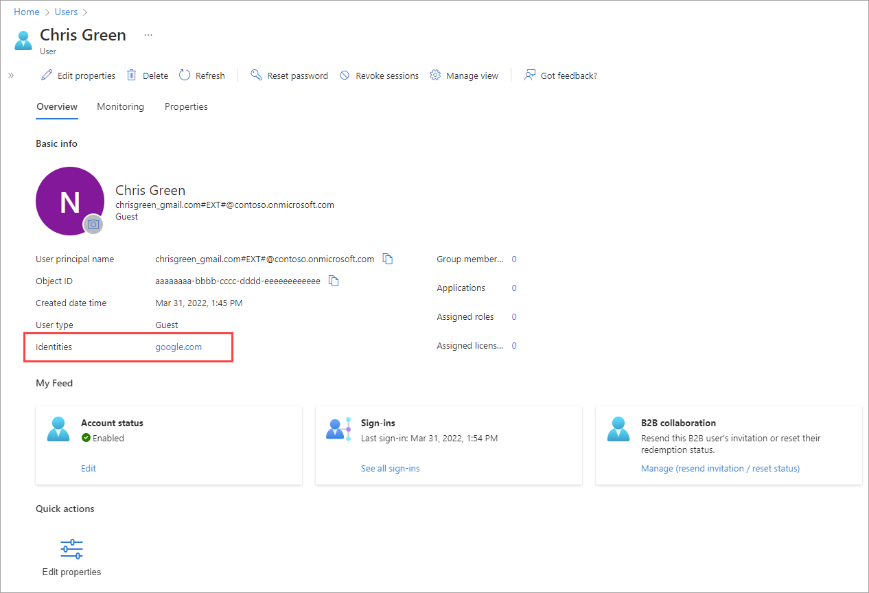
Note
The directory sync information is also available through the onPremisesSyncEnabled property in Microsoft Graph.
Add guests in Microsoft Entra ID
To add guest users to your organization's Microsoft Entra ID, perform the following steps:
- Sign into Microsoft 365 as a Global Administrator or a user with a limited administrator directory role or the Guest Inviter role.
- On the Microsoft 365 admin center, select Show All in the navigation pane.
- Under the Admin centers group in the navigation pane, select Identity.
- In the Microsoft Entra admin center, in the left-hand navigation pane, select Users, and then select All users.
- On the Users window, select +New user on the menu bar. In the drop-down menu that appears, select Invite external user.
- On the Invite external user page, under the Basics tab, enter the guest user's Email address and Display name. You can optionally send an invitation message, which you can also enter here, along with the email address of a recipient you wish to CC.
- You can optionally select the Properties tab to enter the external user's full name and job information.
- You can also select the Assignments tab to assign the external user to existing groups, or to add security roles to the user account.
Note
The system doesn't support Group email addresses. Instead, enter the email address for an individual. Also, some email providers allow users to add a plus symbol (+) and other text to their email addresses to help with things like inbox filtering. However, Microsoft Entra ID doesn’t currently support plus symbols in email addresses. To avoid delivery issues, omit the plus symbol and any characters following it up to the @ symbol.
- When you're ready to send the invitation, select the Review + Invite button. Doing so displays the Review + invite tab, which shows you whether any required information is missing. When everything looks OK, select Invite to automatically send the invitation to the guest user.
After you send the invitation, the system automatically adds the user account to the directory as a guest. It adds the guest user account with a user principal name (UPN) in the format emailaddress#EXT#@domain. For example, john_contoso.com#EXT#@fabrikam.onmicrosoft.com, where fabrikam.onmicrosoft.com is the organization from which you sent the invitation.
Add guest users to a group
To manually add a guest user to a group, perform the following steps:
- Sign into Microsoft 365 as a Global Administrator or a user with a limited administrator directory role or the Guest Inviter role.
- On the Microsoft 365 admin center, select Show All in the navigation pane.
- Under the Admin centers group in the navigation pane, select Identity.
- In the Microsoft Entra admin center, in the left-hand navigation pane, select Groups, and then select All groups.
- Select a group (or select New group in the menu bar to create a new one). It's a good idea to include in the group description that the group contains B2B guest users.
- In the group window that appears, under the Manage section in the middle pane, select Members.
- Select +Add members.
- Perform one of the following steps:
  - If the guest user is already in Microsoft Entra ID:
    - On the Add members page, start typing the name or email address of the guest user.
    - In the search results, choose the user, and then choose Select.
  - If the guest user isn't currently in Microsoft Entra ID:
    - On the Add members page, type the user's full email address in the search box, type a Personal message (optional), and then choose Invite to send an invitation.
    - Choose Select.
    - Now add the user to the group. On the Members page, choose Add members. Type the user's name or email address in the search box, choose the user in the results, and then choose Select.
You can also use dynamic groups with Microsoft Entra B2B collaboration. For more information, see Dynamic groups and Microsoft Entra B2B collaboration.
Add guest users to an application
To add guest users to an application, perform the following steps:
- Sign into Microsoft 365 as a Global Administrator or a user with a limited administrator directory role or the Guest Inviter role.
- On the Microsoft 365 admin center, select Show All in the navigation pane.
- Under the Admin centers group in the navigation pane, select Identity.
- In the Microsoft Entra admin center, in the left-hand navigation pane, select Applications, and then select Enterprise applications.
- On the Enterprise applications | All applications page, select the application to which you want to add guest users.
- On the {application} | Overview page, under the Manage section in the middle pane, select Users and groups.
- Select Add user/group.
- On the Add Assignment page, select the link under Users.
- Perform one of the following steps:
  - If the guest user is already in Microsoft Entra ID:
    - On the Users page, start typing the name or email address of the guest user.
    - In the search results, choose the user, and then choose Select.
    - On the Add Assignment page, choose Assign to add the user to the app.
  - If the guest user isn't currently in Microsoft Entra ID:
    - On the Users page, type the user's full email address in the search box, type a Personal message (optional), and then choose Invite.
    - Choose Select.
    - Now add the invited user to the application: On the Add Assignment page, choose the link under Users. Type the invited user's name or email address in the search box, choose the user in the results, and then choose Select.
    - On the Add Assignment page, choose Assign.
- The guest user appears in the application's Users and groups list with the assigned role of Default Access. If the application provides different roles and you want to change the user's role, perform the following steps:
  - Select the check box next to the guest user, and then select the Edit button.
  - On the Edit Assignment page, choose the link under Select a role, and select the role you want to assign to the user.
  - Choose Select.
  - Select Assign.
Collaborate with guests in a SharePoint site
Completed 100 XP
- 4 minutes
Organizations can use a SharePoint site if they need to collaborate with guests across documents, data, and lists. Modern SharePoint sites are connected to Microsoft 365 Groups and can manage the site membership and provide various collaboration tools such as a shared mailbox and a calendar.
The following sections describe the steps that must be completed to enable guest collaboration with SharePoint sites.
Step 1 - Configure the Microsoft Entra ID external collaboration settings
Sharing in Microsoft 365 is governed at its highest level by the B2B external collaboration settings in Microsoft Entra ID. If guest sharing is disabled or restricted in Microsoft Entra ID, this setting overrides any sharing settings that you configure in Microsoft 365.
To collaborate with guests using SharePoint sites, you must first verify the B2B external collaboration settings to ensure that sharing with guests isn't blocked. Perform the following steps to set external collaboration settings:
- Sign in to Microsoft Entra ID at https://entra.microsoft.com/.
- In the left navigation pane, expand External identities.
- Select External collaboration settings.
- Ensure that either of the following two settings is selected:
  - Member users and users assigned to specific admin roles can invite guest users including guests with member permissions
  - Anyone in the organization can invite guest users including guests and non-admins is selected
- If you made changes, select Save.
You should pay particular attention to the settings in the Collaboration restrictions section. Verify that the domains of the guests that you want to collaborate with aren't blocked.
If you work with guests from multiple organizations, you might want to restrict their ability to access directory data. Doing so prevents them from seeing who else is a guest in the directory. To restrict a guest's ability to access directory data, select either of the following settings under Guest user access restrictions:
- Guest users have limited access to properties and membership of directory objects settings
- Guest user access is restricted to properties and memberships of their own directory objects
Step 2 - Configure the Microsoft 365 Groups guest settings
Modern SharePoint sites use Microsoft 365 Groups to control site access. The Microsoft 365 Groups guest settings must be turned on in order for guest access in SharePoint sites to work.
Perform the following steps to set Microsoft 365 Groups guest settings:
- In the Microsoft 365 admin center, in the left navigation pane, expand Settings.
- Select Org settings.
- In the list of organizations settings, select Microsoft 365 Groups.
- Ensure that BOTH of the following check boxes are selected:
  - Let group owners add people outside your organization to Microsoft 365 Groups as guests
  - Let guest group members access group content
- If you made changes, select Save changes.
Step 3 - Configure the SharePoint organization-level sharing settings
In order for guests to have access to SharePoint sites, the SharePoint organization-level sharing settings must allow for sharing with guests. The organization-level settings determine the settings that are available for individual sites. Site settings can't be more permissive than the organization-level settings.
- If you want to allow unauthenticated file and folder sharing, select Anyone.
- If you want to ensure that all people outside your organization have to authenticate, select New and existing guests.
Choose the most permissive setting that's needed by any site in your organization.
Perform the following steps to set SharePoint organization-level sharing settings:
- In the SharePoint admin center, in the left navigation pane, under Policies, select Sharing.
- In the External sharing window, you can set the sharing settings for both SharePoint and OneDrive. Ensure that the external sharing option for SharePoint is set to Anyone or New and existing guests.
- If you made changes, select Save.
Step 4 - Create a site
The next step in the process is to create the site that you plan to use for collaborating with guests. Perform the following steps to create a site:
- In the SharePoint admin center, under Sites, select Active sites.
- Select Create.
- Select Team site.
- Type a site name and enter a name for the Group owner (site owner).
- Under Advanced settings, choose whether you want this site to be a public or private one.
- Select Next.
- Select Finish.
Users can be invited later. Next, it's important to check the site-level sharing settings for this site.
Step 5 - Configure the SharePoint site-level sharing settings
Check the site-level sharing settings to ensure they allow the type of access that you want for this site. For example, if you set the organization-level settings to Anyone, but you want all guests to authenticate for this site, then make sure the site-level sharing settings are set to New and existing guests.
Note
The site can't be shared with unauthenticated people (Anyone setting), but individual files and folders can. You can also use sensitivity labels to control external sharing settings for SharePoint sites.
Perform the following steps to set site-level sharing settings:
- In the SharePoint admin center, in the left navigation pane, expand Sites and then select Active sites.
- Select the site for the team that you created.
- On the Settings tab, select More sharing settings.
- Ensure that sharing is set to Anyone or New and existing guests.
- If you made changes, select Save.
Step 6 - Invite users
Guest sharing settings are now configured, so you can start adding internal users and guests to your site. Site access is controlled through the associated Microsoft 365 group, so you should add users there. Guests can't be added to the Microsoft 365 group from the site. Perform the following steps to invite internal users to a group:
- Navigate to the site where you want to add users.
- Select Members link in the upper-right portion of the window, which denotes the member count.
- Select Add members.
- Type the names or email addresses of the users that you want to invite to the site, and then select Save.
Important
When sharing files and folders with people outside your organization, there are various options to reduce the chances of accidentally sharing sensitive information. To determine which options best meet the needs of your organization, see Limit accidental exposure to files when sharing with people outside your organization.

Next unit: Create and manage contacts
Create and manage contacts
Completed 100 XP
- 4 minutes
Contacts are people outside of your organization that you would like everyone to be able to find. You can use these contacts for sending emails to these external parties. In Exchange Online organizations, mail contacts are mail-enabled objects that contain information about people who exist outside your organization. Each mail contact has an external email address, but the mail contact is visible in your organization's shared address book (also known as the global address list or GAL) and other address lists.
Mail contacts are different from mail users:
- Mail users have an email address in the organization's domain.
- Mail contacts have an email address outside of the organization's domain.
Organizations can use mail contacts in various scenarios. For example, when you need to send email to someone outside of your organization, but you don't want to create a user account for them in your organization's directory. You can also create a mail contact for a vendor, a customer, or a partner, and then use that contact to send them email.
Organizations can manage mail contacts in the Microsoft 365 admin center, in both the new and classic Exchange admin center (EAC), and in Exchange Online PowerShell. This training examines contact management using the Microsoft 365 admin center and PowerShell. For instruction on using the EAC, see Manage mail contacts in Exchange Online.
Permissions needed to create mail contacts
You must have the necessary permissions to create mail contacts in the Microsoft 365 admin center The required permissions can come from the Global Administrator, or one of the following roles:
- Exchange Administrator. Members of this role can create Contacts using the EAC and the Microsoft 365 admin center.
- Directory Writers. These individuals can create Contacts using the Microsoft 365 admin center.
If you don't have the necessary permissions, you can't create mail contacts in the Microsoft 365 admin center. You can either request the required permissions from an administrator in your organization, or ask them to create the mail contacts on your behalf. If you need to manage who can create Contacts, consider configuring a group for users with the necessary permissions.
Create a contact using the Microsoft 365 admin center
Perform the following steps to create mail contacts in the Microsoft 365 admin center:
- In the Microsoft 365 admin center, select Users in the navigation pane, and then select Contacts.
- In the Contacts window, select Add a contact on the menu bar.
- In the Add a contact pane that appears, update the following fields. The system requires settings marked with an *.
  - First name
  - Last name
  - *Display name. By default, this box shows the values from the First name and Last name boxes. You can accept this value or change it.
  - *Email: Enter the user's email address. The domain should be external to your cloud-based organization.
  - Hide from my organization's global address list. This option isn't selected by default. If you leave this check box blank, everyone in your organization can see this contact in the GAL.
  - Profile information. Optionally enter the contact's company information, including Company name, Office and Mobile phone numbers, Title, Web site, address, and so on.
  - Mail tip
- Select Add and then select Close.
Note
After adding a contact, you should allow 30 minutes for the changes to take effect.
Remove a contact using the Microsoft 365 admin center
Perform the following steps to remove a mail contact in the Microsoft 365 admin center:
- In the Microsoft 365 admin center, select Users in the navigation pane, and then select Contacts.
- Select the check box next to the contact that you want to delete.
- Select the Delete contact option in the menu bar.
- In the Delete [display name] pane that appears, select Delete to confirm the deletion.
- Select Close once the contact is deleted.
Note
The Microsoft 365 admin center doesn't allow bulk edit or removal of mail contacts yet. You must complete bulk editing of mail contacts using either the classic EAC or Exchange Online PowerShell. For instruction on how to bulk edit using the classic EAC, see Manage mail contacts in Exchange Online.
Use Exchange Online PowerShell to create mail contacts
This example creates a mail contact for Debra Garcia using the Exchange Online PowerShell module.
- The name and display name is Debra Garcia (if you don't use the DisplayName parameter, the system uses the value of the Name parameter for the display name).
- The alias is dgarcia.
PowerShell
New-MailContact -Name "Debra Garcia" -ExternalEmailAddress dgarcia@tailspintoys.com -Alias dgarcia
For detailed syntax and parameter information, see New-MailContact.
Use Exchange Online PowerShell to modify mail contacts
In general, use the Get-Contact and Set-Contact cmdlets to view and change organization and contact information properties. Use the Get-MailContact and Set-MailContact cmdlets to view or change mail-related properties. For example, email addresses, the MailTip, custom attributes, and whether the system hides the contact from address lists.
For more information, see the following articles:
- Get-Contact
- Set-Contact
- Get-MailContact
- Set-MailContact
The following examples show how you can change mail contact properties using Exchange Online PowerShell:
This example configures the Title, Department, Company, and Manager properties for the mail contact Allan Deyoung.
PowerShell
Set-Contact "Allan Deyoung" -Title Consultant -Department "Public Relations" -Company Fabrikam -Manager "Alex Wilber"
This example sets the CustomAttribute1 property to a value of PartTime for all mail contacts and hides them from the organization's address book.
PowerShell
$Contacts = Get-MailContact -Resultsize unlimited
$Contacts | foreach {Set-MailContact -Identity $_ -CustomAttribute1 PartTime -HiddenFromAddressListsEnabled $true}
This example sets the CustomAttribute15 property to a value of TemporaryEmployee for all mail contacts in the Public Relations department.
PowerShell
$PR = Get-Contact -ResultSize unlimited -Filter "Department -eq 'Public Relations'"
$PR | foreach {Set-MailContact -Identity $_ -CustomAttribute15 TemporaryEmployee}
Use Exchange Online PowerShell to remove mail contacts
To remove a mail contact, run the following command:
PowerShell
Remove-MailContact -Identity <MailUserIdentity>
This example removes the mail contact for Nestor Wilke:
PowerShell
Remove-MailContact -Identity "Nestor Wilke"
Check your knowledge

1.
You're the Microsoft 365 Administrator for Tailspin Toys, which has a Microsoft 365 Enterprise E3 subscription. When a member of the Accounting department recently left the company, you deleted the user's account. What happens to the user's Microsoft 365 license?

The license for that user becomes available and an administrator can assign it to another user.
2.
As the Microsoft 365 Administrator for Fabrikam, you're planning its migration to Microsoft 365. You plan to authenticate all of Fabrikam's users in Microsoft Entra ID. In doing so, you want the hashes of your users' passwords replicated between Fabrikam's on-premises environment and Microsoft 365. Which type of identity should you use?
Synchronized identity
Correct
Summary
An organization’s Microsoft 365 Administrator is responsible for creating and managing user accounts for all the company's users. User management is one of the most basic tasks for a Microsoft 365 Enterprise Administrator. This process must begin by first planning which user identity model best fits your organization.
In this module, you examined the different user identities supported by Microsoft 365, namely: Cloud identities, Synchronized identities, and Federated identities. You learned that you can either maintain identities in Microsoft 365, or you can integrate identities with your on-premises Active Directory. Determining the identity model that best meets your company's business requirements is essential to successfully deploying Microsoft 365.
This module then provided instruction on how to manage user accounts and licenses in Microsoft 365. You learned how to create and manage user accounts, assign Microsoft 365 licenses to users, and recover deleted user accounts. Assigning appropriate licenses to your organization’s users enables them to use Microsoft 365 services such as Microsoft Outlook and Microsoft SharePoint Online.

Manage groups in Microsoft 365
ntroduction
Completed 100 XP
- 1 minute
After an organization creates the user accounts for its Microsoft 365 tenant, it can then create groups for collaboration between users, both inside and outside the company.
- In Exchange Online, groups enable organizations to distribute email to multiple users.
- In SharePoint Online, groups support cross-team collaboration.
An organization can add people from outside the company to a group. It can do so as long as the Microsoft 365 administrator enables this permission.
In this module, you first learn about the various group types that are available in Microsoft 365. Based on that information, you learn how to create groups for distributing email to multiple users within Exchange Online. You also learn how to create groups to support collaboration in SharePoint Online. Finally, you learn how to create and manage groups using the Microsoft 365 admin center and Windows PowerShell.
Examine groups in Microsoft 365
200 XP
- 9 minutes
Organizations commonly utilize groups to manage and organize sets of users collectively. For instance, when assigning a team to a group, the group can facilitate permissions management on a SharePoint team site. Additionally, the group enables the distribution of messages to all its members. Group membership is based on Microsoft Entra ID accounts. As an admin, your team creates some groups to manage conditional access, devices, and other resources.
Many groups are created by members of your organization for collaboration using Teams, SharePoint, and other collaboration tools. While membership in these groups can be highly dynamic, you still manage the underlying Microsoft Entra ID accounts, including enforcing conditional access, using ID Protection, and other controls to protect your organization.
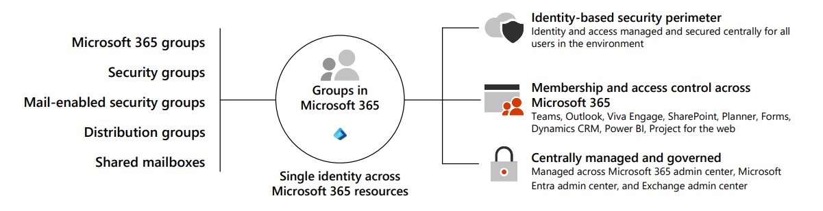
The following table offers an overview of different group types and their creation locations within Microsoft 365.
Group Type | Description | When to use? | Where to create it?
Microsoft 365 group | A Microsoft 365 group is the recommended group type. It includes a group email and shared workspaces, making it ideal for collaboration. It's similar to distribution groups because it has its own mailbox, and its members receive email messages sent to the group. However, it differs from distribution groups in that it allows teams to collaborate by providing them with a shared workspace for email, conversations, files, and calendar events. | When you want to provide distribution list capabilities and other collaboration features. The best option for team work. | - Microsoft 365 admin center  - Microsoft 365 admin app  - Microsoft Entra admin center  - Exchange admin center  - Outlook (also known as the Groups app in Outlook)
Distribution group | In Microsoft 365, a distribution group is also known as a distribution list. Organizations primarily use it for sending notifications to a group of people. You do so by associating a single email address with the distribution group. An organization's email system or mail server distributes messages sent to the group's email address to all members of the group. | When you want to distribute messages using the group only. | - Microsoft 365 admin center  - Microsoft 365 admin app  - Exchange admin center
Mail-enabled security group | When you mail-enable a security group, it means the group has an associated email address, and members of the group can send and receive emails using that address. This design enables the group to function as a mailing list or distribution group. Message delivery works the same as with a distribution group. In other words, an organization's email system or mail server distributes messages sent to the security group's email address to all members of the group.  You can also use a mail-enabled security group to assign group permissions to various resources, such as SharePoint. For example, by adding a mail-enabled security group to SharePoint, you can grant the group's members access permissions to SharePoint sites, libraries, lists, or individual items within SharePoint. Mail-enabled security groups can't be dynamically managed, nor can they contain devices. | When you want to use the group for both permissions and mail distribution. | - Microsoft 365 admin center  - Microsoft 365 admin app  - Exchange admin center
Security group | A security group provides a convenient way to manage and assign permissions to multiple users simultaneously. A security group can grant access permissions to resources such as OneDrive and SharePoint. | When you only require a group to grant permissions. | - Microsoft 365 admin center  - Microsoft 365 admin app  - Microsoft Entra admin center
Dynamic distribution group | A dynamic distribution group automatically manages its membership based on predefined criteria or filters. In a traditional distribution group, users manually manage membership. In a dynamic distribution group, Microsoft 365 dynamically updates its member list based on specific attributes or conditions.  You create and manage dynamic distribution groups in Exchange Online. With Exchange Online, administrators can define the criteria or rules for dynamic distribution groups using PowerShell or the Exchange admin center. They can base these rules on user attributes such as department, location, job title, or custom attributes. Microsoft 365 automatically calculates and updates the membership of the dynamic distribution group based on these rules. | When you want to have a flexible distribution list that changes membership automatically. | - Exchange admin center
Shared mailbox | Shared mailboxes are used when multiple people need access to the same mailbox, such as a company information or support email address, reception desk, or other function that might be shared by multiple people. Users with permissions to the group mailbox can send as or send on behalf of the mailbox email address if the administrator has given that user permissions to do that. This feature is useful for help and support mailboxes because users can send emails from "Contoso Support" or "Building A Reception Desk." | When multiple people need to access the same mailbox, such as a support email address. | - Microsoft 365 admin center  - Microsoft 365 admin app  - Microsoft Entra admin center
Collaboration spaces for Microsoft 365 groups
A Microsoft 365 group consists of the following objects:
- a shared Outlook Inbox
- a shared calendar
- a SharePoint Teams Site
- a SharePoint document library
- Planner
- Power BI
- Yammer (if you created the group from Yammer)
- a Team (if you created the group from Teams)
- a roadmap (if you have Project for the web
Collaboration spaces for Microsoft 365 groups differ based on where the Microsoft 365 group is created. While users can create Microsoft 365 groups in Outlook, other apps create them behind the scenes when users create Teams, SharePoint team sites, Planner plans, and Viva Engage groups.
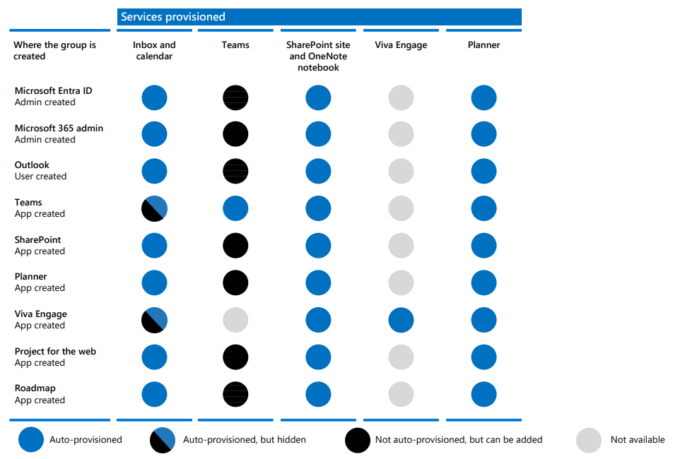
Note
Teams and Viva Engage can't be connected to the same group.
How Microsoft 365 Groups work with Teams
Microsoft 365 Groups is the cross-application membership service in Microsoft 365. At a basic level, a Microsoft 365 group is an object in Microsoft Entra ID with a list of members and a coupling to related workloads including a SharePoint team site, shared Exchange mailbox, Planner, and OneNote notebook. You can add or remove people to the group just as you would any other group-based security object in Active Directory. By default, users in Microsoft 365 can create and manage groups. For more information about Microsoft 365 Groups, see Learn about Microsoft 365 Groups.
When you create a team, a Microsoft 365 group is created to manage team membership. The group's related services, such as a SharePoint site, mailbox, and so on, are created at the same time. People who create teams can choose to use an existing Microsoft 365 group if they're an owner of that group. Each channel in the team has a separate folder in the document library. Creating folders directly in the document library doesn't create channels in the team.
When you create a Microsoft 365 group in the Teams admin center, Outlook, or SharePoint, the group mailbox is visible in Outlook. When you create a team in Teams, the group mailbox is hidden by default. You can use the Set-UnifiedGroup cmdlet with the HiddenFromExchangeClientsEnabled parameter to make a mailbox visible.
Group membership
If you remove a member of a team, they're removed from the Microsoft 365 group as well. Removal from the group immediately removes the team and channels from the Teams client. If you remove a person from a group using the Microsoft 365 admin center, they can no longer access the other collaborative aspects such as SharePoint Online document library, Viva Engage group, or shared OneNote. However, they can still access the team's chat functionality for approximately two hours.
As a best practice for managing team members, add and remove them from Teams to ensure that permissions updates for other group-connected workloads occur quickly. If you add or remove team members outside of Teams (by using the Microsoft 365 admin center, Microsoft Entra ID, or Exchange Online PowerShell), it can take up to 24 hours for changes to be reflected in Teams.
Deleting groups and teams
When you delete a Microsoft 365 group, the system removes the mailbox alias for persistent Outlook/OWA conversations and Teams meeting invites. It also marks the SharePoint site for deletion. It takes approximately 20 minutes between the removal of a team and its effect on Outlook. Deleting a team from Teams removes it immediately from view to all users who are members of the team. If you remove members of a Microsoft 365 group that's connected to Teams, there could be a delay of approximately two hours before the team is removed from view in Teams for the affected people who were removed.
For details about groups and teams end of lifecycle options, see End of lifecycle options for groups, teams, and Viva Engage and Archive or delete a team in Microsoft Teams.
Knowledge check
Choose the best response for each of the questions below.
Check your knowledge

1.
As Contoso's Microsoft 365 Administrator, you're planning to set up some groups in your Microsoft 365 tenant. You want to create a group that enables your Manufacturing team members to collaborate with one another. The purpose of this group is to provide its members with a shared workspace for email, conversations, files, and calendar events. What type of group should you create?

Check your knowledge

1.
As Contoso's Microsoft 365 Administrator, you're planning to set up some groups in your Microsoft 365 tenant. You want to create a group that enables your Manufacturing team members to collaborate with one another. The purpose of this group is to provide its members with a shared workspace for email, conversations, files, and calendar events. What type of group should you create?

Microsoft 365 group
Correct. A Microsoft 365 group is similar to a distribution group. It has its own mailbox and its members receive email messages that are sent to the group. However, it differs from distribution groups in that it allows teams to collaborate by providing them with a shared workspace for email, conversations, files, and calendar events.
Create and manage groups in Microsoft 365
200 XP
- 6 minutes
As the previous unit indicated, organizations can use several different portals in Microsoft 365 to organize users into groups. These groups can be used for various purposes, including assigning permissions and managing access to resources. For example, Contoso establishes a security group in the Microsoft 365 admin center that includes all users from the Marketing department. This security group is then granted Full Control access to a dedicated marketing SharePoint site collection.
Organizations should consider the following best practices to ensure they create and manage their groups correctly:
- Keep group naming conventions simple but clear.
- Create policies and procedures for ongoing group maintenance.
- Add users to security groups and then add those security groups to SharePoint default groups or roles rather than adding individual users to the groups or roles.
- Maintain a consistent and well-defined account provisioning process.
- Assign at least two owners to a group so that one can help out in the other's absence.
To create a group in the Microsoft 365 admin center:
- In the Microsoft 365 admin center, in the left-hand navigation pane, select Groups and then select Active groups.
- On the Active groups page, select Add a group on the menu bar. Similar to adding a user, this option starts a wizard that walks you through the process of adding a group.
- On the Group type page, select the appropriate group type.
- On the Set up the basics page, provide a group name and description for the group.
Tip
You must select the Description field to enable the Next button, even if you don't add a description for the group.
- On the Assign owners page, select an owner for the group. Select in the Owners field to display the list of all active users, or to speed up the search for a given user, enter the first name of the user to display all users with that first name.
- On the Edit settings page, assign a group email address (for mail-enabled groups), identify whether the group is Public or Private, and select whether to create a Microsoft Team for the group.
Tip
The Public group option is selected by default. Even if you want the group to be public, you must still select this option to enable the Next button.
- On the Review and finish adding group page, review the information you entered, and if necessary, correct any information that you incorrectly entered. When all information is correct, select the Create group button to add the group.
Important
An organization can't use the Microsoft 365 admin center to edit security groups if it synchronized the groups with its on-premises Active Directory. The organization must use the local Active Directory management tools for this purpose.
You can also use Windows PowerShell to create security groups for Microsoft 365. Within Microsoft Graph PowerShell, you must use the New-MgGroup cmdlet. For example, you would run the following command to create a new security group titled Test Group:
PowerShell
New-MgGroup -DisplayName 'Test Group' -MailEnabled:$False -MailNickName 'testgroup' -SecurityEnabled

Determining group types
You must use the Microsoft 365 admin center to determine the different types of groups used by an organization. When you view groups in the Microsoft 365 admin center, the Type column displays the group type for your reference. You can retrieve the same information using Microsoft Graph PowerShell. You can use the Get-MgGroup cmdlet to display group type information.
Nesting groups
Microsoft 365 enables group nesting, where you can add one group as a member of another group. To nest groups, select the appropriate group instead of a user when adding group members in the Microsoft 365 admin center. You can also use Windows PowerShell to nest security groups.
Warning
Microsoft 365 limits group nesting. You can't add groups of every type as members of all group types.
The following table identifies which group types Microsoft 365 allows as members of other group types.
Group type | Can be a member of Microsoft 365 groups? | Can be a member of Distribution groups? | Can be a member of Security groups? | Can be a member of Mail-enabled Security groups?
Microsoft 365 groups | No | No | No | No
Distribution groups | No | Yes | Yes | Yes
Security groups | No | No | Yes | No
Mail-enabled Security groups | No | Yes | Yes | Yes
Caution
Nested groups can sometimes cause permission issues. As such, it's important to carefully plan your group hierarchy to ensure that you correctly grant permissions.
Deleting and restoring groups
You must perform the following steps to delete a group in the Microsoft 365 admin center:
- In the Microsoft 365 admin center, in the left-hand navigation pane, select Groups and then select Active groups.
- On the Active groups page, select the group that you want to delete.
- On the menu bar, select the ellipsis (More actions) icon and in the drop-down menu that appears, select Delete group.
- In the details pane that appears, select Delete group.
- Confirm that you want to delete the group.
You can also use Microsoft Graph PowerShell to delete groups by using the Remove-MgGroup cmdlet.
If you delete a Microsoft 365 group, the system retains it for 30 days by default. It treats this 30-day period as a "soft-delete" because you can still restore the group during that time. After 30 days, the system permanently deletes the Microsoft 365 group and its associated contents.
Caution
You can only restore Microsoft 365 groups once you delete them. You can't restore any other group types once you delete them.
When you restore a Microsoft 365 group, the system automatically restores the following content associated with that group:
- Microsoft 365 Groups' object, properties, and members in Microsoft Entra ID
- Group's e-mail addresses
- Exchange Online shared Inbox and calendar
- SharePoint Online team site and files
- OneNote notebook
- Planner
- Teams
- Yammer group and group content (If you created the Microsoft 365 group from Yammer)
- Power BI Classic workspace
Important
Azure Active Directory (Azure AD) is now Microsoft Entra ID. Learn more.
Manage group-based licensing in Microsoft Entra ID
Microsoft paid cloud services, such as Microsoft 365, Enterprise Mobility + Security, Dynamics 365, and other similar products, require licenses. Organizations assign these licenses to each user who needs access to these services. To manage licenses, administrators can use one of the management portals (Microsoft 365 or Microsoft Entra ID) or PowerShell cmdlets. However, you can only manage group-based licensing through the Microsoft Entra admin center.
Microsoft Entra ID includes group-based licensing, which allows you to assign one or more product licenses to a group. Microsoft Entra ID automatically assigns those licenses to all members added to the group. If any members leave the group, the system automatically removes their licenses. This licensing management eliminates the need for automating license management through PowerShell to reflect changes in the organization and departmental structure on a per-user basis.
Group-based licensing requirements
You must have one of the following licenses for every user who benefits from group-based licensing:
- Paid or trial subscription for Microsoft Entra Premium P1 and above.
- Paid or trial edition of Microsoft 365 Business Premium or Microsoft 365 Enterprise E3 or Microsoft 365 A3 or Microsoft 365 GCC G3 or Microsoft 365 E3 for GCCH or Microsoft 365 E3 for DOD and above.
For any groups assigned a license, the system requires a license for each unique member. While you don't have to assign each member of the group a license, you must have enough licenses to include all the group members. For example, if you have 1,000 unique members who are part of licensed groups in your tenant, you must have at least 1,000 licenses to meet the licensing agreement.
Group-based licensing features
The following list identifies the main features of group-based licensing:
- You can assign licenses to any security group in Microsoft Entra ID. Organizations can sync their on-premises security groups through Microsoft Entra Connect Sync. They can also create security groups directly in Microsoft Entra ID (also called cloud-only groups), or automatically through the Microsoft Entra ID dynamic group feature.
- When you assign a product license to a group, the administrator can disable one or more service plans in the product. Administrators typically disable a product service plan when the organization isn't ready to start using a service included in the product. For example, an administrator assigns Microsoft 365 to a department, but temporarily disables the Yammer service.
- The system supports all Microsoft cloud services that require user-level licensing. This support includes all Microsoft 365 products, Enterprise Mobility + Security, and Dynamics 365.
- Group-based licensing is currently available only through the Microsoft Entra admin center. If you primarily use other management portals for user and group management, such as the Microsoft 365 admin center, you can continue to do so. But you must use the Microsoft Entra admin center to manage licenses at the group level.
- Microsoft Entra ID automatically manages license modifications that result from group membership changes. Typically, the system makes license modifications effective within minutes of a membership change.
- A user can be a member of multiple groups with license policies specified. A user can also have licenses directly assigned outside of any groups. The resulting user state is a combination of all assigned product and service licenses. When you assign a user account the same license from multiple sources, the system consumes the license only once.
- In some cases, you can't assign licenses to a user. For example, an organization doesn't have enough available licenses in the tenant, or it assigned conflicting services at the same time. Administrators can access information about users for whom Microsoft Entra ID couldn't fully process group licenses. They can then take corrective action based on that information.
Knowledge check
Choose the best response for each of the questions below.
Check your knowledge

1.
You're the Microsoft 365 Administrator for Contoso. You created a security group in Microsoft 365 that synchronized with your on-premises Active Directory. You now want to edit the group. Which of the following tools should you use to edit the group?

ocal Active Directory management tools
Correct. You can only use local Active Directory management tools to modify security groups that are synchronized with your on-premises Active Directory.
Create dynamic groups using Microsoft Entra rule builder
Completed 100 XP
- 10 minutes
Organizations can use rules to determine group membership. You can base these rules on user or device properties in Microsoft Entra ID. Microsoft 365 supports dynamic membership for Security groups and Microsoft 365 Groups.
When you create a group with dynamic membership, the system evaluates user and device attributes for matches with the membership rule. When an attribute changes for a user or device, the system examines all dynamic group rules in the organization for membership changes. It then adds or removes users and devices if they meet the conditions for a group.
Important
Organizations that implement dynamic groups must either have a Microsoft Entra Premium P1 license or a Microsoft Intune for Education license for each unique user that's a member of a dynamic group. You don't have to assign licenses to users for them to be members of dynamic groups, but you must have the minimum number of licenses in the Microsoft Entra organization to cover all such users. For example, if you had a total of 1,000 unique users in all dynamic groups in your organization, you would need at least 1,000 licenses for Microsoft Entra Premium P1 to meet the license requirement. Organizations don't need a license for devices that are members of a dynamic device group.
Rule builder in the Microsoft Entra admin center
Microsoft Entra ID provides a rule builder tool to create and update your important rules more quickly. The rule builder supports the construction of up to five expressions. The rule builder makes it easier to form a rule with a few simple expressions. However, you can't use it to reproduce every rule. If the rule builder expressions don't support the rule you want to create, you can use the rule syntax text box.
The following list provides some examples of advanced rules or syntax that you should construct using the rule syntax text box:
- Rule with more than five expressions
- The Direct reports rule
- Setting operator precedence
- Rules with complex expressions, such as: (user.proxyAddresses -any (_ -contains “contoso“))
Note
The rule builder may not be able to display some rules constructed in the text box. You may receive a message when the rule builder can't display the rule. The rule builder doesn't change the supported syntax, validation, or processing of dynamic group rules in any way.
Additional reading. For examples of syntax, supported properties, operators, and values for a membership rule, see Dynamic membership rules for groups in Microsoft Entra ID.
Perform the following steps to create a group membership rule:
- Navigate to the Microsoft Entra admin center (enter https://entra.microsoft.com, or from the Microsoft 365 admin center, select Show all, and then under Admin centers section select Identity). Sign in with an account that's either a Global administrator, Intune administrator, or User administrator in the Microsoft Entra organization.
- In the left-hand navigation pane, select Groups and then select All groups.
- On the Groups | All Groups window, select New group on the menu bar.
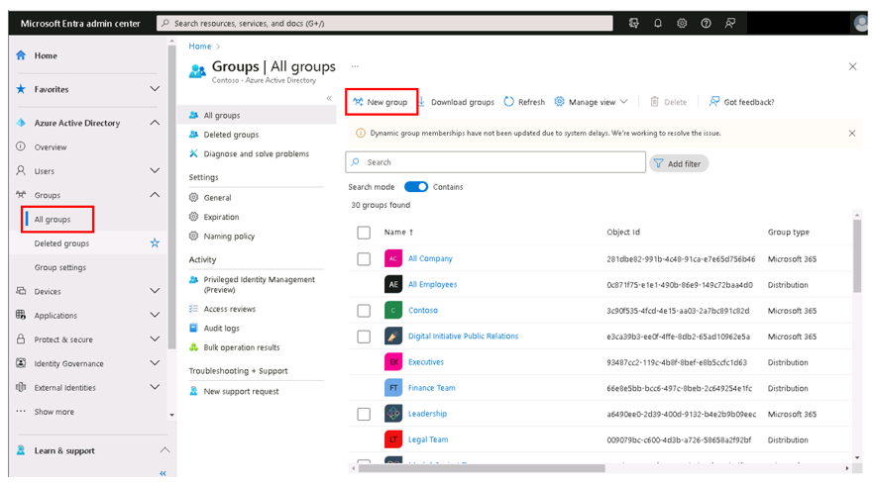
- On the New Group page, enter the following information:
  - Group name
  - Group description
  - Microsoft Entra roles can be assigned to the group. Set the toggle switch to Yes or No.
  - Membership type. Select either Dynamic user or Dynamic device.
- Under the Owners section, select No owners selected. On the Add owners pane that appears, select the owners of the group.
- Under Dynamic user members, select Add dynamic query.
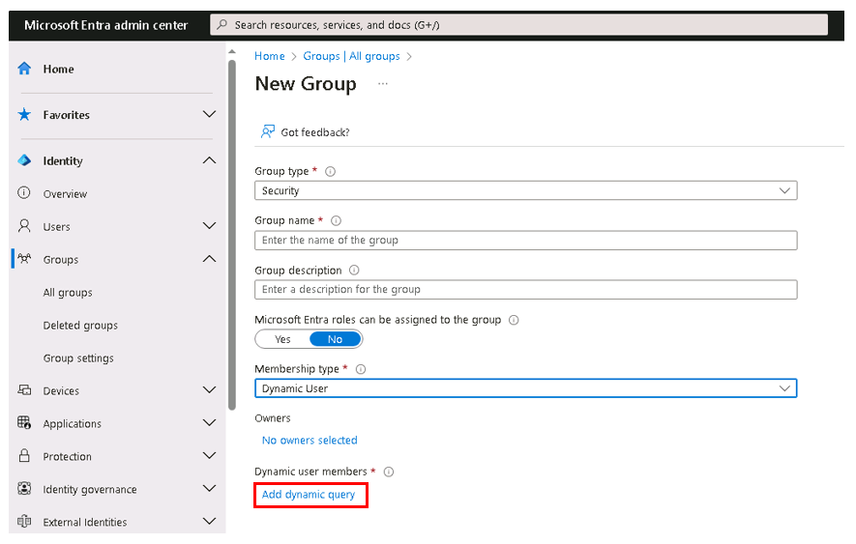
- On the Dynamic membership rules window that appears, the Configure Rules tab displays by default. You can use the rule builder or the rule syntax text box to create or edit a dynamic membership rule. The rule builder supports up to five expressions. To add more than five expressions, you must use the rule syntax text box.
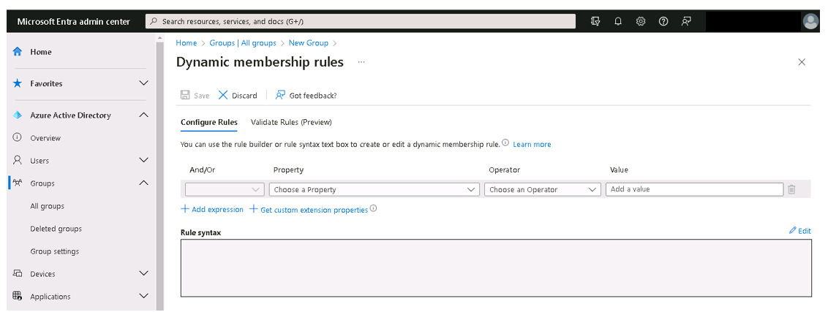
- To see the custom extension properties available for your membership query:
  - Select +Get custom extension properties.
  - In the Get custom extension properties pane that appears, enter the application ID and then select Refresh properties. Doing so displays the full list of custom extension properties to use when creating a dynamic membership rule. For more information on this feature, see the section at the end of this unit titled Extension properties and custom extension properties.
- After creating the rule, select Save.
- Select Create on the New group page to create the group.
If the rule you entered isn't valid, the system displays an explanation as to why it couldn't process the rule. This notification typically provides instruction on how to fix the rule.
Create a dynamic membership rule
Tip
This training introduces you to the basics of creating dynamic membership rules. It outlines the basic syntax used in a single expression, the supported values for expressions, rules for multiple and complex expressions, and extension properties. It also provides some basic examples of commonly used rules. If you're interested in more advanced guidance on rule syntax and various supported properties, see Dynamic membership rules for groups in Microsoft Entra ID.
Attribute-based rules enable dynamic membership for a group in Microsoft Entra ID. You can set up a rule for dynamic membership on security groups or Microsoft 365 groups. When a user or device's attributes change, the system evaluates all dynamic group rules in a directory to see if the change would trigger any group adds or removes. If a user or device satisfies the rule for a group, the system automatically adds them as a member of that group. The system automatically removes them from group membership if they no longer satisfy the rule.
The following rules govern dynamic membership:
- You can't manually add or remove a member of a dynamic group.
- You can create a dynamic group for devices or users, but you can't create a rule that contains both users and devices.
- You can't create a device group based on the user attributes of the device owner. Device membership rules can reference only device attributes.
Rule syntax for a single expression
A single expression is the simplest form of a membership rule. A rule with a single expression looks similar to this example: Property Operator Value, where the syntax for the property is the name of object.property.
The following example illustrates a properly constructed membership rule with a single expression:
user.department -eq “Sales“
Parentheses are optional for a single expression. The total length of the body of your membership rule can't exceed 3072 characters.
Supported expression operators
The following table lists all the supported operators and their syntax for a single expression. You can use operators with or without the hyphen (-) prefix. The Contains operator does partial string matches but not item matches in a collection.
Operator | Syntax
Not Equals | -ne
Equals | -eq
Not Starts With | -notStartsWith
Starts With | -startsWith
Not Contains | -notContains
Contains | -contains
Not Match | -notMatch
Match | -match
In | -in
Not In | -notIn
If you want to compare the value of a user attribute against multiple values, you can use the -in or -notIn operators. Use the bracket symbols "[" and "]" to begin and end the list of values.
In the following example, the expression evaluates to true if the value of user.department equals any of the values in the list:
user.department -in ["50001","50002","50003","50005","50006","50007","50008","50016","50020","50024","50038","50039","51100"]
You can use the -match operator for matching any regular expression.
Example 1:
user.displayName -match "Da.*"
In this example, "Da", "Dav", and "David" evaluate to True, while "aDa" evaluates to False.
Example 2:
user.displayName -match ".*vid"
In this example, "David" evaluates to True, while "Da" evaluates to False.
Constructing the body of a membership rule
A membership rule that automatically populates a group with users or devices is a binary expression that results in a true or false outcome. The three parts of a simple rule are:
- Property
- Operator
- Value
Tip
The order of the parts within an expression is important to avoid syntax errors.
Supported properties
You can use three types of properties to construct a membership rule.
- Boolean
- String
- String collection
Supported values
The values used in an expression can consist of several types, including:
- Strings
- Boolean – true, false
- Numbers
- Arrays – number array, string array
When specifying a value within an expression, it's important to use the correct syntax to avoid errors. Some syntax tips are:
- Double quotes are optional unless the value is a string.
- String and regex operations aren't case sensitive.
- When a string value contains double quotes, you should escape both quotes using the ` character. For example, the proper syntax when “Sales “ is the value is: user.department -eq ` “Sales“ '
- You should escape single quotes using two single quotes instead of one each time.
- You can also perform Null checks, using null as a value. For example: user.department -eq null
Rules with multiple expressions
A group membership rule can consist of more than one single expression connected by the -and, -or, and -not logical operators. You can also use logical operators in combination.
The following are examples of properly constructed membership rules with multiple expressions:
(user.department -eq “Sales“) -or (user.department -eq “Marketing“)
(user.department -eq “Sales“) -and -not (user.jobTitle -contains “SDE“)
Rules with complex expressions
A membership rule can consist of complex expressions where the properties, operators, and values take on more complex forms. The system considers an expression complex when any of the following are true:
- The property consists of a collection of values; specifically, multi-valued properties.
- The expressions use the -any and -all operators.
- The value of the expression can itself be one or more expressions.
Examples of common rules
Create a Direct Reports rule
You can create a group containing all direct reports of a manager. When the manager's direct reports change in the future, the system automatically adjusts the group's membership.
You can construct the direct reports rule using the following syntax:
Direct Reports for “{objectID_of_manager}“
Here's an example of a valid rule, where “62e19b97-8b3d-4d4a-a106-4ce66896a863 “ is the objectID of the manager:
Direct Reports for “62e19b97-8b3d-4d4a-a106-4ce66896a863“
The following tips can help you use the rule properly.
- The Manager ID is the object ID of the manager. You can find the Manager ID in the manager's Profile.
- For the rule to work, ensure you correctly set the Manager property for users in your organization. You can check the current value in the user's Profile.
- This rule supports only the manager's direct reports. In other words, you can't create a group with the manager's direct reports and their reports.
- You can't combine this rule with any other membership rules.
Create an All Users rule
You can create a group containing all users within an organization using a membership rule. When you add or remove users in the future, the system automatically adjusts the group's membership.
You construct the All Users rule using a single expression containing the -ne operator and the null value. This rule adds B2B guest users and member users to a group.
user.objectId -ne null
If you want your group to exclude guest users and include only members of your organization, you can use the following syntax:
(user.objectId -ne null) -and (user.userType -eq “Member“)
Create an All devices rule
You can create a group containing all devices within an organization using a membership rule. As with users, when you add or remove devices in the future, the system automatically adjusts the group's membership.
You construct the All Devices rule using a single expression containing the -ne operator and the null value:
device.objectId -ne null
Extension properties and custom extension properties
The system supports extension attributes and custom extension properties as string properties in dynamic membership rules. It syncs Extension attributes from on-premises Window Server Active Directory or updates using Microsoft Graph. These attributes take the format of extensionAttributeX, where X equals 1 - 15.
Caution
The system doesn't support multi-value extension properties in dynamic membership rules.
The following example displays a rule that uses an extension attribute as a property:
(user.extensionAttribute15 -eq “Marketing“)
You can sync custom extension properties from:
- on-premises Windows Server Active Directory
- a connected SaaS application
- created using Microsoft Graph
Custom extension properties must use the format of user.extension_[GUID]_[Attribute], where:
- [GUID] is the stripped version of the unique identifier in Microsoft Entra ID for the application that created the property. It contains only characters 0-9 and A-Z.
- [Attribute] is the name of the property when originally created.
An example of a rule that uses a custom extension property is:
user.extension_c272a57b722d4eb29bfe327874ae79cb_OfficeNumber -eq "123"
Custom extension properties are also called directory or Microsoft Entra extension properties.
You can find the custom property name in the directory by querying a user's property using Graph Explorer and searching for the property name. Also, you can now select the Get custom extension properties link in the dynamic user group rule builder to enter a unique app ID. Doing so displays the full list of custom extension properties to use when creating a dynamic membership rule. You can refresh this list to get any new custom extension properties for that app. Extension attributes and custom extension properties must be from applications in your tenant.

Create a Microsoft 365 group naming policy
Completed 100 XP
- 4 minutes
Organizations can use a group naming policy to enforce a consistent naming strategy for groups created by its users. A naming policy can help users identify the function of the group, membership, geographic region, or who created the group. The naming policy can also help categorize groups in the address book. You can use the policy to block users from using specific words in group names and aliases.
The naming policy applies to groups that users create across all groups workloads, such as Outlook, Microsoft Teams, SharePoint, Planner, Yammer, and so on. Microsoft 365 applies the policy to both the group name and group alias. It also applies it when a user creates a group, and when a user edits the group name, alias, description, or avatar for an existing group. You create the Microsoft 365 group naming policy in Microsoft Entra ID by using the Microsoft Entra admin center.
Important
A Microsoft 365 group naming policy only applies to Microsoft 365 groups. It doesn't apply to distribution groups created in Exchange Online. To create a naming policy for distribution groups in Exchange Online, see Create a distribution group naming policy in Exchange Online.
The Microsoft 365 group naming policy consists of the following features:
- Prefix-Suffix naming policy. You can use prefixes or suffixes to define the naming convention of groups (for example: "US_My Group_Engineering"). You can configure the prefixes and suffixes as either fixed strings or user attributes like [Department] that can get substituted based on the user who creates the group.
- Custom Blocked Words. You can upload a set of blocked words specific to your organization. In turn, Microsoft 365 blocks your users from using those words in Microsoft 365 groups they create. For example: "CEO, Payroll, HR".
Licensing requirements
To use a Microsoft Entra naming policy for Microsoft 365 Groups, an organization must have a Microsoft Entra Premium P1 license or Microsoft Entra Basic EDU license for each unique user and each guest who is a member of one or more Microsoft 365 groups. However, it's not necessary to assign the license to the users.
The Microsoft Entra Premium P1 license provides extra features for managing Microsoft 365 Groups, such as dynamic membership and self-service group management. On the other hand, the Microsoft Entra Basic EDU license is a lower-cost alternative that provides basic functionality for managing Microsoft 365 Groups. The Microsoft Entra Basic EDU license is primarily intended for recognized educational institutions. It includes features that are relevant to educational institutions, such as user management, group creation, and collaboration capabilities.
In summary, an organization needs to have a valid license for each user who is a member of one or more Microsoft 365 groups in order to use the Microsoft Entra naming policy for Microsoft 365 Groups. The specific license required depends on the organization's needs and the features they require for managing Microsoft 365 Groups.
This licensing requirement also applies to the administrator who creates the groups naming policy.
Prefix-Suffix naming policy
Prefixes and suffixes can either be fixed strings or user attributes.
Fixed strings
You can use short strings that can help you differentiate groups in the GAL and left navigation of the group workloads. Some of the common prefixes suffixes include keywords like 'Grp_Name', '#Name', '_Name'.
User attributes
You can use attributes that help identify who created the group, such as [Department]. You can also use attributes to identify the location of the user who created the group, such as [Country].
Examples of user attributes include:
- Policy = "GRP [GroupName] [Department]"
- User's department = Engineering
- Created group name = "GRP My Group Engineering"
Supported Microsoft Entra ID attributes are [Department], [Company], [Office], [StateOrProvince], [CountryOrRegion], and [Title].
- The system considers unsupported user attributes as fixed strings, such as [postalCode].
- The system doesn't support extension attributes and custom attributes.
Microsoft recommends that organizations use attributes that have values filled in for all users. It also recommends that organization don't use attributes that have longer values.
Microsoft 365 group naming policy considerations
Organizations should keep the following considerations in mind when creating a Microsoft 365 group naming policy:
- During policy creation, you should restrict the total prefixes and suffixes string length to 53 characters.
- Prefixes and suffixes can contain special characters supported in group names and group aliases. When the prefixes and suffixes contain special characters that the system doesn't allow in the group alias, the system only applies them to the group name. As such, the prefixes and suffixes applied to a group name wouldn't match the ones applied to the group alias.
Note
The system permits a period (.) or a hyphen (-) anywhere in the group name, except at the beginning or end of the name. The system permits an underscore (\\\\_) anywhere in the group name, including at the beginning or end of the name.
- If you use Yammer Office 365 connected groups, avoid using the following characters in your naming policy:@, #, [,], <, and >. If these characters are in the naming policy, regular Yammer users can't create groups.
Microsoft recommends that organizations employ the following best practices when developing a group naming policy:
- Use short strings as suffix.
- Use attributes with values.
- Don't be too creative. The system allows a maximum name length of 264 characters.
- Upload your organization specific blocked words to restrict usage.
Custom blocked words
You can enter a comma separated list of blocked words that the system blocks in group names and aliases.
The system doesn't perform substring searches. In other words, the system requires an exact match between the user entered name and the custom blocked words to trigger a failure.
If you create a blocked word list, you should keep in mind the following conditions:
- The blocked words are case-insensitive.
- When a user enters a blocked word, the group client displays an error message with the blocked word.
- There are no character restrictions in the blocked words used.
- The system allows a maximum of 5000 blocked words.
Administrator override
Microsoft 365 exempts some administrators from these policies, across all group workloads and endpoints. This exempted administrators can create groups with these blocked words and with their desired naming conventions. The system exempts the following administrator roles from the group naming policy.
- Global Administrator
- Partner Tier 1 Support
- Partner Tier 2 Support
- User Account Administrator
Set up the naming policy
You must complete the following steps to create a Microsoft 365 group naming policy:
- In the Microsoft 365 admin center, select Show all, and then under the Admin centers section in the left-hand navigation pane, select Identity.
- In the Microsoft Entra admin center, select Groups in the left-hand navigation pane, and then select Group settings.
- In the Groups | General window, under Settings in the middle pane, select Naming policy.
- In the Groups | Naming policy window, the Blocked words tab is displayed by default. Select the Group naming policy tab that appears next to it.
- Under Current policy, select the appropriate check boxes if you want to require a prefix or suffix or both.
- For each selected check box, select its corresponding drop-down field and choose between Attribute and String. Then specify the attribute or string.
- Select Save on the menu bar at the top of the window.
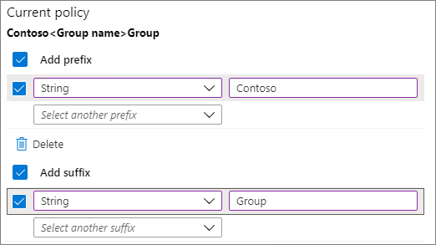
Create groups in Exchange Online and SharePoint Online
Completed 100 XP
- 4 minutes
An organization can create groups not only in the Microsoft 365 admin center, but also in Exchange Online and SharePoint Online.
Creating groups in Exchange Online
An organization can use the Exchange Online admin center to create groups of users. A major benefit of using groups is that you send an email to all the users in a group at the same time. When you create a group in Exchange Online, select the appropriate group type depending on the purpose of the group:
- Microsoft 365. This group type enables teams to collaborate by giving them a group email and a shared workspace for conversations, files, and calendars. In Outlook, they're called Groups. For more information, see Manage Microsoft 365 groups.
- Distribution. People often refer to this group type as a distribution list. It creates an email address for a group of people. For more information, see Manage distribution groups.
- Mail-enabled security. This group type sends messages to all members of the group and gives access to resources like OneDrive, SharePoint, and administrator roles. It also provides a secure and efficient way to manage email communication and assign permissions within an organization. It combines the features of both a security group and an email distribution group. For more information, see Manage mail-enabled security groups.
- Dynamic distribution. A type of distribution group. Microsoft 365 automatically updates its list of recipients every 24 hours based on the filters and conditions the organization defines. It sends email to all members of the list. For more information, see Manage dynamic distribution groups.
After you create distribution groups and mail-enabled security groups in the Exchange admin center, their names and user lists appear on the Active teams and groups page in the Microsoft 365 admin center. You can delete these groups in both locations. However, you can only edit them in the Exchange admin center. Dynamic distribution groups don't appear on the Microsoft 365 Security groups page.
Creating groups in SharePoint Online
Microsoft 365 automatically creates several built-in SharePoint groups whenever you create a site collection in SharePoint Online. SharePoint administrators can also manually create SharePoint Online groups at any time. SharePoint Online groups are collections of users who have the same permission level. This design enables an organization to grant multiple users access to a SharePoint Online site by granting permission to the group. SharePoint Online groups greatly enhance and simplify the permissions-management process for administrators. Although SharePoint Online groups can contain individual users, it's easier to manage them with security groups from Microsoft 365.
The built-in groups that Microsoft 365 automatically creates when you create a site collection in SharePoint Online are referred to as default SharePoint Online groups. The default SharePoint Online groups that Microsoft 365 automatically creates depend on the site template that you use to create the site. For example, the Team Site template contains the following default SharePoint Online groups: Team Site Visitors, Team Site Members, and Team Site Owners.
The default groups use the default permission levels in SharePoint—sometimes called SharePoint roles—to grant users rights and access. For more information, see Default SharePoint groups.
Frequently asked questions about security groups
Let's take a look at some frequently asked questions about security groups to help clarify this subject:
- Question: How is a security group in Microsoft 365 different from security groups I create in SharePoint?
  - Answer: A security group in Microsoft 365, also known as a Microsoft Entra security group, operates at the Microsoft Entra ID level. It can manage access and permissions across various Microsoft 365 services, applications, and resources. It provides a broad scope of security and access control across the entire Microsoft 365 environment. On the other hand, a security group in SharePoint is specific to SharePoint sites and operates at the site collection or site level. Organizations use SharePoint security groups to manage access and permissions within SharePoint, controlling who can view, edit, and interact with SharePoint sites, libraries, lists, and individual items.
- Question: Do I have to use security groups for my organization to be secure?
  - Answer: No. Security groups are just another way to manage security for your organization. You can always grant user permissions and access to sites individually. But with security groups, you can easily manage larger groups of users.
- Question: Can I send email to a security group?
  - Answer: Yes, as long as it's a mail-enabled security group. However, you can't send email to a regular security group.
Check your knowledge
1.
Contoso's Microsoft 365 Administrator created a site collection in SharePoint Online. Which SharePoint Online groups were automatically created for that site collection?

The default SharePoint Online groups that are created depend on the site template used to create the site
Correct
2.

As the Microsoft 365 Administrator for Contoso, you're planning to set up some groups in Contoso's Microsoft 365 tenant. You want to create a dynamic distribution group that recalculates the group's recipients every time you send a message based on filters and conditions that you define. Which of the following tools should you use to create the group?
Exchange admin center
Summary
Completed 100 XP
- 1 minute
Once an organization creates the user accounts for its Microsoft 365 tenant, it can optionally create groups for collaboration between users, both inside and outside the company. Since Microsoft 365 provides various group types, Microsoft 365 Administrators must have a firm understanding of the features associated with each group type. Having completed this module, you should be able to describe the different types of groups available in Microsoft 365.
In this module, you examined how to create groups for distributing email to multiple users within Exchange Online. You also learned how to create groups to encourage collaboration in SharePoint Online. In each case, you learned how to add people from outside your organization to a group.
This module also showed you how to complete these group management tasks using various tools. For example, you learned how to create and manage groups using the Microsoft 365 admin center and Windows PowerShell. You also learned how to create and manage groups in Exchange Online and SharePoint Online.
Add a custom domain in Microsoft 365
Introduction
Completed 100 XP
- 1 minute
This module provides insight into how an organization can implement its domain services. It focuses specifically on how to add custom domains into Microsoft 365. An organization may need multiple domain names for different purposes. For example, it may want to add a different spelling of its company name because customers are already using it and their communications failed to reach you. Custom domains allow companies to have their own branding on emails and accounts. This design enables customers to verify who's emailing them (for example, @contoso.com).
In this module, you examine what considerations need to be addressed when planning for a new domain in Microsoft 365, including the domain's DNS requirements. You then review the steps to be taken and the factors that must be considered to add and set up a new domain. These steps include planning the DNS zones and the DNS record requirements in a custom domain.

Plan a custom domain for your Microsoft 365 deployment
Completed 100 XP
- 4 minutes
There are several factors an organization must consider when planning to add custom domains to Microsoft 365. These factors can differ with the Microsoft 365 subscription it selects.
The following table sets out the planning factors that must be taken into consideration.
Factor | Considerations
Multiple domains | An organization should plan to add the main domain that it currently uses (for example, adatum.com for Adatum Corporation). It should also add any other domain that it uses for email messages within the organization. This scenario is common when the overall company is a business group. It's also common when an organization undergoes a merger process and some employees still have alternative email addresses.
Subdomains | An organization may want to register subdomains. Microsoft 365 Business Premium and Enterprise plans enable subdomains to be added under the root domain. For example, within the adatum.com root domain for Adatum Corporation, the company added a subdomain specific to the Sales department titled sales.adatum.com.
Domain numbers | An organization can register up to 900 domains with Microsoft 365.
Domain adding order | Root domains must be added before subdomains. So in the previous example, the adatum.com root domain must be registered before the sales.adatum.com subdomain is added.
DNS record hosting | An organization’s DNS servers or an external hosting provider can host DNS records.
Access to the DNS console | An organization should check with its DNS hosting provider about the level of access that it has to the DNS console. To configure its Microsoft 365 services, an organization must have access to add the A, CNAME, TXT, MX, and SRV records. If the DNS hosting provider doesn't provide that level of access, the organization may have to send a request to the DNS hosting provider to change DNS records needed for its Microsoft 365 deployment.
Not registering DNS | It's rare that an organization wouldn't want to register a DNS domain with Microsoft 365. However, it does happen occasionally. For example, an organization may want a separate email and directory service for its Microsoft 365 users. One possible scenario is a university that wants to host its faculty members in the on-premises environment and have the students in Microsoft 365 with a different domain name.
Not changing all records | An organization may not want to change all the DNS records to point to Microsoft 365. An upcoming unit in this module identifies how to handle the verification process when you don't change all the DNS records.
Plan the DNS zones for a custom domain
200 XP
- 5 minutes
A publicly available DNS zone setup is critical during the Microsoft 365 deployment for organizations that want to use custom domains, whether in a hybrid deployment or a cloud-only environment. When setting up Microsoft 365 with custom domains, the Domain Name System (DNS) plays a crucial role in enabling the proper functioning of various services and features, such as email, SharePoint, Teams, and other Microsoft 365 applications. A publicly available DNS zone is necessary to publish the required DNS records that associate your custom domain with the Microsoft 365 services.
There are several reasons why a publicly available DNS zone is essential when setting up a custom domain, including:
- Domain Verification. During the Microsoft 365 deployment, you must verify ownership of your custom domain. This process typically involves adding a specific TXT record or CNAME record to the DNS zone of your custom domain. The DNS zone must be publicly accessible for the verification process to succeed.
- Email Delivery. If you want to use Microsoft 365 for email services with your custom domain, the DNS records must be properly configured. This process includes setting up MX (Mail Exchanger) records that specify the mail servers responsible for accepting email on behalf of your domain. You must publish these MX records in the publicly available DNS zone to ensure proper email delivery.
- Autodiscover and Federation. Microsoft 365 relies on autodiscover functionality to configure email clients automatically and establish federation for certain features like single sign-on (SSO). These processes require that you add specific DNS records, such as Autodiscover records and Federation records, to the publicly available DNS zone.
- Web Services and Applications. If your organization uses custom web applications or services hosted within Microsoft 365, it's necessary that you properly configure DNS. Doing so includes creating relevant DNS records like CNAME or A records to point your custom domain to the correct web services or applications.
In both hybrid deployments and cloud-only environments, a publicly available DNS zone is crucial because it allows external entities, such as internet users or other services outside your organization's network, to resolve and access the Microsoft 365 services associated with your custom domain.
Important
While the DNS zone must be publicly available, you can still implement security measures, such as Domain Name System Security Extensions (DNSSEC) and access controls, to protect the integrity and confidentiality of your DNS records and domain.
The first part of this training unit focuses on DNS zone planning in a hybrid configuration. While DNS zone planning principles for a cloud-only environment are similar to a hybrid environment, there are some differences, which the final section of this unit examines.
DNS Zone planning in a hybrid deployment
In a hybrid deployment, an organization spreads its infrastructure across both on-premises and cloud environments. In this scenario, DNS zone planning involves considerations that accommodate the coexistence and communication between these environments. The DNS zone planning principles for a hybrid deployment include:
- Understand the Hybrid Infrastructure. You must gain a clear understanding of your organization's hybrid infrastructure, including the on-premises network and the cloud environment. You should identify the domain structure, IP addressing scheme, and existing DNS infrastructure in both environments.
- Namespace Integration. You must determine how the DNS namespace is integrated between the on-premises and cloud environments. You must decide whether to maintain a single namespace or use separate namespaces for each environment. Common approaches include subdomains, such as "cloud.example.com" for the cloud environment, and "internal.example.com" for the on-premises environment.
- DNS Forwarding. You must configure DNS forwarding between the on-premises DNS servers and the cloud DNS service. DNS forwarding enables resolution of DNS queries that aren't locally authoritative to be forwarded to the appropriate DNS service for resolution. This process ensures seamless name resolution across the hybrid infrastructure.
- Split DNS. Organizations should consider implementing split DNS to handle name resolution differently for internal and external users. This approach enables internal users to resolve internal resources using internal DNS servers while external users resolve the same resources using public DNS servers. Split DNS provides security and control over DNS resolution for internal resources.
- DNS Synchronization. You must implement DNS synchronization mechanisms between the on-premises DNS infrastructure and the cloud DNS service. Doing so ensures that changes made in one environment, such as adding or modifying DNS records, are propagated to the other environment to maintain consistency and synchronization.
- Service Discovery. You should consider the service discovery mechanisms required for hybrid deployments. These mechanisms include DNS-based service discovery solutions like SRV (Service) records or specialized tools like Azure Service Discovery. These mechanisms enable applications and services to dynamically discover and communicate with each other across the hybrid infrastructure.
- Security and Compliance. Organizations should implement security measures, such as firewalls, Domain Name System Security Extensions (DNSSEC), and access controls across both the on-premises and cloud DNS environments. You should comply with the security policies and regulations governing your organization's hybrid infrastructure.
- Monitoring and Troubleshooting. You should set up monitoring and troubleshooting capabilities for DNS resolution in both environments. These features should include monitoring DNS traffic, latency, and health, as well as having logging and alerting mechanisms in place to identify and address any DNS-related issues promptly.
Remember, the specific DNS zone planning principles in a hybrid deployment may vary depending on the chosen DNS solutions, network architecture, and organizational requirements. It's important that you consult the documentation provided by your DNS providers and any relevant hybrid deployment guides for detailed instructions tailored to your specific environment.
DNS zone planning for a custom domain
An organization can prove that it owns the DNS zone if it's able to edit records within that zone. When an organization owns the DNS zone, the Microsoft 365 setup wizard can create the tenant with the organization’s custom domain, such as adatum.com.
Furthermore, during the setup, the Microsoft 365 setup wizard instructs organizations on which DNS records they must add to the public DNS zone. Once the organization configures the DNS zone per these instructions, client software such as Outlook or the Skype for Business Client use auto discover services and resolve custom domain names with the IP addresses of Microsoft 365 servers. This process enables an organization’s client computers to connect to Microsoft 365 services, such as Exchange Online or Skype for Business Online.
Organizations use internal DNS zones configured on internal DNS servers, so that internal clients can resolve computer names and services. Organizations also use external, public DNS zones configured on Internet-accessible DNS servers so that clients located on the Internet can resolve computer names and services. A couple of options are available for hosting the DNS zone for a custom domain:
- Have a third-party provider, such as GoDaddy, host the DNS zone for the custom domain. This scenario enables an organization to manage DNS through a web portal. It still needs a way to handle internal name resolution if it uses the name for resources that are on-premises. Companies usually choose to host an internal DNS zone for the domain.
- Host the DNS zone on-premises by using or deploying DNS servers. This scenario enables an organization to have DNS servers in the perimeter network so that internet users can resolve the organization's internet-facing domain resources. You can also use internal DNS servers to handle name resolution for resources on the local area network.
When an organization plans the DNS zones for a custom domain, it can choose between the following scenarios:
- The internal DNS zones and external DNS zones have different names.
- The internal DNS zones and external DNS zones have the same name. This scenario is referred to as "split brain DNS," or "split DNS" for short.
Internal DNS zones and external DNS zones have different names
Companies in this scenario can set up their own internal DNS for their internal domain, such as adatum.local. They can then use a DNS forwarder on the internal DNS servers to redirect to an external name server the name resolution requests for external domains.
For example, a request for mail.adatum.local would be redirected to an internal IP address, such as 192.168.20.10. Conversely, a request for mail.adatum.com may go to 131.107.43.19, which is the company’s external IP address for that host name.
Internal clients that connect to Microsoft 365 services from the internal network submit resolution requests to the local DNS servers. Then, a local DNS server forwards the client’s request to the external DNS server. The DNS server then resolves the request and returns the answer to the company’s internal DNS server. Lastly, the local DNS server forwards the resolved request to internal clients.
Internal DNS zones and external DNS zones have the same name (referred to as split brain DNS or "split DNS" for short)
Split DNS is a configuration in which the internal and external DNS environments provide different IP addresses to requests for the same host name. The IP address provided depends on which server is used for name resolution.
For example, if a request for mail.adatum.com comes from inside the adatum.com network, the address returned may be 192.168.20.10 (a private IP address). However, if a user directly connected to the Internet made the same request for mail.adatum.com, the IP address returned may be 131.107.43.19 (a public IP address). This configuration is achieved by creating a zone on the internal DNS server for adatum.com.
When a client on the internal network makes a request for mail.adatum.com, the internal DNS server responds with the IP address for that host. In doing so, it uses the A (Address) or CNAME (common name) records that the server maintains for that zone. There's no requirement to forward on the name resolution request to the external DNS servers. However, external clients who try to contact mail.adatum.com receive a response from the external DNS server that's authoritative for that zone.
Internal clients that connect to Microsoft 365 services from the internal network submit resolution requests to the local DNS servers. For a local DNS server to resolve the request to Microsoft 365 services, the local DNS zones and external DNS zones should both be configured with the same records requested by the Microsoft 365 setup wizard. Once both the internal and external DNS zones are configured with the same records, clients can connect to Microsoft 365 services from either inside the company or through the internet.
DNS zone planning when moving an entire tenant to the cloud
The prior sections in this unit focused on planning internal DNS zones in a hybrid configuration. Organizations must also plan for DNS zones when they move their entire tenant to the cloud. In the scenario, there are several key considerations that organizations must keep in mind. The principles for DNS zone planning in a cloud-only environment are similar to the principles for a hybrid environment, with some other aspects to address. The following list introduces those key considerations:
- Understand DNS Zones. A DNS zone is a portion of the DNS namespace that a specific organization or entity manages. It typically represents a domain or a subdomain. Before planning DNS zones, ensure you have a clear understanding of your organization's domain structure and requirements.
- Choose a DNS Provider. In a cloud-only environment, you have the flexibility to choose a DNS provider that best suits your organization's needs. Microsoft Azure offers Azure DNS, a scalable and highly available DNS hosting service. Alternatively, you can opt for other DNS providers like Amazon Route 53 or Google Cloud DNS.
- DNS Zone Hierarchy. You should establish a logical hierarchy for your DNS zones based on your domain structure. This hierarchy typically aligns with your organization's Active Directory (AD) structure, but it can also be customized based on your specific requirements. You should consider creating separate DNS zones for different domains, subdomains, or geographic locations to manage them efficiently.
- DNS Zone Design. You should design your DNS zones based on the services and resources hosted in the cloud. You should consider creating separate DNS zones for various cloud services like web applications, databases, virtual machines, and other resources. This segregation helps in efficient management, security, and delegation of DNS records.
- DNS Record Types. You should identify the different types of DNS records required for your cloud-based services. Some common record types include:
  - A records. Maps a domain/subdomain to an IPv4 address.
  - AAAA records. Maps a domain/subdomain to an IPv6 address.
  - CNAME records. Creates an alias for a domain/subdomain, redirecting it to another domain/subdomain.
  - MX records. Specifies mail servers responsible for accepting email on behalf of a domain.
  - TXT records. Allows you to add additional information or verification records.
- DNS Zone Delegation. If you have multiple DNS zones and you want to delegate control to different teams or departments, you must configure zone delegation accordingly. Doing so allows different teams to manage their own DNS records within their delegated zone.
- DNS Security. You must ensure that proper security measures are in place to protect your DNS zones. You should implement Domain Name System Security Extensions (DNSSEC) to add an extra layer of security to your DNS infrastructure and prevent DNS-related attacks.
- Monitoring and Maintenance. You should regularly monitor and maintain your DNS zones to ensure their integrity and performance. You should configure appropriate monitoring tools to track DNS resolution, latency, and overall health. It's essential that you stay updated with any changes or updates from your DNS provider to ensure compatibility and security.
While these steps provide a general guideline, it's essential that organizations consider their specific requirements and consult the documentation provided by their chosen DNS provider for detailed instructions on zone planning in a cloud-only environment.
Knowledge check
Choose the best response for the following question.
Check your knowledge

1.
As the Microsoft 365 Administrator for Tailspin Toys, you're planning a Microsoft 365 deployment. You want to add a new custom domain where the internal DNS zone and external DNS zone have the same name. You want to design a DNS solution for the new domain that enables Microsoft 365 connectivity and meets this DNS requirement. What should you do?

Configure split brain DNS
Correct. Split brain DNS is a configuration in which the internal and external DNS environments provide different IP addresses to requests for the same host name. The address provided depends on which server is used for name resolution.
Plan the DNS record requirements for a custom domain
Completed 100 XP
- 9 minutes

Choose your shell

When you set up a custom domain in Microsoft 365, you must configure the DNS (Domain Name System) records for proper domain management and email delivery. The specific DNS records you must add depend on the services you want to use with your custom domain in Microsoft 365.
After the Microsoft 365 setup wizard verifies the organization owns the custom domain, the administrator should add other DNS records to the custom DNS zone. These records should enable the organization’s clients to locate Microsoft 365 services. Each DNS zone can contain several different DNS record types that provide differing name resolution services.
- If the organization hosts its own external DNS server, then a DNS administrator should add the necessary DNS records to provide client connectivity to Microsoft 365 services.
- If a DNS provider hosts the organization’s DNS zone, then administrators should add the necessary DNS records through the appropriate management console that the DNS provider created. Some DNS providers, such as GoDaddy, provide automated DNS record configuration for Microsoft 365. This design saves organizations from having to manually create their DNS records for Microsoft 365. Organizations may also select the option to have Microsoft 365 configure and host the DNS records.
If you purchased a custom domain from a third-party hosting provider, you can connect it to Microsoft 365 by updating the DNS records in your registrar’s account. Once you add the domain to Microsoft 365, it remains registered with the host that you purchased it from. However, Microsoft 365 can use it for your email addresses (like user@yourdomain.com) and other services.
If you don't add a custom domain, people in your organization must use the onmicrosoft.com domain for their email addresses until you do.
Tip
You should add your custom domain before you add users, so that you don't have to set them up twice.
If you previously created users and would like to change their domain, follow the steps described in Change your email address to use your custom domain using the Microsoft 365 admin center.
The following sections examine each of the DNS records used by Microsoft 365.
External DNS records required for Microsoft 365 (core services)
Microsoft 365 requires the TXT record, which proves that you own the domain. The system requires this record for all customers.
Microsoft 365 only requires the CNAME record for customers in China who use 21Vianet to operate Microsoft 365 (21Vianet is the largest carrier-neutral Internet data center services provider in China). The CNAME record ensures that Microsoft 365 can direct workstations to authenticate with the appropriate identity platform.
DNS record | Purpose | Value to use | Applies to
TXT  (Domain verification) | Used by Microsoft 365 to verify that you own your domain. It doesn't affect anything else. | Host: @ (or, for some DNS hosting providers, your domain name)  TXT Value: [A text string provided by Microsoft 365]  The Microsoft 365 domain setup wizard provides the values that you use to create this record. | All customers
CNAME  (Suite) | Used by Microsoft 365 to direct authentication to the correct identity platform.  This CNAME record only applies to Microsoft 365 operated by 21Vianet in China. If this record is present and 21Vianet doesn't operate the organization's Microsoft 365 plan, users in the organization's custom domain receive an error message stating that "[custom domain] isn't in our system." As a result, the users can't activate their Microsoft 365 license. | Alias: msoid  Target: clientconfig.partner.microsoftonline-p.net.cn | 21Vianet customers only in China
External DNS records required for email in Microsoft 365 (Exchange Online)
Email in Microsoft 365 requires several different records. Every Microsoft 365 customer should use the following DNS records:
- Autodiscover. This record allows client computers to automatically find Exchange and configure the client properly.
- MX. This record tells other mail systems where to send email for the company's domain.
Note
When an organization changes its email to Microsoft 365, by updating its domain's MX record, ALL email sent to that domain starts coming to Microsoft 365.
- Sender policy framework (SPF). SPF records are actually TXT records used by recipient email systems to validate whether the server sending an organization's email is one that the company approves. This record helps prevent problems such as email spoofing and phishing.
Email customers who use Exchange federation also need the CNAME and TXT records listed at the bottom of the table.
DNS record | Purpose | Value to use
CNAME  (Exchange Online) | Helps Outlook clients easily connect to the Exchange Online service by using the Autodiscover service. Autodiscover automatically finds the correct Exchange Server host and configures Outlook for users. | Alias: Autodiscover  Target: autodiscover.outlook.com
MX  (Exchange Online) | Sends incoming mail for an organization's domain to the Exchange Online service in Microsoft 365.  Once an organization's email is flowing to Exchange Online, the company should remove the MX records that are pointing to its old system. | Domain: For example, contoso.com  Target email server: [MX token].mail.protection.outlook.com  Time To Live (TTL) Value: 3600  Preference/Priority: Lower than any other MX records. This value ensures the system delivers mail to Exchange Online. For example, 1 or 'low.'  Find your [MX token] by following these steps:  - Sign-in to Microsoft 365, go to the Microsoft 365 admin center, and then select Domains.  - In the Action column for your domain, select Fix issues.  - In the MX records section, select What do I fix?  Follow the directions on this page to update your MX record: What is MX priority?
SPF (TXT)  (Exchange Online) | Helps an organization prevent other people from using its domain to send spam or other malicious email. Sender policy framework (SPF) records identify the servers that an organization authorizes to send email from its domain. | External DNS records required for SPF.
TXT  (Exchange federation) | Used for Exchange federation for hybrid deployments. | TXT record 1: For example, contoso.com and associated custom-generated, domain-proof hash text (for example, Y96nu89138789315669824)  TXT record 2: For example, exchangedelegation.contoso.com and associated custom-generated, domain-proof hash text (for example, Y3259071352452626169)
CNAME  (Exchange federation) | Helps Outlook clients easily connect to the Exchange Online service by using the Autodiscover service when an organization uses Exchange federation. Autodiscover automatically finds the correct Exchange Server host and configures Outlook for your users. | Alias: For example, Autodiscover.service.contoso.com  Target: autodiscover.outlook.com
External DNS records required for Microsoft Teams
An organization must take specific steps when it uses Microsoft 365 URLs and IP address ranges to ensure it correctly configured its network.
These DNS records apply only to tenants in Teams-only mode. For hybrid tenants, see DNS implications for on-premises organizations that become hybrid.
DNS record | Purpose | Value to use
SRV  (Federation) | This record enables an organization's Microsoft 365 domain to share instant messaging (IM) features with external clients by enabling SIP federation. | Domain: [domain]  Service: sipfederationtls  Protocol: TCP  Priority: 100  Weight: 1  Port: 5061  Target: sipfed.online.lync.com  If an organization's firewall or proxy server blocks SRV lookups on an external DNS, it should add this SRV record to the internal DNS record.
SRV  (SIP) | An organization may need this record if it has a Teams-only tenant that uses Skype for Business Online phones for Teams. | Domain: [domain]  Service: sip  Protocol: TLS  Priority: 100  Weight: 1  Port: 443  Target: sipdir.online.lync.com
CNAME  (Lyncdiscover) | Teams-only tenants require this record to support PowerShell cmdlets that still use Skype for Business Online infrastructure for management. | Alias: lyncdiscover.[domain]  Target: webdir.online.lync.com
External DNS records required for Microsoft 365 Single Sign-on
DNS record | Purpose | Value to use
CNAME | This record is used to verify domain ownership and configure custom domains. It typically points to a specific value or token provided by Microsoft. The CNAME record is used for domain verification and to direct traffic to the appropriate Microsoft 365 services. | Name/Host: The specific name or alias, such as "autodiscover" or "msoid."  Target: The target domain or hostname provided by Microsoft.
External DNS records required for Sender policy framework (SPF)
SPF records are TXT records that help prevent other people from using an organization's domain to send spam or other malicious email. SPF records identify the servers that an organization authorizes to send email from its domain.
Sender policy framework (SPF) helps prevent spoofing, but there are spoofing techniques that SPF can't protect against. To protect against these techniques, once an organization sets up SPF, it should configure DKIM and DMARC for Microsoft 365. To get started, see Use DKIM to validate outbound email sent from your domain in Microsoft 365 and Use DMARC to validate email in Microsoft 365.
An organization can only have one SPF record. In other words, it can only have one TXT record that defines SPF for its domain. That single record can have a few different inclusions, but the total DNS lookups that result can't be more than 10. This design helps prevent denial of service attacks. See the table and other examples in the following sections to help you create or update the right SPF record values for your environment.
Structure of an SPF record
An SPF record contains the following parts:
- the declaration that it's an SPF record
- the domains
- IP addresses that should be sending email
- an enforcement rule
Here's an example of a common SPF record for Microsoft 365 when you only use Exchange Online email:
TXT Name @ Values: v=spf1 include:spf.protection.outlook.com -all
An email system that receives an email from an organization's domain looks at the SPF record. If the email server that sent the message was a Microsoft 365 server, the email system accepts the message. However, if the server that sent the message was an organization's old mail system or a malicious system on the Internet, the SPF check may fail and the system doesn't deliver the message. Checks like this help to prevent spoofing and phishing messages.
Choose the correct SPF record structure
Sometimes an organization doesn't use just Exchange Online email for Microsoft 365 (for example, when it uses email originating from SharePoint Online as well). In this scenario, the organization must use the following table to determine what to include in the value of the record.
Caution
If you have a complicated scenario that includes, for example, edge email servers for managing email traffic across your firewall, you'll have a more detailed SPF record to set up. In this situation, Microsoft recommends that you read: Set up SPF records in Microsoft 365 to help prevent spoofing. You can also learn much more about how SPF works with Microsoft 365 by reading How Microsoft 365 uses Sender Policy Framework (SPF) to help prevent spoofing.
Number | If you're using... | Purpose | Add these includes
1 | All email systems (required) | All SPF records start with this value. | v=spf1
2 | Exchange Online (common) | Use with just Exchange Online. | include:spf.protection.outlook.com
3 | Third-party email system (less common) |  | include: [email system like mail.contoso.com]
4 | On-premises mail system (less common) | Use if you're using Exchange Online Protection or Exchange Online plus another mail system. | ip4: [0.0.0.0]  ip6: [: : ]  include: [mail.contoso.com]  The value in brackets should be other mail systems that send email for your domain.
5 | All email systems (required) |  | -all
Create a custom domain in Microsoft 365
Completed 100 XP
- 10 minutes
When an organization has a domain name that it wants to add to Microsoft 365, the administrator or Microsoft partner should first verify the organization owns the domain. Domain ownership can sometimes be problematic, particularly if a former employee registered the domain with their personal information and then left the organization.
One of the most common methods that companies previously used to find out who originally registered the domain was to check the domain's WHOIS record. They would do so by using an Internet WHOIS register, such as who.is. However, the Internet Corporation for Assigned Names and Numbers (ICANN), which is a non-profit organization that oversees and coordinates various aspects of the internet's domain name system (DNS), no longer requires that WHOIS information be publicly available. As such, checking WHOIS may likely result in no usable response other than verifying who the registrar is.
As an alternative, organizations typically employ one of the following methods:
- Historical WHOIS databases. There are services that maintain historical WHOIS records, allowing you to search for past registration information even if it's no longer publicly available. Examples include services like DomainTools' Domain History or Whois History.
- Domain registrar. Contacting the current domain registrar directly may provide some insights. They may be able to provide historical information or guide you on the next steps to obtain the original registration details.
- Domain transfer documentation. Domain transfers allow the movement of a domain name from one registrar to another. The domain owner typically initiates this process for various reasons, such as better pricing, improved services, or consolidation of domain management. When a domain transfer occurs, the transfer documentation may contain information about the original registrant. This information is typically available to the current domain owner or the domain registrar. You should verify the organization has administrative access to manage DNS for the domain. Different DNS hosting providers grant varying levels of access to DNS records for a hosted domain.
- Legal assistance. In cases where it's crucial to determine the original domain registration information, seeking legal advice may be necessary. An attorney experienced in domain name disputes or intellectual property law can guide you through the legal process and help obtain the required information.
After an organization verifies that it owns the domain, it should then verify that it can make changes to the DNS records for the domain. At that point, the organization should add the domain to Microsoft 365. To do so, an organization typically needs to follow these steps:
- Access DNS Management. The organization should have administrative access to the DNS management system for the domain in question. This access could be through a domain registrar, a DNS hosting provider, or an internal DNS server within the organization's network.
- Identify DNS Management Method. The organization should determine the specific method or platform used to manage the DNS records for the domain. The method could be a web-based control panel provided by the domain registrar or DNS hosting provider, or it might involve direct access to the DNS server using a management tool or command-line interface.
- Locate DNS Zone. The organization should then identify the DNS zone corresponding to the domain within the DNS management system. This zone contains the DNS records that control how DNS resolves the domain on the internet.
- Make DNS Record Changes. The organization should be able to modify the DNS records within the DNS zone. Depending on the DNS management method, this process typically involves locating the relevant DNS record (such as MX, TXT, CNAME, or others) and making the necessary changes to its configuration.
- Save and Publish Changes. After an organization modifies the DNS record, it must save and publish the changes within the DNS management system. This action ensures that the updated DNS records propagated throughout the DNS infrastructure and become effective.
- Verify DNS Record Propagation. Once the organization changes the DNS records and saves them, the organization should verify the updated DNS records propagated. DNS propagation refers to the time it takes for a process called DNS replication to distribute the updated DNS records across DNS servers worldwide. This propagation period can vary and usually takes anywhere from a few minutes to several hours.
- Perform Microsoft 365 Domain Verification. After confirming that the DNS records propagated, the organization can proceed with the domain verification process within the Microsoft 365 administration portal. This process typically involves adding a specific TXT record or CNAME record to the DNS zone of the domain to prove ownership and control.
- Verify Domain Ownership. Once an organization adds the TXT record or CNAME record to the DNS zone, it can initiate the domain verification process within the Microsoft 365 admin portal. Microsoft 365 then attempts to validate the presence of the DNS record to confirm domain ownership. It may take some time for the verification process to complete, as the DNS record may need to propagate to all DNS servers.
This verification process helps ensure a successful setup and configuration of Microsoft 365 services with the custom domain.
The following sections examine the steps involved in verifying that you own the domain and adding DNS records to connect to Microsoft 365 services.
Tip
If you need help with the following steps, consider working with a Microsoft small business specialist. With Business Assist, you and your employees get around-the-clock access to small business specialists as you grow your business, from onboarding to everyday use.
Step 1: Add a TXT or MX record to verify you own the domain
Recommended: Verify with a TXT record
You must first prove that you own the custom domain that you want to add to Microsoft 365.
- Sign in to the Microsoft 365 admin center. In the left-hand navigation pane, select Show all, then select Settings, and then select Domains.
- In a new browser tab or window, sign in to your DNS hosting provider, and then find where you manage your DNS settings (for example, Zone File Settings, Manage Domains, Domain Manager, DNS Manager).
- Go to your provider's DNS Manager page and add the TXT record indicated in the admin center to your domain. Adding this record doesn't affect your existing email or other services. You can safely remove it once you connect your domain to Microsoft 365.
Example:
  - TXT Name: @
  - TXT Value: MS=ms######## (unique ID from the admin center)
  - TTL: 3600 (or your provider default)
- Save the record, go back to the admin center, and then select Verify. It typically takes around 15 minutes for record changes to register, but sometimes it can take longer. Give it some time and a few tries to pick up the change.
When Microsoft 365 finds the correct TXT record, you verified that you own the domain.
Verify with an MX record
If your registrar doesn't support adding TXT records, you can verify you own the domain by adding an MX record.
- Sign in to the Microsoft 365 admin center. In the left-hand navigation pane, select Show all, then select Settings, and then select Domains.
- In a new browser tab or window, sign in to your DNS hosting provider, and then find where you manage your DNS settings (for example, Zone File Settings, Manage Domains, Domain Manager, DNS Manager).
- Go to your provider's DNS Manager page and add the MX record indicated in the admin center to your domain.
Important
This MX record's Priority must be the highest of all existing MX records for the domain. Otherwise, it can interfere with sending and receiving email. You should delete this record as soon as you finish verifying that you own the domain.
When you create the MX record, you must set the following fields to these values:
- Record Type: MX
- Priority: Set to any large value not used already.
- Host Name: @
- Points to address: Copy the value from the admin center and paste it here.
- TTL: 3600 (or your provider default)
When Microsoft 365 finds the correct MX record, you verified that you own the domain.
Step 2: Add DNS records to connect Microsoft services
In a new browser tab or window, sign in to your DNS hosting provider, and find where you manage your DNS settings (for example, Zone File Settings, Manage Domains, Domain Manager, DNS Manager).
You must add several different types of DNS records depending on the services you want to enable.
Add an MX record for email (Outlook, Exchange Online)
Before you begin: If users already have email with your domain (such as user@yourdomain.com), create their accounts in the Microsoft 365 admin center before you set up your MX records. By doing so, they continue to receive email. After you update your domain's MX record, all new email for anyone who uses your domain now comes to Microsoft 365. Any email you already have stays at your current email host, unless you decide to migrate email and contacts to Microsoft 365.
When you add a domain in the Microsoft 365 admin center, it initiates the Domain setup wizard. The wizard provides the information you need to create the MX record.
On your hosting provider's website, add a new MX record. You must set the following fields to these values:
- Record Type: MX
- Priority: Set to the highest value available, typically 0.
- Host Name: @
- Points to address: Copy the value from the admin center and paste it here.
- TTL: 3600
Note
Exchange Online only supports TTL values less than 6 hours (21,600 seconds).
Save the record, and then remove any other MX records.
The following diagram shows how public domains, managed in their respective provider portals, must point to Microsoft 365 to receive emails and use them in Microsoft 365.
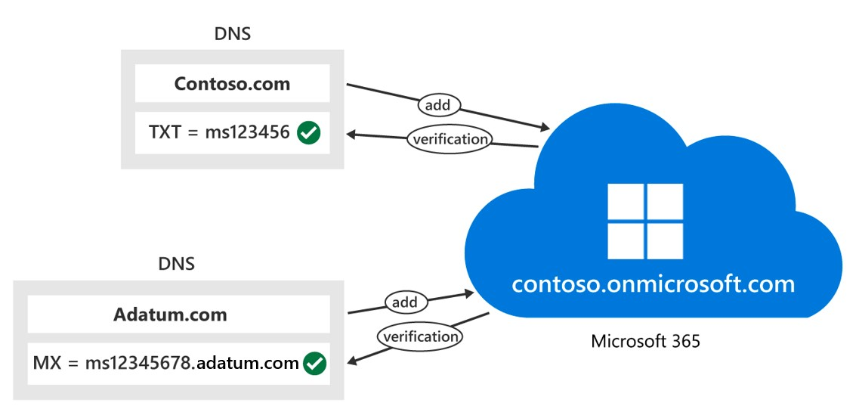
Add CNAME records to connect other services (Teams, Exchange Online, MDM)
The domain setup wizard provides the information you need to create the CNAME record.
On your hosting provider's website, add CNAME records for each Microsoft 365 service that you want to connect. You must set the following fields to these values for each CNAME record that you create:
- Record Type: CNAME (Alias)
- Host: Paste the values you copy from the admin center here.
- Points to address: Copy the value from the admin center and paste it here.
- TTL: 3600 (or your provider default)
Add or edit an SPF TXT record to help prevent email spam (Outlook, Exchange Online)
Before you begin: If you already have an SPF record for your domain, don't create a new one for Microsoft 365. Instead, add the required Microsoft 365 values to the current record on your hosting provider's website so that you have a single SPF record that includes both sets of values.
On your hosting provider's website, edit the existing SPF record or create an SPF record. You must set the following fields to these values:
- Record Type: TXT (Text)
- Host: @
- TXT Value: v=spf1 include:spf.protection.outlook.com -all
- TTL: 3600 (or your provider default)
Save the record.
At this point, you should validate your SPF record by using one of these SPF validation tools.
Important
SPF is designed to help prevent spoofing, but there are spoofing techniques that SPF can't protect against. To protect against these techniques, you should first set up SPF, and then you should set up DKIM and DMARC for Microsoft 365. For more information, see Use DKIM to validate outbound email sent from your domain in Microsoft 365 and Use DMARC to validate email in Microsoft 365.
Add SRV records for communications services (Teams, Skype for Business)
On your hosting provider's website, add SRV records for each Microsoft 365 service you want to connect. You must set the following fields to these values for each SRV record that you create:
- Record Type: SRV (Service)
- Name: @
- Target: Copy the value from the admin center and paste it here.
- Protocol: Copy the value from the admin center and paste it here.
- Service: Copy the value from the admin center and paste it here.
- Priority: 100
- Weight: 1
- Port: Copy the value from the admin center and paste it here.
- TTL: 3600 (or your provider default)
Save the record.
Hosting providers sometimes impose restrictions on field values within SRV records. Some common workarounds for these restrictions include:
- Name. If your hosting provider doesn't allow setting this field to @, leave it blank. Use this approach only when your hosting provider has separate fields for the Service and Protocol values. Otherwise, see the Service and Protocol notes in the next item.
- Service and Protocol. If your hosting provider doesn't provide these fields for SRV records, you must specify the Service and Protocol values in the record's Name field. Depending on your hosting provider, the Name field may have a different name, such as: Host, Hostname, or Subdomain. To add these values, you must create a single string, separating the values with a dot. For example: _sip._tls
- Priority, Weight, and Port. If your hosting provider doesn't provide these fields for SRV records, you must specify them in the record's Target field. Depending on your hosting provider, the Target field may have a different name, such as: Content, IP Address, or Target Host. To add these values, you must create a single string, separating the values with spaces and sometimes ending with a dot, as seen in Example 1. You should check with your provider if you're unsure. You must include the values in this order: Priority, Weight, Port, Target.
  - Example 1: 100 1 443 sipdir.online.lync.com.
  - Example 2: 100 1 443 sipdir.online.lync.com

1.

As the Microsoft 365 Administrator for Contoso, you manage the company's Microsoft 365 tenant. You must add a DNS record for Exchange Online that Outlook clients use to locate the Autodiscover service in Microsoft 365. When you add this DNS record, which DNS record type should it be?
CNAME
2.
Contoso wants to prevent other people from using its domain to send spam or other malicious email. Which external Exchange Online DNS record should Contoso create to prevent spoofing and phishing?
SPF
3.
Fabrikam has a Microsoft 365 Business Premium subscription. The company recently purchased a new subsidiary that it renamed Fabrikam Residences. As Fabrikam's Microsoft 365 Administrator, you want to add a custom domain titled fabrikamresidences.com for the new subsidiary. You also want to register a subdomain titled content.fabrikamresidences.com that's under the fabrikamresidences.com root domain. What should you do to add these two domains to your Microsoft 365 Business Premium subscription?
Register the root domain first and then register the subdomain
Summary
Completed 100 XP
- 2 minutes
This module provided you with insight into how to implement your domain services, and specifically how to add a custom domain into Microsoft 365. Custom domains enable companies to have their own branding, such as @contoso.com, on emails and accounts. One advantage of this type of branding is that it enables customers to verify who is emailing them.
In this module, you learned about the key factors that must be planned for when adding a new domain in Microsoft 365. These factors can differ with the Microsoft 365 subscription you select. They include the domain's DNS requirements, such as the DNS zones used in a custom domain, and the domain's DNS record requirements.
A publicly available DNS zone is critical during the Microsoft 365 deployment for organizations that want to use custom domains. In this module, you learned about the following two scenarios that organizations can choose from when planning DNS zones for custom domains:
- Internal DNS zones and external DNS zones have different names.
- Internal DNS zones and external DNS zones have the same name (referred to as Split brain DNS or "split DNS" for short).
This module concluded by reviewing the steps to be taken to add a new domain to Microsoft 365 using the Microsoft 365 admin center and DNS Manager.
Configure client connectivity to Microsoft 365
Introduction
Completed 100 XP
- 1 minute
This module examines how clients connect to Microsoft 365. You initially examine the name resolution configurations to ensure that clients can connect without user intervention. You then explore Outlook client configuration. Administrators must understand how Outlook uses Autodiscover to connect an Outlook client to Exchange Online.
To configure client connectivity, administrators must be able to identify the DNS records needed for Outlook and other Office-related clients. This information enables you to automatically locate the services in Microsoft 365 using the Autodiscover process. After completing this module, you should be able to describe the connectivity protocols that enable Outlook to connect to Microsoft 365.
The module concludes by reviewing some troubleshooting techniques that can be helpful for Microsoft 365 clients. You learn about the various tools that can help administrators troubleshoot connectivity issues in Microsoft 365 deployments.
Examine how automatic client configuration works
Completed 100 XP
- 2 minutes
Microsoft Outlook includes an Autodiscover feature that automatically configures Outlook to connect to Exchange Online. It does so without the need to manually configure user connection settings. Depending upon their configuration, Outlook users receive their required connection settings from either Exchange Online or Exchange Server on-premises the first time they sign in with their email address and password.
The process for an Outlook client to connect to Exchange Online for the first time includes the following steps:
- An Outlook user enters their email address and password.
- Based on the email address information and Autodiscover record on the Internet-located DNS, the client locates the Autodiscover service in Microsoft 365.
- The client provides its SMTP address and password to authenticate with the Autodiscover service in Microsoft 365.
- The client then asks for the appropriate connection settings.
- Microsoft 365 provides the connection settings in an XML configuration information format.
- Outlook downloads the information and applies it to its connection settings.
- Outlook connects to Exchange Online in Microsoft 365.
Explore the DNS records required for client configuration
200 XP
- 5 minutes
Outlook and other Office-related clients can use the Autodiscover process to automatically locate services in Microsoft 365. For an organization to use Autodiscover in this manner, it must first configure the appropriate DNS records on the publicly available DNS servers on the Internet.
- In organizations where the internal DNS namespace, such as adatum.local, is different from the Internet DNS namespace, such as adatum.com, the internal DNS servers forward internal client queries to Internet DNS servers.
- In organizations that use split-brain DNS, where internal and Internet DNS namespaces are the same, such as adatum.com, both the internal and Internet DNS servers should be configured to resolve the Autodiscover records in Microsoft 365.
The following table identifies the Autodiscover records that Outlook clients need to connect to Exchange Online in Microsoft 365.
DNS record | Purpose | Value to use
CNAME  (Exchange Online) | The Autodiscover service configures Outlook for users. | Alias: Autodiscover  Target: autodiscover.outlook.com
CNAME  (Exchange federation) | The Autodiscover service configures Outlook for users in Exchange federation scenarios. This record is optional, but required when deploying Exchange in a hybrid configuration with Microsoft 365. | Alias: For example, Autodiscover.service.adatum.com  Target: autodiscover.outlook.com
The following graphic shows the domain suffix of a user's email address is resolved against DNS. Redirection to Exchange Online occurs next, which then delivers the correct Autodiscover.xml file back to the Outlook client. This file contains all the configuration information.
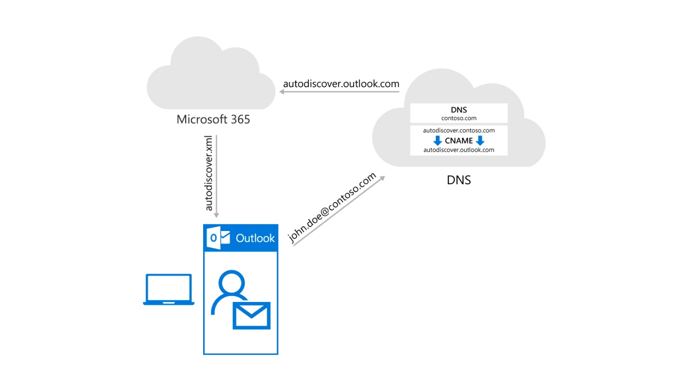
The Microsoft 365 portal provides the administrator who's doing the initial Microsoft 365 configuration with all the DNS records that are required for proper name resolution. For some DNS providers such as GoDaddy, Microsoft 365 can automatically create all necessary records.
Knowledge check
Choose the best response for the following question.
Check your knowledge

1.
Outlook and other Office-related clients can use which of the following features to automatically locate services in Microsoft 365?

Autodiscover
Correct. Microsoft Outlook automatically locates services in Microsoft 365 by using Autodiscover. For example, Autodiscover automatically configures Outlook to connect to Exchange Online. It does so without the need to manually configure user connection settings.

Configure Outlook clients
200 XP
- 5 minutes
When Outlook users connect to Microsoft 365, they must provide their Microsoft 365 email address and password when they start Outlook for the first time. The Autodiscover functionality in Microsoft 365 automatically configures Outlook for use with Microsoft 365. For Autodiscover to work properly, you must configure the appropriate DNS records during the Microsoft 365 tenant setup.
Connectivity protocols
The connectivity protocols that Outlook uses to communicate with Exchange changed over the past several years. The following graphic shows the progression from old to new protocols - from RPC/TCP to RPC/HTTP to MAPI/HTTP.
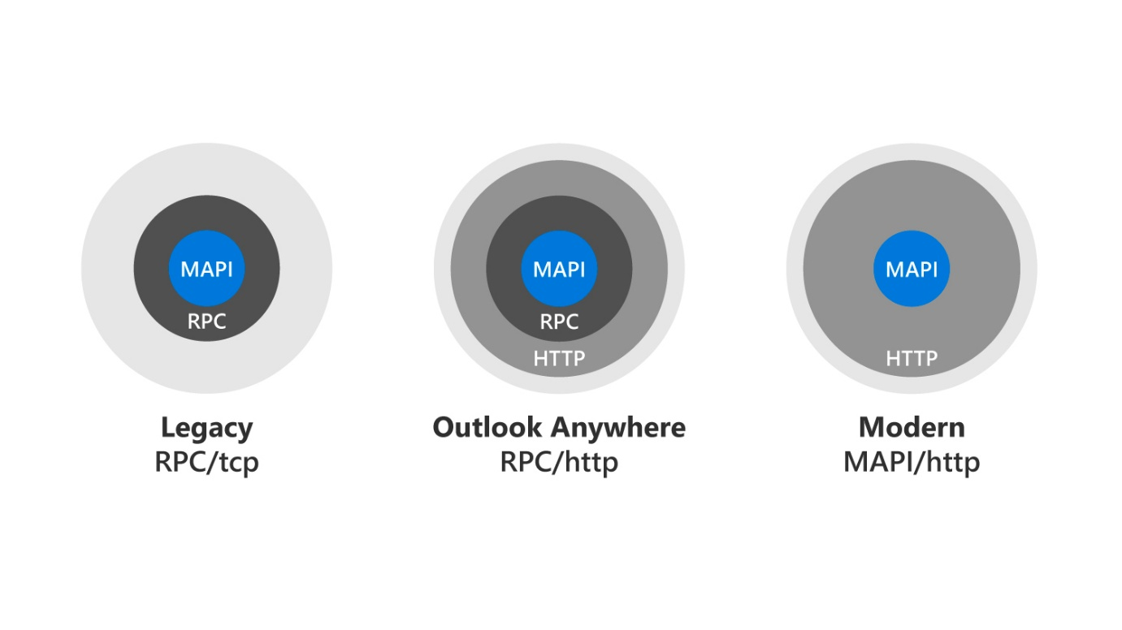
Messaging Application Programming Interface (MAPI) over HTTP is the latest transport protocol that provides connectivity to Outlook. It's also the only protocol that supports Outlook connectivity to Exchange Online in Microsoft 365 and to Exchange Server 2019. In addition, MAPI/HTTP is the only protocol supported by Hybrid modern authentication.
By placing MAPI commands directly in HTTPS packets, MAPI/HTTP provides greater efficiency than its predecessors for several reasons:
- Reduced latency. MAPI/HTTP reduces latency by using HTTP as the transport protocol. HTTP is a more lightweight protocol compared to the Remote Procedure Call (RPC) used in the previous versions. This design results in quicker communication between the email client and the server.
- Improved connection handling. MAPI/HTTP handles unreliable or intermittent network connections more effectively. It provides better support for scenarios where the connection between the client and the server might be less stable or prone to interruptions.
- Enhanced security. MAPI/HTTP supports modern authentication protocols, such as OAuth, providing improved security compared to its predecessors. OAuth helps in secure authentication without exposing user credentials, reducing the risk of unauthorized access.
- Better scalability. MAPI/HTTP is more scalable, particularly in environments with a large number of concurrent users. The protocol demonstrates superior capability in managing a high volume of connections and requests.
- Adaptability to modern network architectures. MAPI/HTTP provides superior design for modern network architectures, including networks with firewalls and proxies. Its use of HTTP makes it more firewall-friendly, allowing organizations to deploy it in diverse networking environments.
- Improved troubleshooting and diagnostics. The use of HTTP facilitates easier troubleshooting and diagnostics compared to the complex RPC traffic. Network administrators can more readily analyze HTTP traffic, leading to quicker identification and resolution of issues.
MAPI/HTTP also improves the reliability and stability of the Outlook and Exchange connections. It does so by moving the transport layer to the industry-standard HTTP model. This design allows a higher level of visibility of transport errors and enhanced recoverability. MAPI/HTTP also supports an explicit pause-and-resume function. This feature enables supported clients to change networks or resume from hibernation while maintaining the same server context.
MAPI over HTTP offers the following benefits:
- Enables future innovation in authentication by using an HTTP based protocol.
- Provides faster reconnection times after a communications break because only TCP connections (not RPC connections) must be rebuilt. Examples of a communication break include:
  - Device hibernation
  - Changing from a wired network to a wireless or cellular network
- Offers a session context that isn't dependent on the connection. The server maintains the session context for a configurable period of time, even if the user changes networks.
Given the benefits of MAPI/HTTP and the fact that it's the only protocol that support Exchange Online, Microsoft enabled it by default in Microsoft 365.
Additional reading. For more information, see MAPI over HTTP in Exchange Server.
Outlook connectivity for cloud-only and hybrid deployments
Outlook clients connect in different ways, depending on whether an organization has a cloud-only or hybrid Microsoft 365 deployment. In a cloud-only deployment, Outlook clients on an internal network connect to Microsoft 365 services by using Autodiscover DNS records on internal or Internet DNS servers. Internet-based Outlook clients connect to Microsoft 365 services by using Autodiscover DNS records on the Internet DNS servers.
However, in a hybrid deployment of Microsoft 365, Outlook clients must always connect to the Autodiscover service that's running on the organization’s Exchange server. When a client is on an internal network, Outlook locates the Exchange server by searching for the Autodiscover Service Connection Point located in Active Directory Domain Services (AD DS). After Outlook connects to the Exchange server, the Exchange server determines whether the user’s mailbox is in an on-premises environment or in Microsoft 365.
- If the user’s mailbox is in Microsoft 365, the Exchange server provides alternate SMTP domain information to Outlook. Outlook uses that alternate SMTP domain to search for the Microsoft 365 Autodiscover service’s record on the Internet. It then connects to Exchange Online in Microsoft 365.
- When a client is on the Internet, Outlook locates the Exchange server by searching for the Autodiscover record that points to the Exchange client access services on the internal network. After Outlook connects to the Exchange server, the Exchange server determines if the user’s mailbox is in an on-premises environment or in Microsoft 365.
Network configuration
Microsoft 365 services contain multiple endpoints. Clients use these endpoints to connect to services, such as Exchange Online, Skype for Business Online, and SharePoint Online. Microsoft 365 endpoints include fully qualified domain names (FQDNs), ports, uniform resource locators (URLs), and IPv4 and IPv6 address ranges. Some organizations restrict computers on their networks from accessing certain Internet resources. For this reason, it's important for an organization to know all of its endpoints that Microsoft 365 uses. This information enables organizations to properly configure their network devices, such as routers and firewalls. After an organization configures its network devices, its clients can connect successfully to Microsoft 365 services.
Knowledge check
Choose the best response for the following question.
Check your knowledge

1.
Microsoft 365 clients can connect to services such as Exchange Online and SharePoint Online. Each service contains a feature that clients use to make these connections. Which of the following features enables these connections?

Microsoft 365 endpoints
Correct. Microsoft 365 services contain multiple endpoints, through which clients connect to services such as Exchange Online and SharePoint Online. IPv4 and IPv6 address ranges and fully qualified domain names (FQDNs) are properties included in each endpoint (including ports, URLs, and IPv4 and IPv6 address ranges). However, it's the endpoints themselves that clients use to connect to services such as Exchange Online and SharePoint Online.
Troubleshoot client connectivity
Completed 100 XP
- 4 minutes
Microsoft provides the following tools that can be used to analyze connectivity issues in Microsoft 365 deployments.
Microsoft Remote Connectivity Analyzer
The Microsoft Remote Connectivity Analyzer is a web-based tool designed to help IT administrators troubleshoot connectivity issues affecting their Microsoft 365, Teams, and Exchange Server deployments. The tool simulates several client logon and mail flow scenarios. When a test fails, many of the errors have troubleshooting tips to assist the IT Administrator in correcting the problem.
‎Microsoft Remote Connectivity Analyzer (RCA) can:
- identify connectivity issues between email clients and an organization's Exchange Server.
- identify connectivity issues between email clients and Microsoft 365.
- troubleshoot Exchange Server and Microsoft 365 deployments.
- identify common problems.
Microsoft Remote Connectivity Analyzer enables end users to run tests from client computers within the corporate network. It then provides a log that shows the test steps that were both successful and unsuccessful. Additionally, the RCA tool provides a "Tell me more about this issue and how to resolve it" link that provides suggestions about how to help fix reported issues.
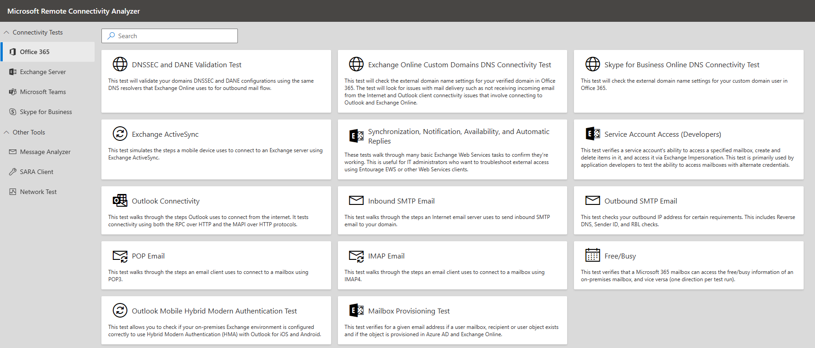
Microsoft 365 Support and Recovery Assistant
The Microsoft Support and Recovery Assistant (SARA) is available here. It works by running tests to figure out what's wrong and offers the best solution for the identified problem. It can currently fix Office, Microsoft 365, or Outlook problems. If the Support and Recovery Assistant can't fix a problem for you, it suggests next steps and helps you get in touch with Microsoft Support.
SARA offers the best solution for these identified problems:
- Office
  - I get an error when I install Office.
  - I can't activate Office.
  - I need to uninstall Office.
- Outlook
  - Outlook fails to start.
  - I can't set up my Microsoft 365 email in Outlook.
  - Outlook keeps asking for my password.
  - Outlook keeps saying "Trying to connect..." or "Disconnected."
  - Shared mailboxes or shared calendars don't work.
  - I'm having problems with my calendar.
  - Outlook stops responding.
  - Outlook keeps crashing.
  - I can't send, receive, or find email.
- OneDrive for Business
  - I can't sync my files with OneDrive.
  - I can't install OneDrive.
- Other Office apps
  - I can't sign into Skype for Business.
  - I can't get email on my phone.
  - I'm having trouble opening or signing in to Outlook on the web.
  - I can't install, connect, or enable Dynamics 365 for Outlook.
  - The Teams Meeting option doesn't appear or the Teams Meeting add-in doesn’t load in Outlook.
SARA offers automated fixes for many of the issues it detects. If you elect to perform an automated fix, SARA enters the recovery actions the fix performed into the log file SARA creates.
When you run the Support and Recovery Assistant to identify or diagnose a particular issue, the tool records anonymous information (telemetry) about the actions and analysis that it performed. Microsoft uses the telemetry data to improve customer experiences and to monitor the health of the application.
The amount of telemetry data collected differs with different scenarios. The log files include comprehensive information such as SessionID, TimeStamp, and Office applications on the affected system. The collected information is anonymous and doesn't trace back to the organization in any form. The following list displays some of the fields collected as part of the telemetry data:
- User GUID. A random GUID stored in the Support and Recovery Assistant settings. It can identify usage trends of the Office application while keeping the data anonymous.
- Client launch ID. A random GUID generated when running the application.
- Tenant ID. Represents the Microsoft 365 tenant information about the organization associated with this ID.
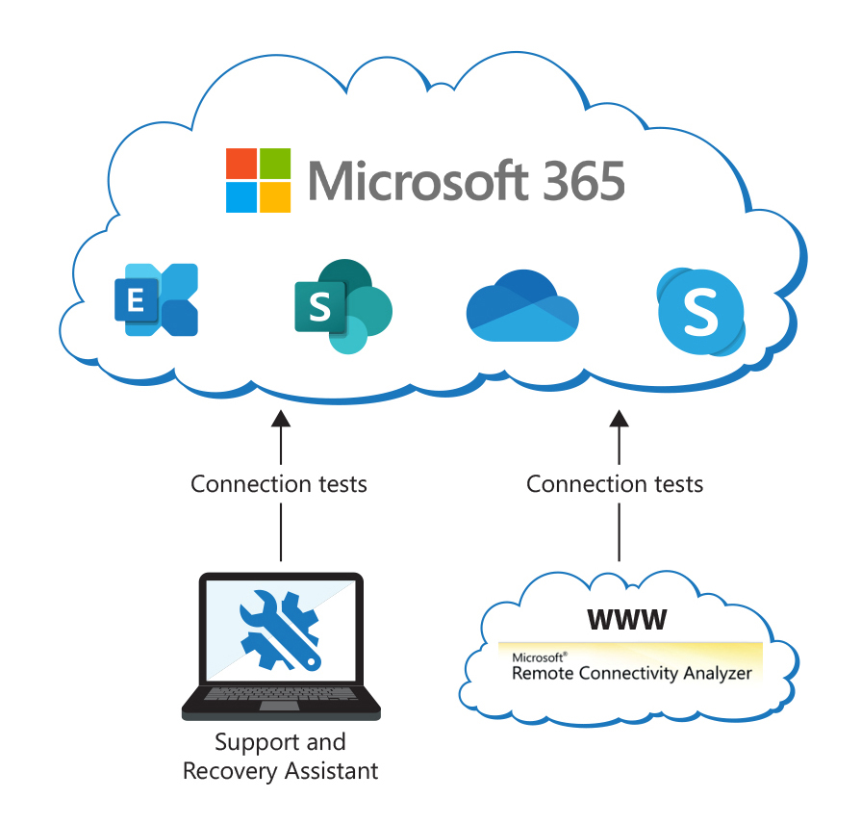
1.
Lucerne Publishing is starting to experience connectivity issues in its Microsoft 365 deployment. The problems began after it migrated its user mailboxes to Microsoft 365. The company experienced Outlook installation and activation issues, and connectivity issues with OneDrive for Business. As Lucerne's Microsoft 365 Administrator, you want to deploy a diagnostic tool to help identify and resolve these issues. You would also like a tool that generates a log file containing test results. Based on this information, which of the following tools should you use?
Microsoft 365 Support and Recovery Assistant
2.
Which of the following DNS record types must be created so that Outlook clients can use the Autodiscover process to connect to Exchange Online?
CNAME
3.
As the Microsoft 365 Administrator for Contoso, you want to implement a protocol that connects Outlook to Exchange Online in Microsoft 365. Which of the following protocols should you use?
MAPI/HTTP
Summary
Completed 100 XP
- 2 minutes
This module examined how clients connect to Microsoft 365. You initially reviewed the name resolution configurations to ensure that clients can connect without user intervention. You then examined Outlook client configuration. Finally, you reviewed some troubleshooting techniques that can be helpful for Microsoft 365 clients.
After completing this module, you should now have a greater understanding how client connectivity works in Microsoft 365, especially with Outlook. You learned how Outlook uses Autodiscover to connect an Outlook client to Exchange Online. You also reviewed the DNS records needed for Outlook and other Office-related clients to automatically locate the services in Microsoft 365 using the Autodiscover process. Finally, you learned about the connectivity protocols that enable Outlook to connect to Microsoft 365.
The module concluded with an analysis of the tools that can help you troubleshoot connectivity issues in Microsoft 365 deployments. These tools include Microsoft Remote Connectivity Analyzer and Microsoft 365 Support and Recovery Assistant.

MS-102 Manage your Microsoft 365 tenant
Manage permissions, roles, and role groups in Microsoft 365
Introduction
Completed 100 XP
- 1 minute
A Microsoft 365 subscription comes with a set of administrative roles that a Microsoft 365 administrator can assign to select users. Each admin role maps to common business functions. They give an organization's users permission to do specific tasks in the admin centers. This module provides a brief overview of the Microsoft 365 admin roles. You learn how to use roles and role groups to control who can do what in your Microsoft 365 environment. You also learn how to delegate admin roles to partners, manage permissions using administrative units, manage SharePoint permissions to prevent oversharing of data, and elevate privileges using Privileged Identity Management.
This module examines the key aspects of the Microsoft 365 permission model, such as how roles are defined, assigned, and scoped, and how they differ from other types of permissions. You also learn how to manage roles for different Microsoft 365 services, such as Exchange Online, SharePoint Online, Teams, and Microsoft Entra ID. This training highlights the best practices and security principles that organizations should follow when configuring administrative roles.
The module also explores the different types of administrator roles in Microsoft 365, including the key permissions assigned to each. An example of the built-in roles that are covered include the Global Administrator, Service Administrator, Billing Administrator, and User Management Administrator. You also learn how to delegate admin roles to external partners and how to monitor and revoke their access.
You also learn how to create and manage role groups, which enable organizations to simplify the role assignment process and consistently apply role permission. Instead of assigning roles directly to users, you create a group and assign specific roles to the group. Members of the group inherit the roles assigned to the group. Finally, you learn how to use administrative units and Privileged Identity Management to limit the scope of role assignments and delegate permissions to specific segments of your organization, and to provide just-in-time and just-enough-access to sensitive resources.
Examine the use of roles in the Microsoft 365 permission model
Completed 100 XP
- 8 minutes
Microsoft 365 is a cloud-based platform that offers various services and applications for businesses and organizations. One of the key features of Microsoft 365 is the permission model, which defines how users and groups can access and manage resources within the platform. Administrators can enhance the security, efficiency, and productivity of their Microsoft 365 environment by understanding and applying the permission model. The permission model is based on the concepts of roles, scopes, and assignments, which can be combined and configured in various ways to suit different scenarios and use cases.
- Roles. Roles are collections of permissions that allow users and groups to perform specific tasks or functions within Microsoft 365. For example, a user with the Global Administrator role can manage all aspects of the platform, while a user with the User Administrator role can only manage user accounts and licenses. There are two types of roles in Microsoft 365: built-in roles and custom roles.
  - Built-in roles. These roles are predefined and available by default in Microsoft 365. They cover the most common scenarios and use cases for the platform. There are over 30 built-in roles in Microsoft 365, such as Exchange administrator, SharePoint administrator, Teams administrator, and Security Reader.
  - Custom roles. Administrators can create custom roles to suit their specific needs and requirements. You can base custom roles on existing built-in roles or created from scratch. Custom roles can have granular permissions that allow or deny access to specific resources or actions within Microsoft 365.
- Scopes. Scopes are filters that limit the range or extent of a role. You can apply scopes to roles to restrict the access and management of resources within Microsoft 365. For example, you can apply a scope to a role to limit its effect to a specific group, department, location, or domain. There are two types of scopes in Microsoft 365: directory scopes and management scopes.
  - Directory scopes. These scopes are based on the organizational structure of Microsoft 365. You can apply directory scopes to roles to limit their effect to a specific organizational unit (OU), such as a group, a site, or a team. You can also apply directory scopes to roles to limit their effect to a specific attribute, such as a location, a department, or a job title.
  - Management scopes. These scopes are based on the service or application of Microsoft 365. You can apply management scopes to roles to limit their effect to a specific service or application, such as Exchange Online, SharePoint Online, or Teams. You can also apply management scopes to roles to limit their effect to a specific condition or criteria, such as a mailbox type, a site collection, or a team type.
- Assignments. Assignments are the links that connect roles and scopes to users and groups. Assignments are the final step in the permission model, as they determine who can do what and where within Microsoft 365. You can make assignments directly or indirectly, depending on the type of role and scope.
  - Direct assignments. These assignments are made directly to a user or a group. Direct assignments are the simplest and most straightforward way of granting permissions within Microsoft 365. You can make direct assignments to any type of role and scope, as long as the administrator has the permission to do so.
  - Indirect assignments. These assignments that are made indirectly through a membership or a rule. Indirect assignments are more dynamic and flexible than direct assignments, as they can automatically grant or revoke permissions based on changes in the membership or the rule. You can only make indirect assignments to custom roles and management scopes, as they require a more granular level of control.
Types and Categories of Roles in Microsoft 365
There are different types and categories of roles in Microsoft 365, depending on the scope and level of permissions they grant. The main types of roles are:
- Global roles. These roles are the highest-level roles that grant permissions to perform tasks across all Microsoft 365 services and features. There are only a few global roles, such as Global administrator, Global reader, and Power Platform administrator. Global roles are reserved for the most senior and trusted administrators in the organization.
- Service-specific roles. These roles grant permissions to perform tasks in a specific Microsoft 365 service, such as Exchange Online, SharePoint Online, Teams, or OneDrive. There are many service-specific roles, such as Exchange administrator, SharePoint administrator, Teams administrator, or OneDrive administrator. Service-specific roles are typically assigned to administrators who are responsible for managing and configuring a particular service.
- Feature-specific roles. These roles grant permissions to perform tasks in a specific feature or function within a Microsoft 365 service, such as security, compliance, or device management. There are many feature-specific roles, such as Security administrator, Compliance administrator, Device administrator, or Intune administrator. Feature-specific roles are typically assigned to administrators who are responsible for managing and configuring a particular aspect of the Microsoft 365 environment.
The main categories of roles are:
- Administrator roles. These roles grant permissions to perform administrative tasks, such as creating and managing users, devices, licenses, policies, settings, and reports. Administrator roles are typically assigned to administrators who must manage and configure the Microsoft 365 environment.
- Reader roles. These roles grant permissions to view information and reports, but not to make any changes or modifications. Reader roles are typically assigned to administrators who must monitor and audit the Microsoft 365 environment, but not to perform any actions.
- Application roles. These roles grant permissions to access and use certain Microsoft 365 applications, such as Power BI, Power Apps, or Power Automate. Application roles are typically assigned to users who must work with these applications, but not to administer them.

Manage roles across the Microsoft 365 ecosystem
Completed 100 XP
- 7 minutes
Administrators can maintain roles in different places, depending on the scope and level of the role. The Microsoft 365 admin center is the main place where administrators can manage the built-in and custom roles that apply across most of the platform. However, some services and applications within Microsoft 365 have their own roles that are specific to their functionality and features. For example, Microsoft Entra ID, Microsoft Defender, and Microsoft Purview have their own roles that are separate from the Microsoft 365 admin center. These roles are similar to the Microsoft 365 roles in that they're based on permissions and assignments. However, they're different in that they're scoped and managed within their respective service or application. Administrators can access and manage these roles from the service or application portal or interface. Administrators can maintain scopes and assignment in the same place where they maintain roles, as scopes and assignments are part of the role definition and configuration.
Important
Azure Active Directory (Azure AD) is now Microsoft Entra ID.
The Microsoft 365 admin center is the main portal for managing and configuring the Microsoft 365 environment. It provides a centralized and unified view of all the Microsoft 365 services and features, and allows administrators to perform various tasks, such as creating and managing users, devices, licenses, policies, settings, and reports. The Microsoft 365 admin center also allows administrators to assign roles and role groups to users, and to create and manage custom role groups. Role groups are examined in greater detail in a later unit in this module.
Role maintenance across Microsoft 365
The Microsoft 365 admin center maintains a set of roles that are applicable to all or most of the Microsoft 365 services and features. These roles include the global roles, such as Global Administrator and Global Reader, and some of the service-specific and feature-specific roles, such as Exchange Administrator, SharePoint Administrator, Security Administrator, and Compliance Administrator. These roles are usually the primary roles that administrators use to manage and configure the Microsoft 365 environment.
In comparison, some of the Microsoft 365 services and features have their own dedicated portals and admin centers, where administrators can perform more advanced and granular tasks. For example, Microsoft Entra ID, Microsoft Defender XDR, and Microsoft Purview. These services and features also maintain their own sets of roles, which are specific to their functionalities and capabilities. These roles are also known as the service, or workload roles. They're the secondary roles that administrators use to manage and configure the specific services and features.
The Microsoft 365 admin center enables you to manage Microsoft Entra roles, plus Exchange, and Intune roles. You can create role groups (also known as role assignable groups) in the Microsoft 365 admin center that can contain one or more roles. You can then assign role groups to users, in which case they inherit the roles that were assigned to role groups of which they're a member.
While Microsoft Entra roles are tenant wide, Exchange, Intune, and Purview are workload roles. When dealing with workload roles and role groups, you assign them in slightly different ways and to different identities. You can assign:
- Microsoft Entra roles to users and role assignable groups.
- Exchange roles to users and mail enabled groups.
- Intune roles to security groups.
Note
While you can create roles groups in Exchange Online and manage them through the Exchange admin center, you can't assign the Exchange role groups in the Microsoft 365 admin center. You can use the Microsoft 365 admin center to assign Exchange roles, but not Exchange role groups.
It’s also important to understand the differences and relationships between the roles that are maintained in the Microsoft 365 admin center and the roles that are maintained in the individual service portals. With this knowledge, you can assign the appropriate roles and role groups to users, depending on their responsibilities and tasks.
For example, the Exchange Administrator role that you assign in the Microsoft 365 admin center grants permissions to perform tasks in Exchange Online, such as creating and managing mailboxes, groups, and policies. However, this same role doesn’t grant permissions to perform all tasks in the Exchange admin center, such as creating and managing connectors, transport rules, and mail flow. To perform these tasks, an administrator needs to have the Exchange Online admin role within the Exchange admin center, which is a separate and more granular role. The Exchange Online admin role in the Exchange admin center can also be customized—permissions can be added or removed, and subroles can be created to tailor access.
Similarly, the Security Administrator role assigned in the Microsoft 365 admin center grants broad permissions across Microsoft’s security services, including the Microsoft Defender portal. This role allows administrators to perform many security-related tasks, such as creating and managing security policies, alerts, and reports. However, this role doesn’t automatically grant all permissions in the Defender portal. To perform advanced tasks such as managing incidents and investigations, or creating and modifying custom RBAC roles, administrators need the appropriate service-specific roles or Defender portal RBAC roles. These Defender roles can also be customized to fine-tune access and align with an organization’s security operations model.
The following table summarizes the roles and their locations.
Service or application | Roles | Location
Microsoft 365 | Built-in and custom roles | Microsoft 365 admin center
Microsoft Entra ID | Data governance roles | Microsoft Entra ID portal
Microsoft Defender XDR | Security roles | Microsoft Defender portal
Microsoft Purview | Data catalog roles | Microsoft Purview portal
Organizations must manage security scenarios that span every Microsoft 365 service. As such, they need the flexibility to give the right administrator permission to the right people in their organization. The Microsoft 365 admin center, Microsoft Defender portal, and the Microsoft Purview portal support directly managing permissions for users who perform security and compliance tasks in Microsoft 365. By using these portals to manage permissions, you can manage permissions centrally for all tasks related to security and compliance.
The following sections provide a summary of each of these portals.
Microsoft 365 admin center
The Microsoft 365 admin center provides robust capabilities for managing permissions within an organization's Microsoft 365 environment. It supports permission management through various features, including:
- User and group management. The Microsoft 365 admin center allows administrators to create and manage user accounts and groups. Administrators can assign roles and permissions to individual users or groups, granting them access to specific Microsoft 365 services and resources.
- Azure role-based access control (RBAC). The admin center implements Azure RBAC, which enables administrators to assign predefined roles with specific permissions to users. These roles include Global Administrator, User Management Administrator, Exchange Administrator, SharePoint Administrator, and more. Administrators can assign appropriate roles that control access and limit permissions based on job responsibilities.
- Service-specific permission management. Within the Microsoft 365 admin center, administrators can manage permissions for various Microsoft 365 services, such as Exchange Online, SharePoint Online, OneDrive, and Microsoft Teams. They can grant or restrict access to specific features and functions within these services, allowing fine-grained control over user capabilities.
- Application and app permissions. Administrators can manage permissions for applications and app integrations within the admin center. This process includes granting consent to non-Microsoft apps to access Microsoft 365 data on behalf of users. It also includes managing app permissions and controlling access to organizational data by external applications.
The Microsoft 365 admin center provides a comprehensive set of tools and features to directly manage permissions within the organization's Microsoft 365 environment. It enables administrators to assign roles, configure service-specific permissions, and ensure efficient and secure access control across the Microsoft 365 ecosystem.
Microsoft Entra ID portal
Microsoft Entra ID is an Identity as a Service (IaaS) solution that offers robust features for managing identity and access. For security teams, Microsoft Entra ID provides essential functionalities to enhance security posture and protect organizational resources. The roles maintained in the Microsoft Entra ID portal are secondary and specific roles that grant permissions to perform tasks in Microsoft Entra ID, such as creating and managing identities, access policies, and governance. Some of the Microsoft Entra ID roles are derived from the Microsoft 365 roles, such as Identity Administrator and Identity Reader. Other Microsoft Entra ID roles are unique to the service, such as Identity Governance Administrator and Entitlement Management Administrator.
Some of the key security features in the Microsoft Entra ID portal include:
- Conditional access policies. Security teams can define granular access policies based on factors like user location, device type, and risk profile. Doing so allows them to enforce specific security measures for different scenarios.
- Risk-based authentication. Microsoft Entra ID evaluates user behavior and context to determine risk levels. Security teams can implement extra authentication steps when suspicious activity is detected, bolstering security.
- Identity insights and monitoring. The portal offers visibility into user identities, sign-in activity, and license utilization. Security teams can monitor trends, detect anomalies, and respond promptly to potential threats.
- Passwordless authentication. Because Microsoft Entra ID supports passwordless authentication, it reduces reliance on traditional passwords, mitigating common security risks associated with password-based access.
- Data residency and security. Microsoft Entra ID securely manages identity and access data in the cloud, enabling mobility scenarios while ensuring robust security measures for organizations.
The Microsoft Entra ID portal serves as a pivotal hub for identity management and access control. It empowers security teams to efficiently manage user identities, enforce access policies, and enhance overall security across the organization.
Microsoft Defender portal
The Microsoft Defender portal is a centralized management console that provides security teams with a comprehensive view of their organization's security posture and helps them protect their digital assets. Microsoft designed the portal for threat protection, detection, investigation, and response across various Microsoft 365 services. The roles maintained in the Microsoft Defender portal are secondary and specific roles that grant permissions to perform tasks in Microsoft Defender XDR, such as creating and managing incidents, investigations, and actions. Some of the Microsoft Defender XDR roles are derived from the Microsoft 365 roles, such as Security Administrator and Security Reader. Other Microsoft Defender XDR roles are unique to the service, such as Incident Responder and Threat Hunter.
Some key functionalities of the Microsoft Defender portal include:
- Threat investigation. The Microsoft Defender portal allows security analysts to investigate and respond to security threats across Microsoft 365 services. For example, Exchange Online, SharePoint Online, OneDrive, Microsoft Teams, and more. It provides a unified view of security alerts and helps identify potential threats.
- Incident management. Administrators can use the Microsoft Defender portal to track, manage, and collaborate upon security incidents within the portal. It enables security teams to triage, assign ownership, and track the progress of incidents, ensuring timely resolution.
- Advanced hunting. The Microsoft Defender portal provides access to powerful query-based hunting capabilities. Security analysts can use the Microsoft Defender Advanced Hunting language (Kusto Query Language) to search for specific indicators of compromise (IOCs) or investigate potential threats proactively.
- Threat analytics. The Microsoft Defender portal offers security reports and insights, using advanced analytics and machine learning. This functionality helps organizations understand their security posture, identify trends, and prioritize actions. Organizations can use these insights to strengthen security policies and implement proactive measures.
- Integration with Microsoft 365 services. The Microsoft Defender portal integrates with other Microsoft security services, such as Microsoft Defender for Endpoint, Microsoft Defender for Office 365, and Microsoft Cloud App Security. This integration provides a holistic view of security across the organization.
The Microsoft Defender portal serves as a central hub for security operations in Microsoft 365. It enables security teams to effectively detect, investigate, and respond to threats while enhancing the overall security posture of the organization.
Microsoft Purview portal
The Microsoft Purview portal is a centralized hub within Microsoft 365 that helps organizations meet their regulatory and compliance requirements. It provides a range of tools, features, and resources to manage compliance-related tasks, assess risk, and protect sensitive data. The roles maintained in the Microsoft Purview portal are a subset of the Microsoft Entra roles. They grant permissions to perform tasks in Microsoft Purview, such as creating and managing data sources, data assets, data policies, and data insights. Some of the Microsoft Purview roles are derived from the Microsoft 365 roles, such as Compliance Administrator and Compliance Reader. Other Microsoft Purview roles are unique to the service, such as Data Source Administrator and Data Asset Curator.
Some key functionalities of the Microsoft Purview portal include:
- Compliance management. The Microsoft Purview portal allows organizations to define and manage compliance policies based on industry regulations and internal requirements. It provides a framework to track and monitor compliance activities across Microsoft 365 services, such as Exchange Online, SharePoint Online, OneDrive, Microsoft Teams, and more.
- Data protection. The Microsoft Purview portal offers features to help protect sensitive data and ensure compliance with privacy regulations. These features include data loss prevention (DLP) policies, information barriers, sensitivity labels, and advanced data governance capabilities.
- Risk assessment and insights. The Microsoft Purview portal provides tools to assess and mitigate risks associated with data and compliance. It offers features like Compliance Score, which assesses an organization's compliance posture and provides recommendations for improvement. It also includes advanced analytics and insights to identify data risks and trends.
- E-discovery and legal hold. The Microsoft Purview portal facilitates the discovery and preservation of electronically stored information (ESI) for legal and regulatory purposes. It provides capabilities for searching, identifying, and exporting relevant data across Microsoft 365 services. Doing so ensures organizations can respond to legal requests and litigation requirements.
- Compliance reporting and auditing. The Microsoft Purview portal offers reporting capabilities to monitor and audit compliance activities within the organization. The portal provides predefined compliance reports, plus the ability to create custom reports, helping organizations demonstrate adherence to regulatory requirements.
- Collaboration and training. The Microsoft Purview portal provides collaboration features to enable cross-functional teams to work together on compliance-related tasks. It also offers training resources and best practices to help organizations educate their employees on compliance requirements and promote a culture of compliance.
The Microsoft Purview portal helps organizations manage their compliance obligations, protect sensitive data, and mitigate risks within their Microsoft 365 environment. Microsoft designed the portal to help simplify compliance management, streamline processes, and provide the necessary tools to meet regulatory requirements.
Explore administrator roles in Microsoft 365
200 XP
- 10 minutes
A Microsoft 365 subscription comes with a set of built-in administrator roles that you can assign to users in your organization using the Microsoft 365 admin center. Each admin role maps to common business functions. They give people in your organization permissions to do specific tasks in the admin centers. Organizations use administrator roles in Microsoft Entra ID to manage all products in Microsoft 365.
Note
The Microsoft 365 admin center lets you manage Microsoft Entra roles and Microsoft Intune roles. However, these roles are a subset of the roles available in the Microsoft Entra admin center and the Intune admin center.
Microsoft 365 uses a permission model referred to as Azure Role-Based Access Control (RBAC). The Azure RBAC model makes it easy to assign permissions to a user. In Microsoft 365, an administrator can assign each user a role that has predefined permissions assigned to it. So instead of assigning multiple permissions to a user, you assign them a role that has those permissions defined. This model makes permission management much more efficient and effective.
Microsoft 365 provides several predefined administrator roles, which provide permissions to do administrative tasks. As such, a Microsoft 365 administrator must carefully plan which users to assign to each role. It's important that you ensure those people are responsible and trustworthy. Each admin role maps to common business functions and gives people in your organization permissions to do specific tasks in the Microsoft 365 admin center.
To manage permissions, you must either be a Global administrator or a member of the Organization Management role group. Specifically, the Role Management role allows users to view, create, and modify role groups in the Microsoft Defender portal. By default, the system assigns the Role Management role to the Organization Management role group.
Other online services have their own permission models. For example, Exchange Online uses a model similar to Azure RBAC to define administrator roles. However, it also uses a security model based on individual permissions for its mailboxes. SharePoint Online has its own security permission model based on security groups, permissions, and permission levels. This model enables administrators to assign individual permissions or groups of permissions to its resources, such as site collections, sites, and documents.
Security guidelines for assigning roles
Because administrators have access to sensitive data and files, Microsoft recommends following these guidelines to keep your organization's data more secure.
Recommendation | Why is this recommendation important?
Only establish two to four global administrators. | A Global administrator is the only user who can reset another Global administrator's password. As such, Microsoft recommends that you have at least two Global administrators in your organization in the event one of them experiences an account lockout.  The Global administrator has almost unlimited access to your organization's settings and most of its data. As such, Microsoft also recommends that you don't have more than four Global administrators due to the security threat posed from having too many global admins.
Assign the least permissive role. | Assigning the least permissive role means giving administrators only the access they need to get the job done.  For example, if you want someone to reset employee passwords, you shouldn't assign the unlimited Global administrator role. Instead, you should assign a limited administrator role, like Password administrator or Helpdesk administrator. This guideline helps keep your data secure.
Require multifactor authentication (MFA) for administrators. | It's a good idea to require MFA for all your users. However, Microsoft recommends that organizations require all their administrators use MFA to sign in. MFA makes users enter a second method of identification to verify they are who they say they are.  Administrators can access customer and employee data. If you require MFA, then even if the admin's password gets compromised, the password is useless without the second form of identification.  When you turn on MFA, the next time the user signs in, they must provide an alternate email address and phone number for account recovery.
Users can receive a message in the admin center indicating they don't have permissions to edit a setting or page. The system sends this message because the user is assigned roles that don't have that permission.
Commonly used Microsoft 365 admin center roles
In the Microsoft 365 admin center, you can go to Role assignments, and then select any role to open its detail pane. To view the detailed list of tasks that a user assigned to that role can perform, select the Permissions tab. Select the Assigned or Assigned admins tab to add users to roles.
The page displays a list of common roles that most organizations use. The following table displays the roles most commonly assigned by an organization.
Admin role (alphabetical order) | Who should be assigned this role?
Billing administrator | Assign the Billing admin role to users who make purchases, manage subscriptions and service requests, and monitor service health.  Billing admins also can:  - Manage all aspects of billing.  - Create and manage support tickets in the Microsoft Entra admin center.
Compliance administrator | Assign the Compliance admin role to users who are responsible for helping your organization:  - Stay compliant with any regulatory requirements.  - Manage eDiscovery cases.  - Maintain data governance policies across Microsoft 365 locations, identities, and apps.  - Monitor compliance-related policies across Microsoft 365 services.  - Manage compliance alerts.  - Perform legal and data investigations.  - Manage Data Subject Requests.  - View all Intune audit data.
Exchange administrator | Assign the Exchange admin role to users who need to view and manage your user's email mailboxes, Microsoft 365 groups, and Exchange Online. The Exchange admin is also responsible for managing message flow in Microsoft 365.  Exchange admins can also:  - Recover deleted items in a user's mailbox.  - Determine how long to retain deleted email before the system permanently deletes it.  - Set up mailbox features such as the mailbox sharing policy, which determines how users can share calendar and contacts information with others outside of your organization.  - Set up, Send As, and Send on Behalf delegates for someone's mailbox; for example, when an executive wants their assistant to have permission to send mail on the executive's behalf.  - Create shared mailboxes so a group of people can monitor and send email from a common email address.  - Set up anti-spam and malware filters for the organization.  - Manage Microsoft 365 Groups.  For users assigned the Exchange Administrator role, Microsoft recommends that you also assign them the Service Administrator role. This way they can see important information in the Microsoft 365 admin center. For example, the health of the Exchange Online service, and change and release notifications.
Global administrator | Assign the Global administrator role to users who need access to all administrative features in Microsoft Entra ID, plus services that use Microsoft Entra identities like the Microsoft 365 Defender portal, the Microsoft Purview compliance portal, Exchange Online, SharePoint Online, and Skype for Business Online. Global Administrators can view Directory Activity logs. They can also elevate their access to manage all Azure subscriptions and management groups. This design allows Global Administrators to get full access to all Azure resources using the respective Microsoft Entra tenant.  The person who signs up for Microsoft 365 online services in their Microsoft Entra organization is automatically assigned the Global Administrator role. There can be more than one Global Administrator at your company. Global Administrators can reset the password for any user and all other administrators. A Global Administrator can't remove their own Global Administrator assignment. This rule prevents a situation where an organization has zero Global Administrators.  Only Global admins can:  - Reset passwords for all users, including other Global admins.  - Add and manage domains.  - Unblock another Global admin.
Global reader | Assign the Global reader role to users who can read settings and administrative information across Microsoft 365 services, but who can't take management actions. Global Reader is the read-only counterpart to Global Administrator. Assign Global Reader instead of Global Administrator for planning, audits, or investigations.  Use Global Reader in combination with other limited admin roles like Exchange Administrator to make it easier to get work done without the assigning the Global Administrator role. Global Reader works with the Microsoft 365 admin center, Exchange admin center, SharePoint admin center, Teams admin center, Microsoft 365 Defender portal, Microsoft Purview compliance portal, Azure portal, and Device Management admin center.  Users with this role can't access the Purchase Services area in the Microsoft 365 admin center.
Groups administrator | Assign the Groups admin role to users who need to create/manage groups and its settings, such as naming and expiration policies. It's important to understand that assigning a user to this role gives them the ability to manage all groups in the organization across various workloads like Teams, SharePoint, Yammer, and Outlook. A Group[s admin can also manage the various groups settings across various admin portals, such as the Microsoft 365 admin center, Azure portal, and workload specific ones like Teams and SharePoint admin centers.  Groups admins can:  - Create, edit, delete, and restore Microsoft 365 groups.  - Create and update group creation, expiration, and naming policies.  - Create, edit, and delete Microsoft Entra security groups.
Helpdesk administrator | Assign the Helpdesk admin role to users who must change passwords, invalidate refresh tokens, create and manage support requests with Microsoft for Azure and Microsoft 365 services, and monitor service health. Invalidating a refresh token forces the user to sign in again. Whether a Helpdesk Administrator can reset a user's password and invalidate refresh tokens depends on the role the user is assigned.  Users with this role can change passwords for people who might have access to sensitive or private information or critical configuration inside and outside of Microsoft Entra ID. Changing the password of a user might mean the ability to assume that user's identity and permissions.  Helpdesk admins can also:  - Reset passwords.  - Force users to sign out.  - Manage service requests.  - Monitor service health.  The Helpdesk admin can only help nonadmin users and users assigned the following roles:  - Directory reader  - Guest inviter  - Helpdesk admin  - Message center reader  - Reports reader
License administrator | Assign the License admin role to users who must read, add, remove, and update license assignments on users and groups (using group-based licensing). This role can also manage the usage location on users. The role doesn't grant the ability to purchase or manage subscriptions, create or manage groups, or create or manage users beyond the usage location. This role has no access to view, create, or manage support tickets.  License admins also can:  - Reprocess license assignments for group-based licensing.  - Assign product licenses to groups for group-based licensing.
Message center reader | Assign the Message center reader role to users who must monitor notifications and advisory health updates in the Message center for their organization on configured services such as Exchange, Intune, and Microsoft Teams. Message Center Readers receive weekly email digests of posts, updates, and can share message center posts in Microsoft 365. In Microsoft Entra ID, users assigned to this role have read-only access on Microsoft Entra services such as users and groups. This role has no access to view, create, or manage support tickets.
Office Apps administrator | Assign the Office Apps admin role to users who need to manage Microsoft 365 apps' cloud settings, cloud policies, self-service download management. This role also grants the ability to manage support tickets, monitor service health within the main admin center, and view the Office apps-related report. Users assigned to this role can also manage communication of new features in Office apps.  Office Apps admins can also:  - Use the Office cloud policy service to create and manage cloud-based policies for Office.  - Create and manage service requests.  - Manage the What's New content that users see in their Office apps.  - Monitor service health.
Password administrator | Assign the Password admin role to a user who needs to reset passwords for nonadministrators and Password Administrators. Users with this role have limited ability to manage passwords. This role doesn't grant the ability to manage service requests or monitor service health. Whether a Password Administrator can reset a user's password depends on the role the user is assigned. For a list of the roles that a Password Administrator can reset passwords for, see Who can reset passwords.
Power Platform administrator | Assign the Power Platform admin role to users who must complete the following tasks:  - Manage all admin features for Power Apps, Flows, and Data loss prevention policies.  - Create and manage service requests.  - Monitor service health.
Reports reader | Assign the Reports reader role to users who must view usage reporting data and the reports dashboard in Microsoft 365 admin center and the adoption context pack in Fabric and Power BI. This role also provides access to all sign-in logs, audit logs, and activity reports in Microsoft Entra ID and data returned by the Microsoft Graph reporting API. A user assigned to the Reports Reader role can access only relevant usage and adoption metrics. They don't have any admin permissions to configure settings or access the product-specific admin centers like Exchange. This role has no access to view, create, or manage support tickets.  Users who are assigned the Reports reader role can also:  - View usage data and the activity reports in the Microsoft 365 admin center.  - Get access to the Power BI adoption content pack.  - Get access to sign-in reports and activity in Microsoft Entra ID.  - View data returned by Microsoft Graph reporting API.
Security administrator | Assign the Security admin role to admins who control your organization's overall security. They do so by managing security policies, reviewing security analytics and reports across Microsoft 365 products, and staying up-to-speed on the threat landscape. Users with this role have permissions to manage security-related features in the Microsoft 365 Defender portal, Microsoft Entra ID Protection, Microsoft Entra Authentication, Azure Information Protection, and Microsoft Purview compliance portal.  Security admins can also:  - Manage security threats and alerts.  - View reports.  - Monitor and respond to suspicious security activity.  - Assign roles.  - Manage machine groups.  - Configure endpoint threat detection and automated remediation.  - View, investigate, and respond to alerts.  - View machines/device inventory.  - View user, device, enrollment, configuration, and application information in Intune.  - Define the threshold and duration for lockouts when failed sign-in events happen.  - Configure custom banned password list or on-premises password protection.
Service Support administrator | Assign the Service Support admin role to users who must create and manage support requests with Microsoft for Azure and Microsoft 365 services, and view the service dashboard and message center in the Azure portal and Microsoft 365 admin center.  You should assign this role as an extra role to admins or users who must complete the following tasks besides their usual admin role:  - Open and manage service requests.  - View and share message center posts.  - Monitor service health.
SharePoint administrator | Assign the SharePoint admin role to users who need to access and manage the SharePoint Online admin center. Users with this role have global permissions within Microsoft SharePoint Online, when the service is present. They can also create and manage all Microsoft 365 groups, manage support tickets, and monitor service health.  This role also grants scoped permissions to the Microsoft Graph API for Microsoft Intune, allowing the management and configuration of policies related to SharePoint and OneDrive resources.  SharePoint admins can also:  - Create and delete sites.  - Manage site collections and global SharePoint settings.  - Define the user profile policies and settings for the organization, including management of promoted sites.  - Create Business Connectivity Services (BCS) connections to data sources that are outside the SharePoint Online site.  - Manage records in place, which means that you can leave a document in its current location on a site, or store records in a specific archive.  - Customize the search experience for users.  - Configure SharePoint Online hybrid with an on-premises SharePoint Online site.  - Use InfoPath Forms Services in SharePoint Online to deploy the organization's forms to its sites, enabling users to fill out these forms in a web browser.
Teams administrator | Assign the Teams administrator role to users who must manage all aspects of the Microsoft Teams workload through the Microsoft Teams & Skype for Business admin center and the respective PowerShell modules. These areas also include all management tools related to telephony, messaging, meetings, and the teams themselves. This role additionally grants the ability to create and manage all Microsoft 365 groups, manage support tickets, and monitor service health.  Teams administrator can also:  - Manage and create Microsoft 365 groups.  - Manage meetings.  - Manage conference bridges.  - Manage all org-wide settings, including federation, teams upgrade, and teams client settings.  - Troubleshoot communication issues within Teams.
User administrator | Assign the User admin role to users who must complete the following tasks for all users:  - Add users and groups.  - Assign licenses.  - Manage most users properties.  - Create and manage user views.  - Update password expiration policies.  - Manage service requests.  - Monitor service health.  The user admin can also complete the following actions:  - Manage usernames.  - Delete and restore users.  - Reset passwords.  - Force users to sign out.  - Update (FIDO) device keys.  The user admin can complete these tasks for users who aren't admins and for users assigned the following roles:  - Directory reader  - Guest inviter  - Helpdesk admin  - Message center reader  - Reports reader  Users with this role can change passwords for people who might have access to sensitive or private information or critical configuration inside and outside of Microsoft Entra ID. Changing the password of a user might mean the ability to assume that user's identity and permissions.
Tip
If you can't find a role in this list, go to the bottom of the list and select Show all by Category. This option sorts all available roles by category.
Additional reading. For more information, including the Windows PowerShell cmdlets associated with a role, see Microsoft Entra built-in roles.
Knowledge check
Choose the best response for the following question.
Check your knowledge

1.
Fabrikam is implementing Microsoft 365. The company's Microsoft 365 administrator, Holly Dickson, was automatically assigned the Global Administrator role when the company signed up for their Microsoft 365 services. Holly has since assigned the Global administrator role to two other users. One of those users needs access to all administrative features in Microsoft Entra ID, plus services that use Microsoft Entra identities. The other user manages Microsoft 365 apps' cloud settings, cloud policies, and self-service download management. Holly also enabled MFA for all Fabrikam users. Which of the following security guidelines recommended by Microsoft did Holly violate?

Assign least permissive roles.
Correct. Assigning the least permissive role means giving administrators only the access they need to get the job done. Holly assigned the Global admin role to a user who manages Microsoft 365 apps' cloud settings, cloud policies, self-service download management. Holly should have assigned this user a limited administrator role, like Office apps administrator. This guideline helps to secure an organization's data.
Examine best practices when configuring administrative roles
Completed 100 XP
- 4 minutes
This unit describes some of the key best practices for using Microsoft Entra role-based access control. Microsoft derived these best practices from its experience over the years with role-based access control and the experiences of its customer base.
1. Manage to least privilege
First and foremost when planning your access control strategy is to manage to least privilege. Least privilege means you grant your administrators exactly the permissions they need to do their job.
There are three aspects to consider when assigning a role to your administrators:
- a specific set of permissions
- over a specific scope
- for a specific period of time
Important
Organizations should avoid assigning broader roles at broader scopes even if it initially seems more convenient to do so. By limiting roles and scopes, organizations limit what resources are at risk if their security principle ever becomes compromised.
Microsoft Entra role-based access control supports over 65 built-in roles. There are Microsoft Entra roles to manage directory objects like users, groups, and applications. There are other roles to manage Microsoft 365 services like Exchange, SharePoint, and Intune.
To better understand Microsoft Entra built-in roles, see Understand roles in Microsoft Entra. If there isn't a built-in role that meets your need, you can create your own custom roles.
Follow these steps to help you find the right role.
- Sign in to the Microsoft Entra admin center.
- In the left-hand navigation pane, select Show more.
- In the left-hand navigation pane, select Roles & admins, and then under this group, select Roles & admins to see the list of Microsoft Entra roles.
- In the Roles and administrators | All roles page, you can optionally use the +Add filters feature to create a filter that narrows down the list of roles.
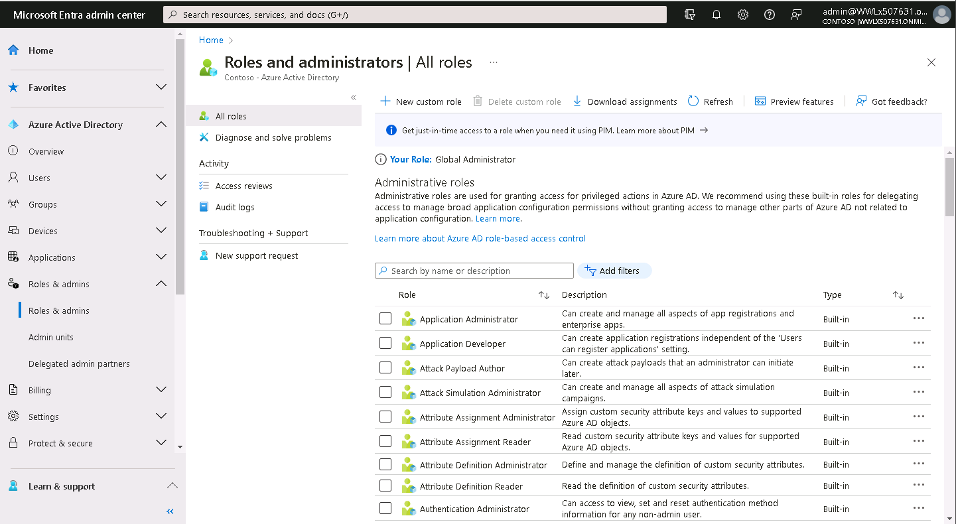
Refer to the Microsoft Entra built-in roles documentation. The system lists together the permissions associated with each role for better readability. To understand the structure and meaning of role permissions, see How to understand role permissions.
Additional reading. For more information, see Least privileged role by task.
2. Use Privileged Identity Management to grant just-in-time access
One of the principles of least privilege states that you should only grant access for a specific period of time. Microsoft Entra Privileged Identity Management (PIM) lets you grant just-in-time access to your administrators. Microsoft recommends that you enable PIM in Microsoft Entra ID.
In PIM, you can make a user an eligible member of a Microsoft Entra role. The user can then activate the role for a limited time when needed. Users assigned the Privileged Role Administrator role can manage PIM and update role assignments for other users. Both the Global Administrator and the Privileged role administrator can assign administrator roles. However, Microsoft encourages organizations to have the Privileged role administrator manage administrator role assignments through Microsoft Entra PIM based on the principle of least privilege.
PIM automatically removes access when the timeframe expires. You can also configure PIM settings to require approval or receive notification emails when someone activates their role assignment. Notifications provide an alert when administrators add new users to highly privileged roles.
3. Turn on multifactor authentication for all your administrator accounts
Based on Microsoft's studies, users have a 99.9% less likely chance of becoming compromised if they use multifactor authentication (MFA).
Organizations can enable MFA on Microsoft Entra roles using two methods:
- Role settings in Privileged Identity Management
- Conditional Access
4. Configure recurring access reviews to revoke unneeded permissions over time
Access reviews enable organizations to review administrator's access regularly to make sure only the right people have continued access. Organizations should regularly audit their administrators. Doing so is crucial for following reasons:
- A malicious actor can compromise an account.
- People often move across teams within a company. If an organization doesn't enable auditing, its users can amass unnecessary access over time.
Additional reading. For information about access reviews for roles, see Create an access review of Microsoft Entra roles in PIM.
For more information about access reviews of groups and assigned roles, see Create an access review of groups and applications in Microsoft Entra access reviews.
5. Limit the number of Global Administrators to less than five
As a best practice, Microsoft recommends that you assign the Global Administrator role to fewer than five people in your organization. Because Global Administrators hold the keys to the kingdom, organizations should keep the attack surface low.
Important
This is all the more reason for organizations to manage to least privilege and only grant their administrators exactly the permissions they need to do their job.
As stated previously, organizations should protect all Global administrator user accounts with multifactor authentication.
By default, when a user signs up for a Microsoft cloud service, the system automatically creates a Microsoft Entra tenant and makes the user a member of the Global Administrators role. Users assigned the Global Administrator role can read and modify every administrative setting in a Microsoft Entra organization. With a few exceptions, Global Administrators can also read and modify all configuration settings in their Microsoft 365 organization. Global Administrators can also elevate their access to read data.
Tip
Microsoft recommends that organizations keep two "break glass" accounts that they permanently assign to the Global Administrator role. They should also ensure these accounts don't require the same MFA mechanism as their normal administrative accounts to sign in, as described in Manage emergency access accounts in Microsoft Entra.
6. Use groups for Microsoft Entra role assignments and delegate the role assignment
If you have an external governance system that takes advantage of groups, then you should consider assigning roles to Microsoft Entra groups instead of individual users. You can also manage role-assignable groups in PIM to ensure there are no standing owners or members in these privileged groups. For more information, see Privileged Identity Management (PIM) for Groups (preview).
You can assign an owner to role-assignable groups. Because the owner decides who gets added to or removed from the group, they indirectly decide who gets the role assignment. In this way, a Global Administrator or Privileged Role Administrator can delegate role management on a per-role basis by using groups. For more information, see Use Microsoft Entra groups to manage role assignments.
7. Use cloud native accounts for Microsoft Entra roles
Organizations should avoid using on-premises synced accounts for Microsoft Entra role assignments. The reason behind this best practice is that if an on-premises account becomes compromised, it can also compromise the company's Microsoft Entra resources.

Assign admin roles to users in Microsoft 365
Completed 100 XP
- 7 minutes
Microsoft 365 uses administrator roles to assign specific administrative functions to users. Each administrator role maps to common business functions and gives users permissions to do specific tasks in the Microsoft 365 admin center. Administrators manage the Microsoft 365 admin roles using the Microsoft 365 admin center or Windows PowerShell.
Individual service administrators can administer their services on the highest level, while the Global administrator role simply includes all these service administrator roles. The following diagram shows this relationship.
Note
All service administrator roles are included in the Global administrator role, not just the four service admin roles shown here. The purpose of the following diagram is to illustrate the relationship between all service administrator roles and the Global administrator role.
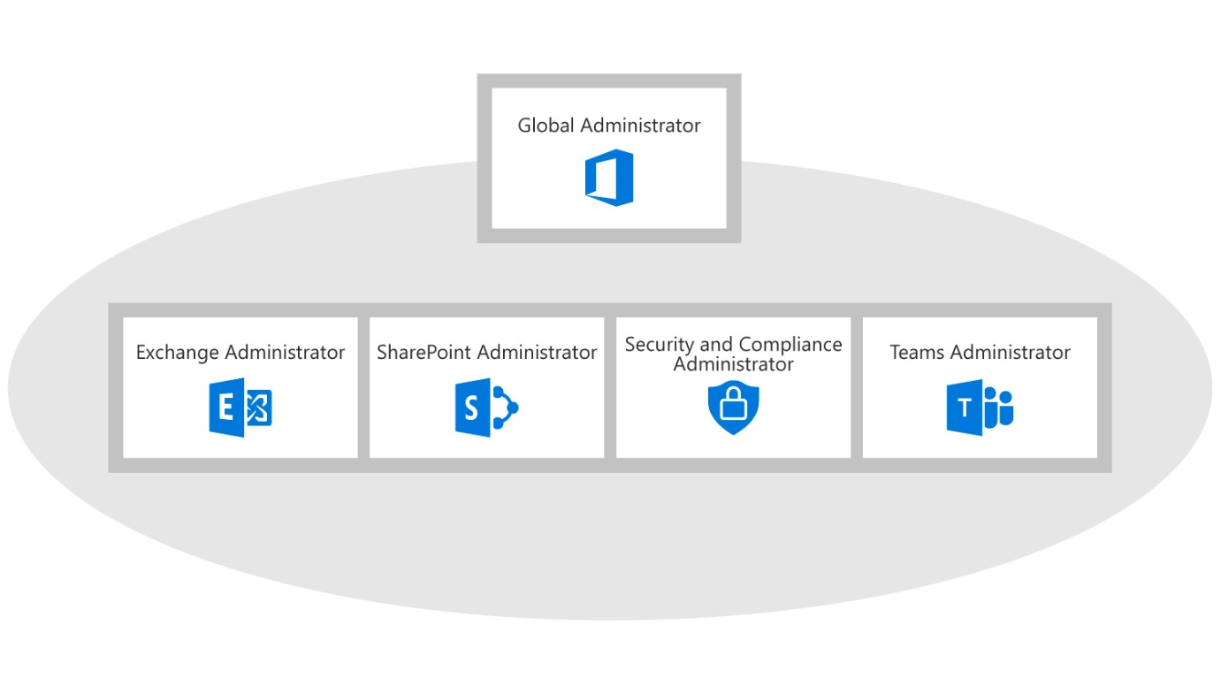
Assign admin roles in Microsoft 365
The Microsoft 365 administrator roles aren't mutually exclusive. An administrator can optionally combine them by assigning multiple admin roles to a user, such as the Exchange admin, SharePoint admin, and User Management admin roles.
Admin roles are based on groups held in Microsoft Entra ID. Even though the Microsoft Entra admin center doesn't display these groups, an administrator can assign them in either the Microsoft 365 admin center or Windows PowerShell.
To assign admin roles in Microsoft 365 admin center, you must sign in using a Global admin account and follow these steps:
- In the Microsoft 365 admin center, select Users, and then select Active Users.
- On the Active users page, choose the user whose administrator role you want to change. The Properties page for the user opens.
- Next to Roles, select Edit.
- On the Edit user roles page, choose one of the following options:
  - User (no administrator access)
  - Global administrator
  - Customized administrator (to see a list of admin roles)
- You use the Alternative email address field for important notifications, including resetting your administrator password. You can enter an email address that's not connected to Microsoft 365.
- To close the Edit user roles page, select Save.
Assign admin roles in Windows PowerShell
Microsoft 365 administrators who prefer to use Windows PowerShell to perform Microsoft 365 tenant maintenance can use the Microsoft Graph PowerShell module to assign administrator roles. An administrator needs to following pieces of data to assign an admin role to a user:
- The object ID of the user.
- The object ID of the directory role.
You can get the object ID of the user by using the Get-MgUser cmdlet to get a list of all the users. For example:
PowerShell
Install-Module Microsoft.Graph -Scope CurrentUser
Import-Module Microsoft.Graph.Identity.DirectoryManagement
Connect-MgGraph -Scopes 'User.Read.All', 'RoleManagement.ReadWrite.Directory'
Get-MgUser -All | Format-List ID, DisplayName, Mail, UserPrincipalName

Id : e4e2b110-8d4f-434f-a990-7cd63e23aed6
DisplayName : Joni Sherman
Mail : JoniS@contoso.com
UserPrincipalName : JoniS@contoso.com

Id : dba12422-ac75-486a-a960-cd7cb3f6963f
DisplayName : Adele Vance
Mail : AdeleV@contoso.com
UserPrincipalName : AdeleV@contoso.com
To retrieve the object ID of the role, it's important to note that Microsoft Graph PowerShell only displays the admin roles that are "activated" (another term for activated roles is "enabled" roles). The system activates a role when you perform one of the following tasks:
- You manually activate the role (even if it has no users assigned to it).
- You assign one or more active users to the role.
To view the activated roles, run the Get-MgDirectoryrole cmdlet. If the role you want to assign appears in this list, then you can add the activated role to a user account. However, if you don't see the role in the list, you must activate it first before assigning it to a user.
To retrieve the object ID of a particular role, you can run the following command to display a list of all activated directory roles:
PowerShell
Get-MgDirectoryRole | Format-List

DeletedDateTime :
Description : Can manage all aspects of Microsoft Entra ID and Microsoft services that use Microsoft Entra identities.
DisplayName : Global Administrator
Id : a2d10e79-df32-47fc-86ef-64d199860810
Members :
RoleTemplateId : 1f12db9c-dbb3-410d-a893-4c0bc322bf85
ScopedMembers :
AdditionalProperties : {}
Assign an activated role to a user account
In the prior example, only one activated role exists - the Global Administrator role. Let's assume you want to assign Joni Sherman to this role. Since you now have the object ID for both the user and the role, you can assign the user to the role by running the following commands.
Note
The first command sets the value of the variable $UserObjectId to the user's object ID. The second command uses the New-MgDirectoryRoleMemberRef cmdlet to assign the value of this variable to the Global Administrator role, which is the directory role defined by the DirectoryRoleId.
PowerShell
$UserObjectId = @{ "@odata.id" = "https://graph.microsoft.com/v1.0/directoryObjects/e4e2b110-8d4f-434f-a990-7cd63e23aed6" }

New-MgDirectoryRoleMemberByRef -DirectoryRoleId 'a2d10e79-df32-47fc-86ef-64d199860810' -BodyParameter $UserObjectId
Activate a role using the role's template and then add the role to a user
In the prior example, only the Global Administrator role appeared in the list of activated roles when you ran the Get-MgDirectoryRole command. Let's assume you now want to assign Adele Vance to the Helpdesk Administrator role. Since the role isn't in the list, it's not active. As such, you can't assign Adele to the role. To resolve this issue, you must first activate the Helpdesk Administrator role by using its corresponding directory role template ID.
To do so, you must acquire the object ID of both the role and the role's template. You can then activate the role from the role template by running the New-MgDirectoryRole cmdlet. The following example displays the PowerShell commands required to complete these steps.
PowerShell
# Run the following steps to activate the Helpdesk Administrator role.

# Step 1 - Run the Get-MgDirectoryRoleTemplate command to display the list of templates for all Microsoft Entra roles. Since you plan to activate the Helpdesk Administrator role from the Helpdesk Administrator role template, you must run the command to get the object Id of this role template.

Get-MgDirectoryRoleTemplate -All | Format-List ID, DisplayName

Id : a2d10e79-df32-47fc-86ef-64d199860810
DisplayName : Global Administrator

Id : fe930be7-5e62-47db-91af-98c3a49a38b1
DisplayName : User Administrator

Id : 95e79109-95c0-4d8e-aee3-d01accf2d47b
DisplayName : Helpdesk Administrator

and so on...

# Step 2 - Activate the directory role that's based on the Helpdesk Administrator role template. Copy and paste the object Id of the Helpdesk Administrator role template from the prior command into this New-MgDirectoryRole command.

New-MgDirectoryRole -roleTemplateId '95e79109-95c0-4d8e-aee3-d01accf2d47b'

# Step 3 - Verify the Helpdesk Administrator role now appears in the list of activated roles. When you ran the Get-MgDirectoryRole command in the prior example, only the Global Administrator role appeared. After activating the Helpdesk Administrator role from its template, this role should now appear along with the Global Administrator role.

Get-MgDirectoryRole | Format-List

DeletedDateTime :
Description : Can reset passwords for non-administrators and Helpdesk Administrators.
DisplayName : Helpdesk Administrator
Id : 227ec638-37b9-4eb7-a661-2773dcce2b36
Members :
RoleTemplateId : 95e79109-95c0-4d8e-aee3-d01accf2d47b
ScopedMembers :
AdditionalProperties : {}

DeletedDateTime :
Description : Can manage all aspects of Microsoft Entra ID and Microsoft services that use Microsoft Entra identities.
DisplayName : Global Administrator
Id : a2d10e79-df32-47fc-86ef-64d199860810
Members :
RoleTemplateId : 1f12db9c-dbb3-410d-a893-4c0bc322bf85
ScopedMembers :
AdditionalProperties : {}
After you verified that you activated the Helpdesk Administrator role in Step 3, you must run the following commands to assign Adele Vance to the role.
- The first command sets the value of the variable $UserObjectId to Adele Vance's object ID.
- The second command uses the New-MgDirectoryRoleMemberRef cmdlet to assign the value of this variable to the Helpdesk Administrator role. This role is the directory role defined by the DirectoryRoleId.
PowerShell
$UserObjectId = @{ "@odata.id" = "https://graph.microsoft.com/v1.0/directoryObjects/dba12422-ac75-486a-a960-cd7cb3f6963f" }

New-MgDirectoryRoleMemberByRef -DirectoryRoleId '227ec638-37b9-4eb7-a661-2773dcce2b36' -BodyParameter $UserObjectId

Delegate admin roles to partners
Completed 100 XP
- 4 minutes
If an organization doesn't have in-house administrators, it can outsource its Microsoft 365 administration to a Microsoft partner. For example, Adventure Works Cycles is regional bicycle distributor that doesn't need specialized IT administration roles. As such, it decided to rely on a Microsoft partner to provide IT administrative functionality.
Outsourcing administration to a Microsoft partner is referred to in Microsoft 365 as delegated administration. A partner initiates delegated administration by sending an email message to an organization, requesting permission to act as an administrator on their behalf.
To accept the delegated administration offer, the organization should complete the following steps:
- Open the email message from the partner and read the terms of the offer.
- Select the link to authorize the agreement, which displays an authorization page in Microsoft 365.
- Under Delegated administration, select Yes to authorize the partner to be the organization's delegated administrator.
- If the delegated administration offer came with a trial subscription or a purchase offer, create the trial or subscription tenant account.
To view the delegated administrators, the organization should complete the following steps:
- In the Microsoft 365 admin center, on the Active users page, select Filter on the menu bar.
- In the drop-down list that appears, select any of the assigned roles.
If you don't have a delegated administrator, the message on that page will state, “There are no delegated administrators associated with your account.”
Administrator roles set by partners
When you delegate administration to a partner, they can specify administration roles to users they create on the organization's behalf. The partner can assign these roles to support agents in their own organization or to users in the customer's organization. However, when you delegate administration to a partner, you restrict them to the following two roles:
- Full Administration
  - Users assigned the Full Administration role have extensive administrative privileges within the delegated organization.
  - They have broad access to manage various aspects of the organization's Microsoft 365 environment, including user accounts, licenses, domains, and services.
  - Full Administration users can create and manage other users, including assigning roles and permissions to them.
  - They have the ability to manage security settings, such as configuring password policies and security features.
  - Full Administration users can manage Microsoft 365 subscriptions, including purchasing and assigning licenses.
  - They can access and modify Exchange Online settings, including email and mailbox management.
  - Full Administration users also have access to the organization's data and can manage SharePoint Online sites and files.
- Limited Administration
  - Users assigned the Limited Administration role have restricted administrative privileges.
  - While they have some administrative capabilities, they have limited access and permissions compared to Full Administration users.
  - Limited Administration users can manage user accounts, including creating and modifying them.
  - They can reset passwords for users and manage user group memberships.
  - Limited Administration users have access to service health and support information.
  - They can view and manage support tickets related to the organization's Microsoft 365 services.
  - Limited Administration users don't have access to more sensitive settings and configurations, such as managing domains, subscriptions, or security settings.
Important
Organizations should carefully consider the level of trust and access they grant when delegating administration to a partner. They should review and clearly communicate the roles and responsibilities of the partner's users and ensure that the assigned roles align with their security and compliance requirements.
Microsoft recommends the following best practices to ensure delegated administrators correctly manage the Microsoft 365 administrator roles:
- Carefully plan administrator roles by creating a matrix to distribute roles based on the organization’s operational model.
- Document and audit administration roles and their privileges.
- Ensure that you keep administration roles up to date by changing or removing roles as needed.
- Ensure that you receive management approval for your final administration role design.
Tip
Keep in mind that the specific permissions and capabilities of these roles may be subject to updates and changes by Microsoft. As such, Microsoft recommends that you to refer to the official Microsoft documentation or consult with your Microsoft 365 partner for the most up-to-date information.
Implement role groups in Microsoft 365
Completed 100 XP
- 6 minutes
Previous training examined how to assign roles to user accounts as a means of assigning permissions to users. Microsoft 365 provides an alternative method of assigning roles to users, which is through a feature known as role groups. Role groups simplify role management, ensures consistent access, and makes auditing permissions more straightforward. Role groups enable organizations to assign roles to a group instead of directly to individuals. This method allows for easy addition or removal of users from a role. It also creates consistent permissions for all members of the group. Role groups can include Microsoft 365's built-in roles and an organization's custom roles.
Why assign roles to role groups?
Role groups are a convenient and efficient way of managing and delegating the administration of Microsoft 365. Role groups allow administrators to assign multiple roles to one or more users, granting them the permissions assigned to all the roles in the group.
For example, let's consider our favorite fictitious organization known as Contoso. It hired people across geographies to manage and reset passwords for employees in its Microsoft Entra organization. Instead of asking a Privileged Role Administrator or Global Administrator to assign the Helpdesk Administrator role to each person individually, they can create a Contoso Helpdesk Administrators group and assign the role to the group. When people join the group, they're assigned the role indirectly. Your existing governance workflow can then take care of the approval process and auditing of the group's membership. Doing so ensures that only legitimate users are assigned the Helpdesk Administrator role.
Role groups also allow administrators to create and manage custom role groups, which they can tailor to the specific needs and requirements of their organization. Role groups have several benefits, such as:
- Simplifying the role assignment process. Role groups reduce the complexity and effort of assigning roles to users. Administrators only need to assign one role group instead of multiple roles. Role groups also ensure that users have the right and consistent set of permissions, as administrators only need to update one role group instead of multiple roles.
- Improving the security and compliance posture. Role groups enhance the security and compliance of the Microsoft 365 environment. Administrators can apply the principle of least privilege, which means granting users only the minimum permissions they need to do their tasks. Role groups also enable the separation of duties, which means preventing users from having conflicting or overlapping permissions that could compromise the integrity or confidentiality of the Microsoft 365 environment.
- Increasing productivity and collaboration. Role groups boost the productivity and collaboration of the Microsoft 365 users. Administrators can provide them with the appropriate and sufficient permissions to access and use the Microsoft 365 services and features they need to work efficiently and effectively. Role groups also foster teamwork and communication among the Microsoft 365 users. Administrators can group user according to their roles and responsibilities, allowing them to share and exchange information and resources.
To maximize the benefits of using role groups, administrators should follow some best practices, such as:
- Using the built-in role groups. Microsoft 365 provides several built-in role groups, which are predefined and ready to use. These role groups are based on the common and typical scenarios and tasks that administrators and users do in the Microsoft 365 environment. For example, Helpdesk Administrator, Service Support Administrator, or Reports Reader. Administrators should use the built-in role groups whenever possible. Microsoft designed and tested these built-in role groups to provide optimal and secure permissions and access rights.
- Creating custom role groups. If the built-in role groups don't meet the specific needs and requirements of the organization, administrators can create custom role groups. Administrators can create custom role groups by selecting the roles they want to include in the group. Administrators should create custom role groups only when necessary. They should also follow the principle of least privilege and the separation of duties when selecting the roles for the group.
- Reviewing and updating role groups. Administrators should regularly review and update the role groups. Doing so helps ensure they remain aligned with their organization's current and changing requirements. As Microsoft introduces or deprecates services in the Microsoft 365 environment, administrators might need to add or remove roles from their role groups to reflect those changes. Administrators should also add or remove users from the role groups, as users join or leave the organization, or change their roles and responsibilities.
Creating custom role groups
To assign a role to a group, you must create a security or Microsoft 365 group that’s role assignable. For a group to be role assignable, its isAssignableToRole property must be set to true. There are multiple ways to accomplish this depending on where the role group is created.
Create role groups in the Microsoft 365 admin center
You should perform the following steps to create a role group and assign it to a user in the Microsoft 365 admin center:
- When you create a new Security group, you must select the Azure AD roles can be assigned to the group check box. This option sets the group's isAssignableToRole property to true, which makes the group role-assignable.
- When you create a new Microsoft 365 group, you must set the Privacy setting to Private and then select the Allow admin roles to be assigned to this group check box. This option sets the group's isAssignableToRole property to true, which makes the group role-assignable.
- After creating the group, you must reopen the group and assign the selected roles to the group.
- Once the roles are assigned to the group, you must assign the user as a group member. To do so, you can either open the group and assign the user as a member of the group or open the user account and assign the group to the user's account.
Create role groups in the Microsoft Entra admin center
You should perform the following steps to create a role group and assign it to a user in the Microsoft Entra admin center:
- When you create a new security or Microsoft 365 group, you must set the Microsoft Entra roles can be assigned to the group option to Yes. This option sets the group's isAssignableToRole property to true, which makes the group role-assignable.
- When you're creating the group, you can assign one or more Microsoft Entra roles to the group. You don't have to reopen the group to assign roles like you do in the Microsoft 365 admin center.
- After creating the group, you must assign the user as a group member. To do so, you can either reopen the group and assign the user as a member of the group or open the user account and assign the group to the user's account.
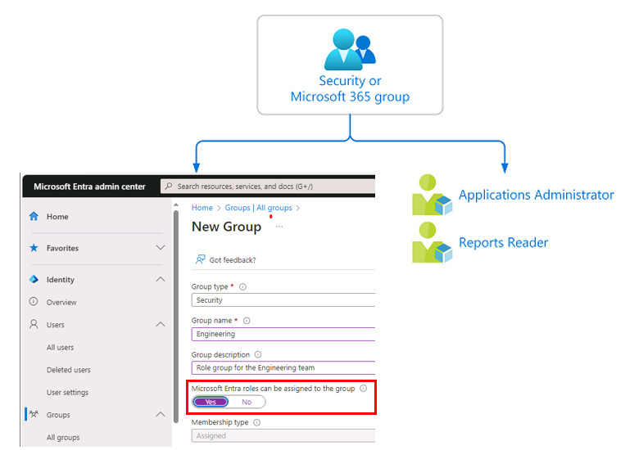
Create role groups in Windows PowerShell
You should perform the following steps in Microsoft Graph PowerShell to create a role group and assign roles to it:
- Use the New-MgGroup command to create a role group.
PowerShell
Connect-MgGraph -Scopes "Group.ReadWrite.All"
PowerShell
$group = New-MgGroup -DisplayName "Contoso_Helpdesk_Administrators" -Description "Helpdesk Administrator role assigned to group" -MailEnabled:$false -SecurityEnabled -MailNickName "contosohelpdeskadministrators" -IsAssignableToRole:$true
- Use the Get-MgRoleManagementDirectoryRoleDefinition command to get a role definition.
PowerShell
$roleDefinition = Get-MgRoleManagementDirectoryRoleDefinition -Filter "displayName eq 'Helpdesk Administrator'"
- Use the New-MgRoleManagementDirectoryRoleAssignment command to assign the role.
PowerShell
$roleAssignment = New-MgRoleManagementDirectoryRoleAssignment -DirectoryScopeId '/' -RoleDefinitionId $roleDefinition.Id -PrincipalId $group.Id
How are role groups protected?
If a group is assigned a role, any IT administrator who can manage group membership could indirectly manage the membership of that role. Let's consider the following scenario. At Contoso, the User Administrator role is assigned to a group named Contoso User Administrators. An Exchange administrator who can modify group membership could add themselves to the Contoso User Administrators group. In doing so, they would become a User Administrator. As you can see, an administrator could potentially elevate their privilege in a way that wasn't intended.
So how would role groups prevent this scenario from happening? To begin with, a role group's membership type is Assigned, which means only authorized administrators (such as Global Administrators) can manage it. As such, unauthorized administrators (like the Exchange administrator in this example) can't directly modify the group’s membership. This feature would restrict the Exchange administrator from elevating their privilege by adding themselves to the group and gaining the User Administrator role.
Role groups have the following restrictions:
- The isAssignableToRole property is immutable. Once a group is created with this property set, it can't be changed.
- You can't make an existing group a role group.
- A maximum of 500 role groups can be created in a single Microsoft Entra organization (tenant).
Role groups are designed to help prevent potential breaches by having the following restrictions:
- Only Global Administrators and Privileged Role Administrators can create a role group. However, you can delegate the management of role groups by adding group owners.
- The membership type for role groups must be Assigned and can't be a Microsoft Entra dynamic group. Automated population of dynamic groups could lead to an unwanted account being added to the group and thus assigned to the role.
- For Microsoft Graph, the RoleManagement.ReadWrite.Directory permission is required for managing the membership of role groups. The Group.ReadWrite.All permission doesn't work.
- To prevent elevation of privilege, only a Privileged Authentication Administrator or a Global Administrator can change the credentials or reset MFA or modify sensitive attributes for members and owners of a role group.
- Group nesting isn't supported. A group can't be added as a member of a role group.
Use PIM to make a group eligible for a role assignment
If you don't want members of the group to have standing access to a role, you can use Microsoft Entra Privileged Identity Management (PIM) to make a group eligible for a role assignment (PIM is introduced later in this module). Each member of the group is then eligible to activate the role assignment for a fixed time duration.
For groups used for elevating into Microsoft Entra roles, Microsoft recommends that you require an approval process for eligible member assignments. Assignments that can be activated without approval can leave you vulnerable to a security risk from less privileged administrators. For example, the Helpdesk Administrator has permission to reset eligible users’ passwords.
License requirements
Organizations that plan to use role groups must have a Microsoft Entra ID P1 license. If you plan to use Privileged Identity Management for just-in-time role activation, then you must have a Microsoft Entra ID P2 license.

Manage permissions using administrative units in Microsoft Entra ID
Completed 100 XP
- 3 minutes
An administrative unit is a Microsoft Entra resource that can be a container for other Microsoft Entra resources. An administrative unit can contain only users, groups, or devices.
Administrative units restrict permissions in a role to any portion of your organization that you define. For example, you could use administrative units to delegate the Helpdesk Administrator role to regional support specialists. By doing so, they can manage users only in the region they support.
You can assign a user as a member of multiple administrative units. For example, an organization can add users to administrative units by geography and division. In this example, the organization can add the same user to both the "London" (geography) and "Marketing" (division) administrative units.
Deployment scenario
Organizations made up of independent divisions of any kind can find it useful to restrict administrative scope by using administrative units. For example, consider a large university consisting of many autonomous schools (School of Business, School of Engineering, and so on). Each school has a team of IT admins who control access, manage users, and set policies for their school.
In this scenario, a central administrator could:
- Create an administrative unit for the School of Business.
- Populate the administrative unit with only students and staff within the School of Business.
- Create a role with administrative permissions over only Microsoft Entra users in the School of Business administrative unit.
- Add the business school IT team to the role, along with its scope.
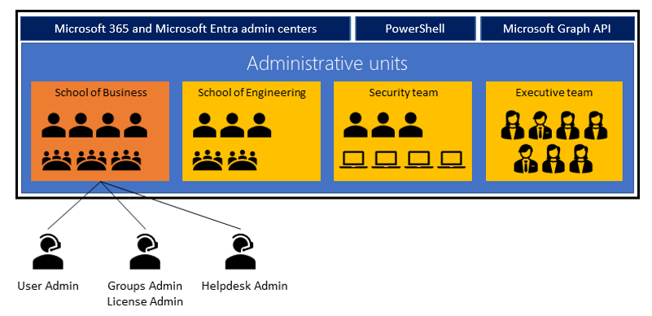
License requirements
Using administrative units requires:
- A Microsoft Entra Premium P1 license for each administrative unit administrator.
- A Microsoft Entra Free license for each administrative unit member.
If you'e using dynamic membership rules for administrative units, each administrative unit member requires a Microsoft Entra Premium P1 license.
Manage administrative units
You can manage administrative units by using the Microsoft Entra admin center, PowerShell cmdlets and scripts, or Microsoft Graph API.
Administrative units can logically group Microsoft Entra resources. Consider the following scenarios:
- An organization scattered its IT department globally. As such, it created administrative units that defined relevant geographical boundaries.
- A global organization has suborganizations that are semi-autonomous in their operations. As such, administrative units could represent the suborganizations.
An organization must use its unique requirements to guide which administrative units to create. Administrative units are a common way to define structure across Microsoft 365 services. When an organization plans its administrative units, it should consider how it uses them across Microsoft 365 services. You can get maximum value out of administrative units when you can associate common resources across Microsoft 365 under an administrative unit.
An organization can expect its administrative units to go through the following stages:
- Initial adoption. The organization creates administrative units based on initial criteria. The number of administrative units increase as the organization refines the criteria.
- Pruning. After the organization defines the criteria, it deletes administrative units no longer required.
- Stabilization. Once an organization defines its organizational structure, it doesn't significantly change the number of administrative units in the short term.
Currently supported scenarios
As a Global Administrator or a Privileged Role Administrator, you can use the Microsoft Entra admin center to:
- Create administrative units.
- Add users, groups, or devices as members of administrative units.
- Manage users or devices for an administrative unit with dynamic membership rules.
- Assign IT staff to administrative unit-scoped administrator roles.
Administrative unit-scoped admins can use the Microsoft 365 admin center for basic management of users in their administrative units. A group administrator with administrative unit scope can manage groups by using PowerShell, Microsoft Graph, and the Microsoft 365 admin centers.
Administrative units apply scope only to management permissions. They don't prevent members or administrators from using their default user permissions to browse other users, groups, or resources outside the administrative unit. To address this issue, organizations use the Microsoft 365 admin center to filter out users outside the administrative units of a scoped admin. However, the scoped admin can browse other users in the Microsoft Entra admin center, PowerShell, and other Microsoft services.
Note
Only the features described in this unit are available in the Microsoft 365 admin center. No organization-level features are available for a Microsoft Entra role with administrative unit scope.
The following sections describe current support for administrative unit scenarios.
Administrative unit management
Permissions | Microsoft Graph/PowerShell | Microsoft Entra admin center | Microsoft 365 admin center
Create or delete administrative units | X | X
Add or remove members individually | X | X
Add or remove members in bulk by using CSV files |  | X | No plan to support
Assign administrative unit-scoped administrators | X | X
Add or remove users or devices dynamically based on rules (Preview) | X | X
Add or remove groups dynamically based on rules
User management
Permissions | Microsoft Graph/PowerShell | Microsoft Entra admin center | Microsoft 365 admin center
Administrative unit-scoped management of user properties, passwords | X | X | X
Administrative unit-scoped management of user licenses | X |  | X
Administrative unit-scoped blocking and unblocking of user sign-ins | X | X | X
Administrative unit-scoped management of user multifactor authentication credentials | X | X
Group management
Permissions | Microsoft Graph/PowerShell | Microsoft Entra admin center | Microsoft 365 admin center
Administrative unit-scoped management of group properties and membership | X | X
Administrative unit-scoped management of group licensing | X | X
Note
Adding a group to an administrative unit doesn't grant scoped group administrators the ability to manage properties for individual members of that group. For example, a scoped group administrator can manage group membership. However, they can't manage authentication methods of users who are members of a group added to an administrative unit. Let's assume you want to manage the authentication methods of users who are members of a group that you previously added to an administrative unit. In this case, you must directly add the individual group members as users of the administrative unit. You must also assign a role that can manage user authentication methods to the group administrator.
Device management
Permissions | Microsoft Graph/PowerShell | Microsoft Entra admin center | Microsoft 365 admin center
Enable, disable, or delete devices | X | X
Read BitLocker recovery keys | X | X
Managing permissions in administrative units
When managing permissions using administrative units in Microsoft Entra ID, you can create custom roles and scope them to a specific administrative unit. You can use these roles to grant specific permissions to users or groups within that administrative unit.
However, you can't create a role and globally scope it for all administrative units in the organization. Each administrative unit has its own set of roles and permissions, and you can't apply them across the entire organization.
While you can't globally scope a role for all administrative units, you can work around this restriction. How? You create a custom role that includes permissions for multiple administrative units within an organization. To do so, you must create a role with permissions that apply to all of the administrative units in question. You must then assign that role to users or groups within each of those administrative units.
Adding a group to an administrative unit brings the group itself into the management scope of the administrative unit, but not the members of the group. In other words, an administrator scoped to the administrative unit can manage properties of the group, such as group name or membership. However, they can't manage properties of the users or devices within that group (unless those users and devices are separately added as members of the administrative unit). Why? Because Microsoft Entra ID uses the Azure Role-Based Access Control (RBAC) model, where administrators grant access to resources based on the user's role and the permissions associated with that role.
Constraints
Organizations should keep in mind the following constraints when using administrative units to help manage permission levels:
- They can't nest administrative units.
- Administrative unit-scoped user account administrators can't create or delete users.
- A scoped role assignment doesn't apply to group members added to an administrative unit, unless the organization directly adds the group members to the administrative unit. For more information, see Add members to an administrative unit.
- The system doesn't currently include administrative units in Microsoft Entra Identity Governance.

Manage SharePoint permissions to prevent oversharing of data
Completed 100 XP
- 4 minutes
Organizations operate at various levels of maturity in governing SharePoint data. While some enterprises strictly monitor permissions and oversharing of content, others don't. The situation is further complicated because many enterprises have legitimate reasons to share "some" data widely within the organization. Sometimes, end users in your organization make choices that result in the oversharing of SharePoint content. For example:
- Users might save critical files in locations accessible to a wider audience, including external users.
- Some users prefer sharing with large groups rather than specific individuals, leading to oversharing.
- Users might not pay close attention to permissions when uploading files.
Services such as Microsoft SharePoint and Microsoft Copilot for Microsoft 365 utilize all data to which individual users have at least View permissions, which might include broadly shared files that the user is unaware of. As a result, users might see these applications as exposing content that was overshared. Oversharing can lead to sensitive information being exposed to unintended recipients. End users, while well intentioned, might not always grasp the implications of their sharing choices. They might overlook permissions or opt for convenience over security.
As a result, it's important to use the permission models in SharePoint to ensure the right users or groups have the right access to the right content within your organization. The following sections describe the key steps that administrators can implement to configure their SharePoint permissions model to help prevent data oversharing.
Note
These steps are provided for SharePoint administrators. Some of the following features require a SharePoint Advance Management license.
Step 1: Review site-level sharing controls and remove "Everyone Except External Users" from the People Picker
By default, SharePoint allows users to share content with a wide audience, including internal users and external collaborators. As such, administrators must encourage users to assign permissions at the site/library/folder level thoughtfully. It's important that they educate users by raising awareness about the effect of oversharing and the importance of setting appropriate permissions.
Setting granular permissions to help prevent oversharing is where the People Picker comes into play. The People Picker is a web control used in SharePoint to find and select users, groups, and claims when assigning permissions to items such as lists, libraries, or sites. When a site, list, or library owner assigns permissions, they utilize the People Picker to search for and designate the appropriate individuals or groups who should have access to specific content. One of the People Picker options is "Everyone Except External Users." This option is a convenient way to share content broadly within the organization. However, it can lead to oversharing if not used judiciously. When end users upload files or save critical content without paying attention to permissions, they might inadvertently share it with a larger audience than intended.
The “Everyone Except External Users” setting includes internal users but excludes external collaborators. If sensitive data is shared this way, it could inadvertently reach external parties. To prevent oversharing, organizations should review site-level sharing controls and disable the “Everyone Except External Users” option. Doing so ensures that only authorized individuals have access to specific content. By excluding this option, you reduce the likelihood of unintentionally sharing content with a wide internal audience. Users can still share with specific individuals or groups, but the default should be more restrictive.
In addition to removing this control, SharePoint administrators should:
- Educate site admins on the site-level controls they can use to restrict members from sharing. One key setting here ensures that Site Owners are the recipients of access requests.
- Consider hiding broad-scope permissions from your end users to reduce risks around accidental misuse. This example hides the "Everyone Except External Users" in the People Picker control so that no end user can use it.
- Consider adopting sharing best practices like changing sharing link defaults from companywide sharing to specific people links.
Step 2: Identify inactive sites, then restrict access or delete
Reduce your surface area for potentially overshared content by identifying SharePoint sites that have been inactive for a long time. See how you can easily do that through the Inactive Site Policies in SharePoint Advanced Management. You can then lock down permissions on these sites through the Restricted Access Control policy. You can also consider deleting these sites.
Step 3: Identify potentially overshared content
A SharePoint administrator can run reports in the SharePoint admin center to discover broad sharing activity happening over the last month. SharePoint Advanced Management’s new data access governance reports can help here. A SharePoint admin can run reports on:
- Usage of "Everyone Except External Users" in the last 28 days
- Usage of broad org-wide "People in your organization" sharing links in the last 28 days
- Usage of "Anyone" sharing links in the last 28 days
These reports can be downloaded as CSV files. You can also build your own report by using Microsoft Graph Data Connect for SharePoint.
Step 4: Take remediation actions to address oversharing
Once you identify the SharePoint sites with potential oversharing issues, it's time to act. Your actions should consider several factors, including data sensitivity, the severity of the oversharing, and the need to maintain business operations. These actions include:
- For content that has been overshared and needs immediate action:
  - Configure a Restricted Access Control Policy for such sites. As a result, all existing access to the site is restricted to only the group of users configured by the admin. Accordingly, the content from this site is visible only for this restricted group of users. This policy works for both OneDrive and SharePoint.
  - For high-profile instances, you should determine who/how/when the oversharing took place. Use the Change History feature to see what changes contributed to the oversharing.
- For cases where the SharePoint administrator needs to consult with site owners/admins for action:
  - The SharePoint admin can reach out to the owners of sites identified in data access governance reports. SharePoint admins can advise site owners on the overshared files/folders in that site and request them to act to manually remove unnecessary access.
  - In 2024, Microsoft is releasing a new SharePoint Advanced Management feature called "Site Access Review" that a SharePoint admin can initiate from any Data Access Governance report. Site owners use a Site Access Review UI to review broadly shared content on their side and either take remediation action to remove overly broad permissions or provide business justification to the SharePoint admin.
Step 5: Set restricted access control and block file download policies on business-critical sites
SharePoint administrators should use Restricted Access Control to proactively protect against oversharing. In doing so, they should consider blocking downloads from selected sites through a block download policy. They can also specifically block the download of Teams meetings recordings. Lastly, they should consider applying encryption action with "extract rights" enforced on business-critical office documents. Learn more here.
Elevate privileges using Microsoft Entra Privileged Identity Management
200 XP
- 5 minutes
Microsoft Entra Privileged Identity Management (PIM) enables organizations to manage, control, and monitor user access. PIM provides access to resources in Microsoft Entra ID, Azure resources, and other Microsoft online services like Microsoft 365 and Microsoft Intune.
Microsoft Entra Privileged Identity Management provides organizations with the following benefits:
- It identifies the users assigned privileged roles to manage Azure resources.
- It identifies the users assigned administrative roles to manage Azure resources.
- It enables on-demand "Just in time" administrative access to:
  - Microsoft online services like Microsoft 365 and Intune
  - Azure resources
  - Resource groups
  - Individual resources such as virtual machines
- The organization can see a history of administrator activation, including changes administrators made to Azure resources.
- Organizations receive alerts about changes in administrator assignments.
- Users require approval to activate Microsoft Entra privileged admin roles.
- Organizations can review membership of administrative roles and require users to provide a justification for continued membership.
Note
You examine Privileged Identity Management in greater detail in the Learning Path titled Explore security metrics in Microsoft 365 Defender.
Just in time administrator access
Historically, an administrator assigns users to admin roles through the Microsoft Entra admin center, other Microsoft online services portals, or the Microsoft Entra cmdlets in Windows PowerShell. As a result, that user becomes a permanent admin, always active in the assigned role.
Besides these traditional Microsoft 365 administrator roles, the Microsoft Entra PIM service introduces the concept of an eligible administrator. Eligible admins are users that need privileged access periodically, but not all-day, every day. The role is inactive until the user needs access. At that point, the user must complete an activation process to become an active admin for a predetermined amount of time. Using this approach is becoming more common for organizations to reduce or eliminate “standing admin access” to privileged roles.
The following diagram shows how a regular user can use PIM to elevate privileges to selected administrative roles.
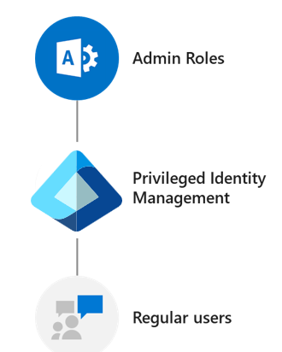
The Privileged Role Administrator
The Privileged Role Administrator (PRA) manages Microsoft Entra PIM and updates role assignments for other users. This role is critical role in maintaining effective privileged access management and ensuring the security and integrity of sensitive resources and data within an organization. The responsibilities and capabilities associated with the PRA role include:
- Managing Privileged Roles
  - The PRA is responsible for defining and managing privileged roles within the organization.
  - They identify the roles that require elevated privileges and determine the appropriate individuals or groups who should hold these roles.
  - The PRA can assign, modify, and remove privileged roles based on business requirements and the principle of least privilege.
- Granting Just-in-Time (JIT) Access
  - JIT access is a feature in PIM that allows temporary elevation of privileges to perform specific tasks for a limited time.
  - The PRA configures JIT policies to define the tasks that require elevated access and the conditions for granting access.
  - They review and approve or reject access requests from users who need temporary privileged access.
- Monitoring and Auditing Privileged Access
  - The PRA is responsible for monitoring and auditing privileged access within the organization.
  - They review access logs and reports to ensure compliance and identify any unauthorized or suspicious activities related to privileged accounts.
  - The PRA takes necessary actions, such as revoking access or conducting further investigations, if the organization detects any anomalies or security incidents.
- Security and Compliance
  - The PRA aligns privileged access with security and compliance policies.
  - They collaborate with security teams to establish and enforce access controls, policies, and procedures related to privileged accounts.
  - The PRA works to minimize security risks associated with privileged access and maintains a secure and compliant environment.
- Training and Documentation
  - The PRA can also create documentation, guidelines, and training materials related to privileged access management.
  - They educate other administrators and users about best practices, security measures, and proper usage of privileged accounts and roles.
The Privileged Role Administrator, as the designated administrator within PIM, has the authority to assign specific administrator roles to users within the organization. The PRA manages and controls privileged access by defining and assigning roles through PIM. They determine which users require elevated privileges for specific administrative tasks and assign them the appropriate roles.
PIM offers a range of built-in roles for common administrative tasks, such as Global Administrator, Exchange Administrator, SharePoint Administrator, and more. The PRA can assign these predefined roles to users or create custom roles tailored to the organization's specific needs.
Through the PIM interface, the PRA can:
- Review access requests from users.
- Approve or reject access requests based on established policies.
- Set the duration for which a user has elevated privileges.
The PRA ensures that organizations follow the principle of least privilege, granting elevated access only when necessary and for a limited time. The next unit examines the principle of least privilege.
In summary, the Privileged Role Administrator within PIM is responsible for:
- Assigning administrator roles to users.
- Managing user access requests.
- Ensuring the secure and controlled delegation of privileged access in Microsoft 365.
Additional reading. For more information, see Assign directory roles to users using Microsoft Entra PIM.
Request role activation
If you're eligible for an administrative role, then you must activate the role assignment when you need to perform privileged actions. For example, if you occasionally manage Microsoft 365 features, your organization's privileged role administrators might not make you a permanent Global Administrator, since that role also impacts other services. Instead, they would make you eligible for Microsoft Entra roles such as Exchange Online Administrator. You can request to activate that role when you need its privileges so that you have administrator control for a predetermined time period.
Important
When the PRA activates a role, Microsoft Entra PIM temporarily adds active assignment for the role. PIM creates active assignment (assigns user to a role) within seconds. When deactivation (manual or through activation time expiration) happens, PIM removes the active assignment within seconds as well. Application may provide access based on the role the user has. In some situations, application access may not immediately reflect the fact that user got role assigned or removed. If an application previously cached the fact the user doesn't have a role, the user may not receive access when they try to access the application again. Similarly, if an application previously cached the fact the user has a role, the user may still receive access if the role gets deactivated. Each specific situation depends on the application’s architecture. For some applications, signing out and signing back in may help get access added or removed.
When you need to assume a Microsoft Entra role, you can request activation by completing the following steps:
- Sign in to the Microsoft Entra admin center as at least a Privileged Role Administrator.
- In the Microsoft Entra admin center, under the Identity governance group in the navigation pane, select Privileged Identity Management.
- On the Privileged Identity Management | Quick start page, in the middle navigation pane under the Tasks group, select My roles.
- On the My roles page, the Eligible assignments tab is displayed by default. This tab displays the list of your eligible roles.
- Find the role you want to activate. Under the Action column for that role, select Activate.
- In the Activate pane that appears, select Additional verification required and follow the instructions to provide security verification. You must only authenticate once per session.
- After multifactor authentication, select Activate before proceeding.
- If you want to specify a reduced scope, select Scope to open the filter pane. On the filter pane, you can specify the Microsoft Entra resources that you need access to. It's a best practice to request access to the fewest resources that you need.
- If necessary, specify a custom activation start time. When you specify a start time, the system activates the role after the selected time.
- In the Reason box, enter the reason for the activation request.
- Select Activate.
- If the role requires approval to activate, a notification appears in the upper right corner of your browser informing you the request is pending approval.
Additional reading. For more information, see How to activate or deactivate roles in Privileged Identity Management.
Knowledge check
Choose the best response for the following question.
Check your knowledge

1.
Which of the following items describes the eligible admin process?

A user with an inactive role must complete an activation process to activate the role for a predetermined amount of time
Correct. Eligible admins are users that need privileged access periodically, but not all-day, every day. The role is inactive until the user needs access. At that point, the user must complete an activation process to become an active admin for a predetermined amount of time.

1.
Which of the following administrator roles in Microsoft 365 can assign other admin roles?
Privileged Role Administrator
2.
Tailspin Toys is a small organization that doesn't have specialized IT administration roles. As such, it outsourced IT administrative functionality to a Microsoft partner. The partner then sent an email message to Tailspin Toys. In the email, the partner requested permission to act as an administrator on Tailspin's behalf. What should Tailspin do next?
Accept the delegated administration offer in Microsoft 365
3.
Microsoft recommends that when you assign someone the Exchange Administrator role, you should assign them a second role that works in conjunction with the Exchange Administrator role. This second role enables the user to see important information in the Microsoft 365 admin center, including the health of the Exchange Online service, and change and release notifications. What second role does Microsoft recommend assigning to a user who was assigned the Exchange Administrator role?
Service Administrator
Summary
Completed 100 XP
- 1 minute
A Microsoft 365 subscription comes with a set of administrative roles that a Microsoft 365 administrator can assign to select users. Each admin role maps to common business functions. They give an organization's users permission to do specific tasks in the admin centers. This module provided a brief overview of the Microsoft 365 admin roles. In this unit, you learned how to use roles and role groups to control who can do what in your Microsoft 365 environment. You also learned how to delegate admin roles to partners, manage permissions using administrative units, manage SharePoint permissions to prevent oversharing of data, and elevate privileges using Privileged Identity Management.
This module examined the key aspects of the Microsoft 365 permission model, such as how roles are defined, assigned, and scoped, and how they differ from other types of permissions. You also learned how to manage roles for different Microsoft 365 services, such as Exchange Online, SharePoint Online, Teams, and Microsoft Entra ID. This training highlighted the best practices and security principles that organizations should follow when configuring administrative roles.
The module also explored the different types of administrator roles in Microsoft 365, including the key permissions assigned to each. You examined built-in roles such as the Global Administrator, Service Administrator, Billing Administrator, and User Management Administrator. You also learned how to delegate admin roles to external partners, such as Microsoft Partners or Cloud Solution Providers, and how to monitor and revoke their access.
You also learned how to create and manage role groups, which enable organizations to simplify the role assignment process and consistently apply role permission. Instead of assigning roles directly to users, you create a group and assign specific roles to the group. Members of the group inherit the roles assigned to the group. Finally, you learned how to use administrative units and Privileged Identity Management to limit the scope of role assignments and delegate permissions to specific segments of your organization, and to provide just-in-time and just-enough-access to sensitive resources.

MS-102 Implement identity synchronization
https://learn.microsoft.com/en-us/collections/p3pmiztjndm6rq?

