/*

* Google Drive api (file uploader) integration

* @Jakir Hosen Khan

* @Date : 2 May, 2016

*/

Prerequisites

* PHP 5.3.2 or greater with the command-line interface (CLI) and JSON extension installed.
* The Composer dependency management tool.
* Access to the internet and a web browser.
* A Google account with Google Drive enabled.

**PHP Quick start**

Complete the steps described in the rest of this page, and in about five minutes you'll have a simple PHP command-line application that makes requests to the Drive API.

**Google Drive uploaded file directory**

* Create a folder in your google drive root directory
* Go to the folder directory
* Copy Folder id from url and set into the constants (FOLDER_ID)

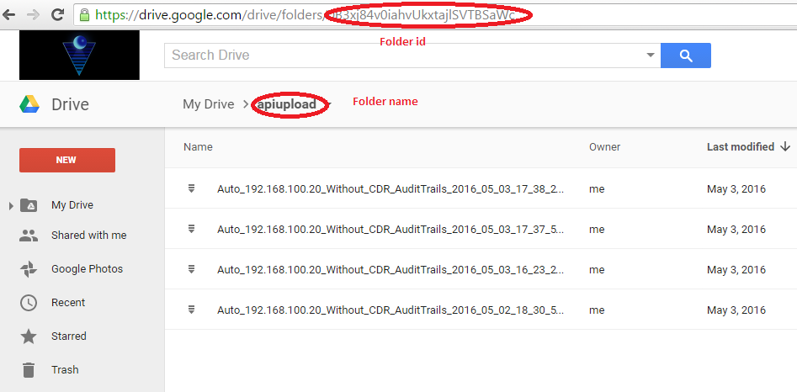

Step 1: Turn on the Drive API

* Go to the following link
  + <https://console.developers.google.com/flows/enableapi?apiid=drive>
* Click continue button
* 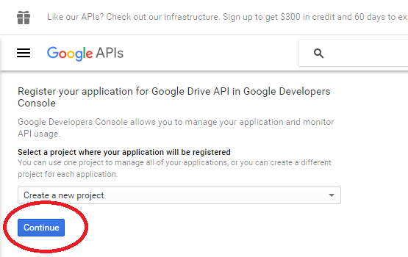
* Click "Go to Credentials" button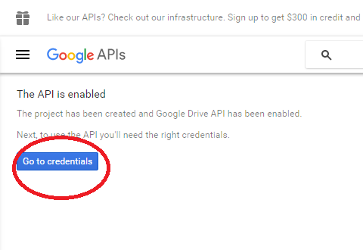

* Add Credentials information

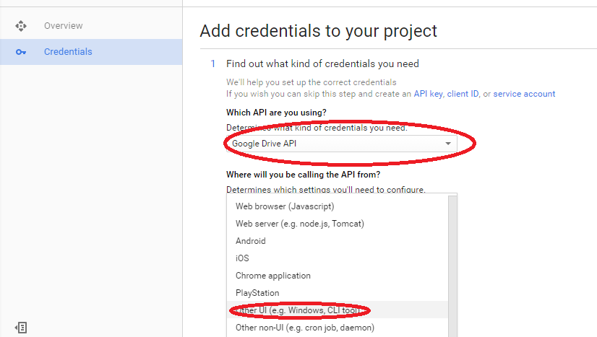

* Check **user data**

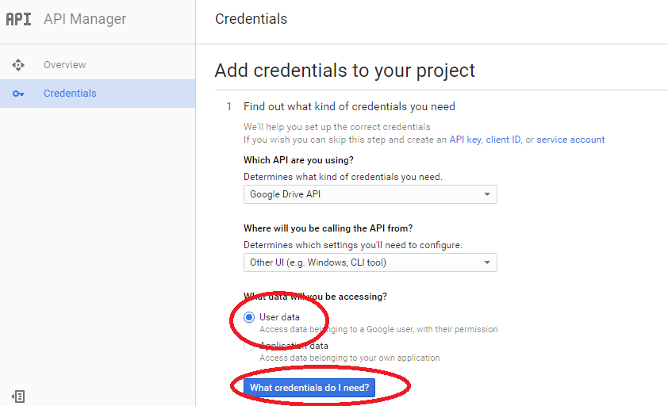

* Add **OAuth2 client name**

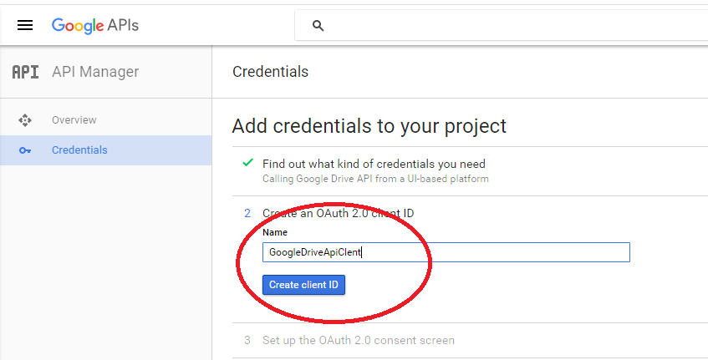

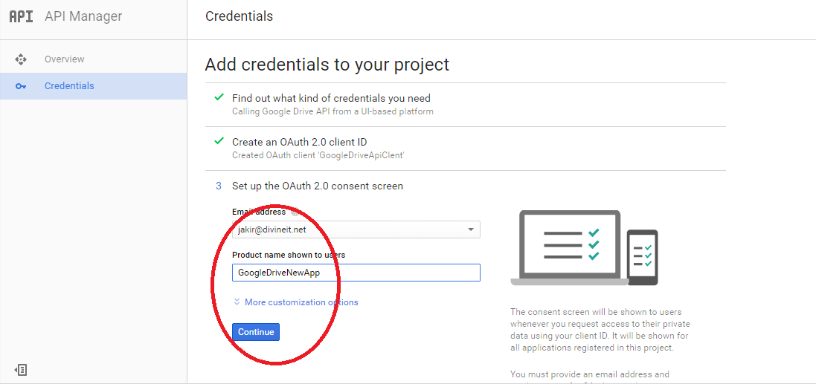

* **Click done**

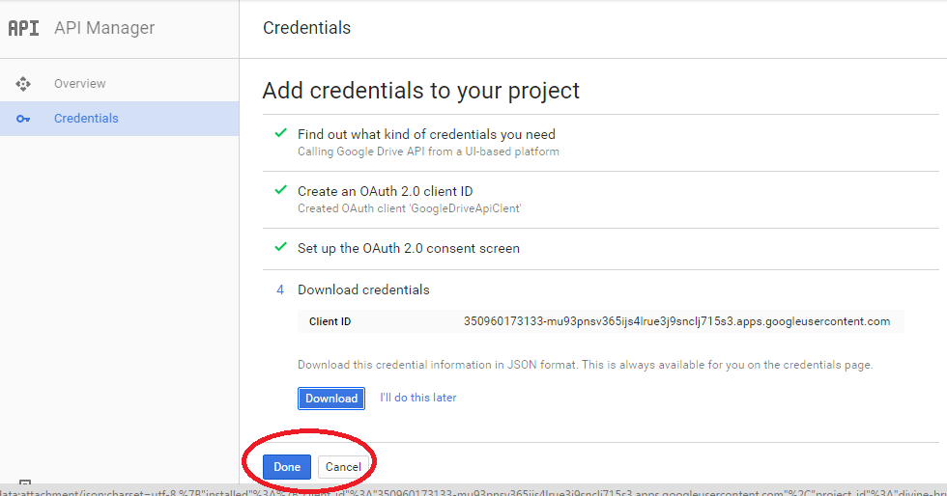

* Enable **Google Drive Api**

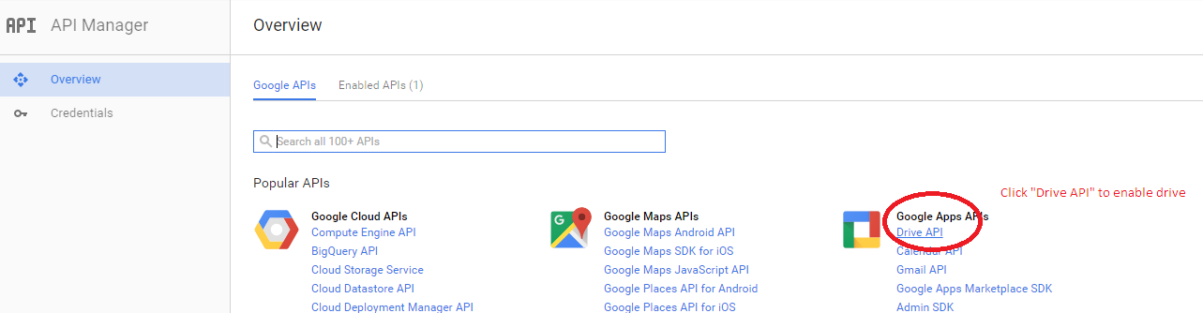

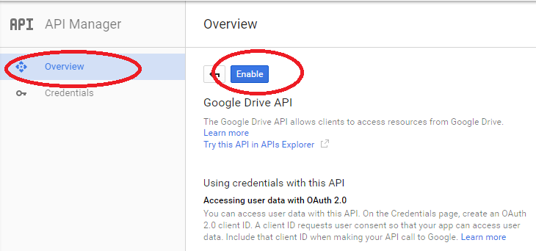

* Download **Credentials information**

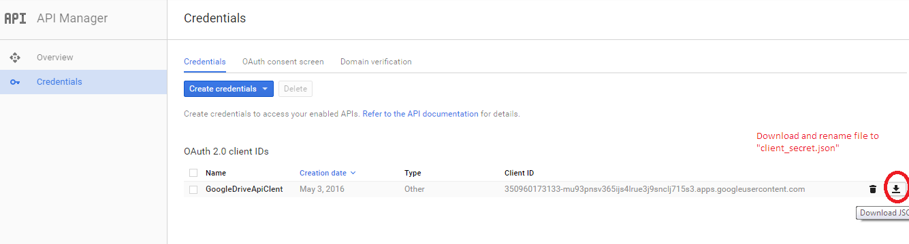

* Rename and Put the **Credentials information** into **project root /env** directory

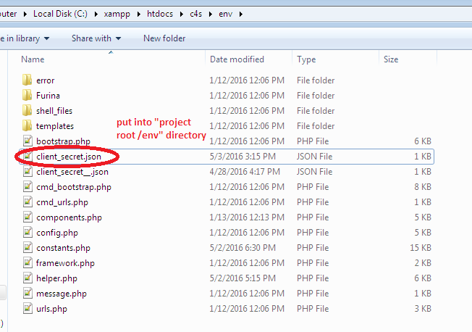

* Run the following shell command

php [**project root**]\[**project name**]\console\run.php --url=core4switch/GoogleDriveApi/FileUpload/?auth_login=0

* Then we will got a link

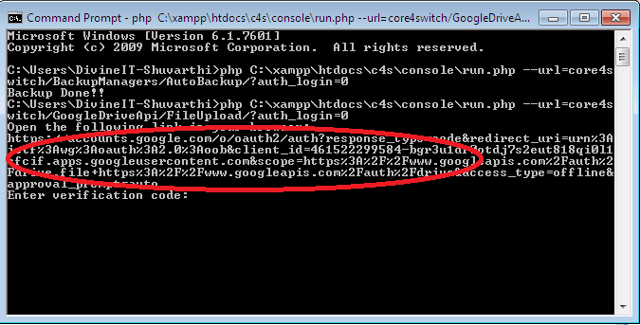

* Copy the link and run on browser

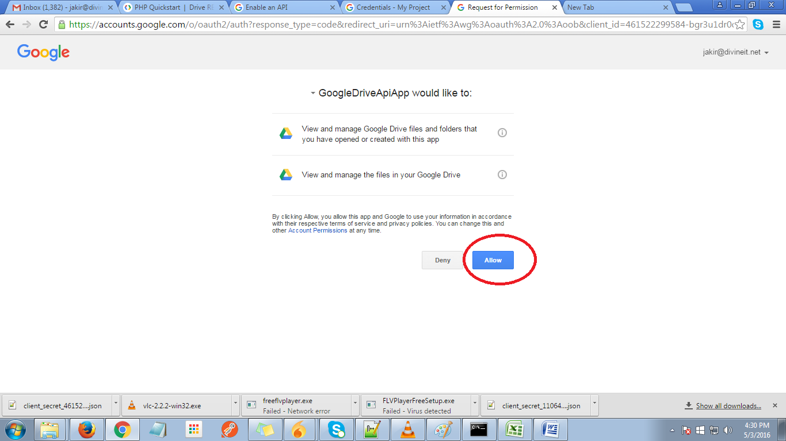

* Click allow then we get a key

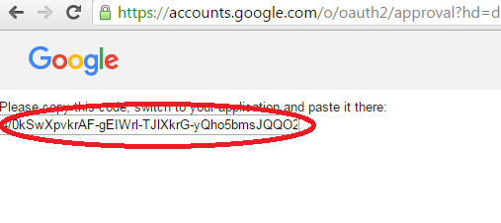

* Copy the key and paste into console then Api refresh key automatically save

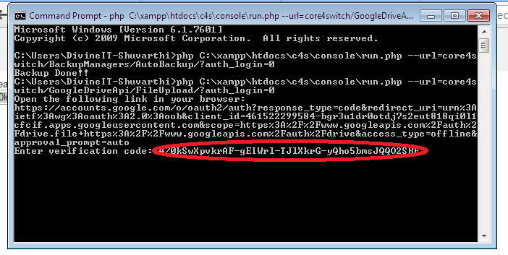

* Run the following commands

php [**project root**]\[**project name**]\console\run.php --url=core4switch/BackupManagers/AutoBackup/?auth_login=0



Create / Select a project in the Google Developers Console.[You must login with your google emailId]

*Enable Google Drive API

*Select the Credentials tab and add Credentials

*