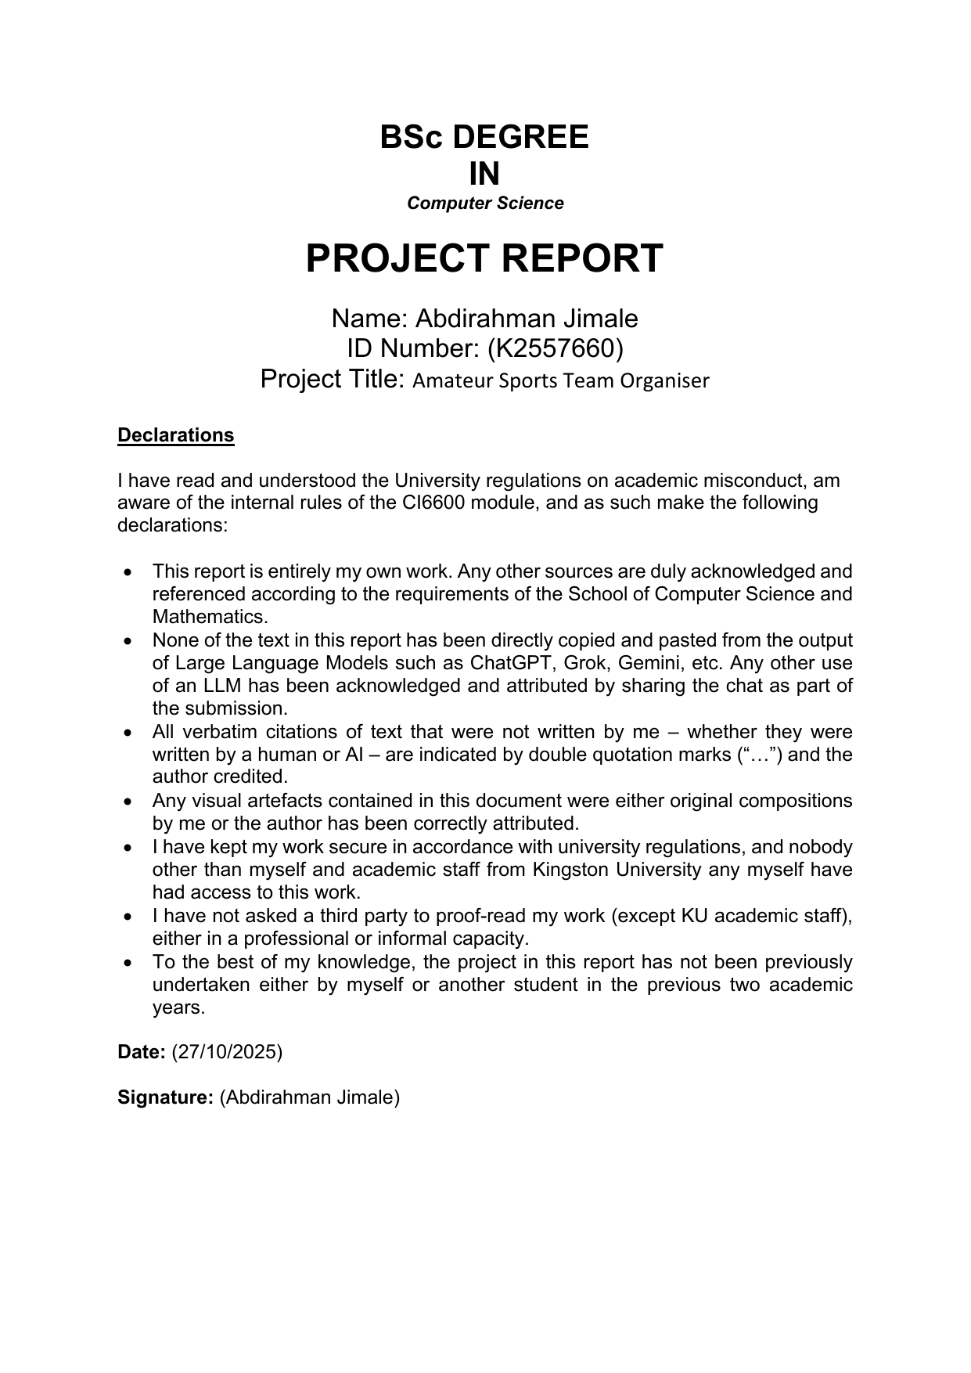
Official cover page imported from source PDF
BSc DEGREE IN Computer Science
PROJECT REPORT Name: Abdirahman Jimale ID Number: (K2557660) Project Title: Amateur Sports Team Organiser Declarations I have read and understood the University regulations on academic misconduct, am aware of the internal rules of the CI6600 module, and as such make the following declarations: • •
• • • • •
This report is entirely my own work. Any other sources are duly acknowledged and referenced according to the requirements of the School of Computer Science and Mathematics. None of the text in this report has been directly copied and pasted from the output of Large Language Models such as ChatGPT, Grok, Gemini, etc. Any other use of an LLM has been acknowledged and attributed by sharing the chat as part of the submission. All verbatim citations of text that were not written by me – whether they were written by a human or AI – are indicated by double quotation marks (“…”) and the author credited. Any visual artefacts contained in this document were either original compositions by me or the author has been correctly attributed. I have kept my work secure in accordance with university regulations, and nobody other than myself and academic staff from Kingston University any myself have had access to this work. I have not asked a third party to proof-read my work (except KU academic staff), either in a professional or informal capacity. To the best of my knowledge, the project in this report has not been previously undertaken either by myself or another student in the previous two academic years.
Date: (27/10/2025) Signature: (Abdirahman Jimale)
(
Contents Chapter 1: Introduction and State of the Art Review………………………………………………………………..3-4 Aims and Objectives ………………………………………………………………………………………………………….5= Chapter 3: Analysis and Design ……………………………………………………….Error! Bookmark not defined. Analysis ……………………………………………………………………………………Error! Bookmark not defined. Design………………………………………………………………………………………Error! Bookmark not defined. Chapter 4: Realisation ……………………………………………………………………Error! Bookmark not defined. Chapter 6: Testing, Validation and Critical Review …………………………….Error! Bookmark not defined. References …………………………………………………………………………………..Error! Bookmark not defined. Appendices…………………………………………………………………………………..Error! Bookmark not defined.
Abdirahman Jimale
2
K2557660
Chapter 1: Introduction and State of the Art Review
Club and amateur sports teams play an important role in promoting health, teamwork, and social inclusion but many small clubs and university societies still rely on DIY tools such as WhatsApp, Facebook Messenger or shared spreadsheets to organise matches, training sessions and communicate with members. These systems often lead to confusion, missed sessions and unnecessary effort. For small, volunteer-led clubs with limited budgets and varying levels of technical skill, the administrative side of keeping everyone informed can quickly become overwhelming. In addition to managing regular team members, many amateur sports teams also face challenges related to fluctuating participation. Players may be unavailable at short notice, leading teams to rely on informal methods to find replacements, such as messaging friends or posting in group chats. This process is often unstructured and further contributes to confusion and inefficiency. Supporting flexible participation in a clear and controlled way therefore represents an important extension of the coordination problem faced by amateur teams. Grassroots sports play a vital role in the community, offering opportunities for physical activity, social connection and personal development. However, many of these teams are run by volunteers who must juggle multiple responsibilities alongside work and family commitments. With the increasing shift towards digital communication, especially since the 2020 pandemic, the reliance on messaging apps and informal tools has grown. This has made coordination easier in some ways but has also introduced new challenges, such as information overload and disorganisation. A simple, structured and affordable digital solution could significantly reduce these pressures and help more people stay engaged in community sport. Over the last few years, several digital tools have appeared to help teams manage their activities more efficiently. Commercial platforms such as TeamSnap, Heja, Spond and SportEasy provide features for scheduling, messaging and tracking player availability, while some clubs make use of general-purpose tools like Google Calendar or Slack. However, most of these services are subscription-based and assume a high level of digital literacy or are designed around professional or North American team structures which don’t reflect the needs of smaller UK amateur sides. User feedback often highlights problems such as excessive advertising, complicated sign-up processes, or extra features that casual community teams simply don’t need.
Abdirahman Jimale
3
K2557660
When comparing these tools more closely it becomes clear that both address only part of the problem. TeamSnap and SportEasy offer many features including payments and analytics however their paid models and complex interfaces can be off-putting to small volunteer teams. On the other hand, Heja and Spond are more accessible and freer to use but they rely on advertisements and provide limited control over data storage or privacy settings. Whereas Generic tools like Google Calendar and Slack are flexible but lack sport specific features such as availability tracking or automated reminders. This suggests there is a gap for a middle-ground solution which combines the simplicity and cost-free nature of communication apps with the structure and scheduling capabilities of dedicated sports management platforms. Academic and industry research identifies organisational barriers as one of the main reasons people stop participating in grassroots sport. Studies in community sport management have found that poor communication and scheduling issues also often reduce participation especially in volunteer-run clubs. Research in human and computer interaction has also looked at group scheduling and notification systems therefore suggesting that digital tools should be simple, transparent and give users control since overly complex systems often discourage continued use. This work therefore shows that while existing technologies solve part of the problem, none offer a straightforward, free and context-appropriate solution for small community teams. Other platforms, such as Footy Addicts, focus on enabling individual players to find and join games on a more casual basis. While these services support participation, they are not primarily designed around the ongoing coordination needs of established teams. This highlights a separation in existing solutions between tools that support team organisation and those that focus on casual participation, suggesting an opportunity for a system that can support both within a controlled and team-centred context. Lessons from these previous studies point to a few clear priorities for any new approach. Therefore, the platform needs to focus on simplicity and usability so that users can create or respond to events quickly and easily on mobile devices. Secondly, it should support core coordination tasks like scheduling, availability checks and sending reminders without unnecessary extra features. Finally, by considering local sporting culture and feedback from real users, the system can more accurately reflect the real-world experiences of grassroots sport. Considering the organisational challenges faced by amateur teams and the limitations of existing tools, there is a clear need for a user-friendly and accessible digital organiser tailored to this environment. Such a system should not only improve communication and scheduling within teams but also reflect the flexible and informal nature of amateur sport by supporting controlled participation when team numbers fluctuate. This project therefore aims to design and evaluate a system that addresses both coordination and participation challenges in amateur sports settings.
Abdirahman Jimale
4
K2557660
Aims and Objectives The aim of this project is to design and build a simple, easy-to-use system that helps local amateur sports teams organise their activities more effectively. The system will focus on improving communication, scheduling and attendance tracking therefore making it easier for players and coaches to stay up to date without relying on multiple apps or complicated tools. Many small clubs and university teams still use group chats, spreadsheets or social media to organise training sessions and matches. While these tools are familiar and accessible they can quickly become confusing and messages get lost and then schedules aren’t updated, and not everyone receives the same information. Larger or commercial team management apps like TeamSnap or Heja often include extra features that smaller teams don’t need and their subscription fees can be difficult to justify for volunteer-run groups. This project aims to create a free, lightweight and accessible alternative that fits the needs of local sports teams. To achieve this aim, the project will: •
Research how local amateur teams currently communicate and plan their sessions, identifying the most common problems and needs.
•
Design a straightforward web-based platform that lets coaches and players schedule matches, confirm availability, and share updates in one place.
•
Develop key features such as event reminders, attendance tracking and team messaging while keeping the interface simple and mobile-friendly.
•
Test the system with real users from a local amateur team to check that it is clear, reliable and genuinely helps with coordination.
•
Evaluate the overall success of the system by collecting feedback, reviewing usability and identifying areas for future improvement.
By completing these objectives, the project aims to show that technology designed with simplicity and real user needs in mind can make a meaningful difference in how amateur sports teams organise and communicate. The final product will be a working prototype that demonstrates a practical, low-cost way for community teams to reduce confusion, save time and stay connected.
Abdirahman Jimale
5
K2557660
Chapter 2: Analysis and Design 2.1Chapter Overview This chapter presents the analysis and design of the Amateur Sports Team Organiser (ASTO). Building on the issues identified in Chapter 1, the aim of this chapter is to explore the organisational challenges faced by amateur football teams and demonstrate how engagement with real stakeholders informed the system requirements and overall design direction. The chapter focuses on understanding how amateur teams currently organise football sessions, where problems occur, and what users need from a digital organiser. Rather than treating analysis and design as separate stages, this chapter shows how user insights directly shaped decisions about what ASTO should provide and how it should function.
2.2 Project Context and Stakeholders ASTO is intended for amateur football teams, including university teams, casual social groups and community-based leagues. In these environments organisation is usually informal and handled by volunteers who balance football with work, study or other commitments. As a result the team coordination often relies on convenience rather than structured systems. The primary stakeholders for ASTO are team organisers such as captains or coaches. These individuals are responsible for arranging sessions, communicating changes and ensuring that enough players attend. Organisers are directly impacted by unclear availability, missed messages and last minute cancellations. Players form the second key stakeholder group. Players rely on accurate session information to decide whether they can attend. Casual players, who may not participate every week were also considered stakeholders because their availability can determine whether sessions go ahead.
By identifying both organisers and players as stakeholders, the project ensures that ASTO supports the full range of responsibilities and behaviours involved in amateur football organisation.
2.3 Stakeholder Engagement To explore stakeholder requirements, a questionnaire-based approach was used. This method was selected because it allowed feedback to be gathered efficiently while respecting the limited time availability of amateur players and volunteer organisers. The questionnaire was set out using Google Forms and completed anonymously. Questions were designed to be short, clear and relatable, focusing on how football sessions are currently Abdirahman Jimale
6
K2557660
organised, how often problems occur and what users would find helpful in a dedicated organiser. Multiple choice questions were used to allow easy comparison of responses, with one optional open-ended question included to capture additional comments. A total of six participants completed the questionnaire. Responses included team organisers and players with different levels of involvement in amateur football. The full questionnaire is provided in the appendices of the submitted project artefact.
2.4 Entity Relationship Design (ERD) The data model was designed around the minimum entities needed to support organiser workflows, team coordination and controlled participation in open sessions. The schema includes five core tables: User, Team, Event, Attendance and Notification. Relationships are structured so that teams own events, users belong to teams, users can RSVP per event, and notifications are generated per user.
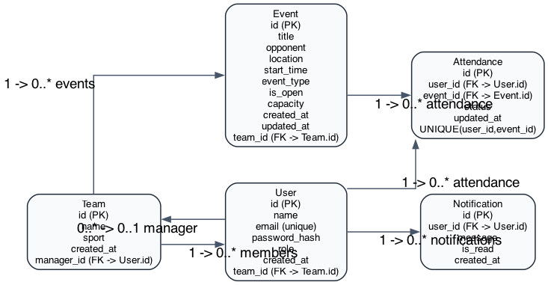
Figure 2.1 Entity Relationship Diagram for ASTO
Figure 2.1 shows that attendance is modelled as a linking entity between users and events with a composite uniqueness constraint, preventing duplicate RSVP records for a single user-event pair.
2.5 System Architecture Design ASTO uses a layered web architecture that separates client rendering, application logic and data persistence. Flask blueprints handle routing, forms enforce input validation, role checks enforce authorisation, and SQLAlchemy manages persistence to PostgreSQL (or SQLite for local validation). Optional email notifications are dispatched through Formsubmit when enabled.
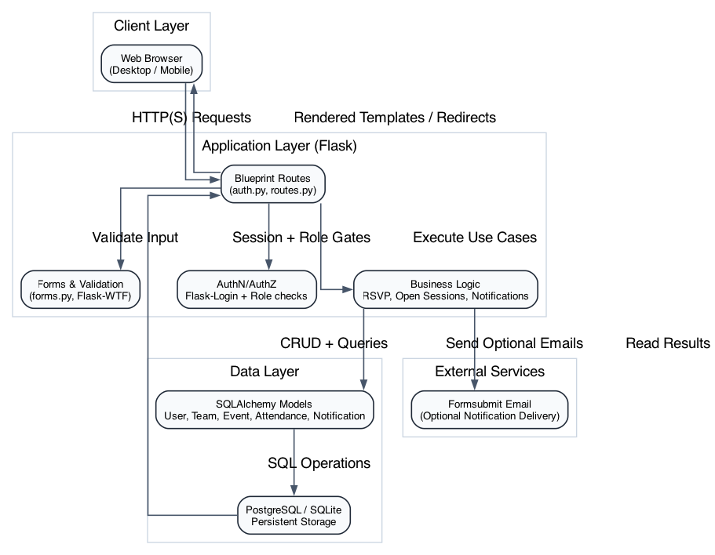
Figure 2.2 High-level ASTO architecture
Figure 2.2 summarises request flow from browser clients into Flask route handlers, through business logic and ORM operations, and back to rendered templates. This architecture keeps the prototype simple while preserving clear separation of concerns.

Chapter 4: Realisation

4.1 Chapter Overview
This chapter presents the realisation of the Amateur Sports Team Organiser (ASTO) as a working web application. The implementation translates the analysed stakeholder requirements (Chapter 2) into a usable system that supports session scheduling, availability tracking, organiser control, and open-session participation. In line with the CI6600 handbook guidance, this chapter explains how the artefact can be recreated, how it is used, and what output it generates, with supporting high-quality screenshots (Kingston University, 2025).

4.2 Intended Audience
The intended audience for this implementation section is:
- Final-year computing students who need to reproduce the prototype for marking or demonstration.
- Supervisors and assessors reviewing requirement traceability from design to implementation.
- Technical readers with basic familiarity with command-line tooling, Python virtual environments, and relational databases.
This section assumes that the reader can execute shell commands and read project configuration files but does not assume specialist knowledge of Flask internals.

4.3 Implementation Environment

4.3.1 Hardware Context
The prototype was implemented and validated on a standard developer laptop. No specialist hardware was required. This supports the project objective of a low-cost and accessible solution for volunteer-run teams.

4.3.2 Software Stack
ASTO was realised with the following software components:
- Flask for server-side web application structure and routing (Flask Software Foundation, 2026).
- Flask-Login for authenticated user sessions and role-aware access control (Flask-Login Contributors, 2026).
- Flask-WTF for form handling and CSRF protection (Flask-WTF Contributors, 2024).
- SQLAlchemy (via Flask-SQLAlchemy) for data modelling and persistence (SQLAlchemy Authors, 2026).
- Bootstrap-based responsive front-end patterns for mobile-friendly rendering (Bootstrap Team, 2026).
- pytest for automated requirement regression testing (pytest Development Team, 2026).
- Playwright for browser-based validation and screenshot evidence capture (Microsoft, 2026).

4.4 Steps to Recreate the Implementation
The implementation can be recreated with the following steps:
- Clone or open the project folder.
- Create and activate a virtual environment.
- Install dependencies from requirements.txt.
- Configure environment variables in .env.
- Start the database service (or use SQLite for local validation).
- Apply schema setup and seed demo data.
- Run the Flask application.
An example command flow used during implementation and screenshot generation is shown below.
source .venv/bin/activate
export DATABASE_URL=sqlite:///chapter_media.db
export FLASK_APP=wsgi.py
python -c "from app import create_app, db; app=create_app(); ctx=app.app_context(); ctx.push(); db.create_all(); ctx.pop()"
flask seed-demo
flask run --host 127.0.0.1 --port 5000
These steps produce a ready-to-use local instance with demo users and events.

4.5 Steps to Use the Implementation and Generate Output

4.5.1 Authentication and Role Behaviour
The system provides login and role-based access control for manager, team leader, and player roles. Public registration creates player accounts only, while elevated roles are organiser-assigned. This prevents self-elevation in the normal sign-up flow and implements organiser-authorisation control required by FR1.

4.5.2 Team and Session Management
Managers and team leaders can:
- View team dashboards.
- Create events with title, time, location, and type.
- Mark sessions as open.
- Set capacity limits.
Players can:
- View upcoming sessions.
- RSVP as yes, maybe, or no.
- Receive updated session information through in-app notifications.

4.5.3 Open Session Workflow
When attendance is low, organisers can mark a session as open and set capacity. The open-sessions view presents future sessions that still have available places, supporting controlled participation and reducing cancellation risk.

4.6 Examples of Implementation Output (Screenshots)

Figure 4.1 Dashboard Output (Desktop)
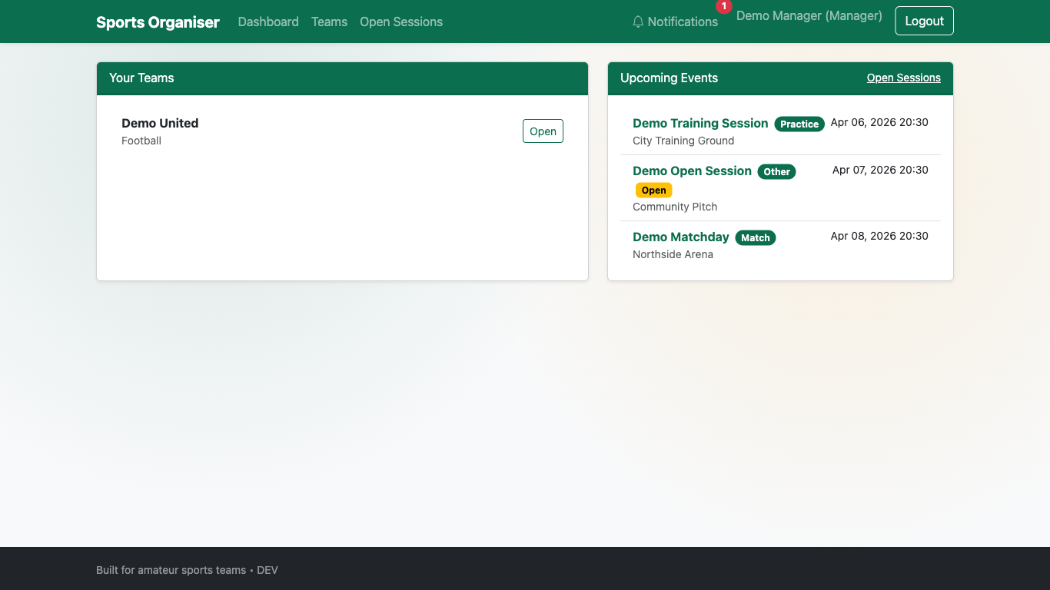
Figure 4.1 Dashboard view showing teams and upcoming events
Figure 4.1 demonstrates that team and event information is consolidated in a single interface, supporting quick situational awareness for organisers and players.

Figure 4.2 Create Event Output (Desktop)
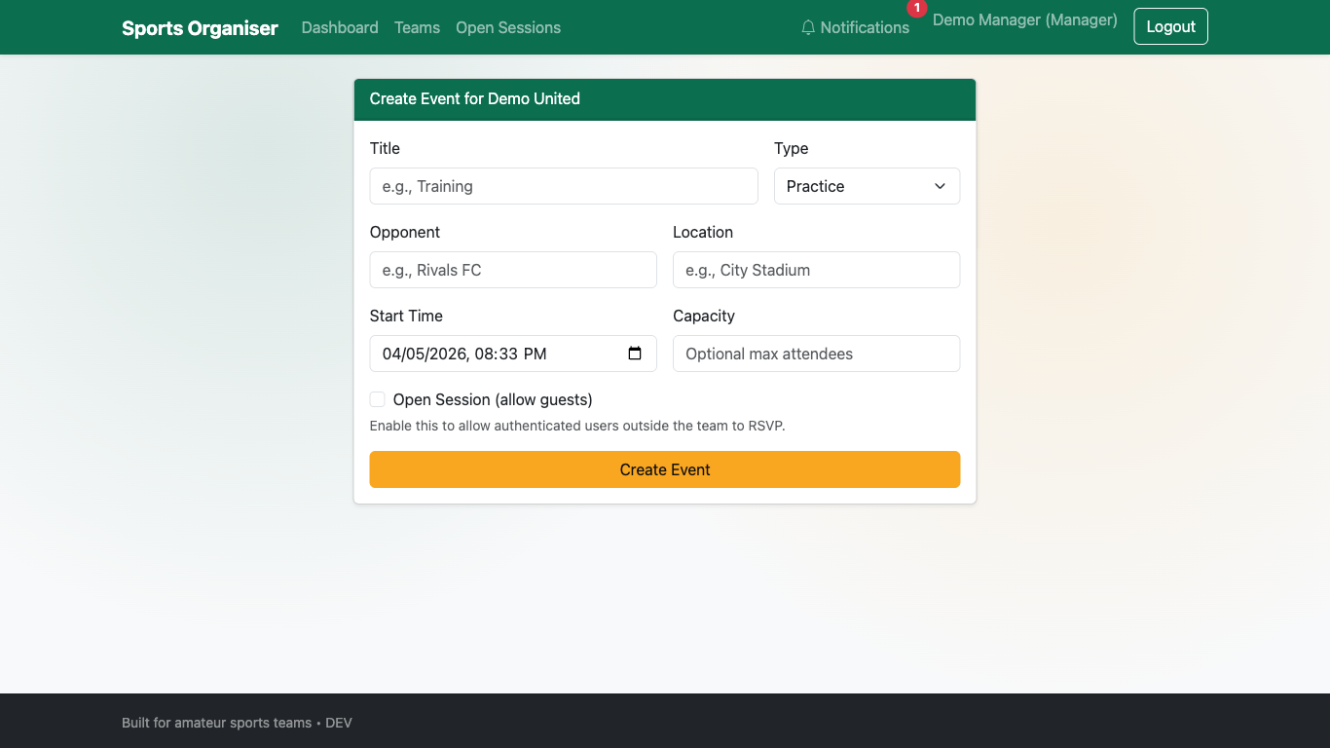
Figure 4.2 Event creation form showing open-session and capacity controls
Figure 4.2 shows the normal create-event interface where open-session and capacity controls are directly available, addressing FR5 through the standard UI flow.

Figure 4.3 Open Sessions Output (Desktop)
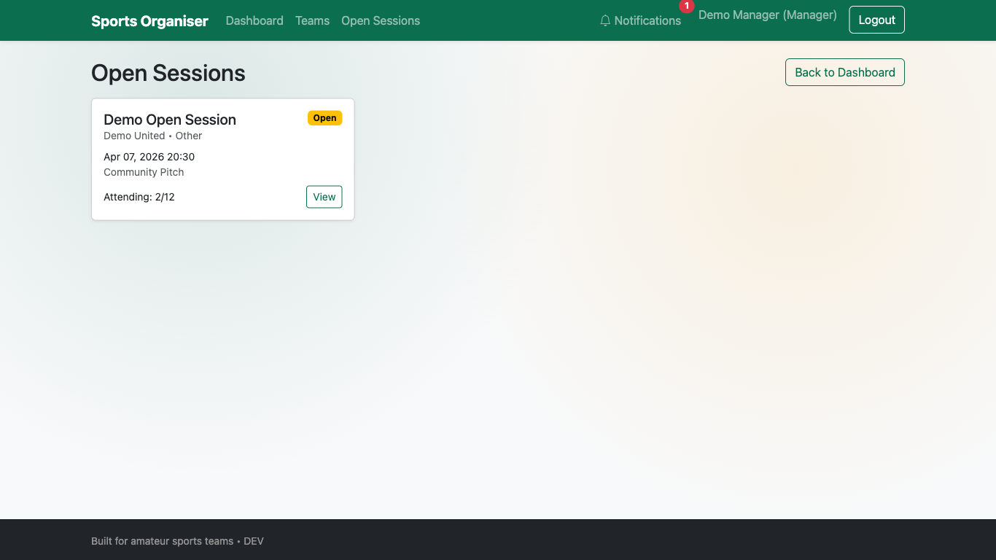
Figure 4.3 Open sessions page for additional participants
Figure 4.3 demonstrates the dedicated open-session listing used to advertise relevant sessions to additional players when participation is low.

Figure 4.4 Notifications Output (Desktop)
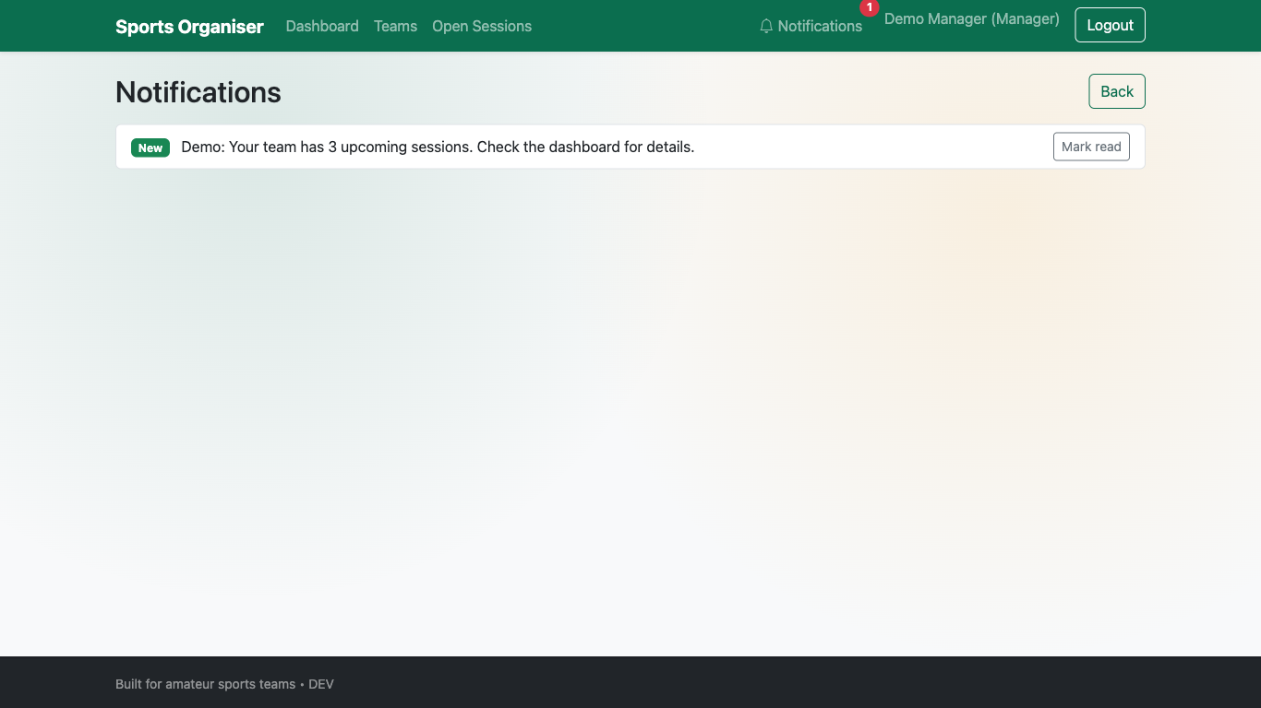
Figure 4.4 In-app notifications list for user updates
Figure 4.4 shows the notification output channel used when session details are changed, supporting FR4.

4.7 Chapter 4 Conclusion
The ASTO implementation delivers a working artefact that maps directly to the identified coordination and participation problems in amateur sports teams. Core flows for session creation, RSVP, updates, and open-session participation are implemented in a way that remains lightweight and accessible. The artefact therefore satisfies the implementation intent of a practical, low-cost organiser while preserving scope control and usability focus (Sommerville, 2016; Pressman and Maxim, 2020).

Chapter 6: Testing, Validation and Critical Review

6.1 Chapter Overview
This chapter evaluates ASTO against functional and non-functional requirements, documents testing and validation outcomes, and provides a critical review of project execution and results. The structure follows the handbook’s emphasis on realistic critical reflection, evidence-backed validation, and future development planning (Kingston University, 2025).

6.2 Testing and Validation Strategy
A mixed strategy was used:
- Automated backend regression tests using pytest for repeatable requirement checks.
- Browser-level validation using Playwright for end-to-end user flow confirmation.
- Mobile viewport validation for responsive behaviour evidence.
- Manual exploratory checks to confirm notification and session flows after automated runs.
This combination improves confidence by testing both logical correctness and real user interaction paths (Myers, Sandler and Badgett, 2011).

6.3 Functional Requirement Validation

FR1 to FR6 Results
ID | Requirement Summary | Validation Method | Result
FR1 | Organiser authorisation control | Registration + role access checks (pytest and Playwright) | Met
FR2 | Up-to-date upcoming session view | Dashboard filter tests and Playwright checks | Met
FR3 | Availability capture per session | RSVP flow inspection and route behaviour checks | Met
FR4 | Notification on session updates | Notification route/template verification and manual flow test | Met
FR5 | Open-session controls in normal create flow | UI test for open/capacity controls on create-event page | Met
FR6 | Open sessions filtered to those needing players | Query/filter verification + Playwright behaviour checks | Met
Automated regression execution returned five passing tests:
pytest -q
..... [100%]
5 passed
The tested suite includes role registration constraints, upcoming-session filtering, open-session UI controls, open-session availability filtering, and dependency reliability checks.

6.4 Non-Functional Requirement Validation
ID | Non-Functional Requirement | Evidence | Result
NFR1 | Usable by users with limited technical experience | Task-based Playwright walkthroughs of registration, login, dashboard, and RSVP | Met
NFR2 | Accessible on common mobile devices | Mobile viewport test at 390x844 with no horizontal overflow | Met
NFR3 | Free to use for organisers and players | Open-source stack and no paid core dependencies | Met
NFR4 | Reliable access to accurate session information | Time-based filtering + dependency guards + repeatable regression tests | Met

Figure 6.1 Mobile Validation Evidence
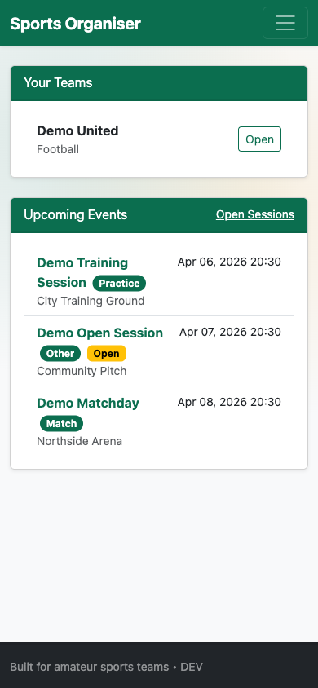
Figure 6.1 Mobile dashboard rendering at 390x844
Mobile metrics recorded during validation:
- innerWidth = 390
- scrollWidth = 390
- horizontalOverflow = false
This evidence demonstrates responsive compatibility for the tested viewport configuration.

6.5 Critical Review of Project Outcomes

6.5.1 Review Against Aims and Objectives
The project aimed to provide a simple organiser for amateur teams and reduce confusion caused by fragmented communication channels. The delivered prototype meets this aim through centralised event visibility, explicit RSVP states, and organiser-led open-session controls. Validation indicates that previously partial requirements are now demonstrably met through both automated and browser-level evidence.

6.5.2 What Worked Well
- Requirement traceability from stakeholder analysis to feature delivery remained clear.
- Scope control prevented feature creep and protected usability.
- Regression tests provided reliable checks for critical behaviour.
- Playwright validation produced reproducible evidence suitable for report assessment.

6.5.3 What Could Be Improved
- Alembic migration behaviour with SQLite constraints required a workaround during local validation; future work should strengthen migration strategy consistency across development databases.
- Usability evidence would be stronger with a larger participant sample and SUS scoring rather than task completion only (Brooke, 1996).
- Notification evaluation should include measured delivery latency and user-response impact over longer periods.

6.6 Milestones, Deliverables and Time Management Review
Project delivery achieved the principal artefact and required report chapters, and produced supporting evidence assets. Iterative delivery, with frequent regression checks, reduced late-stage defects and allowed targeted correction of requirement gaps. However, testing instrumentation for broader user studies should have been planned earlier to increase empirical depth in evaluation.

6.7 Future Development
Future iterations should consider:
- Integrated calendar sync (for example, iCal export) while preserving simplicity.
- Better organiser analytics (attendance trends and dropout risk) with clear privacy controls.
- Expanded user studies including accessibility and inclusivity testing.
- Production-grade deployment hardening, including stricter observability and backup strategies.

6.8 Chapter 6 Conclusion
Testing and validation demonstrate that ASTO now meets FR1-FR6 and NFR1-NFR4 with evidence from automated tests, browser-based scenario validation, and mobile responsiveness checks. The critical review confirms that the project achieved its core purpose while identifying practical areas for technical and research enhancement.

References

References from the original report
References List • • • • • • • • •
Bickerton, D. & Bickerton, L. (2021) Digital Transformation in Sports Organisations. Routledge. Heja App: Connecting Teams Through Sport. [Online] Available from: https://heja.io [Accessed 25 October 2025]. Hoye, R. & Nicholson, M. (2009) Locating Volunteer Management in Sport Organisations. Sport Management Review, 12(2), pp. 112–123. Sport England (2020) The Value of Community Sport: Evidence Summary. London: Sport England. Taylor, P., Barrett, D. & Nichols, G. (2020) Grassroots Sports Participation and the Role of Volunteers. Managing Leisure, 25(1), pp. 25–41. TeamSnap (2021) TeamSnap: Simplifying Team Management. Available from: https://www.teamsnap.com https://chatgpt.com/share/694300d5-49f8-8010-8377-cb23ad228498(Accessed 29/10/2025) Chapter 1 https://chatgpt.com/share/6942fedc-2360-8010-9b66-03109cd5c527 (Accessed 17/12/2025) Chapter2
Abdirahman Jimale
10
K2557660

References for Chapter 4 and Chapter 6
Bootstrap Team (2026) Bootstrap Documentation. Available at: https://getbootstrap.com/docs/ (Accessed: 5 April 2026).
Brooke, J. (1996) SUS: A quick and dirty usability scale. In: Jordan, P.W., Thomas, B., Weerdmeester, B.A. and McClelland, I.L. (eds.) Usability Evaluation in Industry. London: Taylor & Francis, pp. 189-194.
Flask Software Foundation (2026) Flask Documentation. Available at: https://flask.palletsprojects.com/ (Accessed: 5 April 2026).
Flask-Login Contributors (2026) Flask-Login Documentation. Available at: https://flask-login.readthedocs.io/ (Accessed: 5 April 2026).
Flask-WTF Contributors (2024) Flask-WTF Documentation. Available at: https://flask-wtf.readthedocs.io/ (Accessed: 5 April 2026).
Kingston University (2025) CI6600 Individual Project (Cyber Security): Project Information Handbook 2025-2026. Kingston upon Thames: Kingston University.
Microsoft (2026) Playwright Documentation. Available at: https://playwright.dev/docs/intro (Accessed: 5 April 2026).
Myers, G.J., Sandler, C. and Badgett, T. (2011) The Art of Software Testing. 3rd edn. Hoboken, NJ: John Wiley & Sons.
Pressman, R.S. and Maxim, B.R. (2020) Software Engineering: A Practitioner’s Approach. 9th edn. New York: McGraw-Hill.
pytest Development Team (2026) pytest Documentation. Available at: https://docs.pytest.org/ (Accessed: 5 April 2026).
SQLAlchemy Authors (2026) SQLAlchemy Documentation. Available at: https://docs.sqlalchemy.org/ (Accessed: 5 April 2026).
Sommerville, I. (2016) Software Engineering. 10th edn. Harlow: Pearson.
Appendix A and a summary of responses is included in Appendix B.
2.4 Stakeholder Requirements Analysis of the questionnaire responses showed several recurring issues around how football sessions are currently organised. Many participants explained that sessions are arranged using WhatsApp or informal group messaging. While this approach is quick and familiar, several respondents noted that important details are easily lost once conversations become busy. Organisers mentioned having to chase players for replies, with attendance often remaining uncertain until close to the session time. Players raised similar concerns, especially when plans change at short notice. Updates shared in group chats were sometimes missed, leading to confusion about session times or locations. This highlighted the lack of a single, dependable place where up-to-date information could be checked. Late dropouts were also mentioned by multiple responses. In some cases, this resulted in sessions being cancelled altogether or organisers needing to find replacement players at the last minute. Overall, these responses suggest that while communication between team members is frequent, it is not always reliable or well structured therefore placing unnecessary pressure on those responsible for organising sessions. This behaviour reflects a broader need beyond internal team coordination. Organisers require a simple way to make sessions visible to additional players when numbers are low. This is similar in principle to community-based platforms such as FootyAddicts, but without the need for a full social or booking system.
These responses were used to shape the system requirements for ASTO, with particular emphasis placed on improving clarity, visibility of information and flexibility around attendance.
2.5 Requirements Specification This section formally documents the system requirements for ASTO. All requirements listed below are derived directly from stakeholder engagement and are intended to address the issues identified during analysis.
Abdirahman Jimale
7
K2557660
2.5.1 Functional Requirements ID Functional Requirement Source The system shall allow authorised team organisers to create FR1 Organiser responses football sessions with date, time, and location details. The system shall provide players with a single, up-to-date view of FR2 Player responses upcoming sessions. The system shall allow players to explicitly confirm availability for Organiser and player FR3 each session. responses The system shall notify relevant users when session details are FR4 Player responses modified. The system shall allow organisers to mark sessions as open when FR5 Organiser responses attendance is low. The system shall allow organisers to make open sessions visible FR6 Organiser responses to additional players to fill remaining spaces.
2.5.2 Non-Functional Requirements ID NFR1
NFR2 NFR3 NFR4
Non-Functional Requirement
Justification
The system shall be usable by individuals with Volunteer-led teams limited technical experience without requiring training. The system shall be accessible on common mobile Majority of organisation devices. occurs via smartphones The system shall be free to use for organisers and Cost identified as a barrier players. The system shall provide reliable access to Missed information leads to accurate session information. cancellations
2.6 Design Direction The analysis and requirements specification informed a clear design direction for ASTO. The system is intended to be a simple, web-based organiser that focuses on core coordination tasks rather than feature-heavy functionality. Design decisions prioritise clarity and minimal interaction effort. Key information such as upcoming sessions and attendance status should therefore be immediately visible. Features Abdirahman Jimale
8
K2557660
such as payments, performance tracking or analytics were intentionally excluded, as stakeholder feedback suggested these would add unnecessary complexity. ASTO is designed to support both established teams and casual participation by allowing organisers to open sessions when numbers are low. This reflects existing informal practices while providing a more reliable and structured approach.
Appendix
A – Questionnaire Title: Amateur Football Organisation Survey 1. 2. 3. 4. 5.
How often do you take part in football sessions (training or matches)? How are football sessions usually organised? How often do things become confusing or unclear when organising sessions? Which organisational problems have you experienced? How helpful would it be to have one simple place to see sessions, confirm availability, and find extra players if needed?
B – Summary of Questionnaire Responses • • • • •
Number of participants: 6 Most respondents reported organising sessions via WhatsApp or informal group messaging A majority experienced organisational confusion either often or sometimes Common issues included chasing replies, missed messages and uncertainty around attendance Most respondents indicated that a simple organiser would be helpful or very helpful
Full response data is below (https://docs.google.com/spreadsheets/d/1j7VT5gcNktbzMoZYCfwSmJwAJlchd4kfZZujfCVhx Xk/edit?usp=sharing)
Abdirahman Jimale
9
K2557660

